

Accessing Kortext
- Visit app.kortext.com/login
- If you do not have a Kortext account, type or select the name of your Trust from Sign in to browse your institution library
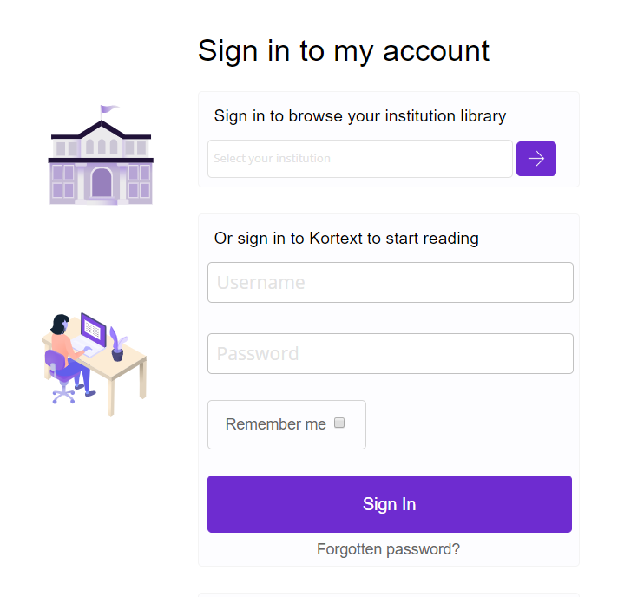
- Click the purple arrow. You will then be prompted to sign-in with your OpenAthens username and password.
- Once you have signed with your OA account you will see the ebook discovery page. There are two tabs:
  - Books – this is your personal bookshelf of books you have opened
  - Collections – this is where to find the list of available ebooks

If you want to use the Kortext app, you will need to create a Kortext account.
- Follow steps 1-4
- At the Kortext eBook discovery page, select the three dots in the menu and Sign out
- At the login screen, your OA email address will display in the username box. Click Forgotten password.
- Set your password
- Log in to the app with your OA email address and your new password.

Discover Content
When you login in to Kortext you will see a Books and a Collections tab.
- Books- this is your bookshelf. It is where all the books you have opened may be found for the duration of the loan period. At the end of the loan period, they will expire and be removed from your bookshelf.
- Collection – this is where all the books to which you have access may be found. Search for a title or browse. Selecting and opening a book will add it to your bookshelf.
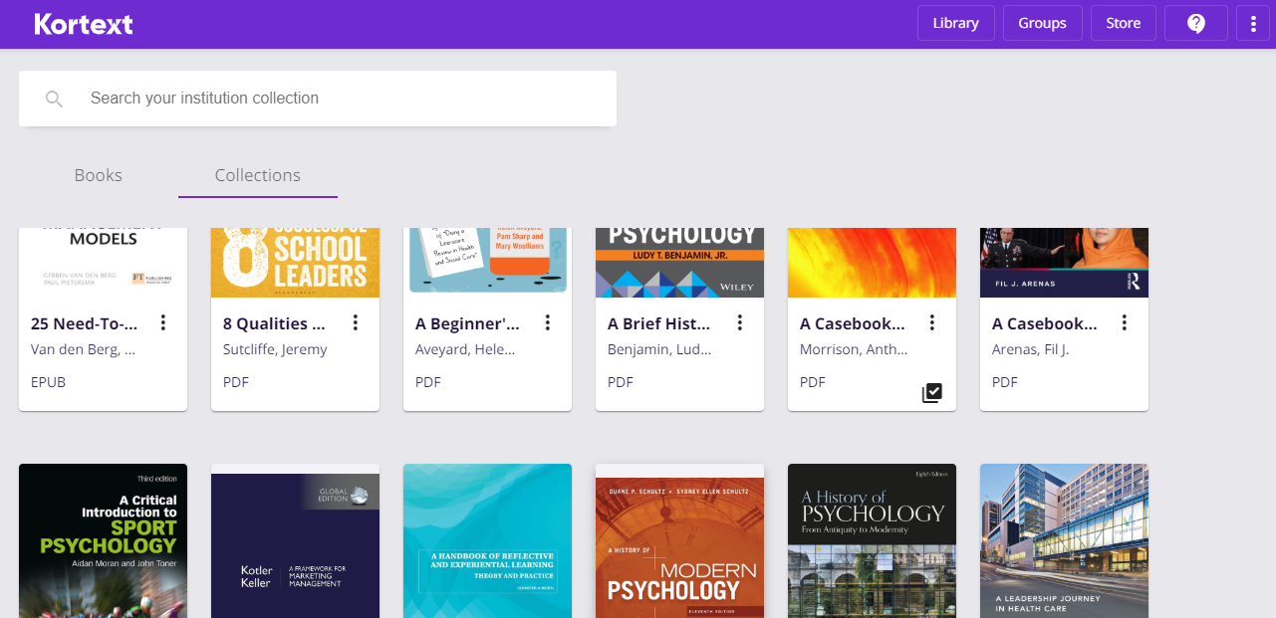

Using eBooks
Ebook options will vary depending on whether it is an ePub or a PDF
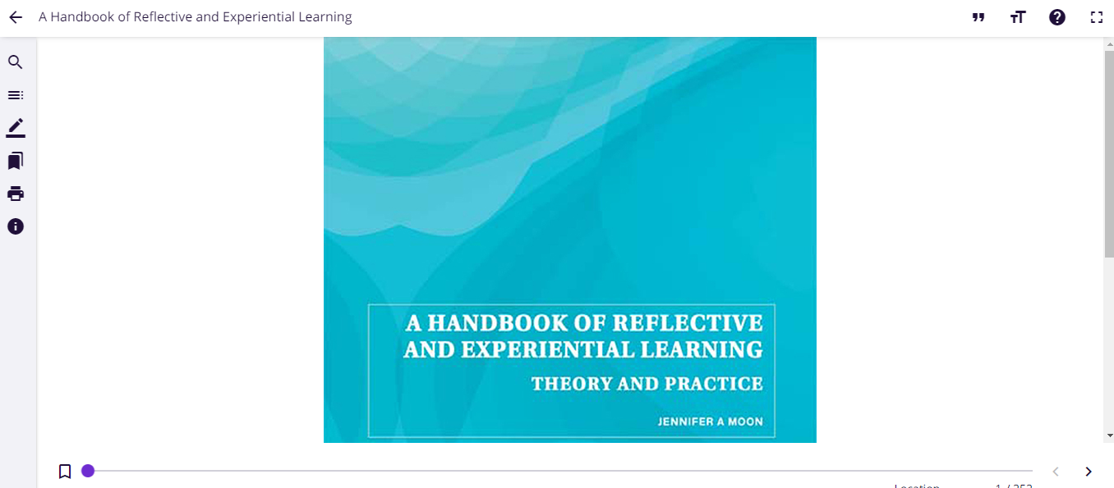

Scroll through the eBook using he table of contents, the page left/page right arrows or the slider.
Use the vertical icons to search the ebook; list the table of contents, make notes, bookmark pages, print or find out more information about the book
Use the horizontal icons for accessibility features: change background colour, alter text size or the font. Also export references, full screen options and to find help.

Useful Links
Training videos and user guides are available online to show how to get the most from the Kortext platform. For any queries, please contact Kortext at support@kortext.com.

Kortext Login Page – https://app.kortext.com/login
Training videos and user guides - https://www.kortext.com/support-and-accessibility/

