https://teamhively.com/wp-content/themes/hively_2018/images/hively_logo_60.png

**Go to:** <https://teamhively.com/>

**What is it?**

Real-time customer and employee feedback.  
Make every email a feedback opportunity via 'Smileys' in your team's email signatures or request feedback when you need it.

**How does it work?**

Explained here in nine steps: <https://teamhively.com/how-it-works>

**How much does it cost?**

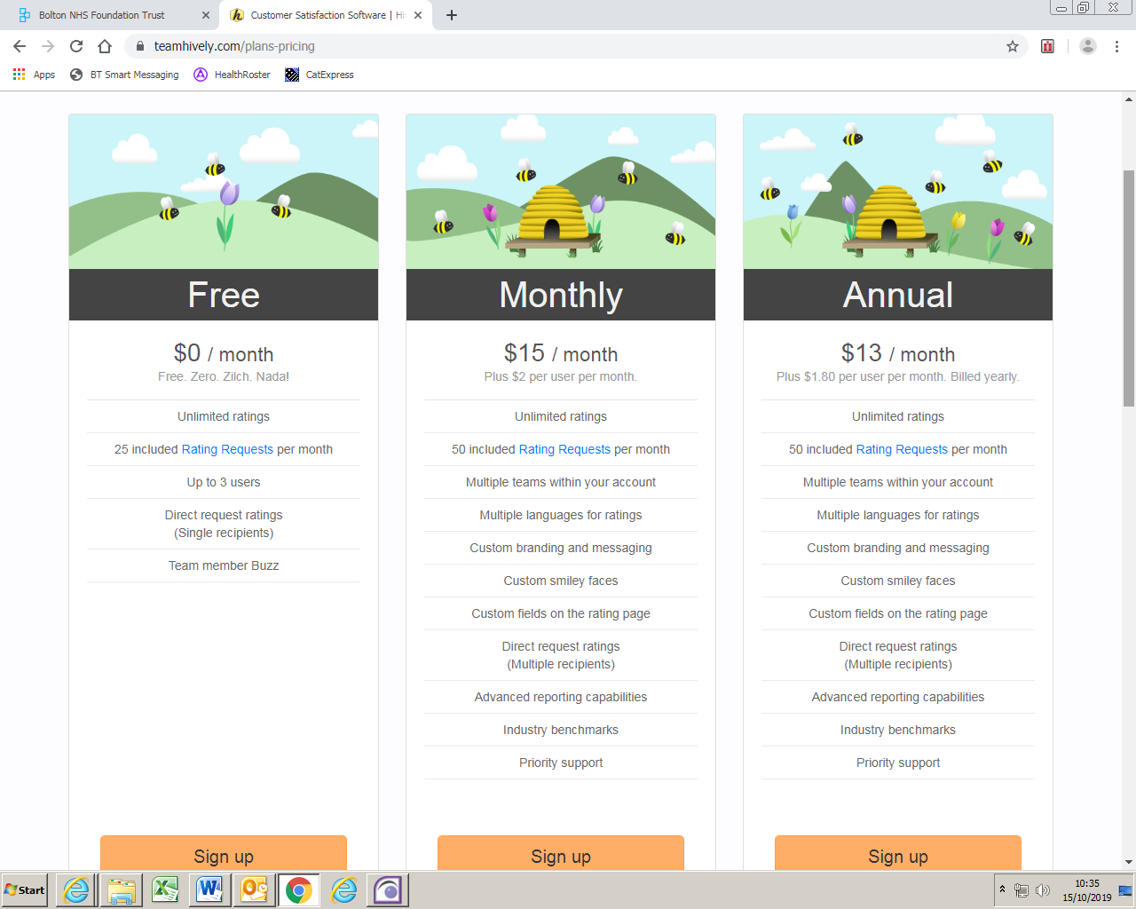

Free version is suitable for teams of up to three. Rating Requests are emails sent from within Hively asking for feedback and only these requests count towards your plan’s free allocation. Most ratings received in Hively come from responses to the smileys in your email signature and there’s no limit on how many of these you can receive.

**How could library staff use Hively?**

**Example 1**

“We’ve been using Hively since the end of August. We’ve learnt that it is very easy to set up and use but there is not a huge amount of information gained from it as not many people have clicked (only 26 people for all three of us since August). We’ve only had one person write a (positive) comment and leave details. If anything we are using Hively internally amongst the team to generate a bit of friendly competition as it provides rankings. Once we get the new team member we won’t really be able to do this as it’ll take us over the 3 free accounts. [name removed] gets the most feedback which is reflective of his role in document supply and dealing with regular enquiries.

I suppose down the line, I’ll probably use the feedback for our annual reports (eg 98% of people rated us positively in the last year) to support the rest of our metrics and impact data.”

From: Knowledge Specialist in a Northern LKS (community service with no physical library)

**Example 2**

During the phase 2 pilot, we used Hively to gather feedback for:

* search results delivered by the Clinical Librarian – sent 26; received 4 (by 23rd Jan)
* document supply – sent 9; received 5 (by 23rd Jan)

All respondents were ‘happy’; 5 gave positive comments; 4 gave their email

Below are some examples of what messages look like and the type of feedback you see when you log in to Hively.

**Example email signature, including the ‘snippet’:**

Hello  
Please find attached your requested article.

How did I do?

[Happy](https://secure.teamhively.com/ratings/add/user/88922/rating/3)[Satisfied](https://secure.teamhively.com/ratings/add/user/88922/rating/2)[Unhappy](https://secure.teamhively.com/ratings/add/user/88922/rating/1)

[**Click on a face to provide feedback on my performance!**](https://secure.teamhively.com/ratings/new/user/88922)

Kind regards  
Kelly Doolan  
Library Assistant

[http://**bolton.nhslibraries.com**](http://bolton.nhslibraries.com/)

**Example of how the snippet might appear in external emails (this one went to an aol account):**

>

> How did I do?

>

> Click on a face to provide feedback on my performance!

>

> Kind Regards

> Kelly Doolan

> Library Assistant

>

> <http://bolton.nhslibraries.com>

>

> @libraryboltonft

> @ Internal: 5935 External: 01204 390935

> 0 Education Centre Library |Royal Bolton Hospital |Minerva Road |Farnworth |Bolton |BL4 0JR

**Example email notification when feedback is received:**

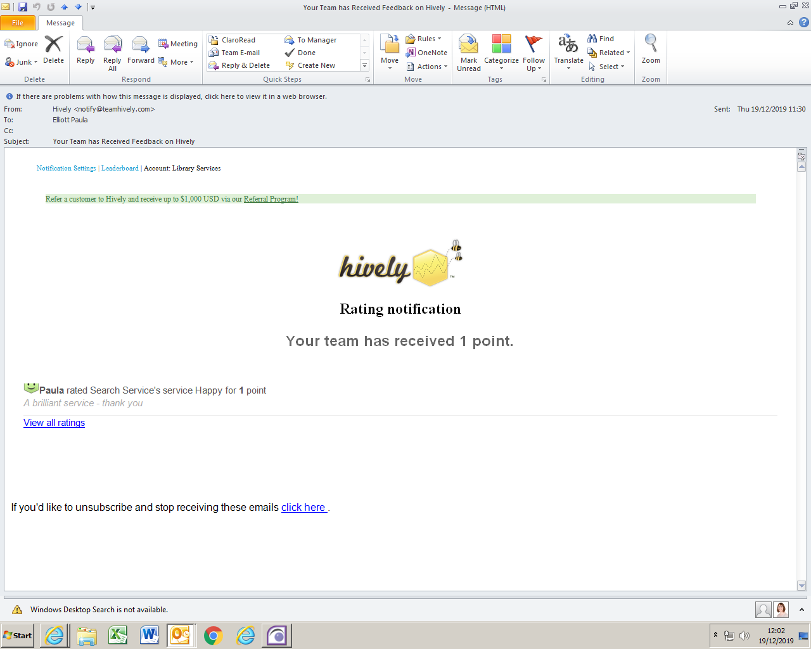

**Example of feedback detail:**

