**Quality and Improvement Outcomes Framework for**

**NHS Funded Library and Knowledge Services:**

**Handbook for baseline self-evaluation, 2019**

# Foreword and Introduction

Healthcare library and knowledge services are a powerhouse for education, lifelong learning research and evidence-based practice.

Health Education England’s ambition is to extend this role so that healthcare library and knowledge services become business critical instruments of informed decision-making and innovation.

Enhancing the quality and demonstrating the value of library and knowledge services is essential in delivering this ambition and the vision of *Knowledge for Healthca*re.

The *Quality and Improvement Outcomes Framework* has been developed in response to *Knowledge for Healthcare* and thecommitment to:

...refresh the Library Quality Assurance Framework to ensure it continues to drive service improvement and is aligned with wider education and service monitoring. p. 48

The result of this commitment is the development of an outcomes-based approach for assuring quality and a framework to underpin service improvement, innovation and to demonstrate the impact of library and knowledge services.

The *Quality and Improvement Outcomes Framework* is also integral to the wider Health Education England *Quality Strategy* and *Framework* as part of assuring a quality learning environment.

This handbook has been developed as supporting documentation for NHS organisations and library and knowledge specialist teams who use the *Quality and Improvement Outcomes Framework*. The handbook provides an overview of the Outcomes Framework and the process for self-evaluation and validation. It also acts as guidance on how to use the framework to evaluate current practice and identify areas for development and service improvement.

**Clare Edwards**

**Chair of the HEE Library and Knowledge Services Leads Quality and Impact Group**

Contents

Foreword and Introduction 2

Part 1: Introduction 5

Strategic Context 5

Developing the *Quality and Improvement Outcomes Framework* 6

Purpose of the *Outcomes Framework* 7

Guiding principles and values 8

Overview of the six quality and improvement outcomes 9

Overview of the *Outcomes Framework* for the baseline self-evaluation 9

The structure of the *Outcomes Framework* 10

Part 2: The Baseline Self-Evaluation Process 11

What is self-evaluation? 11

Planning and preparation for the baseline self-evaluation 11

Evaluation team – who should be involved? 11

Timescales 12

Toolkit to aid self-evaluation 12

The principles of self-evaluation 12

How well are we doing? Evaluating current practice 12

How do we know? Gathering evidence 13

What are we going to do now? Planning and implementing improvements 15

How to self-evaluate using the *Outcomes Framework* 15

Evaluating current practice 15

Gathering the evidence 17

Evaluate evidence and decide level of development 17

Sharing good practice and key strengths 18

Improvement planning 18

Part 3: What happen next? Validated self-evaluation process 19

Validation 19

What are the validators looking for in the submissions? 19

Narrative statements 20

Evidence 20

Choice of levels 21

Validated levels and feedback report 21

Part 4: How developed is our library and knowledge service? The Quality and Improvement Outcomes Framework 22

OUTCOME 1: All NHS organisations enable their workforce to freely access proactive library and knowledge services that meet organisational priorities within the framework of Knowledge for Healthcare. 23

OUTCOME 2: All NHS decision making is underpinned by high quality evidence and knowledge mobilised by skilled library and knowledge specialists. 26

OUTCOME 3: Library and knowledge specialists identify the knowledge and evidence needs of the workforce in order to deliver effective and proactive services. 29

OUTCOME 4: All NHS organisations receive library and knowledge services provided by teams with the right skill mix to deliver on organisational and *Knowledge for Healthcare* priorities. 32

OUTCOME 5: Library and knowledge specialists improve the quality of library and knowledge services using evidence from research, innovation and good practice. 35

OUTCOME 6: Library and knowledge specialists demonstrate that their services make a positive impact on healthcare. 38

Bibliography 41

Appendix 1: Quality and Improvement Outcomes Framework Self-Evaluation and Evidence Report Template 42

Appendix 2: Improvement Planning Worksheet 43

Appendix 3: Improvement Action Plan Template 43

Appendix 4:  Quality and Improvement Outcomes Framework: Self-evaluated and Validated Levels 45

Appendix 5: Links to Glossary of Terms – alphabetical and by outcome 46

Acknowledgements 47

# Part 1: Introduction

## Strategic Context

Healthcare is a knowledge industry. It is not enough to have the right teams in the right place, collaborating to deliver high quality, efficient patient care. It is essential that they use the right knowledge and evidence at the right time. *(NHS Library and Knowledge Services in England Policy[1]* p.2*)*

Healthcare library and knowledge specialists (i.e. all members of the library and knowledge services team regardless of job title, role or banding) act as knowledge brokers. They use their expertise to mobilise evidence obtained from research, staff “know-how” and external innovation and good practice to aid the workforce in making effective and informed decisions.

Health Education England’s (HEE) published *Knowledge for Healthcare: a Development framework for NHS Library and Knowledge Services[2] in England* in December 2014. This set out a clear vision:

NHS bodies, their staff, learners, patients and the public use the right knowledge and evidence, at the right time, in the right place enabling high-quality decision making, learning, research and innovation, to achieve excellent healthcare and health improvement. p.9

*The NHS Library and Knowledge Services in England Policy* outlines HEE’s commitment to ensuring the use in the health services of evidence obtained from research. It is also committed to enabling the NHS workforce to freely access library and knowledge services to achieve excellent healthcare and has the ambition that the role of library and knowledge specialists becomes business critical to the NHS.

The importance of knowledge, evidence and digital technologies to the NHS is reinforced by both the *NHS Long Term Plan*[3] and the Health Education England *Topol Review*.[4]

Effective knowledge management is essential to enable the spread and adoption of innovation, with lessons from early adoption shared widely (OD6): an innovation culture is dependent on a learning culture. … p.68

## Developing the *Quality and Improvement Outcomes Framework*

From 2010 to 2018 the *Library Quality Assurance Framework* (LQAF) raised standards across healthcare library and knowledge services. HEE’s *Knowledge for Healthcare* provided a commitment to:

…refresh the Library Quality Assurance Framework to ensure it continues to drive service improvement and is aligned with wider education and service monitoring processes. p.48

The subsequent review has moved quality assessment away from process, standards and compliancy that drove the LQAF. This change in emphasis will ensure a concentration on improvement, development and delivery of service outcomes. The development of the *Quality and Improvement Outcomes* (the *Outcomes Framework*) was informed by the HEE *Knowledge for Healthcare Evaluation Framework* [5] and builds on the learning from both the LQAF process and the 2018 pilot of the draft *NHS Library and Knowledge Services Quality Improvement Standards.*

The Outcomes will be integral to the *HEE Quality Strategy[6]* which defines quality as:

Education and training within a well-led effectively managed and supportive learning environment that provides opportunities for the current and future healthcare workforce to develop the knowledge, skills, values and behaviours to deliver the highest quality patient care. p.7

They are also critical to the *HEE Quality* *Framework* [7] providing a new outcomes-based structure to support quality and improvement and evidence for quality standard 1.5:

The learning environment provides suitable educational facilities for both learners and educators, including space, IT facilities and access to quality assured library and knowledge. p.9

## Purpose of the *Outcomes Framework*

HEE is responsible for ensuring that there are high quality learning environments for all healthcare learners in England. Key to this are library and knowledge services, supporting both individual and organisational learning and development needs. HEE also seeks assurance that the funding provided to organisations through the *Learning Development Agreement* is used to deliver library and knowledge services that are fulfilling the requirements of *Knowledge for Healthcare,* in line with the *NHS Library and Knowledge Services in England Policy.*

The library and knowledge service’s NHS host organisation, and those who commission such services, are required to ensure that the service is helping them meet their obligations under the *Health and Social Care Act 2012[8]*  to ensure *“...the use in the health service of evidence obtained from research…”* (Section 1E) so that the NHS workforce is enabled to deliver high quality patient care.

The focus of the six outcomes is on library and knowledge service improvement. The *Outcomes Framework* has a dual role and has been designed and developed to:

* drive progress in library and knowledge service improvement leading to better health outcomes
* provide a tool for NHS organisations to ensure that library and knowledge specialists are providing a quality, high performing service that is continually developing and improving to meet the changing evidence and knowledge needs of organisations and individuals.

The *Outcomes Framework* is underpinned by four important features:

* A self-evaluation process that focuses on the quality improvements made in your library and knowledge service delivered to the organisation or organisations served.
* A whole team approach that plans and gathers information and evidence to support quality improvements made to the library and knowledge service.
* External and national validation of the self-evaluation to ensure consistency in the self-evaluations and provide an avenue for sharing good practices between library and knowledge services.
* The process results in a written report and service improvement action plan that can be used to demonstrate the library and knowledge service’s performance and indicate areas for further improvement.

## Guiding principles and values

*Knowledge for Healthcare’s* principles and values and design criteria underpin the six outcomes and inform service improvement.

|  |  |
| --- | --- |
| Guiding Principles and values (*Knowledge for Healthcare p*. 17) | |
| Collaboration | Do once and share working across boundaries |
| Collective purchasing | Central procurement at scale |
| Core service | Core service offer, products, tools and expertise |
| Digital by default | Digital and mobile by default |
| Effective and efficient | Applying the principles of lean thinking |
| Equity | Equity of access and opportunity |
| Federation | Pooling budgets, staff, resources across boundaries |
| Innovation | Flexibility, new models of service, best practice |
| Quality | Benefits to patients improving lives, outcomes, Impact |
| Streamlined | Streamline structure, management, systems, process |
| Technology | Harnessing technology to streamline back-office functions |
| Workforce development | Planning, role redesign, specialisation, career pathways |

|  |  |
| --- | --- |
| Criteria for the redesign of library and knowledge services (*Knowledge for Healthcare p*. 18) | |
| Economy of scale | Function can generate economies of scale, offering value for money if delivered at a large scale |
| Local knowledge | Function requires in depth knowledge of needs of the local health economy and/ or strong organisational relationships |
| Nationwide functions | Function will benefit from a geographical focus or nationwide leadership to achieve national delivery, and/or building on the foundation of established regional service/s |
| Opportunity for standardisation | Function can be delivered using a standardised approach across a wide geography/ number of customers |
| Specialist skills | Function requires specialist skills that are scarce and may not be widely available at a local level, or equitably across the country |

## Overview of the six quality and improvement outcomes

The six outcomes:

1. All NHS organisations enable their workforce to freely access proactive library and knowledge services that meet organisational priorities within the framework of *Knowledge for Healthcare.*
2. All NHS decision making is underpinned by high quality evidence and knowledge mobilised by skilled library and knowledge specialists.
3. Library and knowledge specialists identify the knowledge and evidence needs of the workforce in order to deliver effective and proactive services.
4. All NHS organisations receive library and knowledge services provided by teams with the right skill mix to deliver on organisational and *Knowledge for Healthcare* priorities.
5. Library and knowledge specialists improve the quality of library and knowledge services using evidence from research, innovation and good practice.
6. Library and knowledge specialists demonstrate that their services make a positive impact on healthcare.

## Overview of the *Outcomes Framework* for the baseline self-evaluation

The new *Outcomes Framework* offers a different focus to the former *Library Quality Assurance Framework.* Quality improvement techniques, when applied consistently and systematically, enable library and knowledge services to develop and improve, ensuring evidence is used by the right people, at the right time to deliver high-quality efficient healthcare. Consequently, the *Outcomes Framework* underpins a wider organisational focus on quality improvement to deliver higher-quality healthcare.

The *Outcomes Framework* provides a tool to aid in the self-evaluation of the strengths of the library and knowledge service and highlights areas for development.  It offers a structure for prioritising development and it is assumed that the library and knowledge service will pass through the levels in sequence as the service becomes more developed.

The self-evaluation and validation do not provide an overall score. Therefore, one service cannot be compared with others either nationally or regionally.  This is intentional as the focus should be on individual service development and improvement.

The framework has six “dimensions” or outcomes. In this way the service could be a level 2 in outcome one but a level 3 in outcome four. The result of using the framework is not what level the service is but rather the list of areas for development to improve the quality of the service.

### The structure of the *Outcomes Framework*

For each of the outcomes there are five levels which show progress from “not developed” to “highly developed”. Each level provides the opportunity to self-evaluate as being low, medium or high performing within the level.

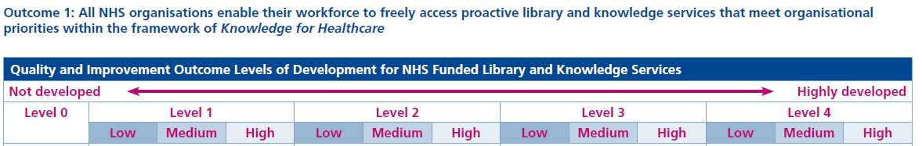

For each level there are a variable number of specific “indicators”. In many cases the indicators show a natural progression from the previous level. The indicators are linked by a Boolean AND/OR. Where there is an AND you should include evidence for all the indicators. The OR means you can choose which of the two indicators to evidence.

Also provided is a note on scope of the outcome, key questions to ask when evaluating the development level, details of why the outcome is important and most importantly examples of outcomes-based evidence types. While the LQAF largely focused on having processes in place to deliver services, the new framework is based on providing evidence of the effect or result of delivering a service or carrying out an activity for the service user.

At the end of each outcome there is a table which provides some indicators of the value of the outcome in decision making for library and knowledge specialists and the organisation and how it will help with service improvement.

# Part 2: The Baseline Self-Evaluation Process

## What is self-evaluation?

Self-evaluation is a continuous process of improvement in which library and knowledge specialists critically examine the services they provide against the quality outcomes to evaluate how well they are delivering the services and identify improvements that can be made.

Self-evaluation assists library and knowledge specialists to:

* Recognise strengths in their service provision.
* Identify areas for improvement and draw up plans for action.
* Share good practice.
* Report to stakeholders on the quality of service provision.
* Demonstrate the relevance, value and impact of the library and knowledge service to their user base.

For the baseline self-evaluation, each organisation will be asked to provide a narrative commenting on how the library and knowledge specialists deliver against each outcome. They will provide evidence to support the narrative and the self-evaluated level for each outcome. Close examination of the service will demonstrate the strengths of the service, show good practice, but also identify areas where the service can improve and change.

## Planning and preparation for the baseline self-evaluation

To ensure a successful completion of the self-evaluation it is crucial that the process is planned and evidence gathering is seen as part of the everyday work of the library and knowledge team and not something that is just done because HEE requests it. Quality is not solely a management responsibility or activity. All staff within the library and knowledge service are responsible for the quality of the services they provide and are best able to evaluate where improvement may be required.

### Evaluation team – who should be involved?

Conducting a self-evaluation has an important value especially for the library and knowledge specialists involved. An effective self-evaluation requires the involvement of the full team who are clear about the process of gathering and selecting good evidence that demonstrates impact. These activities can also support staff development by encouraging a wider understanding of the service enabling staff to clearly see the priorities of the service and areas for improvement but equally what is working well.

### Timescales

Timescales for reporting the self-evaluation will be confirmed by the HEE Library and Knowledge Service Leads, shared with NHS organisations and promoted via <https://kfh.libraryservices.nhs.uk/> and regional newsletters and email lists.

## Toolkit to aid self-evaluation

A Toolkit to support library and knowledge specialists undertaking self-evaluation will be available online at <https://kfh.libraryservices.nhs.uk/quality-and-improvement-outcomes-documentation/> and comprises:

* A digital version of this document
* Quality and improvement self-evaluation and evidence report template
* Printable glossary of terms used in this document
* Summary of quality and improvement self-evaluated levels
* Improvement planning worksheet
* Improvement action plan template
* Recorded webinars providing an overview of each of the six outcomes
* Resources to support quality and improvement in the [Learning Zone](https://kfh.libraryservices.nhs.uk/learning-zone/)

## The principles of self-evaluation

Self-evaluation is based on answering three questions:

* How well are we doing?
* How do we know?
* What are we going to do now?

### 

### How well are we doing? Evaluating current practice

Library and knowledge specialists need to evaluate the impact (how they make a difference or change) of their work with NHS organisations, individuals, teams and groups to know that the services delivered are:

* appropriate and based on workforce need;
* of high quality and in line with good practice;
* in need of review and improvement;
* improved by change, innovation and adaptation.

### How do we know? Gathering evidence

Evidence helps to support self-evaluation processes by demonstrating proof of activity and impact. It can help in establishing how well the library and knowledge specialists are meeting users’ needs. All services will be asked to provide key evidence of the most recent:

* library and knowledge service strategy
* annual implementation/ business/ action plan for the strategy
* library and knowledge service annual report/review.

Evidence should be a by-product of everyday activity and part of a planned and systematic approach to the evaluation of services and activity. It should not be created solely to support self-evaluation against the *Outcomes Framework*. Evaluation should be made about the library and knowledge service’s performance based on the evidence available.

#### Range of evidence

Evidence can be quantitative or qualitative. Quantitative evidence reports what can be measured, for example numbers of mediated literature searches. Qualitative evidence will draw out the value which users may put on services, and this is often unstructured in format, for example feedback from users. Library and knowledge specialists have a long history of collecting statistical information on how they provide services. Statistical, quantitative and qualitative evidence help shape the evidence base for an evaluation of services.

Note: library and knowledge specialists should focus on listing and organising evidence to report on an outcome, not just responding to the key question or ‘things to think about’.

#### Sources of evidence

Examples of sources of evidence are suggested in each of the outcomes (see Part 4), and some more general examples are included below.

These sources of evidence are complementary and may provide more than one view on the same outcome. One example of evidence may be applicable to multiple outcomes.

##### Evidence may include:

* existing evidence on the quality and impact of the service’s own self-evaluation processes;
* data collected to monitor performance against national priorities and performance indicators, supplemented by local targets and priorities as set out in local plans and any other relevant documentation;
* a range of management information including individual and project outcomes; budgetary and resource provision; library and knowledge service staffing levels; information systems.
* outcomes of consulting users, non-users and library and knowledge specialists:
* results of observing activities such as the use of:
  + the services provided
  + the range of resources and services available
  + the library environment
* measurable outcomes from analysing quantitative evidence from sources such as performance indicators, annual statistical returns, surveys and the library management system
* reviews of library and knowledge specialist involvement in internal and external partnerships
* evaluation of externally-funded programmes
* selected photographs of library and knowledge specialist activities.

#### Demonstrating impact: are we making a difference, the “so what” question

It is crucial that health library and knowledge specialists can demonstrate how the services they provide, or are planning to provide, will make a difference to the organisations, teams, groups and individuals that they serve. Measuring and demonstrating impact provides a valuable opportunity to step back and consider the value of the service to organisations and their workforce. After all, if we cannot demonstrate impact, then why should our services be funded?

The self-evaluation process can also assist staff when considering difficult decisions such as ‘Should we really be doing this work with this partner?’ or ‘Will this work really make a difference?’ Quantitative data and good quality impact information should complement each other as they have different roles and purposes; the quantitative data can reassure stakeholders, but this, presented alongside the qualitative evidence, can present a broader picture and demonstrate value and impact effectively.

### What are we going to do now? Planning and implementing improvements

As library and knowledge specialists progress through the process of self-evaluation, strengths in provision and areas for improvement will be identified. Strengths in provision need to be celebrated, maintained and continuously reviewed. Areas for improvement require analysis and discussion before plans for action can be developed and implemented. The improvement plan should feed the continuous cycle of review and action.

An effective improvement plan will have:

* A small number of priorities which focus on improvement for users.
* Clearly identified responsibilities for implementation linked to individuals and/or teams from the library and knowledge service.
* Clear timelines with milestones and deadlines.
* Measures of success which include performance data and senior stakeholders’ views.

Self-evaluation is a continuous process which can be used throughout improvement planning. Library and knowledge specialists should use it to check their starting point and identify what they need to do. They should then monitor improvement progress and do a further evaluation to check the impact of the action taken.

## How to self-evaluate using the *Outcomes Framework*

### Evaluating current practice

The library and knowledge specialists should aim to:

* Conduct an initial self-evaluation of each quality and improvement outcome
* Identify strengths and areas for improvement
* Identify preliminary evidence of impact
* Ask the “So what?” question
* List the possible evidence base

This will enable participants to gain a good understanding of:

* the self-evaluation process
* using the *Outcomes Framework*
* strengths and areas for improvement
* sources of evidence to demonstrate value and impact.

This can be used to inform the evidence gathering process and highlight gaps in the evidence that could be filled.

#### How to identify the level for an outcome

Library and knowledge specialists should consider each quality and improvement outcome by looking at the scope of the outcome and the key questions to ask. This will help them to understand what the outcome covers and provide some pointers to start the self-evaluation. Begin with level 0 and look at each indicator, noting whether it is joined to the next indicator by AND/OR, asking:

1. Do we do some or all of this? or
2. Does some or all of this exist?
3. Do we have existing evidence that can be supplied to demonstrate this indicator? If so, what is the evidence?
4. Do we have strengths that we can show in this outcome?

Where there is an AND you will need to be able to include evidence for all the indicators. The OR means you can choose which of the two indicators to evidence. Continue through the levels until you reach the one where you cannot answer yes to the first three questions. This will mean you have reached the current level for your service. The strength of your evidence will help you to determine whether you should assess your service as low, medium, or high.

Example for outcome one:

You decide you can provide high-quality evidence for all the indicators in levels 1 and 2 but only have high-quality evidence for one indicator in level 3. This shows you are likely to be a low level three and suggests further development is required.

The library and knowledge specialists should then ask the following questions (See Improvement Planning for further information):

* + How can we improve in this outcome?
  + What do we need to do to make this change happen?
  + What do we predict will happen?
  + How will we evaluate that an improvement has taken place?
  + Ask “So what?" - If we do as planned, so what?

### Gathering the evidence

Following the evaluation of current practice the library and knowledge specialists should then gather a range of existing evidence (see Part 4 for the individual outcomes for suggested outcomes-based evidence) to support and confirm the level of development. For the baseline evaluation HEE would prefer that you only use the evidence that you already have (i.e. do not create fresh evidence) as this will enable a more realistic self-evaluation and highlight areas for improvement.

All organisations will supply the following key evidence:

* the organisation’s library and knowledge services strategy,
* the library and knowledge service implementation plan for 2019/20
* The library and knowledge service annual report for 2019/20
* copies of Service Level Agreements for library and knowledge service provision to NHS organisations with a Learning and Devlopment Agreement.

The evidence will, in the majority of cases, cover the previous 12 months (April to March) and be the most current evidence available. For further guidance on range and type of evidence see How do we know? Gathering evidence

See What are the validators looking for? for information on what constitutes quality evidence.

### Evaluate evidence and decide level of development

When the evidence gathering stage is completed, (this may however be an ongoing process if the self-evaluation process is truly embedded in library and knowledge service planning) the drafting of the self-evaluation report should take place, using the *Quality and Improvement Self-Evaluation and Evidence Report* template to draw everything together. The report narrative aims to document current levels of development; recognise key strengths and identify where improvements can be made. The library and knowledge specialists should review the initial self-evaluation and consider, in the light of all the evidence and taking into account the level indicators, at what level they can evidence their performance.

It is important to engage any members of the library and knowledge team who have not been involved in the evaluation process as the information is refined and reconsidered.

### Sharing good practice and key strengths

One of the key benefits of, and an important potential outcome, from the *Outcomes Framework* is the sharing of good practice about what works well in healthcare library and knowledge services. While undertaking the self-evaluation process we ask library and knowledge specialists to extract examples of good practice in their services. This will allow good practice to be captured and selected by the validators for wider sharing.

### Improvement planning

Once the narrative for the self-evaluation report has been completed and the evidence has been embedded in the report then it is time to consider what improvements could be made to the library and knowledge service.

The *Improvement Planning Worksheet* (see Appendix 2) , available in the [Toolkit](https://kfh.libraryservices.nhs.uk/quality-and-improvement-outcomes-documentation/), can be used to develop improvement ideas and rank them in order of priority:

* Start with the list of opportunities for improvement identified during the self-evaluation, and then group them according to themes, or similarities in likely action steps.
* For each opportunity, consider alternative strategies for the improvement outcome that is being sought, i.e. the general approaches you could use to create the improvement.
* Once the alternative strategies have been written onto the worksheet, score them using the criteria on the worksheet: impact, cost, time, and difficulty.
* Use this to set the priorities for your action plan.
* Review the results and make sure they make practical sense, e.g. a low-scoring but very important strategy might still be retained if a way can be seen to achieve it.
* Make a final choice of which improvements you wish to make and the improvement implementation strategies you plan to undertake and then develop action plans with enough detail to begin implementation.

*The Improvement Action Plan Template*, (see Appendix 3), available as part of the [Toolkit](https://kfh.libraryservices.nhs.uk/quality-and-improvement-outcomes-documentation/), will be a useful resource here.

# Part 3: What happen next? Validated self-evaluation process

## Validation

Once the self-evaluations are completed, they will be returned to HEE for a comparative view. The HEE Library and Knowledge Services Leads will validate the self-evaluation reports as part of the HEE *Quality Framework* assessment. The purpose this is to support, extend and challenge the library and knowledge specialists’ own self-evaluation, to affirm, or otherwise, their evaluation of strengths and areas for improvement, thereby strengthening outcomes for service users and other stakeholders.

The validation process will:

* build and support the capacity of library and knowledge specialists to evaluate their services and improve the quality of provision;
* support and provide evidence for HEE’s quality systems;
* support, promote and develop good practice in NHS library and knowledge services;
* provide information to HEE and the NHS on the quality of provision in library and knowledge services; and
* offer a national and consistent validation of self-evaluation processes.

As part of this process the HEE Library and Knowledge Service Leads will consider your self-evaluation report, review and consider your evidence, and ensure the level you have allocated is an accurate reflection of service delivery. The HEE Quality and Impact Group will carry out a consistency check of the levels awarded and the feedback provided .This will ensure that the validation process is seen as a national approach which is applied in the same way across all HEE regions and types of library and knowledge services. The validators will also act as an aggregator of levels across the regions and nationally and identify good practice that can be shared with both healthcare library and knowledge staff and colleagues in the wider library and knowledge profession.

## 

## What are the validators looking for in the submissions?

Your “pen portrait” will provide us with the background to your service. The validation will be based solely on the narrative and evidence provided. The validators will not be using any prior knowledge they have of your service. The validators will review the narrative statement and the evidence to decide which level of development is appropriate for your service. This will ensure a consistent approach is taken across England. Submitters will not be requested to clarify their returns or provide additional evidence.

### Narrative statements

Remember the validators will not necessarily know your service so you should not assume they do.

The statement you provide should:

* **be objective and honest –** rememberthis is your baseline and the aim is to show improvement and progress in future years
* **be tailored** to each outcome
* **be concise** and **clearly address all the indicators** for the level
* **explain** why you have self-evaluated at the level you have
* **explain** the relevance of the evidence that has been included
* **signpost and cross reference to the evidence** that you have provided
* **cross reference to other outcomes** where necessary
* **be easy to read** – Double-check that you haven’t included any acronyms for organisation or department names.

### Evidence

The validators want to see evidence that identifies service improvement that:

* **is relevant** and supports the narrative statement. We will be asking “So what?” after each piece of evidence. Even if this evidence is true, does it do much to support the narrative? Does it merely sound like evidence, but upon closer inspection it does not support the claimed level at all?
* **is enough** to make the case and consists of selective key evidence. ***Think quality, not quantity.*** An excessive amount of evidence provided “just in case” will not guarantee a validated level.
* **confirms or possibly exceeds the level** of development claimed with evidence for all the indicators.
* **has not been created** solely for the baseline evaluation. It should be a by-product of everyday activity and part of a planned and systematic approach to the evaluation of your services and activity. If you do not have the evidence, then that is an area for development.
* **is recent** i.e. within the period covered by the submission unless we indicate otherwise
* **if statistical in nature** makes sense and is clearly labelled (i.e. includes the total number of items/people etc. not just a percentage). We will be interested in your analysis of the data rather than just seeing numbers without any discussion of the implications etc.
* **includes reflective analysis:** what is the outcome of this activity or of providing this service? What worked? What could be improved?

Remember evidence may be relevant to more than one outcome and you can refer to other evidence you have provided by cross-referencing it using the evidence number(s).

### Choice of levels

The *Outcomes Framework* is focused on service development and improvement so we expect services will be at different levels within the six outcomes. We also anticipate that for the baseline evaluation, few will be validated as a high performing level 4.

We will review the narrative statement and the evidence and if we cannot make the connection between them then we are likely to validate at a lower level than your self-evaluated level. We will be looking for any gaps in the narrative and the evidence that will suggest a claimed level is not appropriate.

If evidence does not exist for a higher level this will suggest further development is required.

The validated current level will act as the baseline against which future development will be measured.

## Validated levels and feedback report

The validators will supply you with:

* a copy of the validated levels
* feedback on your self-evaluated submission covering
  + the self-evaluated level
  + quality of the narrative statement
  + evidence provided
* general comments on the submission
* recommended areas for improvement over the next 12 months
* a radar (or spider) chart that plots the self-evaluated and validated levels against the six outcomes providing a visual representation of the levels.

It is important to share the results of the self-evaluation and validation process with all library and knowledge staff and stakeholders. It is an opportunity to celebrate and recognise the levels of development received and also to share the next steps and improvement plan resulting from the process.

Following completion of the self-evaluation process, we encourage you to:

* Implement your improvement plan.
* Track the improvements you make.
* Share good practice ideas with others.
* Start gathering evidence for the next self-evaluation.

# Part 4: How developed is our library and knowledge service? The Quality and Improvement Outcomes Framework

The pages that follow provide the six outcomes with words included in the Glossary underlined in black font e.g. outcomes and:

* The five levels which show progress from “not developed” to “highly developed”. Each level also provides the opportunity to self-evaluate as being low, medium or high performing within the level.
* details of the indicators within the levels
* scope: what does the outcome cover?
* key questions to ask when self-evaluating
* examples of outcome-based evidence
* suggested answers to three questions:
  + How does this outcome help in decision making for the organisation?
  + How does this outcome help in decision making for library and knowledge specialists?
  + How does this outcome help in library and knowledge service improvement?

.

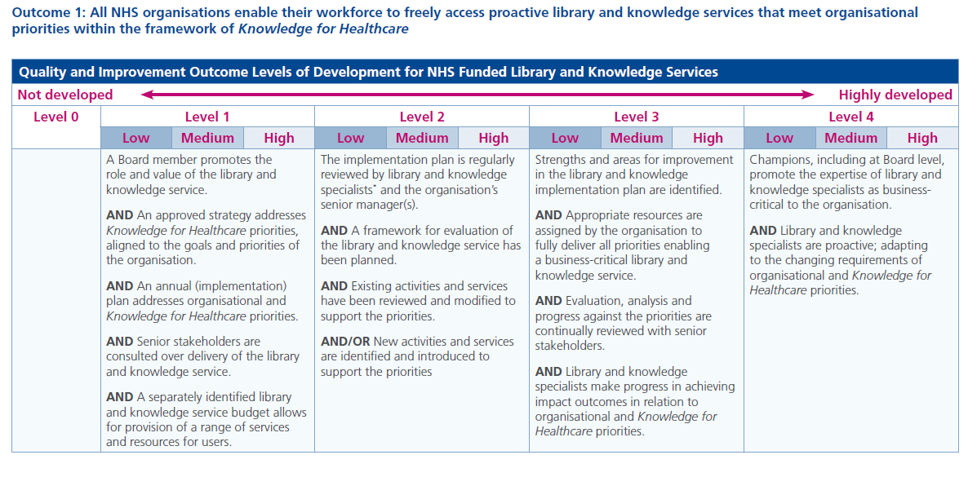

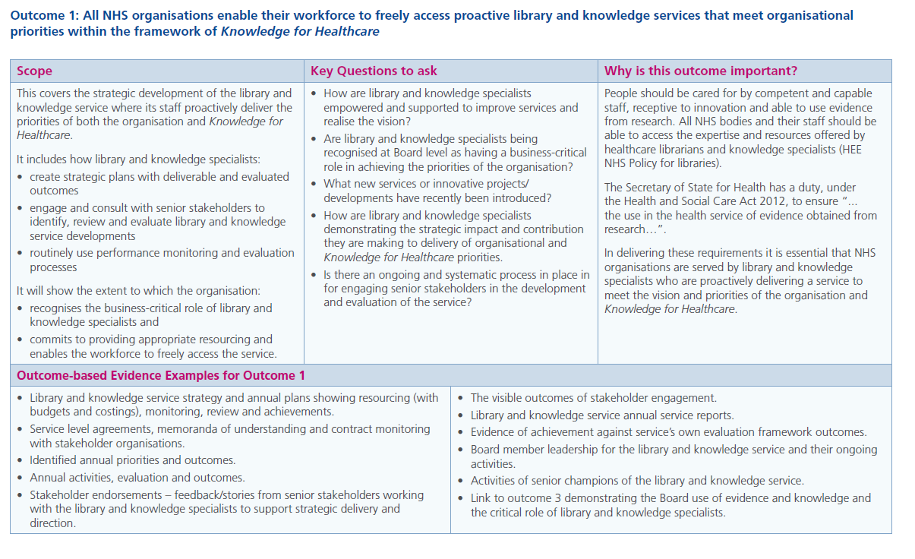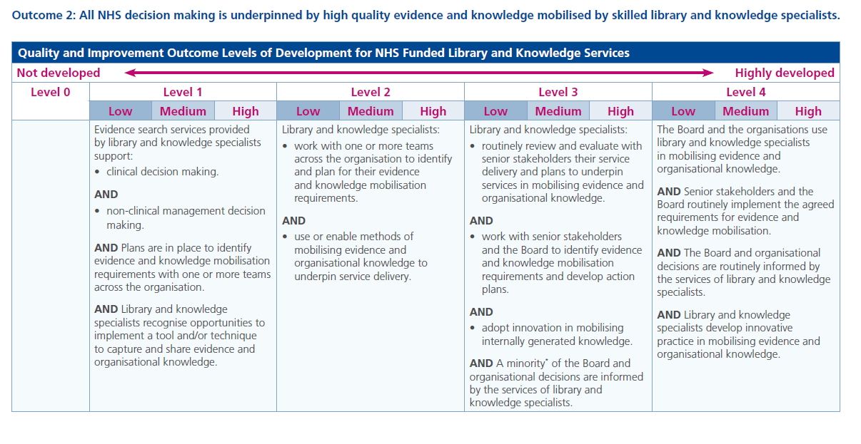

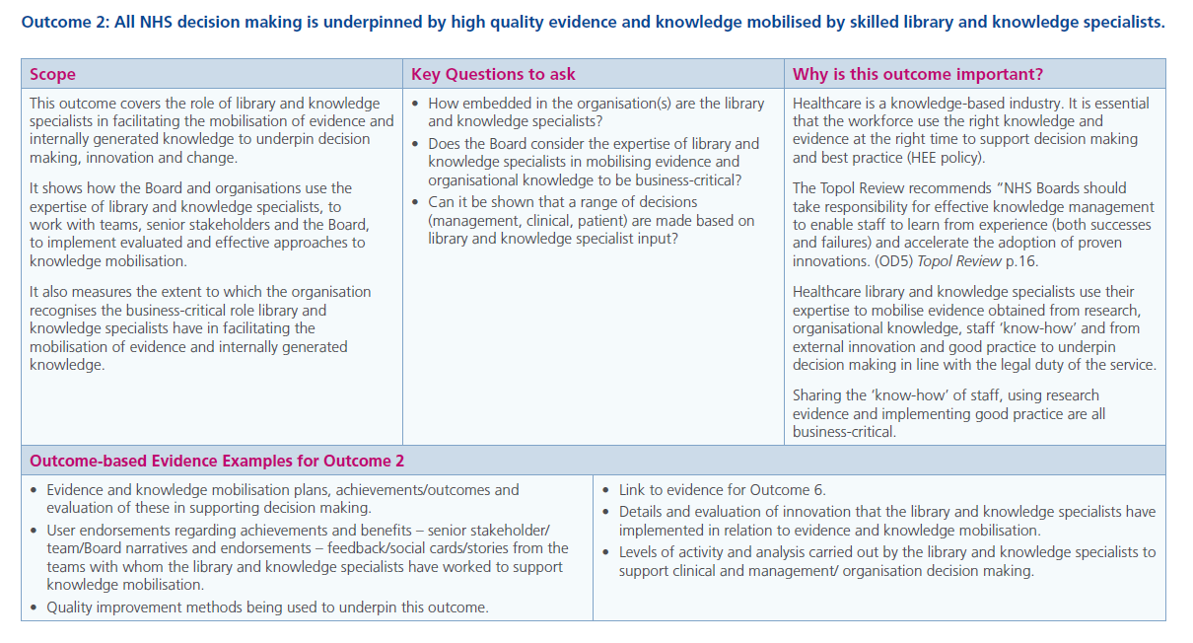

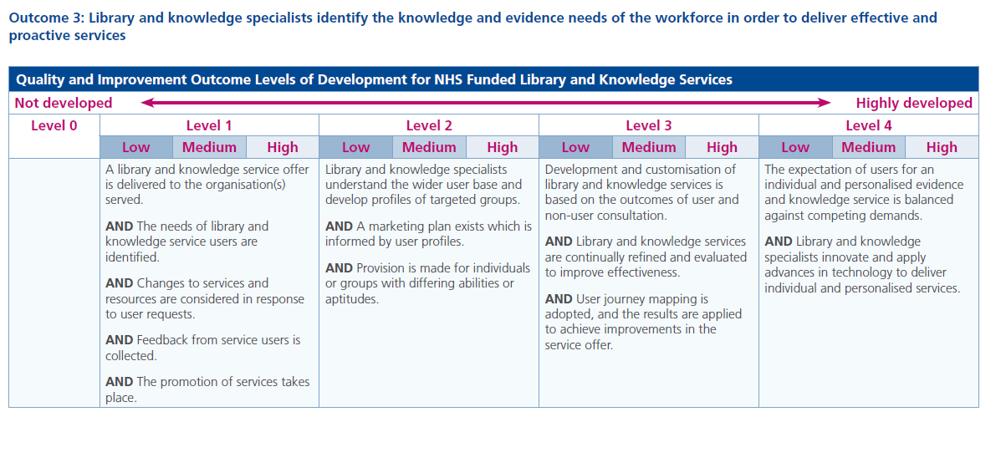

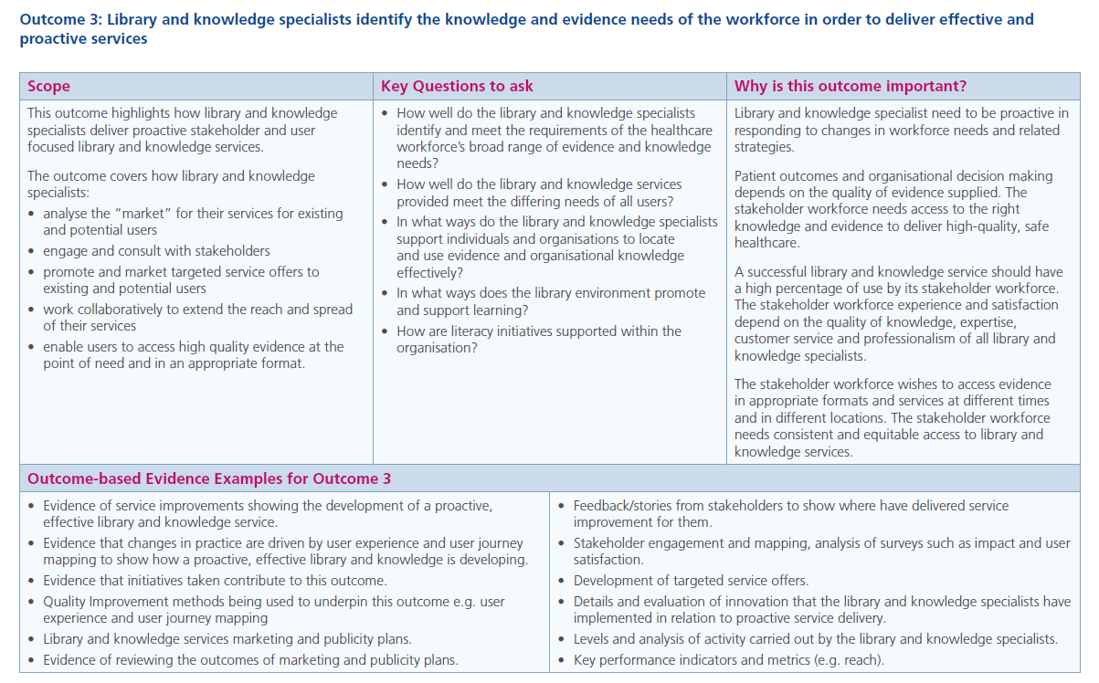 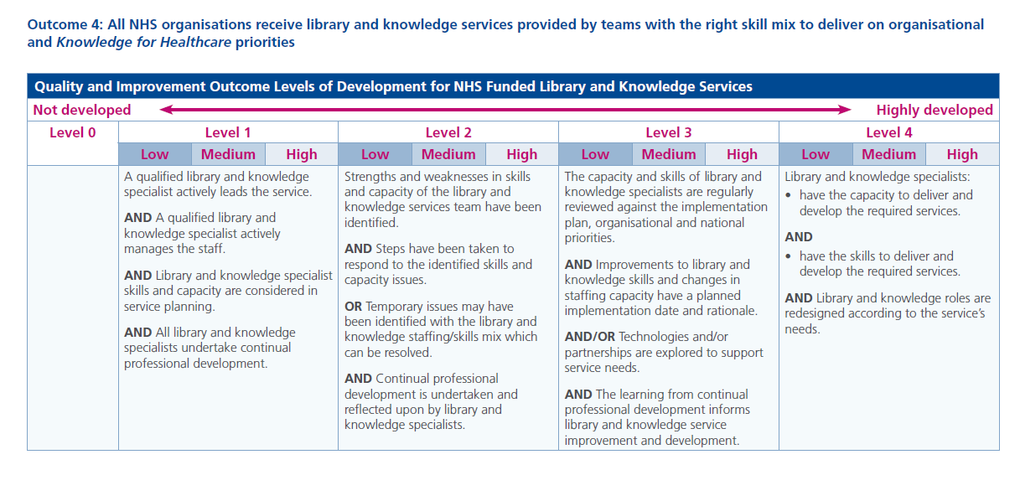

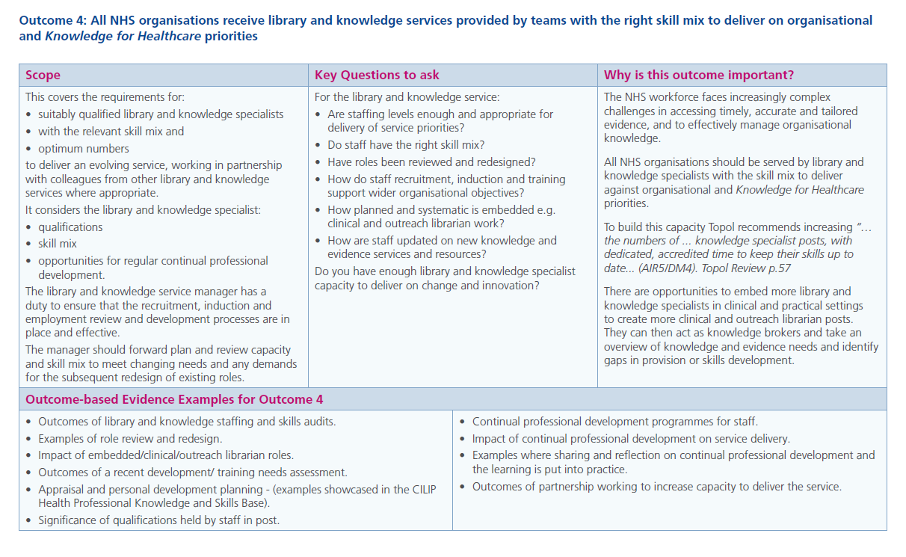

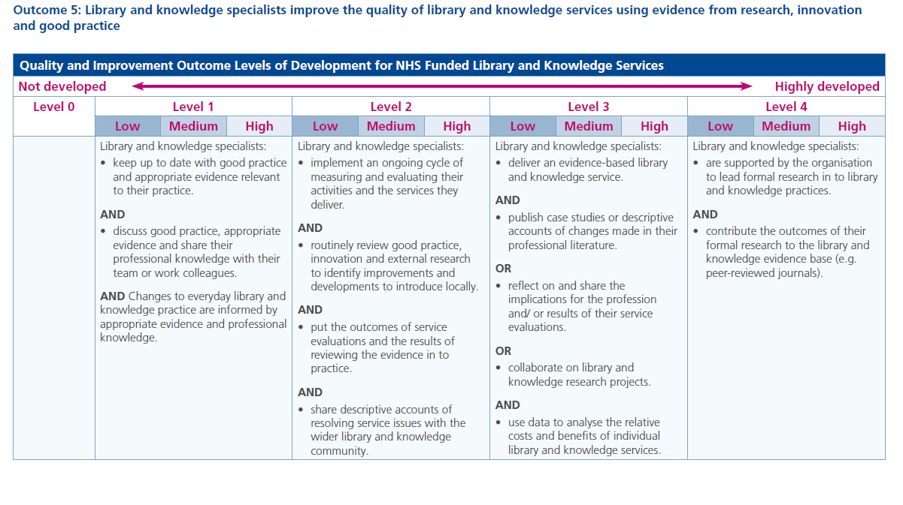

## 

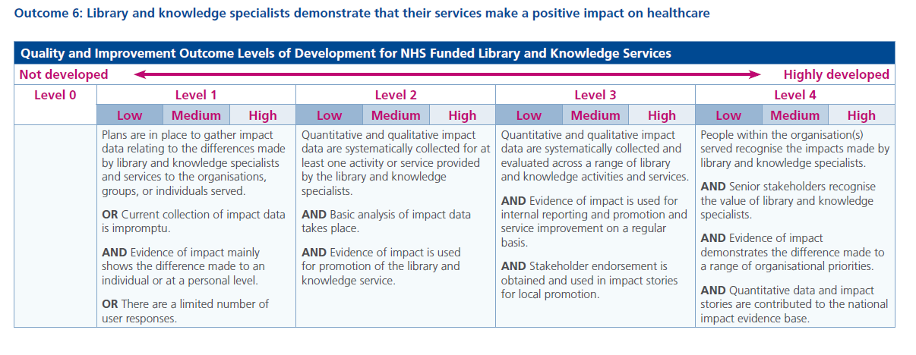

## 

Bibliography

Health Education England (2014) *Knowledge for Healthcare: a development framework for NHS library and knowledge services*. Available from: <https://www.hee.nhs.uk/sites/default/files/documents/Knowledge_for_healthcare_a_development_framework_2014.pdf>

Health Education England (2016) *NHS Library Quality Assurance Framework (LQAF): Version 2.3a*.

Available from: <http://www.libraryservices.nhs.uk/forlibrarystaff/lqaf/>

Health Education England (2016) *HEE Quality Strategy 2016-20*. Available from: <https://healtheducationengland.sharepoint.com/:b:/g/Comms/Digital/EVpQCfWbiTdFkwMGPeIfKScBeeVR8dAaOEBFTYbuCXOwhQ?e=oH9A7H>

Health Education England (2016) *NHS Library Services in England: Policy*. Available from: <https://www.hee.nhs.uk/sites/default/files/documents/NHS%20Library%20and%20Knowledge%20Services%20in%20England%20Policy.pdf>

Health Education England Library and Knowledge Service Leads (2017) *Knowledge for Healthcare Evaluation Framework*.

Available from: <https://kfh.libraryservices.nhs.uk/ef-intro/>

Health Education England (2019) *HEE Quality Framework 2019-20*. Available from: <https://healtheducationengland.sharepoint.com/:b:/g/Comms/Digital/EXmEo9yM_uJNrV4715sujKwBzTUm_N3XoZvtHMyk_rNpDg>

Health Education England (2019) *The Topol Review: Preparing the healthcare workforce to deliver the digital future.*

Available from: <https://topol.hee.nhs.uk/>

NHS England (2019) *The NHS Long Term Plan*.

Available from: <https://www.longtermplan.nhs.uk/publication/nhs-long-term-plan/>

Scottish Library and Information Council (2017) *How Good is Our Public Library Service: a public library improvement model for Scotland.*

Available from: <https://scottishlibraries.org/advice-guidance/frameworks/how-good-is-our-public-library-service/>

State Library of Victoria ( 2011) *Being the Best We Can Be: Self-evaluation Framework and Toolkit*.

Available from: <http://libraries.vic.gov.au/cgi-bin/infonet/org.cgi?detail=1&id=87>

# Appendix 1: Quality and Improvement Outcomes Framework Self-Evaluation and Evidence Report Template

Available from: <https://kfh.libraryservices.nhs.uk/quality-and-improvement-outcomes-documentation/>

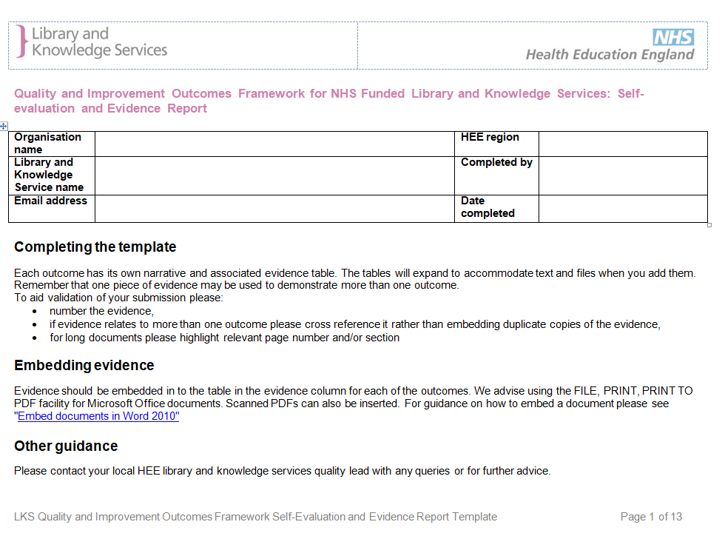

# Appendix 2: Improvement Planning Worksheet

Available from: <https://kfh.libraryservices.nhs.uk/quality-and-improvement-outcomes-documentation/>

# Appendix 3: Improvement Action Plan Template

Available from: <https://kfh.libraryservices.nhs.uk/quality-and-improvement-outcomes-documentation/>

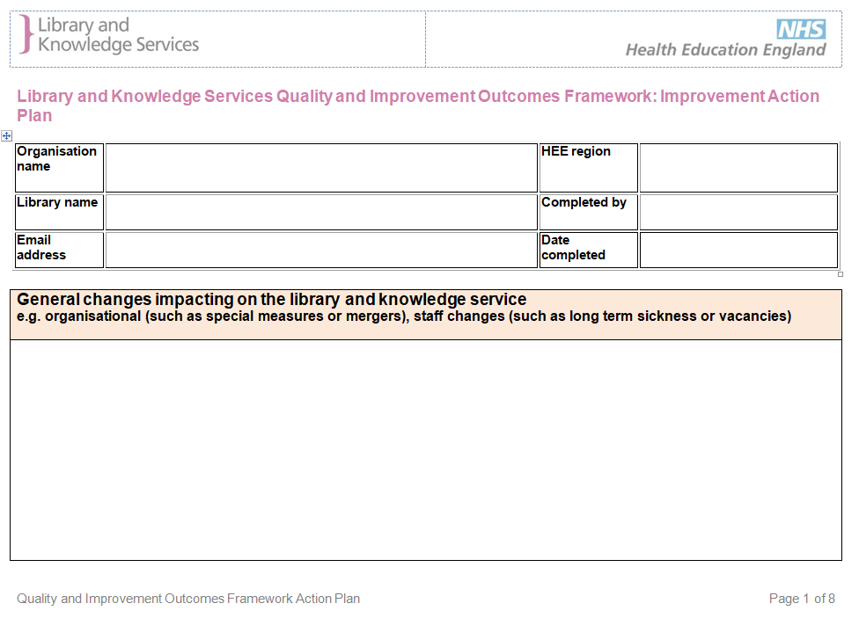

# Appendix 4:  Quality and Improvement Outcomes Framework: Self-evaluated and Validated Levels

Available from: <https://kfh.libraryservices.nhs.uk/quality-and-improvement-outcomes-documentation/>

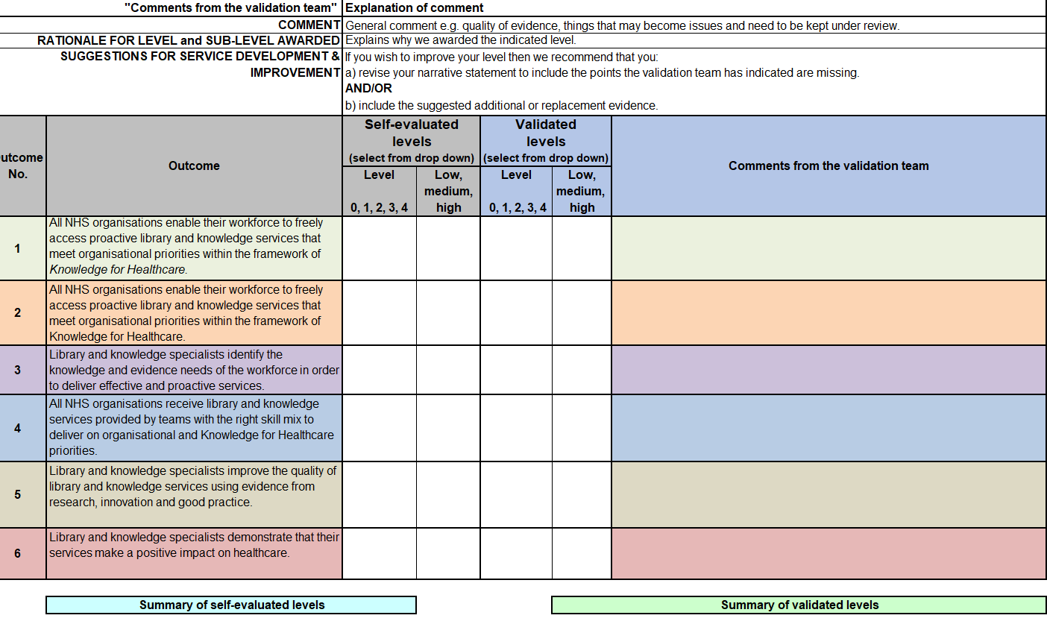

# Appendix 5: Links to Glossary of Terms – alphabetical and by outcome

 Available from: <https://kfh.libraryservices.nhs.uk/quality-and-improvement-outcomes-documentation/>

|  |  |
| --- | --- |
|  |  |

# Acknowledgements

The *Quality and Improvement Outcomes Framework for NHS Funded Library and Knowledge Services in England* has been developed by a project group of the HEE Library and Knowledge Services Leads.

|  |  |  |  |
| --- | --- | --- | --- |
| Clare Edwards (Chair) | HEE Midlands and East | Lucy Reid | HEE London and Kent Surrey and Sussex |
| Linda Ferguson | HEE North | Sue Robertson | HEE South |
| Dominic Gilroy | HEE North | Holly Case Wyatt | HEE London and Kent Surrey and Sussex |
| Emma Ramstead | HEE London and Kent Surrey and Sussex |  |  |

The structure of *Outcomes Framework* is adapted, with permission, from that used in *Being the Best We Can Be (2011)* developed by the State Library of Victoria and the subsequent *How Good is Our Public Library Service?* (Scottish Library & Information Council, 2017).

The project group would like to thank the members of the pilot group who completed self-evaluations to test the original outcomes and support documentation. The evaluations were then validated by the project group to further test the process and identify areas for improvement. The services who took part in the pilot were from:

|  |  |
| --- | --- |
| * Avon and Wiltshire Mental Health Partnership NHS Trust | * Library and Knowledge Services for NHS Ambulance Services in England |
| * Bridgewater Community Healthcare NHS Foundation Trust | * Northumberland, Tyne and Wear NHS Foundation Trust |
| * Central and North West London NHS Foundation Trust | * Oxford University – Bodleian Healthcare Library |
| * Doncaster and Bassetlaw Teaching Hospitals NHS Foundation Trust | * Surrey and Sussex Healthcare NHS Trust |
| * East and North Hertfordshire NHS Trust | * Taunton and Somerset NHS Foundation Trust |
| * Imperial College London University | * University Hospitals of Leicester NHS Trust |

The project group would also like to thank:

* members of the Library Standards Review Task and Finish Group whose contributions started us on the road to developing outcomes and
* Alison Brettle (University of Salford), Alan Fricker (King’s College London), Mic Heaton (University Hospitals of Derby and Burton NHS Foundation Trust) and Jenny Turner (East Sussex Healthcare NHS Trust) who challenged us and acted as the perfect sounding-board.

1. Health Education England (2016) NHS Library Services in England: Policy. <https://www.hee.nhs.uk/sites/default/files/documents/NHS%20Library%20and%20Knowledge%20Services%20in%20England%20Policy.pdf>
2. Health Education England (2014) Knowledge for Healthcare: a development framework for NHS library and knowledge services. <https://www.hee.nhs.uk/sites/default/files/documents/Knowledge_for_healthcare_a_development_framework_2014.pdf>
3. NHS England (2019) The NHS Long Term Plan. <https://www.longtermplan.nhs.uk/publication/nhs-long-term-plan/>
4. Health Education England (2019) The Topol Review: Preparing the healthcare workforce to deliver the digital future. <https://topol.hee.nhs.uk/>
5. Health Education England Library and Knowledge Service Leads (2017) Knowledge for Healthcare Evaluation Framework. <https://kfh.libraryservices.nhs.uk/ef-intro/>
6. Health Education England (2016) HEE Quality Strategy 2016-20. https://healtheducationengland.sharepoint.com/:b:/g/Comms/Digital/EVpQCfWbiTdFkwMGPeIfKScBeeVR8dAaOEBFTYbuCXOwhQ?e=oH9A7H
7. Health Education England (2019) HEE Quality Framework 2019-20. <https://healtheducationengland.sharepoint.com/:b:/g/Comms/Digital/EXmEo9yM_uJNrV4715sujKwBzTUm_N3XoZvtHMyk_rNpDg>
8. Health and Social Care Act 2012 c.7 <http://www.legislation.gov.uk/ukpga/2012/7/section/6/enacted>