­

The NHS Copyright First Responders’ guide to

**Using Copyright Materials in Presentations and Training**

including tips on finding and using free images



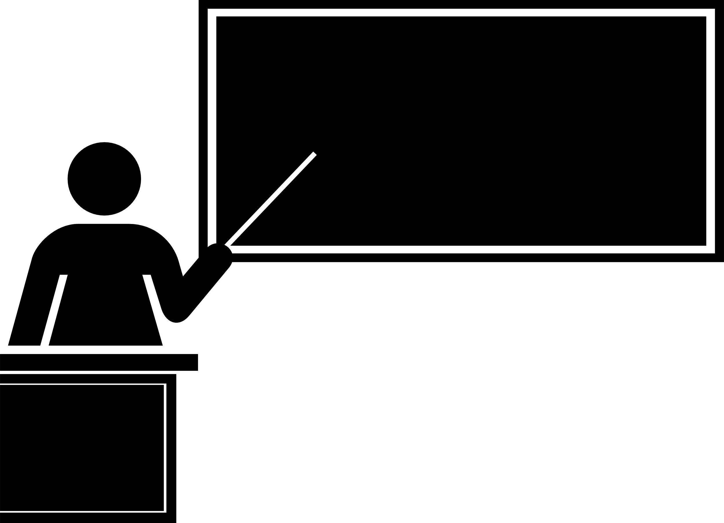

Prepared by Ian Rennie, Knowledge, Library and Information Manager, Cambridgeshire and Peterborough NHS Foundation Trust, on behalf of the NHS Copyright First Responders

September 2021 (reviewed July 2022)

**Contents**

Introduction 1

Who is your audience? 2

NHS staff 2

A paying audience 2

Open to the public 2

Finding and using free images 3

Public domain 3

Creative Commons 3

How to find public domain and creative commons images 4

Open Government Licence 5

For more information 5

## Introduction

As training becomes ever more multimedia, digital-by-default becomes the norm for presenting, and the amount of freely available web content grows, it is increasingly important – and can seem increasingly difficult – to know whether and how copyright materials, whether text, diagrams, images, videos or sound recordings, may be incorporated in presentations and teaching. Just because content is freely available doesn’t mean it is free to use.

This guide is for NHS library staff who may often receive queries on this topic from their NHS customers and colleagues. In this guide we’ll look at how what you may use depends on your audience, and how you can find great free-to-use images online.

## Who is your audience?

Your ability to use copyright materials in face-to-face or virtual presentations or training largely depends on your audience.

### NHS staff

If your presentation or training is viewable *only* by individuals and groups covered by the CLA Licence for the NHS in England then you may use the following:

* Materials from publications that the NHS owns or subscribes to which are covered by the NHS CLA Licence. This includes most items with ISBNs or ISSNs. If in doubt use the permissions checker at <https://www.cla.co.uk/nhs-england-licence> (select ‘public sector’).
* Materials purchased or licenced from a publisher or copyright holder who has given their permission in the usage licence (check the small print) or otherwise in writing. Note that obtaining written permission may incur a fee.
* Materials which have been deliberately placed in the public domain or released under a Creative Commons licence or the Open Government Licence (see below for more details).
* Very small excerpts from other copyright works where the purpose of including it in your presentation or training is for the “fair dealing” purpose of criticism or review.
* Original materials you have created.

In all cases:

* You should always acknowledge the source of all copyright materials you use
* Presentations containing copyright materials may not be placed on the internet
* Copyright materials included in presentations or training may not be altered, unless for making into accessible format for print disabled, or where a Creative Commons licence specifically permits this.

### A paying audience

If your presentation or training will generate income then it is considered to be commercial. Neither the CLA Licence nor the principle of “fair dealing” allow use of copyright materials for commercial purposes. This means that you may only use the following:

* Materials purchased or licenced from a publisher or copyright holder who has given their permission for their use **for commercial purposes,** either in the usage licence or otherwise in writing. Obtaining written permission may incur a fee.
* Materials placed in the public domain or released under one of the types of Creative Commons licence which covers commercial usage, or the Open Government Licence.
* Original materials you have created.

### Open to the public

If your training or presentation will be viewable without restriction (e.g. at an event which is open for anyone to attend or via a video made available on the open Internet), then neither the CLA Licence nor the principle of “fair dealing” apply. You may only use the following:

* Materials purchased or licenced from a publisher or copyright holder who has given their permission for their use **for public display,** either in the usage licence or otherwise in writing. Obtaining written permission may incur a fee.
* Materials placed in the public domain, or released under a Creative Commons licence, or the Open Government Licence, subject to the terms of those licences.
* Original materials you have created.

## Finding and using free images

Images are probably the type of copyright material most commonly required to illustration presentations and training. As above, options for using copyright images in presentations and training vary according to audience and are limited. One alternative is subscribing to an image bank service such as Alamy or Shutterstock, however it is possible to find images published in the public domain, under Creative Commons licences or the Open Government Licence. This section explores these in more detail.

### Public domain

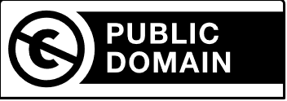

Public domain materials are not protected by intellectual property laws and are thus considered to belong to the public. Commonly these are works where either copyright has expired, or the copyright owner has deliberately placed the work in the public domain. In the UK, copyright usually lasts until 70 years after the creator’s death. So, for example, the photography of Alfred Stiegliz who died in 1946 is now all in the public domain. Individuals may also choose to place their work in the public domain, and the work of some government institutions, especially in the US, is automatically in the public domain.

If a work is in the public domain, it may be copied and shared, or even altered and used as the basis of an original work, without restriction. You are not required to give attribution to the work (although it is good practice to do so).

### Creative Commons

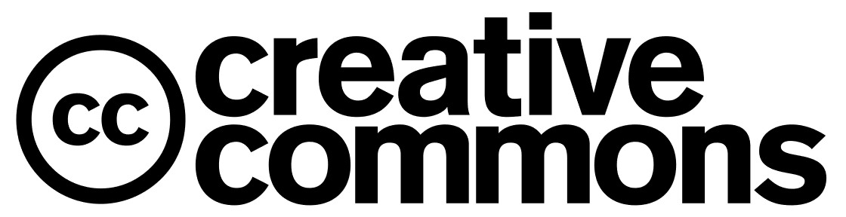

A work that is released under a Creative Commons licence is one where the creator has chosen to make their work freely available, with conditions attached to re-use. The different types of Creative Commons licence, ranging from least to most restrictive, are:

|  |  |
| --- | --- |
| **CC0** | The creator of the work has deliberately placed it in the public domain. |
| **CC BY** | Allows you to distribute, alter, adapt, and build upon the work as long as you give credit to the original creator. Works under a CC BY licence can be sold commercially or used as part of a broader commercial work. |
| **CC BY-SA** | Allows you to distribute, alter, adapt, and build upon the work as long as you give credit to the original creator, and as long as the work you create is *also released under a CC-BY licence*. Works under a CC BY-SA licence can be sold commercially or used as part of a broader commercial work. |
| **CC BY-NC** | Allows you to distribute, alter, adapt, and build upon the work as long as you give credit to the original creator, and as long as you only use it for *non-commercial purposes*. |

|  |  |
| --- | --- |
| **CC BY-NC-SA** | Allows you to distribute, alter, adapt, and build upon the work as long as you give credit to the original creator, only use it for *non-commercial* purposes, and release the resulting work on the *same licence*. |
| **CC BY-ND** | Allows you to copy and distribute the work and use it for commercial or non-commercial purposes, as long as credit is given to the creator. You *may not alter, adapt, or build on the work*. |
| **CC BY-NC-ND** | This allows you to copy and distribute the work and use it for *non-commercial* purposes only, as long as credit is given to the creator. You *may not alter, adapt, or build on the work*. |

Given the number of Creative Commons licences, it’s worth checking that your proposed use is covered under the licence. So for example an unaltered image used to illustrate a slide in a presentation could be used under most versions of the licence, but an image that had been edited, had the colours changed, and had text added to it would need a licence that permitted alteration and adaptation.

Further information about Creative Commons can be found at <https://creativecommons.org/>

### How to find public domain and creative commons images

Searching on Google for “public domain images” can bring up some strange and not necessarily useful results. However, the following sources for images are generally reliable, easy to search, and display the rights details of their images clearly.

* **Wikimedia Commons**: An open collection of some 74 million images that may be used by anyone. Depending on your search terms, you may have a lot of images to look through, but a good chance of finding what you're looking for: <https://commons.wikimedia.org/wiki/Main_Page>
* **National Institute for Mental Health Image Library**: The National Institute for Mental Health in the US release all images that belong to the Institute into the public domain: <https://images.nimh.nih.gov/public_il/>
* **Open Access Medical Images**: A list of sources for public domain and Creative Commons medical images curated by the University of Arkansas for Medical Sciences: <https://libguides.uams.edu/open-access-medical-images>
* **Unsplash**: a collection of public domain stock images. Not always useful for medical images but potentially useful for other purposes: <https://unsplash.com/images/stock/public-domain>
* **Pixabay**: a huge general interest public domain image site: <https://pixabay.com/>
* **Public Domain Vectors**: a site filled with free to use clipart images and icons released in the public domain. Vector images are usually icons, and easier to modify and resize than standard images: <https://publicdomainvectors.org/>

### Open Government Licence



The Open Government Licence is a licensing framework used to allow people to use images and materials created by the public sector without having to pay to do so, and without the creator of the materials losing ownership. The Open Government Licence covers a range of content (referred to in the licence as the Information) on public sector websites, bearing the OGL logo and phrasing such as “All content is available under the Open Government Licence v3.0, except where otherwise stated”.

The OGL gives you permission to do the following, on the condition that you properly acknowledge and attribute the information and where possible provide a link to the Licence.

* Copy, publish, distribute and transmit the Information;
* Adapt the Information;
* Exploit the Information commercially and non-commercially, for example, by combining it with other Information, or by including it in your own product or application.

A copy of the Open Government Licence can be found here: <https://www.nationalarchives.gov.uk/doc/open-government-licence/version/3/>

A useful gov.uk content design guide on better ways to use images and other content in your pages and presentations can be found here: <https://www.gov.uk/guidance/content-design/images>

## For more information

This guide covers the basics in using copyrighted materials in your training. For more information, or for clarification on anything the guide doesn’t cover, please contact the **NHS Copyright First Responders**:

* Copyright information including links to the Copyright Licence and information about “Library Privilege” <https://library.hee.nhs.uk/resources/copyright>
* Or email the team at [nhscopyrightqueries@knowledgeforhealthcare.nhs.uk](mailto:nhscopyrightqueries@knowledgeforhealthcare.nhs.uk)

Attribution: Presenter clipart taken from Public Domain Vectors; Public Domain, Creative Commons, and Open Government Licence logos from their respective websites.