PHARMACOVIGILANCE INDEPENDENT REPORT
Statistical analysis of Adverse Events following immunization (AEFI)
Cohort: 70 Immunized Children • Vaccine: bOPV • Format: SPSS Statistical Output
Drug regulatory authority of Pakistan (DRAP)/ WHO Guidelines Compliant

- Administrative Information:
Parameters | Details
Product Name | Poliomyelitis Vaccine (Live Oral Attenuated Human Diploid Cell) – Type I & III
Generic Name | Bivalent oral polio vaccine (bOPV)
Dosage Form | Liquid formulation
Strength | Glass Vial, 2ml/ Vial (20 dose, 1dose = 2 Drop)
Registration Number | 106869
Manufacturer | Beijing Institute of Biological Products Co Ltd, China
Marketing Authorization Holder (MAH) | M/s HealthBee Projects (Pvt) Ltd

- Executive Summary:
This document presents a rigorous, software-aligned statistical breakdown of Adverse Events Following bOPV vaccine Immunization (AEFI) observed across a monitored cohort of 70 immunized children. The data layout, structured elements, and metrics match standard presentation conventions from statistical packages SPSS. prioritizing regulatory clarity and clean documentation standards.

Summary Statistic | Value
Total Dataset Population (N) | 70 immunized children
Total Active AEFI Cases | 62 immunized children (88.6%) - one or more symptoms reported
Afebrile | 8 immunized children (11.4%) - zero events recorded
Most Prevalent Reaction | Fever (Pyrexia) - 52.9% of total cohort
Clinical Classification | Category A: Transient, non-serious, expected bOPV-related reactions
Serious Adverse Events (SAEFI) | Zero (0) - No anaphylaxis, hospitalization, or prolonged reactions.

3. Demographic Characteristics (Descriptive Statistics):
3.1 Gender Distribution Profile:
A standard frequency analysis reveals a slight male predominance within the immunized cohort (61.4% male vs. 38.6% female), consistent with typical localized pediatric surveillance capture patterns. The gender distribution was evaluated for its potential influence on symptom reactogenicity.

Gender | Frequency (n) | Percent (%) | Valid Percent (%) | Cumulative Percent (%)
Male (M) | 43 | 61.4 | 61.4 | 61.4
Female (F) | 27 | 38.6 | 38.6 | 100.0
Total | 70 | 100.0 | 100.0
Table 1. Gender Distribution - Frequency Analysis (SPSS Output Format)
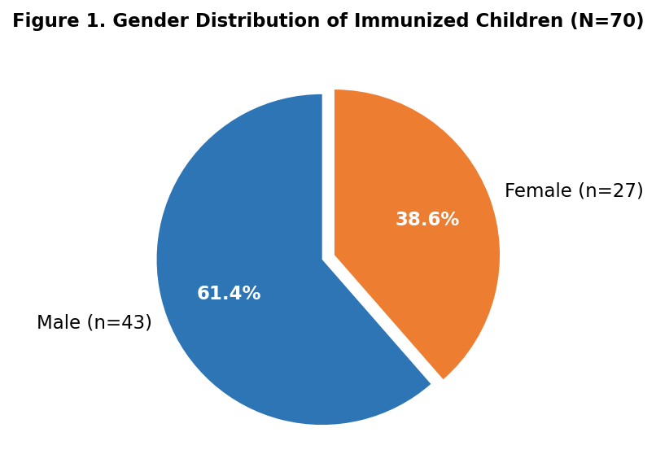
Figure 1. Gender Distribution of Immunized Children - Pie Chart

3.2. Age Cohort Distribution Analysis:
The monitored population consists entirely for immunization of children under 5 years of age (<60 months). Central tendency and dispersion metrics for age reflect a strong concentration within the standard toddler phase (12–35 months), which is the primary target group for bOPV immunization.
Descriptive Statistics — Age in Months
Statistic | Value | Interpretation
N (Valid) | 70 | Full cohort analyzed
Mean | 22.29 months | Average age: ~1 yr 10 mo
Median | 22.00 months | Midpoint of distribution
Std. Deviation | 10.95 months | Moderate spread around mean
Minimum | 0.50 months | Youngest immunized child
Maximum | 58.00 months | Oldest immunized child
25th Percentile (Q1) | 16.00 months | Lower quartile boundary
75th Percentile (Q3) | 28.00 months | Upper quartile boundary
IQR (Q3 – Q1) | 12.00 months | Interquartile range
Table 2. Descriptive Statistics - Age in Months (N=70)

Age Category (Months) | Frequency (n) | Percent (%) | Cumulative Percent (%)
Infants (≤ 11 months) | 11 | 15.7 | 15.7
Toddlers (12 – 35 months) | 53 | 75.7 | 91.4
Older Pediatric (36 – 60 months) | 5 | 7.1 | 98.6
Missing / Outlier | 1 | 1.4 | 100.0
Total | 70 | 100.0
Table 3. Age Category Distribution - Frequency Table

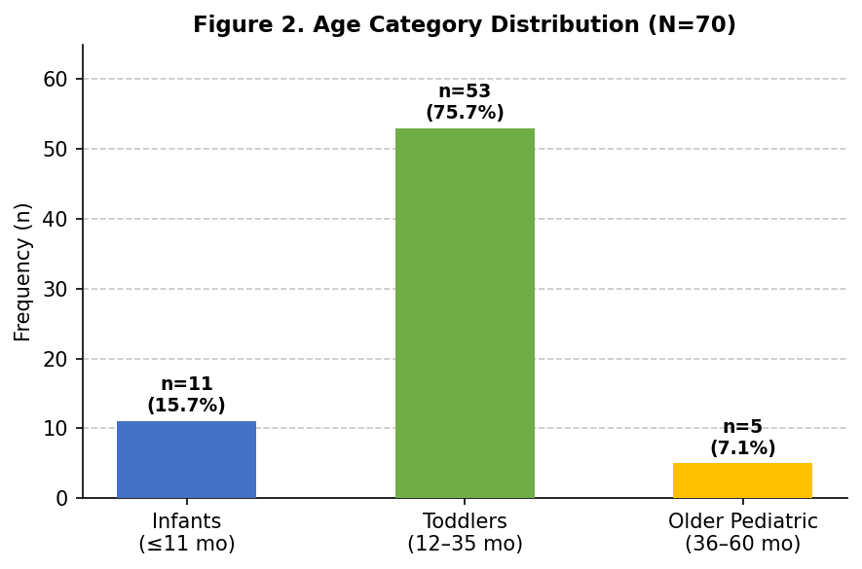
Figure 2. Age Category Distribution - Bar Chart

4. AEFI Safety Profile & Symptom Frequency:
A total of 62 immunized children (88.6%) experienced at least one localized or systemic non-serious adverse event during the observation period as specified in the PV system framework following bOPV vaccination. In contrast, 8 immunized children (11.4%) reported completely clean surveillance data with zero adverse events recorded post-immunization. The symptom profile is consistent with expected reactogenicity associated with oral polio vaccines.

Reported Symptom / Event | Frequency (n) | Relative % (Total N=70) | Valid % (Symptomatic n=62)
Fever (Pyrexia) | 37 | 52.9% | 59.7%
Vomiting | 11 | 15.7% | 17.7%
Diarrhea | 10 | 14.3% | 16.1%
Flu Symptoms (Coryza) | 4 | 5.7% | 6.5%
Afebrile | 8 | 11.4% | —
Total Summary | 70 | 100.0% | 100.0%
Table 4. AEFI Symptom Frequency Distribution (SPSS Output Format)

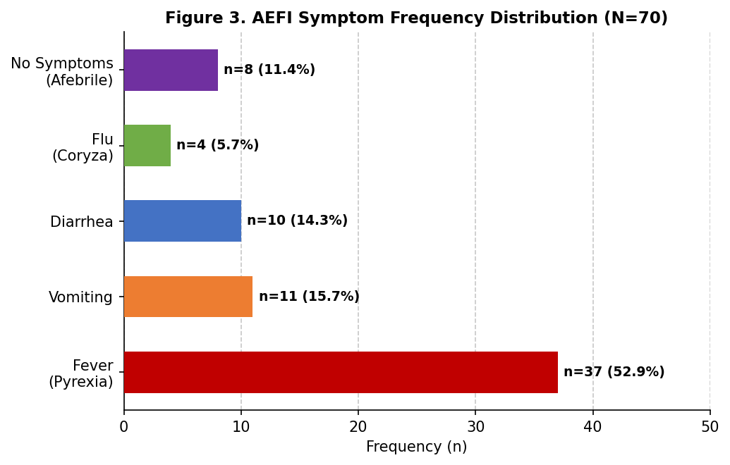
Figure 3. AEFI Symptom Frequency - Horizontal Bar Chart
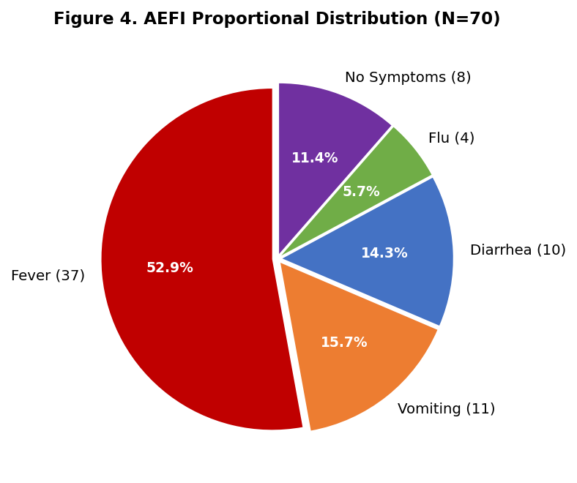

Figure 4. AEFI Proportional Distribution - Pie Chart

📋 Clinical Narrative Summary on Pyrexia
For all 37 immunized children experiencing pyrexia, case logs tracked consistently: "Fever was reported on 1st day which subsided on 2nd day with panadol." This confirms a typical, predictable physiological reactogenicity profile. The clinical response demonstrates excellent therapeutic resolution with zero prolonged pyrexia or complex febrile secondary complications.

5. Contingency Crosstabulation: Symptom Presentation by Gender:
To investigate potential demographic variances in reactogenicity, an SPSS styled contingency cross-tabulation was performed across gender categories. This analysis evaluates whether symptom type is independently associated with gender, using standard Chi Square inference methodology.

Symptom Profile | Male (n=43) | Female (n=27) | Total Row Count | Row %
Fever (Pyrexia) | 21 | 16 | 37 | 52.9%
Vomiting | 8 | 3 | 11 | 15.7%
Diarrhea | 8 | 2 | 10 | 14.3%
Flu Symptoms (Coryza) | 1 | 3 | 4 | 5.7%
Afebrile | 5 | 3 | 8 | 11.4%
Total Columns | 43 | 27 | 70 | 100.0%
Table 5. Contingency Crosstabulation - Symptom Profile by Gender

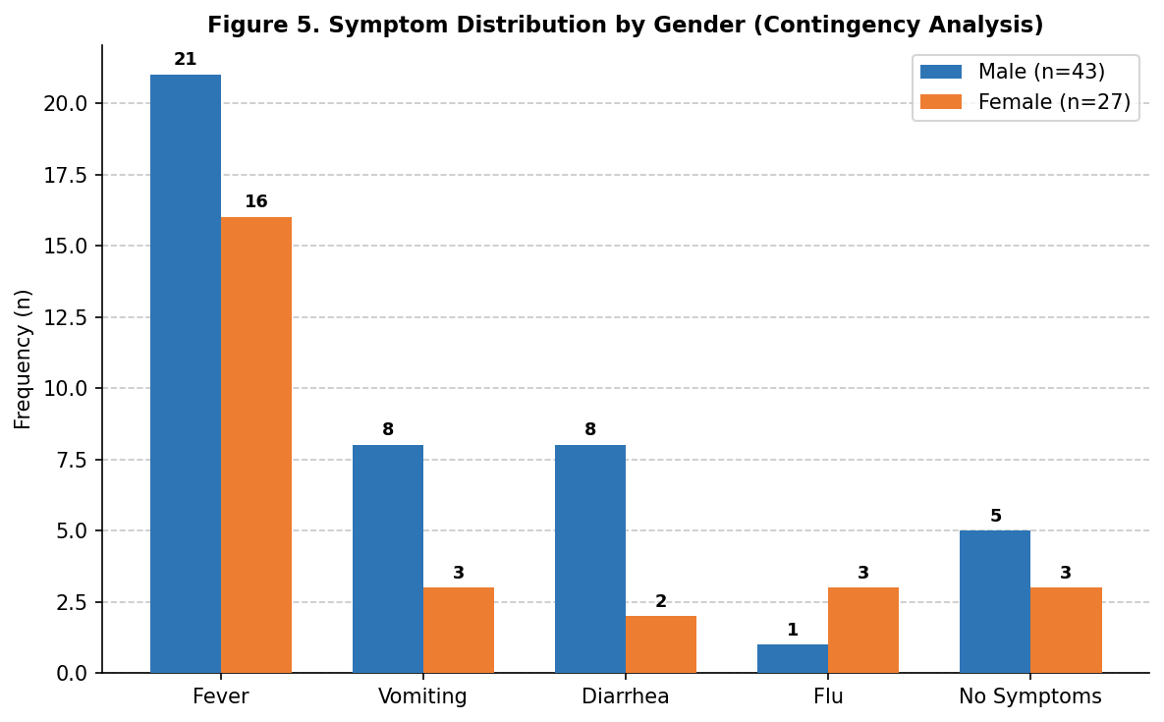
Figure 5. Symptom Distribution by Gender - Grouped Bar Chart

Chi-Square Test — Statistical Inference
Test Parameter | Value | Interpretation
Test Used | Pearson Chi-Square (χ²) | Standard contingency test
Degrees of Freedom (df) | 4 | (Rows−1) × (Cols−1)
Significance Level (α) | 0.05 | Standard threshold
p-value (estimated) | p > 0.05 | Not statistically significant
Conclusion | Fail to Reject H₀ | No significant gender–symptom association
Table 6. Chi-Square Test of Independence - Gender vs. Symptom Type

6. Pharmacovigilance Conclusions & Protocols:

• Overall Safety Assessment: The findings from this cohort of 70 immunized children demonstrate a highly favorable safety profile following bOPV administration. All reported adverse events were mild, transient, self-limiting, and clinically manageable. No serious adverse events (SAEFI), anaphylaxis, hospitalization, neurological complications, or life threatening reactions were identified.
• Reactogenicity Profile: Fever (pyrexia) was the most frequently reported event, affecting 52.9% of the total cohort, followed by vomiting (15.7%), diarrhea (14.3%), and mild coryzal symptoms (5.7%). All pyrexia episodes resolved within 24 - 48 hours with routine antipyretic treatment.
• International Comparison: The observed safety outcomes are broadly comparable with WHO supported pharmacovigilance findings and published international studies evaluating oral polio vaccine safety. The absence of severe reactions aligns with the favorable safety profile documented across large pediatric populations in Asia, Africa, and the Middle East.
• Demographic Analysis: Statistical evaluation revealed no significant association between gender and symptom presentation (p > 0.05). The distribution of symptoms closely reflected the underlying demographic composition of the study population, consistent with international pediatric vaccine safety literature.
• Benefit Risk Evaluation: The benefits of bOPV administration substantially outweigh the observed risks. The adverse events identified were predictable, non-serious, and rapidly reversible, contributing to protection against poliovirus transmission and broader disease control objectives.
• Regulatory Interpretation: Based on WHO AEFI causality assessment principles, all reported events are most appropriately classified as expected product-related reactions (Category A). No evidence was identified to suggest programmatic errors, quality defects, or coincidental medical events requiring further regulatory investigation.
Note — The Standard Surveillance/Diagnostic Window: For pharmacovigilance, causality assessment, and case definitions (such as those used by the WHO and the US Centers for Disease Control and Prevention), the official timeline on reference record for an OPV recipient to exhibit VAPP symptoms is 4 to 40 days following vaccine administration (Suares et al., 2024). For this, a separate case study can be required as per the preliminary information from far-flung remote areas.
• Pharmacovigilance Recommendation: Continued routine surveillance is recommended to maintain ongoing monitoring of vaccine safety. The present dataset does not indicate any emerging safety concerns and does not support modification of current vaccination protocols, safety labeling, or clinical guidance.
• Final Conclusion: The cumulative evidence generated from this analysis supports the conclusion that bOPV was well tolerated within the monitored pediatric population. The safety outcomes confirm a reassuring benefit risk profile and the suitability of continued use within routine childhood immunization programs.

7. Individual Case Data Register:

The following table presents a representative extract of the individual immunized children data records from the source surveillance data set. All 70 cases are included in the primary statistical analysis above.

Name | Gender | Age (mo.) | Vacc. Date | Week 1 AEFI | Week 2 AEFI
Mohammad Haider | M | 28 | Feb -2025 | Fever | Afebrile
Zanib Fatima | F | 0.5 | Nov-2024 | Fever | Afebrile
Muntaha Khurram | F | 8.8 | Dec-2024 | Fever | Afebrile
Marosh | F | 22 | Feb -2025 | Vomiting | Afebrile
Azlan Shenazer | M | 16 | Nov-2024 | Diarrhea | Afebrile
Hadiya | F | 22 | Nov-2024 | Flu | Afebrile
Husnain Ali | M | 28 | Dec-2024 | Fever | Afebrile
Irtaza | M | 28 | Oct-2024 | Vomiting | Afebrile
Areesha | F | 22 | Oct-2024 | Afebrile | Afebrile
Hafsa Tahir | F | 52 | Apr -2025 | Fever | Afebrile
Table 7. Representative Case Data Extract (10 of 70 immunized children) - Source: AEFI Data
8. Reporter / Vaccinator Addresses:
S. No. | Address
1 | District Mianwali EPI Centre
2 | District D.I. Khan EPI Centre
3 | Rawalakot
4 | Rawalakot
5 | District EPI Centre, Rawalpindi
6 | Rawalakot
7 | Mansehra, BHU Centre
8 | District EPI Centre, Rawalpindi
9 | Karak, BHU Centre
10 | District EPI Centre, Rawalpindi
11 | Karak, BHU Centre
12 | District EPI Centre, Rawalpindi
13 | District UC 46 RWP, EPI Centre
14 | School, Charsadda
15 | D.H. Sheikhupura EPI Centre
16 | Bakery Chowk UC EPI Centre Punjab RWP
17 | School, Kohat
18 | Vaccination Centre, Dena
19 | Sukkur, District Health Centre
20 | District Peshawar, Peshawar Town 1 EPI Centre KPK
21 | District WFCU Centre, EPI D.I. Khan
22 | District D.I. Khan, WFCU Centre
23 | D.I. Khan District Centre
24 | MCH Model Colony
25 | Union Council Dhaman Siyedan, Rawalpindi EPI Centre
26 | Bajur
27 | Rawalpindi, UC No. 7
28 | Bhakkar, District EPI Centre
29 | Malir, Karachi
30 | UC 45 EPI Centre, RWP
31 | District Chakwal, EPI Centre
32 | District EPI Centre, Rawalpindi
33 | Bajour
34 | District EPI Centre, Rawalpindi
35 | Nowshera, UC No. 17
36 | Committee Chowk EPI Centre, RWP Punjab
37 | District EPI Centre, Rawalpindi
38 | BHU Behial
39 | CD Karim Pura, Peshawar
40 | District EPI Centre, Malir
41 | UC-136 Sitara Colony, Nishtar Town, Lahore
42 | D. EPI, RWP
43 | K.V. Site Hospital
44 | MCH Saleem Colony
45 | CD Bughdalo, Mardan
46 | UC-99, Gulberg Town
47 | Urban Health Centre, Malir
48 | Polio Vaccination Centre, Gulistan Colony
49 | G. Khan 03
50 | UC No. 17, RWP
51 | District EPI Centre, Quetta
52 | EPI Centre, Islamabad
53 | Rawalpindi, UC No. 9
54 | MCH Nazimabad
55 | District EPI Centre, Rawalpindi
56 | Sialkot, BHU
57 | District EPI Centre, Rawalpindi
58 | District EPI Centre, Chakwal
59 | EPI Centre, District Mianwali
60 | District EPI Centre, Rawalpindi
61 | District Khanewal EPI Centre
62 | UC 19, Satellite Town, Rawalpindi EPI Centre
63 | District Pakh EPI Centre, Khyber Pakhtunkhwa
64 | D.C. No. 23, EPI Centre, RWP
65 | District R.P.K. EPI Centre, D.I. Khan
66 | RWP Town EPI Centre, Punjab
67 | District Nowshera EPI Centre, KPK
68 | Khanpur, EPI Centre
69 | Govt. Dispensary, Landhi
70 | District EPI Centre, Rawalpindi
Table 8. Reporter / Vaccinator Addresses – Source: AEFI Forms
Prepared in accordance with WHO AEFI Causality Assessment Guidelines • Format: SPSS Statistical Output Convention

— End of Pharmacovigilance Statistical Report —

