Method to Measure and Enhance Sleep

Argudelo S., Fennell R., Florestal C., Kalytovskyy I., Yane L.

Florida Atlantic University

Author Note

Final Report for Team 2 for Cen4214, Software-Hardware Code Design, Dr. Shankar

April 29, 2016

**Abstract**

Sound sleep is a necessary part of human health and is a common medical complaint and complicating factor. Recent advances in technology allow the monitoring and measurement of sleep performance in the home or other locations. The advancement of computer system and virtual computer systems has enabled software and hardware systems to be easily added to existing system. A computer application that measures, evaluates and enhances sleep performance is demonstrated in this report using, Android software, an Android Pad, a Bluetooth accelerometer, and Wi-Fi and internet connections.

**Background**

Sound sleep is a necessary part of human health and is a common medical complaint and complicating factor. Recent advances in technology allow the monitoring and measurement of sleep performance in the home or other locations. In addition this information can now be easily loaded into computers and communications systems for further analysis. With the advent of portable computers, tablets and smart telephones an interactive, monitoring and analysis system can be achieved. The advancement of computer system and virtual computer systems has enabled software and hardware systems to be easily added to existing systems. A computer application that measures and evaluates and enhances sleep performance is demonstrated in this report using Android software, a Nexus Seven Pad, a Bluetooth accelerometer, and Wi-Fi and internet connections.

# Method

When we first started this project, we had the idea of utilizing the raspberry pi, an ekg/ecg sensor device, and build our app using android studio. Though we did change most of what we were going to use, our first idea behind this project seemed really practical. We thought of connecting the raspberry pi to a server that would represent the healthcare provider system. The sensor device collects the data from the patients and our app is supposed to take in that data. This will allow the patients to view the results of the testing and we also wanted to add a feature where the information that is collect can be sent through the healthcare provider using the app. We wanted the sensor device to be Bluetooth enabled, this would have allowed the patients to freely sleep without any wires connecting from them to the phone or the raspberry pi.

First trouble we ran into with our first idea was finding the right sensor that is also Bluetooth enabled and that also would have been easy to integrate into our app. Therefore, we decided to get a sensor device that is already integrated with an app. The sensor device we obtained is already Bluetooth enabled and has its own app that it communicates with, this eliminated the use of using the raspberry pi that we had plan to use in our first idea.

Rethinking our project base on the sensor device that we now possess, we decided to build our app and attempt to have it communicate with the sensor device app. If it was successful it would have allowed us to take in the data collected from the sensor device through its app, then utilize that data to give feedback to the patient through our app.

## Results

We were not able to get the data from the sensor device app, but our app has a function where it can call this app, where it can then display the information it had collected from the patients (the app requires you to log in). A way we decided to simulate what we wanted to do for our app using this sensor device is we decided to have one of our team members collect data on themselves. We had our nursing student study that data and see what feedback can be giving to that patient in our app. This allowed us to create a Tip section in our app base on the information collected on the patient. Other than this section we have other sections within the app that helps or monitor the user with their sleeping conditions.

Ideally if we were to continue this app and make it marketable then we would have want to either obtain or built our own sensor device that is Bluetooth enabled that can communicate with our app. Which would have allowed the patient to only use our app for their testing.

Discussion

In this project, we investigated certain sleeping conditions and the affect they had on the quality of sleep. We were able to do this with the help of the Sense app and the corresponding hardware, The Sense Pill. This device was able to provide us with data such as what was the temperature in the room, the sound level, the lighting in the room and as well how much the user was tossing and turning during the night. With all this information we are able to provide the user a visual interpretation of how they are sleeping and after a while help the user adjust their sleeping patterns. Unlike other apps, which usually tell the user if they slept good or not our app was mainly focusing on providing the different sleep pattern data and provide this to the user so they could use this along with their own perception to draw a conclusion about how their sleep quality is. We also provide the user with a sleep measuring tool shown below:

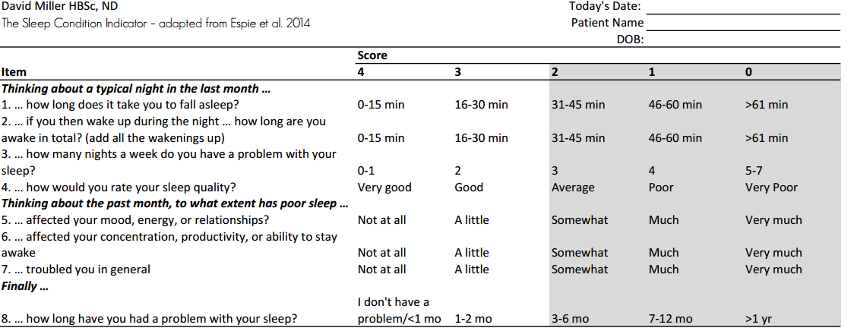

With this tool the user is able to give him or herself a personal score. There are 8 questions which measure 8 different areas concerning sleep. Scores are on a 5 point grade (0-4), total scores range from 0-32, where 0 indicates no problems with sleep and 32 indicates the most problems with sleep. Scores of 0-10 are indicative of adequate sleep and if needed can be improved through building stronger sleeping habits. Continue to use our sleep tracking device to help monitor any changes in sleep pattern. Scores of 11-20 are indicative of sleep disturbances and lifestyle changes need to be made with special attention to improve sleep pattern. Patient/client can self-manage sleep problems and use our device to track sleep. Scores of 20 and higher are indicative of poor sleep and individuals should seek medical/professional support for proper diagnosis and aggressive treatment. Our app can also save this information for future use to share data with healthcare team for evaluation.

In our trials with our SleepFit and Sense app we used one of the group members to measure their sleep quality. With the Sense Pill, our team member measured the temperature and sound in the room. On one night he found that sleeping with the door closed produced less noise and less movement throughout the night. We also found out that what he could do get a better night sleep was pretty close to that of what we had hypothesized at the start of the project. At the start of the project we had talked about avoiding eating late at night and not consuming any alcohol or caffeine would lead to a better night sleep. This was put to the test and it was confirmed that the user woke up twice during the night where he had a cup of coffee before bed, compared to not waking up at all on the night that he didn’t consume within two hours of going to sleep. One of our many limitations of our project was time constrain and unfortunately we were not able to conduct these sleeping trials over a longer period of time, this would have given us a better sleep pattern to analyze with the data collected.

Conclusion

In summary, sleep enhances the mental and emotional wellbeing of children, teens and adults. Sleep controls metabolism and weight and lack of sleep can cause weight gain. Also adds to aggression, moodiness & irritability decreases pain tolerance, can increase confused reactions, weakens immunity defenses and negatively affects attention span. Getting adequate sleep boosts the right mood for productivity and improves safety when performing daily tasks. Besides, sound sleep promotes hormonal balance and boosts the immune system. Although none of us are professionals in sleep disorders our Sleep Fit app was designed to aid in developing good sleeping habits and lead to a better night’s sleep.

**References**

Balakrishnan G., Burli D., Burk J., Lucas, E., Behbehani K, (2005)Comparison of a Sleep Quality Index between Normal and Obstructive Sleep Apnea Patients: Proceedings of the 2005 IEEE

Engineering in Medicine and Biology 27th Annual Conference

Long X., Haakna R., Rolink J., Fonseca Pl Aarts R., (2015)Improving Sleep/Wake Detection via Boundary Adaptation for Respiratory Spectral Features: 978-1-4244-9270-1/15/$31.00 ©2015 IEEE

Espie, C.A., Kyle, S.D., Hames, P., Gardani, M., Fleming, L., Cape, J., (2014). The sleep condition indicator : a clinical screening tool to evaluate insomnia disorder. *BMJ Open*

Marino, M., Yi, Li., Rueschman, J.W., Winkelman, J.M., Ellenbogen, J.M., Dllin, S.H., Berkman, L.F, Buxton, O.M., (2013). Measuring sleep accuracy, sensitivity, and specificity of wrist actigraphy compared to Polysomnography. *PubMed Central*

Richardson, A., Crow, W., Coghill, E., Turnock, C., (2007). A comparison of sleep assessment tools by nurses and patients in critical care*. Journal of Clinical Nursing*

Appendix

“Fitbit” Software-Hardware Codesign project location in Github

<https://github.com/HealthCareApps/Group-2-Healthy-Sleep-and-Sleep-Hygiene>

Partner App: Sense

Compatible with IOS on 8.0 and Android.

**Figures**

