Thinking Healthy

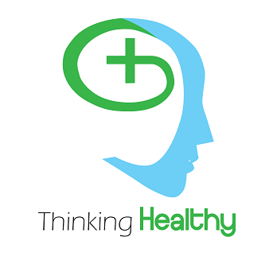

Khalil Millwood

Avinash Rao

Steven Smodish

Ariana Santiago

Abstract:

Many people are not aware of the differences between Healthy thinking and positive thinking. One may think if you think positively it is one and the same to think in a healthy manner. Our App is designed to educate the user on the differences between positive and negative thinking and how they are both important when relating back to Healthy Thinking. This report will cover the background of each teammate, what our educational and professional experiences bring to the table, as well as some of the processes and tools used to complete this project. This report will also cover the expectations of the group, the scope of our project as well as the final result as well as our thoughts and opinions on the final product.

**Background:**

Each group was to consist of 3 engineers, a nursing student, and an arts student. Being a health care related app, the nursing student was to provide expertise and advice regarding the topic chosen for the app. Each group was given a general area to cover regarding health care and medicine, and based off this genre would have to decide what their app would specify on. The arts student was to create visuals for the app and presentations. The arts student in each group was essentially the graphic designer of the group. Any pictures, icons, slideshows would be handled by this student. Finally, the engineering team would be responsible for the development of the app. We were responsible for developing the functionality of the app limited to constraints given by our arts and nursing student.

The engineering team consisted of Khalil Millwood, Avinash Rao and Steven Smodish. Khalil has experience and efficiency in the following languages: C, C++ and Python. He also has experience with programming and debugging an msp430 microcontroller. Avinash Rao has experience and expertise in C++ coding , as well as developing code and debugging an Arduino as well as msp430 microcontroller. Steven Smodish is an experienced Java developer, C# as well as Visual Basic. Steven has worked with Rasberry Pi’s and Arduinos in the past. He also is well informed in IT related knowledge and is a recording engineer.

Ariana Santiago was our arts student, who worked heavily on developing visuals for our app. She also assisted in creating visuals and slideshows for any presentations or story boards that were required throughout the semester. She is also responsible for creating icons and logos with our app as well as creating visuals for the augmented reality portion of our app.

Our particular group did not have a nursing student. We were not provided with one which made retrieving medical information regarding our topic a big challenge. As nobody in the group was well versed in health care, we were forced to reach out to outside sources for assistance and information.

**Methods**:

The majority of the app was developed using Android Studios. Our layout within the app used different methods learned throughout the semester in Android Studios. For example, we used TabBarLayout to create each individual Tab in the app. Code and implementation from assignments throughout the semester, such as the Fragment assignment, was used to assist in creating the layout for the app. These tools were used for all of the layout including the informational portion of the app. Regarding the Augmented Reality portion, Steve was the main developer for this. Some tools used for this were Unity, which was used for its interactivity, gave access to android sensors, as well as 3d modeling. Vuforia was also used for camera tracking and model placement for our AR. Particle systems were also used in order to generate text flowing out of our brain as demonstrated below.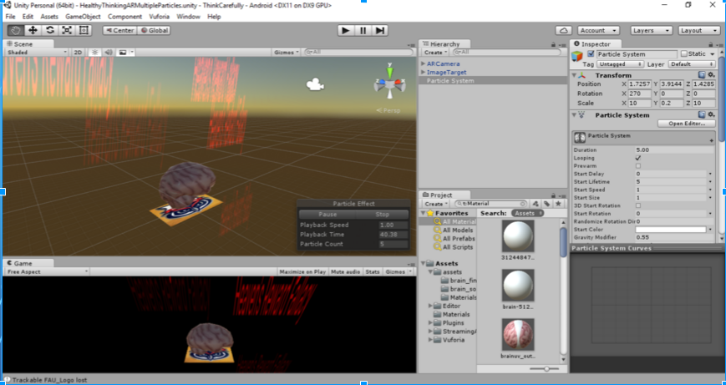w.

**Results**:

The final product was close to what the group envisioned from the start. After understanding the scope of this project, we determined that the app itself would have to be limited in numerous ways due to time constraints. Originally, due to the lack of a medical student we decided to take a creative route which involved little to no medical information. The group planned and designed code for a game related to Simon, in which the user will have to repeat a random output of colors viewed in augmented reality. This was initially meant to test the user’s memory to see who could achieve a high score. This particular project also tailored to the skills of the group, with Steve and Khalil having android expertise and Avinash with a database background being able to store information as needed. Ultimately this idea was scrapped as it did not relate to the medical side of the project.

The final result of our project was meant to be personalized for each user, in which a questionnaire would be administered to the user. This was meant to identify different thinking patterns. Based off this result, different messages would be displayed for the user in our augmented reality portion of the application. Due to time constraints, the group was able to complete everything but the personalized messages. Overall the group is satisfied with the outcome of the project.

**Discussion**:

Communication was not an issue for this group. Although primarily, the nursing student assigned was not to be found. After being notified that we would have to be proceed without a student with a medical background the group came together to discuss possibilities for the app. Without guidance our app was not going to be too medical based but outside sources as well as assistance from professors. All presentation materials were completed as a group. Our Arts student was able to use her graphic design background to provide different artworks for PowerPoints, videos etc. The final marketing video was completed by Steve. His background in audio engineering allowed us to create a sleek professional video satisfying the requirements. We believe as a group the skill sets were even spread when the original groups were created. We each had our own areas of expertise which would prove useful towards completing this project. Constant communication between professors and students also made it easy to tailor our project to the needs of the professors. It also allowed us to compensate for our lack of a medical student.

**Conclusion**:

Overall, the project was a success. The group was able to define a clear scope of the project. We were able to identify which parts would be challenging and which parts would be simpler and allow us to complete everything on a timely manner. The overall layout designed by Khalil was sleek and user friendly as it allowed any average user to browse the information provided. The swift response and contribution by several professors allowed us to tackle challenges our groups faced regarding the informational portion. The group was also satisfied with the combined efforts of our Arts student and Steve’s audio and video engineering background to create sleek, pleasant graphic design work.

**Appendix**

<https://github.com/HealthCareApps/Group-9-Healthy-Cognition-and-Memory/tree/master/App%20Versions> (Links to several versions of our app)

<https://github.com/HealthCareApps/Group-9-Healthy-Cognition-and-Memory/tree/master/App%20Versions/Version%202.2> (Most recent version of the app to be submitted)

**References**

Music attribution

Kevin - MacLeod (incompetech.com)

Licensed under Creative Commons: By Attribution 3.0 License

<http://creativecommons.org/licenses/by/3.0/>

http://www.mayoclinic.org/healthy-lifestyle/stress-management/in-depth/positive-thinking/art-20043950

http://www.rncentral.com/nursing-library/careplans/100_positive_thinking_exercises_to_incorporate_into_your_life/

http://www.cognitivetherapyguide.org/negative-thinking-patterns.htm

http://www.heretohelp.bc.ca/wellness-module/wellness-module-8-healthy-thinking

https://www.iaff.org/ET/JobAid/EAP/Healthy_Thinking_Skills.htm