**NCI Connect Cohort Link - v1.0.0**

This external module facilitates the link between REDCap project and NCI Connect API system for token/pin generation for the participant(s) and also supports other functional data exchanges.

**The current active functionality:**

* Participant token/PIN Generation through NCI Connect API
* Batch Mode with Visual Interface
* Ad-hoc Mode - On specific instrument for a record create or modified (Using Data Entry Trigger method configuration)
* REST API Call – to support cron job or autosys job setup

**System Level External Module Configuration:**

Since it is project level external module, all system level configuration are optional and managed by REDCap admin.

**Project Level External Module Configuration:**

**For Super User Only:**

|  |  |
| --- | --- |
| To identify NCI Connect Server Environment to Connect and Easily Change between DEVELOPMENT and PRODUCTION | C:\Users\VXTHIR~2\AppData\Local\Temp\SNAGHTML133a6889.PNG |
| Enter the API key received from NCI Team on specific environment. This will change either DEV-NCIAPIKEY or PROD-NCIAPIKEY based on NCI connect server environment selection |  |
| Enter the API endpoint. This will change either DEV-NCIConnect server or PROD-NCIConnect server based on NCI connect server environment selection |  |
| This help to setup cron job or autosys job with secure REST call service. |  |

**For Project Design User Level:**

|  |  |
| --- | --- |
| **For general token/PIN generation setting**  **Input param**: select study id field from project data field list.  **Output param** (values received from NCI) :   1. NCI token storage data field 2. NCI PIN storage data field   **The record filter logic:**  to select participant population based on condition. It is similar to branching logic or report builder filter logic  **The Batch size:** to help to run token/pin generation on larger population on batch. NCI Connect API allows upto 1000 records per request |  |
| **For Ad-hoc token/PIN generation**  This will use all general input param & outparam data field configuration for API exchange except record filter logic and batch size (as it single record at a time).  **Select list of instrument for Data Entry Trigger:** This allowed to add trigger point to run token/pin generation on current record when instrument open.  **The Record Filter Logic:** This will validate the provided rule on current record before starting token/pin generation process. |  |
| This will help to send email notification to configured email address if any network or programming issue part of data exchange through NCI API. |  |

Batch Job Manager Interface: 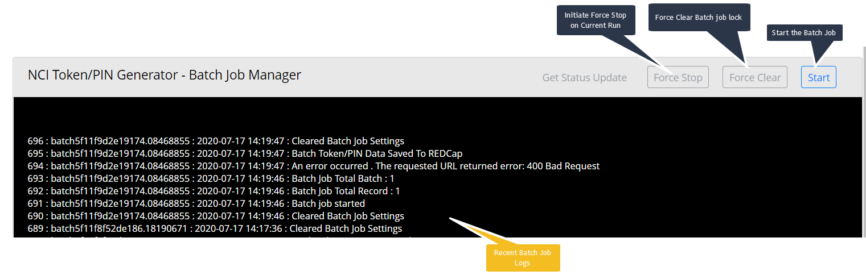

**REST API call to start initiate token/PIN generation batch job and Data Entry Trigger Service URL:**

**NCI Connect Cohort Link API Manager** - REST Services Base URL: http://{YOURREDCapServer}/redcap/api/?type=module&prefix=nci_connect_cohort_link&page=apimanager&pid={PROJECTID}&NOAUTH  
  
1. Token and PIN Generation Batch Job Initiation: GET params: **action = start_batch** and **passcode=[Your REST Call Secret]**  
  
example : http://localhost/redcap/api/?type=module&prefix=nci_connect_cohort_link&page=apimanager&pid=16&NOAUTH&action=start_batch&passcode=123456789  
  
2. DET Service URL: GET params: **action = DET** and **passcode=[Your REST Call Secret]**  
  
example : http://localhost/redcap/api/?type=module&prefix=nci_connect_cohort_link&page=apimanager&pid=16&NOAUTH&action=DET&passcode=123456789