Chinook Salmon Redd Survey Methods
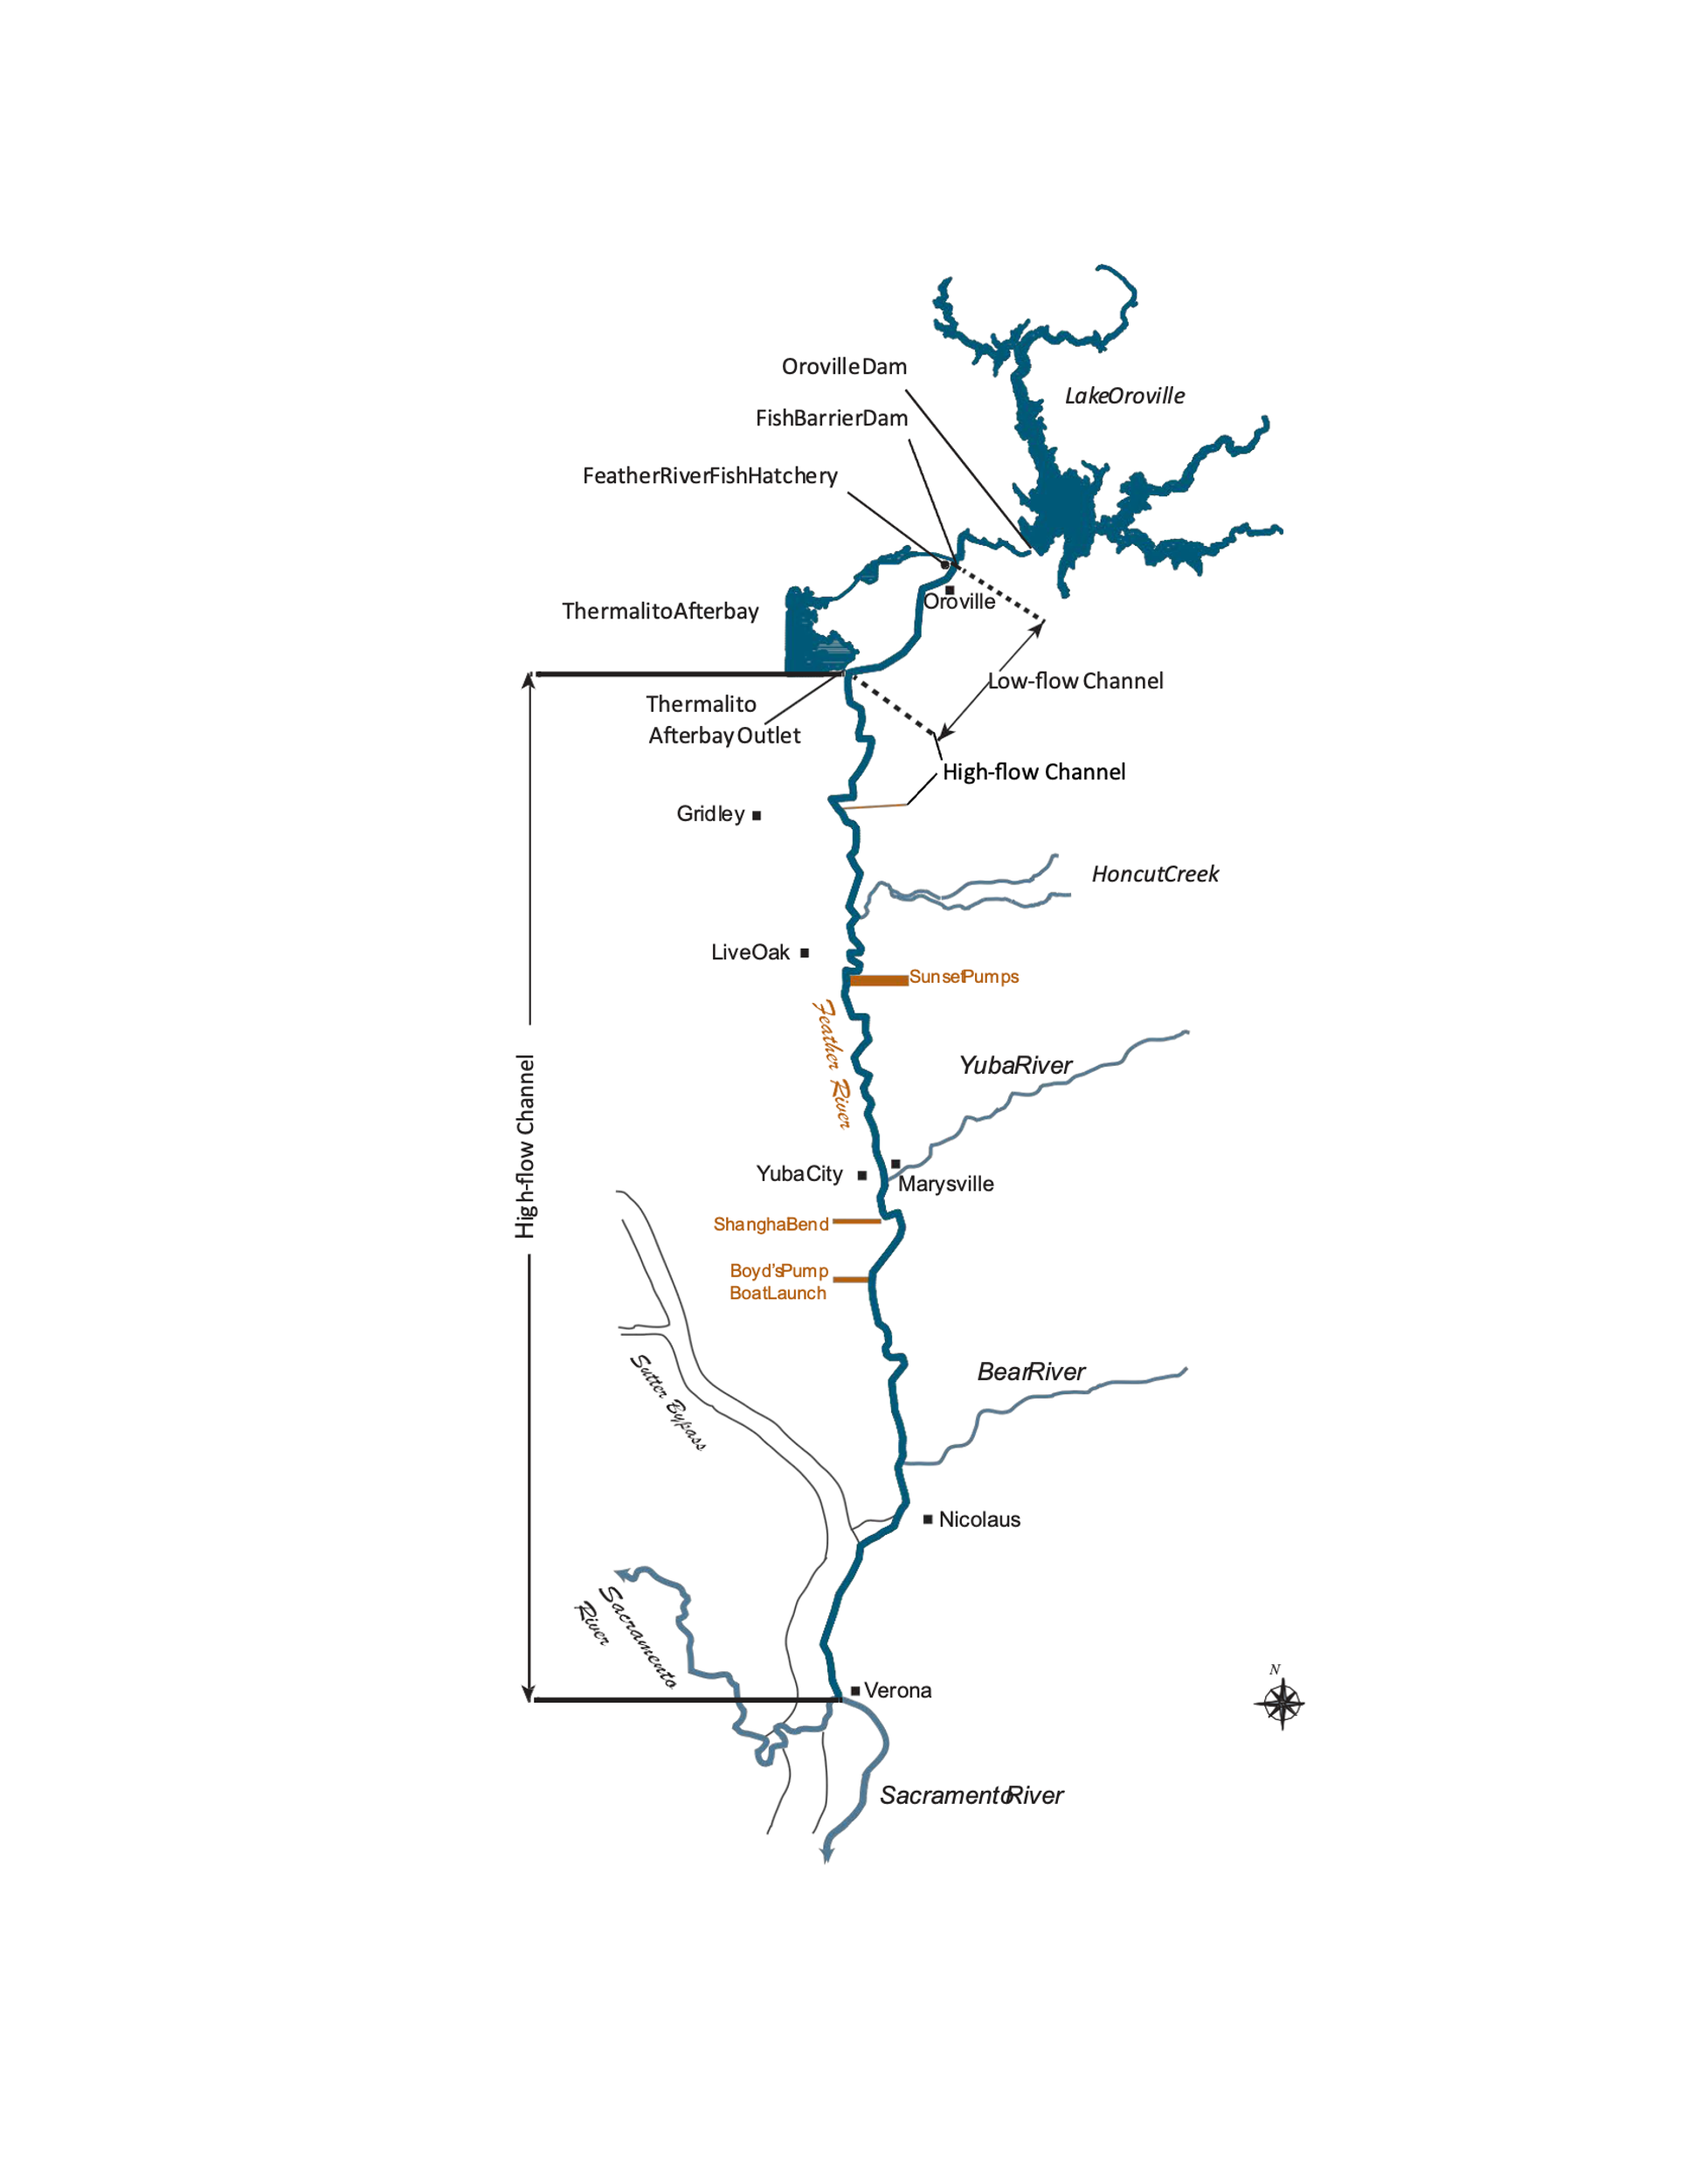
Chinook salmon redd surveys begin in mid-September at the onset of spawning and generally conclude at the end of November. The redd surveys are conducted in the uppermost 16 miles of the lower Feather River. Surveys extend from the Table Mountain Bridge in downtown Oroville, CA, downstream to the East Gridley Road Bridge near Gridley, CA (Figure 1). Since 2014, the Chinook salmon redd survey effort has been concentrated in the uppermost 2 miles of the lower Feather River in, and adjacent to the Gravel Supplementation Areas (GSAs) (Figures 2 and 3). Redd surveys are also conducted, but less frequently, in the 14 miles downstream of the GSAs. The redd data from these locations can be used to quantify and understand potential shifts in redd distribution and to quantify potential physical habitat differences (size, substrate, etc.) between historic and restored sites.
Figure 1. Map of the redd study area.
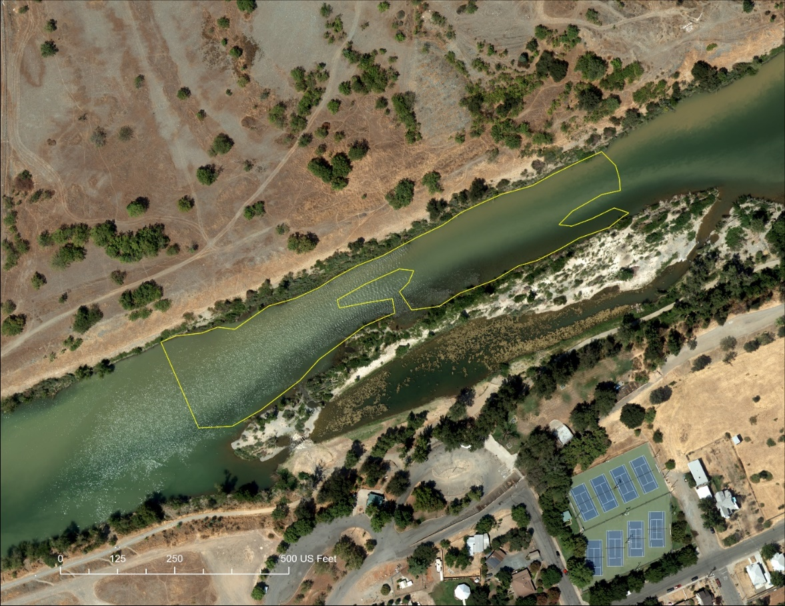
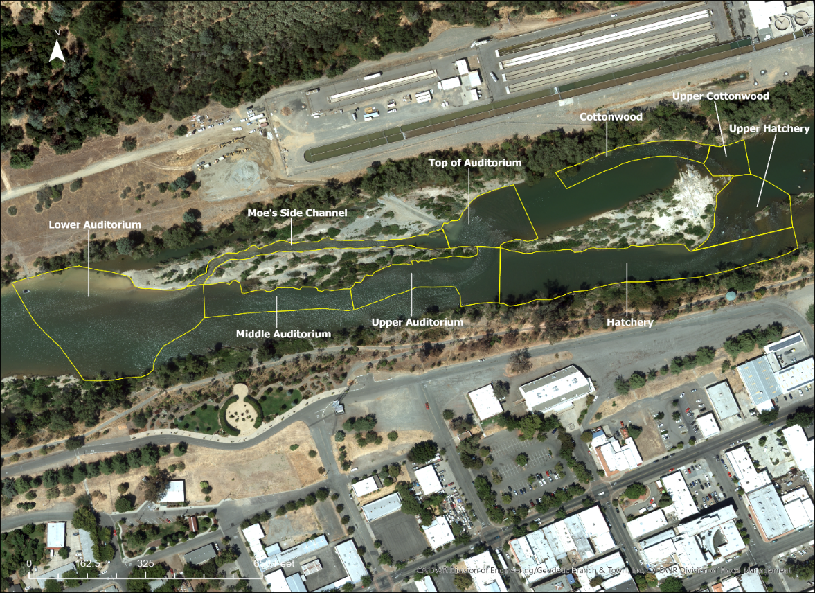
Figure 2. Map of the uppermost Gravel Supplementation Areas near downtown Oroville, CA.
Figure 3. Map of the lowermost Gravel Supplementation Area adjacent to Bedrock Park in downtown Oroville, CA.
One of the goals for the redd survey every year is to inspect the entirety of the GSAs and adjacent sites multiple times each survey week for newly developed redds. Surveys in and adjacent to the GSAs are suspended when it is no longer possible to distinguish new redds due to superimposition. For this reason, the duration of the survey period in the GSAs can change between years.

Redd mapping in locations outside of the GSAs is primarily used to provide annual spatial and temporal spawning information and to inform future gravel enhancement projects. These sites are less heavily utilized for spawning than the GSAs. As such these sites can be mapped less frequently than those in and adjacent to the GSAs. Survey sites downstream of the GSAs are mapped weekly or every other week depending on the amount of time needed to perform multiple surveys per week in the GSAs (Figure 4). Redd surveys conducted in the HFC (Figure 1) are also used to provide spatial and temporal spawning information but can be used to investigate the potential for redd dewatering when flows reductions occur in the HFC.
Visual redd surveys are performed by a crew of two staff members wearing polarized sunglasses. The crew members thoroughly search each survey location looking for newly developed redds. A boat is used to locate and position surveyors over redds in deeper sections (>3 ft) of the river where wading is not possible. Only completed redds, identified by a pit and tail spill, are marked and counted. Test redds, those without a completed pit and tail spill, are not marked.

Redds are recorded geospatially with a Trimble GeoXH 6000 handheld GPS utilizing virtual reference station real time position correction with accuracy of 10 cm or a Juniper Systems Geode GNS3M Multi-Frequency Antennae. A single point is recorded by placing the GPS antennae over the center of the redd to record its location (Redd Point).

Depth, velocity, and substrate data is recorded on every fifth or tenth redd based on time constraints during each survey week. Substrate composition is recorded by visually estimating the percentage of five substrate size categories: Fines (< 1cm), Gravel (1-5 cm), Cobble (6-15 cm), Large Cobble (16-30 cm), and Boulder (> 30 cm). Physical data (depth, velocity, and substrate) is not recorded for redds where a boat is necessary to collect position data. Depth measurements are recorded with a standard top-setting wading rod at the head and in the pot of the redd. Velocity readings are measured at 60% depth at the head of the redd with an Ott MF Pro flowmeter.

At locations where depth and velocity data are collected, the width and length are also measured at the widest and longest part of the redd to the nearest 0.1 meter. When individual redds are difficult to distinguish from one another (overlapping), no area measurements are collected.

After field data collection, information is downloaded and processed using Trimble GPS Pathfinder Office 3.10 or Juniper System’s Uinta software.

Microsoft Excel is used for statistical analysis and graphical representation of the data. ArcGIS Pro is used for spatial analysis. Sample means ± 1 standard error are reported for measured parameters.
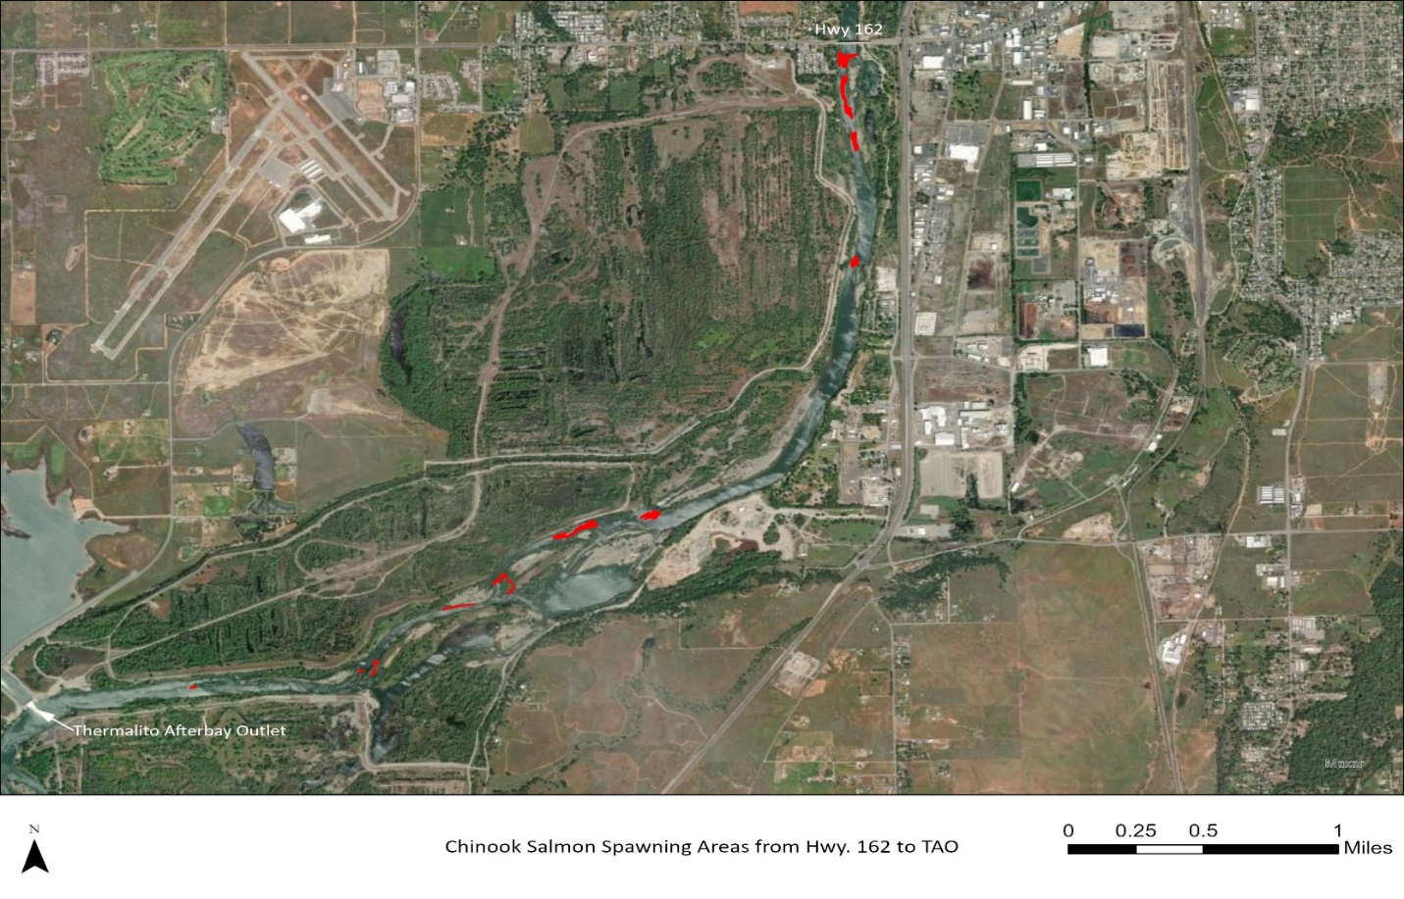
Figure 4. Chinook Salmon Redd Survey Sites from Hwy. 162 to the Thermalito Afterbay Outlet.

