Cost-Effectiveness Analysis of Treatments for
Chronic Airway Infection Syndrome (CAIS)
Manufacturer’s Base Case Economic Evaluation
Prepared for: | Health Technology Assessment Agency
Submitted by: | Infectaguard Pharma Inc.
Intervention: | Infectaguard (oral, once daily)
Comparator: | Usual Care
Date: | March 2026

NOTE: this document, and the model it describes, was generated with Claude AI. The disease area, treatment options, manufacturer, and parameter values are all fictitious. The structure of the model is meant to resemble models that are used for HTA decision-making. Any resemblance to an existing decision model is entirely coincidental.

1. Disease Background
Chronic Airway Infection Syndrome (CAIS) is a progressive chronic respiratory condition characterised by recurring exacerbations and susceptibility to two distinct patterns of chronic bacterial colonisation. Patients experience recurring inflammatory episodes (exacerbations) that are associated with hospitalisation, quality-of-life impairment, and elevated mortality. Left untreated, a substantial proportion of patients acquire chronic infections of type PathA or PathB, each of which further amplifies exacerbation risk and disease-specific mortality.
CAIS patients carry approximately 50% higher all-cause mortality than age-matched general population individuals (standardised mortality ratio 1.50). Exacerbation states and chronic infection states carry additional mortality increments. At baseline (age 60, 55% female), the burden of disease is substantial: annual exacerbation rates approach 35% in untreated patients on Usual Care, and acquisition of chronic infection further elevates exacerbation risk by 25–30%. Healthcare resource utilisation is high, with per-exacerbation costs of approximately $3,200 and chronic infection adding $6,000–$7,500 per year in additional management costs.

1.1 Current Treatment Landscape
Usual Care (UC) represents standard background pharmacological management for CAIS, including regular physician visits, standard inhaled medications, and routine microbiological monitoring at an estimated annual background cost of $4,500. There are no approved disease-modifying agents for CAIS in the base case comparator arm.
Infectaguard is a novel oral small-molecule agent targeting airway neutrophil elastase activity. In the clinical programme (assumed for illustration), Infectaguard reduced the annual exacerbation rate by 45% (rate ratio 0.55; log-scale SE 0.12) and substantially reduced rates of PathA and PathB acquisition (RR 0.55 and 0.58, respectively). Infectaguard is available as a generic oral formulation at an annual drug cost of $2,000, substantially below conventional biologics.

2. Model Structure and Key Assumptions

2.1 Model Type and Time Horizon
A cohort-level Markov state-transition model was developed to evaluate the cost-effectiveness of Infectaguard versus Usual Care for CAIS. The model adopts a Canadian public payer perspective with a lifetime (100-year) time horizon, using annual cycles (100 cycles total). The starting cohort age is 60 years (55% female). Both costs and QALYs are discounted at 3% per annum. Half-cycle correction is applied via standard weighting (0.5 weight on first and final cycle rows).
This model uses a standard Markov state-transition architecture, with per-cycle transition probability matrices applied iteratively across the cohort. Age-dependent background mortality is embedded directly in the transition matrix at each cycle via interpolation of a US 2023 abridged life table, consistent with the approach described by Paulden (2025) for array-formula Excel implementations.

2.2 Health States
The model comprises seven mutually exclusive and exhaustive health states, structured to capture both exacerbation status and chronic infection status:
- Stable: no exacerbation in the current cycle; no chronic bacterial infection.
- Stable_Exac: exacerbation occurring in the current cycle; no chronic infection. Patients recover with probability 0.85 per cycle and return to Stable; the remaining 15% stay in an exacerbation state for a further cycle.
- PathA: chronic PathA infection (Gram-negative bacterial analogue); no current exacerbation. Patients can clear PathA spontaneously at 5% per year.
- PathA_Exac: concurrent PathA infection and active exacerbation.
- PathB: chronic PathB infection (mycobacterial analogue); no current exacerbation. Spontaneous clearance rate 4% per year.
- PathB_Exac: concurrent PathB infection and active exacerbation.
- Dead: absorbing state, entered via age-dependent background mortality scaled by disease- and state-specific standardised mortality ratios.

All patients enter the model in the Stable state. PathA and PathB infections are treated as mutually exclusive within any single annual cycle; direct transitions between PathA and PathB states are not permitted.

2.3 Transition Probability Structure
In each annual cycle, the cohort distributes across states according to a 7×7 transition probability matrix. Key structural features include:
- Exacerbation onset (Stable → Stable_Exac) is governed by the arm-specific exacerbation probability, with PathA and PathB states experiencing proportionally elevated rates via multiplicative rate ratios.
- Exacerbation recovery (Stable_Exac → Stable, PathA_Exac → PathA, PathB_Exac → PathB) occurs with probability 0.85 per cycle.
- PathA and PathB acquisition (Stable → PathA / PathB) are modelled as competing events, jointly with exacerbation, within each annual cycle.
- Background mortality is age-dependent (from a US 2023 abridged life table, piecewise linearly interpolated) and scaled by state-specific SMRs. The CAIS SMR (1.50) applies to all alive states; the exacerbation (1.20), PathA (1.30) and PathB (1.35) SMRs are multiplied onto the CAIS-adjusted probability of death.

2.4 Calculation Conventions
Cycles are one year long. The cohort starts in Stable at age 60 at time 0. Costs, QALYs and life years are summed over trace rows with trapezoidal (half-cycle) weights, giving half weight to the first and last rows, and are discounted at 3% from the start of each cycle (time t). Costs and utilities are assigned to state occupancy. The Infectaguard drug cost accrues to every living patient for the whole horizon; treatment discontinuation is not modelled. Life years count all living states.

2.5 State-Transition Diagram
Figure 2.1 illustrates the health-state structure and permitted transitions. Exacerbation transitions (Stable ↔ Stable_Exac; PathA ↔ PathA_Exac; PathB ↔ PathB_Exac) are bidirectional and occur each cycle. Infection acquisition is unidirectional from Stable states; clearance returns patients to the corresponding Stable state. Background mortality flows from all alive states to Dead.
Figure 2.1. CAIS Markov model — seven health-state structure
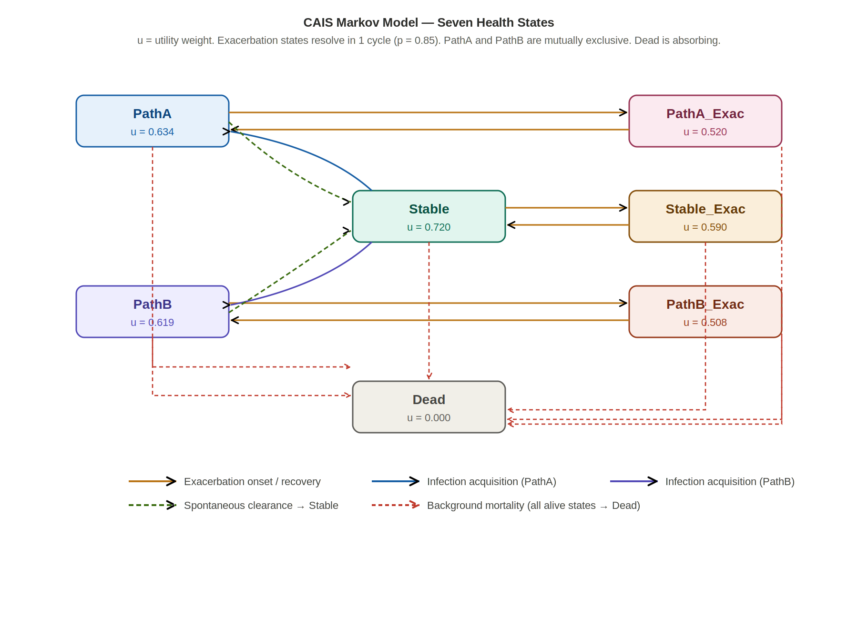

3. Model Parameters

3.1 Treatment Arms and Efficacy Parameters
Table 3.1 presents transition probability parameters for both treatment arms. All values are assumed for illustration and are not derived from any proprietary source.
Table 3.1. Transition probability parameters
Parameter | Usual Care | Infectaguard | SE | PSA Dist.
Annual exacerbation probability | 0.35 | 0.193 | 0.070 | Beta
Annual PathA acquisition probability | 0.04 | 0.022 | 0.008 | Beta
Annual PathB acquisition probability | 0.03 | 0.017 | 0.006 | Beta
Exacerbation recovery probability | 0.85 | 0.85 | 0.043 | Beta
PathA spontaneous clearance | 0.05 | 0.05 | 0.013 | Beta
PathB spontaneous clearance | 0.04 | 0.04 | 0.010 | Beta
RR for exacerbation (Infectaguard vs UC) | — | 0.55 | 0.12† | Log-normal
RR for PathA acquisition (Infectaguard vs UC) | — | 0.55 | 0.15† | Log-normal
RR for PathB acquisition (Infectaguard vs UC) | — | 0.58 | 0.15† | Log-normal
† SE on log scale. Infectaguard exacerbation probability = UC probability × RR. All values assumed for illustration.

3.2 Health-State Utilities
Utilities are assigned to health states using a multiplicative approach. The baseline Stable utility (0.72) represents the chronic respiratory disease burden in a stable, non-infected, non-exacerbating CAIS patient. Exacerbation imposes a utility multiplier of 0.82 (reflecting short-term but meaningful HRQoL reduction). Chronic infection states carry multipliers of 0.88 (PathA) and 0.86 (PathB), capturing the additional burden of chronic infection management. In the PSA the three multipliers are sampled from Beta distributions (SE 0.03) and the state utilities are derived from them.
Table 3.2. Health-state utility values
Health state | Utility | Derivation | PSA Dist.
Stable | 0.720 | Base utility — direct estimate | Utility (1−Gamma)
Stable_Exac | 0.590 | 0.720 × 0.82 multiplier | Derived
PathA | 0.634 | 0.720 × 0.88 multiplier | Derived
PathA_Exac | 0.520 | 0.720 × 0.88 × 0.82 | Derived
PathB | 0.619 | 0.720 × 0.86 multiplier | Derived
PathB_Exac | 0.508 | 0.720 × 0.86 × 0.82 | Derived
Dead | 0.000 | Conventional | Fixed

3.3 Costs
All costs are expressed in 2026 Canadian dollars and represent direct costs from the perspective of the Canadian public payer. Costs are applied per cycle, with drug and management costs accruing throughout the modelled lifetime. The per-exacerbation cost is applied to the occupancy of each exacerbation state in every cycle, so patients whose exacerbation continues into a further cycle incur it again. Chronic infection states incur an additional annual management cost.
Table 3.3. Cost parameters
Cost component | Annual value | SE | PSA Dist.
Infectaguard drug cost | $2,000 | $400 | Gamma
Usual Care background cost | $4,500 | $900 | Gamma
Per-exacerbation event cost | $3,200 | $800 | Gamma
Additional annual cost — PathA infection | $6,000 | $1,200 | Gamma
Additional annual cost — PathB infection | $7,500 | $1,500 | Gamma
All costs in 2026 CAD; assumed for illustration. Drug and background costs accrue annually; infection costs accrue while patients occupy the relevant state, and the exacerbation cost accrues for each cycle spent in an exacerbation state.

3.4 Mortality Parameters
Background mortality is drawn from a US 2023 abridged life table (sex-weighted at 55% female) and updated at each model cycle as the cohort ages. Piecewise linear interpolation is used between published age points. Disease- and state-specific excess mortality is applied via multiplicative standardised mortality ratios (SMRs), consistent with the approach used in the reference R model. Condition-specific SMRs are multiplied onto the CAIS-adjusted probability of death rather than added to it (for example, an exacerbation with PathA infection carries 1.50 × 1.20 × 1.30 times the background probability). Standardised ratios are sampled from log-normal distributions in the PSA.
Mortality parameter | Value | PSA Dist.
SMR — CAIS vs general population | 1.50 | Log-normal
Additional SMR — exacerbation states | 1.20 | Log-normal
Additional SMR — PathA infection states | 1.30 | Log-normal

