Cost-Effectiveness Analysis of Treatments for
Chronic Immune Skin Syndrome (CISS)
Manufacturer's Base Case Economic Evaluation
Prepared for: Health Technology Assessment Agency
Submitted by: Dravex Pharmaceuticals Inc.
Date: March 2026

NOTE: this document, and the model it describes, was generated with Claude AI. The disease area, treatment options, manufacturer, and parameter values are all fictitious. The structure of the model is meant to resemble models that are used for HTA decision-making. Any resemblance to an existing decision model is entirely coincidental.

1. Disease Background
Chronic Immune Skin Syndrome (CISS) is a chronic, relapsing inflammatory skin condition characterised by widespread erythematous plaques, intense pruritus, and impaired skin barrier function. The condition typically presents in early adulthood and follows a waxing-and-waning course, with flares triggered by environmental factors, stress, and immune dysregulation. CISS affects approximately 2–5% of the adult population, with moderate-to-severe disease accounting for roughly one-third of prevalent cases.
The burden of moderate-to-severe CISS is substantial. Patients experience persistent itch, sleep disruption, and visible skin involvement that significantly impairs quality of life, social functioning, and work productivity. Health state utilities in uncontrolled disease are typically in the range of 0.55–0.65, comparable to other chronic disabling conditions. The economic burden includes direct medical costs (outpatient visits, prescription medications, hospitalisations for severe flares), as well as indirect costs from reduced productivity, though the present analysis adopts a direct-cost payer perspective.

1.1 Current Treatment Landscape
The treatment of moderate-to-severe CISS has been transformed in recent years by the introduction of targeted therapies, including Janus kinase (JAK) inhibitors and monoclonal antibodies directed against key cytokines in the inflammatory cascade. Prior to these therapies, patients were managed with topical corticosteroids, phototherapy, and conventional systemic immunosuppressants — collectively referred to as best supportive care (BSC). BSC remains the relevant comparator for economic evaluation, as it represents the treatment pathway for patients who are not candidates for, or who have not yet received, targeted therapy.
Five targeted therapies are included in this analysis. Three are oral JAK inhibitors (Dravokimab, Barisetinib, Uvestinib), which offer the convenience of oral administration but carry class-specific safety considerations including potential cardiovascular and thromboembolic risks. Two are subcutaneous monoclonal antibodies (Tremacept, Dorilumab), which require injection training and periodic self-administration but have a favourable long-term safety profile. All five therapies have demonstrated superiority over BSC in randomised controlled trials, with varying response rates and durability of effect.

2. Model Structure and Key Assumptions

2.1 Model Type and Time Horizon
A cohort-level Markov state-transition model was developed to evaluate the cost-effectiveness of six treatment strategies for moderate-to-severe CISS. The model adopts a US payer perspective with a 5-year time horizon, reflecting the chronic but manageable nature of the condition. Cycles are 16 weeks in length, corresponding to the standard clinical assessment interval in pivotal trials, yielding 17 model cycles over the 5-year horizon. Both costs and health outcomes are discounted at 3% per annum using mid-cycle convention.

2.2 Health States
The model comprises five mutually exclusive health states, defined by treatment response level as measured by a validated composite severity index. Four states represent living patients at different levels of disease control, and one state represents death.
NonResponder represents patients who have not achieved a clinically meaningful response to therapy. This is the starting state for all patients entering the model and also serves as the absorbing alive state for patients who lose treatment response through discontinuation. Resp_Low, Resp_Moderate, and Resp_High represent increasing levels of disease control, corresponding to progressively better skin clearance and symptom improvement. Death is an absorbing state entered at a constant background mortality rate.

2.3 Model Phases
The model has a structurally distinctive two-phase design reflecting the clinical pathway of targeted therapy for CISS.
Induction phase (cycle 1). All patients enter the model as NonResponders and undergo a single response assessment at week 16. Based on treatment-specific response probabilities, patients are allocated to NonResponder, Resp_Low, Resp_Moderate, or Resp_High. This initial sorting reflects the clinical practice of evaluating treatment response at the end of the induction period and continuing therapy only in patients who demonstrate benefit.
Maintenance phase (cycles 2–17). During maintenance, patients in responder states may discontinue treatment at a treatment-specific per-cycle rate and transition to NonResponder. Once in NonResponder during maintenance, patients do not re-respond — this is an absorbing alive state. Discontinuation rates vary between year 1 (cycles 2–4) and year 2 onward (cycles 5–17), reflecting higher early attrition that stabilises over time.
Figure 2.1. Markov state-transition diagram
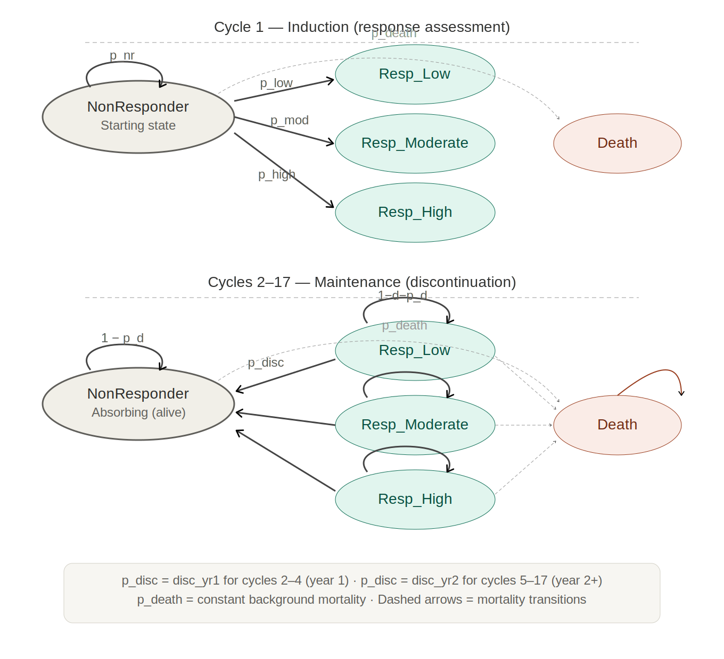
Notes: Upper panel shows cycle 1 (induction), where all patients start as NonResponder and are sorted into response states. Lower panel shows cycles 2–17 (maintenance), where responders may discontinue to NonResponder at time-dependent rates. Dashed arrows represent background mortality. All transitions apply identically across the six treatment arms, with treatment-specific response and discontinuation probabilities.

2.4 Key Structural Assumptions
Several simplifying assumptions govern the model. Background mortality is constant and identical across treatment arms, reflecting the negligible impact of CISS on life expectancy. There is no treatment-related mortality. Patients who discontinue therapy are assumed to revert to NonResponder status and remain there for the duration of the model; re-treatment or treatment switching is not modelled. Drug costs in the induction cycle are applied to all alive patients, reflecting the treat-to-assess paradigm, while in maintenance cycles drug costs accrue only to patients who remain in responder states. Subcutaneous injection training costs are applied once, in cycle 1, for injectable therapies only.

3. Model Parameters

3.1 Response Probabilities
Treatment-specific response probabilities determine the proportion of patients allocated to each response level at the end of the 16-week induction period. These probabilities were derived from the pivotal trial programme for each therapy. The proportion of non-responders is the complement of the three response categories.
Table 3.1. Induction response probabilities by treatment
Treatment | P(Resp_Low) | P(Resp_Mod) | P(Resp_High) | P(NonResp)
BSC | 0.105 | 0.070 | 0.060 | 0.765
Dravokimab | 0.155 | 0.175 | 0.380 | 0.290
Barisetinib | 0.150 | 0.135 | 0.170 | 0.545
Tremacept | 0.145 | 0.140 | 0.180 | 0.535
Uvestinib | 0.130 | 0.170 | 0.475 | 0.225
Dorilumab | 0.155 | 0.170 | 0.295 | 0.380
PSA distribution: Beta (SE = 10% of mean) for each response probability.

3.2 Discontinuation Rates
Per-cycle discontinuation probabilities represent the likelihood of a patient in a responder state losing treatment response and transitioning to NonResponder during maintenance. Year 1 rates apply to cycles 2–4; year 2+ rates apply from cycle 5 onward.
Table 3.2. Discontinuation rates per 16-week cycle
Treatment | Year 1 | Year 2+
BSC | 0.240 | 0.240
Dravokimab | 0.040 | 0.040
Barisetinib | 0.075 | 0.075
Tremacept | 0.055 | 0.055
Uvestinib | 0.075 | 0.075
Dorilumab | 0.040 | 0.050
PSA distribution: Beta (SE = 10% of mean).

3.3 Health State Utilities
Utility values are expressed on the EQ-5D scale and represent the health-related quality of life associated with each model health state. In the induction cycle, utility is calculated as the average of the baseline value (NonResponder) and the post-assessment state value, reflecting the transition from uncontrolled to controlled disease over the 16-week period.
Table 3.3. Health state utilities
Health State | Utility
NonResponder | 0.62
Resp_Low | 0.78
Resp_Moderate | 0.84
Resp_High | 0.87
Death | 0.00
PSA distribution: Utility (1 minus Gamma on disutility; SE = 0.02).

3.4 Costs
All costs are expressed in 2021 US dollars. Drug costs are converted from annual to per-cycle values by multiplying by the cycle length in years (16/52). State costs represent the direct medical costs of managing a patient in each health state, excluding drug acquisition costs, and are similarly annualised to per-cycle values.
Table 3.4a. Annual drug costs by treatment
Treatment | Annual Drug Cost
BSC | $0
Dravokimab | $38,500
Barisetinib | $18,200
Tremacept | $29,500
Uvestinib | $58,700
Dorilumab | $29,500
PSA distribution: Gamma (SE = 20% of mean); BSC fixed at $0.
Table 3.4b. Annual health state costs
Health State | Annual State Cost
NonResponder | $17,200
Resp_Low | $9,500
Resp_Moderate | $8,400
Resp_High | $8,100
PSA distribution: Gamma (SE = 20% of mean).
A one-time subcutaneous injection training cost of $25.00 is applied in cycle 1 for Tremacept and Dorilumab.

