Cost-Effectiveness Analysis of Treatments for
Chronic Neurocognitive and Relapsing Disorder (CNRD)
Manufacturer’s Base Case Economic Evaluation
Prepared for: Health Technology Assessment Agency
Submitted by: Velonix Therapeutics Inc.
Date: March 2026
NOTE: this document, and the model it describes, was generated with Claude AI. The disease area, treatment options, manufacturer, and parameter values are all fictitious. The structure of the model is meant to resemble models that are used for HTA decision-making. Any resemblance to an existing decision model is entirely coincidental.

1. Disease Background
Chronic Neurocognitive and Relapsing Disorder (CNRD) is a persistent psychiatric condition characterised by recurrent episodes of psychotic symptoms, cognitive impairment, and functional decline. The condition typically presents in early adulthood and follows a relapsing-remitting course, with acute episodes triggered by medication non-adherence, substance use, and psychosocial stressors. CNRD affects approximately 0.5–1.0% of the adult population, with treatment-resistant disease accounting for roughly one-third of prevalent cases.
The burden of CNRD is substantial. Patients experience recurring psychotic episodes, persistent negative symptoms, and progressive functional impairment that significantly affects quality of life, social functioning, and employment. Health state utilities in stable disease are typically in the range of 0.65–0.75, with acute relapse episodes reducing utility by 0.40–0.45. The economic burden includes direct medical costs (inpatient hospitalisations, outpatient psychiatric care, emergency department visits, and medications), as well as supported housing and community mental health services.

1.1 Current Treatment Landscape
The treatment of CNRD involves sequential lines of antipsychotic therapy. First-line treatment is selected from among several oral and long-acting injectable options, with response assessed after an acute stabilisation phase. Patients who achieve a clinically meaningful response continue on maintenance therapy; those who do not respond are switched to second-line and subsequently third-line regimens. Treatment discontinuation due to adverse effects (particularly metabolic syndrome and its complications) is a significant driver of treatment switching.
Two branded therapies are included in this analysis. Velonix is a novel atypical antipsychotic with a favourable metabolic profile and high response rates. Doralene is a generic first-generation antipsychotic with established efficacy but higher rates of metabolic adverse effects. Both therapies are evaluated as first-line treatments, with subsequent lines comprising mixed regimens of available agents.

2. Model Structure and Key Assumptions

2.1 Model Type and Time Horizon
A cohort-level Markov state-transition model was developed to evaluate the cost-effectiveness of Velonix versus Doralene as first-line treatment for CNRD. The model adopts a Canadian public payer perspective with an 80-year time horizon (320 quarterly cycles), reflecting the chronic, lifelong nature of the condition. Starting age is 42 years. Both costs and health outcomes are discounted at 3% per annum using mid-cycle convention.

2.2 Health States
The model comprises six health states within each treatment line, defined by disease control status and the presence of comorbid metabolic complications. Three treatment lines are modelled, yielding an 18-state expanded vector representation.
Stable (No Complications) represents patients on active treatment with controlled symptoms and no metabolic comorbidities. This is the target state for treatment.
MetabX represents patients who develop metabolic syndrome, a common adverse effect of antipsychotic therapy characterised by weight gain, dyslipidaemia, and insulin resistance.
DiabX represents patients who progress from metabolic syndrome to type 2 diabetes, an irreversible complication with additional morbidity and cost.
CardioY represents patients who develop cardiovascular complications secondary to metabolic syndrome.
DiabX+CardioY represents patients with both diabetes and cardiovascular complications.
Dead is an absorbing state. Background mortality is age-dependent (US 2023 abridged life table, 42% male) and increased by disease-specific and comorbidity-specific standardised mortality ratios.

2.3 Treatment Lines and Discontinuation Cascade
Patients enter the model at Line 1 (first-line therapy). During each cycle, patients on Lines 1 and 2 may discontinue treatment and move to the next line. Discontinuation is modelled as a fixed per-cycle probability for each line (Section 3.1); it is not linked to the occurrence of metabolic adverse effects. It applies only during the active treatment period (cycles 1–80, i.e., the first 20 years). After cycle 80, discontinuation ceases and patients remain on their current line, and relapse probabilities are blended with the no-treatment relapse probability (weights 0.818 / 0.182) to reflect patients no longer on active therapy; drug costs continue to accrue.
The three treatment lines for each arm are:
Line | Velonix Arm | Doralene Arm
Line 1 | Velonix | Doralene
Line 2 | Mixed regimen (48% component 2a / 52% component 2b) | Mixed regimen (48% component 2a / 52% component 2b)
Line 3 | Mixed regimen (33% 2a / 37% 2b / 30% clozapine analogue) | Mixed regimen (33% 2a / 37% 2b / 30% clozapine analogue)

The discontinuation cascade is implemented as a coupled 18-state system: in each cycle, a proportion of alive patients on Line 1 transfer to Line 2, and similarly from Line 2 to Line 3. This coupling is modelled within a single REDUCE formula using an 18×18 block-diagonal transition matrix with off-diagonal discontinuation flows.
Figure 2.1. CNRD Markov state-transition model
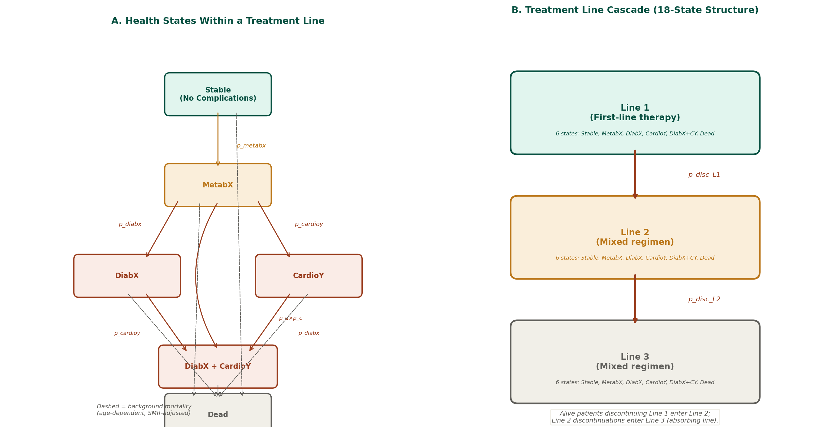
Notes: Panel A shows the six health states within each treatment line, with metabolic complication progression (amber/red arrows) and age-dependent background mortality (dashed arrows, SMR-adjusted). Panel B shows the three-line discontinuation cascade implemented as an 18-state coupled system.

2.4 Key Structural Assumptions
Background mortality is age-dependent, using a sex-weighted US 2023 abridged life table (42% male, 58% female). Disease-specific mortality is elevated via a standardised mortality ratio (SMR) of 2.20 for CNRD, with additional SMRs of 2.00 for diabetes and 1.60 for cardiovascular complications; SMRs are additive to the background mortality (full SMR × background mortality). Metabolic syndrome develops as a treatment-related adverse effect at line-specific rates. Once metabolic complications (DiabX, CardioY) develop, they are irreversible. Relapse episodes occur at a line-specific per-cycle probability and incur acute costs and utility decrements but do not alter the Markov state. The first quarter of the model is an acute stabilisation phase: patients incur the acute hospitalisation cost and are allocated to Lines 1, 2 or 3 according to response, with no mortality, life years or QALYs accrued in that quarter; the Markov process starts from the second cycle.

3. Model Parameters

3.1 Treatment Response and Relapse
Parameter | Velonix | Doralene | Line 2 | Line 3
Response rate (Line 1) | 50% | 34% | 44% | —
Relapse probability (per cycle) | 0.10 | 0.12 | 0.1148* | 0.1073*
Discontinuation probability | 0.055 | 0.050 | 0.040 | —
*Line 2 and 3 relapse probabilities are weighted averages of component regimens (Line 2: 48% × 0.12 + 52% × 0.11; Line 3: 33% × 0.12 + 37% × 0.11 + 30% × 0.09). In the PSA the component probabilities are sampled from Beta distributions (SE from 95% CI) and the blends are recomputed from the sampled components.

3.2 Metabolic Adverse Effects
Parameter | Velonix | Doralene | Line 2 | Line 3
MetabX probability (per cycle) | 0.005 | 0.034 | 0.0417* | 0.0606*
DiabX | MetabX (per cycle) | 0.011 | 0.011 | 0.011 | 0.011
CardioY | MetabX (per cycle) | 0.005 | 0.005 | 0.005 | 0.005
*Line 2 and 3 MetabX probabilities are weighted averages of component regimens (Line 2: 48% × 0.050 + 52% × 0.034; Line 3: 33% × 0.050 + 37% × 0.034 + 30% × 0.105). DiabX and CardioY progression is conditional on MetabX. PSA: Beta (component MetabX, DiabX, CardioY), with blends recomputed from the sampled components.

3.3 Mortality
Parameter | Value | PSA Distribution
Background mortality | US 2023 life table | Fixed
SMR — CNRD | 2.20 | Gamma
SMR — Diabetes | 2.00 | Gamma
SMR — Cardiovascular | 1.60 | Gamma

3.4 Health State Utilities
Parameter | Value | PSA Distribution
Stable CNRD (no complications) | 0.710 | Utility (Gamma disutil.)
Disutility — MetabX | −0.055 | Gamma
Disutility — DiabX | −0.095 | Gamma
Disutility — CardioY | −0.095 | Gamma
Disutility — Relapse episode | −0.430 | Gamma

3.5 Costs
Parameter | Value | PSA Distribution
Velonix (annual) | $18,000 | Gamma
Doralene (annual) | $38 | Fixed
Stable base cost (quarterly) | $933 | Fixed
Relapse episode cost | $13,290 | Fixed
Acute hospitalisation (per line entry) | $30,000 | Fixed
DiabX management (quarterly) | $2,900 | Gamma
CardioY management (quarterly) | $3,700 | Gamma

