Cost-Effectiveness Analysis of Zelravine for
Nocturnal Cortical Dysrhythmia (NCD)
Manufacturer's Base Case Economic Evaluation
Prepared for: Health Technology Assessment Agency
Submitted by: Marovex Therapeutics Inc.
Date: September 2026

NOTE: this document, and the model it describes, was generated with Claude AI. The disease area, treatment, manufacturer, and parameter values are all fictitious. The structure of the model is meant to resemble models that are used for HTA decision-making. Any resemblance to an existing decision model is entirely coincidental.

1. Disease Background
Nocturnal Cortical Dysrhythmia (NCD) is a chronic, relapsing neurological condition characterised by disordered cortical rhythm regulation during sleep, leading to fragmented sleep, daytime cognitive slowing, and episodic sensory and motor disturbances. The condition typically presents in early to mid adulthood and follows a fluctuating course. NCD affects approximately 0.5–1% of the adult population, and moderate-to-severe disease accounts for roughly three-quarters of cases seen in specialist care.
The burden of moderate-to-severe NCD is substantial. Patients experience persistent sleep disruption, daytime fatigue, and impaired concentration that significantly reduce quality of life, social functioning, and work productivity. Health state utilities range from about 0.48 in severe disease to 0.88 in remission. Patients with active disease also have higher all-cause mortality than the general population. The economic burden includes direct medical costs (specialist visits, sleep studies, prescription medications, emergency care for severe episodes), as well as indirect costs from reduced productivity, though the present analysis adopts a direct-cost payer perspective.

1.1 Current Treatment Landscape
There is currently no disease-modifying therapy for NCD. Patients are managed with sleep-hygiene programmes, behavioural therapy, symptomatic medication, and specialist follow-up — collectively referred to as usual care. Usual care is the relevant comparator for this economic evaluation, as it represents the treatment pathway for patients who have not received a targeted course of therapy.
Zelravine is a novel oral agent given as a single 12-week course with clinic monitoring. A shorter re-treatment course may be given once if symptoms recur. Its efficacy was established in a pivotal randomised trial (113 participants analysed at week 12: 58 zelravine, 55 usual care), which showed a shift of patients toward milder severity states compared with usual care.

2. Model Structure and Key Assumptions

2.1 Model Type and Time Horizon
A cohort-level Markov state-transition model, preceded by a one-year decision-tree phase, was developed to evaluate the cost-effectiveness of zelravine versus usual care. The model adopts a US payer perspective with a lifetime time horizon, running from a cohort start age of 45 years to age 100. Cycles are one year in length, yielding 55 model cycles. Both costs and health outcomes are discounted at 3% per annum; cycle 1 is undiscounted, occupancy is counted at the start of each cycle, and no half-cycle correction is applied.

2.2 Health States
The model comprises nine mutually exclusive health states. Four states represent living patients who have not been re-treated (the naive states), defined by disease severity on a validated composite scale: Remission, Mild, Moderate, and Severe. Four further states (Remission (R), Mild (R), Moderate (R), and Severe (R)) represent the same severity levels in patients who have received their one-time re-treatment; they carry the same utility and annual cost as the corresponding naive state but cannot be re-treated again. Death is an absorbing state.

2.3 Model Phases
The model has a two-phase design reflecting the clinical pathway of a single treatment course.
Treatment phase (cycle 1). The cohort enters the model at age 45 already distributed across the four naive severity states according to each arm’s week-12 trial results (Table 3.1). The whole of year 1 is valued on that distribution (base case). A scenario analysis (Section 4.3) instead values the first w weeks of year 1 on the pre-treatment baseline distribution.
Maintenance phase (cycles 2–55). From year 2 the cohort moves through annual cycles to age 100. Severity states do not change after year 1. Patients leave a state only through death or, in the zelravine arm during cycles 1 to 3, through one-time re-treatment: 8% of surviving patients in any naive state move to the corresponding R states, redistributed by the zelravine post-treatment distribution. Usual care has no re-treatment.
Figure 2.1. Model structure: year-1 decision tree and Markov model
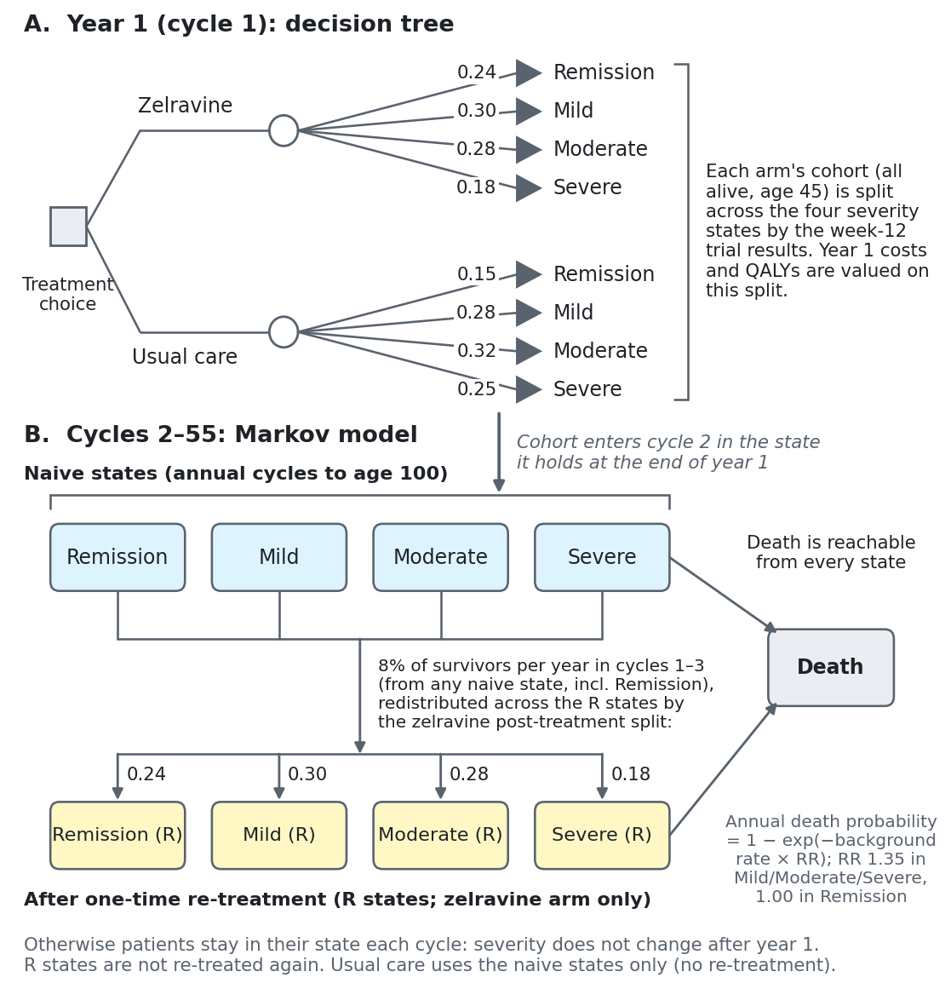
Notes: Panel A: in year 1 each arm’s cohort is split across the four severity states using the week-12 trial proportions (probabilities on the branches). Panel B: from cycle 2 the cohort moves through annual cycles. In the zelravine arm, 8% of survivors per year in cycles 1–3 are re-treated once and are redistributed across the four post-re-treatment (R) states in proportion to the zelravine post-treatment split, regardless of the severity state they left. Death can occur from every state.

2.4 Key Structural Assumptions
Several simplifying assumptions govern the model. Severity does not fluctuate after year 1; the only movement between states is re-treatment and death. Re-treatment is available once per patient, in cycles 1 to 3 only, at the same annual probability regardless of severity. Patients in Remission have the general-population mortality rate; patients in Mild, Moderate and Severe states (naive or re-treated) have that rate multiplied by a relative risk of 1.35. There is no treatment-related mortality. The initial course cost is applied to every zelravine patient in cycle 1, and the re-treatment course cost is applied when a patient enters an R state. Usual care patients incur health-state costs only.

2.5 Calculation Conventions
The following rules are needed to reproduce the results. Timing. Cycle 1 occupancy equals the arm’s post-treatment distribution (all patients alive, age 45). Transitions from cycle t to t+1 use the age at the start of cycle t (45 + t − 1). Outcomes. Life years are the sum over cycles of alive occupancy × discount factor; QALYs use occupancy × utility × discount factor; state costs use occupancy × annual state cost × discount factor (cycle length 1 year). The discount factor for cycle t is 1/(1.03)^{t−1}. Mortality. The annual death probability is 1 − exp(−rate), where the rate is the general-population all-cause crude rate for the age (Appendix B), multiplied by 1.35 in Mild, Moderate and Severe states. Ages 85 and over use the pooled 85+ rate. Re-treatment. Patients who die in a cycle are removed before re-treatment is applied; re-treatment flows enter the R states at the start of the next cycle and their cost is discounted at the entry cycle. Distributions. Post-treatment proportions sum to 1.

3. Model Parameters

3.1 Severity Distributions
The severity distribution at the end of the 12-week treatment period determines the proportion of each cohort in each naive state at cycle 1. These proportions were derived from the pivotal trial. The baseline (pre-treatment) distribution is used only in the year-1 scenario analysis. Table 3.1 also gives the whole-person counts used to parameterise the Dirichlet distributions in the probabilistic analysis (largest-remainder rounding, so each group’s counts sum to its sample size).
Table 3.1. Severity distribution: proportion (Dirichlet count)
Severity state | Zelravine (n=58) | Usual care (n=55) | Baseline (n=113)
Remission | 0.24 (14) | 0.15 (8) | 0.00 (0)
Mild | 0.30 (17) | 0.28 (15) | 0.12 (14)
Moderate | 0.28 (16) | 0.32 (18) | 0.46 (52)
Severe | 0.18 (11) | 0.25 (14) | 0.42 (47)
PSA distribution: Dirichlet, with alpha equal to the counts shown (a zero count fixes that component at 0).

3.2 Health State Utilities
Utility values are expressed on the EQ-5D scale, estimated from trial EQ-5D-5L data by severity state. Each health state’s utility is applied to its occupancy for the full cycle; R states carry the same utility as the corresponding naive state.
Table 3.2. Health state utilities
Health state | Utility | 95% interval
Remission | 0.88 | 0.82 – 0.93
Mild | 0.79 | 0.73 – 0.85
Moderate | 0.66 | 0.60 – 0.72
Severe | 0.48 | 0.36 – 0.60
Death | 0.00 | —
PSA distribution: Utility (1 minus Gamma on disutility; SE = (upper − lower) / 3.92).

3.3 Costs
All costs are expressed in 2024 US dollars. State costs represent the direct medical costs of managing a patient in each health state, excluding the zelravine course, and were estimated from a claims analysis. Cycle length is one year, so annual costs are applied per cycle without conversion.
Table 3.3a. Treatment course costs
Item | Cost
Zelravine initial course (drug and monitoring) | $60,000
Zelravine re-treatment course | $38,000
Usual care | $0
PSA distribution: Fixed. The initial course is applied to all zelravine patients in cycle 1 (undiscounted); the re-treatment course is applied on entry to an R state.
Table 3.3b. Annual health state costs
Health state | Annual state cost | 95% interval
Remission | $3,100 | $2,200 – $4,000
Mild | $5,200 | $3,600 – $6,800
Moderate | $7,400 | $5,200 – $9,600
Severe | $10,800 | $7,500 – $14,100
PSA distribution: Gamma (SE = (upper − lower) / 3.92).

3.4 Mortality and Re-treatment
General-population mortality is taken from CDC WONDER (Underlying Cause of Death 1999–2020, year 2020), all-cause crude rates by single year of age (Appendix B). The relative risk of death for symptomatic states was derived from an observational cohort.
Table 3.4. Mortality and re-treatment inputs
Input | Value | Note
Mortality RR, Mild / Moderate / Severe | 1.35 (95% CI 1.10 – 1.65) | Applies to naive and R states
Mortality RR, Remission | 1.00 | General-population rate
Re-treatment probability | 8% per year | Cycles 1–3 only; zelravine arm; once per patient; all alive naive states
Start age / terminal age | 45 / 100 years | Same for both arms; 55 cycles
PSA distribution: mortality RR log-normal (log-scale SE = (ln 1.65 − ln 1.10) / 3.92 = 0.1034); re-treatment probability Fixed.

4. Base Case Results

4.1 Deterministic Analysis
Table 4.1 presents the total discounted costs, life years, and QALYs for each strategy over the lifetime horizon. Zelravine adds a small number of life years because fewer patients are in the symptomatic states that carry excess mortality.
Table 4.1. Deterministic base case results
Treatment | Total Cost | Total LYs | Total QALYs
Usual care | $141,524 | 20.3459 | 13.9586
Zelravine | $196,234 | 20.4497 | 14.7556
Table 4.2. Cost breakdown (discounted)
Cost component | Usual care | Zelravine
Zelravine courses (initial + re-treatment) | $0 | $67,877
of which re-treatment | $0 | $7,877 (0.219 per patient)
Health-state costs | $141,524 | $128,357
Total | $141,524 | $196,234
Undiscounted life expectancy from age 45: usual care 32.70 years; zelravine 32.97 years.

4.2 Cost-Effectiveness Frontier
Neither strategy is dominated: zelravine is more costly and more effective than usual care. Table 4.3 presents the incremental analysis. Zelravine costs $54,710 more per patient, of which $67,877 is course cost partly offset by $13,167 lower health-state costs, and gains 0.7970 QALYs, giving an ICER of $68,644 per QALY gained.
Table 4.3. Deterministic cost-effectiveness frontier
Treatment | Total Cost | Total QALYs | Inc. Cost | Inc. QALY | Seq. ICER | Status
Usual care | $141,524 | 13.9586 | — | — | — | Reference
Zelravine | $196,234 | 14.7556 | $54,710 | 0.7970 | $68,644 | Frontier
At a willingness-to-pay threshold of $100,000 per QALY, zelravine is cost-effective because its ICER ($68,644/QALY) falls below the threshold.

4.3 Year-1 Scenario Analysis
The base case values all of year 1 on the post-treatment distribution. In the scenario, the first w weeks of year 1 are valued on the baseline distribution and the remaining weeks on the post-treatment distribution (costs and QALYs only; mortality, transitions and life years are unchanged). The ICER is not materially affected.
Table 4.4. Year-1 scenario analysis
Switch week w | Usual care cost / QALY | Zelravine cost / QALY | ICER
0 (base case) | $141,524 / 13.9586 | $196,234 / 14.7556 | $68,644
6 | $141,706 / 13.9488 | $196,493 / 14.7418 | $69,091
12 | $141,888 / 13.9391 | $196,752 / 14.7280 | $69,543
26 | $142,312 / 13.9164 | $197,356 / 14.6959 | $70,614
52 (whole year at baseline) | $143,099 / 13.8742 | $198,478 / 14.6362 | $72,675

4.4 Probabilistic Sensitivity Analysis
Probabilistic sensitivity analysis (PSA) was conducted with 1,000 Monte Carlo iterations (seed 2024). All uncertain parameters (Appendix A) were sampled simultaneously, with both arms evaluated on the same draw. Table 4.5 presents the PSA mean results, which closely approximate the deterministic base case (within 0.5%), confirming the stability of the model.
Table 4.5. PSA mean results
Treatment | Mean Cost | Mean QALYs
Usual care | $141,969 | 13.9218
Zelravine | $196,919 | 14.7113
The probabilistic frontier is consistent with the deterministic analysis.
Table 4.6. Probabilistic cost-effectiveness frontier
Treatment | Total Cost | Total QALYs | Inc. Cost | Inc. QALY | Seq. ICER | Status
Usual care | $141,969 | 13.9218 | — | — | — | Reference
Zelravine | $196,919 | 14.7113 | $54,951 | 0.7895 | $69,601 | Frontier
The 95% interval for incremental cost is $34,927 to $74,748 and for incremental QALYs is -0.40 to 2.08. The probability that zelravine is cost-effective is 35% at $50,000, 63% at $100,000, and 74% at $150,000 per QALY (Figure 4.2).
Figure 4.1. Incremental cost-effectiveness plane
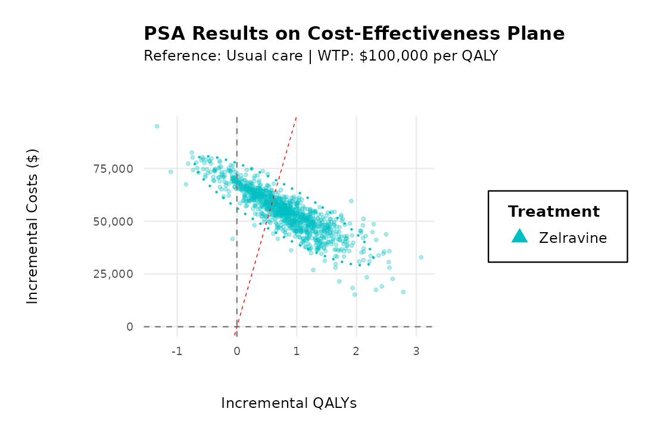
Notes: Each point is one of 1,000 PSA iterations (zelravine versus usual care). The dashed line marks a willingness-to-pay threshold of $100,000 per QALY; the dotted ellipse is the 95% confidence region.
Figure 4.2. Cost-effectiveness acceptability curve
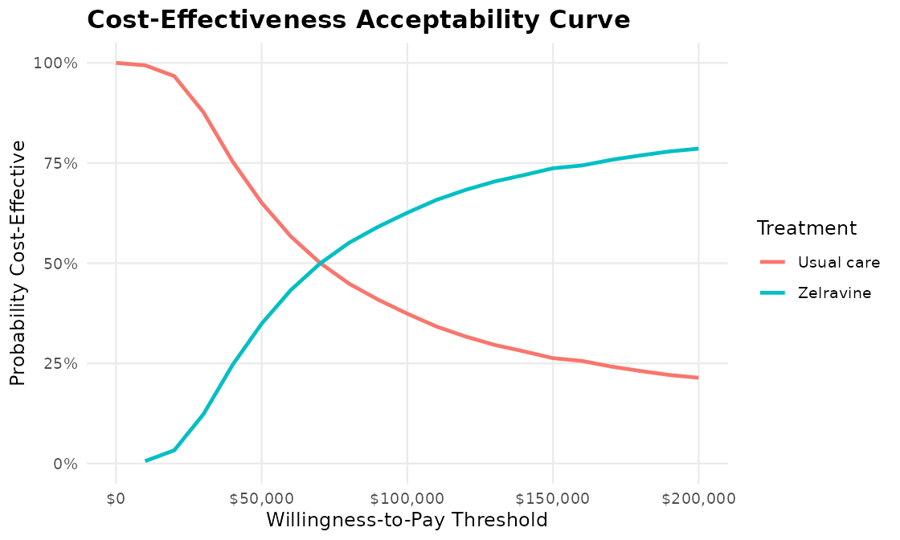
Notes: Probability that each strategy has the highest net monetary benefit at willingness-to-pay thresholds from $0 to $200,000 per QALY. Independent utility draws violated the Remission > Mild > Moderate > Severe ordering in 1.9% of iterations and were not constrained.

5. Discussion
This analysis suggests that a single course of zelravine offers a clinically meaningful QALY gain over usual care (0.80 QALYs per patient over a lifetime) at an incremental cost of about $54,700. The gain is driven mainly by patients moving from Moderate and Severe states into Remission and Mild states, which carry higher utility, lower state costs and lower mortality. Health-state savings of about $13,200 offset roughly one fifth of the $67,900 course cost (initial course plus expected re-treatment).
The ICER of $68,600 per QALY falls below a $100,000 threshold in the deterministic analysis, and zelravine was cost-effective in 63% of probabilistic iterations at that threshold, but only 35% at $50,000. The result is sensitive to uncertainty in the trial-derived severity distributions: the 95% interval for incremental QALYs includes zero. The year-1 valuation convention has a smaller effect, moving the ICER between $68,600 and $72,700.

5.1 Limitations
Several limitations should be considered when interpreting these results. Severity distributions come from a single 12-week trial with 113 participants and are extrapolated over a lifetime with no further severity transitions, which may understate natural fluctuation and any waning of treatment effect. The mortality relative risk comes from observational data. The re-treatment rate is applied to all alive patients regardless of severity. Utilities are sampled independently in the PSA, so some draws violate the expected ordering of states. Indirect costs and caregiver burden are excluded, consistent with the payer perspective. Finally, all parameter values used in this analysis are assumed for illustrative purposes and do not represent actual clinical trial data.

Appendix A. PSA Specification
Parameter | Base value | Distribution and parameters
Severity proportions (each arm and baseline) | Table 3.1 | Dirichlet, alpha = whole-person counts in Table 3.1
Mortality RR (symptomatic states) | 1.35 | Log-normal; log-scale SE 0.1034
Utilities (4 states) | Table 3.2 | 1 − Gamma(1 − mean, SE); SE = (upper − lower) / 3.92
State costs (4 states) | Table 3.3b | Gamma(mean, SE); SE = (upper − lower) / 3.92
Re-treatment probability | 0.08 | Fixed
Initial and re-treatment course costs | $60,000 / $38,000 | Fixed
Gamma: shape = mean² / SE², scale = SE² / mean. Utility draws are 1 minus a Gamma draw with mean (1 − utility). Dirichlet draws are normalised Gamma(alpha) draws.

Appendix B. General-Population All-Cause Mortality
CDC WONDER, Underlying Cause of Death 1999–2020, year 2020. Crude rate per 100,000, both sexes, single year of age; ages 85 and over use the pooled 85+ rate. Ages 45–100 are shown (the model uses the age at the start of each cycle, 45 to 99).
Age | Rate | Age | Rate | Age | Rate | Age | Rate | Age | Rate
45 | 322.0 | 57 | 844.8 | 69 | 1,959.6 | 81 | 5,951.0 | 93 | 15,210.9
46 | 350.9 | 58 | 911.2 | 70 | 2,107.7 | 82 | 6,567.7 | 94 | 15,210.9
47 | 380.8 | 59 | 991.7 | 71 | 2,310.7 | 83 | 7,362.9 | 95 | 15,210.9
48 | 412.6 | 60 | 1,059.1 | 72 | 2,522.3 | 84 | 8,186.1 | 96 | 15,210.9
49 | 441.0 | 61 | 1,161.1 | 73 | 2,648.1 | 85 | 15,210.9 | 97 | 15,210.9
50 | 467.7 | 62 | 1,231.3 | 74 | 3,127.6 | 86 | 15,210.9 | 98 | 15,210.9
51 | 514.6 | 63 | 1,334.7 | 75 | 3,254.0 | 87 | 15,210.9 | 99 | 15,210.9
52 | 562.3 | 64 | 1,419.9 | 76 | 3,665.9 | 88 | 15,210.9 | 100 | 15,210.9
53 | 608.6 | 65 | 1,488.9 | 77 | 3,973.3 | 89 | 15,210.9
54 | 666.4 | 66 | 1,610.2 | 78 | 4,459.5 | 90 | 15,210.9
55 | 713.1 | 67 | 1,717.0 | 79 | 4,879.5 | 91 | 15,210.9
56 | 778.4 | 68 | 1,845.8 | 80 | 5,348.0 | 92 | 15,210.9

