Abstract

The purpose of this final master degree project was to experiment with various algorithms for speech and text alignment either with granularity of sentences, single words or even single phonemes. The output of this study was expected to find out how little data is necessary to give a proper alignment at various levels. This project focuses mainly on polish language, however it can be quite easily generalized for different languages. From so many different dialects in the world one can always find similar, like I did with polish and Russian. I also focus solely on a audio with quite low level of noise, since noise introduces a lot of problems, which are out of the scope of this project.

Contents

- Introduction
- Speech signal
  - Human factor
  - Mel scale.
  - Frequency spectrum.
  - Cepstrum
  - Sphinx frontend
- Speech modelling
  - Phonetics
  - Audio distances
  - Gaussian models
  - EM algorithm
  - Hidden Markov Model
  - Baum-Welch algorithm
- Simple pause and length alignment.
  - Speech detection
  - Text split
  - Estimating time.
  - Alignment
  - Results
- Word alignment based on similar audio model.
  - Speech recognition.
  - Differences between Russian, Polish and English phonology.
  - Grapheme to phoneme conversion grammar.
  - Alignment using audio model.
- Phoneme alignment.
  - Using foreign audio model.
  - Training phoneme distribution using word alignment.
  - Phoneme alignment with trained Gaussian distribution.
  - Results
- Training audio from large audio files
  - Using imperfect large chunk alignment as training database.
  - Word alignment with imperfect model.
  - Results
  - Conclusions
- Testing alignment with synthesizer.
  - Synthesizing speech with phoneme alignment.
  - Testing application of synthesizer.
  - Results and conclusions.
- Summary and conclusions.
- Bibliography

1. Introduction

2. Speech Signal

  - Human factor

Speech is a most efficient way the human communicate. For generations this process was refined by evolution, so we can easily exchange messages even in hard situations. For this purpose our vocal mechanisms must well cooperate with our hearing ability. There is a certain set of sounds we can produce, so our ears evolved to hear them as well as possible.

What is sound? According to dictionary: „Vibrations transmitted through an elastic solid or liquid or gas, with frequencies in the approximate range of 20 to 20000 hertz, capable of being detected by human organs of hearing”. [1]

How do we hear? Human ear consist about 30000 hair-cells, which can convert mechanical wave of the sound into electromagnetic wave inside auditory nerves [2].
Each of these cell is excited by different frequency of mechanical wave of internal ear fluids, so it is no surprise, that people can hear only a certain range of frequencies, as stated in definition. These we expect to be finely tuned to the frequencies of the sounds we can produce. Although it seems, that we can hear a bit more, but as we don't need them it happens, that as we grow older, our hearing range is getting smaller, because our hear cells fail sometimes, but mostly those responsible for high frequencies, which we don't use too often.

Humans can hear frequencies, that begins as low as 12Hz (under laboratory conditions) to 20kHz (for adults usually much lower). However speech range is a little bit smaller than that [3]:

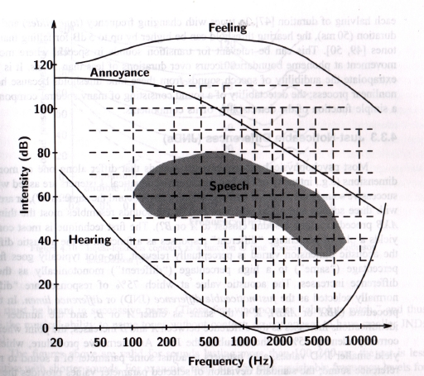

2.2. 2.2. Mel scale.

How we perceive sound, that is completely different matter and topic for long philosophical discussion. However we can help ourselves with some subjective experiments. For example Stevens, Volkman and Newman conducted an experiment on a number of listeners to measure, what do we perceive as equally distanced pitches. In this experiment, the participants of the experiment were asked to judge if given pitches were in equal distances. The output was, that humans don't experience sound linearly to the frequency scale, but a perceptual scale was closer to logarithmic one. [5]

Certain formulas were conceived to translate frequency scale to some, that is closer to how human actually perceive sound.

One popular is mel scale, where mel comes from melody: [6]

What looks like that:

Another popular formula of so called bark scale, which is based on perception of loudness of the sound and proposed by Eberhard Zwicker in 1961. [7]

In this project we use mel scale implemented in sphinx library, although bark scale is becoming more popular recently.

2.3. Frequency spectrum.

The conclusion from the anatomy of human ear is, that frequencies of the sound are important.
How can we obtain frequency spectrum from a digitized sound, so we can process this further?

The obvious tool for conversion of discrete function to frequencies is Discrete Fourier Transform.
Named after Jean Baptiste Joseph Fourier it is one of the most often used techniques of modern times.

It all starts from the postulate, that a heat equation can be satisfied by function of form: [11]

or in complex form:

Basically we convert our function's domain to frequency domain or to domain of sinusoidal functions. coefficients are complex values that encode bother amplitude and phase of the converted signal/function at each frequency.

The coefficients for any integrable functions over an interval can be obtain using formula: [11]

or for the discrete case:

So far we haven't found any use in the speech recognition for phase part of the coefficients, however amplitude determins how powerful is signal at given frequncy. The power value is given by:

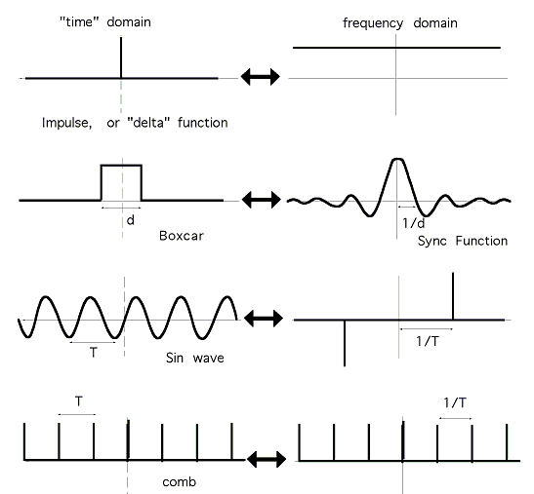
A sample conversion:

What size of the window should we use? First we have to notice, that in order to capture certain frequency, the window needs to be large enough. We would like to examine signals of frequency ranged from 100Hz (see speech frequencies ranges in chapter 2.1), which is a period of 100th of the second, so a 10millisecond window would be our bottom limit.

Also windows with abrupt signal discontinuities may cause result with spectral artefacts, so a windowing function is usually applied. Popular choice is a Hamming window function: [8]

Which plot is:
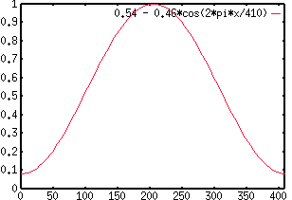

Note that it emphasises values in the middle of the window, so our actual windows should overlap to cover whole time domain. For example by shifting a window by a percentage of it actual width:

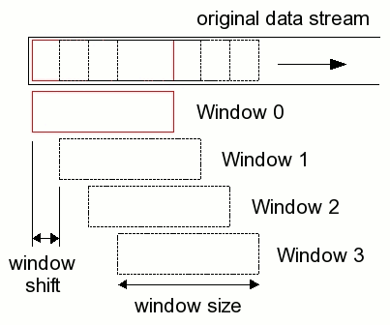

A human speech signal in frequency and time domain: [3]
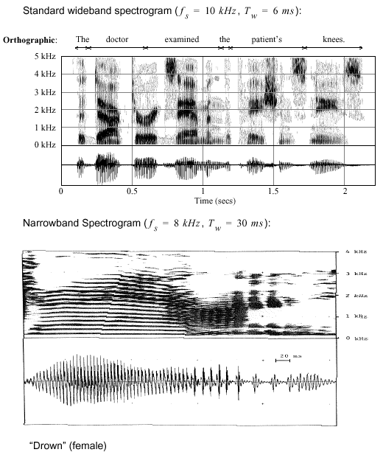

2.4. Cepstrum.

Looking at the frequency spectrum of human speech we see, that the signal in the frequency domain contain features that are quite periodic. As it is with converting initial signal with DFT, we would like to extract the information of periodicity in the spectrum.
A cepstrum of the signal is gives us this additional information.

The word is derived by reordering characters in the word spectrum to indicate switch of domains, similarly as word 'quefrency'. The cepstrum operates in the domain of time and the basic intuition is, that it reveals a rate of change in the different spectrum bands.
For example a cepstrum of an echoed signal in the picture below shows clearly a three 'quefrencies' of the echo of the signal. [12]

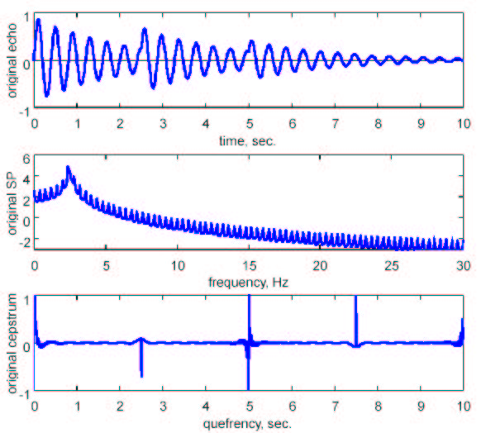
Cepstrum definition is: „Inverse Fourier transform of the logarithm of the magnitude of the Fourier transform ” or:

,or:

This is the definition of the power cepstrum, since it is calculated from the magnitude of each frequency band. However there also exists a complex, real and phase cepstrum depending on what part of initial Fourier transform it uses.
In speech related problems a power cepstrum is usually used and I haven't see any reason to not focus only on this.

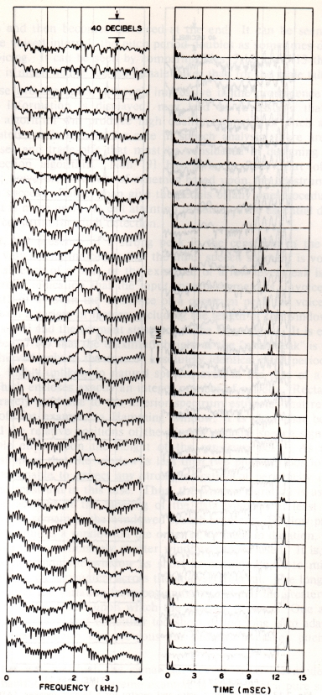
This is a typical cepstrum sequence of the vowel [3] computed every 10ms.
If the sound becomes periodic in the frequency domain it quefrency domain contains a peak which is related to the periodicity of the sound.
Note that similar results can be obtained by taking just additional DFT of the signal. Inverse Fourier Transform is closely related to Fourier Transform and also performs a split of the function into periodic components.
After all IFT is defined:
while FT is defined:

Why taking logarithm of the magnitude? It serves as a normalization of power spectrum. In speech for example it happens, that low frequency components are usually more powerful than high frequncy components and by normalizing the signal, the periodicity becomes more apparent.

A bit different way of looking at the signal cepstrum is as a homomorphic transformation which changes convolution into sum. [3]

Which on it's own can be seen as way of separating signals. In the example with echo, we could have used the cepstrum to separate echoed signal from initial signal, and for example it might be used to filter out the audio feedback.

2.5. Sphinx frontend.

Sphinx is a speech recognition toolkit with a lot of useful features for any speech related problem.
There is a certain common way to prepare a speech signal for the further processing. With slight variations in each step, the useful informations about speech are drawn from a cepstrum of the reduced signal (in the number of data dimensions), as presented in this chapter.

In order to skip the reinventing the wheel, I used the fronted part of the sphinx library for any experiment in this project. The sphinx fronted performs signal transformation and produces data composed of only 39 voice features, while actually only 13 are base ones and the rest is a derivation of these.

Sphinx frontend is a list of transformations executed on the result of the transformation placed higher in the list or stated differently a transformation composition.
This includes:
Data Blocker,
Preemphasizer,
Windower,
Discrete Fourier Transform,
Mel Frequency Filter Bank,
Discrete Cosine Transform,
Cepstral Mean Normalization,
Deltas Feature Extractor.

2.5.1. Data Blocker

This initial transformation reads incoming double data read from audio source (way or microphone) and
prepares blocks of the data to be used in later phases. In our case blocks contain 10ms of audio data.

2.5.2. Preemphasizer

The Preemphasizer applies a formula: .
The purpose of this transformation is to emphasize the high frequency components. It is kind of filter,
which allows high frequency components to pass through, but weakens the low frequency ones.

2.5.3. Raised cosine windower

Creates windows from the incoming data. A windowing function
is applied afterwards. Alpha coefficient set to 0.46 results with a mentioned before Hamming windowing
function, which is a default setting and the one used by me.

2.5.4 Discrete Fourier Transform

Implementation of fast Fourier transform .The FFT can perform this operation in ,
where N is the size of the input data.
It can be perform on whole data, however in speech we would like to get an information of the frequencies
of a small frame, that contains consistent speech signal, in particular a single phoneme.
The output data is the power spectrum of input data window and the complex/phase information is lost.
The number of FFT points is the closest power of 2 equal or larger to the number of samples in the incoming window of data. However the input signal is real, so resulting FFT is symmetric, so only half of the data is return (output size is FFT points / 2 + 1).

2.5.5. Mel frequency filter bank

This step is a part of calculating a Mel Frequency Cepstrum.

Conversion of frequency spectrum into a mel-spectrum using triangular overlapping windows defined as:

The number of triangles/filters defined the size of mel-spectrum (default in sphinx is 40).
The filters are chosen, so the result would simulate a mel-scale given by the formula:

The given filters should look similar to the picture:
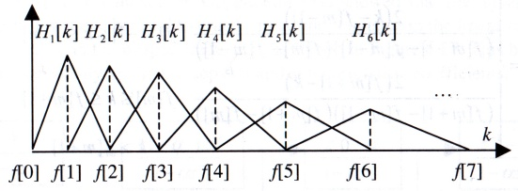

Not all frequencies are covered by the filters. The chosen range of frequencies may differ for various audio encodings, but generally should cover only the speech ranges. The default values for 16kHz are 130Hz-6800Hz and are not changed in this project.

2.5.6. Discrete Cosine Transform

Another part of calculating Mel Frequency Cepstral Coefficient vector.
It applies a logarithm and the DST type II to the input data.

A DST type II (most common) coefficients are defined as:
and it is clearly visible that quite tighly related to real part of the Fourier Transform. [18]
The transform represents a function as a sum of cosine functions and it is equivalent to the DFT operating
real data with even symmetry.
The number of dimensions returned is set by default to 13.

2.5.7. Cepstral Mean Normalization

Performs a normalization of MFCC vector by subtracting a mean of all the input. There are two versions
of this step. One that calculates mean online and the other that reads all data before performing
subtraction.

2.5.8. Deltas feature extractor

The final transformation in the sphinx frontend chain. It calculates first and second order derivative of the
cepstrum as additional features of the speech signal. It improves noticeable speech processing algorithms
by adding additional information about changes in the cepstrum data.

For the initial cepstrum data it adds additionally twice the size vector with first and second order
differences, calculated as follows:
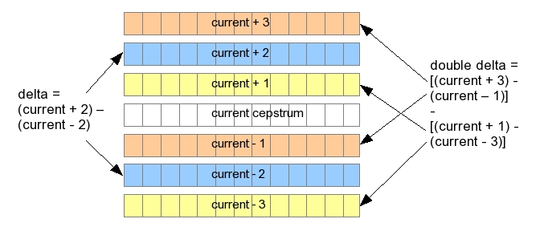

3. Speech Modelling.

  - Phones, phonemes and graphemes.

A phone is a unit of speech sound [20], while a phoneme's definition is: „The smallest contrastive linguistic unit, which may bring about a change of meaning” [21]. So the phoneme is a classification unit of phones, which allow us to represent speech while preserving its meaning.

While speech is being modelled using phonemes the graphical part of the language in form of text is modelled with characters or graphemes.

Language grapheme set usually differs quite substantially from it audio counterparts. Often it contains more characters than needed to represent every word from given language and at the same time it is much too small to represent all the nuances of human speech. What is more problematic, the word graphic representation often has very little to do with actual phones of the word. There are homographes, that are written the same yet it pronunciation differs („zamarzać” from „marznąć” and „morzyć”) or homophones look differently, but are pronounced similar („może”, „morze”). In polish though, the former is quite rare and this fact is actually used by me (chapter 5.3).

However actual phones that are classified under single phoneme create quite a substantial family. Different variants of a phoneme are called allophones. For example /l/ in English „leap” and „deal” or polish soundles allophones (/ł/ in „umysł” might be soundless contrary to „ławka”) or allophones of vowels between soft consonants (/a/ in „jajko”). [22]

The phonemes can differ quite substantially depending of the surrounding phones. For example soft versions of almost each phoneme in polish when surrounded by softening one (/i/ and /j/). Consecutive phones are not necessarily separated by clearly visible moment, where neither one is spoken. Often one phone is converting slowly into another. To model such a transitions a diphones or triphones are modelled for each sequence of two or three phones.

Phonemes are very important in the computational language modelling, either in speech recognition or alignment. The importance is derived directly from its definition. It is a unit of speech, which if changed, may change the meaning. This is the unit, that need to be modelled if we want to recognize and/or distinguish different words. Finer granularity of model is necessary only to make a better prediction where an observed phone belongs.

Some of English phonemes and example phones:
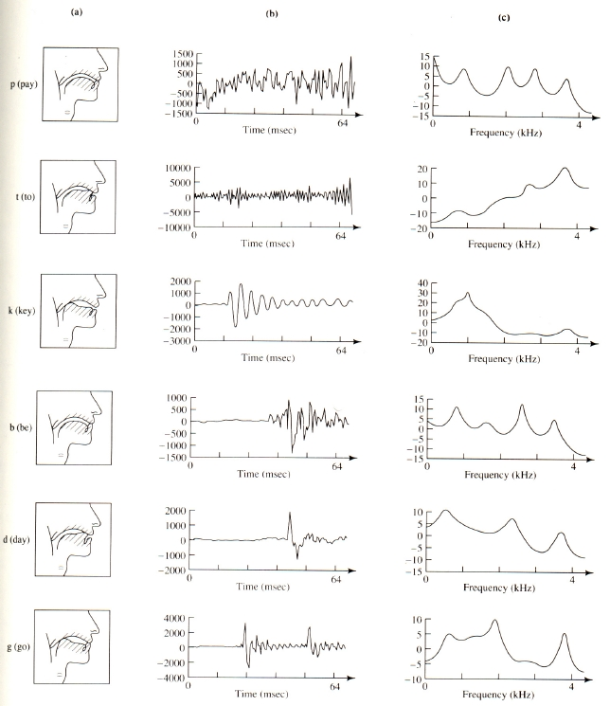

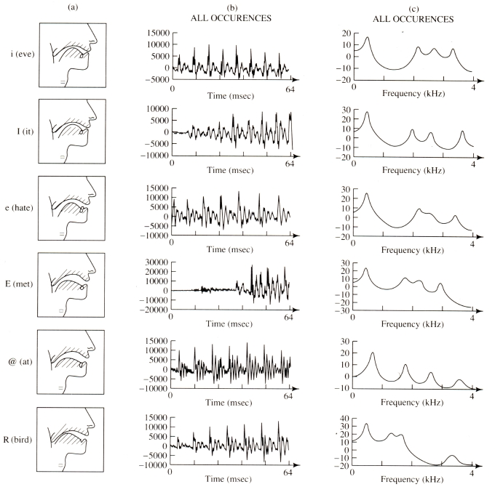

  - Audio distances.

The simplest way to find similar audio sequence is to find a sequence which is nearby to other, that we know it represents a certain sound, phoneme or word.

There are different norms we could use here:, where
and they are all fine for uncorrelated vectors, which is not really our case.

For correlated cases, we could try to introduce some weighting factor inside.
What factor can we use?
One approach is to tune the factors using external methods, which theoretically may give us some additional benefit of properly modelling phonemes we try to measure distance from, however this is a bit out of the scope of this chapter and most probably would in the end look similar to a different method.
A simpler approach would be to calculate correlations and use them in a distance measure.
We would like to have a correlation matrix (Р) and than our distance would be:

Karl Pearson introduced such an idea [23] in form of correlation coefficient defined between two random populations:
and in the form of matrices:

It should be noted, that in the denominator we have standard deviations which don't really bring any value to our measure, since this is a constant factor.
By removing them we obtain so called Mahalanobis distance [16]:

If we knew elements belonging to given phoneme, we could calculate a distance from a phoneme.

I conducted couple of experiments with different distances by having an flawed alignment with larger chunks I tried to and based on:
  - find the same word, that is quite lengthy and occurs multiple times just by searching for similar sequences,
  - find a given sequence of three phonemes in a text based on estimated location (by time)
Mahalanobis distance in those experiments where not expected to give any results, since there were conducted without knowledge of phone classification and even then the expectations where not met.

The euclidean norm were performing the best and it actually was able to find around 50% of a starting phonemes while other found were quite similar (80% of time is contain two out of three). Although I was lucky, that in my testing speech, that starting three phonemes occurred later in text quite far from each other.

Searching for whole word didn't give me any satisfying results. I could find a similar word when I pointed which it should have matched, but normally it always found a sequence which weren't similar at all (from a speech point of view) and the matching words were far in the list.

  - Gaussian Model.

Given observation points belonging to a single class (phoneme) with a given probability, we would like to model a distribution of emitting data point of the class.

A natural choice is a normal distribution, although we have to remember, that observation is a comes from multidimensional universum where populations are not independent.
Luckily there is a definition of multivariate normal distribution, that considers correlations:

where is a covariance matrix is its determinant.

Covariance matrix is always symmetric and positive-semidefinitive.
Symmetry comes directly from a definition: and outer product of one vector gives a symmetric matrix. Positive-semidefinitive matrix is a matrix, where a product

It is also equal to:
and each element of the sum is square of inner product of two vectors, so it is always positive (or equal to zero).
In order to prevent degenerate cases we can allow only positive-definite matrices, which are guaranteed to be invertible.

If the number of dimensions is equal to one, then the formula reduces to single-variable normal distribution:

To calculate a distribution of emitting signal frame, we first need to calculate a mean vector and a covariance matrix.
Given are a list of observation with assigned probability. If probability is actually a likelihood of emitting the signal (or it estimation),
than we can calculate mean with a formula:
and a covariance matrix from a formula:

In the case, that probability is not a direct likelihood of given point, but a conditional probability of emitting the signal given, i.e. that it belongs to given sequence, we would have to normalize the result.
We can assume, that conditional probability is the same for each observation,
so ,
then given formulas have to be divided by a total sum to produce actual likelihood:
,
since the denominator should sum to 1, after all it is a probability of emitting given point under a condition, that only number of points were emitted.

  - EM algorithm

Expected-Maximization method is a technique for estimating parameters of any underlying or given distribution based on observed data. It tries to maximize the likelihood, that the data would be observed by the distribution:

For certain distribution parameters, that maximize likelihood of the data, can be solved, i.e. calculated mean vector and variance are parameters to normal distribution, that do maximize the likelihood of observing the observation data.
We can calculate a derivative of normal density function to show it:

what is a definition of a mean,

what is a definition of variance and standard deviation is a square root of variance.
And similarly can be done for many other distributions, including multivariate normal distribution.

It is not always the case, that one can calculate parameters so easily, i.e. mixture models of several populations may not give so easily.
Let's consider a mixture of Gaussian models of some populations. We have a random population, where each point is randomly drawn from each distribution.
So the total likelihood of any point is: , where is a probability of drawing a point from ith distribution and is a density function of ith model.

Since each model from a mixture is easily solvable, if we knew to which model each point belonged, than estimating parameters would be easy, or at least what is the probability, that given point was drawn from a given class (see chapter about Gaussian model).

On the other hand it would be simple to calculate a probability, that given point was drawn from given distribution if we knew all the parameters.

The Expected-Maximization technique deals with this problem, by finding better estimation of parameters using previous estimation, and thus by iterating over series of converging estimates it is guaranteed to find some local maximum.

, here is an unknown data, which can be estimated using , and when known, then can be found, that maximizes log likelihood of observing and random variables.

Thus the EM algorithm contains two steps in single iteration: expectation step and maximization step.
During E step, we find data given previous estimate of .
During M step, we calculate, that maximizes likelihood of observed data and expected hidden data.
In each iteration a likelihood converges to some local maximum.
We are happy with only local maximum, because the problem resists to be solved.

For example with mixture model:
In E step we calculate a probability, that a observation is drawn from each class.
In M step we use this probabilities to calculate a new parameters (), that maximize likelihood of our observed data, as well as a estimated probability of data classification.

  - Hidden Markov Model

We can describe a HMM by a triple: ,
where A is a transition matrix ,
B is a observation probability function vector , where each is a function, that calculates a probability that a given observation is produced by state i, and is an initial state distribution

For our purpose a B functions will be a Gaussian multivariate distribution of given state.

The most probable state sequence for given sequence of observations can be calculated using dynamic programming (i.e. Viterbi algorithm).

At the end of k-th iteration we keep a vector of probabilities P of being at state i after observing k points.
We initiate this vector with initial probabilities .

The is calculated as follows: ,
where is a probability of transition from state j to state i, and is probability, that state i emitted (k+1)-th observation.

At the end a maximum probability from elements of gives us a the maximum likelihood of observing given sequence.

To find a sequence we can keep a state for which a maximum was produced for each time k and state i and recreate the state path, which produced the maximum likelihood.

  - Baum Welch algorithm

For training Hidden Markov Models we have to use a generalized version of EM algorithm, namely Baum-Welch algorithm.

For HMM training we have observed data X and we want to find parameters set θ, which will maximize the probability of observing X, meaning: .

If we knew what was the sequence of states in the HMM, we would be able to calculate optimal value of θ parameters. However we don't know, what the states of HMM were, hence hidden in the name. On the other hand if we knew θ, then we would easily calculate sequence of states, which would maximize the probability (i.e. using Viterbi algorithm).

EM algorithm is meant for such a situations.

In the EM spirit, for each iteration we will perform two steps, bringing us to some local maximum:
  - expectation step
Given previous estimation of parameters θ, we calculate the probability of being at any given time t at any states Pr(s_i, t)
  - maximization
Given probabilities of being at any state, we calculate next estimation of θ parameters, which will maximize the likelihood of observing X: .

How can we calculate θ parameters?
θ = {A, B}, where:
A – transition probabilities (probability of transition between any two states)
B – observation probabilities (probability of observing any data at any given time)

To calculate observation probabilities, we need:

Both of these values can be calculated using dynamic programming. One is calculated by Viterbi's algorithm in forward passage, the other can be calculated in similar manner by backward passage.

Combining these values, we can obtain:

and:

While probability of transition from states i to state j at any given time is:

While just a probability of being at time t at state i can be used to calculated new probabilities of observing (observation at time t) from given state, since it is emitted by state i with probability of being at this state at this time.

New parameters of multivariate normal distribution would be:

4. Simple pause and length based alignment

The basic idea behind this approach is to match sentences with continuous sequence of speech.
Humans rarely make pauses inside a sub-sentence and rarely continue to another sentence without a pause.
One simple approach to the alignment problem which uses this fact is to try to match part of speech with a text which would take a similar time to say it.

  - Speech Detection

Before we can continue with alignment, we need to detect pauses first. Dual problem to the one is a problem of detecting speeches.

On its own in various environments the problem is quite hard, however we don't want to consider situations where extracting speech from background is too difficult. It is true, that humans are quite proficient at extracting speech from quite challenging situations like recognizing words of the song, or distinguishing speakers in a crowd.
However even humans are not perfect, and are often prone for errors. Recognizing song lyrics is not always an easy task, and it remains an open question how much you can attribute the difficulty of this to the background music, how much to changed modulation of singer voice and how much to overabundance of signal in melody scale.
On the other hand, humans can hear voices in white noise, or in the sounds of nature. Sound hallucinations are the most common among all. It's an easy test, where you try to hear something, when it is not there, but after couple of minutes, you'll start to imagine things. People are sometimes overfit to hear speech.

We leave this problematic cases and focus only on situations where noise to signal ratio is low and we can utilize statistics to detect speech.

Our signal contains speech and silence parts and we assume an environment where speech volume is clearly larger than silence/noise volume. Obviously it may also contain non-speech parts which are similar to actual speech, like i.e. inhales or other sounds that talking people can make during speech intervals. At this point I don't care about them and leave dealing with them to other approaches.
This is preprocessing of the speech signal required by every single approach to either speech recognition or alignment.
Nevertheless I'll show later, that it actually can be used to extract some alignment information after all.

Speech parts are loud and silence is well, silent, almost at least. If we knew some threshold value, that split a background noise from the speech, than algorithm of detecting the speech would be to find those parts that are consistently louder then the threshold.

The only problem is to find a threshold and to deal with consistency of being above it, since small peak can always happen in the background.
One should choose wisely how to deal with it, since in theory it is possible to figure out even small pauses in the speech signal, like i.e. between syllables. I found out, that on one hand it is quite difficult to find those pauses and at the same time not ignore endings of the sentences, which often are slowly fading to silence (because speaker lacks a breath). On another for alignment using length estimations it didn't improve algorithm, because it produce to fine granularity and this algorithm works better when the chunks of signal are bigger, so there's a greater chance they align with punctuation marks at the text.

In the speech recognition systems a detection algorithms have to process the incoming data in an online fashion. Sphinx library implements Bent-Schmidt-Nielsen algorithm, which calculates background noise level and current average signal online, meaning it is update with each incoming frame.
Generally when signal average level from an input window (see 2.5) is larger than a signal threshold (given) and background average, than the window is classified as a speech.

And background average is updated.

I found this algorithm to be to volatile at the beginning of the recording and way to easy to stop a the middle of the longer sentence. I really needed an offline algorithm, which could detect quite reliably longer pauses, which are better aligned with punctuation marks.

Firstly my algorithm worked with a spectrum of a given window. It processed the same window, but a volume was calculated as a sum of magnitudes of all frequencies. On it's own it doesn't give me additional gain, but I also experimented with different transformations of frequency spectrum:
- i.e. weighting frequencies depending on distance from normal distribution, what in theory should favour these bands, that are responsible for speech signal,
- applying logarithm or square root, to check how different band contribute to speech signal, by normalizing the power of each frequency
- counting how many times a magnitude of frequency exceeds an average value of a background
Distance from a normal distribution actually found out, that lower frequencies have more irregular histogram, which agrees with consensus, that most important speech data are located at lower frequency bands.
I also found out, that by increasing magnitude differences in favour of lower frequencies gave me better results, then decreasing them, what also agrees with above.

Anyway after mingling with above ideas, my best working solution is to calculate average for the whole frequency spectrum (not only power), without any transformation to initial values (except for sphinx's preemphasizer transformation).
Next step is to calculate background averages from the frame considered background, which is all frames where each frequency power is below average, so all frames for which below formula is equal 0

For all these frame a background average is calculated.
A frame is considered a speech frame if all frequency magnitudes are above a background average.

These is not enough though, because there are often frames inside a speech, which are quite low on volume. These are pauses between phonemes, or some frames of quiet talking (at the end of sentence usually), which didn't not passed the above filter.
However it is enough to find all interesting parts, but the granularity is to big for my purposes.

To deal with great granularity I marked all the frames, which didn't pass through filter, but where surrounded by frames, that did, as a speech as well.
The reason for that, is to remove all the short pauses, because they don't have value for pause based alignment and might even be an actual speech. My choice was to mark as a speech all pauses that were shorter than 300ms.

Theoretically filling holes is similar way to just calculating average volume of couple of frames, which introduces a certain inertia for pauses or speeches, but at this point I need just a proper longer pause detection with abrupt endings as quickly as speech starts/ends. Although I must admit, that a certain inaccuracies are not so important for the paused based alignment, if only because these algorithm is quite inefficient and produces only approximated results.

  - Text to sentences split

Before we can continue with alignment, we still would like to have text split to sentences. It is necessary to have a certain knowledge about punctuation in a given language.
Many modern languages use similar punctuation symbols for marking sentence or sub-sentences,
but we still need to know a given language alphabet.

This part is very simple. We treat all the alphabets characters as a part of speech, while every other character as punctuation mark, which separates parts of the text, and which may result with a pause in a recording. Resulting chunks are those, that contain only characters from alphabet and blanks.

Couple of details are to be dealt with. Not only alphanumeric characters make a word, i.e. a `'` is also a character, that must be treated as part of speech character at this point, although later on it may not be.

Another is that, a sequence of white character might also be a separation. A title for example might not be separated by a dot mark, but only be a series of line breaks. Generally more than one line break is considered a pause indicator.

  - Estimating time

We want to match a given sequence of speeches in a form of time intervals to sentences in a form of word list.

Given:
– time intervals
– sequence of list of words

First we need create a method for estimating time, that it takes to speak a given sentences or any chunk of text.

A simple approach to this problem is to estimate a time to say a single character and use it to estimate time for whole sentence.

Although I added additional factor, which is an estimation of how much time would take on average to say a single word from a text:

The actual estimation of text chunk is combination of above values in ratio:

The values above are derived from purely empirical observations and tweaked without further testing.

  - Alignment

We would like to minimize the difference of the estimated time and a speech time:

This problem is easily solvable with dynamic programming.

We iterate over speeches.
At k-th iteration a vector of partial results are kept. The i-th element of vector contains a result of matching first k speeches and first i sentences.

Initial values of the vector is matching of first speech part with first i chunks:

Next values are calculated based on the previous results:

Sum of estimated of text chunks would be quite consuming to calculate at each iteration, but it can be precomputed.
Additionally a zero match was added as a way of skipping speech completely, as a way to add a speech to a text chunk from previous iteration. Note however, that it won't produce a result, where everything is matched to everything (what theoretically would give a result 0), because each iteration contributes to the score separately, so the previous adds a difference of matching speech (k-1)th and a certain number of chunks, and the skipping speech, will also produce a difference in a form of squared time of the speech.
It does improve the algorithm though, because of some short speech leftovers, which actually are part of previously matched sentence.

At the end we have a best time difference of the matching. To recreate a matching, one could iterate backwards over partial values, or as I did it, to store separately, when calculating values, indexes of previous results, that maximize the current ones.
At end I traverse back through these indexes to produce a matching. Empty matching is considered to be merged with previous matching (i.e. two speeches ↔ text chunks).

From results labels are produced for given time interval with a merged text of the matched chunks.

Small amendment was added to time difference calculation, to favour alignment of small chunks,
by multiplying times by a constant factor greater than 1.

The reasons are:
- small chunks are often better defined, there are shouts, commands, remarks etc. and are clearly distinguish in both text and speech
- are rare and are surrounded by bigger neighbour and because of that, they may behave as additional anchors
- small parts are better for training for other approaches, so we want them to be more correct

These algorithm could be further improved in many ways. From tweaking magic constants, using additional information to obtain some additional anchorage (like volume increase as an indicator of sentence/word start), and by realignment of larger chunks.
The problem is, that these is a blind path and it is quite certain, that outstanding results is impossible.
It might be a good idea for a starting alignment, which will be used by different methods, but at the end, we can't possibly expect too much from this method.

I also experimented with running above algorithm multiple times while removing first and last labeled speech, however these produced worse results.

4.5. Results

Results are calculated based on word alignment of better methods.

By having word labels an efficiency of above method was tested in two ways:
- for a given label find words which produce the label,
merge the word times to produce total time of the text chunk,
give some statistics about time differences
- for a given label find words that are located within the time frame
produce a chunk, which should equal to a labelled chunk
count the biggest word difference between the texts by formula below:

produce statistics about the word differences

For a testing recording of “Doktor Piotr” by Stefan Żeromski, which is 80minute long and consists 1886 sentences, the algorithm produced 503 labelled chunks.

The statistics are:
- time differences:
- there were 154 chunks which time frame where within a 0.5s difference,
- average time difference was 5.24s
- standard deviation was 5.23s
- maximum time difference was 37.9s
- word differences:

- 179 chunks had 0 difference in words
- 54 chunks where different by 1 word (missing or additional)
- 20 different by 2 words
- 94 with a difference over 10 words

The time statistics are showing a bit worse results, because word labels are more precise than chunk time frames.

The results are within expectations, after all it is very crude algorithm. It probably could be improved though, however it is hard without introducing much more knowledge about language and possibly some additional training data (i.e. time of phonemes).

5. Audio based alignment.

  - Speech recognition

Audio based alignment is simplified problem of speech recognition. Usually in speech recognition the language consist of millions of words in different conjugations, which may create much more number of sentences.

Usually speech recognition is based on trained Hidden Markov Models with Gaussian Phoneme models, although successful systems rarely rely on single state phoneme model.
As I mentioned before (3.1) there are many different allophones of single phoneme. A variations are largely attributed to surrounding they are spoken in. For example in polish there are softening phonemes 'i' and 'j', that clearly change how preceding or succeeding phonemes are realized. At some contexts it may happen that certain phoneme will lose it voice are even get silent completely, at another they will strengthened by additional voice, i.e.:
“staw płytki” → “w” loses it voice and starts to remind a phoneme “f”
“plac budowy” → “c” gains additional voice and reminds a phoneme “dz”
And almost never one can cleanly separate two consecutive phones.

In order to better model different realisations of phonemes, an audio modelling contains models of phonemes at different triphone contexts.
For every possible neighbourhood a given phoneme might appear, a separate Gaussian model is trained, for example a WSJ model from sphinx database contains 40 different phonemes and additional silence phoneme, that gives 68921 different triphones, however WSJ model contains over 110k elements, because of additional information about location within a word.

It is not over yet, because transitioning from phoneme to phoneme should be modelled somehow as well. The obvious solution is to train a triple state HMM, which will better fit the changing phone.
That triples number of states.

This huge number of different models requires a lot of training data, which is on one hand not easy to come along with, on another requires a lot of time to train with.
Training data for speech recognition is one constant problem, which have to be dealt with. The problem is amplified, by the fact, that training samples should be small and very well described. That hardly can be done manually.
Another bad news is, that a model trained on news feeds, is expected to perform poorly as a spoken address recognition software.

Once we have our audio model, than speech recognition is easy piece, isn't it?
Not really, since so many possible and similar words make it hard problem. Rarely a speech recognition software is based solely on audio model to recognize a sequence of phonemes.
Problem is, that the number of states is too huge in order to be processed exhaustively, even though we can use a Viterbi algorithm to find a best (most probable) sequence of states for given observation sequence and we keep states only from a present moment in time.

The sphinx library deals with this problem by searching for in a breadth first search manner, meaning that it will keep states only from a current moment. To cut on number of states to process, a priority queue is used, which keeps only best scoring ones.

And this is the part of recognition software we would like to use for the alignment problem.
The difference from here is that, we do know what text is spoken, while for recognition there is no such knowledge.
However let's dwell on this a little bit longer, so we can see what a huge simplification this is.

Let's start with a simple example by using WSJ dictionary:
phoneme sequence “W AH N”, which on it's own can be recognized as word “one” or “won” is also a prefix for 36 another different words and subsequence of total 117 different words.
There is a sequence “W AH N S EH L F”, which assigned to word “oneself”, however it may also be from the end of word “penguin” (“W AH N”) and beginning of word “cellphone” (“S EH L F”).

Sphinx library provides two ways of language modelling to deal with this problem:
  - ngrams frequencies
  - language grammar
For simple languages, like a sequence of digits or language containing one long sequence (like in case of text alignment), it is advisable to use language grammar.

For general recognition software like Apple Siri, ngrams are necessary, although I am not convinced that they haven't used a sort of grammar for typical queries.
Ngrams (in wsj only up to 3) are a way to assign a probability to word sequences. In above example it is expected, that “oneself” is more probable to occur in real word, than the later case, although obviously we can't judge, since the probability of choosing these particular word depends on a probability of whole sentence.

Anyway I think that's enough about speech recognition.
For our purposes we need “only” audio model and word to phoneme sequence dictionary, in order to efficiently align text to speech.

The question is what we can do, if we don't have an audio model for our specific language?
My solution is to try to use an audio model for similar language and see how it can perform.

  - Differences between english, russian and polish phonetics.

The sets of phonemes for any given language differ slightly between publications and they differ even more between different models. For that reason I'm not going to introduce here established phonology for any language, however I'll try to match a phoneme set used by WSJ model for English, VoxForge model for Russian, Corpora and mine for Polish.

In the table below I collected phonemes from four used sets and analysed differences, that may cause problem with representing word using given phonetics and in result may cause problems with alignment. The table is organized so the similar phonemes are next to each other. If there is not alternative in a language, than the row remains empty.

English phonemes | like in word | Russian phonemes | like in word | Corpora Polish phonemes | Used by me Polish phonemes | Like in word | Notes on similarities
AA | adopt | a | арена | a | a | dwa | The most different from this set is English „AE”, which also shows a similarity to Polish and Russian „e”
AE | act | aa | акт
AH | acute
AW | allow |  |  | a_ (ą) |  | tą | There is no such a vowel in Russian however it can be substituted with „oo l”, similar for my Polish model with „o ł”.
OW | aero
AY | bike |  |  |  |  |  | Simulated with Russian and Polish  „a j”
B | bill | b | был | b | b | być | Quite similar
 |  | bb | дебет |  |  |  | A soften version of „b”, a bit different, but Polish and English „b” also can be slightly softened
 |  | c | цвет | c | c | coś | In English it is something like „T S”
CH | jackovich | ch | девочка | ci (ć) | ć | czcić | English „CH” is actually used for slavian words containing „c”, „ć”, „cz” like phonemes. Russian „ch” is like softened Polish „cz”, so it has replace both „ć” and „cz”
 |  |  |  | cz | cz | czego
JH | just |  |  | drz |  | dżem | Simulated by „d zh” or „d ż”, English „JH” is quite similar.
 |  |  |  | dzi (dź) |  | kadź | Simulated by „d zh” or „d ź”, English „JH” must simulate this one as well, although it might be softened is not very similar.
D | dad | d | длина | d | d | duży | Except for Russian and Polish „d”, all are a bit different. „dd” is again a softened version.
 |  | dd | дитя
DH | they |  |  |  |  |  | No counterparts, something between „d” and „z”.
 |  |  |  | e_ (ę) |  | sęk | Like „ee l” or „e ł” or „EH W”
EH | thread | e | диване | e | e | ela | Similary as „a” alternatives, all sound quite alike, but a bit different. Russian differs in a stress, English in „ER” is merged with a silent „R”.
ER | thriller | ee | дне
EY | thursday |  |  |  |  |  | Like „e j”.
F |  | f |  | f | f | film | Very alike, except of course a softened Russian version.
 |  | ff |  |  |  |  | Very alike, except of course a softened Russian version.
G | eager | g | долго | g | g | gęś | As above.
 |  | gg | долге |  |  |  | As above.
HH | who | h | домах | h | h | chata | As above.
 |  | hh | духи |  |  |  | As above.
IH | picture | i | духами | i | i | igła | Russian and English differ in a stress, but all are quite similar
IY | acree | ii | духи
 |  | ae | ранят |  |  |  | This is a quite like „i” phoneme, but not completely. In Russian many vowels can be shortened to unrecognized version, which sounds like „i”.
K |  | k |  | k | k | kto | Very alike, except of course a softened Russian version.
 |  | kk |  |  |  |  | Very alike, except of course a softened Russian version.
Y | lawyer | j | раной | j | j | jak | Very similar.
L | lawyer | ll | алекс | l | l | lato | Quite similar, although Russian is a softened version of „l”, so it doesn't cover all cases of Polish „l”
W | work | l | лад | l_ (ł) | ł | łąka | Quite similar
M | mom | m | малы | m | m | mama | Very alike, except of course a softened Russian version.
 |  | mm | малыми |  |  |  | Very alike, except of course a softened Russian version.
N | nail | n | надеюсь | n | n | nos | Very alike.
 |  | nn | надень | ni (ń) | ń | koń | No English alternatives, although I tried with „N Y” sequence.
NG | thing |  |  |  |  |  | In Russian and Polish might be simulated with „n g” or just „n”, but no natural alternatives
AO | for | oo | поднёс | o | o | tok | Quite similar
 |  | ay | погадай |  |  |  | Non stressed version of „oo”, however it sounds more like „a”
OY | foil |  |  |  |  |  | Can be simulated with „o i”.
P | pack | p | поезд | p | p | pas | Similar. Russian softened version is a complement of Polish and English version.
 |  | pp | помпе
R | race | r | рад | r | r | rura | As above.
 |  | rr | рюкзак |  |  |  | As above.
S | sand | s | сцен | s | s | sen | As above.
 |  | ss | сегодня |  |  |  | As above.
SH | shop | sh | шёлка | si | ś | śliwka | Quite alike.
 |  |  |  | sz | sz | szosa | It is a bit similar like above, but no real alternatives.
 |  | sch |  |  |  |  | No real counterpart. Can be simulated with „SH CH” and „ś ć' or „sz cz” and variations
T | tin | t | та | t | t | ten | Similar. Russian softened version is a complement of Polish and English version.
 |  | tt | тёмный
TH | thanks |  |  |  |  |  | No counterparts, something between „f” and „t”.
UH | foot | u | ёлку | u | u | ósemka | All are quite alike, although subtle differences remain.
UW | fool | ur | юг |  |  |  | All are quite alike, although subtle differences remain.
 |  | uu | абсолют |  |  |  | All are quite alike, although subtle differences remain.
V | visit | v | ваза | w | w | wiedza | Similar. Russian softened version is a complement of Polish and English version.
 |  | vv | живьем
 |  | y | живы | y | y | dym | Russian differs in stress, but there is a problem with English equivalent. The most alike phoneme is „IH”.
 |  | yy | живых
Z | visor | z | ваза | z | z | zebra | Quite alike.
 |  | zz | вазе | zi (ź) | ź | źle | Russian and Polish are very alike. No English equivalent, „ZH” is the closest.
ZH | visual | zh | жаба | rz (ż) | ż | rzeka | Quite alike.

I can try to draw some conclusions from the table alone.
In English there are no natural alternatives in 8 cases, while in Russian only in 2 cases, although there are some other dissimilarities, it is clearly visible now (if it wasn't before), that Russian is much more similar language to Polish, than English.
It might be a surprise though, that English isn't so different, that it is impossible to emulate every Polish word with English phonemes. After all we are all humans.

  - Grapheme to phoneme conversion grammar.

For the purpose of speech recognition we require very accurate dictionaries of each trained word and its phonetic represantation.
Although we are dealing here with a slightly easier problem and only an approximation of phonetic description can be used. My proposal is to use a conversion grammar, which assigns a sequence of phonemes to given sequence of graphemes.
The idea behind is, that we don't really want to distinguish certain words and we can merge similar phones in single phoneme and use only one of that. It will work as far as we still can distinguish each phones in a any given word. Which means, that our phonetic conversion must have the same amount of phonemes as there are distinguished phones and each used phoneme should stand out from the neighboring phonemes.

It seems, that for polish language it works well enough.

  - Audio model alignment.

6. Phoneme alignment

test results:

#russian word alignment, russian phoneme alignment
#start and end
#0.05 (1446, 3570, 0.5949579831932773, 0.05707844353356384, 0.05740460832720529, 0.515500000000003)
#0.1 (2494, 3570, 0.3014005602240896, 0.05707844353356384, 0.05740460832720529, 0.515500000000003)

#start only
#0.05 (2235, 3570, 0.3739495798319328, 0.05707844353356384, 0.05740460832720529, 0.515500000000003)
#0.1 (2919, 3570, 0.18235294117647058, 0.05707844353356384, 0.05740460832720529, 0.515500000000003)

#end only
#0.05 (2281, 3570, 0.3610644257703081, 0.05707844353356384, 0.05740460832720529, 0.515500000000003)
#0.1 (2931, 3570, 0.17899159663865546, 0.05707844353356384, 0.05740460832720529, 0.515500000000003)

#russian word alignment, training

#start and end
#0.02 (1248, 3611, 0.6543893658266409, 0.02402445656885345, 0.024390807275252006, 0.5131249999999454)
#0.03 (2309, 3611, 0.36056494045970644, 0.02402445656885345, 0.024390807275252006, 0.5131249999999454)
#0.04 (2792, 3611, 0.22680697867626695, 0.02402445656885345, 0.024390807275252006, 0.5131249999999454)
#0.05 (3002, 3611, 0.16865134311824978, 0.02402445656885345, 0.024390807275252006, 0.5131249999999454)
#0.06 (3136, 3611, 0.13154250900027692, 0.02402445656885345, 0.024390807275252006, 0.5131249999999454)
#0.07 (3230, 3611, 0.10551093879811686, 0.02402445656885345, 0.024390807275252006, 0.5131249999999454)
#0.08 (3298, 3611, 0.08667959014123512, 0.02402445656885345, 0.024390807275252006, 0.5131249999999454)
#0.09 (3364, 3611, 0.068402104680144, 0.02402445656885345, 0.024390807275252006, 0.5131249999999454)
#0.10 (3411, 3611, 0.055386319579063974, 0.02402445656885345, 0.024390807275252006, 0.5131249999999454)

#start only
#0.02 (2202, 3611, 0.3901966214345057, 0.02402445656885345, 0.024390807275252006, 0.5131249999999454)
#0.03 (2885, 3611, 0.2010523400720022, 0.02402445656885345, 0.024390807275252006, 0.5131249999999454)
#0.04 (3136, 3611, 0.13154250900027692, 0.02402445656885345, 0.024390807275252006, 0.5131249999999454)
#0.05 (3258, 3611, 0.09775685405704791, 0.02402445656885345, 0.024390807275252006, 0.5131249999999454)
#0.06 (3338, 3611, 0.07560232622542232, 0.02402445656885345, 0.024390807275252006, 0.5131249999999454)
#0.07 (3398, 3611, 0.05898643035170313, 0.02402445656885345, 0.024390807275252006, 0.5131249999999454)
#0.08 (3439, 3611, 0.047632234837995016, 0.02402445656885345, 0.024390807275252006, 0.5131249999999454)
#0.09 (3472, 3611, 0.03849349210744946, 0.02402445656885345, 0.024390807275252006, 0.5131249999999454)
#0.10 (3500, 3611, 0.030739407366380506, 0.02402445656885345, 0.024390807275252006, 0.5131249999999454)

#end only
#0.02 (2033, 3611, 0.43699806147881476, 0.02402445656885345, 0.024390807275252006, 0.5131249999999454)
#0.03 (2862, 3611, 0.20742176682359456, 0.02402445656885345, 0.024390807275252006, 0.5131249999999454)
#0.04 (3186, 3611, 0.11769592910551094, 0.02402445656885345, 0.024390807275252006, 0.5131249999999454)
#0.05 (3295, 3611, 0.08751038493492107, 0.02402445656885345, 0.024390807275252006, 0.5131249999999454)
#0.06 (3359, 3611, 0.0697867626696206, 0.02402445656885345, 0.024390807275252006, 0.5131249999999454)
#0.07 (3404, 3611, 0.05732484076433121, 0.02402445656885345, 0.024390807275252006, 0.5131249999999454)
#0.08 (3434, 3611, 0.04901689282747161, 0.02402445656885345, 0.024390807275252006, 0.5131249999999454)
#0.09 (3470, 3611, 0.0390473553032401, 0.02402445656885345, 0.024390807275252006, 0.5131249999999454)
#0.10 (3492, 3611, 0.03295486014954306, 0.02402445656885345, 0.024390807275252006, 0.5131249999999454)

Bibliography

- Houghton Mifflin Company. The American Heritage Dictionary of the English Language, Fourth Edition, 2000.
- Prof. W. Alberti. The anatomy and physiology of the ear and hearing.
- Prof. Joseph Picone Fundamentals of speech recognition
- Olson Harry F. (1967) Music, Physics and Engineering
- Stevens Stanly Smith, Volkman John, Newman Edwin B. (1937) A scale for the measurement of the psychological magnitude pitch Journal of the Acoustical Society of America
- Douglas O'Shaughnessy (1987) Speech communication: human and machine.
- Zwicker E. (1961) Subdivision of the audible frequency range into critical bands.
- H.P. Combrinck and E.C. Botha On The Mel-scaled Cepstrum
- Welch P. (1967) The use of fast Fourier Transform for the estimation of power spectra: A method based on time averaging over short, modified periodograms
- Steven W. Smith The scientist and engineer's guide to digital signal processing.
- Mark A. Pinsky Introduction to Fourier analysis and wavelets
- B.P. Bogert, M. J. R. Healy, J. W. Tukey The Quefrency Alanysis of Time Series for Echoes: Cepstrum, Psuedo-Autocovariance, Cross-cepstrum and Saphe Cracking
- Seyed Hamidreza Mohammadi, Hossein Sameti, Amirhossein Tavanaei, Ali Soltani-Farani
Filter-bank design based on dependencies between frequency components and phonem characteristic
- Dr. James Glass, prof. Victor Zue Automatic Speech Recognition MIT course.
- Daniel Jurafsky, James H. Martin Speech and language processing
- B. Plannerer An Introduction to Speech Recognition
- Davis, Marmelstein (1980 Comparison of parametric representation of monosyllable word recognition in continously spoken sentences
- Ahmed N., Natarjan T., Rao K.R. (1974) Discrete Cosine Transform
- Syed Ali Khayam The Discrete Cosine Transform (DCT): Theory and Application
- Crystal David Linguistic
- Chomsky N., Halle M. The sound pattern of English
- Jagodziński G. Gramatyka języka polskiego.
- J.L. Rodgers, W.A.Nicewander Thirteen ways to look at the correlation coefficient.
- Jae Myung Tutorial on maximum likelihood estimation
- Prof. A. Moore Clustering with Gaussian Mixtures
- Jeff A. Bilmes A Gentle Tutorial of the EM Algorithm and its Application to Parameter Estimation for Gaussian Mixture and Hidden Markov Models
- M. Karaś, M. Madejowa Słownik wymowy polskiej.

