**NISHH Café Project – Screenshots**

## Architecture

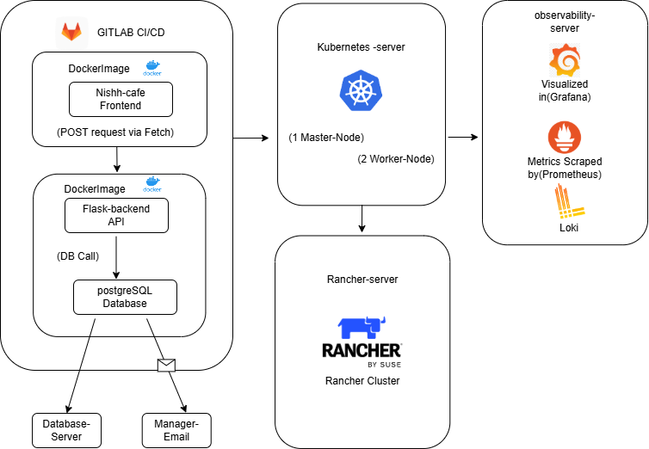

## User Interface

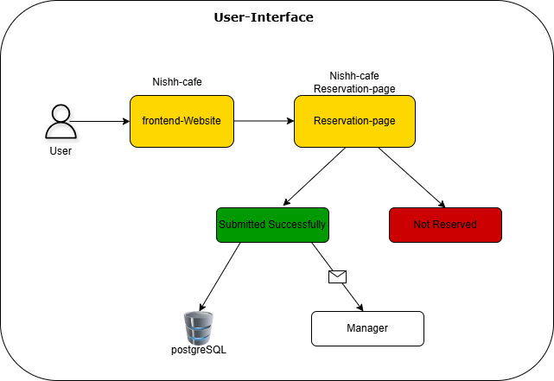

## Nishh Cafe Template

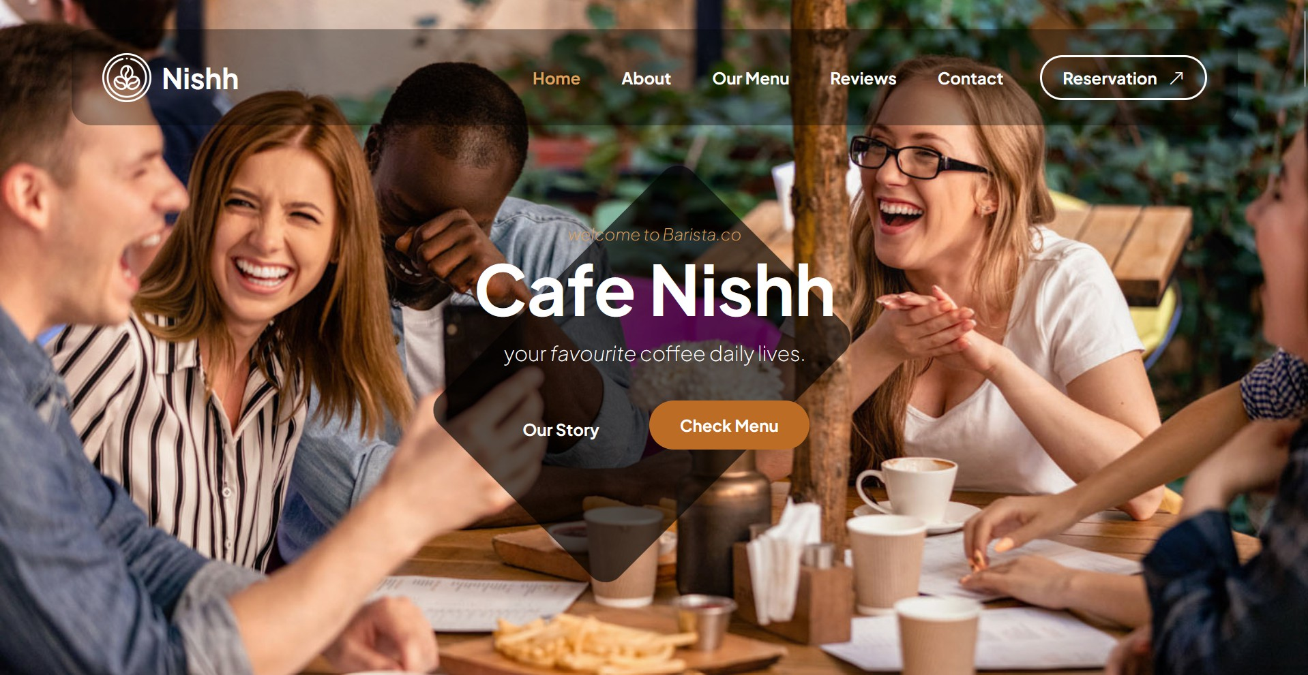

## Flask Backend Receives and Processes POST Requests

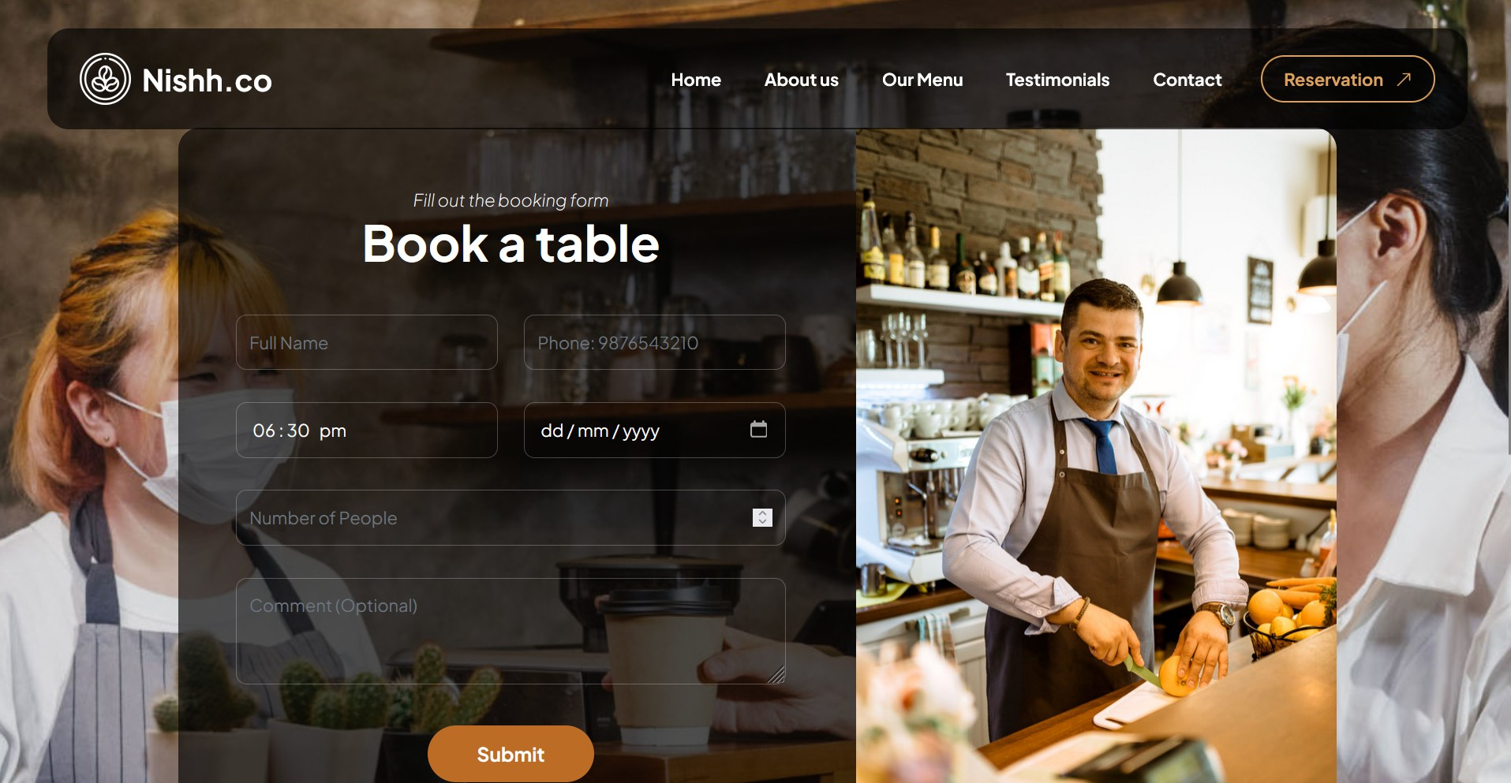

## GitLab

## 

## 

## PostgreSQL

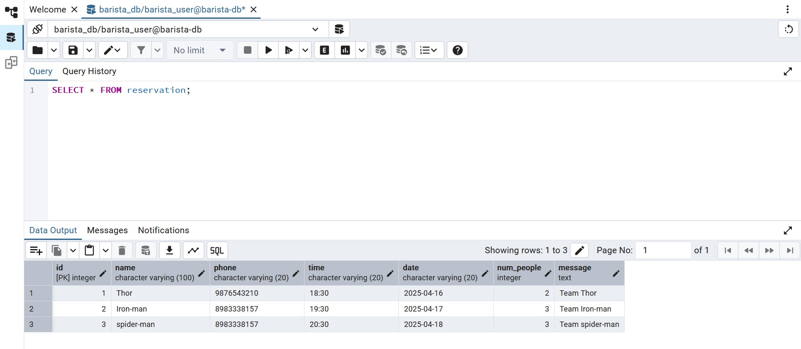

## Grafana Live Metrics:

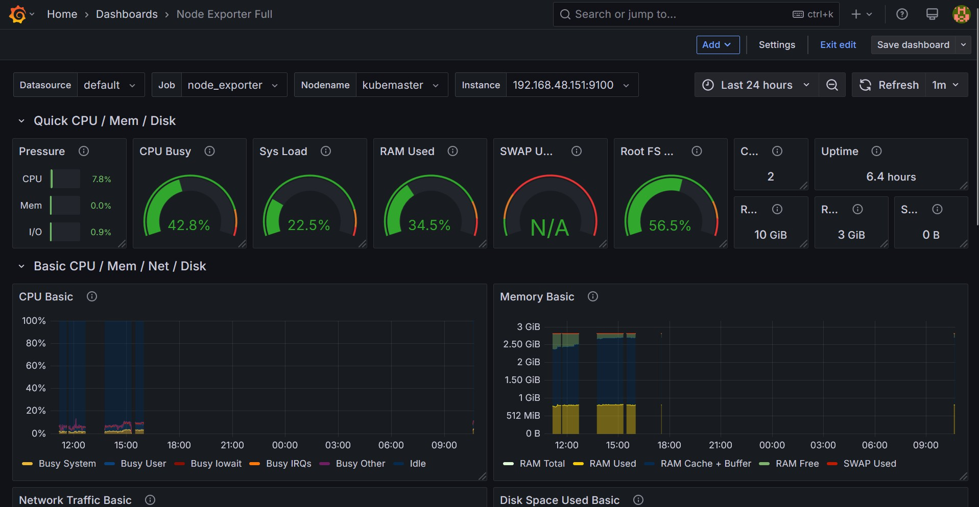

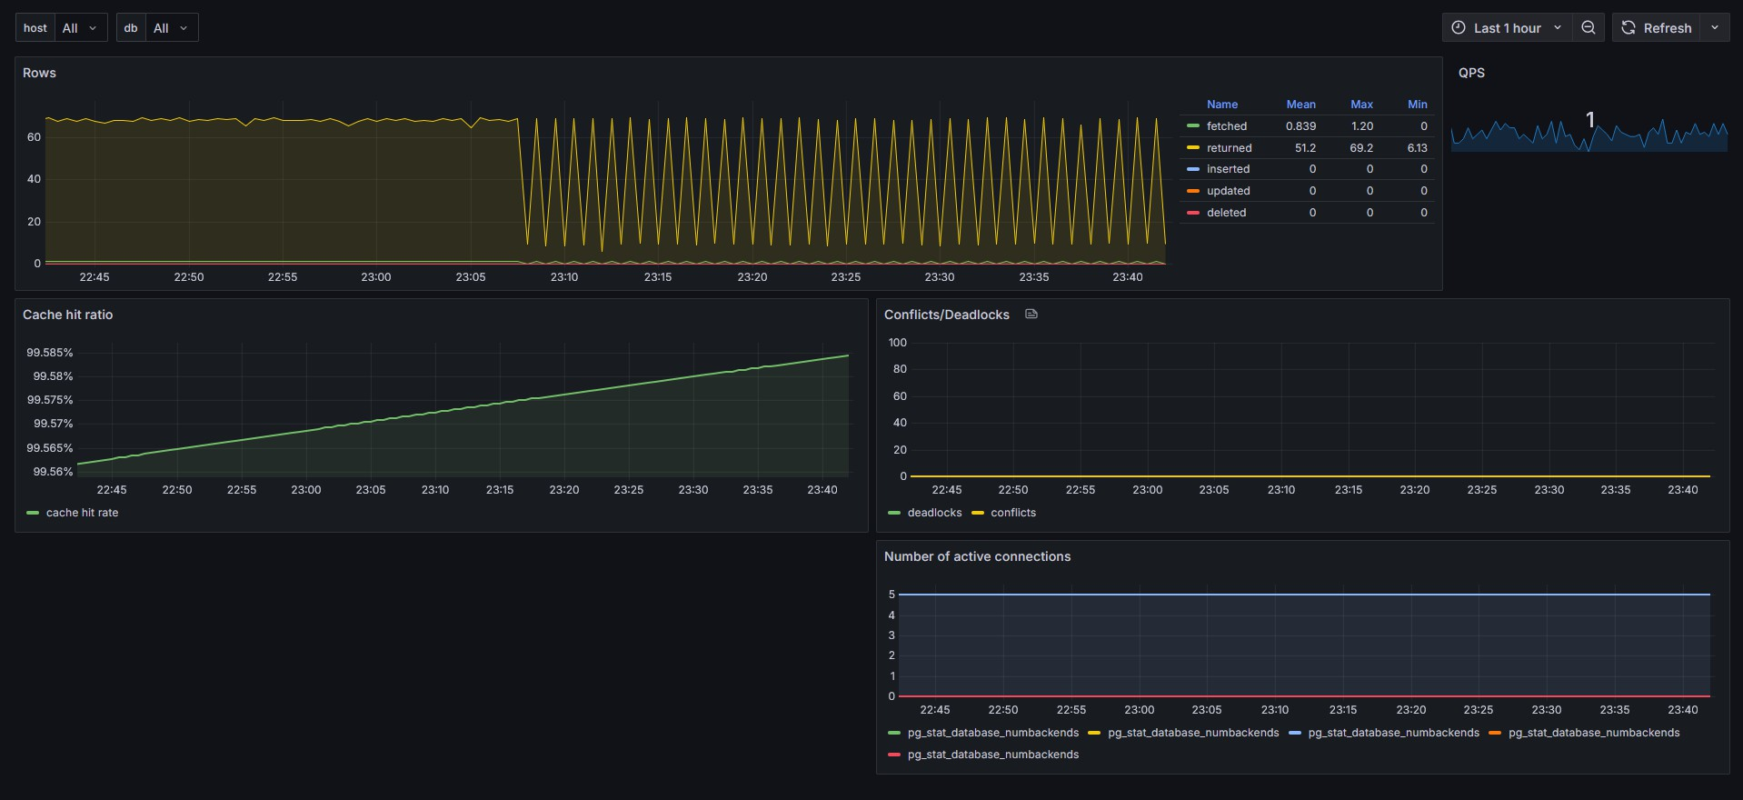

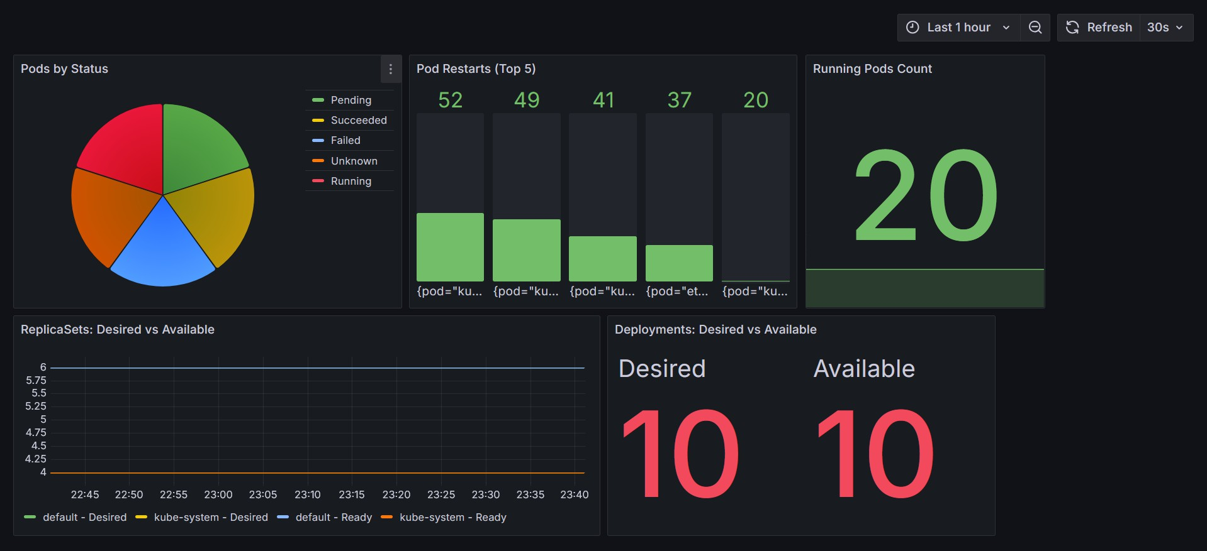

## Prometheus Scraping Metrics from Node Exporter:

## 

## Kubernetes:

