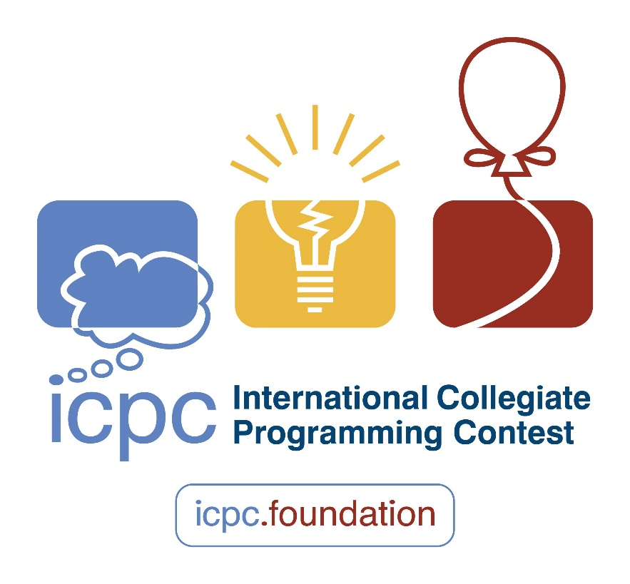

Standard Code Library

02 - Data Structure

HeartFireY, eroengine, yezzz

Jiangxi Normal University

**Ver.2021-EC-FINAL(2022.7.17)**