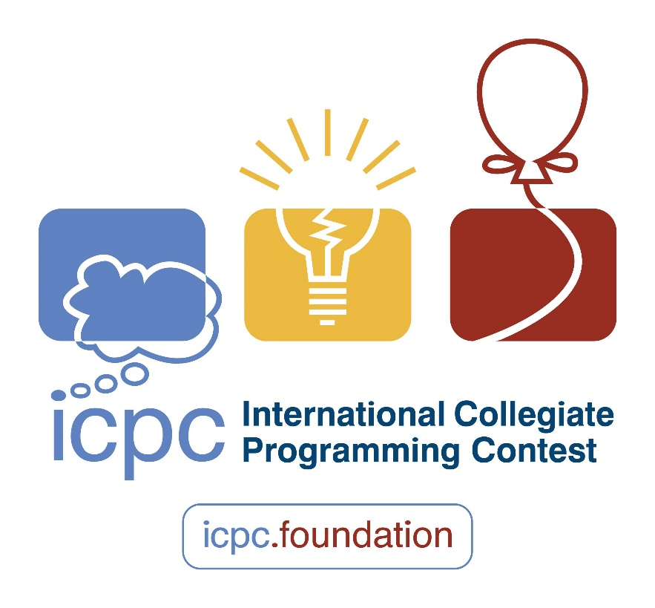

Standard Code Library

05 – Graph Theory

HeartFireY, eroengine, yezzz

Jiangxi Normal University

**Ver.2021-EC-FINAL(2022.7.17)**