

HearthMesh High Level Design
Global attributable emergency continuity mesh
Field | Value
Document version | 0.1
Project status | Experimental pre-alpha
Date | 24 September 2026
Project owner | Valerio Musella

Purpose
Define the target architecture and the deliberately narrower three-node MVP used to validate signed publication, replication, corruption detection and peer-assisted recovery.
Status statement
This design is not a production security assessment. The MVP demonstrates selected system behavior and requires protocol hardening, independent review and multi-host testing before real continuity data is entrusted to it.

1 Executive summary
HearthMesh is designed as a global, non-anonymous emergency continuity mesh. Independently operated nodes exchange readable public content that is signed, attributable, versioned and locally verified. A node can continue serving content already acquired when the original publisher, a peer or the wider Internet becomes unavailable.
The first implementation is intentionally smaller: three explicitly configured Go nodes on one Docker host. It proves the mechanics of signed HearthPacks, peer replication, local access, tamper detection and repair from a healthy replica. It does not yet provide global discovery, permissionless enrollment, private-cell confidentiality, key revocation or production-grade transport security.
The central architectural choice is accountability. The official design does not include onion routing, anonymous publication, payments, marketplaces or public encrypted blind storage. Runtime trust decisions use signatures, hashes and explicit operator policy; no AI model or inference service participates.

2 Scope and design principles
Goal | Architectural response
Continuity during disruption | Serve locally complete packs without a central cloud or reachable publisher.
Attributable public publishing | Bind each manifest to a persistent publisher key and visible operator record.
Integrity and provenance | Sign immutable manifests and verify each referenced blob by SHA-256.
Failure recovery | Pull a valid object from another approved peer after local corruption is detected.
Operator control | Apply local publisher, category, size, retention and replication policies.
AI independence | Use deterministic protocol rules with no model, agent or inference dependency.

2.1 Explicit non-goals
- Anonymous participation, hidden publishers, onion routing or traffic-obfuscation guarantees.
- A global consensus protocol or universally authoritative latest version.
- Guaranteed truth, legality, safety, completeness or availability of published information.
- Real-time emergency dispatch or replacement of official emergency channels.
- Arbitrary anonymous uploads, payments, marketplaces or public blind storage.
- Production private cells, automated moderation or secure key recovery in the MVP.

3 Architecture overview
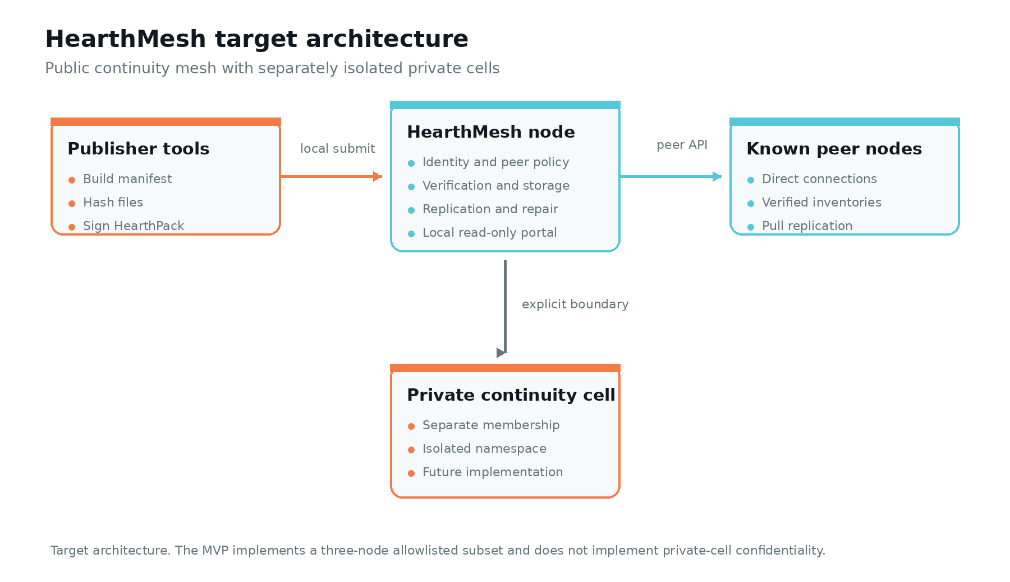
Figure 1. Target architecture and the private-cell isolation boundary.
The target system uses the same core node software for the public mesh and future private cells, but the two spaces must not share discovery, indexes, membership or storage by default. For early private-cell work, separate processes and volumes are safer than unproven in-process multi-tenancy.
Component | Primary responsibility
Identity manager | Loads node identity, publisher trust records and pinned peer identities.
Peer transport | Connects directly to configured peers and applies timeouts and transfer limits.
Pack verifier | Checks manifest structure, publisher signature, paths, media policy and blob hashes.
Content store | Stores immutable manifests and content-addressed blobs with atomic promotion.
Replication scheduler | Polls known peers and pulls locally eligible missing or damaged objects.
Integrity scanner | Recomputes hashes, quarantines corrupt objects and requests repair.
Local portal | Shows available packs, versions, provenance and node status without executing pack content.
Publisher tools | Builds and signs HearthPacks through a local administrative path.

4 Trust model and boundaries
A valid signature proves control of a publisher key; it does not prove that the material is correct. An authenticated peer is identifiable; it is not automatically honest. HearthMesh therefore keeps publisher trust, peer admission and content verification as separate decisions.
Boundary | Risk | Required control
Operator to local administration | Policy deletion or misuse of signing material | Local binding, restricted permissions and separated publisher keys.
Peer to transport | False inventory, resource exhaustion or stale content | Pinned identities, limits, pull replication and backoff.
Received bytes to storage | Malformed, oversized or altered objects | Staging, schema checks, signature verification and digest verification.
Publisher to reader | Authentic but incorrect or harmful content | Visible attribution, local trust tier and operator moderation.
Public mesh to private cell | Metadata or content leakage | Separate membership, namespace, storage, discovery and keys.
Host to node | Key and data compromise | Host hardening; acknowledge that host compromise defeats local guarantees.

4.1 Identity and trust tiers
Node identity, publisher identity and accountable operator identity are distinct. An Ed25519 key alone creates a stable pseudonym, not verified real-world identity. Public enrollment must therefore attach an operator name or organization, contact route and explicit verification status to the cryptographic identity.
Tier | Meaning | Default replication treatment
Blocked | Locally prohibited publisher | Reject and do not advertise.
Unrecognized | Valid signature without operator approval | Do not replicate automatically.
Enrolled | Accountable publisher record approved locally | Eligible under local content policy.
Endorsed | Approved for a defined role or information domain | Display endorsement and its exact scope.

5 HearthPack data model
A HearthPack is an immutable signed manifest plus the immutable blobs referenced by that manifest. The pack identifier is derived from canonical manifest bytes; a blob identifier is derived from the exact blob bytes.
Element | Required content
Protocol metadata | Protocol version, manifest schema version and algorithm identifiers.
Publisher | Publisher identifier, public-key reference and signature envelope.
Publication identity | Logical publication ID, revision and optional predecessor manifest digest.
Descriptive metadata | Title, summary, language, topic tags, geography, license and review-by date.
Entries | Normalized path, media type, byte size and SHA-256 digest for every file.
Classification | Public in MVP; private classifications are rejected until private cells exist.

Protocol version 1 must freeze canonical encoding and signature inputs before interoperability is claimed. Ordinary JSON map serialization is not sufficient unless field ordering, whitespace, duplicate-field handling and numeric representations are specified and tested.
blob_id = SHA-256(blob bytes)
pack_id = SHA-256(canonical manifest bytes)

6 Networking and interfaces
The MVP uses direct, explicitly configured peer addresses and periodic pull replication. The target design should use TLS 1.3 mutual authentication with peer identities pinned to expected node keys. Bootstrap peers provide initial addresses; they are not authorities.
Interface | Purpose | Exposure
GET /v1/node | Signed node descriptor and protocol capabilities | Approved peers
GET /v1/inventory | Bounded pages of complete shareable pack IDs | Approved peers
GET /v1/manifests/{pack_id} | Signed manifest envelope | Approved peers
GET /v1/blobs/{blob_id} | Verified immutable blob bytes | Approved peers
Local portal | Browse, verify and download installed public material | Local network by policy
Administrative API | Publish, trust, retention and maintenance actions | Local host only

The target protocol requires bounded response sizes, timeouts, concurrency limits, retry backoff and jitter. Nodes must never dial arbitrary endpoints embedded in a manifest or automatically admit transitively advertised peers.

7 Core system flows

7.1 Publish
1. The local operator selects files and publication metadata.
2. Publisher tooling validates paths, sizes and allowed media types.
3. Files are hashed and a canonical manifest is signed.
4. The local node independently verifies the pack and publisher policy.
5. Objects move from staging into immutable storage only after verification.
6. A complete pack becomes visible locally and eligible for peer inventory.

7.2 Replicate
1. A node polls an approved peer inventory.
2. It fetches an unfamiliar signed manifest and evaluates local admission policy.
3. Missing blobs are pulled into bounded staging storage.
4. Every size and digest is verified before the pack is committed.
5. Only complete packs appear in the local portal or outgoing inventory.

7.3 Detect and repair corruption
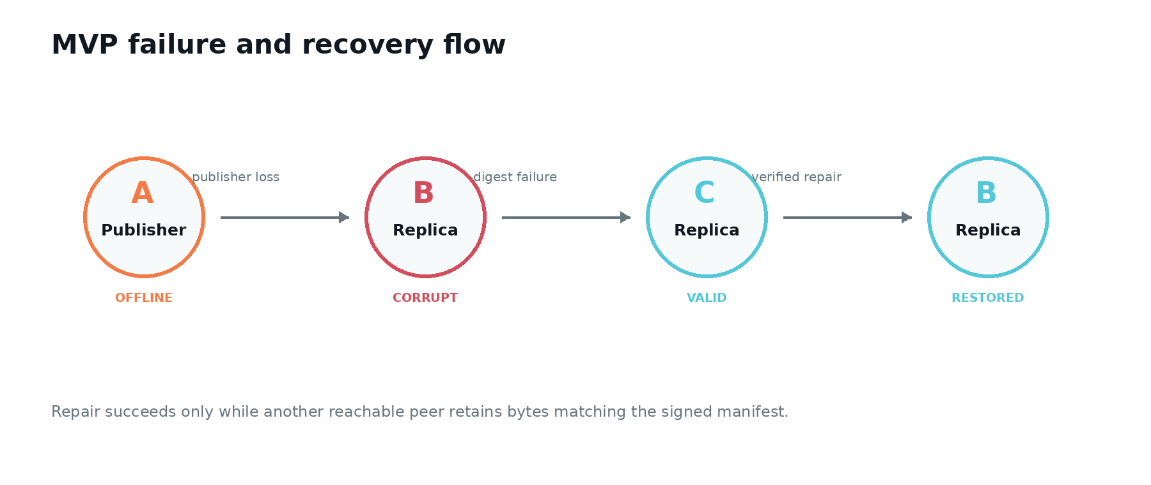
Figure 2. The MVP recovery case: publisher loss, damaged replica and verified repair.
On a digest mismatch, the object is quarantined and dependent packs become unavailable. The scheduler asks other configured peers for the expected digest, verifies replacement bytes and installs them atomically. Hashes detect damage but cannot reconstruct data; recovery fails if every correct replica has been lost.

8 Public mesh and private continuity cells
Property | Global public mesh | Private continuity cell
Purpose | Broadly distributable emergency and continuity knowledge | Restricted operational or personal material
Content visibility | Readable public content | Authorized members only
Publisher model | Attributable publisher with local trust status | Known membership and cell-scoped authorization
Discovery | Future global federation; allowlisted in MVP | Isolated and not publicly advertised
Storage | Public immutable objects | Separate encrypted store and index
MVP status | Partially demonstrated | Architecture placeholder only

A private cell is not a hidden anonymous channel. It requires explicit membership, isolated peer lists, authenticated encrypted transport, data-at-rest policy and tested key management. Revoking membership cannot erase copies already obtained.

9 Security and misuse resistance
The MVP should demonstrate cryptographic integrity, not broad security. It must reject malformed manifests, unsafe paths, altered blobs and unsupported algorithms. Publisher-supplied code must never execute in the portal, and the node must not automatically extract archives or fetch embedded external resources.
Threat | MVP response | Remaining exposure
Dishonest publisher | Visible signature and local trust policy | Signature cannot establish truth.
Compromised publisher key | Manual block configuration | Disconnected nodes may not learn the revocation.
Malicious peer | Allowlist, pull transfer and limits | Approved peer can suppress or waste resources.
Corrupt local object | Digest scan, quarantine and peer repair | No repair if all valid copies are lost.
Path traversal | Normalize and reject unsafe entry paths | Parser defects still require testing and fuzzing.
Active file content | MVP allows a small passive format set | A valid file may still exploit an external viewer.
Sybil enrollment | Manual enrollment in MVP | Global admission remains unsolved.
Traffic analysis | No concealment is attempted | Peer relationships and timing remain visible.

9.1 Misuse constraints
- No onion routing, hidden services, anonymous publisher mode or traffic-obfuscation claim.
- No public encrypted blind-storage service in the official network.
- No payments, marketplace, anonymous messaging or arbitrary unauthenticated upload endpoint.
- Public packs remain readable and attributable; node operators choose what they replicate.
- Moderation and deletion are local. Global recall of replicated material cannot be guaranteed.
These choices reduce darknet-like utility but cannot prevent modification or misuse of open-source code. The project should describe enforceable protocol behavior precisely and avoid claiming that file-extension checks can prove the absence of hidden or encrypted data.

10 Failure behavior
Failure | Required behavior
One peer unavailable | Continue local service and retry another approved peer.
All peers unavailable | Serve complete local packs and show disconnected status.
Interrupted transfer | Keep bounded staging state; never expose an incomplete pack.
Digest mismatch | Quarantine the object, record the event and request another source.
Invalid signature | Reject the manifest with a visible reason.
Disk full | Stop acquisition safely and preserve installed content where possible.
Conflicting revisions | Retain and show both branches; do not resolve silently by timestamp.
Lost node key | Require explicit reenrollment under a new identity.
All correct copies lost | Declare content unavailable; do not imply recoverability.
MVP Docker host lost | All three logical nodes may fail because they share one physical host.

11 Deployment and operations
Docker Compose starts three logical Go nodes with distinct identities, ports, configurations and persistent volumes. This is reproducible and sufficient for behavior testing, but all nodes share one host, disk, power source and network path. A meaningful resilience pilot requires independent machines and failure domains.
Operational signal | Interpretation
Process healthy | The node process is running and local checks pass.
Content ready | At least the required locally pinned packs are complete and verified.
Mesh degraded | One or more peers are unavailable; local continuity may still be intact.
Pack quarantined | A signature, schema or digest verification failed.
Storage pressure | Acquisition may stop before installed pinned content is affected.

Logs and metrics should cover peer reachability, pack states, replication retries, bytes transferred, verification failures, integrity-scan coverage, disk quotas and protocol versions. Private content and unnecessary reader identifiers must not be logged.

12 MVP implementation
Capability | MVP position
Runtime | Single Go binary per node
Topology | Three allowlisted nodes with explicit bootstrap peers
Identity | Persistent Ed25519 node and publisher material
Integrity | Signed manifest plus SHA-256 file verification
Replication | Direct peer polling and pull transfer
Recovery | Detect modified bytes and obtain a valid peer copy
Access | Local read-only web view and status endpoints
Packaging | Docker Compose and scripted demonstration
Status | Experimental pre-alpha; not production-secure

12.1 Demonstration acceptance
1. Node A publishes a signed sample HearthPack.
2. Nodes B and C replicate and verify the same pack.
3. Node A is stopped and no longer serves as publisher.
4. A stored file on node B is deliberately modified.
5. Node B detects that the file digest does not match the signed manifest.
6. Node B retrieves the expected bytes from node C and verifies them before restoration.
7. The recovered pack remains available through the local portal.
Acceptance was completed on 24 September 2026 on a Windows x86-64 host. All four Go tests passed, the Windows binary built successfully, and the three-node Docker drill demonstrated publication, replication, continued availability after node A stopped, corruption detection on node B and repair from node C. This is single-host functional evidence, not an independent security audit or a multi-host resilience test. Continuous integration must repeat tests and builds for ongoing changes.

13 Architecture decisions
Decision | Rationale
Immutable content addressing | Makes stored objects independently verifiable and avoids silent mutation.
Separate publisher and node identities | Publishing authority should not be implied by transport participation.
Direct identifiable peers | Supports accountability and intentionally rejects anonymity infrastructure.
Pull replication | Prevents unsolicited peers from pushing arbitrary content into storage.
Local policy | Signing does not create a storage obligation for every node.
No global consensus | The system can preserve conflicting branches without pretending to select truth.
No AI at runtime | Trust decisions remain deterministic, inspectable and service-independent.
Separate private-cell process | Avoids claiming safe multi-tenancy before isolation is designed and tested.

14 Roadmap
Phase | Outcome | Exit evidence
1 Protocol specification | Canonical encoding, IDs, limits and test vectors | Independent implementations produce identical IDs and signatures.
2 Three-node MVP | Publication, replication, portal, tamper detection and repair | Automated tests plus a recorded repeatable Docker drill.
3 Multi-host pilot | Independent operators and physical failure domains | Measured recovery during network and publisher loss.
4 Security hardening | Rotation, revocation, fuzzing, abuse response and dependency review | Independent assessment and tracked remediation.
5 Private cells | Membership, isolation, encryption and key lifecycle | Confidentiality and revocation-limit tests.
6 Broader federation | Scalable discovery and inventory exchange | Pilot evidence without a mandatory central coordinator.

15 Principal limitations
- The MVP proves a local three-node behavior, not an operational global mesh.
- Three containers on one machine do not provide hardware, power or geographic resilience.
- A valid signature proves key control and byte integrity, not factual correctness.
- Manual enrollment reduces the initial attack surface but does not solve global identity or Sybil resistance.
- Key rotation, revocation, recovery and publisher withdrawal require protocol and governance work.
- Public replication makes universal deletion impossible once another party retains a copy.
- Private continuity cells are an architectural direction, not an implemented confidentiality feature.
- Security claims require independent review, adversarial testing and operational evidence.
The correct pre-alpha claim is narrow: HearthMesh demonstrates how attributable signed content can remain locally available, detect alteration and recover from another known peer without relying on the original publisher.

