STANDARD OPERATING PROCEDURE (SOP)

VIBI SURVEY123 DATA - FROM SPREADSHEETS TO WETLANDS DATABASE

This SOP describes procedures for uploading VIBI Survey123-generated Excel spreadsheets into the HTLNWetlands MS Access database using R tidyverse.

Overview

This SOP describes the uploading process of Excel files generated by Survey123 surveys for VIBI field data into the HTLNWetlands database . The survey data is collected for VIBI herbaceous and VIBI woody analysis. VIBI woody data also includes data for big trees (>= 40 cm in diameter). For all three datasets (herbaceous, woody, and big trees) the workflow is the same. Excel spreadsheets derived from Survey123 surveys are loaded into R scripts and reformatted to match their destination tables in Access. The R scripts generate “loadfiles” which are imported into the HTLNWetlands Access database. The imported load files are appended to each respective table (, tbl_VIBI_herb, tbl_VIBI_woody, and tbl_BigTrees). The complete code listing for each script is provided in Appendix A. Once the data is appended to Access tables, it is exported back out as .csv files for end-to-end validation. The validation tests consist of (1) verifying no duplicate records are contained in either the load file or the exported datasets, (2) verifying no missing values anywhere in the measured fields and (3) matching record counts between loadfiles and data exports.

PROCEDURES

Review the Survey123 Excel files:

1. Begin by reviewing the Survey123 Excel files.
2. Make working copies of the original spreadsheets and store the original files in a safe location.
3. Open the spreadsheets using Excel.
4. Review column headings. Remove any spaces or special characters. Spaces should be replaced with underscores. Special characters such as commas, apostrophes, percent signs, and math symbols should be replaced with text.
5. Ensure that all columns contain data. Columns that do not contain data should be deleted.
6. Remove all commas in the comments column to prevent parsing errors associated with the comma delimiter.

Generating the load file: "Load_VIBI_herb_2023.xlsx"

1. Export the VIBI spreadsheets from Excel into csv format. Use the CSV UTF-8 format.
2. Run the script Survey123_VIBI_herb_final.R
3. The following is a description of the following code in Survey123_VIBI_herb_final.R

################################################################################

#

# Survey123_VIBI_herb_final.R

#

# Gareth Rowell, 2/16/2024

#

# This script converts csv files exported from Survey123 VIBI herbaceous

# data to create a file that can be loaded into MS Access and directly

# appended to the tbl_VIBI_herb table.

#

################################################################################

library(tidyverse)

#setwd("./VIBI-herbaceous")

Step 1 loads the csv files into dataframes. The bind_rows() function combines multiple csv files into a single dataframe, “Access_data”.

#################

#

# Step 1 - load spreadsheet csv files and appended them

#

#################

# load the Survey123 data

load_file1 <- read_csv("CUVA_VIBI_herb1.csv")

load_file2 <- read_csv("CUVA_VIBI_herb2.csv")

load_file3 <- read_csv("CUVA_VIBI_herb3.csv")

glimpse(load_file1)

glimpse(load_file2)

glimpse(load_file3)

Access_data <- bind_rows(load_file1,load_file2)

glimpse(Access_data)

Access_data <- bind_rows(Access_data,load_file3)

glimpse(Access_data)

In Step 2, HerbSiteName and CoverClass_LT_6m columns are renamed to match up with the table tbl_VIBI_herb. The mm/dd/yyyy date format is converted to the universal date format yyyy-mm-dd.

#################

#

# Step 2 - select and rename columns, convert date to yyyy-mm-dd

#

#################

Access_data <- Access_data |>

select(Species, Comments, Module, CoverClass_LT_6m,

CoverClassAll, EditDate, HerbSiteName) |>

mutate(

FeatureID = HerbSiteName,

CoverClass = CoverClass_LT_6m,

EditDate = (EditDate <- as.Date(EditDate, format = "%m/%d/%Y"))

)

glimpse(Access_data)

In Step 3, I’m removing missing records and duplicate records. In Step3a, I am replacing the “NA” symbols. NA means “not available”. Here, I substitute it with -9999 in numerical columns. Then I inspect the -9999 rows. After inspection, I remove the -9999 records from the dataframe.

#################

#

# Step 3a - Substitute NA with -9999 in CoverClass and CoverClassAll

# Then remove those with -9999 in CoverClass

#

#################

Access_data$CoverClass <- Access_data$CoverClass |> replace_na(-9999)

Access_data$CoverClassAll <- Access_data$CoverClassAll |> replace_na(-9999)

Access_data |>

filter(CoverClass == -9999)

Access_data <- Access_data |>

filter(CoverClass != -9999)

# then test

Access_data |>

filter(CoverClass == -9999)

In Step 3b, I am inspecting and removing duplicate rows.

##########

#

# Step 3b - check for duplicates

#

##########

# test for dups

Access_data |>

count(Species, Comments, Module, CoverClass_LT_6m, CoverClassAll,

EditDate, HerbSiteName, FeatureID, CoverClass

) |>

filter(n > 1)

# Remove dups with distinct()

Access_data <- Access_data |>

distinct(Species, Comments, Module, CoverClass_LT_6m, CoverClassAll,

EditDate, HerbSiteName, FeatureID, CoverClass

)

Access_data

# test for dups

Access_data |>

count(Species, Comments, Module, CoverClass_LT_6m, CoverClassAll,

EditDate, HerbSiteName, FeatureID, CoverClass

) |>

filter(n > 1)

In Step 4, I am generating the EventID.

#################

#

# Step 4a - Generate EventID from EditDate

#

#################

Access_data <- Access_data |>

mutate( EventID = str_c( 'CUVAWetlnd', EditDate)) |>

mutate(EventID = str_replace_all(EventID, "-", "")) |>

mutate(NumMonth = str_sub(EventID, start = 15L, end = -3L))

#################

#

# Step 4b - Replace numeric month with text month abbreviation

#

#################

Months_LUT <- read_csv("Months_LUT.csv")

Access_data <- Access_data |>

left_join(Months_LUT, join_by(NumMonth))

Access_data <- Access_data |>

mutate(EventID_left = str_sub(EventID, start = 1L, end = -5)) |>

mutate(EventID_right = str_sub(EventID, start = 17, end = -1))

Access_data <- Access_data |>

mutate(EventID = str_c(EventID_left, TxtMonth, EventID_right))

In step 5, I’m generating a LocationID column based on the FeatureID.

#################

#

# Step 5 - Create the LocationID column from the FeatureID column

#

#################

Locations_LUT <- read_csv("tbl_Locations_20230316.csv")

glimpse(Locations_LUT)

Access_data <- Access_data |>

left_join(Locations_LUT, join_by(FeatureID))

Finally, in this last step, Step 6, I am just selecting the columns that will be needed to append the data to tbl_VIBI_herb in the database. The last line writes the dataframe to the loadfile.

#################

#

# Step 6 - Clean up columns and write load file

#

#################

# clean up columns

Access_data <- Access_data |>

select(EventID, FeatureID, LocationID, Species, Comments, Module,

CoverClass, CoverClassAll, EditDate )

writexl::write_xlsx(Access_data, "Load_VIBI_herb_2023.xlsx"

The load file should be ready to import into Access to be joined to tbl_VIBI_herb.

Generating the load file: "Load_VIBI_woody_2023.xlsx"

In the following script, I am taking Survey123 data for VIBI woody observations and converting them to a load file to append to tbl_VIBI_woody in the Access database.

################################################################################

#

# Survey123_VIBI_woody_final.R

#

# Gareth Rowell, 2/16/2024

#

# This script converts csv files exported from Survey123 VIBI woody

# data to create a file that can be loaded into MS Access and directly

# appended to the tbl_VIBI_woody table.

#

################################################################################

library(tidyverse)

#setwd("../HTLN-Data-Capture-Scripts/wetlands/src")

#setwd("./VIBI-woody")

In Step 1 below, I am loading the VIBI woody spreadsheet data. This is almost identical to Step 1 in the script above except I am dealing with species codes as well as scientific names. The records with species codes have been placed into their own spreadsheets with a column called SpeciesCode. The scientific name is then attached to the dataframe by way of a left_join() from the lookup table”WoodySpecies_LUT2.csv”

#################

#

# Step 1 - load spreadsheet csv files and appended them

# Note - species codes were only used in CUVA_VIBI_woody1.csv

# and also CUVA_VIBI_woody3.csv

# They were joined to WoodySpecies_LUT2.csv to create WoodySpecies

#

#################

# species codes were only used in CUVA_VIBI_woody1.csv

# join to WoodySPecies_LUT2.csv to create WoodySpecies

load_file1 <- read_csv("CUVA_VIBI_woody1.csv")

problems(load_file1)

WoodySpecies_LUT <- read_csv("WoodySpecies_LUT2.csv")

load_file1 <- load_file1 |>

left_join(WoodySpecies_LUT, join_by(SpeciesCode))

glimpse(load_file1)

glimpse(WoodySpecies_LUT)

load_file2 <- read_csv("CUVA_VIBI_woody2.csv")

problems(load_file2)

load_file3 <- read_csv("CUVA_VIBI_woody3.csv")

problems(load_file3)

load_file3 <- load_file3 |>

left_join(WoodySpecies_LUT, join_by(SpeciesCode))

glimpse(load_file3)

load_file4 <- read_csv("CUVA_VIBI_woody4.csv")

problems(load_file4)

glimpse(load_file1)

glimpse(load_file2)

glimpse(load_file3)

glimpse(load_file4)

Access_data <- bind_rows(load_file1,load_file2)

glimpse(Access_data)

Access_data <- bind_rows(Access_data,load_file3)

glimpse(Access_data)

Access_data <- bind_rows(Access_data,load_file4)

glimpse(Access_data)

load_file <- Access_data # used for normalization test in step 8

Step 2 below cleans things up with select() and renaming columns using mutate(). The date is converted to YYYY-MM-DD

#################

#

# Step 2 - select and rename columns, convert date to yyyy-mm-dd

#

#################

Access_data <- Access_data |>

select(WoodyModule, WoodySpecies, EditDate, WoodySiteName, ShrubClump, D0to1,

D1to2_5, D2_5to5, D5to10, D10to15, D15to20, D20to25, D25to30, D30to35,

D35to40, Dgt40, Dgt40_1, Dgt40_2, Dgt40_3, Dgt40_4, Dgt40_5)

Access_data <- Access_data |>

mutate( FeatureID = WoodySiteName) |>

mutate(EditDate = (EditDate <- as.Date(EditDate, format = "%m/%d/%Y"))) |>

mutate( Module_No = WoodyModule )

glimpse(Access_data)

Step 3 below introduces the processing steps to normalize the diameter columns in the spreadsheet. The goal is to go from … ShrubClump, D0to1, D1to2_5, Diam2_5to5… to two columns, one containing the category of diameter called DiamID and a second column called Count. This process starts in Step 3 by renaming columns as Access_data$Colx. The process is completed in Step 6 using the pivot longer function. Steps 4 and 5 generate the EventID and LocationID and are identical to the methods used for VIBI herbaceous above.

#################

#

# Step 3 - Rename columns using DiamID values for pivot_longer

#

#################

Access_data$Col1 <- Access_data$ShrubClump

Access_data$Col2<- Access_data$D0to1

Access_data$Col3 <- Access_data$D1to2_5

Access_data$Col4 <- Access_data$D2_5to5

Access_data$Col5 <- Access_data$D5to10

Access_data$Col6 <- Access_data$D10to15

Access_data$Col7 <- Access_data$D15to20

Access_data$Col8 <- Access_data$D20to25

Access_data$Col9 <- Access_data$D25to30

Access_data$Col10 <- Access_data$D30to35

Access_data$Col11 <- Access_data$D35to40

Access_data$Col12 <- Access_data$Dgt40

glimpse(Access_data)

Steps 4 and 5 generate the EventID and LocationID and are identical to the methods used for VIBI herbaceous above.

#################

#

# Step 4a - Generate EventID from EditDate

#

#################

Access_data <- Access_data |>

mutate( EventID = str_c( 'CUVAWetlnd', EditDate)) |>

mutate(EventID = str_replace_all(EventID, "-", "")) |>

mutate(NumMonth = str_sub(EventID, start = 15L, end = -3L))

glimpse(Access_data)

#################

#

# Step 4b - Replace numeric month with text month abbreviation

#

#################

Months_LUT <- read_csv("Months_LUT.csv")

Access_data <- Access_data |>

left_join(Months_LUT, join_by(NumMonth))

Access_data <- Access_data |>

mutate(EventID_left = str_sub(EventID, start = 1L, end = -5)) |>

mutate(EventID_right = str_sub(EventID, start = 17, end = -1))

Access_data <- Access_data |>

mutate(EventID = str_c(EventID_left, TxtMonth, EventID_right))

#################

#

# Step 5 - create the LocationID column from the FeatureID column

# and a lookup table from HTLNWetlands

#

#################

Locations_LUT <- read_csv("tbl_Locations_20230316.csv")

glimpse(Locations_LUT)

Access_data <- Access_data |>

left_join(Locations_LUT, join_by(FeatureID))

glimpse(Access_data)

In Step 6, we are taking the columns created in Step 3 and running them through the pivot_longer() function. Step 3 and step 6 together generate a normalized form that can be attached to tbl_VIBI_woody.

#################

#

# Step 6 - set up columns before normalization, then pivot longer

#

#################

Access_data <- Access_data |>

select(EventID, LocationID, FeatureID, Module_No, WoodySpecies,

EditDate, WoodySiteName, Col1, Col2, Col3, Col4, Col5,

Col6, Col7, Col8, Col9, Col10, Col11, Col12)

glimpse(Access_data)

# pivot longer (normalize)

Access_data <- Access_data |>

pivot_longer(

cols = starts_with("Col"),

names_to = "DiamID",

values_to = "Count",

values_drop_na = TRUE

)

glimpse(Access_data)

Step 7 attaches the diameter code values which are required in the database to join tlu_WoodyPlants to tbl_VIBI_woody. The lookup table tlu_WoodyPlants in the database contains diameter ranges and midpoint values.

#################

#

# Step 7 - Join the diameter information from a LUT

#

#################

Diam_LUT <- read_csv("Diam_LUT.csv")

glimpse(Diam_LUT)

Access_data <- Access_data |>

left_join(Diam_LUT, join_by(DiamID))

Step 8 serves as a end-to-end test of the pivot_longer process in steps 3 and 6. The control is the loadfile dataframe which was created in Step 1. The test is based on the total count for each diameter class before and after the pivot_longer process is applied. The totals for each diameter class before and after must match exactly.

#################

#

# Step 8 - Validate normalization and join using

# Sum of counts in initial load file

# against total_counts for each diameter

# in final version

#

#################

Initial_load <- load_file |>

select(ShrubClump, D0to1,

D1to2_5, D2_5to5, D5to10, D10to15, D15to20, D20to25, D25to30, D30to35,

D35to40, Dgt40)

colSums(Initial_load, na.rm=TRUE)

Access_data |>

group_by(Diam_Desc) |>

summarize(

total_count = sum(Count)

)

Steps 9a and 9b below process missing values and duplicate records using the same methods as those in the VIBI herbaceous script. Step 10 loads the files into the load file "Load_VIBI_woody_2023.xlsx".

#################

#

# Step 9a - Substitute NA with -9999 in CoverClass and CoverClassAll

# Then remove those with -9999 in CoverClass

#

#

#################

glimpse(Access_data)

Access_data$Count <- Access_data$Count |> replace_na(-9999)

Access_data |>

filter(Count == -9999)

Access_data <- Access_data |>

filter(Count != -9999)

# then test

Access_data |>

filter(Count == -9999)

##########

#

# Step 9b - check for duplicates

#

##########

# test for dups

Access_data |>

count(EventID, LocationID, FeatureID, Module_No, WoodySpecies, DiamID,

Count, Diam_Code, Diam_Desc) |>

filter(n > 1)

# Remove dups with distinct()

Access_data <- Access_data |>

distinct(EventID, LocationID, FeatureID, Module_No, WoodySpecies, DiamID,

Count, Diam_Code, Diam_Desc)

Access_data

# test for dups

Access_data |>

count(EventID, LocationID, FeatureID, Module_No, WoodySpecies, DiamID,

Count, Diam_Code, Diam_Desc) |>

filter(n > 1)

##########

#

# Step 10 - Write load file

#

##########

Access_data <- Access_data |>

select(EventID, LocationID, FeatureID, Module_No, WoodySpecies, Diam_Code,

Count)

writexl::write_xlsx(Access_data, "Load_VIBI_woody_2023.xlsx")

Generating the load file: "Load_VIBI_BigTrees_2023.xlsx

The load file for the database table tbl_BigTrees is described below.

################################################################################

#

# Survey123_VIBI_Big_trees_final.R

#

# Gareth Rowell, 2/29/2024

#

# This script converts csv files exported from Survey123 VIBI woody big tree

# data to create a file that can be loaded into MS Access and directly

# appended to the tbl_BigTrees table.

#

################################################################################

library(tidyverse)

# setwd("./VIBI-BigTrees")

Step 1 below shows the code for loading the big tree csvs. Note that these are the exact same csv files used for tbl_VIBI_Woody except we will only be using the last columns for diameter type > 40 cm. So Step 1 is essentially identical to Step 1 in the VIBI woody section above.

#################

#

# Step 1 - load spreadsheet csv files and appended them

# Note - species codes were only used in CUVA_VIBI_woody1.csv

# and also CUVA_VIBI_woody3.csv

# They were joined to WoodySpecies_LUT2.csv to create WoodySpecies

#

#################

# species codes were only used in CUVA_VIBI_woody1.csv

# join to WoodySPecies_LUT2.csv to create WoodySpecies

load_file1 <- read_csv("CUVA_VIBI_woody1.csv")

problems(load_file1)

WoodySpecies_LUT <- read_csv("WoodySpecies_LUT2.csv")

load_file1 <- load_file1 |>

left_join(WoodySpecies_LUT, join_by(SpeciesCode))

glimpse(load_file1)

glimpse(WoodySpecies_LUT)

# view(load_file1)

# check for NAs in WoodySpecies

load_file1 |>

select(SpeciesCode, WoodySpecies) |>

filter(is.na(WoodySpecies)) |>

distinct()

load_file2 <- read_csv("CUVA_VIBI_woody2.csv")

problems(load_file2)

load_file3 <- read_csv("CUVA_VIBI_woody3.csv")

problems(load_file3)

load_file3 <- load_file3 |>

left_join(WoodySpecies_LUT, join_by(SpeciesCode))

glimpse(load_file3)

load_file4 <- read_csv("CUVA_VIBI_woody4.csv")

problems(load_file4)

glimpse(load_file1)

glimpse(load_file2)

glimpse(load_file3)

glimpse(load_file4)

Access_data <- bind_rows(load_file1,load_file2)

glimpse(Access_data)

Access_data <- bind_rows(Access_data,load_file3)

glimpse(Access_data)

Access_data <- bind_rows(Access_data,load_file4)

glimpse(Access_data)

At Step 2, we begin processing the columns specifically for big trees. Note that the data columns used here are Dgt40_1, Dgt40_2, Dgt40_3, Dgt40_4, Dgt40_5.

##########

#

# Step 2 - select columns for Access import

# for big trees, need columns 40_1 onwards

#

##########

Access_data <- Access_data |>

select(WoodyModule, WoodySpecies, EditDate, WoodySiteName,

Dgt40_1, Dgt40_2, Dgt40_3, Dgt40_4, Dgt40_5)

glimpse(Access_data)

Steps 3 through 5 include renaming columns and creating EventID and LocationID. These are essentially the same as those described for VIBI herbaceous and VIBI woody.

##########

#

# Step 3 - create columns for FeatureID and Module_No

# and convert date format

#

##########

Access_data <- Access_data |>

mutate( FeatureID = WoodySiteName) |>

mutate(EditDate = (EditDate <- as.Date(EditDate, format = "%m/%d/%Y"))) |>

mutate( Module_No = WoodyModule )

Access_data

##########

#

# Step 4 - Generate EventID from EditDate

#

##########

Access_data <- Access_data |>

mutate( EventID = str_c( 'CUVAWetlnd', EditDate)) |>

mutate(EventID = str_replace_all(EventID, "-", "")) |>

mutate(NumMonth = str_sub(EventID, start = 15L, end = -3L))

glimpse(Access_data)

#################

#

# Step 4b - Replace numeric month with text month abbreviation

#

#################

Months_LUT <- read_csv("Months_LUT.csv")

glimpse(Months_LUT)

Access_data <- Access_data |>

left_join(Months_LUT, join_by(NumMonth))

Access_data <- Access_data |>

mutate(EventID_left = str_sub(EventID, start = 1L, end = -5)) |>

mutate(EventID_right = str_sub(EventID, start = 17, end = -1))

Access_data <- Access_data |>

mutate(EventID = str_c(EventID_left, TxtMonth, EventID_right))

glimpse(Access_data)

##########

#

# Step 5 - create the LocationID column from the FeatureID column

# and a lookup table from HTLNWetlands

#

##########

Locations_LUT <- read_csv("tbl_Locations_20230316.csv")

glimpse(Locations_LUT)

Access_data <- Access_data |>

left_join(Locations_LUT, join_by(FeatureID))

glimpse(Access_data)

Step 6 uses the pivot_longer() function in the same manner as Steps 3 and 6 for woody plants. Here we are converting Dgt40_1, Dgt40_2, Dgt40_3 … to two columns, one called Trees and the second one called DBH which contains measures of DBH cm.

##########

#

# Step 6 - Normalize DBH columns

#

#

##########

# Rename columns using DiamID values for pivot_longer

Access_data$Tree1 <- Access_data$Dgt40_1

Access_data$Tree2 <- Access_data$Dgt40_2

Access_data$Tree3 <- Access_data$Dgt40_3

Access_data$Tree4 <- Access_data$Dgt40_4

Access_data$Tree5 <- Access_data$Dgt40_5

Access_data <- Access_data |>

mutate( Scientific_Name = WoodySpecies) |>

mutate( SampleDate = EditDate) |>

select(EventID, LocationID, Module_No, Scientific_Name, Tree1,

Tree2, Tree3, Tree4, Tree5)

glimpse(Access_data)

# pivot longer (normalize)

Access_data <- Access_data |>

pivot_longer(

cols = starts_with("Tree"),

names_to = "TreeName",

values_to = "DBH",

values_drop_na = TRUE

)

glimpse(Access_data)

Step 7 is a check for duplicate records which is basically the same code as used in previous scripts for detecting and eliminating duplicate records. It ends with writing the dataframe to "Load_VIBI_BigTrees_2023.xlsx".

##########

#

# Step 7 - check for duplicates

#

##########

# test for dups

Access_data |>

select(EventID, LocationID, Module_No, Scientific_Name, DBH)

Access_data |>

group_by(EventID, LocationID, Module_No, Scientific_Name, DBH) |>

summarize(

n = n(),

) |>

filter(n > 1)

# Remove dups with distinct()

Access_data <- Access_data |>

distinct(EventID, LocationID, Module_No, Scientific_Name, DBH)

Access_data

# test for dups

Access_data |>

group_by(EventID, LocationID, Module_No, Scientific_Name, DBH) |>

summarize(

n = n(),

) |>

filter(n > 1)

#view(Access_data)

writexl::write_xlsx(Access_data, "Load_VIBI_BigTrees_2023.xlsx")

PROCEDURES – CONTINUED

Importing the load files into MS Access

The process for importing the load files is basically the same for tbl_BigTrees, tbl_VIBI_herb and tbl_VIBI_woody. We will import the load file generated by the R script then append it to the data table. The detailed steps are explained below for tbl_VIBI_herb, but they are basically the same for tbl_BigTrees and tbl_VIBI_woody.

1. Backup the original table tbl_VIBI_herb in Access using copy and paste in the Navigation pane. Name the backup table tbl_VIBI_herb_orig. This will allow you do go back and re-run the append operation if anything goes wrong.
2. Import the spreadsheet Load_VIBI_BigTrees_2023.xlsx into Access. Go to the External Data ribbon and click on New Data. Follow the wizard to import a spreadsheet into a table. Name the new table Loadfile_VIBI_herb_2023.

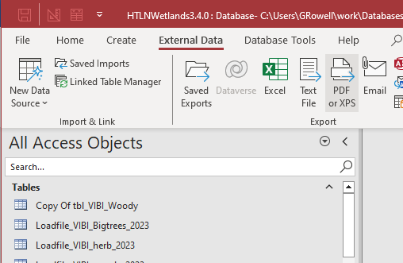



1. Append the table Loadfile_VIBI_herb_2023 to the data table called tbl_VIBI_herb. We will use an append query to accomplish this. Go to the Create ribbon and click on Query Design.

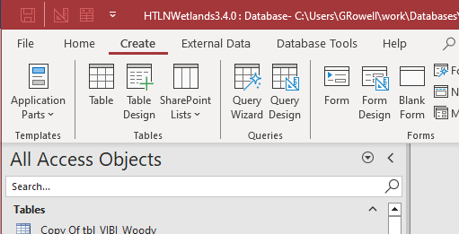



1. Once you are in the Design view of the query editor, double click on the Loadfile_VIBI_herb_2023 table in the Add Tables box.

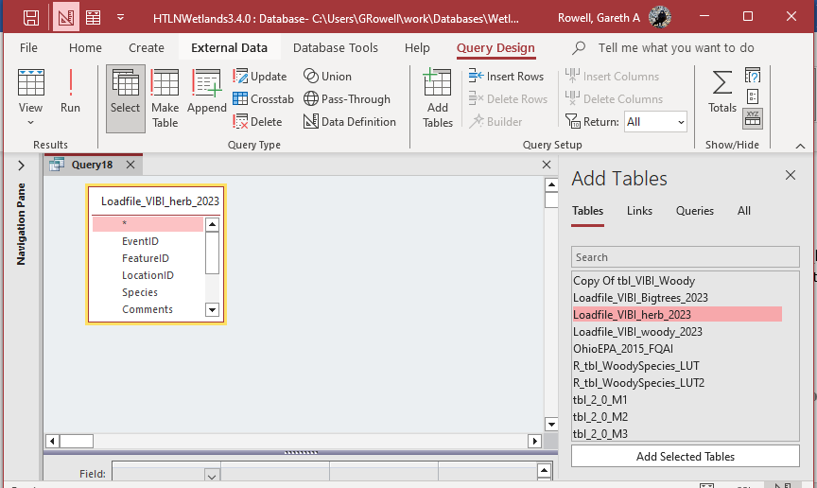



1. Select all the fields in the table box and drag them to the field design panel.

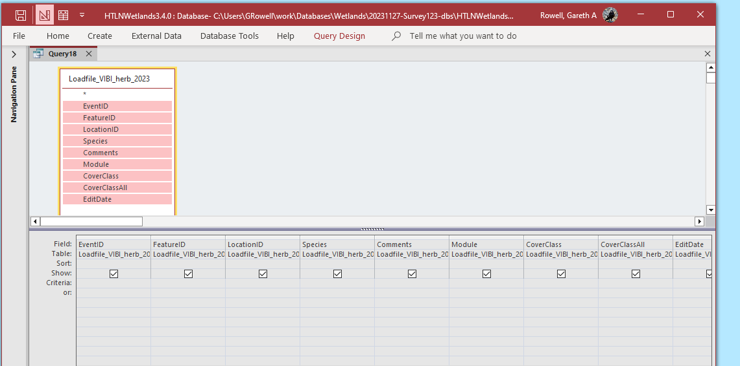



1. Click on the Append Query button on the query design ribbon and select the table tbl_VIBI_herb

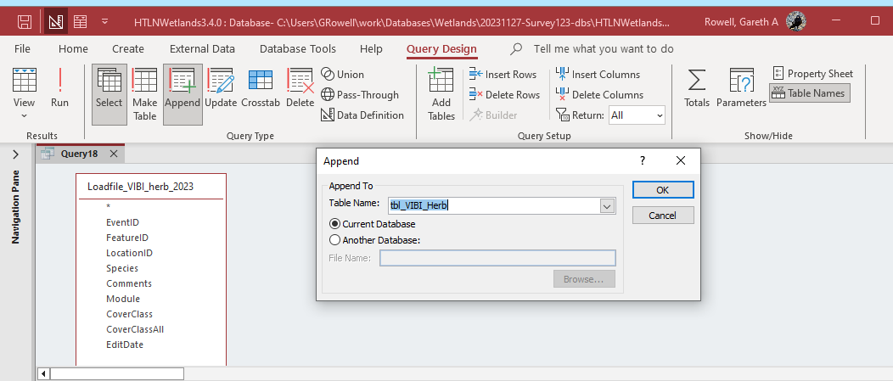



1. When you click on the OK button, Access will attempt to match column names. For other columns, you will have to match them up manually (see highlighted columns).

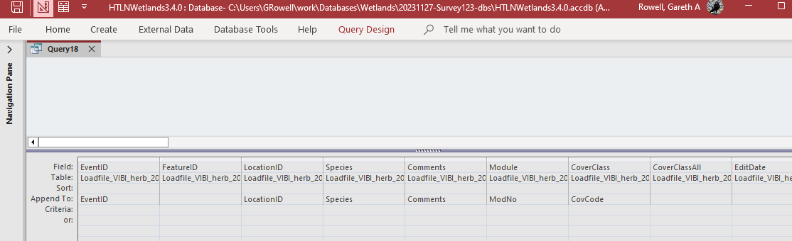



1. Once you have matched all the columns, you can click on the run icon. Be sure to click on it just once. If you click on it multiple times, it will append additional copies of your load file to tbl_VIBI_herb. One of the end2end tests (below) is to verify that you have only appended once (test for duplicates).

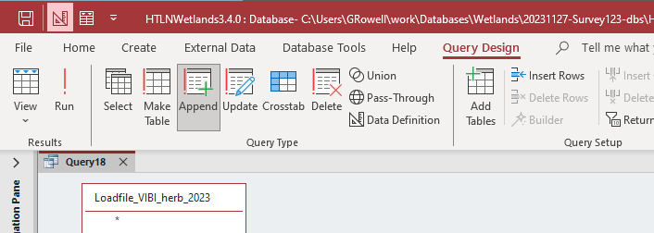



1. You can repeat these same procedures to append "Load_VIBI_woody_2023.xlsx” to tbl_VIBI_woody and “"Load_VIBI_BigTrees_2023.xlsx" to tbl_BigTrees.

PROCEDURES – CONTINUED

Running End-to-End tests

Once you have appended data to the VIBI tables, you really need to validate the new data. To do this, we compare the dataframe generated by R script with the data loaded in the VIBI table. We will step through this process for VIBI herbaceous data but the process is the same for VIBI woody and Big Trees. (The complete scripts for all three end-to-end tests are in Appendix 3).

1. Open the query called qrye2e_VIBI_herb in design view. Note that the EventID is filtered for Like “*2023*”.

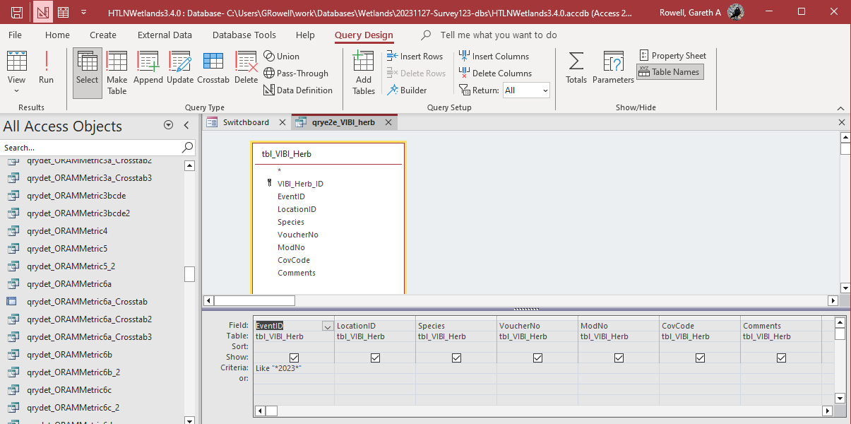



1. This will pull out just the 2023 data. Change the query from Design to View mode. Be sure to save the query just in case you’ve made any modifications you need to keep. Go to the External Data ribbon and the Text File export button. Follow the export wizard steps to export the data to csv format. Save the file as “qrye2e_VIBI_herb.csv”

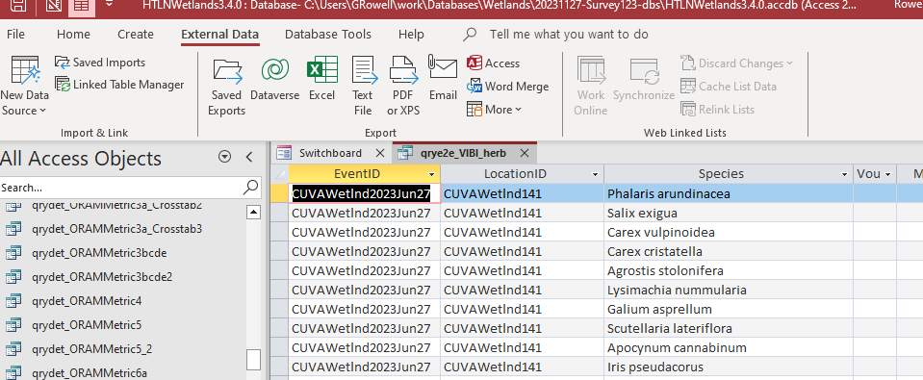



1. Load the script VIBI_herb_end2end.R in RStudio and examine the script. The first 6 steps are identical to the script Survey123_VIBI_herb_final.R Run the first 6 steps to generate the load file Access_data dataframe. Starting at the comment “End2End test begins here”, we load the export data from Access into an R dataframe called end2end. We make some minor changes in column names so they match up exactly.

#################

#

# Step 6 - Clean up columns and write load file

#

#################

# clean up columns

Access_data <- Access_data |>

select(EventID, FeatureID, LocationID, Species, Comments, Module,

CoverClass, CoverClassAll, EditDate )

# writexl::write_xlsx(Access_data, "Load_VIBI_herb_2023.xlsx")

#------------------------------------------------------------------------------

# End2End test begins here

# load end2end data

end2end <- read_csv("qrye2e_VIBI_herb.csv")

problems(end2end)

glimpse(end2end)

glimpse(Access_data)

# matching column names

Access_data <- Access_data |>

mutate(

ModNo = Module,

CovCode = CoverClass

)

glimpse(Access_data)

# Selecting the columns that matter

Access_data <- Access_data |>

select(EventID, LocationID, Species, ModNo, CovCode)

end2end <- end2end |>

select(EventID, LocationID, Species, ModNo, CovCode)

1. Next, we test for duplicates in both the initial load file (Access_data) and the end2end exported data from MS Access.

# test for duplicates in Access_data and End2end dataframes.

Access_data |>

count(EventID, FeatureID, Species, Module, CoverClass) |>

filter(n > 1)

# Need to resolve these duplicates with Sonia.

# Also, there's a bunch of null values in the CoverClass variable

Access_data |>

filter(CoverClass == -9999)

glimpse(Access_data)

# matching column names

Access_data <- Access_data |>

mutate(

ModNo = Module,

CovCode = CoverClass

)

# Selecting the columns that matter

Access_data <- Access_data |>

select(EventID, LocationID, Species, ModNo, CovCode)

end2end <- end2end |>

select(EventID, LocationID, Species, ModNo, CovCode)

1. Finally, we compare record counts for the load dataframe Access_data and the export dataframe called end2end

# compare record counts

Access_data |>

count(EventID, LocationID, Species, ModNo, CovCode)

end2end |>

count(EventID, LocationID, Species, ModNo, CovCode)

The record counts between the load files and the exported tables should match exactly. If they don’t, review the load files and Access table exports again for duplicate records as this is the most likely scenario for mismatched record counts. If no duplicates are detected, either a record was introduced or deleted during the import process. Rerun the script, check the sample size of the load file and import the load file once more using new copies of the *original* tables: tbl_VIBI_herb, tbl_VIBI_woody and tbl_BigTrees. Trace the sample sizes through each step. The before and after sample sizes must match to pass the end-to-end test.

PROCEDURES – CONTINUED

Final steps

1. Increment the final version of the updated database.

2. Update the changelog spreadsheet to reflect the newly added data.

3. Upload the new version to the N:\HTLN\Databases\Wetlands folder.

Appendix A – Complete code listings for VIBI herbaceous, VIBI woody, and VIBI Big Trees.

################################################################################

#

# Survey123_VIBI_herb_final.R

#

# Gareth Rowell, 2/16/2024

#

# This script converts csv files exported from Survey123 VIBI herbaceous

# data to create a file that can be loaded into MS Access and directly

# appended to the tbl_VIBI_herb table.

#

################################################################################

library(tidyverse)

#setwd("./VIBI-herbaceous")

#################

#

# Step 1 - load spreadsheet csv files and appended them

#

#################

# load the Survey123 data

load_file1 <- read_csv("CUVA_VIBI_herb1.csv")

load_file2 <- read_csv("CUVA_VIBI_herb2.csv")

load_file3 <- read_csv("CUVA_VIBI_herb3.csv")

glimpse(load_file1)

glimpse(load_file2)

glimpse(load_file3)

Access_data <- bind_rows(load_file1,load_file2)

glimpse(Access_data)

Access_data <- bind_rows(Access_data,load_file3)

glimpse(Access_data)

#################

#

# Step 2 - select and rename columns, convert date to yyyy-mm-dd

#

#################

Access_data <- Access_data |>

select(Species, Comments, Module, CoverClass_LT_6m,

CoverClassAll, EditDate, HerbSiteName) |>

mutate(

FeatureID = HerbSiteName,

CoverClass = CoverClass_LT_6m,

EditDate = (EditDate <- as.Date(EditDate, format = "%m/%d/%Y"))

)

glimpse(Access_data)

#################

#

# Step 3 - Substitute NA with -9999 in CoverClass and CoverClassAll

# Then remove those with -9999 in CoverClass

#

#################

Access_data$CoverClass <- Access_data$CoverClass |> replace_na(-9999)

Access_data$CoverClassAll <- Access_data$CoverClassAll |> replace_na(-9999)

Access_data |>

filter(CoverClass == -9999)

Access_data <- Access_data |>

filter(CoverClass != -9999)

# then test

Access_data |>

filter(CoverClass == -9999)

##########

#

# Step 3b - check for duplicates

#

##########

# test for dups

Access_data |>

count(Species, Comments, Module, CoverClass_LT_6m, CoverClassAll,

EditDate, HerbSiteName, FeatureID, CoverClass

) |>

filter(n > 1)

# Remove dups with distinct()

Access_data <- Access_data |>

distinct(Species, Comments, Module, CoverClass_LT_6m, CoverClassAll,

EditDate, HerbSiteName, FeatureID, CoverClass

)

Access_data

# test for dups

Access_data |>

count(Species, Comments, Module, CoverClass_LT_6m, CoverClassAll,

EditDate, HerbSiteName, FeatureID, CoverClass

) |>

filter(n > 1)

#################

#

# Step 4a - Generate EventID from EditDate

#

#################

Access_data <- Access_data |>

mutate( EventID = str_c( 'CUVAWetlnd', EditDate)) |>

mutate(EventID = str_replace_all(EventID, "-", "")) |>

mutate(NumMonth = str_sub(EventID, start = 15L, end = -3L))

#################

#

# Step 4b - Replace numeric month with text month abbreviation

#

#################

Months_LUT <- read_csv("Months_LUT.csv")

Access_data <- Access_data |>

left_join(Months_LUT, join_by(NumMonth))

Access_data <- Access_data |>

mutate(EventID_left = str_sub(EventID, start = 1L, end = -5)) |>

mutate(EventID_right = str_sub(EventID, start = 17, end = -1))

Access_data <- Access_data |>

mutate(EventID = str_c(EventID_left, TxtMonth, EventID_right))

#################

#

# Step 5 - Create the LocationID column from the FeatureID column

#

#################

Locations_LUT <- read_csv("tbl_Locations_20230316.csv")

glimpse(Locations_LUT)

Access_data <- Access_data |>

left_join(Locations_LUT, join_by(FeatureID))

#################

#

# Step 6 - Clean up columns and write load file

#

#################

# clean up columns

Access_data <- Access_data |>

select(EventID, FeatureID, LocationID, Species, Comments, Module,

CoverClass, CoverClassAll, EditDate )

writexl::write_xlsx(Access_data, "Load_VIBI_herb_2023.xlsx")

################################################################################

#

# Survey123_VIBI_woody_final.R

#

# Gareth Rowell, 2/16/2024

#

# This script converts csv files exported from Survey123 VIBI woody

# data to create a file that can be loaded into MS Access and directly

# appended to the tbl_VIBI_woody table.

#

################################################################################

library(tidyverse)

#setwd("../HTLN-Data-Capture-Scripts/wetlands/src")

#setwd("./VIBI-woody")

#################

#

# Step 1 - load spreadsheet csv files and appended them

# Note - species codes were only used in CUVA_VIBI_woody1.csv

# and also CUVA_VIBI_woody3.csv

# They were joined to WoodySpecies_LUT2.csv to create WoodySpecies

#

#################

# species codes were only used in CUVA_VIBI_woody1.csv

# join to WoodySPecies_LUT2.csv to create WoodySpecies

load_file1 <- read_csv("CUVA_VIBI_woody1.csv")

problems(load_file1)

WoodySpecies_LUT <- read_csv("WoodySpecies_LUT2.csv")

load_file1 <- load_file1 |>

left_join(WoodySpecies_LUT, join_by(SpeciesCode))

glimpse(load_file1)

glimpse(WoodySpecies_LUT)

# view(load_file1)

# check for NAs in WoodySpecies

load_file1 |>

select(SpeciesCode, WoodySpecies) |>

filter(is.na(WoodySpecies)) |>

distinct()

load_file2 <- read_csv("CUVA_VIBI_woody2.csv")

problems(load_file2)

load_file3 <- read_csv("CUVA_VIBI_woody3.csv")

problems(load_file3)

load_file3 <- load_file3 |>

left_join(WoodySpecies_LUT, join_by(SpeciesCode))

glimpse(load_file3)

load_file4 <- read_csv("CUVA_VIBI_woody4.csv")

problems(load_file4)

glimpse(load_file1)

glimpse(load_file2)

glimpse(load_file3)

glimpse(load_file4)

Access_data <- bind_rows(load_file1,load_file2)

glimpse(Access_data)

Access_data <- bind_rows(Access_data,load_file3)

glimpse(Access_data)

Access_data <- bind_rows(Access_data,load_file4)

glimpse(Access_data)

load_file <- Access_data # for normalization test in step 8

#################

#

# Step 2 - select and rename columns, convert date to yyyy-mm-dd

#

#################

Access_data <- Access_data |>

select(WoodyModule, WoodySpecies, EditDate, WoodySiteName, ShrubClump, D0to1,

D1to2_5, D2_5to5, D5to10, D10to15, D15to20, D20to25, D25to30, D30to35,

D35to40, Dgt40, Dgt40_1, Dgt40_2, Dgt40_3, Dgt40_4, Dgt40_5)

Access_data <- Access_data |>

mutate( FeatureID = WoodySiteName) |>

mutate(EditDate = (EditDate <- as.Date(EditDate, format = "%m/%d/%Y"))) |>

mutate( Module_No = WoodyModule )

glimpse(Access_data)

#################

#

# Step 3 - Rename columns using DiamID values for pivot_longer

#

#################

Access_data$Col1 <- Access_data$ShrubClump

Access_data$Col2<- Access_data$D0to1

Access_data$Col3 <- Access_data$D1to2_5

Access_data$Col4 <- Access_data$D2_5to5

Access_data$Col5 <- Access_data$D5to10

Access_data$Col6 <- Access_data$D10to15

Access_data$Col7 <- Access_data$D15to20

Access_data$Col8 <- Access_data$D20to25

Access_data$Col9 <- Access_data$D25to30

Access_data$Col10 <- Access_data$D30to35

Access_data$Col11 <- Access_data$D35to40

Access_data$Col12 <- Access_data$Dgt40

glimpse(Access_data)

#################

#

# Step 4 - Generate EventID from EditDate

#

#################

Access_data <- Access_data |>

mutate( EventID = str_c( 'CUVAWetlnd', EditDate)) |>

mutate(EventID = str_replace_all(EventID, "-", "")) |>

mutate(NumMonth = str_sub(EventID, start = 15L, end = -3L))

glimpse(Access_data)

#################

#

# Step 4b - Replace numeric month with text month abbreviation

#

#################

Months_LUT <- read_csv("Months_LUT.csv")

Access_data <- Access_data |>

left_join(Months_LUT, join_by(NumMonth))

Access_data <- Access_data |>

mutate(EventID_left = str_sub(EventID, start = 1L, end = -5)) |>

mutate(EventID_right = str_sub(EventID, start = 17, end = -1))

Access_data <- Access_data |>

mutate(EventID = str_c(EventID_left, TxtMonth, EventID_right))

#################

#

# Step 5 - create the LocationID column from the FeatureID column

# and a lookup table from HTLNWetlands

#

#################

Locations_LUT <- read_csv("tbl_Locations_20230316.csv")

glimpse(Locations_LUT)

Access_data <- Access_data |>

left_join(Locations_LUT, join_by(FeatureID))

glimpse(Access_data)

#################

#

# Step 6 - set up columns before normalization, then pivot longer

#

#################

Access_data <- Access_data |>

select(EventID, LocationID, FeatureID, Module_No, WoodySpecies,

EditDate, WoodySiteName, Col1, Col2, Col3, Col4, Col5,

Col6, Col7, Col8, Col9, Col10, Col11, Col12)

glimpse(Access_data)

# pivot longer (normalize)

Access_data <- Access_data |>

pivot_longer(

cols = starts_with("Col"),

names_to = "DiamID",

values_to = "Count",

values_drop_na = TRUE

)

glimpse(Access_data)

#################

#

# Step 7 - Join the diameter information from a LUT

#

#################

Diam_LUT <- read_csv("Diam_LUT.csv")

glimpse(Diam_LUT)

Access_data <- Access_data |>

left_join(Diam_LUT, join_by(DiamID))

#################

#

# Step 8 - Validate normalization and join using

# Sum of counts in initial load file

# against total_counts for each diameter

# in final version

#

#################

Initial_load <- load_file |>

select(ShrubClump, D0to1,

D1to2_5, D2_5to5, D5to10, D10to15, D15to20, D20to25, D25to30, D30to35,

D35to40, Dgt40)

colSums(Initial_load, na.rm=TRUE)

Access_data |>

group_by(Diam_Desc) |>

summarize(

total_count = sum(Count)

)

#################

#

# Step 9a - Substitute NA with -9999 in CoverClass and CoverClassAll

# Then remove those with -9999 in CoverClass

#

#

#################

glimpse(Access_data)

Access_data$Count <- Access_data$Count |> replace_na(-9999)

Access_data |>

filter(Count == -9999)

Access_data <- Access_data |>

filter(Count != -9999)

# then test

Access_data |>

filter(Count == -9999)

##########

#

# Step 9b - check for duplicates

#

##########

# test for dups

Access_data |>

count(EventID, LocationID, FeatureID, Module_No, WoodySpecies, DiamID,

Count, Diam_Code, Diam_Desc) |>

filter(n > 1)

# Remove dups with distinct()

Access_data <- Access_data |>

distinct(EventID, LocationID, FeatureID, Module_No, WoodySpecies, DiamID,

Count, Diam_Code, Diam_Desc)

Access_data

# test for dups

Access_data |>

count(EventID, LocationID, FeatureID, Module_No, WoodySpecies, DiamID,

Count, Diam_Code, Diam_Desc) |>

filter(n > 1)

##########

#

# Step 10 - Write load file

#

##########

Access_data <- Access_data |>

select(EventID, LocationID, FeatureID, Module_No, WoodySpecies, Diam_Code,

Count)

writexl::write_xlsx(Access_data, "Load_VIBI_woody_2023.xlsx")

################################################################################

#

# Survey123_VIBI_Big_trees_final.R

#

# Gareth Rowell, 2/29/2024

#

# This script converts csv files exported from Survey123 VIBI woody big tree

# data to create a file that can be loaded into MS Access and directly

# appended to the tbl_BigTrees table.

#

################################################################################

library(tidyverse)

# setwd("./VIBI-BigTrees")

#################

#

# Step 1 - load spreadsheet csv files and appended them

# Note - species codes were only used in CUVA_VIBI_woody1.csv

# and also CUVA_VIBI_woody3.csv

# They were joined to WoodySpecies_LUT2.csv to create WoodySpecies

#

#################

# species codes were only used in CUVA_VIBI_woody1.csv

# join to WoodySPecies_LUT2.csv to create WoodySpecies

load_file1 <- read_csv("CUVA_VIBI_woody1.csv")

problems(load_file1)

WoodySpecies_LUT <- read_csv("WoodySpecies_LUT2.csv")

load_file1 <- load_file1 |>

left_join(WoodySpecies_LUT, join_by(SpeciesCode))

glimpse(load_file1)

glimpse(WoodySpecies_LUT)

# view(load_file1)

# check for NAs in WoodySpecies

load_file1 |>

select(SpeciesCode, WoodySpecies) |>

filter(is.na(WoodySpecies)) |>

distinct()

load_file2 <- read_csv("CUVA_VIBI_woody2.csv")

problems(load_file2)

load_file3 <- read_csv("CUVA_VIBI_woody3.csv")

problems(load_file3)

load_file3 <- load_file3 |>

left_join(WoodySpecies_LUT, join_by(SpeciesCode))

glimpse(load_file3)

load_file4 <- read_csv("CUVA_VIBI_woody4.csv")

problems(load_file4)

glimpse(load_file1)

glimpse(load_file2)

glimpse(load_file3)

glimpse(load_file4)

Access_data <- bind_rows(load_file1,load_file2)

glimpse(Access_data)

Access_data <- bind_rows(Access_data,load_file3)

glimpse(Access_data)

Access_data <- bind_rows(Access_data,load_file4)

glimpse(Access_data)

##########

#

# Step 2 - select columns for Access import

# for big trees, need columns 40_1 onwards

#

##########

Access_data <- Access_data |>

select(WoodyModule, WoodySpecies, EditDate, WoodySiteName,

Dgt40_1, Dgt40_2, Dgt40_3, Dgt40_4, Dgt40_5)

glimpse(Access_data)

# n = 1731

##########

#

# Step 3 - create columns for FeatureID and Module_No

# and convert date format

#

##########

Access_data <- Access_data |>

mutate( FeatureID = WoodySiteName) |>

mutate(EditDate = (EditDate <- as.Date(EditDate, format = "%m/%d/%Y"))) |>

mutate( Module_No = WoodyModule )

Access_data

##########

#

# Step 4 - Generate EventID from EditDate

#

##########

Access_data <- Access_data |>

mutate( EventID = str_c( 'CUVAWetlnd', EditDate)) |>

mutate(EventID = str_replace_all(EventID, "-", "")) |>

mutate(NumMonth = str_sub(EventID, start = 15L, end = -3L))

glimpse(Access_data)

#################

#

# Step 4b - Replace numeric month with text month abbreviation

#

#################

Months_LUT <- read_csv("Months_LUT.csv")

glimpse(Months_LUT)

Access_data <- Access_data |>

left_join(Months_LUT, join_by(NumMonth))

Access_data <- Access_data |>

mutate(EventID_left = str_sub(EventID, start = 1L, end = -5)) |>

mutate(EventID_right = str_sub(EventID, start = 17, end = -1))

Access_data <- Access_data |>

mutate(EventID = str_c(EventID_left, TxtMonth, EventID_right))

glimpse(Access_data)

##########

#

# Step 5 - create the LocationID column from the FeatureID column

# and a lookup table from HTLNWetlands

#

##########

Locations_LUT <- read_csv("tbl_Locations_20230316.csv")

glimpse(Locations_LUT)

Access_data <- Access_data |>

left_join(Locations_LUT, join_by(FeatureID))

glimpse(Access_data)

##########

#

# Step 6 - Normalize DBH columns

#

#

##########

# Rename columns using DiamID values for pivot_longer

Access_data$Tree1 <- Access_data$Dgt40_1

Access_data$Tree2 <- Access_data$Dgt40_2

Access_data$Tree3 <- Access_data$Dgt40_3

Access_data$Tree4 <- Access_data$Dgt40_4

Access_data$Tree5 <- Access_data$Dgt40_5

Access_data <- Access_data |>

mutate( Scientific_Name = WoodySpecies) |>

mutate( SampleDate = EditDate) |>

select(EventID, LocationID, Module_No, Scientific_Name, Tree1,

Tree2, Tree3, Tree4, Tree5)

glimpse(Access_data)

# pivot longer (normalize)

Access_data <- Access_data |>

pivot_longer(

cols = starts_with("Tree"),

names_to = "TreeName",

values_to = "DBH",

values_drop_na = TRUE

)

glimpse(Access_data)

##########

#

# Step 7 - check for duplicates

#

##########

# test for dups

Access_data |>

select(EventID, LocationID, Module_No, Scientific_Name, DBH)

Access_data |>

group_by(EventID, LocationID, Module_No, Scientific_Name, DBH) |>

summarize(

n = n(),

) |>

filter(n > 1)

# Remove dups with distinct()

Access_data <- Access_data |>

distinct(EventID, LocationID, Module_No, Scientific_Name, DBH)

Access_data

# test for dups

Access_data |>

group_by(EventID, LocationID, Module_No, Scientific_Name, DBH) |>

summarize(

n = n(),

) |>

filter(n > 1)

#view(Access_data)

writexl::write_xlsx(Access_data, "Load_VIBI_BigTrees_2023.xlsx")