**National Park Service**

**U.S. Department of the Interior**

Bingham, S. N., C. C. Young, J. L. Haack-Gaynor , L. W. Morrison, and G. A. Rowell. 2016. Wetland monitoring protocol for Cuyahoga Valley National Park: Narrative. Natural Resource Report NPS/HTLN/NRR—2016/ 1336. National Park Service, Fort Collins, Colorado.

# Standard Operating Procedure 16: Data Management

**Version 1.00 (12/27/2016)**

|  |  |  |  |  |  |
| --- | --- | --- | --- | --- | --- |
| Previous Version # | Revision Date | Author | Changes Made | Reason for Change | New Version # |
|  |  |  |  |  |  |
|  |  |  |  |  |  |
|  |  |  |  |  |  |
|  |  |  |  |  |  |
|  |  |  |  |  |  |

**Wetland Monitoring Protocol for Cuyahoga Valley National Park**

*Standard Operating Procedures*

**Contents**

Page

Standard Operating Procedure 16: Data Management 3

Heartland Wetlands Geodatabase (HTLNWetland.gdb) 3

Heartland Wetlands Database (HTLNWetland.mdb) 4

NPSTORET Database (NPSTORET.mdb) 5

Aquarius Database 6

Heartland Water Depth Spreadsheets 7

**Figures**

**Figure 16.1.** Diagram of the nomenclature (location IDs) assigned to various spatial features in the geodatabase. Location IDs include the *WetlndID*, *VIBIPlotID*, *VIBIModID*, *WellID*, *CentroidID* and *ShedID*. These Location IDs were assigned systematically to link spatial data in GIS with non-spatial data in an Access database (HTLNWetland.mdb). In the Sentinel Site example, Wetland 1077, the *WetlndID,* is also referred to as Rockside (1077RS). Sentinel Sites are large and may have more than one *WellID* and sampling array (*VIBIPlotID*). This is sampling array 1 (1077RS1) of 3 different Rockside locations. The well is situated in the center of the plot so the *Well ID* and *Plot ID* numbers match (1077RS1). They are distinguished from each other by a Feature Type option in the Access Database. Sampling arrays are made up of between 1 and 10, 10 x 10 m modules, which are distinguished from the *VIBIPlotID* by adding an underscore and module number. In this example, Rockside sampling array 1, Module 1 would be 1077RS1_1 (*VIBIModID*). On a larger scale, watersheds included in the

Page

Landscape Development Intensity Index are identified by their *ShedID* 4

**Figure 16.2.** Switchboard for HTLNWetlands.mdb, the database used to manage wetland

monitoring data for Cuyahoga Valley National Park. 5

**Figure 16.3.** NPSTORET main log-in screen requires selecting the organization

(HTLNCUVA) and observer name (i.e., log in ID) to begin data entry 6

**Figure 16.4.** Springboard used to launch data management activities associated with the

Aquarius database 7

**Standard Operating Procedure 16: Data Management**

This SOP describes the databases used to manage all data associated with wetlands monitoring in Cuyahoga Valley National Park (CUVA).

## Heartland Wetlands Geodatabase (HTLNWetland.gdb)

The wetland monitoring geodatabase, *HTLNWetland.gdb*, manages the spatial features for the wetlands monitoring project in Cuyahoga Valley National Park (Figure 16.1). The spatial data include: 1) the watersheds and wetlands used to construct the reference frame, including those watersheds and wetlands selected for sampling, 2) sampling arrays and centroid for that array, 3) the modules which compose each array and the corner of each module where biomass is potentially sampled, and 4) groundwater well and staff gauge locations.

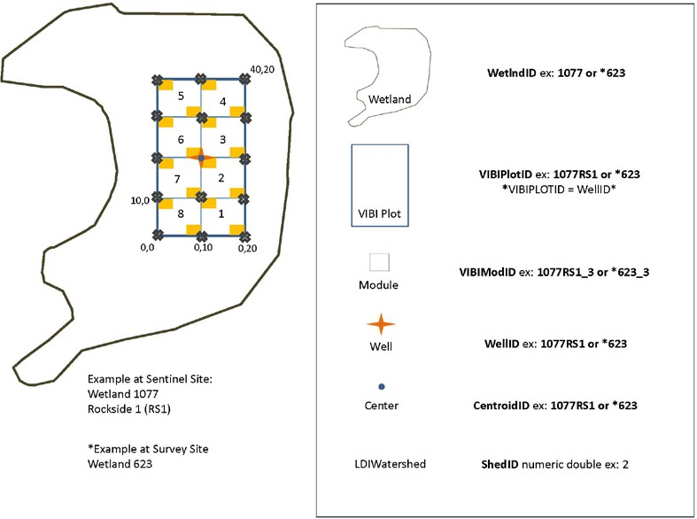

**Figure 16.1.** Diagram of the nomenclature (location IDs) assigned to various spatial features in the geodatabase. Location IDs include the *WetlndID*, *VIBIPlotID*, *VIBIModID*, *WellID*, *CentroidID* and *ShedID*. These Location IDs were assigned systematically to link spatial data in GIS with non-spatial data in an Access database (HTLNWetland.mdb). In the Sentinel Site example, Wetland 1077, the *WetlndID,* is also referred to as Rockside (1077RS). Sentinel Sites are large and may have more than one *WellID* and sampling array (*VIBIPlotID*). This is sampling array 1 (1077RS1) of 3 different Rockside locations. The well is situated in the center of the plot so the *Well ID* and *Plot ID* numbers match (1077RS1). They are distinguished from each other by a Feature Type option in the Access Database. Sampling arrays are made up of between 1 and 10, 10 x 10 m modules, which are distinguished from the *VIBIPlotID* by adding an underscore and module number. In this example, Rockside sampling array 1, Module 1 would be 1077RS1_1 (*VIBIModID*). On a larger scale, watersheds included in the Landscape Development Intensity Index are identified by their *ShedID*.

## Heartland Wetlands Database (HTLNWetland.mdb)

The wetlands database stores the primary data associated with spatial features except wells (i.e., hydrological information) including land cover information, vegetation data, and plant voucher information, as well as metadata associated with establishing sites and deploying wells (*HTLNWetland.mdb*). *HTLNWetland.mdb* uses a hierarchical design based on the NPS NRDT standard. Like most monitoring databases, the database is event- and location-driven. Locations (see HTLNWetlands.gdb above, Figure 17.1) and sampling periods should be maintained at the top of the hierarchy. The switchboard (Figure 17.2) guides the data entry process.

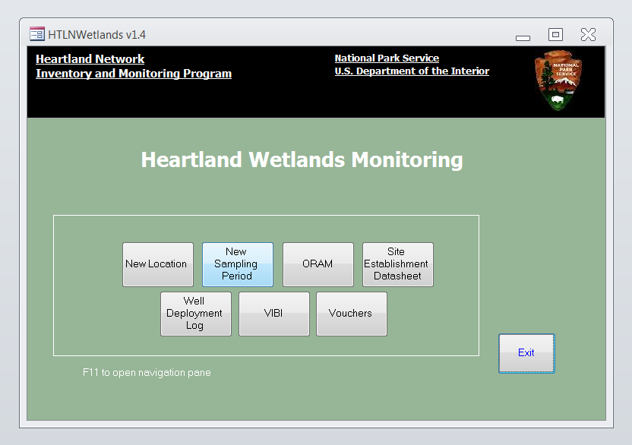

**Figure 16.2.** Switchboard for HTLNWetlands.mdb, the database used to manage wetland monitoring data for Cuyahoga Valley National Park.

## NPSTORET Database (NPSTORET.mdb)

NPSTORET (*NPSTORET.mdb*) is a national-level, National Park Service (NPS) database that serves as a repository of water quality monitoring data in a common, publicly available format as required by The Natural Resources Management Guideline (NPS-77). NPSTORET is comprised of a front- end named “*NPSTORET.mdb*” (Figure 16.3) that contains all of the forms, reports, code modules, and system tables and the following three linked back-end databases:

* *NPSTORET_be.mdb* – contains the user-entered data,
* *NPSTORET_defTab.mdb* – contains the STORET and WQX Reference tables for compatibility with EPA’s STORET data warehouse, and
* *NPSTORET_defLeg.mdb* – contains tables of reserved Station and Project IDs already used by NPS.

*NPSTORET.mdb* resides on an individual computer, while the three back-end databases reside on the server. For more information see: <http://www.nature.nps.gov/water/vitalsigns/vitalsignsmgt.cfm>

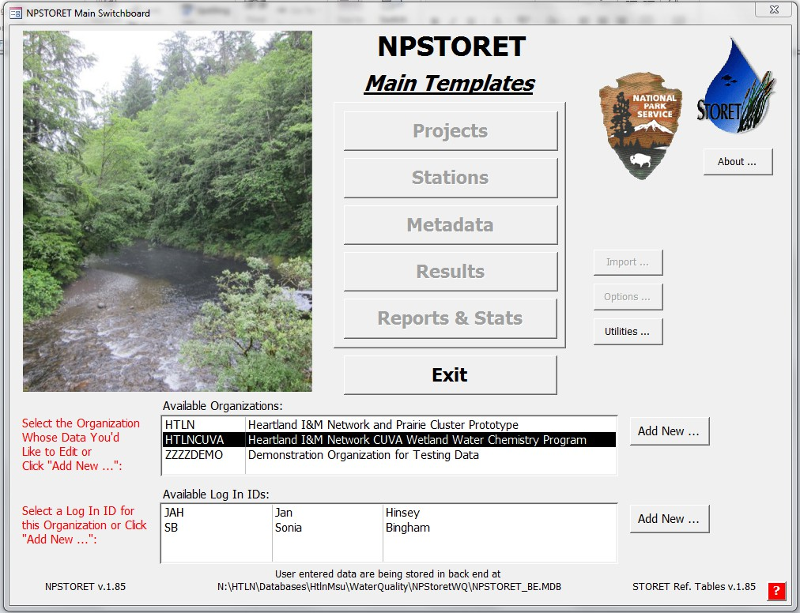

**Figure 16.3.** NPSTORET main log-in screen requires selecting the organization (HTLNCUVA) and observer name (i.e., log in ID) to begin data entry.

## Aquarius Database

Continuous water level data collected from the Ecotone™ digital water level loggers (SOP 8) are managed in the Aquarius database. Aquarius is managed by Aquatic Informatics and the NPS has a limited number of servicewide licenses for its use. Aquarius is available on the NRSS Fort Collins server. The installation includes the access to the Aquarius server which provides the Springboard interface (Figure 16.4), automation, and access to the Aquarius database and Aquarius workstation. Springboard provides the basic toolboxes for importing/appending time series, managing folders, locations, and field visits; quick view; data correction; exporting, and reporting.

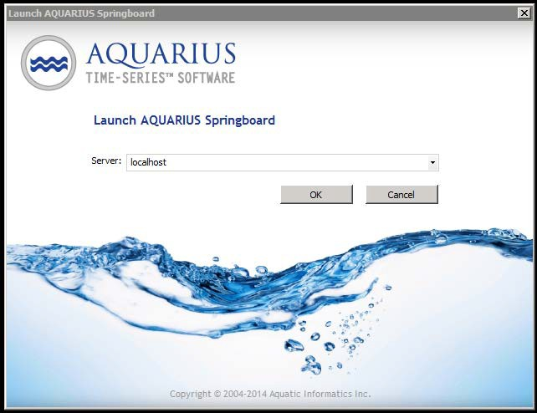

**Figure 16.4.** Springboard used to launch data management activities associated with the Aquarius database.

Datasets entered into Aquarius can be downloaded by the public from the NPS Aquarius web data portal (https://irma.nps.gov/aqwebportal/). For more details on this, consult the Aquarius Web Data Portal Overview Document.

## Heartland Water Depth Spreadsheets

The Heartland water depth spreadsheets are used to manage the data associated with manual groundwater measurements (SOP 7) at Wetlands of Management Concern. The spreadsheets use a time and location ID for each measurement. The data for each groundwater well are stored on a separate worksheet. Currently we manage 8 water depth spreadsheets. For Intensive survey sites, water depth is recorded in NPStoret with water quality measurements.