logo

QEPlot Widget

Andrew Starritt

11th December 2019

Copyright (c) 2019 Australian Synchrotron

Permission is granted to copy, distribute and/or modify this document under the terms of the GNU Free Documentation License, Version 1.3 or any later version published by the Free Software Foundation; with no Invariant Sections, no Front-Cover Texts, and no Back-Cover Texts.  
A copy of the license is included in the section entitled "GNU Free Documentation License" within the QE_QEGuiAndUserInterfaceDesign document.

Contents

Introduction 3

Description 3

Properties 4

Variable Names 4

Individual trace presentation 4

Scaling and units 5

Plot presentation 5

Scalar attributes 5

Waveform attributes 6

# Introduction

This document describes in detail the QEPlot widget which is an EPICS aware widget provided by the EPICS Qt Framework, also known as the QE Framework.

This document was created as a separate widget specification document. The main reason for this is ease of maintenance and avoiding editing large and unwieldly word documents.

The QE Framework is distributed under the GNU Lesser General Public License version 3, distributed with the framework in the file LICENSE. It may also be obtained from here: <http://www.gnu.org/licenses/lgpl-3.0-standalone.html>

# Description

The QEPlot widget is a basic widget for plotting scalar variables over time, or presenting waveform variables. On receiving an update of a scalar value it will add the value to the scalar values already presented in the plot. On receiving an update of a waveform it will replace the current plot with a plot of the new waveform. This widget is intended for presentation as small indicator plot. It has limited scaling ability and no user interaction such as cursors and measurements, or user defined scaling or timescale. For a more sophisticated scalar and waveform presentation, do consider using the QEStripChart and QEPlotter widgets respectively.

Up to eight variables may be plotted. By default plots are auto-scaled with a time span of 60 seconds.

While both scalar and waveform variables can be shown on the same QEPlot widget, this is not the intended use.

QEPlot only uses the data timestamp as-is within reasonable limits. If necessary the timestamp is adjusted to stay within 100mS into the future and 500mS into the past. This should cater for typical limitations in machine time synchronisation and occasional network latencies.

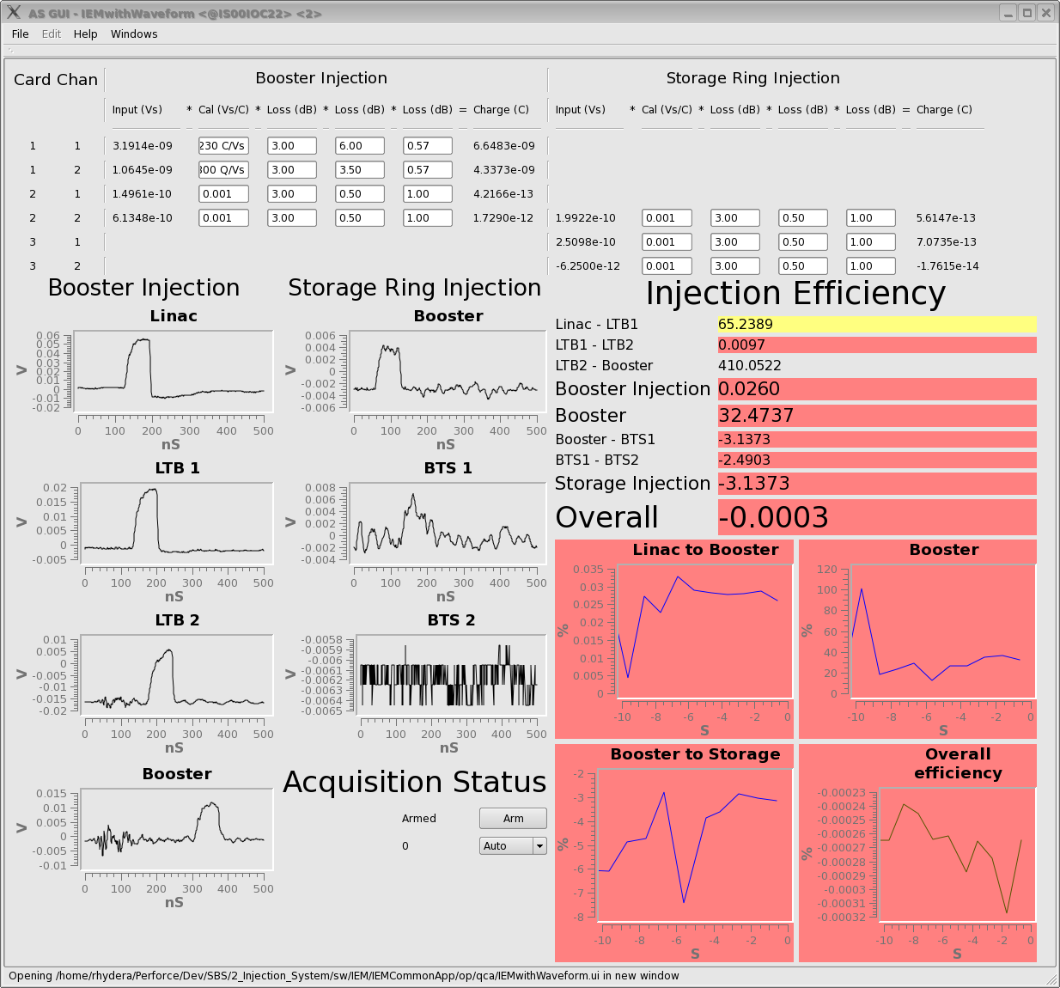

Figure 1 GUI using QEPlot widgets to plot waveforms (left) and scalar values (right)

# Properties

The QEPlot widget inherits directly from QEFrame, and as such has all the properties provided by the QEFrame widget.

## Variable Names

The Process Variable names may be specified in the usual QE Framework fashion:

* variable1-8
* variableSubstitutions - specified the default variable name substitutions – this applies to all the variable names.

## Individual trace presentation

Each trace may be given a colour, line style, line and a legend using the following properties:

* traceColour1-8
* traceStyle1-8
* traceWidth1-8
* traceLegend1-8

## Scaling and units

All traces must be scaled as a set. The QEPlot widget can auto-scale all traces, or can use a fixed range. With the following properties:

* autoScale (default is to auto-scale)
* yMin and yMax

X and Y units may be specified using the following properties: Note, these are presented regardless of the actual data.

* xUnit,
* yUnit

## Plot presentation

X and Y axis are independently optional, as are major and minor X and Y grids, using the following properties:

* axisEnableX and axisEnableY (default is display axis)
* gridEnableMajorX and gridEnableMajorY (default is no grids)
* gridEnableMinorX and gridEnableMinorY (default is no grids)

The plot background and grid colours may be changed using:

* backgroundColor
* gridMajorColor and gridMinorColor

The entire plot may be given a title:

* title (default is no title)

## Scalar attributes

When displaying scalar values, the QEPlot widget displays all updates with timestamps within the time span specified. The entire plot is redrawn asynchronously to updates. The values on the X axis are seconds before the current time. The relevant properties are:

* timeSpan (default is 60 seconds)
* tickRate (default is 50mS)

## Waveform attributes

When displaying waveforms, the QEPlot widget presents the waveform and sets the range of values on the X axis according to properties specifying an initial value and an incremental value per point in the waveform. The xFirst/XLast can be used to limit/truncate the amount of data displayed.

* xStart (default is 0.0)
* xIncrement (default is 1.0)
* xFirst (default is -1000000.0)
* xLast (default is +1000000.0)