Heather, here is the information you will need to get you rolling.
- Go here: https://qcgames.zendesk.com/agent/discovery
- Use the login information of
  - Email: tbiafore@gmail.com
  - Pass: Snowflake4433
- For the email website to customize it, you will need to go here and select “GUIDE”. Guide is the term used for the support site/help center:
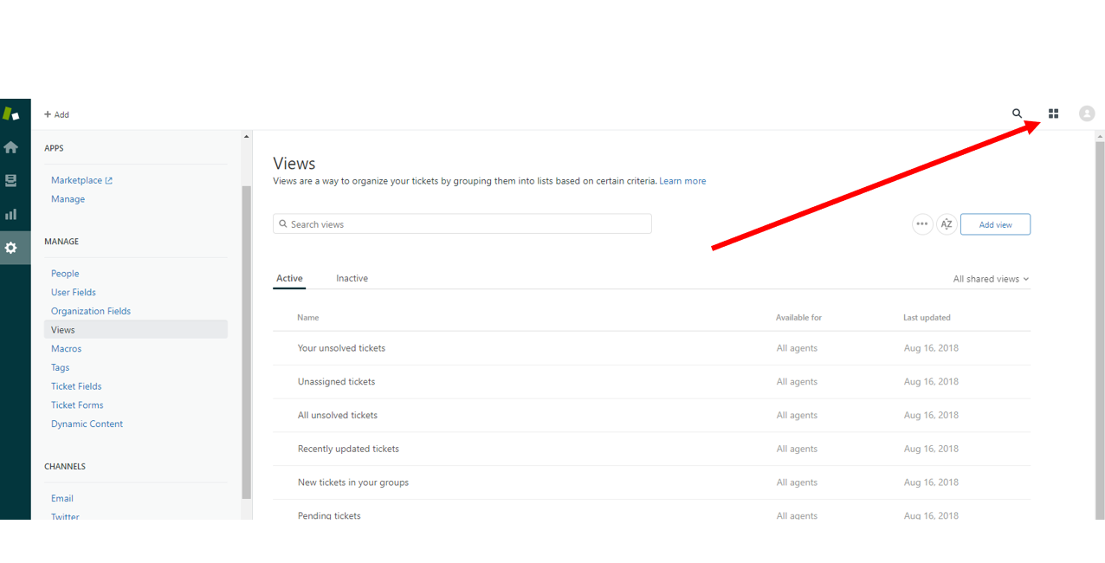

We have some articles that we have set to “promoted” and other articles that are normal so you can work with them and see the difference.
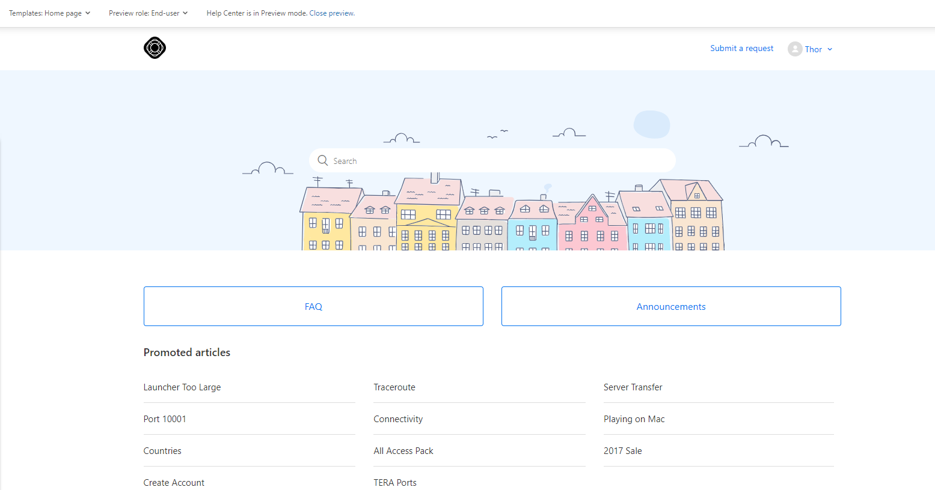
You will want to make sure that at the top it is selected as “preview role: End User” to see what the customer would see.

To edit and customize the current “out of the box layout” you select “Guide Admin” in the upper right hand corner (but the Preview needs to be closed in order to see “guide admin”).
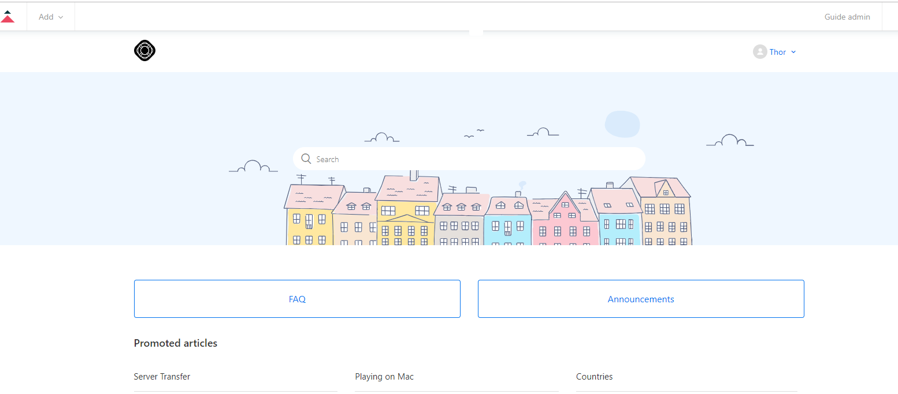

To apply customization to the “out of the box layout” there is an article that explains how to do this here: https://support.zendesk.com/hc/en-us/articles/203664326

https://qcgames.zendesk.com/hc/en-us/requests/new is the location to the webform

