Jeopardy Project All Seasons

Heather Deel

11/18/2019

## Libraries

library(readr)  
library(dplyr)

##   
## Attaching package: 'dplyr'

## The following objects are masked from 'package:stats':  
##   
## filter, lag

## The following objects are masked from 'package:base':  
##   
## intersect, setdiff, setequal, union

library(tidyr)  
library(stringr)  
library(ggplot2)  
library(forcats)  
library(RColorBrewer)

## Read in the data

seasons_all <- read_tsv("master_season1-35.tsv")

## Parsed with column specification:  
## cols(  
## round = col_double(),  
## value = col_double(),  
## daily_double = col_character(),  
## category = col_character(),  
## comments = col_character(),  
## answer = col_character(),  
## question = col_character(),  
## air_date = col_date(format = ""),  
## notes = col_character()  
## )

## Create new dataframe with all seasons

seasons_all_cat <- seasons_all %>%  
 group_by(category) %>%   
 count() %>%   
 arrange(desc(n))

## Clean up seasons data

seasons_all_clean <- seasons_all %>%   
 separate(air_date, sep="-", into = c("year", "month", "day")) %>%   
 select(-comments, -notes) %>%   
 mutate(category = str_to_lower(string = category)) %>%  
 mutate(answer = str_to_lower(string = answer)) %>%   
 mutate(question = str_to_lower(string = question)) %>%   
 filter(year != "2019")

Question 2: How often does the mythology category appear over each year? Is there a trend in how often it occurs over time?

## Filter by mythology category and group by year

seasons_all_myth <- seasons_all_clean %>%   
 filter(category == "mythology") %>%   
 group_by(year) %>%   
 count()

## Plot mythology category by year

seasons_all_myth %>%   
 ggplot(aes(x = year, y = n)) +  
 geom_bar(stat = "identity", fill = "pink") +  
 theme_classic() +  
 ggtitle("Number of questions asked in the Mythology category by season") +  
 theme(axis.text.x = element_text(angle = 45, hjust = 1)) +  
 labs(x = "Year", y = "Number of questions")

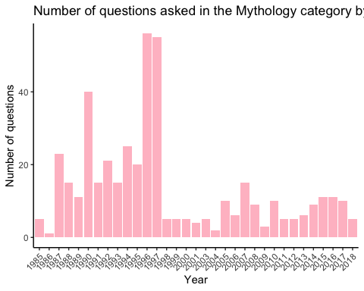

Question 3: How often does “Athena”, the greek goddess of war, appear over time? Is there a trend?

## Filter to “Athena” in question and answer columns and group by year

# note that with this code, it includes "Athena" not just in the mythology category - increases occurrences from 21 to 103  
  
seasons_all_athena <- seasons_all_clean %>%   
 filter(str_detect(question, "athena") | str_detect(answer, "athena")) %>%   
 group_by(year) %>%   
 count()  
  
# create dataframe without grouping to see what other categories are there  
seasons_all_athena_cat <- seasons_all_clean %>%   
 filter(str_detect(question, "athena") | str_detect(answer, "athena")) %>%   
 group_by(category) %>%   
 count()

## Plot “Athena” by season

seasons_all_athena %>%   
 ggplot(aes(x = year, y = n)) +  
 geom_bar(stat = "identity", fill = "purple") +  
 theme_classic() +  
 ggtitle("Number of times 'Athena' is mentioned in the question or answer") +  
 theme(axis.text.x = element_text(angle = 45, hjust = 1)) +  
 labs(x = "Year", y = "Number of mentions")

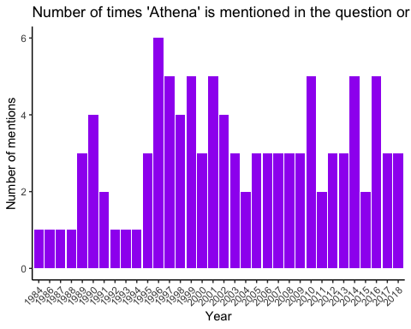

## Try plotting but by category

seasons_all_athena_cat %>%   
 ggplot(aes(x = category, y = n)) +  
 geom_bar(stat = "identity", fill = "purple") +  
 theme_classic() +  
 ggtitle("Number of times 'Athena' is mentioned in the question or answer") +  
 theme(axis.text.x = element_text(angle = 45, hjust = 1)) +  
 labs(x = "Category", y = "Number of mentions")

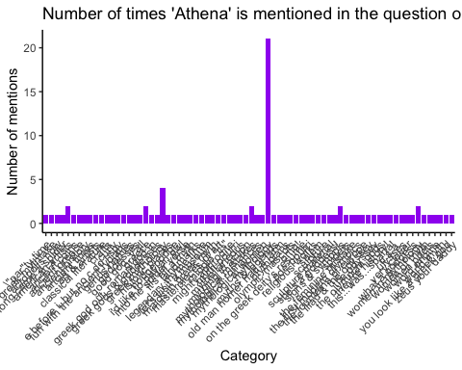

### Do it with multiple greek gods

## Filter to multiple greek gods in question and answer columns and group by year

greek_gods <- c("athena", "zeus", "poseidon", "hades", "hera", "apollo", "demeter", "artemis", "aphrodite", "ares")  
  
seasons_all_greek <- seasons_all_clean %>%   
 filter(str_detect(question, greek_gods) | str_detect(answer, greek_gods))

## Warning in stri_detect_regex(string, pattern, negate = negate, opts_regex  
## = opts(pattern)): longer object length is not a multiple of shorter object  
## length  
  
## Warning in stri_detect_regex(string, pattern, negate = negate, opts_regex  
## = opts(pattern)): longer object length is not a multiple of shorter object  
## length

## Norse

norse_gods <- c("odin", "loki", "thor", "njord", "heimdall", "frigg", "tyr", "baldur", "idun", "bragi")  
  
seasons_all_norse <- seasons_all_clean %>%   
 filter(str_detect(question, norse_gods) | str_detect(answer, norse_gods))

## Warning in stri_detect_regex(string, pattern, negate = negate, opts_regex  
## = opts(pattern)): longer object length is not a multiple of shorter object  
## length  
  
## Warning in stri_detect_regex(string, pattern, negate = negate, opts_regex  
## = opts(pattern)): longer object length is not a multiple of shorter object  
## length

## Graph norse gods by category

seasons_all_norse_top5 <- seasons_all_norse %>%   
 filter(category == "authors" |  
 category == "books & authors" |  
 category == "literature" |   
 category == "english literature" |   
 category == "fictional characters") %>%   
 group_by(category) %>%   
 count()  
   
  
seasons_all_norse_top5 %>%  
 ggplot(aes(x = reorder(category, -n), y = n)) +  
 geom_bar(stat = "identity", fill = "blue") +  
 theme_classic() +  
 ggtitle("Number of times Norse Gods are mentioned in the question or answer") +  
 labs(x = "Category", y = "Number of mentions")

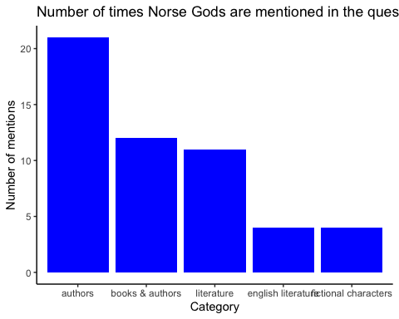

## Hindu

hindu_gods <- c("vishnu", "brahma", "shiva", "lakshmi", "hanuman", "ganesha", "krishna", "kali", "rama", "saraswati")  
  
seasons_all_hindu <- seasons_all_clean %>%   
 filter(str_detect(question, hindu_gods) | str_detect(answer, hindu_gods))

## Warning in stri_detect_regex(string, pattern, negate = negate, opts_regex  
## = opts(pattern)): longer object length is not a multiple of shorter object  
## length  
  
## Warning in stri_detect_regex(string, pattern, negate = negate, opts_regex  
## = opts(pattern)): longer object length is not a multiple of shorter object  
## length

### Try adding column for god name

seasons_all_hindu_name <- seasons_all_clean %>%   
 filter(str_detect(question, hindu_gods) | str_detect(answer, hindu_gods)) %>%   
 mutate(god_name = stringr::str_extract(question, "vishnu"))

## Warning in stri_detect_regex(string, pattern, negate = negate, opts_regex  
## = opts(pattern)): longer object length is not a multiple of shorter object  
## length  
  
## Warning in stri_detect_regex(string, pattern, negate = negate, opts_regex  
## = opts(pattern)): longer object length is not a multiple of shorter object  
## length

## Merga all 3 datasets

seasons_all_gods3 <- merge(merge(seasons_all_greek, seasons_all_norse, all = TRUE), seasons_all_hindu, all = TRUE)

## Group by category

seasons_all_gods_cat <- seasons_all_gods3 %>%   
 group_by(category) %>%   
 count()  
  
seasons_all_gods_top5 <- seasons_all_gods_cat %>%  
 filter(category == "authors" |  
 category == "books & authors" |  
 category == "literature" |   
 category == "mythology" |   
 category == "english literature")

## Now graph

seasons_all_gods_top5 %>%  
 ggplot(aes(x = reorder(category, -n), y = n)) +  
 geom_bar(stat = "identity", fill = "blue") +  
 theme_classic() +  
 ggtitle("Number of times all Gods are mentioned in the question or answer") +  
 labs(x = "Category", y = "Number of mentions")

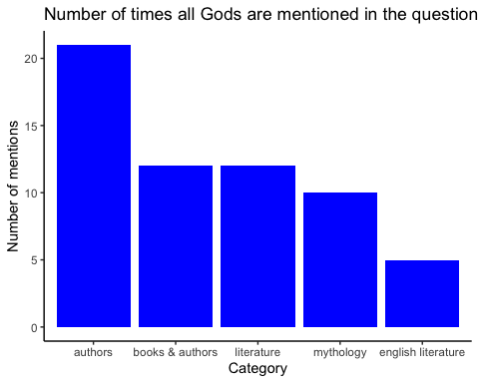

### will maybe try to facet by god or something for another interesting figure

### In depth analysis of gods and their prevalence in certain categories

### create columns for Zeus and Athena

seasons_all_gods3_athenaQ <- seasons_all_gods3 %>%   
 mutate(god_name = stringr::str_extract(question, "athena"))  
  
seasons_all_gods3_athenaA <- seasons_all_gods3 %>%   
 mutate(god_name = stringr::str_extract(answer, "athena"))  
  
seasons_all_gods3_zeusQ <- seasons_all_gods3 %>%   
 mutate(god_name = stringr::str_extract(question, "zeus"))  
  
seasons_all_gods3_zeusA <- seasons_all_gods3 %>%   
 mutate(god_name = stringr::str_extract(answer, "zeus"))  
  
seasons_all_gods_ZAcat <- merge(merge(merge(seasons_all_gods3_athenaQ, seasons_all_gods3_athenaA, all = TRUE), seasons_all_gods3_zeusQ, all = TRUE), seasons_all_gods3_zeusA, all = TRUE)

### Fill by god (Zeus or Athena) to look at their prevalences over time

seasons_all_gods_ZAcat_group <- seasons_all_gods_ZAcat %>%  
 group_by(category, year, god_name) %>%   
 count()

## Releveling

# make it so it says 'other'  
seasons_all_gods_ZAcat$god_name <- as.character(seasons_all_gods_ZAcat$god_name)  
seasons_all_gods_ZAcat$god_name[is.na(seasons_all_gods_ZAcat$god_name)] <- "other"  
  
seasons_all_gods_ZAcat$god_name <- as.factor(seasons_all_gods_ZAcat$god_name)  
  
seasons_all_gods_ZAcat$god_name <- relevel(seasons_all_gods_ZAcat$god_name, "other")

color_pal <- c("grey75", "tomato1", "royalblue1")  
  
seasons_all_gods_ZAcat_group %>%  
 ggplot(aes(x = year, y = n, fill = god_name)) +  
 scale_fill_manual(values = color_pal) +  
 geom_bar(position = "stack", stat = "identity") +  
 theme_classic() +  
 ggtitle("The prevalence of Zeus and Athena in questions and answers over time") +  
 theme(axis.text.x = element_text(angle = 45, hjust = 1))

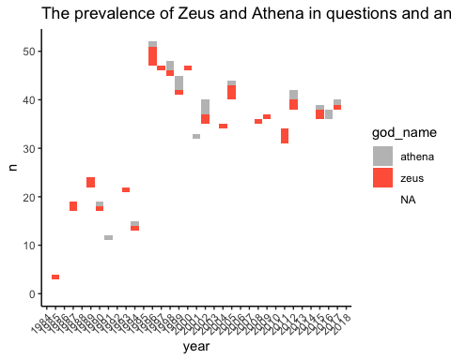

### note that this is testing the prevalence of Zeus and Athena out of all 15 tested gods from all categories

### Then filter to the top 5 categories (authors, books & authors, literature, mythology, english literature, and fill by god)

seasons_all_gods_ZAcat_top5 <- seasons_all_gods_ZAcat %>%  
 filter(category == "authors" |  
 category == "books & authors" |  
 category == "literature" |   
 category == "mythology" |   
 category == "english literature")  
  
seasons_all_gods_ZAcat_top5_group <- seasons_all_gods_ZAcat_top5 %>%   
 group_by(category, year, god_name) %>%   
 count()

seasons_all_gods_ZAcat_top5_group %>%  
 ggplot(aes(x = reorder(category, -n), y = n, fill = god_name)) +  
 geom_bar(stat = "identity") +  
 theme_classic() +  
 ggtitle("Number of times all Gods are mentioned in the question or answer") +  
 labs(x = "Category", y = "Number of mentions")

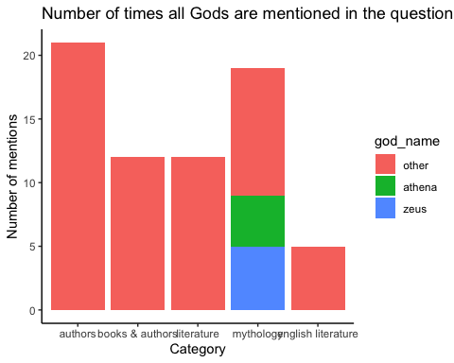

### use forcats to change 'NA' to 'other and reorder so that Zeus and Athena are on the bottom of the chart