**Univariative Charts:**

**(1)**

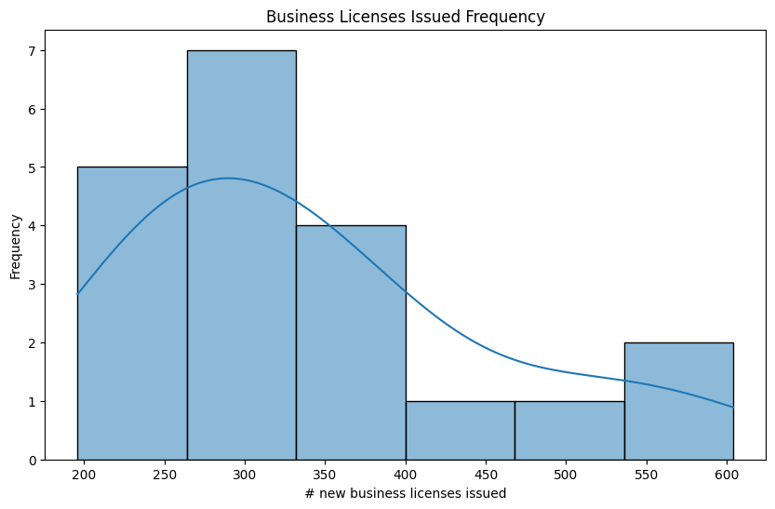

Understanding the amount of business licenses being issues will be crucial for understanding the trends of both Ecommerce and Brick-and-Mortar stores.

**(2)**

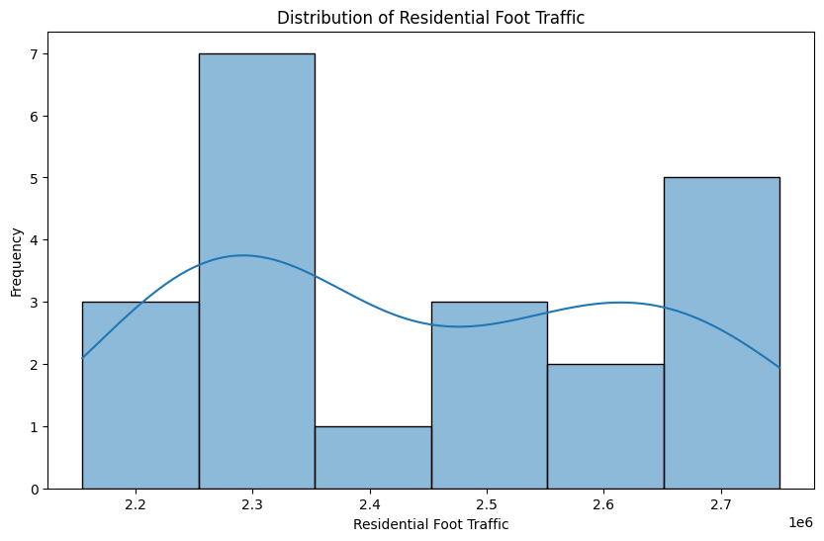

This taken from the Seattle Foot traffic data will help us understand the variation in the variable which will ultimately be important to consider as we incorporate foot traffic into our

**(3)**

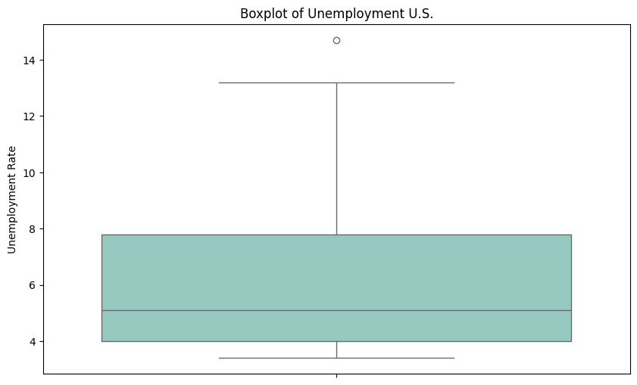

Taken from our Economic Indicators data set, this boxplot will be helpful when weighing the impact of unemployment on sales in general.

Bivariate Charts:

**(1)**

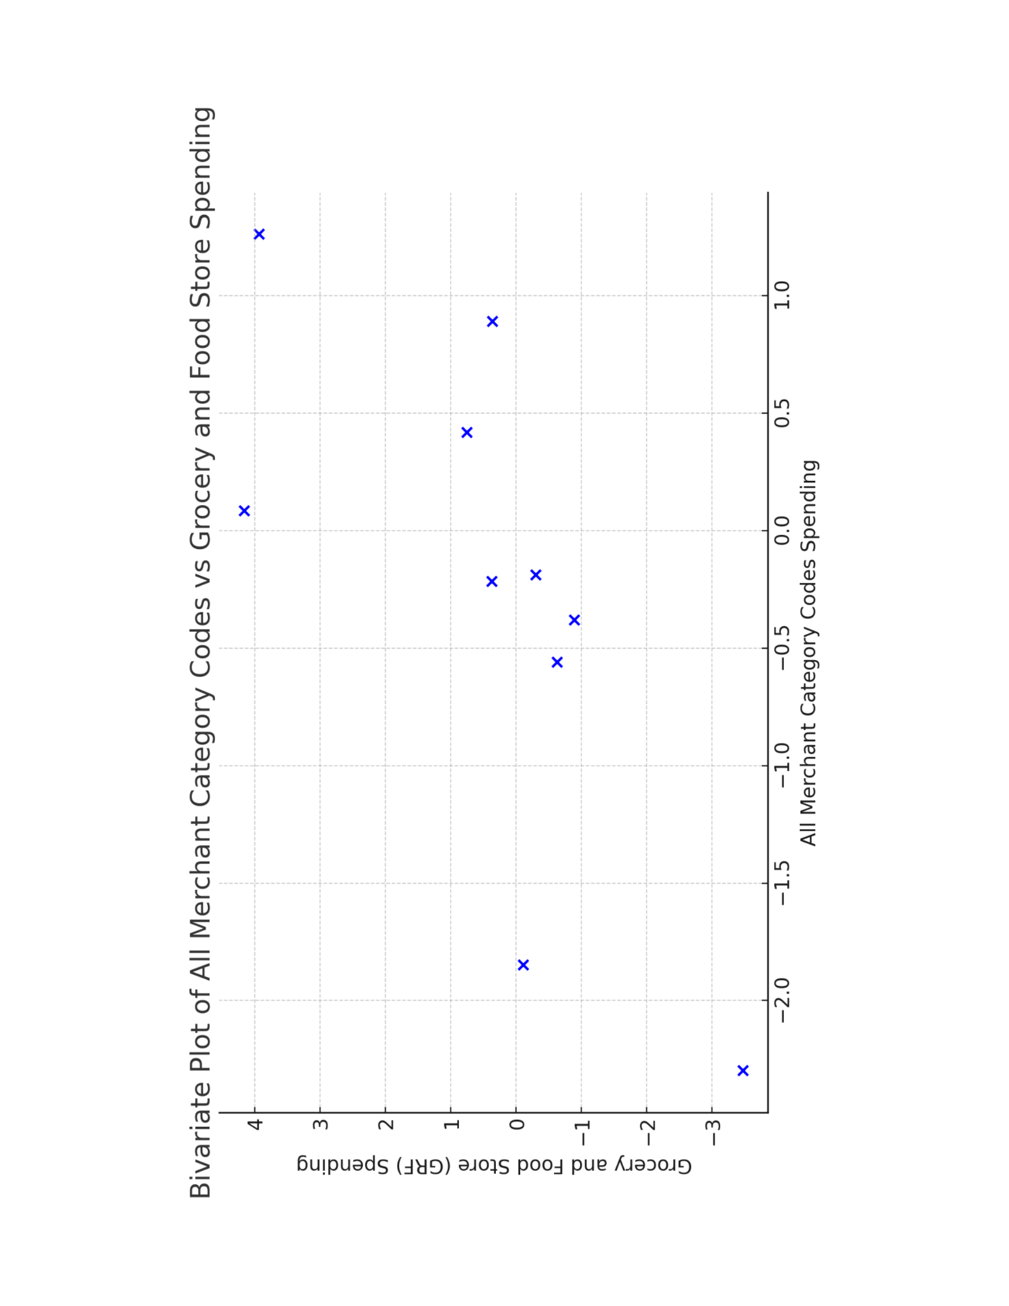

This graph showcasing a comparison of merchant codes to grocery store and food spending will help in the process of deciphering what industries consumers are spending their money on.

**(2)**

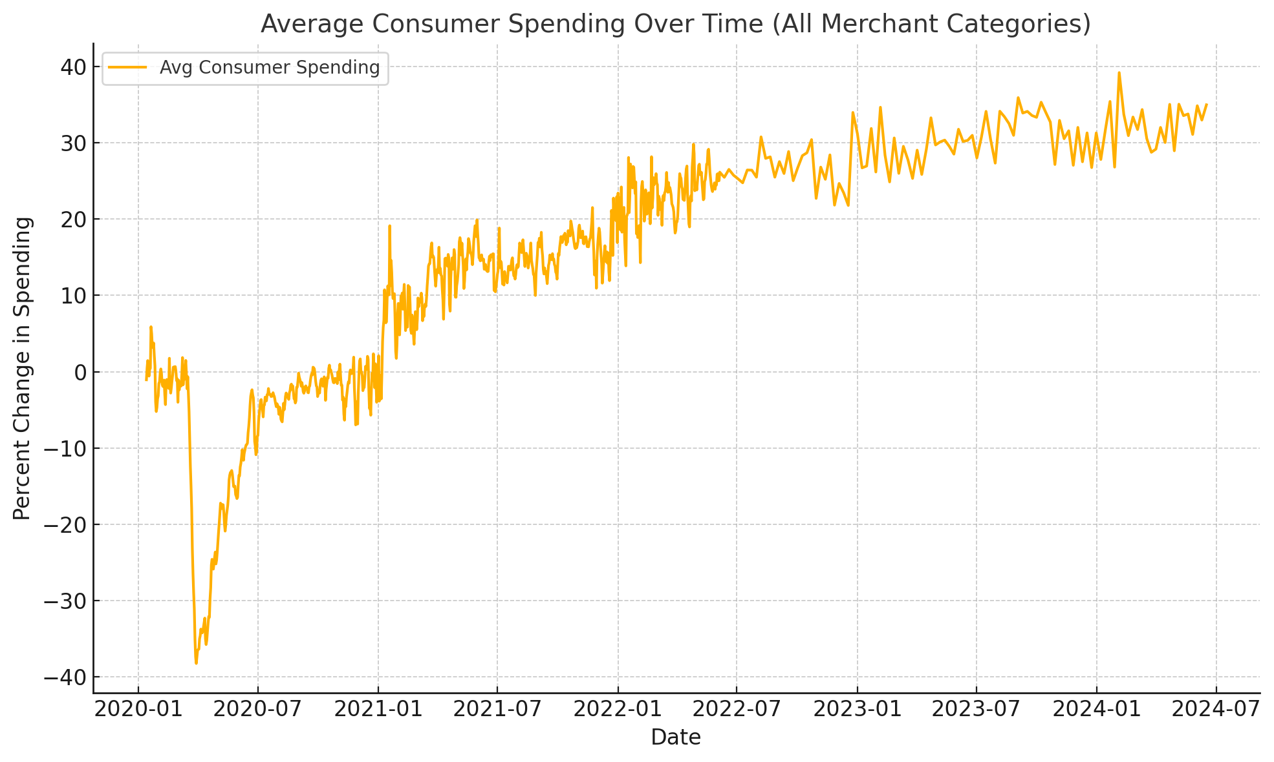

This visual gives us a good understanding of how spending overtime has evolved. This will be a crucial component to consider when weighing the total impact of Ecommerce on Brick-and-Mortar stores.

**(3)**

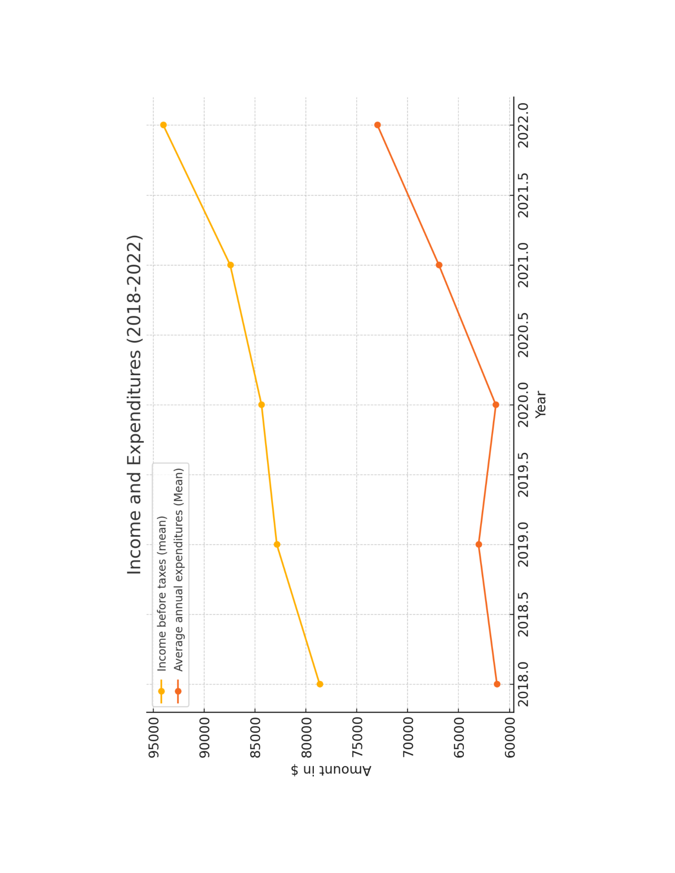

Having a base understanding of the populations mean income versus expenditures as shown in this graph will be necessary when it comes to assessing potential outside impacts on Brick-and-Mortar and Ecommerce sales.

**Descriptive Statistics Table and Graphs that show issues**

The descriptives table gives the means, standard deviations, min and maxes, for the chosen feature. Consumer confidence and price are important as it shows how confident the consumers are in their finances. The lower the score, the less likely they think their finances are doing well. Consumer prices reflect the change in prices (think inflation and deflation). Retail occupancy is important as it can indicate the demand for physical shopping locations. Generally, the higher the value, the better, though what is considered high may differ from location to location. For instance, cities would need a higher value for a demand for physical stores then rural locations, as cities have higher populations then rural locations. The graphs shows issues with data, such as outliers (consumer price index) and missing values (retail occupancy).

