**Assignment 3.3 – NodeBookCo Heather Peterson 18 May 2018**

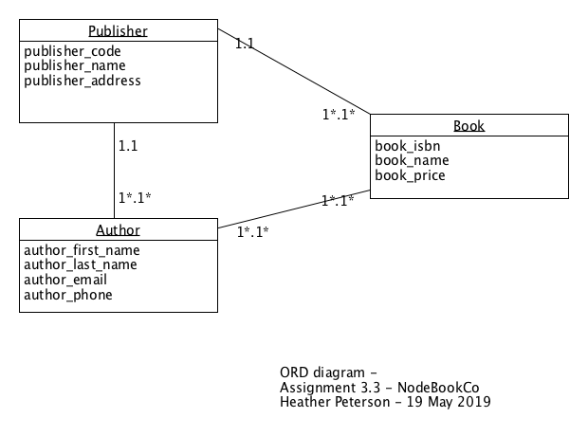

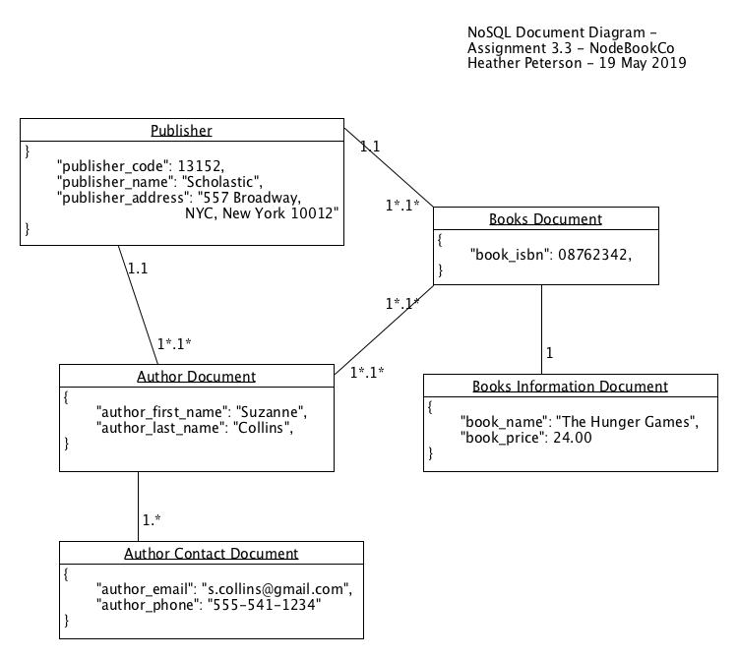

**NoSQL Data Structure**

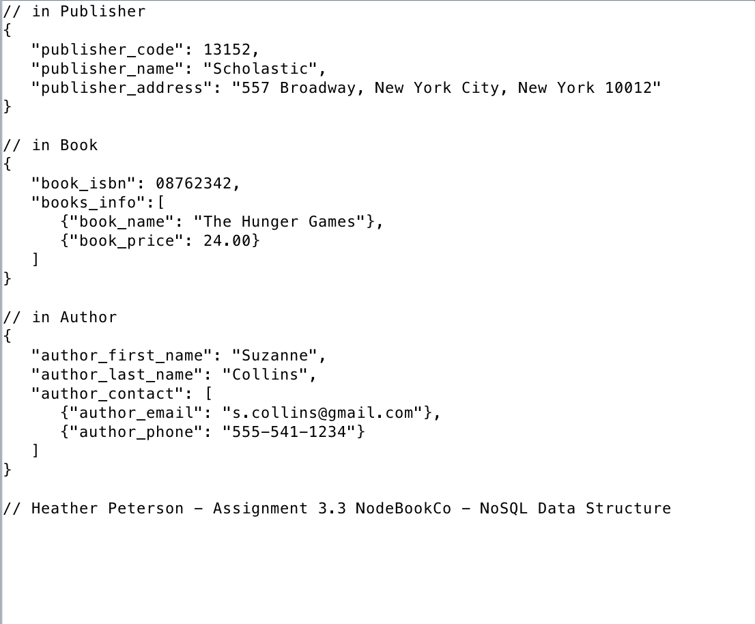

**Business Rules**

- One **publisher** can publish one or more **books**.

- One or many **books** can be published by one **publisher**.

- One or more **authors** can write one or more **books**.

- One or more **books** can be written by one or more **authors**.

- One or more **authors** can have a book published by one **publisher**.

- One **publisher** can publish a book for one or more **authors**.