AquaFlux User Manual

Written by Heather Speckman

Last Updated July 8, 2019

Accompanies scientific paper: “AquaFlux: Swift and Transparent Analysis of Plant-level Transpiration”, Submitted to Methods in Ecology and Evolution. Authored by H.N. Speckman, D.B. Beverly, and B.E. Ewers

Table of Contents

Chapter 1: What is Sap Flux? Science background 3

1.1 What AquaFlux does 4

Chapter 2: AquaFlux File Requirements 5

2.1 Data structure requirements: 5

2.2 Where to save raw data 6

Chapter 3: Installing and Starting AquaFlux “Set Up Site” 6

3.1 Installing AquaFlux 6

3.2 Starting AquaFlux and “Set Up Site” 7

3.3 Starting a new site 8

3.4 Restarting AquaFlux / Including New Data 9

3.5 It Crashed! Troubleshooting Guide 10

Chapter 4: List Broken Sensors 10

Chapter 5: Process dT Data - QAQC 10

5.1 What Am I looking at? “Process dT” Dashboard. 10

5.2 QAQC: knowing what’s good, what’s bad 12

5.3 QAQC: How To Delete Points 16

5.4 Restore Data: The “Undo” Button 16

5.5 Saving Data And Closing AquaFlux 16

Chapter 6: Process dT Data – Tmax 17

Chapter 7: Review Calculated Sap Flux 20

Chapter 8: Export Final Sap Flux Data 20

Chapter 9: Post Processing Options 21

9.1 Gapfilling 21

9.2 Rescaling Sap Flux 21

9.3 Radial Trends 22

Appendix: R 101 22

A.1: Downloading R and RStudio. 22

A.2: How to define a directory in AquaFlux 23

Works Cited 23

# ****Chapter 1: What is Sap Flux? Science background****

Plant-level transpiration is commonly quantified either as the flow rate (e.g., *sap flow*, g s-1) or mass of water per conducting area (e.g., *sap flux*, g m-2 of sapwood s-1) (Vandegehuchte & Steppe 2013). Measuring sap quantifies spatiotemporal variability of plant transpiration, improves understanding of plants’ response to the environment, and better relates plant traits to transpiration rates. Such investigations range from individual sites to global analysis facilitated by SAPFLUXNET network (Poyatos *et al.* 2016).

Sap flux can be quantified by applying heat to the stem of a plant and measuring the rate at which heat is dissipated up the stem by water. Thermal dissipation probes (TDP) are popular sap flux sensor design (Bush *et al.* 2010; Vandegehuchte & Steppe 2013). The design and use of TDP sensors are comprehensively reviewed in Lu (Lu 2004), but in brief:

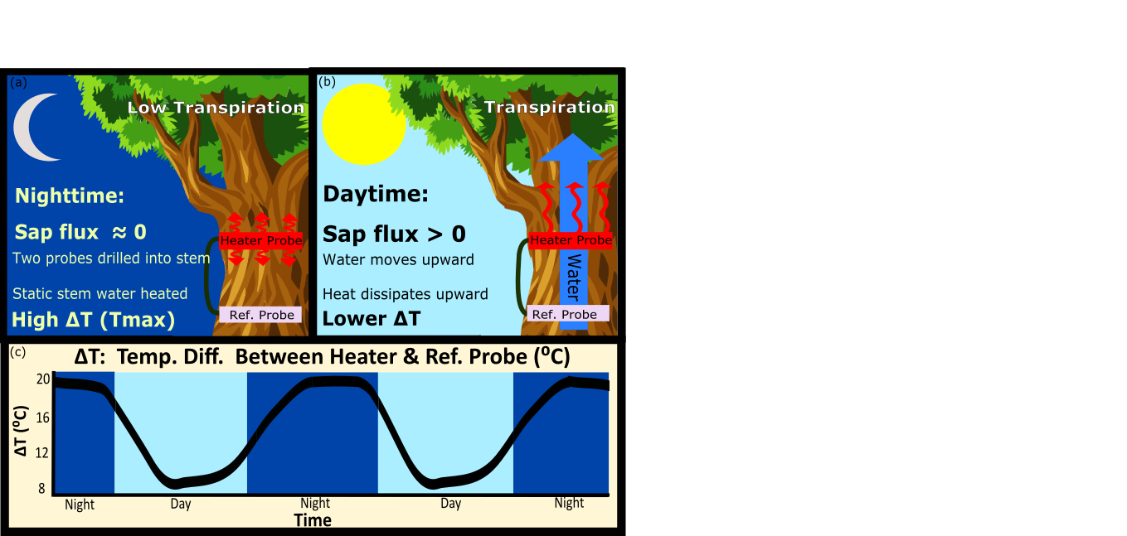

Figure 1.1: TDP Set up and methodology. See text for more detail

Each TDP sensor consists of two probes that are inserted into a plant’s sapwood (Figure 0.1). The top probe is heated and the bottom probe serves as a reference. A thermocouple links the two probes, and the TDP sensor reports the temperature difference between the probes (ΔT). On nights when sap flux =0, the static water around the heater becomes very warm, causing the greatest temperature gradients to be observed (ΔTmax). The AquaFlux package helps the user detect, quantify and evaluate the consequences of night time transpiration on calculations of sap flux. (b) During the day, transpiration causes water to be conducted up the stem and actively moves heat away, reducing the temperature gradient. (c) The resulting diel patterns in ΔT night-day cycles in transpiration.

Sap flux is calculated from the temperature gradient between the two probes:

( 1 )

where Fd is sap flux density (g m-2 of sapwood s-1) (Granier 1987) and the temperature gradient between the probes is ΔT (°C or K). ΔTmax represents the maximum temperate difference when Fd = 0. Calibration constants α and β are empirically derived. Originally, these constants were believed to be consistent across all woody plants (Granier 1987), but later studies revealed that some species demonstrated different values due to variation in wood anatomy or water content, For more details of TDP probes and theory, see (Speckman, Beverly & Ewers In review) Speckman in review.

### What AquaFlux does

AquaFlux is an open-source R package designed to efficiently process and analyze TDP data. AquaFlux can continually import raw TDP values with flexible formatting and alerts the user of malfunctioning sensors, thus optimizing data collection. Post-processing analysis addresses gapfilling, radial trends, and rescaling. To ensure reproducibility and transparency, all user decisions are automatically documented, highlighting the impact of the user’s decisions.

AquaFlux is divided into two sections: data processing and post-processing (Figure 1.2). The data processing takes raw TDP measurements into estimates of sap flux. This code has a point-and-click R interface, and does not require any programming skill. The second section is focused on giving an advanced user post-processing options for their data. These options take the form of useful functions in base R.

For ease of use, AquaFlux also includes an example dataset and walkthrough to properly use this data.

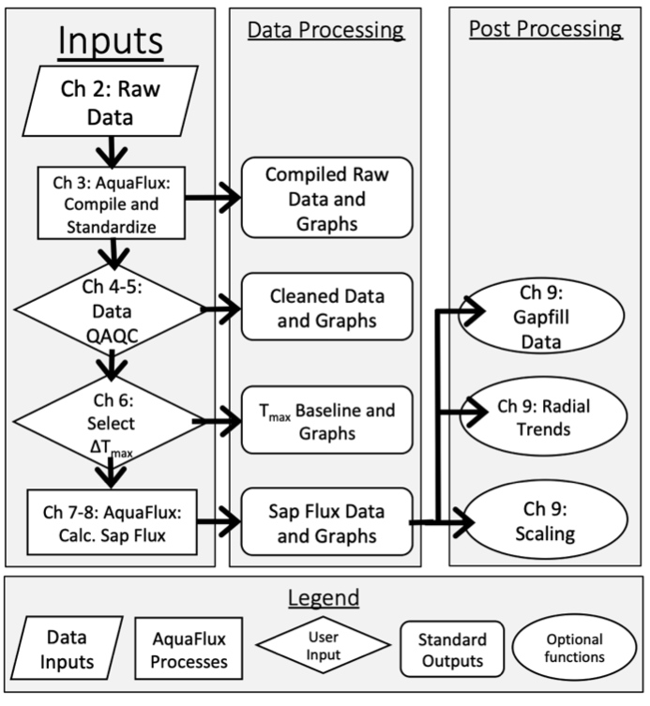

Figure 1.2: AquaFlux workflow and corresponding readme chapters.

# ****Chapter 2: AquaFlux File Requirements****

### Data structure requirements:

AquaFlux has the following file structure requirements:

1. Data is somehow delimited. Excel files (*.xlsx) are not accepted.
2. Data contains a timestamp.
3. Data structure is internally consistent- no renaming columns or changing units.

The following are things that do not matter in regard to data formatting or collection:

* How many sensors you have
* What your sensors are named.
* Data units (AquaFlux will standardize them)
* If you have data intermingled other than TDP sensors
* How many files you have (AquaFlux will merge them all for you).
* How many sites you have (AquaFlux will merge them all for you).
* How big is each file (as long as file size < 3 GB).
* Duplicated data will be removed by AquaFlux.
* Missing data
* Sampling/Averaging frequency, AquaFlux will even handle inconsistent timestamps.

### Where to save raw data

To run AquaFlux, you need to save your raw TDP data in a folder. Follow these directions exactly:

1. Each TDP sap flux site gets its own folder.
2. All of the data from that site goes in that folder.
3. Nothing else goes in that folder.

When you acquire more raw TDP data, simply place it in that same folder and re-run AquaFlux. Aquaflux will then combine your new data, the old data, and including previous work you have done.

Warning: if you have mixed types of data files in the same folder, AquaFlux will not properly function. You can have several sensor types in that same file (such as having raw TDP and meteorological data), but only one consistent file structure.

Meteorological data: If your meteorological data is on the same data files as the raw TDP data, no special steps need to be taken. If you meteorological data is on different data files, please place those meteorological files in their own folder, using the same guidelines outlines above.

# ****Chapter 3: Installing and Starting AquaFlux “Set Up Site”****

### Installing AquaFlux

To use AquaFlux, you will need to have R and RStudio installed on your computer. If you are unfamiliar with these programs, see Appendix for a primer and install guide. To download AquaFlux, below code either. You can either 1) copy/pasting it from here, or 2) use the already made R script found in this link: https://github.com/HeatherSpeckman/AquaFlux/blob/master/README%20and%20Getting%20Started/AquaFlux_Installation_Script

##### Installation

#' Install package “devtools” to download from Github

install.packages("devtools")

library(devtools)

# Actually download AquaFlux

install_github("HeatherSpeckman/AquaFlux")

library(AquaFlux)

# Launch AquaFlux

AquaFlux()

### Getting Example Data

The AquaFlux Github repository includes example data. This dataset will be referenced throughout this tutorial. It is recommended that you download this data, save it to your computer, and follow the walkthrough.

Download the example meteorological data from this link:

<https://github.com/HeatherSpeckman/AquaFlux/blob/master/README%20and%20Getting%20Started/Example%20Data/Met%20Tower%20Data.csv>

Download the example dT data from this link:

<https://github.com/HeatherSpeckman/AquaFlux/blob/master/README%20and%20Getting%20Started/Example%20Data/SF%20Data.csv>

**Important**: you want move each of these files to be in their own folder, with no other data in there. See section 2.2 for further explanation.

### Starting AquaFlux and “Set Up Site”

In RStudio, as shown Section 3.1, launch AquaFlux by typing the command “AquaFlux()” into the RStudio console. You will then have a graphical user interface appear (Figure 3.1):

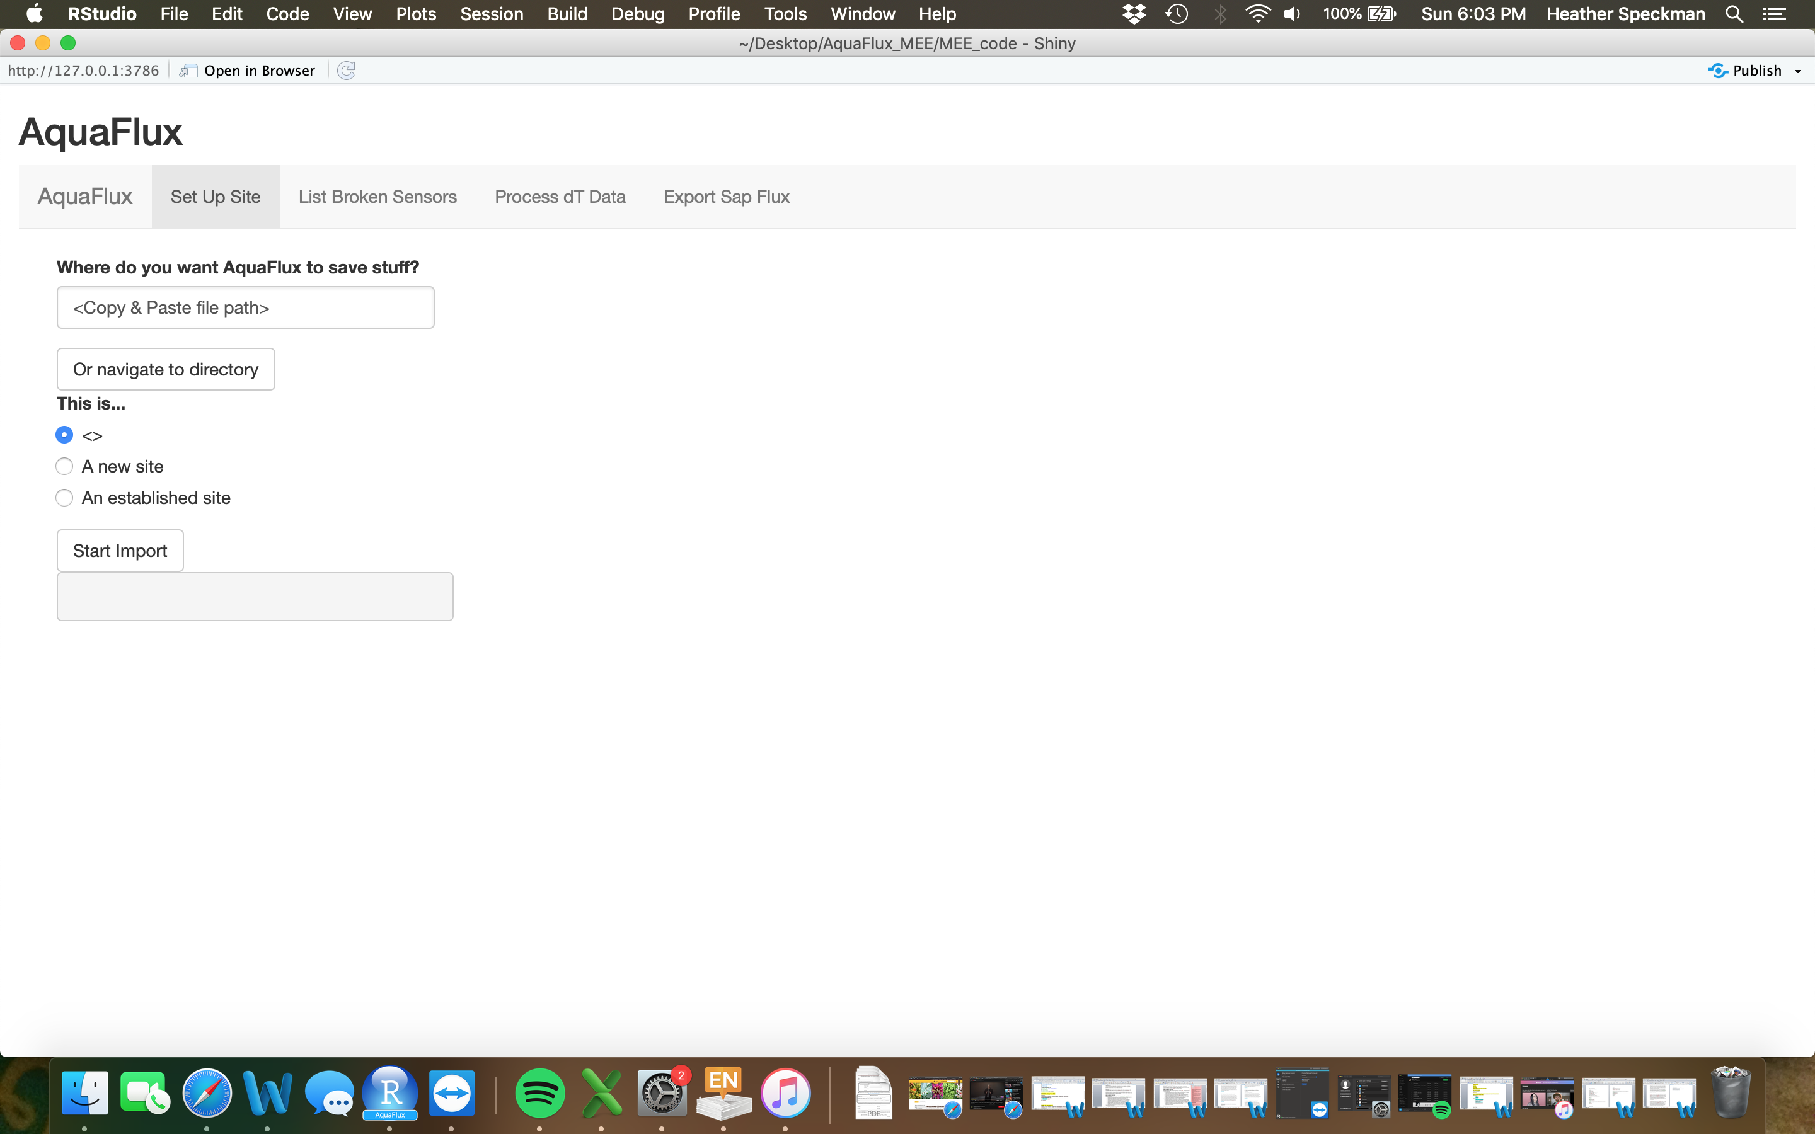

Figure 3.1: AquaFlux graphical user interface, “Set Up Site” panel.

By default AquaFlux will load up to the “Set Up Site” panel. This is where you will establish metadata about your site. This only needs to be done once per year of data.

**Start by telling AquaFlux the folder you wish to save things in.** You can do this one of two ways:

1. Paste the file path to where you want R to save metadata, midway products, and your final outputs. A guide to file paths is included in this Appendix of this readme.
2. Navigate to the folder by clicking the “navigate to directory button”.

Then indicate whether this is a new site or an established site, and then clicking the “Start Import” button. As a reminder: each calendar year of data much be ran separately, so select “a new site” if this is a new year of data.

### Starting a new site

When starting a new site, AquaFlux will ask a series of questions for you about your data. If you are working with the example data, see section 3.4.3.

3.4.1 First Group of Questions:

**“Where is your meteorological data?”** Navigate or paste the file path to where you saved your raw meteorological data (see Section 2.2).

“**Raw dT directory”:** Navigate or paste the file path to where you put your raw dT data (see Section 2.2).

**“Check my work”** Once you have finished answering the first group of questions, click this button. AquaFlux will now attempt to read in your data and tell you if everything is working correctly. This takes a minute. If you get an error here, please check

* Your file paths are correct and the data is actually there.
* No other file types are located in those folders.

More details in Chapter 1 of this manual.

3.3.2 Second Group of Questions

**Study Year:** AquaFlux can read in multiple years of data, but will filter it down to only process this 1 year at a time. If you wish to process multiple years of data, run AquaFlux multiple times, and save the results of each year to different directories.

**Timestamps:** AquaFlux will ask you the formatting of your data’s timestamp. If you accidently reason you tell it the wrong one, AquaFlux will automatically try the other options and will only alert you if it still cannot resolve things.

**Different time steps:** AquaFlux will automatically resolve any inconstancies in timestamps or timestamp formatting. If the meteorological and dT data have different time steps, AquaFlux uses spline interpolation to make the VPD data have the same timestamps as the dT data.

3.4.3 Example Data Walkthrough

Here is the metadata for the AquaFlux example data:

Where do you want AquaFlux to save stuff: <user must define>

Where is your meteorological data: <user must define>

Data delimiter: Comma

How many lines before your header: 1

How many lines before your data proper: 4

Site Names: Example

Raw dT directory: <user must define>

Study year: 2015

Common timestamp formula: %m/%d/%y %H:%M

Timestamp name in dT data: TIMESTAMP

Timestamp name in met data: TIMESTAMP

What are the dT units: mV

Air_Temp = ? : AirT_C

Air_Temp units: C

Relative Humidity: RH_percent

Relative Humidity Units: %

Choose non-sapflux columns: TIMESTAMP, Example_Stem_Temp

### Restarting AquaFlux / Including New Data

Once you have established site metadata, there is no need to do so again. To load your previous metadata:

1. Answer “Where do you want AquaFlux to save stuff?” with the same file path you used previously.
2. Click “Load my metadata”.

When you acquire more raw TDP or met data, simply place it in that same folder with rest of the data of the same type. Re-start AquaFlux and load in your previous metadata. AquaFlux will automatically combine your new data, the old data, and including previous work you have done.

### It Crashed! Troubleshooting Guide

The most common cause of R crashing is having incorrect directories. Please check that your file paths are accurate. Also, double-check that the instructions in Section 2.2 are followed correctly. If you have mixed file types in the same folder, AquaFlux will not properly run.

If AquaFlux crashes and you can’t get the program to restart with the command “AquaFlux()”, look for a stop-sign symbol in the top right corner of the R console. If these is a stop-sign there, press the stop-sign and try “AquaFlux()” command again.

If you incorrectly entered your site’s metadata, simply re-create the metadata using the “New Site” option. You cannot modify an already existent metadata file.

# ****Chapter 4: List Broken Sensors****

This option exists to quickly alert you of any sensor which AquaFlux suspects of malfunctioning in the last five days of data collection. This is especially useful for on-site system checks. See Section 5.2 for plotted examples of common errors.

# ****Chapter 5: Process dT Data - QAQC****

### What Am I looking at? “Process dT” Dashboard.

In this next section we will process dT from the raw output to measurements of sap flux. Clicking on the “Process dT data” tab, pulls up a screen similar to this one (Figure 4.1):

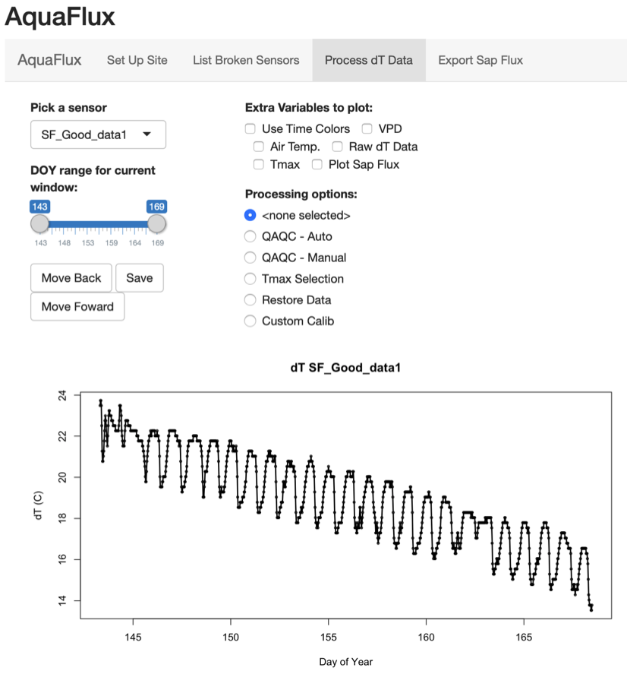

Figure 5.1 Example output displayed in “Process dT data”, see text for more details.

Note: your dT gradients will be smaller than this example. Again, see text for details

You have several options for viewing and manipulating the data here. **The graphed data is the current dT data from your TDP sensor, and does not include any points you have deleted during quality control**. The graph title is the sensor’s name. The x-axis is the Day of Year (DOY) and the y-axis is dT in Celsius. If the sensor is working correctly, it will have sinusoidal pattern to it, similar to this example and conceptual Figure 0.1. It is okay if the sinusoidal pattern has a trend over time (such as in Figure 4.1). We will discuss more possible data trends in Section 5.2.

The left hand column gives you several options for viewing and manipulating the data here.

* “Pick a sensor” allows you to plot different sensors.
* “DOY range for current window” DOY stands for Day of Year. Manipulating this slider will allow you to change days of data being plotted. You can manipulate this slider manually, or by using the “Move Back” and “Move Forward” buttons.
* “Move Back” moves the plotted window back to an earlier time
* “Move Forward” moves the plotted window forward to a later time
* “Save” saves your data and any manipulations you have done. More on saving in Section 5.5.

The section “Extra variables to plot” plots optional data sets for you.

* “Use time colors” colors the data based on the time of day they were observed:
  + Red = 0000-0400
  + Orange = 0400-0800
  + Light Green = 0800-1200
  + Dark Green = 1200-1600
  + Blue = 1600-2000
  + Purple = 2000-2400
* “VPD” is the vapor pressure deficit, a measure of how dry the air is. We will talk more about this graph in Chapter 6.
* “Air Temp” is the air temperature (Celsius) graphed in red. The axis for this is on the right hand side of the graph.
* “Raw dT data” is the raw dT data for the sensor, graphed in grey. This differs from the black dT data in that the grey data plots any points you removed during quality control.
* “Tmax” is the Tmax line. More on this in Chapter 6.
* “Plot Sap Flux” generates a second graph below the dT graph, showing the current calculated sap flux values. More on this in Chapter 7.

“Processing Options” are the different commands we will use to process this data, detailed in the next section.

5.1.1 Example Data Walkthrough – An Important Note

Your TDP data will not have this high of dT gradients as shown in this example dataset. This example data was taken from an experiment where in very hot TDP sensors were used to see if it increased sensor resolution. These warm temperatures did not affect TDP output (Supplemental of Speckman et al., in review).

### QAQC: knowing what’s good, what’s bad

The next step in processing dT data is quality assurance and quality control (QAQC). In this section, we will now look at examples of high quality dT and low quality and common causes of low quality data.

Note: this screen shots have the timestamp colors turned on and are from an older version of the program, hence the y-axis is in mV, not Celsius. Data trends remain the same in either axis.



**Figure 5.2 High quality data** will have a sinusoidal pattern. Typically the red/orange points will be on the top of the sinusoidal pattern-- these points were observed between midnight and predawn and indicate little sap flow is occurring. The green colored points are from midday and indicate more sap flux occurring.



**Figure 5.3 High quality Data:** This also good data, displaying the correct sinusoidal pattern. The long term trend does not hurt data quality.



**Figure 5.4 Bad Data—erroneous points:** Points randomly separated from the larger trend (i.e. DOY 240-243, DOY 252-260, DOY 267-270) are erroneous and should be deleted. Parts of this data (like DOY 261-266) are good and should be kept



**Figure 5.5 Bad Data— spikes.** Sometimes an early morning “spike” will be observed in the data. These spike are erroneous and should be deleted, leaving the rest of the day’s data. For more details on morning spikes, see TDP2004.



**Figure 5.6 Bad Data— system crashes.** A flat line of zeros (for example DOY 221-226) means the system crashed and the data is bad.



**Figure 5.7 Bad Data— offline sensor.** Data without any trend or that averages around zero indicates the sensor is offline. All this data should be deleted.

5.2.2 Example Data Walkthrough

The AquaFlux example dataset includes TDP data of varying quality and are thus named.

* Dead_Sensor: is offline, similar to Figure 5.7. All data should be deleted
* Good_data1: is an example of high quality data, all of which should be kept.
* Bad_Sections: is a mixture is of high and low quality data, similar to Figures 5.4 and 5.6. The low-quality sections should be removed from the data set.
* Good_Incomplete: is high quality data, but is missing some days of data. Such data loss is realistically happens.
* Erractic_Sensor: this sensor’s data is erratic and does not display any sinusoidal trend. Such a sensor should be replaced and the erratic data discarded.

### QAQC: How To Delete Points

AquaFlux has two methods of performing QAQC: automatically and manual. Both QAQC methods may be used repeatedly until data in sufficiently quality controlled. **Note: you can only delete data in the plotted window.**

The automatic QAQC option presents the user a minimum and maximal threshold of acceptable dT values. It also has a despiker that will detect spikes and remove them. A larger “max deviance” value will be permissive of spikes in the data, versus a smaller value that will remove more points. To activate these options, click “suggest new QAQC”. Following your guidelines, AquaFlux will suggest points to be deleted (shown in red) and ask for your approval to remove them.

The manual QAQC option allows the user to manually select data to remove by clicking on the graph. For example, if you wish to remove data above a certain point, select “Delete Above”, click on the graph, and AquaFlux will remove all data above that point.

### Restore Data: The “Undo” Button

While performing data QAQC, it is not uncommon to accidentally delete some high quality data. For this reason, AquaFlux includes data recovery options, listed under “Restore Data”. You can:

* “Undo Delete” – undoes the last thing you deleted, restoring that data.
* “Restore between” – restore data between two time points, chosen by clicking the graph.
* “Restore all” - restores all data from this sensor in the plotted Day of Year range. You cannot restore data outside of the plotted window.

### Saving Data And Closing AquaFlux

AquaFlux regularly automatically saves your data: the raw dT values, the QAQC’d version, Tmax values, and calculated sapflux. If at any point you wish to manually save your progress, hit the “Save” button.

No special steps need to be take to close AquaFlux, simply exit out using the “X” button in in the top corner to exit. To re-open AquaFlux and continue working, see Section 3.2.

# ****Chapter 6: Process dT Data – Tmax****

** Note: for ease of use, AquaFlux uses “dT” and “Tmax” nomenclature instead of “ΔT” and “ΔTmax” **

After erroneous data points have been removed during QAQC, we must select a “Tmax”: the observed dT value when sap flux = 0 (see Chapter 1). AquaFlux assumes that Tmax occurs when the following conditions are met:

1. It is nighttime
2. The vapor pressure deficient (VDP) is low (between 0 and a certain threshold)
3. VPD has been below this threshold for a certain, allowed for stem water capacitance to recharge

If all three conditions are met, Tmax is the highest dT value during this time period. Due to nighttime transpiration, Tmax is not achieved every night. Tmax can change over a season due to changes in stem water capacitance. Incorrectly selecting ΔTmax values results in a systematic underestimation of transpiration throughout the entire day (Speckman, in review).

To start selecting Tmax values, select that under “Processing options”. AquaFlux will generate a graph similar to Figure 6.1:

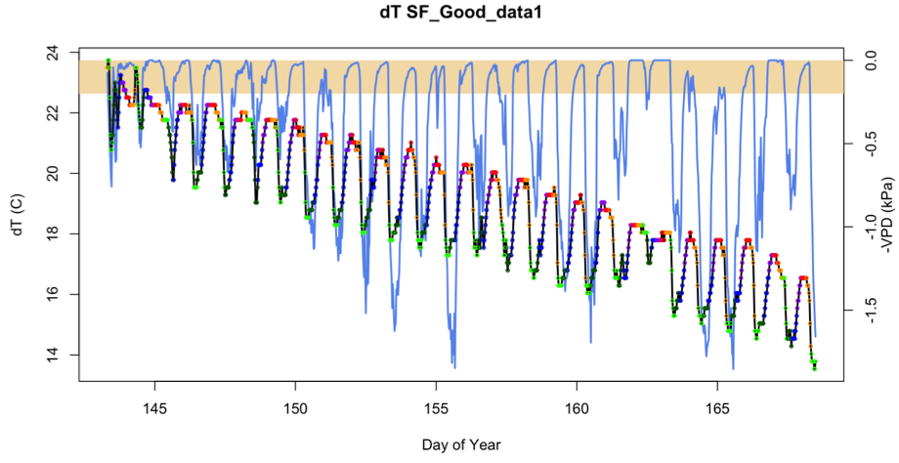

Figure 6.1: An example graph generated by “Tmax selection”.

This graph contains several type of information useful for selecting Tmax values. The multi-color dots are dT values, colored based on the time of observation:

- Red = 0000-0400

- Orange = 0400-0800

- Light Green = 0800-1200

- Dark Green =1200-1600

- Blue = 1600-2000

- Purple = 2000-2400

The blue line is VPD data you provided, multiplied by -1 to be plotted so that the sinusoidal trend matches the sinusoidal trend of the dT data. See the right hand axis for VPD units. The tan box uses this same VPD axis and marks when VPD is in between 0 and the VPD threshold (specified by user).

To actually select Tmax, the user has two options: automatically and manual. It is recommend that to use the automatic option first, and manually make any required changes. To automatically select Tmax, specific the VPD threshold to be used (default 0.2 kPa), the number of hours VPD must be below that threshold (default 2), and the window time frame to select Tmax values (default 7 days). Then click “Auto Select Tmax”. Tmax will be shown like in Figure 6.2.

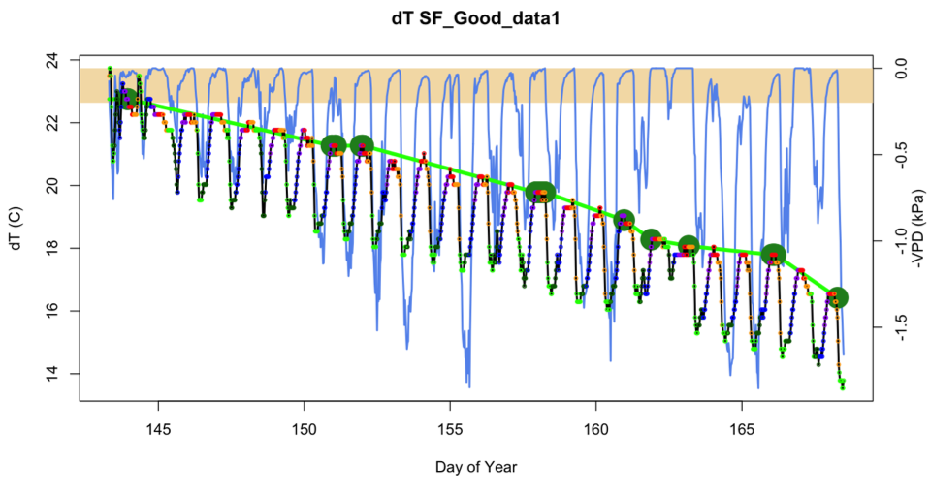

Figure 6.2: An example graph with Tmax points selected. The selected Tmax points are shown as large dark green dots. The light green line in a linear interpolation between these points and is the Tmax ultimately used for calculating sap flux at any time point (Equ 1).

To manually select Tmax points, select that option and click the graph.

To delete any undesired Tmax points, select that option and click the graph.

**An important note: How AquaFlux calculated VPD:** AquaFlux uses Air Temp and RH to calculate VPD data using Murray’s formula (1966). If the meteorological and dT data have different time steps, AquaFlux uses spline interpolation to make the VPD data have the same timestamps as the dT data.

**What if I do not have Air Temp, RH, or VPD data?** AquaFlux will run smoothly without any of these variables, but will not be able to plot them or automatically select Tmax points. Please manually select your Tmax points.

# ****Chapter 7: Review Calculated Sap Flux****

After you have selected Tmax points, AquaFlux will calculate sap flux. View these by selecting “Plot Sap Flux” under “Extra variables to plot”. This will generate a second graph below the dT graph, showing the current calculated sap flux values. You can continue working while the sap flux graph is visible, and see how sap flux responds to any changes you make to Tmax or points removed by QAQC.

By default, AquaFlux uses the traditional calibration coefficients described by Granier (1987)(see Chapter 1). If you wish to use custom calibration values, those options are listed under “Processing options”.

# ****Chapter 8: Export Final Sap Flux Data****

When you are satisfied with your plotted sap flux values, click on the “Export Sap Flux” tab. This will create files of your data outside of R (*.csv and *.pdf), as well as data.frames that can be used within R.

External data files include:

1. A *.csv file your raw dT data (no QA/QC)
2. Your QAQC’d dT data
3. List of your selected Tmax points
4. Interpolated Tmax lines which were used to calculate sap flux
5. Calculated sap flux data
6. Meteorological data
7. PDF graphs of the each sensor.

Internal data.frames within R:

1. raw.dT.data = your raw dT data
2. dT.data' = your post-QAQC dT data
3. Tmax.data.points = the Tmax points you picked.
4. Tmax.data.line = the Tmax line, interpolated from Tmax.data.points
5. sapflux.data' = your calculated sap flux data in g s-1 m-2.sapwood"
6. met.data' = your meteorological data, including VPD

While working with the R data.frames, you’ll frequently see the following data columns:

* TIMESTAMP = data timestamp, in POSIXt format
* LDate = data timestamp, in continuous numerical day of year format.

# 

# ****Chapter 9: Post Processing Options****

AquaFlux’s post-processing options are a series of functions in the base R environment to maximize user flexibility. These are designed for an advanced user whom is familiar with the R environment. These functions also have R documentation.

### Gapfilling

If desired, you may gapfill sap flux data using the command “gapfill.sapflux”. This function uses a spline to gapfill sapflux data and is best suited for filling small gaps. It is recommend that you do not fill gaps larger than 3 hours.

The “gapfill.sapflux” requires use input “max.gap.size”, which limits the size of gap that can be filled. For example, if your data is taken hourly, “max.gap.size=2” will not allow gaps larger than 32 hours to be gapfilled. For another example, if your data was recorded every 5 minutes, “max.gap.size=6” will only will not allow gaps larger than 30 minutes (5 mins * 6 = 30 mins) to be filled.

### Rescaling Sap Flux

There are a number of different units that can be used for sap flux data. These commands exist to help facilitate common conversions. For details about their arguments and use, see the R help files.

“calc.tree.sapwood.area” - Calculate individual tree sapwood area in cm2.

“convert.sapflux.time.units” - Convert sap flux time units.

“convert.sapflux.vol.units” - Convert sap flux volume units.

“convert.sapflux.m2sapwood.to.m2ground” - Convert sapflux area units from (m2 of sapwood) to (m2 of ground).

“convert.sapflux.m2ground.to.mm” - Convert sap flux from units of ( g / m2 ground area / time ) to ( mm / time).

### Radial Trends

The function “radial.trends” accounts for radial trends in sap flux by modeling the relationship between sap flux at two observed different depths. This relationship can be an average value, a linear regression, or a Gaussian regression. The relationship is then plotted, both in terms of sap flux (vol/m2 of sapwood /time) and sap flow (vol/time) after accounting for different sapwood areas. Function Output is a time series of average sap flow after accounting for radial trends. Units are (vol / time / whole tree). For example (g of water / s / tree).

# ****Appendix: R 101****

This chapter provides a very basic Introduction to R, designed for people who have zero experience with the program.

### A.1: Downloading R and RStudio.

To process sap flux data, we will be loading a program named “R”. R is cutting edge statistical program, and completely free. Do the following:

1. Install R (<https://www.r-project.org>)
2. Install RStudio (<http://www.rstudio.com/ide/download/>).



RStudio is the program we will be using to run R. Why? It’s prettier and more user friendly.

### A.2: How to define a directory in AquaFlux

AquaFlux needs to know where to find your data is saved, known a “directory”.

How to define a directory (For Windows):

1. From your desktop, navigate to where your file is. In the top part of the folder, you’ll see a file path.
2. Copy the file path.
3. In R, paste the file path in the appropriate spot.

How to define a directory (For Mac):

1. From your desktop, navigate to where your file is.
2. Right click on the file and select “get info”.
3. A screen will pop up, describing the file, including “Where:” it is. This is your file path. Copy it.
4. In R, paste the file path in the appropriate spot.

# ****Works Cited****

Bush, S.E., Hultine, K.R., Sperry, J.S. & Ehleringer, J.R. (2010) Calibration of thermal dissipation sap flow probes for ring- and diffuse-porous trees. *Tree Physiol,* **30,** 1545-1554.

Granier, A. (1987) Evaluation of transpiration in a Douglas-fir stand by means of sapflow measurements. *Tree Physiol,* **3,** 10.

Lu, P. (2004) Granier's Thermal Dissipation Probe (TDP) Method for Measuring Sap in Trees: Theory and Practice. *Acta Botanica Sinica*.

Murray, F.W. (1966) On the computation of saturation vapor pressure.Rand Corp Santa Monica Calif.

Poyatos, R., Granda, V., Molowny-Horas, R., Mencuccini, M., Steppe, K. & Martinez-Vilalta, J. (2016) SAPFLUXNET: towards a global database of sap flow measurements. *Tree Physiol,* **36,** 1449-1455.

Speckman, H.N., Beverly, D.B. & Ewers, B.E. (In review) AquaFlux: Swift and Transparent Analysis of Plant-level Transpiration”, .

Vandegehuchte, M.W. & Steppe, K. (2013) Corrigendum to: Sap-flux density measurement methods: working principles and applicability. *Functional Plant Biology,* **40,** 1088.