<!DOCTYPE html>

<html lang="en-US">

<head>

<meta charset="UTF-8">

<meta http-equiv="X-UA-Compatible" content="IE=edge">

<meta name="viewport" content="width=device-width, initial-scale=1">

<title>THARANEESHWARAN J </title>

<link rel="preconnect" href="https://fonts.gstatic.com" crossorigin="crossorigin"/>

<link rel="preload" as="style" href="https://fonts.googleapis.com/css2?family=Poppins:wght@600&amp;family=Roboto:wght@300;400;500;700&amp;display=swap"/>

<link rel="stylesheet" href="https://fonts.googleapis.com/css2?family=Poppins:wght@600&amp;family=Roboto:wght@300;400;500;700&amp;display=swap" media="print" onload="this.media='all'"/>

<noscript>

<link rel="stylesheet" href="https://fonts.googleapis.com/css2?family=Poppins:wght@600&amp;family=Roboto:wght@300;400;500;700&amp;display=swap"/>

</noscript>

<link href="css/font-awesome/css/all.min.css?ver=1.2.0" rel="stylesheet">

<link href="css/bootstrap.min.css?ver=1.2.0" rel="stylesheet">

<link href="css/aos.css?ver=1.2.0" rel="stylesheet">

<link href="css/main.css?ver=1.2.0" rel="stylesheet">

<noscript>

<style type="text/css">

[data-aos] {

opacity: 1 !important;

transform: translate(0) scale(1) !important;

}

</style>

</noscript>

</head>

<body id="top">

<header class="d-print-none">

<div class="container text-center text-lg-left">

<div class="py-3 clearfix">

<h1 class="site-title mb-0">THARANEESHWARAN J </h1>

<div class="site-nav">

<nav role="navigation">

<ul class="nav justify-content-center">

<li class="nav-item"><a class="nav-link" href="https://mobile.twitter.com/explore" title="Twitter"><i class="fab fa-twitter"></i><span class="menu-title sr-only">Twitter</span></a>

</li>

<li class="nav-item"><a class="nav-link" href="https://m.facebook.com/100050339382704/" title="Facebook"><i class="fab fa-facebook"></i><span class="menu-title sr-only">Facebook</span></a>

</li>

<li class="nav-item"><a class="nav-link" href="https:// https://instagram.com/tharan._.eshwar?igshid=YmMyMTA2M2Y=/" title="Instagram"><i class="fab fa-instagram"></i><span class="menu-title sr-only">Instagram</span></a>

</ul>

</nav>

</div>

</div>

</div>

</header>

<div class="page-content">

<div class="container">

<div class="cover shadow-lg bg-white">

<div class="cover-bg p-3 p-lg-4 text-white">

<div class="row">

<div class="col-lg-4 col-md-5">

<div class="avatar hover-effect bg-white shadow-sm p-1"><img src="pic.jpeg" width="200" height="200"/></div>

</div>

<div class="col-lg-8 col-md-7 text-center text-md-start">

<h2 class="h1 mt-2" data-aos="fade-left" data-aos-delay="0">THARANEESHWARAN J </h2>

<p data-aos="fade-left" data-aos-delay="100">Aspiring Student & Entrepreneur</p>

<div class="d-print-none" data-aos="fade-left" data-aos-delay="200"><a class="btn btn-light text-dark shadow-sm mt-1 me-1" href="https://drive.google.com/file/d/17zUI9J9ydW2RU7HsTsMQ2aepZTB1yYBI/view?usp=drivesdk" target="_blank">Download CV RESUME </a><a class="btn btn-success shadow-sm mt-1" href="#contact">Hire Me</a></div>

</div>

</div>

</div>

<div class="about-section pt-4 px-3 px-lg-4 mt-1">

<div class="row">

<div class="col-md-6">

<h2 class="h3 mb-3">About Me</h2>

<p>Hello! I’m THARANEESHWARAN J . I am passionate about Software development and Web Design. I am a skilled Front-end Developer and Strong in Python programing and logical thinking.</p>

</div>

<div class="col-md-5 offset-md-1">

<div class="row mt-2">

<div class="col-sm-4">

<div class="pb-1">Age</div>

</div>

<div class="col-sm-8">

<div class="pb-1 text-secondary">20</div>

</div>

<div class="col-sm-4">

<div class="pb-1">Email</div>

</div>

<div class="col-sm-8">

<div class="pb-1 text-secondary">tharaneeshwaran89@gmail.com</div>

</div>

<div class="col-sm-4">

<div class="pb-1">Phone</div>

</div>

<div class="col-sm-8">

<div class="pb-1 text-secondary">7395870428</div>

</div>

<div class="col-sm-4">

<div class="pb-1">Address</div>

</div>

<div class="col-sm-8">

<div class="pb-1 text-secondary">No.533,Pillayar Koil Street,Thamaraipakkam Koot Road,Thiruvallur,601103</div>

</div>

</div>

</div>

</div>

</div>

<hr class="d-print-none"/>

<div class="skills-section px-3 px-lg-4">

<h2 class="h3 mb-3">Professional Skills</h2>

<div class="row">

<div class="col-md-6">

<div class="mb-2"><span>HTML</span>

<div class="progress my-1">

<div class="progress-bar bg-primary" role="progressbar" data-aos="zoom-in-right" data-aos-delay="100" data-aos-anchor=".skills-section" style="width: 90%" aria-valuenow="90" aria-valuemin="0" aria-valuemax="100"></div>

</div>

</div>

<div class="mb-2"><span>CSS</span>

<div class="progress my-1">

<div class="progress-bar bg-primary" role="progressbar" data-aos="zoom-in-right" data-aos-delay="200" data-aos-anchor=".skills-section" style="width: 85%" aria-valuenow="85" aria-valuemin="0" aria-valuemax="100"></div>

</div>

</div>

<div class="mb-2"><span>JavaScript</span>

<div class="progress my-1">

<div class="progress-bar bg-primary" role="progressbar" data-aos="zoom-in-right" data-aos-delay="100" data-aos-anchor=".skills-section" style="width: 50%" aria-valuenow="50" aria-valuemin="0" aria-valuemax="100"></div>

</div>

</div>

</div>

<div class="col-md-6">

<div class="mb-2"><span>Adobe Photoshop</span>

<div class="progress my-1">

<div class="progress-bar bg-success" role="progressbar" data-aos="zoom-in-right" data-aos-delay="400" data-aos-anchor=".skills-section" style="width: 80%" aria-valuenow="90" aria-valuemin="0" aria-valuemax="100"></div>

</div>

</div>

<div class="mb-2"><span>Python</span>

<div class="progress my-1">

<div class="progress-bar bg-success" role="progressbar" data-aos="zoom-in-right" data-aos-delay="500" data-aos-anchor=".skills-section" style="width: 65%" aria-valuenow="85" aria-valuemin="0" aria-valuemax="100"></div>

</div>

</div>

<div class="mb-2"><span>C++</span>

<div class="progress my-1">

<div class="progress-bar bg-success" role="progressbar" data-aos="zoom-in-right" data-aos-delay="600" data-aos-anchor=".skills-section" style="width: 60%" aria-valuenow="75" aria-valuemin="0" aria-valuemax="100"></div>

</div>

</div>

</div>

</div>

</div>

<hr class="d-print-none"/>

<div class="projects-section px-3 px-lg-4">

<h2 class="h3 mb-4">Projects</h2>

<div class="timeline">

<div class="timeline-card timeline-card-primary card shadow-sm">

<div class="card-body">

<div class="h5 mb-1">Automatic Door Lock System Using NODE MCU<span class="text-muted h6"></span></div>

<div class="text-muted text-small mb-2">Sep 2022-Present</div>

<div>It's all about the Personal Security Purpose And Safety Purpose For Bank Locker And The Home Security Locking.</div>

</div>

</div>

<div class="timeline-card timeline-card-primary card shadow-sm">

<div class="card-body">

<div class="h5 mb-1">Photo store <span class="text-muted h6"></span></div>

<div class="text-muted text-small mb-2">Aug,2022-Present</div>

<div>Photo gallery is an online music store.It's based on HTML and CSS which are used for structural language and Layouts </div>

</div>

</div>

<div class="timeline-card timeline-card-primary card shadow-sm">

<div class="card-body">

<div class="h5 mb-1">HOME AUTOMATION USING ARDUINO UNO <span class="text-muted h6"></span></div>

<div class="text-muted text-small mb-2">March, 2022 - June, 2022</div>

<div>From controlling the room lights with your smartphone to scheduling events to occur automatically, home automation has taken convenience to a whole new level.<br>Instead of using mechanical switches, you can now conveniently control all the devices in your home from your fingertips.</div>

</div>

</div>

</div>

</div>

<hr class="d-print-none"/>

<div class="page-break"></div>

<div class="education-section px-3 px-lg-4 pb-4">

<h2 class="h3 mb-4">Education</h2>

<div class="timeline">

<div class="timeline-card timeline-card-success card shadow-sm">

<div class="card-body">

<div class="h5 mb-1">Bachelor of Electronics and Communication<span class="text-muted h6">from Veltech HighTech Engineering College</span></div>

<div class="text-muted text-small mb-2">2019 - 2023(Present)</div>

<div>Electronics and communication engineering (ECE) is a discipline of engineering that involves developing and testing electronic circuits and communication devices like transmitters, receivers and integrated circuits<br>And also Love to learn the Programming language</div>

</div>

</div>

<div class="timeline-card timeline-card-success card shadow-sm">

<div class="card-body">

<div class="h5 mb-1">Science and Mathematics<span class="text-muted h6">from St.Claret Matriclation Higher Secondary School</span></div>

<div class="text-muted text-small mb-2">2017-19</div>

<div>User generated content in real-time will have multiple touchpoints for offshoring. Organically grow the holistic world view of disruptive innovation via workplace diversity and empowerment Of The Mathematics</div>

</div>

</div>

<div class="timeline-card timeline-card-success card shadow-sm">

<div class="card-body">

<div class="h5 mb-1">Schooling<span class="text-muted h6">from St.Claret Matriclation Higher Secondary School</span></div>

<div class="text-muted text-small mb-2">2013-2019</div>

<div>Where I got basic knowledge on favourite things</div>

</div>

</div>

</div>

</div>

<hr class="d-print-none"/>

<div class="contant-section px-3 px-lg-4 pb-4" id="contact">

<h2 class="h3 text mb-3">Contact</h2>

<div class="row">

<div class="col-md-7 d-print-none">

<div class="my-2"><form action="https://formspree.io/your@email.com"

method="POST">

<div class="row">

<div class="col-6">

<input class="form-control" type="text" id="name" name="name" placeholder="Your Name" required>

</div>

<div class="col-6">

<input class="form-control" type="email" id="email" name="_replyto" placeholder="Your E-mail" required>

</div>

</div>

<div class="form-group my-2">

<textarea class="form-control" style="resize: none;" id="message" name="message" rows="4" placeholder="Your Message" required></textarea>

</div>

<button class="btn btn-primary mt-2" type="submit">Send</button>

</form>

</div>

</div>

<div class="col">

<div class="mt-2">

<h3 class="h6">Address</h3>

<div class="pb-2 text-secondary"> No.533,Pillayar Koil Street,Thamaraipakkam Koot Road,Thiruvallur,601103</div>

<h3 class="h6">Phone</h3>

<div class="pb-2 text-secondary">7395870428</div>

<h3 class="h6">Email</h3>

<div class="pb-2 text-secondary"> tharaneeshwaran89@gmail.com</div>

</div>

</div>

<div class="col d-none d-print-block">

<div class="mt-2">

<div>

<div class="mb-2">

<div class="text-dark"><i class="fab fa-twitter mr-1"></i><span>https://mobile.twitter.com/explore</span>

</div>

</div>

<div class="mb-2">

<div class="text-dark"><i class="fab fa-facebook mr-1"></i><span>https://m.facebook.com/100050339382704/</span>

</div>

</div>

<div class="mb-2">

<div class="text-dark"><i class="fab fa-instagram mr-1"></i><span>https://www.instagram.com/tharan._.eshwar/</span>

</div>

</div>

</div>

</div>

</div>

</div>

</div>

</div>

</div></div>

</div>

<footer class="pt-4 pb-4 text-muted text-center d-print-none">

<div class="container">

<div class="my-3">

<div class="h4"> THARANEESHWARAN J </div>

<div class="footer-nav">

<nav role="navigation">

<ul class="nav justify-content-center">

<li class="nav-item"><a class="nav-link" href="https://mobile.twitter.com/explore" title="Twitter"><i class="fab fa-twitter"></i><span class="menu-title sr-only">Twitter</span></a>

</li>

<li class="nav-item"><a class="nav-link" href=" https://m.facebook.com/100050339382704/" title="Facebook"><i class="fab fa-facebook"></i><span class="menu-title sr-only">Facebook</span></a>

</li>

<li class="nav-item"><a class="nav-link" href="https://www.instagram.com/tharan._.eshwar/" title="Instagram"><i class="fab fa-instagram"></i><span class="menu-title sr-only">Instagram</span></a>

</li>

</li>

</ul>

</nav>

</div>

</div>

</footer>

<script src="scripts/bootstrap.bundle.min.js?ver=1.2.0"></script>

<script src="scripts/aos.js?ver=1.2.0"></script>

<script src="scripts/main.js?ver=1.2.0"></script>

</body>

</html>

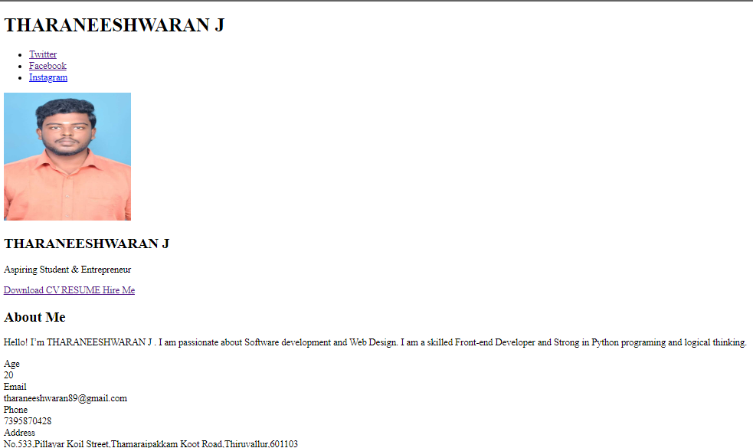

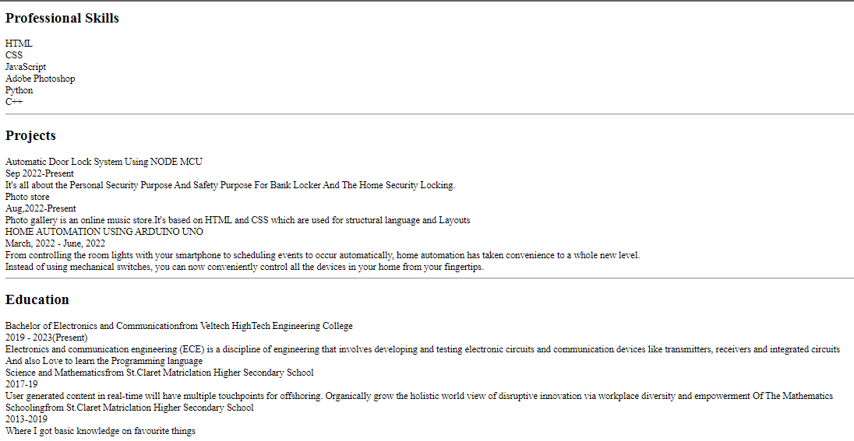

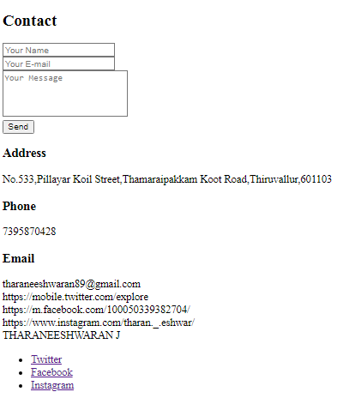

MY OUTPUT LINK:

file:///C:/Users/Admin/Desktop/cv%20design/CV/cv.html