Game Design Document
Fill up the following document

- Write the title of your project.
Hit The Robot

- What is the goal of the game?
The goal of the game is to get to the Data server, so the player can fix the error which cause the AI robots to malfunction

- Write a brief story of your game.

When A Boy was trying to go home somehow the dataserver
Got a spark and the AI robots got malfunction. The goal of the game
is to get to the Data server, so the player can fix the error which
cause the AI robots to malfunction
- Which are the playing characters of this game?
- Playing characters are the ones who respond to the user based on the input from the user.
- Cars, monkeys, dinos, wizards, etc., are the playing characters in the game.

Number | Character Name | What can this character do?
1 | Boy | Can jump, can shoot the robots
2
3
4
5
6
7
8

- Which are the Non-Playing Characters of this game?
- Non-Playing characters are the ones that don't have an action or behavior when the user interacts with the game.
- Hurdles, stones, bananas, coins, etc., are non-playing characters in the game.

Number | Character Name | What can this character do?
1 | Small Robot | Can cause 2 damage and can be killed with 2 bullets
2 | Medium Robot | Can cause 3 damage and can be killed with 3 bullets
3 | Large Robot | Can cause 5 damage and can be killed with 5 bullets
4
5
6
7
8

Draw your imagination of this game. What does this game look like?
- Draw the game either on your computer or on paper.
- Add images of the game scenes to show each of the playing and non-playing characters at least once.
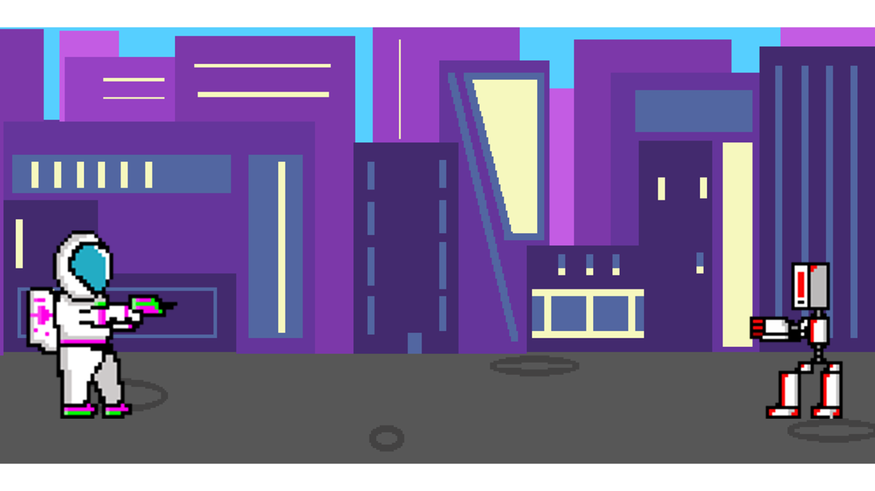
Astronaut boy and small robot

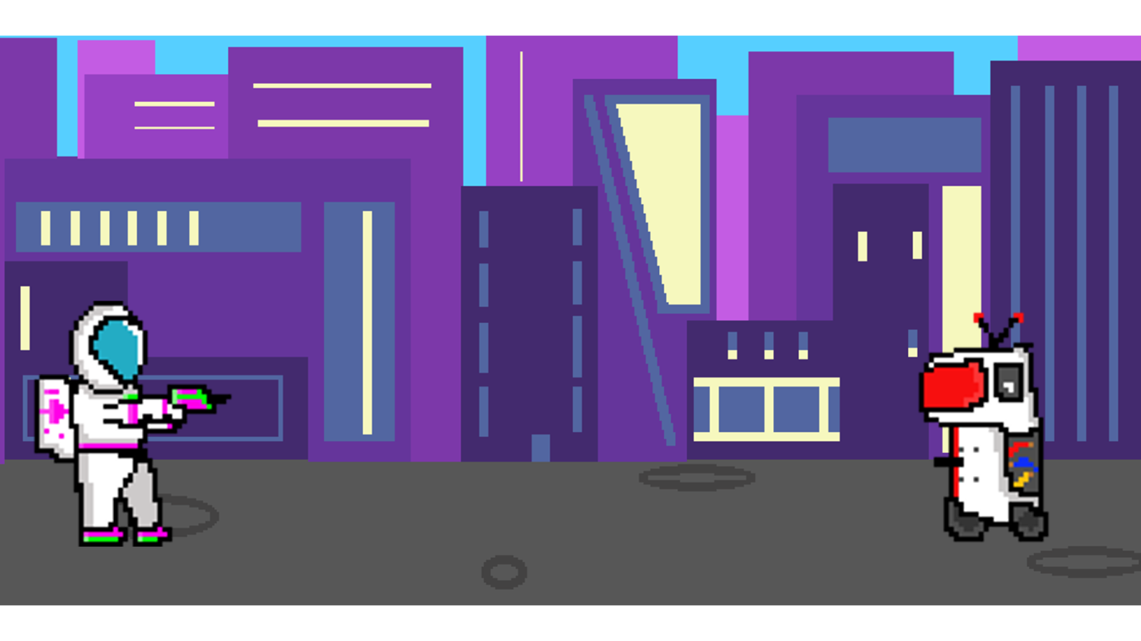
Astronaut boy and medium robot

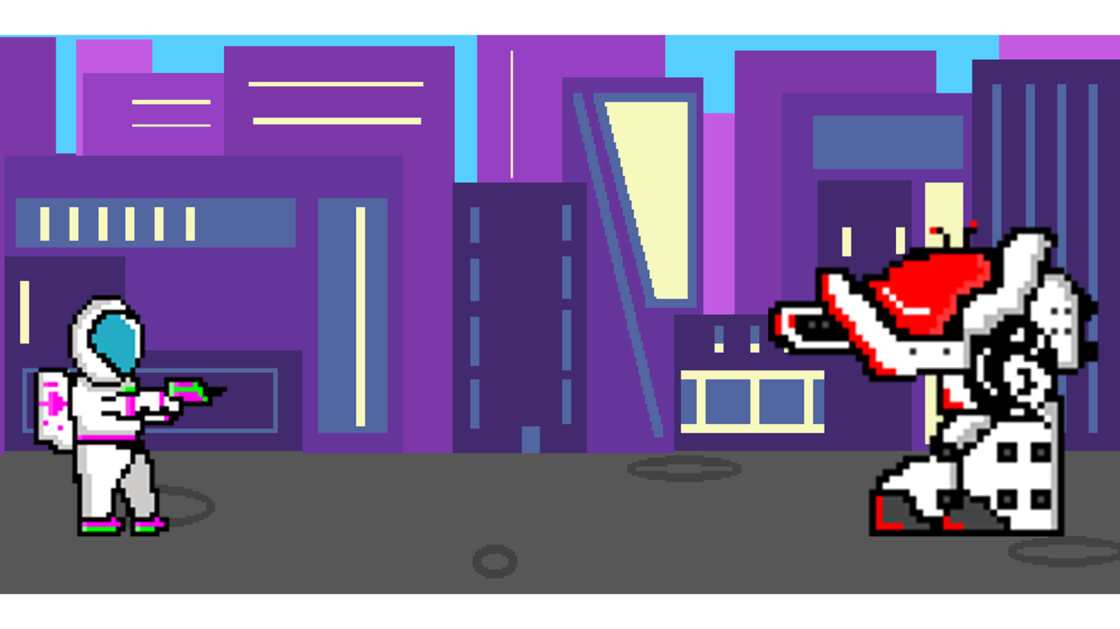
Astronaut boy and big robot

How do you plan to make your game engaging?

I Will try to add music and points

