

Software Engineering Lab
BCSE301P
Exp 10 - Project Report

REG NO: 24BRS1110
NAME: Lanka Venkata Nishant Rao
SLOT: L29+L30
DATE: 18th October 2026

1. INTRODUCTION

1.1 Background and Motivation
Students increasingly depend on digital devices for learning, programming, online classes, research, and academic preparation. Although these devices provide access to useful educational resources, they also expose students to distractions such as social media, entertainment platforms, unrelated browsing, and frequent application switching. These distractions can interrupt study sessions, reduce concentration, and make it difficult to maintain consistent study habits.
Traditional productivity tools generally focus on timers, reminders, or application blocking. However, these approaches do not fully address the need to understand study behaviour, identify patterns associated with distraction, and provide personalized guidance based on observed activity.
FocusSense AI – AI Study Behaviour Analyzer is proposed to address this problem through behavioural data collection, machine learning-based analysis, performance prediction, and adaptive study recommendations. The system aims to help students understand their study patterns and make informed improvements to their study routines. It also includes a parent-oriented monitoring component intended to provide visibility into a student's study progress while respecting access permissions.
The motivation behind this project comes from the need for a more analytical and personalized approach to study management, moving beyond simple time tracking towards behaviour-aware insights and recommendation outcome tracking.

1.2 Problem Statement
Students often find it difficult to maintain concentration, identify recurring distractions, and consistently follow effective study schedules. Conventional study-planning applications primarily record time or provide reminders, but may not offer integrated behavioural analysis, machine learning-based predictions, personalized recommendations, and systematic tracking of recommendation outcomes.
Therefore, a system is required to collect study-session activity data, analyse measurable behavioural patterns, estimate focus and distraction levels, predict academic performance using available features, and provide recommendations that can be evaluated against subsequent study outcomes.
FocusSense AI addresses this requirement by integrating study-session management, activity collection, machine learning analysis, recommendation generation, and intervention outcome tracking into a unified software system.

1.3 Objectives
The primary objective of FocusSense AI is to develop an AI-assisted study behaviour analysis system that helps students understand and improve their study practices.
The specific objectives are:
- To provide secure student authentication and role-based access.
- To manage study sessions and record associated study activities.
- To extract measurable behavioural features, including productive activity duration, distraction duration, activity switching, and application diversity.
- To estimate focus scores and classify distraction levels using machine learning models.
- To predict academic performance using available behavioural and academic features.
- To generate personalized study recommendations using a lightweight, rule-based adaptive recommendation foundation.
- To record whether recommendations are followed and measure subsequent study-session outcomes when sufficient data is available.
- To present behavioural insights, predictions, and recommendation history through a student dashboard.
- To support a parent-oriented view with appropriate authorization and access restrictions.
- To establish a foundation for interactive counterfactual explanations and further improvements to recommendation personalization.

1.4 Scope and Limitations

Scope
The project covers the design and implementation of a web-based study behaviour analysis system using a React frontend, FastAPI backend, Supabase authentication and database services, and Python-based machine learning components.
The implemented scope includes authentication foundations, study-session management, activity data collection, behavioural feature extraction, focus regression, distraction classification, performance prediction, rule-based recommendation generation, and recommendation outcome tracking.
The system stores relevant analysis and recommendation information to support student-facing insights and future improvements. Role-based authorization is used to restrict access to protected resources.

Limitations
The quality of predictions depends on the availability, quality, and representativeness of the collected behavioural and academic data. Initial models trained on synthetic data provide development benchmarks and should not be treated as proof of real-world predictive accuracy.
The rule-based recommendation personas are engineering heuristics rather than scientifically validated psychological categories. Recorded changes after recommendations indicate observed associations and do not establish that the recommendations caused those changes.
The current project should not be considered a medical or psychological diagnostic system. Continuous operating-system-level activity monitoring, extensive real-world validation, and interactive counterfactual explanations require separate implementation and verification where not yet completed.

2. LITERATURE SURVEY / EXISTING SYSTEM

2.1 Review of Existing Systems
Existing digital study and productivity systems provide features such as time tracking, distraction reduction, learning analytics, and academic performance monitoring. These systems offer useful support for students, but their capabilities differ according to their primary purpose.

2.1.1 Study Timers and Productivity Applications
Study timer applications support structured study sessions through countdown timers, work-break intervals, reminders, and activity summaries. They encourage students to organize their study time and maintain regular routines.
However, time tracking alone does not necessarily indicate whether a student is engaged in productive learning. A student may keep a timer running while browsing unrelated websites or switching repeatedly between applications. Therefore, duration-based tracking provides limited information about behavioural patterns.

2.1.2 Website and Application Blocking Tools
Website and application blocking tools attempt to reduce distractions by restricting access to selected websites or applications during study periods. They can help students avoid common sources of interruption and establish boundaries for focused work.
These tools primarily prevent or restrict selected activities. They may not analyse the relationship between observed activity patterns, focus estimates, academic indicators, and subsequent study-session outcomes. Their effectiveness can also depend on the student's configuration and willingness to follow the restrictions.

2.1.3 Learning Analytics Systems
Learning analytics systems analyse educational data such as learning platform interactions, assessment activity, attendance, and course participation. These systems can help identify learning patterns and support educational decision-making.
However, systems focused mainly on learning management data may not capture the detailed activity patterns associated with an individual student's study sessions. Integrating session-level behavioural measurements with academic indicators can provide an additional perspective on study practices.

2.1.4 Machine Learning-Based Academic Performance Prediction
Machine learning techniques can be applied to historical academic and behavioural data to estimate student performance or identify students who may require additional academic support. Regression and classification models are common approaches for numerical prediction and category assignment.
The reliability of such predictions depends on the quality and representativeness of the training data, the selection of relevant features, and proper evaluation. Predictions based on synthetic datasets require further validation before being interpreted as evidence of real-world performance.

2.1.5 Personalized Recommendation Systems
Recommendation systems use user characteristics, preferences, or historical interactions to suggest relevant actions. In an educational context, recommendations may include revision, additional practice, improved scheduling, or changes to study habits.
A recommendation system becomes more useful when it records whether recommendations were followed and evaluates subsequent outcomes. However, an observed improvement after a recommendation does not, by itself, demonstrate that the recommendation caused the improvement.

2.2 Gaps Identified and Proposed Solution

Gaps in Existing Approaches
The review identifies several limitations that motivate the proposed system:
- Limited behavioural insight: Study timers primarily measure time and may not describe productive activity, distractions, or frequent activity switching.
- Limited integration: Study management, behavioural analysis, performance prediction, and personalized recommendations are often provided as separate functions.
- Limited personalization: Generic reminders and blocking rules may not reflect an individual student's observed study patterns.
- Limited outcome tracking: Recommendation systems may not systematically record follow-through and measure subsequent study-session outcomes.
- Data reliability concerns: Machine learning predictions can be misleading if training data is unrepresentative or if synthetic benchmark results are interpreted as real-world validation.
- Need for controlled access: A system that provides student and parent views requires appropriate authentication and authorization to protect student information.

Proposed Solution: FocusSense AI
FocusSense AI is designed as an integrated study behaviour analysis system combining study-session management, activity data collection, machine learning predictions, and recommendation outcome tracking.
The system records measurable study activity and derives features such as productive duration, distraction duration, activity switching, and application diversity. These features are used by the implemented machine learning pipeline to estimate focus, classify distraction, and predict academic performance when sufficient activity data is available.
A lightweight rule-based recommendation engine generates study suggestions based on the latest available analysis. Recommendation events retain information about the selection reason and behavioural persona, while outcome tracking records follow-through and subsequent focus measurements when suitable data becomes available.
The proposed system therefore extends basic time tracking by connecting behavioural measurements, predictive analysis, recommendations, and outcome evaluation within a single application. Its predictions and recommendations are intended to support student decision-making rather than provide guaranteed outcomes or establish causal relationships.
The system uses synthetic data for initial model development and benchmarking. Validation with representative real-world data remains necessary to establish practical reliability.

3. SOFTWARE PROCESS MODEL AND PROJECT PLANNING

3.1 SDLC Model Chosen and Justification

3.1.1 Spiral Model
The Spiral Model is a software development life cycle (SDLC) model that combines iterative development with systematic risk analysis. The project progresses through repeated cycles, with each cycle involving planning, risk identification and analysis, development and verification, and evaluation before proceeding to the next cycle.
The Spiral Model was selected for FocusSense AI because the project integrates multiple components, including web application development, database management, authentication, machine learning, recommendation generation, and outcome tracking. These components introduce technical uncertainties that benefit from incremental implementation and continuous verification.
The model also supports changes in requirements as the project develops. For example, the initial study-session functionality can be implemented and tested before introducing machine learning predictions and recommendation outcome tracking.

3.1.2 Phases of the Spiral Model in FocusSense AI
Phase 1: Planning and Objective Definition
The project requirements, objectives, scope, technologies, and expected deliverables are identified. The main objectives include recording study activity, analysing behavioural patterns, predicting performance, and generating recommendations.
Phase 2: Risk Analysis
Potential risks are identified and assessed before major implementation decisions. Examples include insufficient activity data, unreliable machine learning predictions, authentication failures, data privacy concerns, and integration difficulties between the frontend and backend.
Phase 3: Engineering and Development
The system is developed incrementally. The initial iterations establish the project structure, database, authentication, REST APIs, study-session management, and activity collection. Subsequent iterations introduce machine learning analysis, performance prediction, recommendations, and intervention outcome tracking.
Phase 4: Testing and Evaluation
Each iteration is verified through relevant tests, including backend API tests, frontend build and lint checks, machine learning validation, and access-control tests. Identified issues are corrected before subsequent functionality is added.
After evaluation, the results and remaining risks inform the next iteration.

3.1.3 Justification for Selecting the Spiral Model
The Spiral Model is appropriate for FocusSense AI for the following reasons:
- Risk-driven development: Technical and data-related risks can be identified and addressed during each iteration.
- Incremental implementation: Core application features can be developed and verified before advanced analytical features are introduced.
- Support for changing requirements: New requirements can be incorporated after evaluating earlier iterations.
- Continuous verification: Each development cycle includes testing and evaluation.
- Suitable for AI integration: Machine learning components can be integrated after the underlying data collection and feature extraction mechanisms are established.
Thus, the Spiral Model provides a structured approach for developing FocusSense AI while managing technical uncertainty and maintaining incremental progress.

3.2 Project Schedule
The project schedule is organized into development phases corresponding to the iterative implementation of FocusSense AI. The following table presents the major activities and their deliverables.
Phase | Major activities | Expected deliverables
1. Requirement analysis | Define objectives, scope, users, and requirements | SRS and requirement specifications
2. Project planning and design | Select SDLC model, plan modules, prepare architecture and UML diagrams | Project plan and design documents
3. Foundation development | Establish frontend, backend, database, and version control | Project structure and database foundation
4. Authentication and APIs | Implement authentication, authorization, schemas, and REST endpoints | Protected APIs and frontend integration
5. Study management | Implement session lifecycle and activity collection | Study-session and activity modules
6. Machine learning | Develop focus regression, distraction classification, and performance prediction | Trained models and inference pipeline
7. Recommendation system | Implement rule-based recommendations and recommendation history | Recommendation generation module
8. Outcome tracking | Record recommendation follow-through and measure subsequent outcomes | Intervention outcome tracking
9. Testing and integration | Execute backend tests, verify frontend builds, and check access control | Test results and defect records
10. Documentation and demonstration | Prepare report, capture evidence, and create demonstration material | Final project report and demo
The project is developed iteratively, with testing and evaluation performed throughout implementation rather than being postponed entirely until the end.
The completed implementation checkpoint includes Tasks 1–16. Interactive counterfactual explanations and further enhancements are treated as subsequent work until implemented and verified.

3.3 Risk Analysis
Risk analysis identifies potential events that could affect the project's functionality, reliability, security, schedule, or deliverables. The following risks and mitigation strategies were identified for FocusSense AI.
Risk ID | Identified risk | Impact | Mitigation strategy
R1 | Insufficient or unrepresentative training data | Unreliable predictions | Clearly label synthetic data and evaluate models using appropriate metrics; validate with representative real data before practical claims
R2 | Inaccurate focus or performance predictions | Misleading student insights | Apply model evaluation, input validation, output bounds, and clear prediction disclaimers
R3 | Unauthorized access to student information | Privacy and security issues | Use authentication, role-based authorization, and student-specific resource ownership checks
R4 | Frontend and backend integration errors | Features may fail or display incorrect information | Test API contracts, validate responses, and perform integration checks
R5 | Incomplete or invalid activity records | Analysis may be unavailable or unreliable | Validate incoming activity data and require sufficient real activity data before inference
R6 | Recommendations are not followed | Limited ability to evaluate recommendation outcomes | Record follow-through explicitly and distinguish unavailable outcomes from measured outcomes
R7 | Observed changes are incorrectly interpreted as causal effects | Misleading conclusions | Report observational changes without claiming that recommendations caused them
R8 | Development delays or model/tool integration problems | Delayed completion | Prioritize core functionality, implement incrementally, maintain Git checkpoints, and verify each phase
R9 | Loss of project files or accidental code changes | Development disruption | Use Git for version control and push verified checkpoints to GitHub
R10 | Incomplete testing or documentation evidence | Reduced submission quality | Maintain test records, capture genuine screenshots, and verify all report deliverables before submission

3.3.1 Risk Management Approach
Risks are reviewed during the development and evaluation stages. High-impact risks, particularly those involving student data security, model reliability, and data quality, require particular attention.
Mitigation measures are incorporated into the implementation and testing process. Version control provides recovery points, while automated tests help identify regressions as new functionality is introduced.
This approach supports systematic risk management throughout the project lifecycle.

3.4 Cost and Effort Estimation (Optional)
FocusSense AI is developed primarily using software tools and frameworks that provide free or open-source development options. These include React, Vite, FastAPI, Python, scikit-learn, SQLAlchemy, Git, and GitHub.
The development effort includes requirement analysis, software design, frontend development, backend implementation, database integration, machine learning development, testing, documentation, and demonstration preparation.
Resource | Purpose | Cost consideration
Development computer | Software development and testing | Existing hardware
React and Vite | Frontend development | Free/open-source
FastAPI and Python | Backend and machine learning integration | Free/open-source
scikit-learn | Machine learning model development | Free/open-source
Git and GitHub | Version control and source-code hosting | Free tier available
Supabase | Authentication and database services | Free tier available, subject to current limits
StarUML | Software design and UML diagrams | Licensing depends on the edition and usage
The project does not require dedicated hardware for machine learning inference in its current scope. Actual monetary costs depend on the development environment, selected service plans, and any applicable software licences.

4. Requirements Analysis

4.1 Functional Requirements
Functional requirements describe the operations and services that the FocusSense AI system is designed to provide.
FR-01: User Authentication
The system shall support secure authentication for registered users. Access to protected resources shall require a valid authenticated session.
FR-02: Role-Based Access Control
The system shall distinguish between student and parent/guardian roles. Access to student information shall be restricted according to the user's role and authorization.
FR-03: Study Session Management
The system shall allow students to manage study sessions, including starting and completing sessions. Session information shall be stored for subsequent analysis.
FR-04: Study Activity Collection
The system shall collect or accept supported study activity records associated with a session. These records shall provide the data required to analyze study behaviour.
FR-05: Behavioural Feature Extraction
The system shall derive behavioural features from available activity and session records. These may include productive duration, distraction duration, activity switching, and application diversity, depending on the data available.
FR-06: Focus Prediction
The system shall provide a machine-learning-based focus score using the behavioural features supported by the implemented model.
FR-07: Distraction Classification
The system shall classify study behaviour into supported distraction categories or classes using the implemented classification model.
FR-08: Academic Performance Prediction
The system shall provide an estimated academic performance outcome using the features accepted by the implemented prediction model.
FR-09: Recommendation Generation
The system shall generate study recommendations using the available behavioural information and configured recommendation rules.
FR-10: Recommendation History
The system shall maintain records of generated recommendations and their associated information, where supported by the implemented data model.
FR-11: Recommendation Outcome Tracking
The system shall record whether a recommendation was followed and associate the outcome with the relevant recommendation event. Where supported, the system shall compare the next eligible study session's focus outcome with the earlier session.
FR-12: Student Dashboard
The system shall present available study-session information, behavioural insights, predictions, recommendations, and outcome information through the student interface.
FR-13: Parent/Guardian Monitoring
The system shall provide an authorized parent or guardian with access to the student information permitted by the application's access-control rules.
FR-14: Data Validation and Integrity
The system shall validate incoming data and preserve the consistency of stored records. Invalid requests and unauthorized access attempts shall be handled appropriately.
Note: These requirements describe the system's intended and implemented scope. The final testing section must confirm each requirement against the actual running application. Features that are not yet implemented or verified must be reported as pending rather than completed.

4.2 Non-Functional Requirements
Non-functional requirements define the quality attributes and constraints of the system.
NFR-01: Security
The application shall protect authenticated resources and enforce authorization checks on protected operations. Sensitive configuration values and credentials shall not be exposed in publicly accessible frontend code.
NFR-02: Privacy
The application shall handle study behaviour and academic information responsibly. Student information shall only be accessible to authorized users for the permitted purposes.
NFR-03: Usability
The user interface shall present session information, predictions, recommendations, and other insights in a clear and understandable format. Navigation and feedback shall be consistent across the application.
NFR-04: Performance
The application should process ordinary user requests and display available results within a reasonable time. Actual response times and throughput must be measured during performance testing rather than assumed.
NFR-05: Reliability
The system shall handle invalid inputs and expected application errors without unnecessarily interrupting unrelated operations. Data-processing and prediction failures should be reported clearly.
NFR-06: Maintainability
The frontend, backend, database models, and machine-learning components shall be organized into manageable modules. Version control shall be used to track implementation changes.
NFR-07: Scalability
The system design should allow additional users, study records, behavioural features, and recommendation rules to be introduced without requiring a complete redesign.
NFR-08: Data Integrity
Study sessions, activity records, recommendations, and outcome records shall maintain valid relationships. Duplicate or inconsistent outcome records shall be prevented or handled according to the implemented data constraints.
NFR-09: Explainability and Transparency
Predictions and recommendations should be presented as estimates or guidance, not guaranteed outcomes. The system should communicate relevant limitations and avoid treating observed behavioural patterns as definitive proof of a student's abilities or intentions.
NFR-10: Compatibility
The web application should operate in a supported modern browser, subject to the compatibility of its frontend framework and backend services.

4.3 Software Requirements Specification (SRS) Summary
The Software Requirements Specification defines the expected behaviour, interfaces, constraints, and quality requirements of FocusSense AI.
The system follows a client-server architecture. The frontend provides the user interface, while the backend handles application logic, data processing, prediction requests, and protected operations. Supabase provides the configured authentication and data services.
The principal users are:
- Student: Manages study sessions and views available behavioural insights, predictions, and recommendations.
- Parent/Guardian: Views permitted student information through authorized access.
The main inputs include study-session details, supported activity records, and the features required by the prediction models. The main outputs include focus estimates, distraction classifications, performance estimates, recommendations, and available dashboard summaries.
The major system constraints are the quality and completeness of the collected activity data, the accuracy of the trained models, the availability of configured external services, and the need to protect student information.
Machine-learning predictions depend on the model and its training data. In particular, synthetic development data cannot establish real-world predictive accuracy. The system therefore requires appropriate testing and future validation using representative data before its predictions can be treated as dependable in practical settings.
The SRS serves as the basis for system design, implementation, and testing. Each functional requirement should be mapped to one or more test cases so that the completed system can be evaluated systematically.

4.4 Hardware and Software Requirements

4.4.1 Hardware Requirements
The following describes the general hardware environment for developing and using the application. Exact minimum specifications should be confirmed through testing on the target machine.
Component | Requirement
Development computer | A computer capable of running the frontend development server, Python backend, and development tools
Processor | A modern processor suitable for web development and local model execution
Memory | Sufficient RAM to run the browser, frontend, backend, and development tools simultaneously
Storage | Sufficient free storage for source code, dependencies, model files, logs, and test evidence
Network | Internet connectivity for configured cloud services, repository access, and package installation
Display and input | Monitor or laptop display, keyboard, and pointing device

4.4.2 Software Requirements
Software/Technology | Purpose
Windows development environment | Operating system used for development
Visual Studio Code | Source-code editing and project management
Python | Backend development and machine-learning implementation
FastAPI | Backend API framework
SQLAlchemy | Database interaction and object-relational mapping
Pydantic | Request and data validation
Supabase | Configured authentication and database services
scikit-learn | Machine-learning model development and prediction
NumPy and pandas | Numerical operations and data processing
joblib | Model or related Python object persistence where used
JavaScript | Frontend application logic
React | Component-based frontend development
Vite | Frontend development and build tooling
Tailwind CSS | Frontend styling
Axios | HTTP communication with backend APIs
React Router | Frontend navigation
Recharts | Dashboard charts and data visualization
Lucide | Interface icons
Git | Version control
GitHub | Remote repository hosting and source-code collaboration
The software versions and dependencies used in the final submission should be recorded from the actual project environment. Any additional tools used for diagram creation, API testing, or automated testing should also be documented in the relevant sections of the report.

5. System Design

5.1 System Architecture
FocusSense AI follows a client-server architecture that separates the user interface, backend application logic, data storage, and machine-learning components. This separation improves modularity, maintainability, and the ability to extend the application.
The frontend is developed using React and Vite, with Tailwind CSS for styling. It provides the interfaces through which students and authorized parents or guardians interact with the system. The frontend communicates with the backend through HTTP API requests.
The backend is developed using FastAPI. It handles application operations, validates requests, manages study-related data, invokes supported machine-learning functions, and generates recommendations. SQLAlchemy is used for database interaction, while Pydantic supports data validation.
Supabase provides the configured authentication and database services. Python-based machine-learning components use scikit-learn and related data-processing libraries to produce behavioural and academic predictions.

Figure 5.1: System Architecture of FocusSense AI
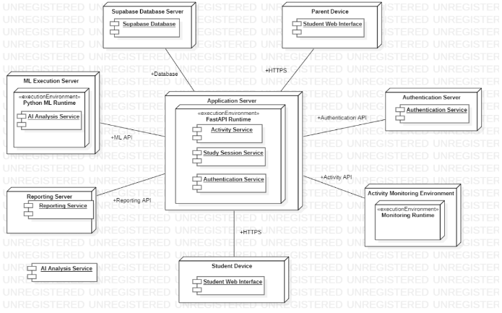

5.2 Use Case Diagram
The use case diagram identifies the main actors and the services available to them.
Actors
- Student: Uses the system to manage study sessions and view available behavioural insights.
- Parent/Guardian: Views student information permitted by the application's authorization rules.
- Administrator: Support authentication and data operations where configured. These may be represented as external systems if required by the diagram notation.

Main Use Cases
Student use cases:
- Register or log in.
- Manage study sessions.
- Provide or generate supported study activity records.
- View focus predictions.
- View distraction classifications.
- View academic performance estimates.
- View recommendations.
- Review recommendation history and available outcomes.
Parent/Guardian use cases:
- Log in.
- Access authorized student information.
- Review available study progress and insights.
Shared system responsibilities:
- Validate requests.
- Enforce authorization.
- Store and retrieve records.
- Generate predictions and recommendations.
Figure 5.2: Use Case Diagram of FocusSense AI
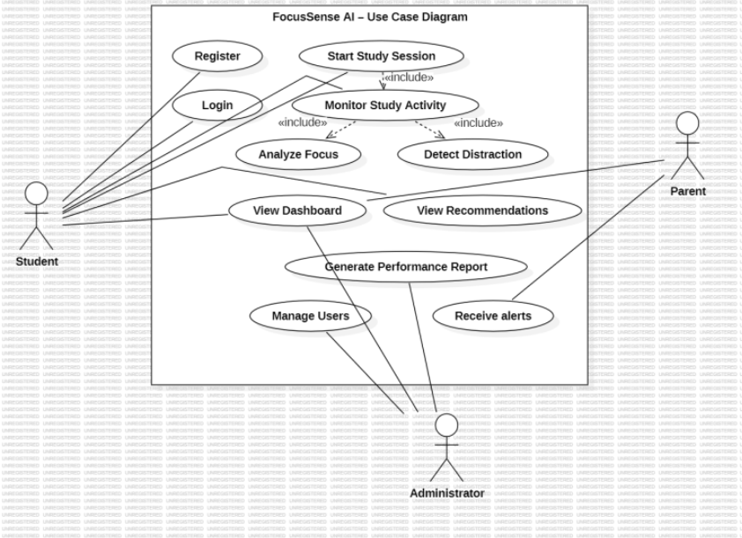

5.3 Class Diagram
The class diagram represents the major software entities and their relationships.
The design includes the following conceptual classes. The final diagram should be checked against the actual source code and database models before submission.
Class | Responsibility
Student | Represents a student account and its associated study information
Parent/Guardian | Represents a parent or guardian with authorized access
StudySession | Stores information about a study session
StudyActivity | Represents an activity record associated with a session
Subject | Represents a subject associated with academic or study information
PerformanceReport | Represents available performance summaries or predictions
Recommendation | Represents a recommendation generated for a student
RecommendationOutcome | Records the supported outcome associated with a recommendation event
BehaviourAnalysis | Represents the logical operation of analysing supported behavioural features and generating predictions
Figure 5.3: Class Diagram of FocusSense AI
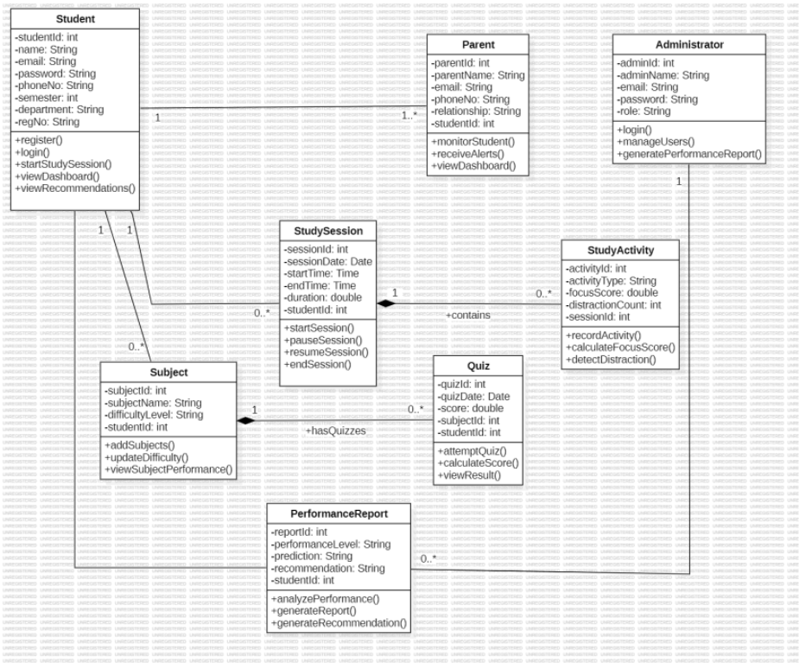
The diagram should show associations between students and their study sessions, sessions and activity records, and recommendation events and their outcomes. The relationship between students and parents must reflect the actual authorization and database design rather than assume a relationship that has not been implemented.

5.4 Sequence and Activity Diagrams

5.4.1 Sequence Diagram/Activity Diagram
A sequence diagram illustrates the order in which components interact during a specific operation.
For FocusSense AI, a useful example is generating study-behaviour insights.
The sequence is:
- The student opens the dashboard.
- The frontend sends an authenticated request to the backend.
- The backend validates the request and checks authorization.
- The backend retrieves the relevant records from the configured data service.
- The backend derives or retrieves the supported behavioural features.
- The appropriate prediction or recommendation component processes the available information.
- The backend returns the result to the frontend.
- The dashboard displays the available information.
Figure 5.4: Sequence Diagram for Study Behaviour Analysis
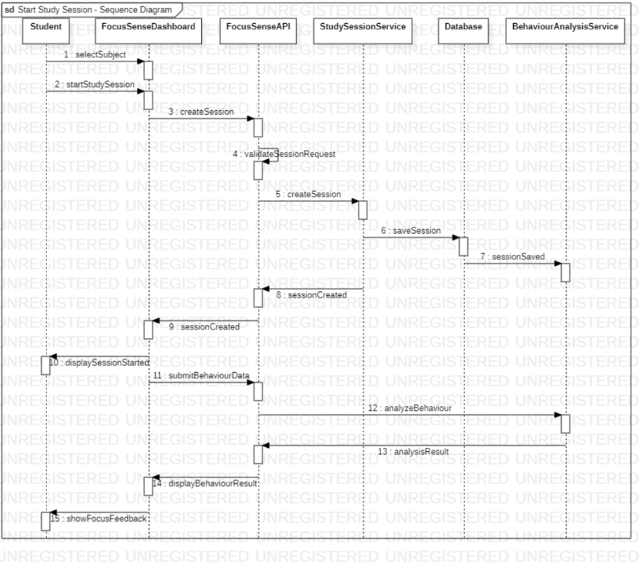

5.5 ER Diagram and Database Design
The Entity-Relationship (ER) diagram represents the data entities, their attributes, and the relationships used to store study information.
The principal conceptual entities are Student, Parent, Study_Session, Study_Activity, Subject, Quiz, and Performance_Report. Recommendation-related entities should also be included if they are part of the implemented database design.

Entity Descriptions
Student: Stores student-related information and links the student to relevant study records.
Parent: Represents a parent or guardian account and its authorized relationship with a student.
Study Session: Stores session-level information, such as the session identifier, associated student, and supported session timestamps or status.
Study Activity: Stores activity records associated with a study session. The exact attributes depend on the implemented activity collection mechanism.
Subject: Represents subjects associated with study or academic records.
Quiz: Represents quiz-related information if quiz records are part of the implemented application.
Performance Report: Represents available performance information or analysis results.
Recommendation and Recommendation Outcome: Represent recommendation events and their associated follow-through or outcome information where implemented.

Main Relationships
- A student may have multiple study sessions.
- A study session may contain multiple activity records.
- A student may have multiple performance reports.
- A recommendation event may have an associated outcome record.
- Parent-to-student relationships must follow the actual database schema and access-control design.
Figure 5.6: Entity-Relationship Diagram of FocusSense AI
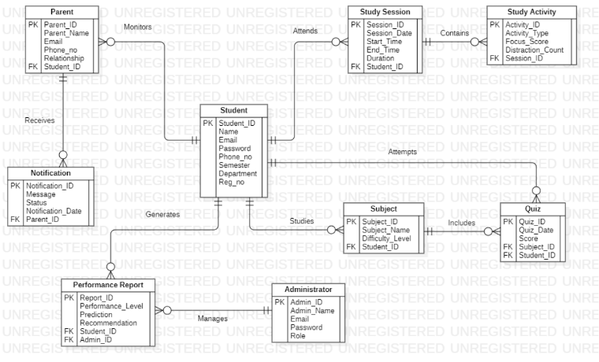

5.6 User Interface Design and Wireframes
The user interface is designed to present study-related information in a clear, organized, and accessible manner. The interface uses a dashboard-based layout to group session information, predictions, recommendations, and progress summaries.

Student Interface
The student interface is intended to provide access to:
- Study-session management.
- Study-behaviour summaries.
- Focus and distraction insights.
- Academic performance estimates.
- Recommendations and recommendation history.
- Available outcome information.

Parent/Guardian Interface
The parent/guardian interface is intended to display the student information permitted by the configured access-control rules. The information presented should be relevant to monitoring study progress without exposing data belonging to unrelated users.

Design Principles
The interface follows these principles:
- Clarity: Present important information using clear labels and concise descriptions.
- Consistency: Maintain consistent navigation, layout, and visual elements.
- Readability: Use suitable spacing, typography, and chart labels.
- Transparency: Identify predictions as estimates and explain their limitations.
- Access control: Display information according to the authenticated user's permissions.
Figure 5.7: Student Dashboard
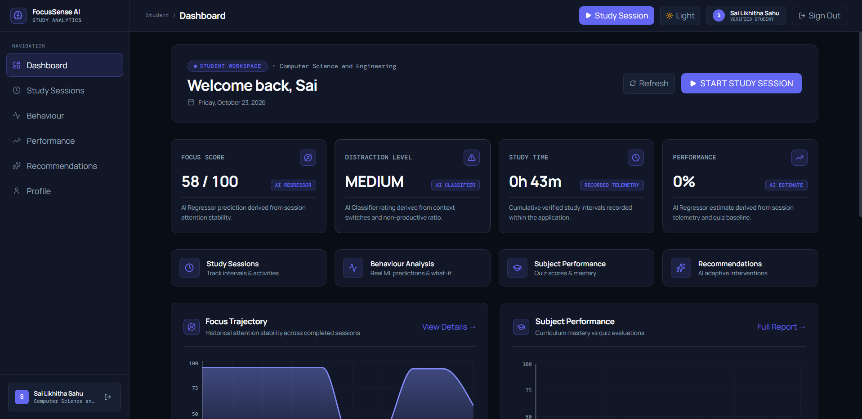
Figure 5.8: Parent/Guardian Dashboard
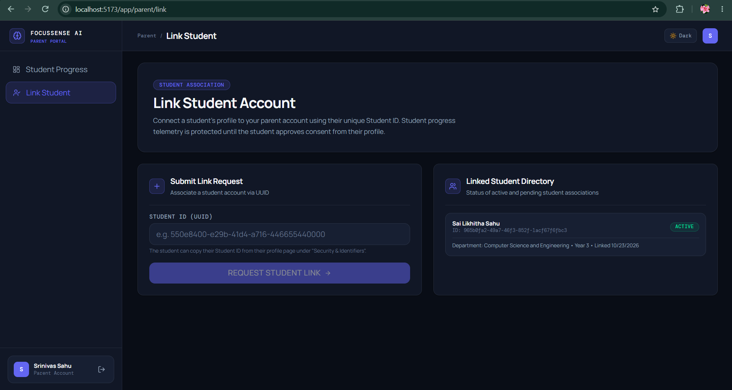

Figure 5.9: Study Insights and Recommendation Interface

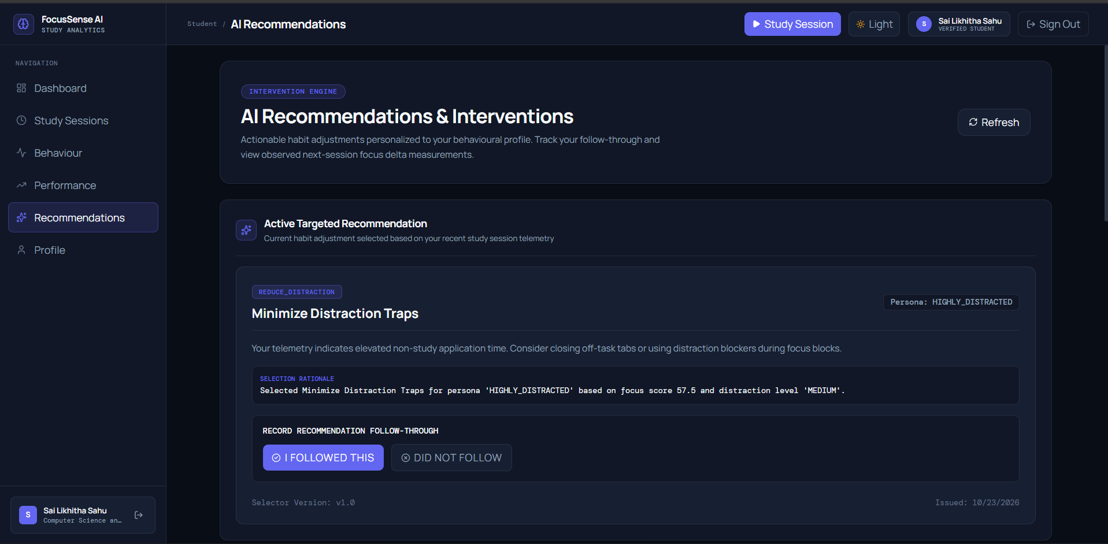

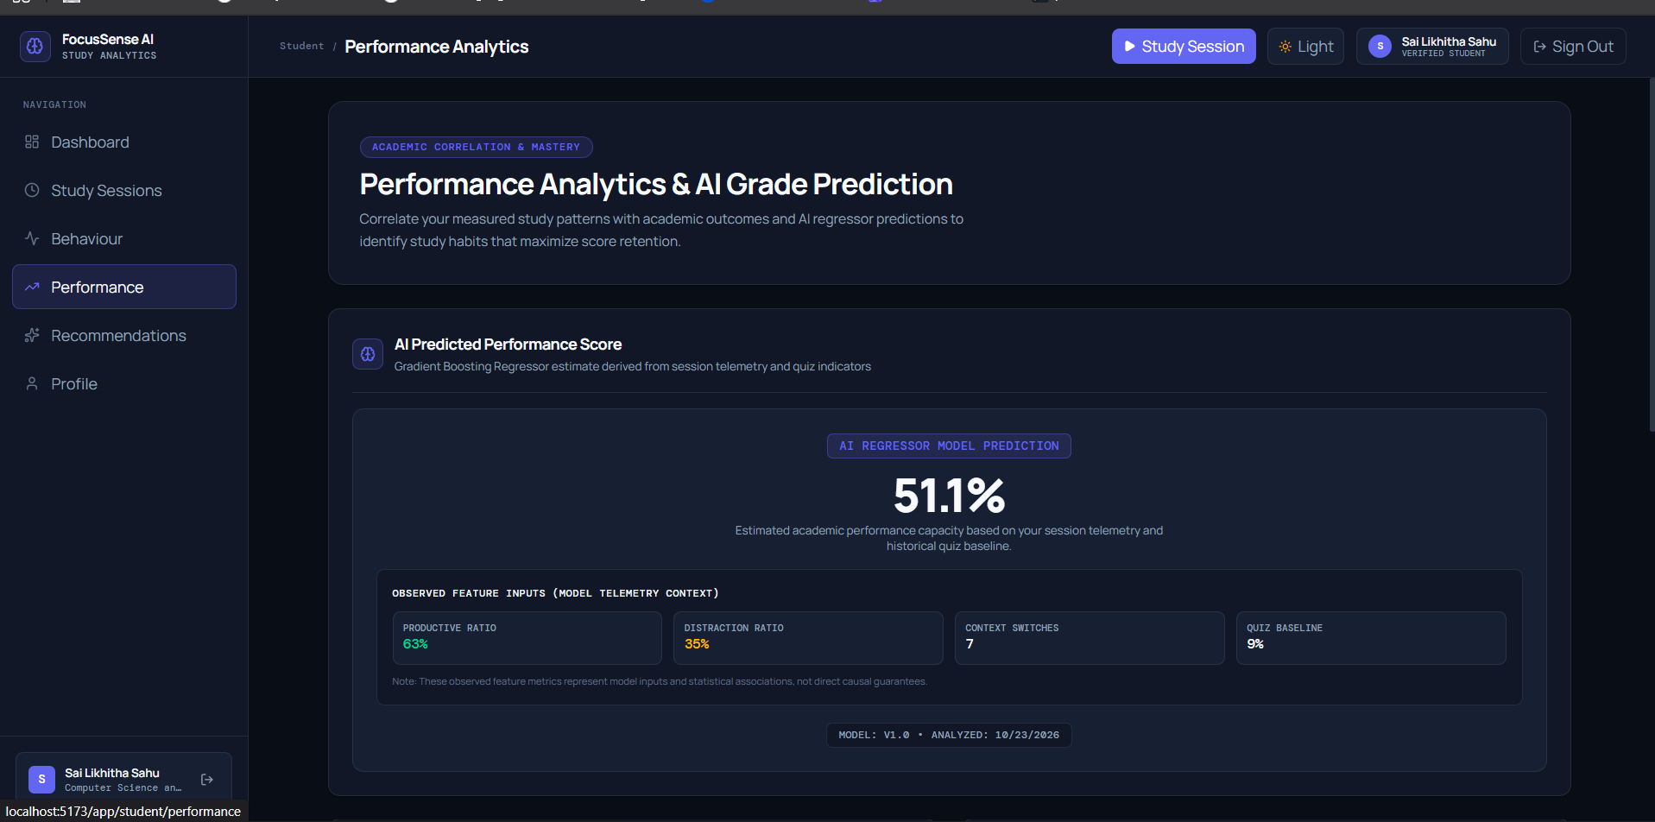

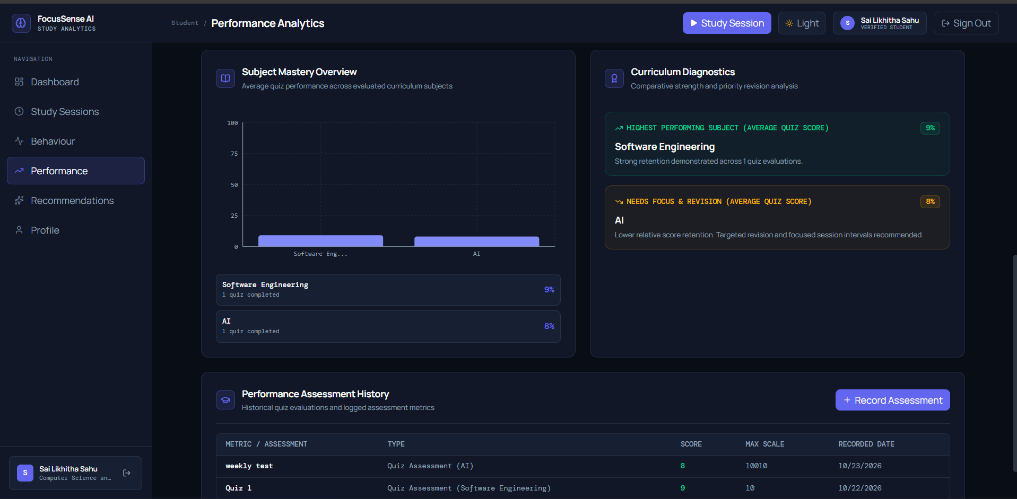

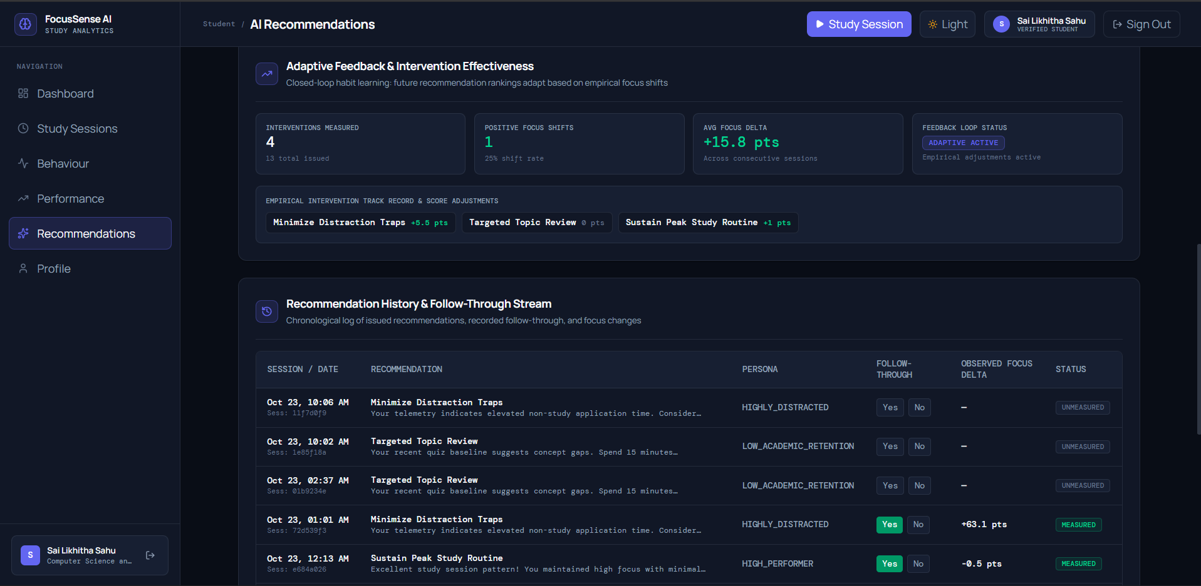

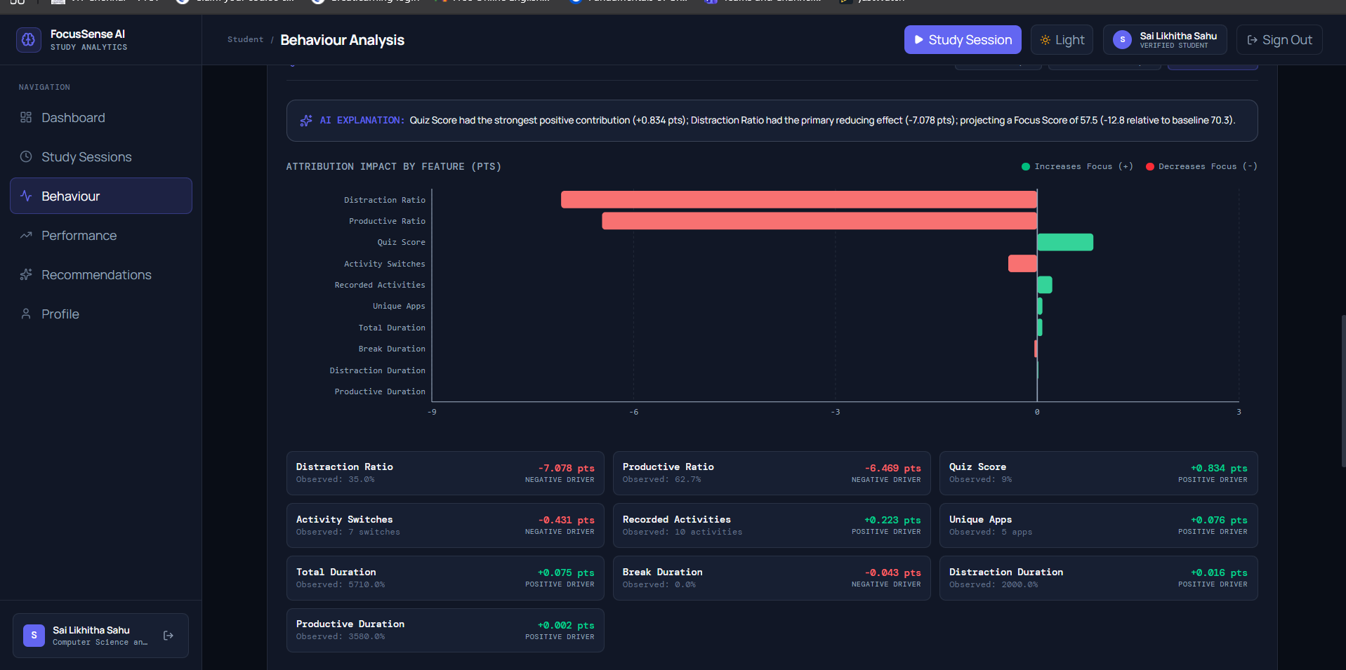

6. Implementation

6.1 Technology Stack
FocusSense AI is developed using a modern web application stack that combines frontend development, backend API services, database integration, and machine-learning capabilities.
Technology | Purpose in the Project
React | Builds the user interface using reusable components
Vite | Provides frontend development and production build tooling
Tailwind CSS | Styles the user interface
JavaScript | Implements frontend interactions and application logic
FastAPI | Provides backend API endpoints and application services
Python | Implements backend logic and machine-learning operations
SQLAlchemy | Defines and manages database interactions through models
Pydantic | Validates incoming request data and structured information
Supabase | Provides the configured authentication and database services
scikit-learn | Supports focus regression, distraction classification, and performance prediction
NumPy and pandas | Support numerical computation and data processing
joblib | Supports model or object persistence where used
Axios | Sends HTTP requests between the frontend and backend
React Router | Manages navigation between frontend pages
Recharts | Displays charts and dashboard visualizations
Lucide | Provides interface icons
Git and GitHub | Track changes and maintain the remote source-code repository
The selected technologies separate the presentation layer from backend processing and data management. This modular structure makes it easier to test components, identify errors, and extend the application.

6.2 Module Description

6.2.1 Authentication and Authorization Module
This module manages user authentication and access to protected resources. The application distinguishes between student and parent/guardian roles, with access governed by the configured authorization rules.
Authentication and authorization are important because the system processes study-related and academic information. The backend must validate protected requests and prevent users from accessing information they are not permitted to view.

6.2.2 Study Session Management Module
This module manages study-session records. Session information provides the basic unit for organizing activity data and analysing study behaviour over time.
The module supports the storage and retrieval of relevant session information. The resulting records can be used to calculate behavioural features and associate recommendations with subsequent study activity.

6.2.3 Study Activity and Feature Extraction Module
The activity-processing component works with available activity records to derive features for behavioural analysis. Depending on the collected data, these features may include productive duration, distraction duration, activity switching, and application diversity.
Feature extraction converts raw or recorded activity information into a structured representation that can be consumed by machine-learning models.
The quality of the extracted features depends on the completeness and reliability of the input data. Missing or incomplete activity records can reduce the reliability of subsequent predictions.

6.2.4 Machine-Learning Analysis Module
The machine-learning module supports three principal prediction tasks.
Focus Regression: Estimates a focus score from supported behavioural features. Regression is appropriate when the output is a numerical value rather than a discrete category.
Distraction Classification: Classifies behaviour into the categories supported by the trained classification model.
Academic Performance Prediction: Estimates an academic performance outcome using the input features expected by the implemented model.
The predictions are intended to support self-reflection and study planning. They are estimates rather than guarantees of future performance. Their practical reliability must be evaluated using appropriate test data and, ultimately, representative real-world observations.

6.2.5 Recommendation Generation Module
The recommendation module generates study suggestions using the configured rules and available behavioural information.
Recommendations are intended to help students respond to observed patterns, such as reduced focus or recurring distraction. The specific suggestion depends on the information available and the rules implemented in the system.
The system maintains relevant recommendation-event information so that recommendations can be reviewed and their outcomes tracked where supported.

6.2.6 Recommendation Outcome Tracking Module
This module records information about whether a recommendation was followed and links the outcome to its corresponding recommendation event.
Where the required records are available, the system evaluates the next eligible completed study session and compares its focus outcome with the earlier session. The outcome is associated with the relevant recommendation rather than treated as an independent event.
This design supports consistent outcome tracking and reduces the risk of creating duplicate outcome records for the same recommendation event.
A change in focus after a recommendation should not automatically be interpreted as proof that the recommendation caused the change. Other factors may influence study behaviour.

6.2.7 Dashboard and Visualization Module
The dashboard presents available study information in a user-friendly format. Depending on the implemented screens, this may include study-session summaries, behavioural insights, prediction results, recommendations, and outcome information.
Charts and visual summaries help users interpret trends more easily than raw records alone. The interface should clearly distinguish observed data from model-generated estimates.

6.2.8 Parent/Guardian Monitoring Module
The parent/guardian component supports authorized access to permitted student information. Its purpose is to help parents or guardians understand study progress while respecting access restrictions.
The information shown must be limited to the students and records the authenticated user is authorized to access. Any functionality that has not yet been implemented or verified should be identified as pending in the final report.

6.3 Key Code Snippets
This section should contain short, representative code excerpts from the actual FocusSense AI repository. Full source code is maintained in the project's GitHub repository.
The following are illustrative examples of the logic involved. Before including them as implementation evidence, replace them with the corresponding verified snippets from the source code.

6.3.1 Example: Validating a Backend Request
FastAPI and Pydantic can be used to validate structured incoming data before processing it.
from pydantic import BaseModel, Field

class StudySessionInput(BaseModel):
student_id: str
duration_minutes: int = Field(gt=0)
This example defines a request structure with a student identifier and a positive session duration. The actual field names and constraints in the submitted report must match the project's implemented schema.

6.3.2 Example: Numerical Prediction
A regression model can produce a numerical estimate from a prepared feature vector.
prediction = model.predict(features)
focus_score = float(prediction[0])
The model and feature vector must be initialized correctly before prediction. The actual implementation may include preprocessing, input validation, model loading, and output handling.

6.3.3 Example: Recording a Recommendation Outcome
A recommendation outcome should be associated with the corresponding recommendation event.
outcome = RecommendationOutcome(
recommendation_event_id=event_id,
followed=followed
)
This is an illustrative fragment, not a complete database transaction. The actual implementation must follow the project's model definitions and persistence logic, including the constraints that prevent duplicate outcomes.

6.3.4 Source Code Availability
The complete implementation and project history are maintained in the FocusSense AI GitHub repository:
https://github.com/Likhitha09-code/FocusSenseAI
The repository should be made accessible to the evaluator according to the submission requirements. The final report should include code excerpts that are directly verified against the committed implementation, rather than presenting illustrative snippets as exact source code.

7. Software Tools Used (Demo Screenshots)
Several software tools were used during the development of FocusSense AI to support coding, version control, API development, system design, and testing. These tools help organize the development workflow and improve maintainability.

7.1 Visual Studio Code
Purpose: Visual Studio Code is a source-code editor used for developing and maintaining application code.
Usage in the Project: Visual Studio Code is used to work with the React frontend, FastAPI backend, Python machine-learning components, configuration files, and project documentation. It provides a common development environment for managing the different parts of FocusSense AI.
Screenshot Evidence: Insert a screenshot of the FocusSense AI project opened in Visual Studio Code, showing the project folder structure and relevant source files.

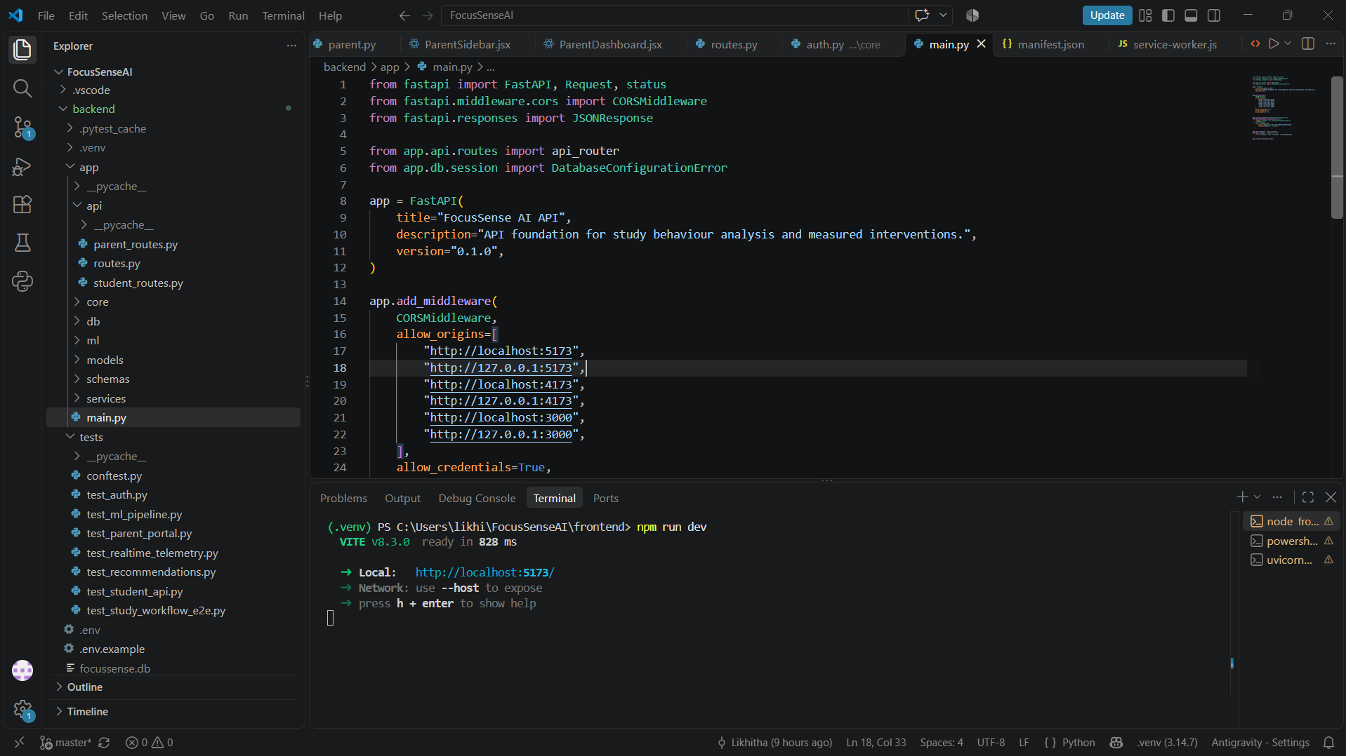

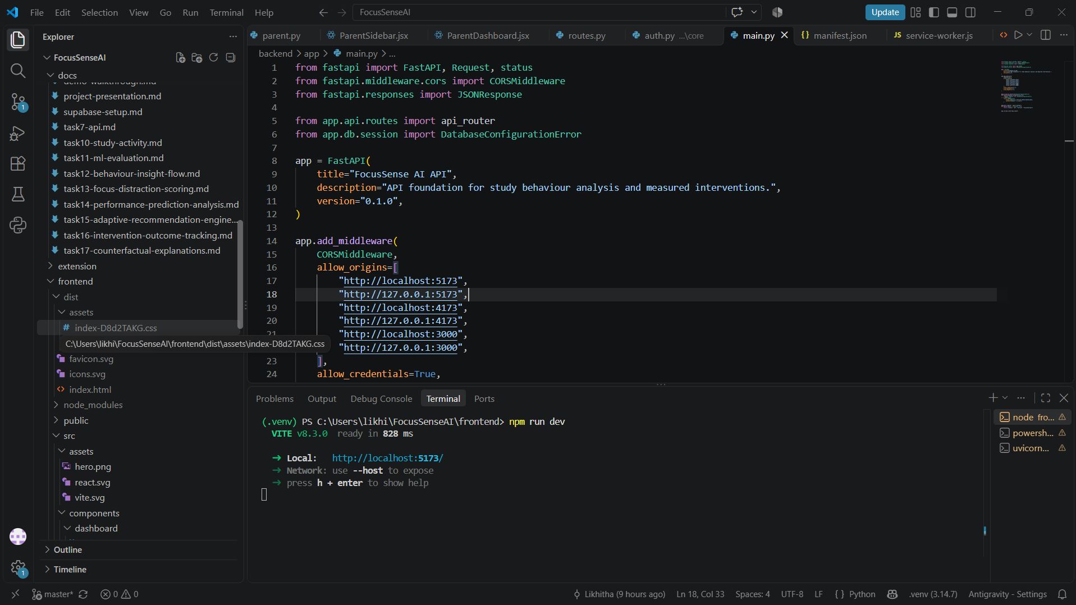

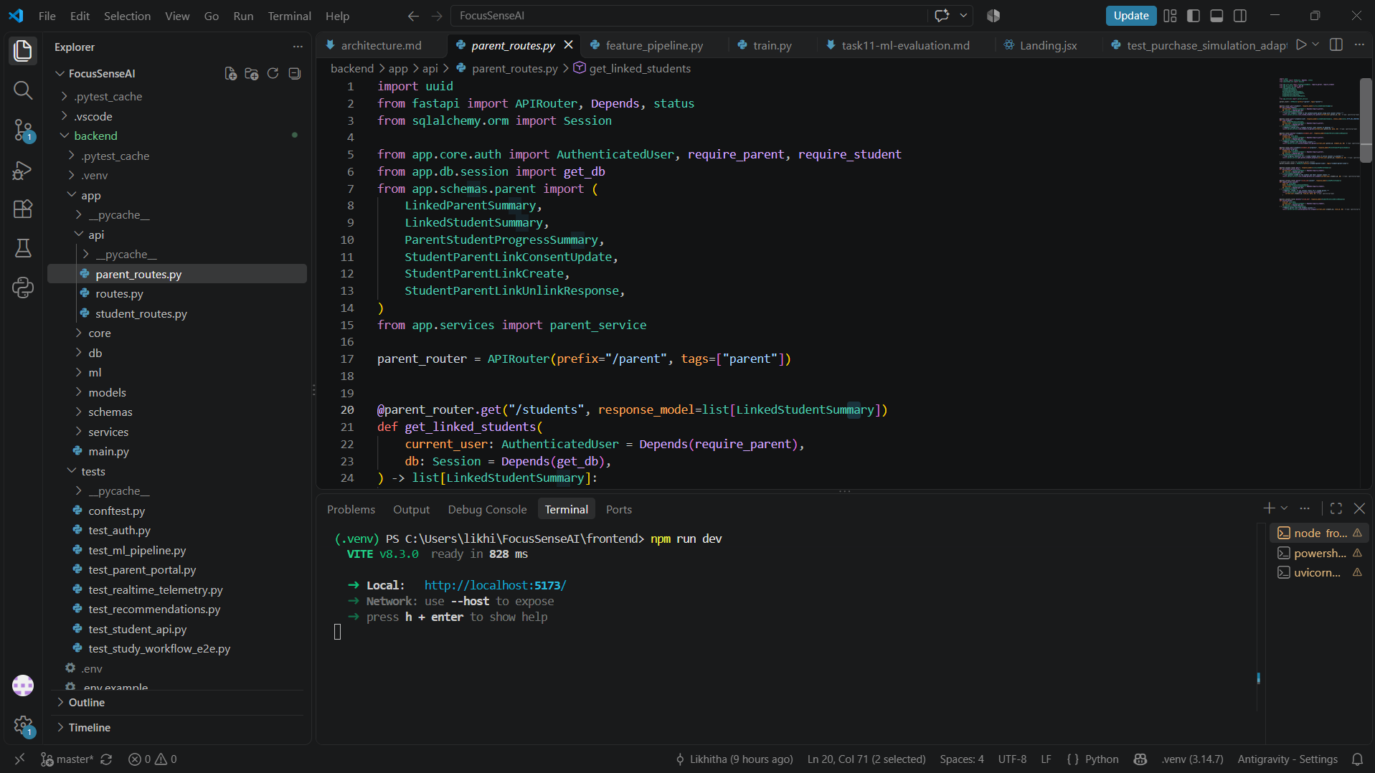

7.2 Git and GitHub
Purpose: Git is a version-control system that records changes to source code. GitHub hosts the remote repository and provides access to the project history.
Usage in the Project: Git and GitHub are used to maintain the FocusSense AI source code, record implementation checkpoints, and preserve the development history. The project repository provides a central location for the code and supports review of committed changes.
Repository: https://github.com/Likhitha09-code/FocusSenseAI
Screenshot Evidence:
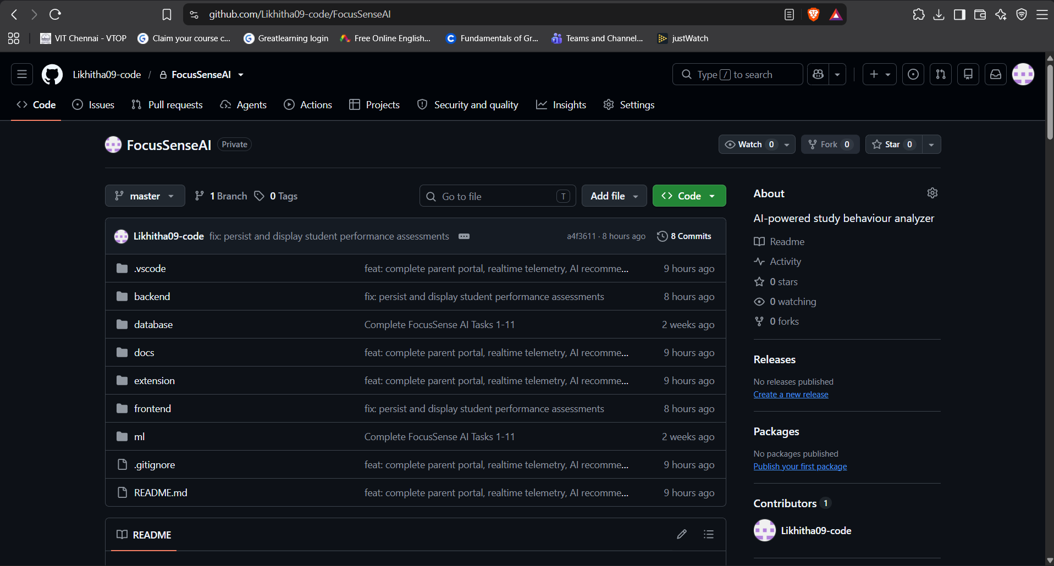
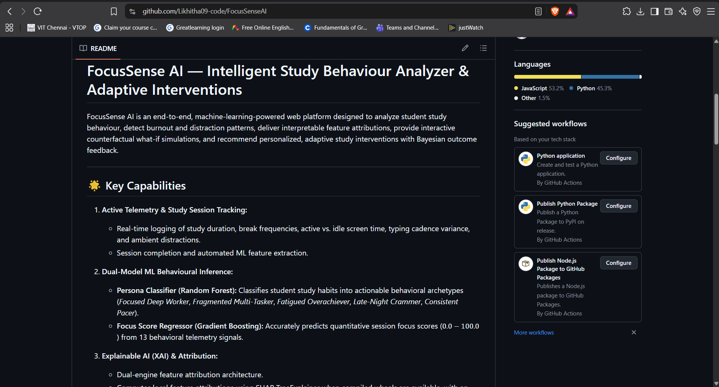
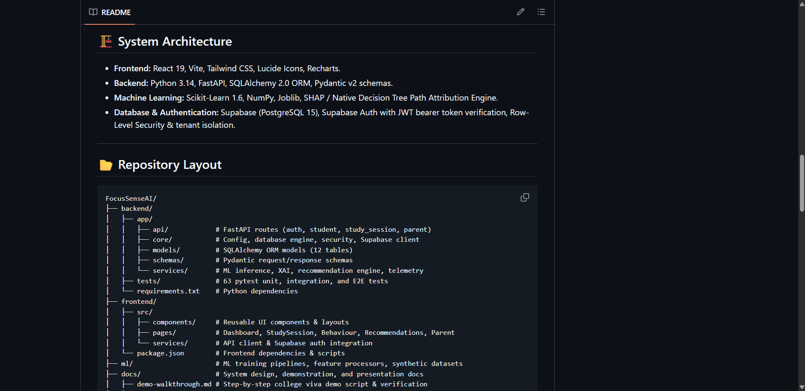

7.3 API Development and Testing Tools
Purpose: API development and testing tools help verify backend endpoints, request formats, response data, and error handling.
Usage in the Project: FocusSense AI uses FastAPI to expose backend API endpoints. API testing tools can be used to send requests to these endpoints and inspect the responses during development and verification.

7.4 Summary of Software Tools
Tool | Purpose | Phase of SDLC | Usage in the Project
Visual Studio Code | Source-code editing | Implementation | Developing frontend, backend, and configuration files
Git | Version control | Implementation and maintenance | Recording changes and maintaining checkpoints
GitHub | Remote repository hosting | Implementation and maintenance | Hosting source code and development history
FastAPI interactive documentation or an API testing tool | Endpoint inspection and testing | Testing | Inspecting API definitions and verifying requests and responses
Selenium IDE | Functional testing | Testing | Automating user-interface test scenarios
Apache JMeter, if used | Load and performance testing | Testing | Measuring response time, throughput, and errors under a defined workload
The tools listed above support different stages of the software development life cycle. The final submission should distinguish tools actually used from tools considered for future testing. Only tools supported by genuine usage and screenshot evidence should be described as completed project activities.

8. Testing

8.1 Test Plan and Strategy
Testing is an important phase of FocusSense AI development. It verifies that the application behaves according to its requirements, handles invalid inputs appropriately, protects user information, and produces the expected outputs.
The testing strategy covers backend API testing, frontend validation, machine-learning component testing, access-control testing, and integration testing.

8.1.1 Functional Testing
Functional testing verifies that user-visible features operate according to the requirements. It includes authentication, session management, dashboard access, recommendation generation, and permitted parent/guardian access.

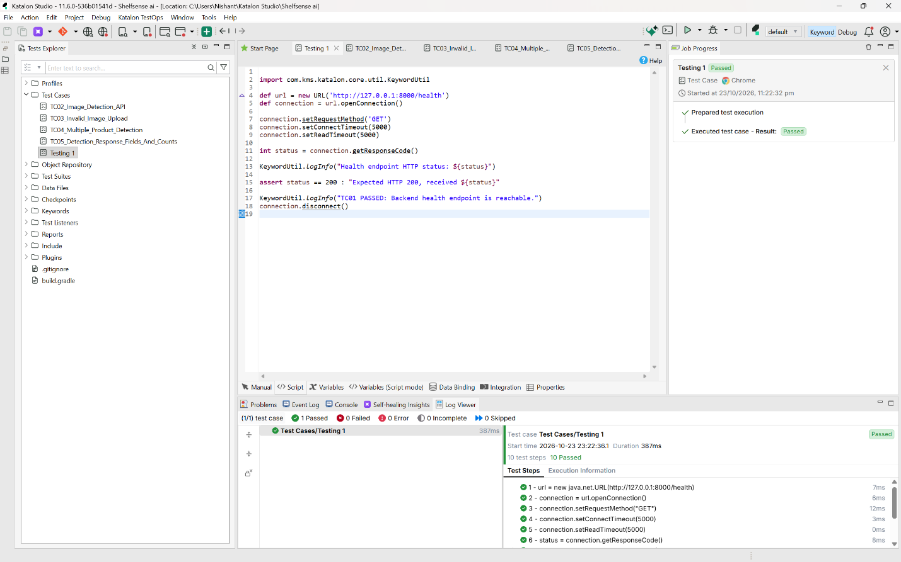

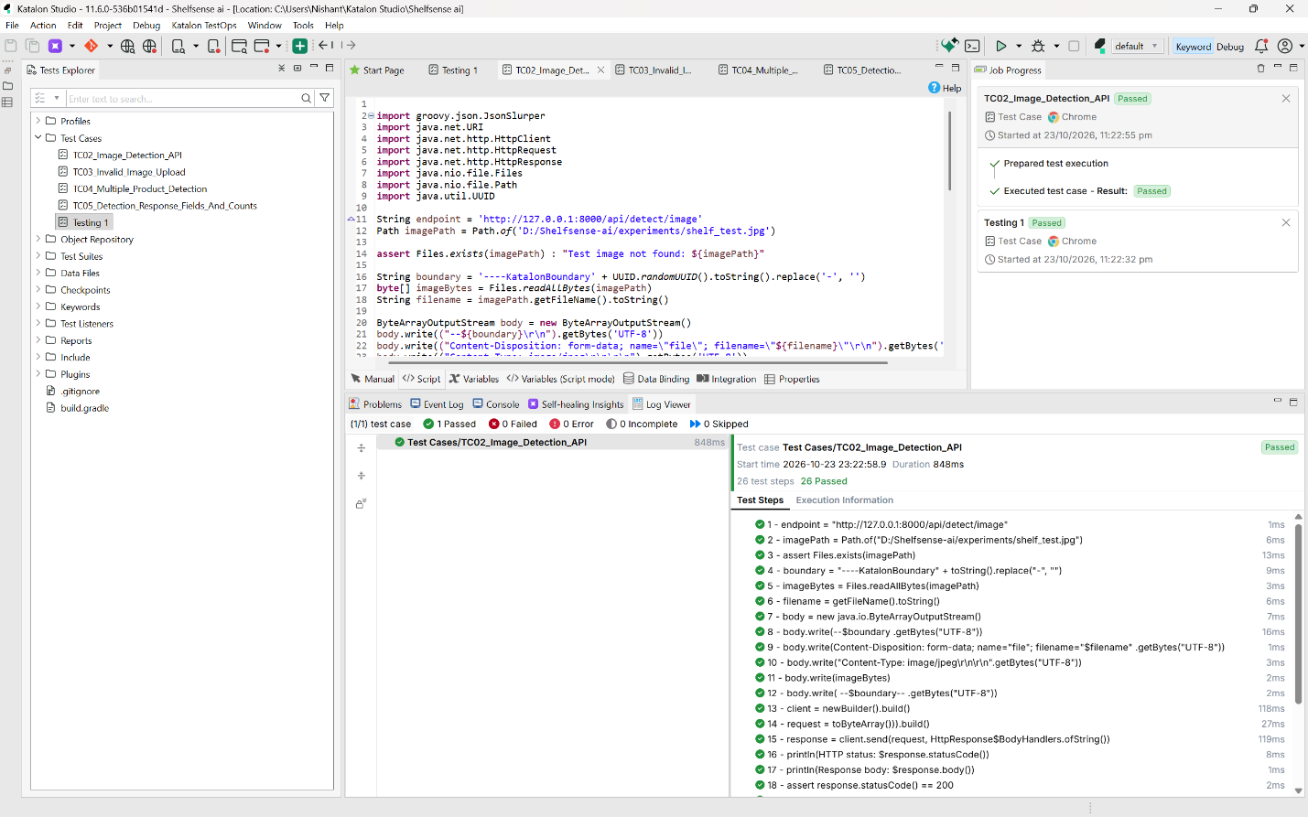

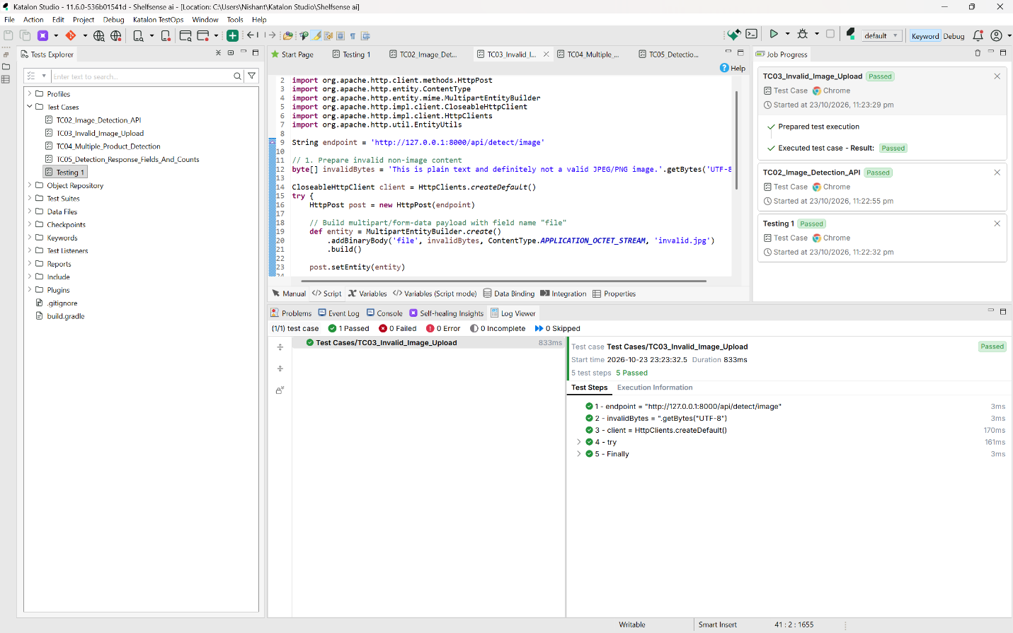

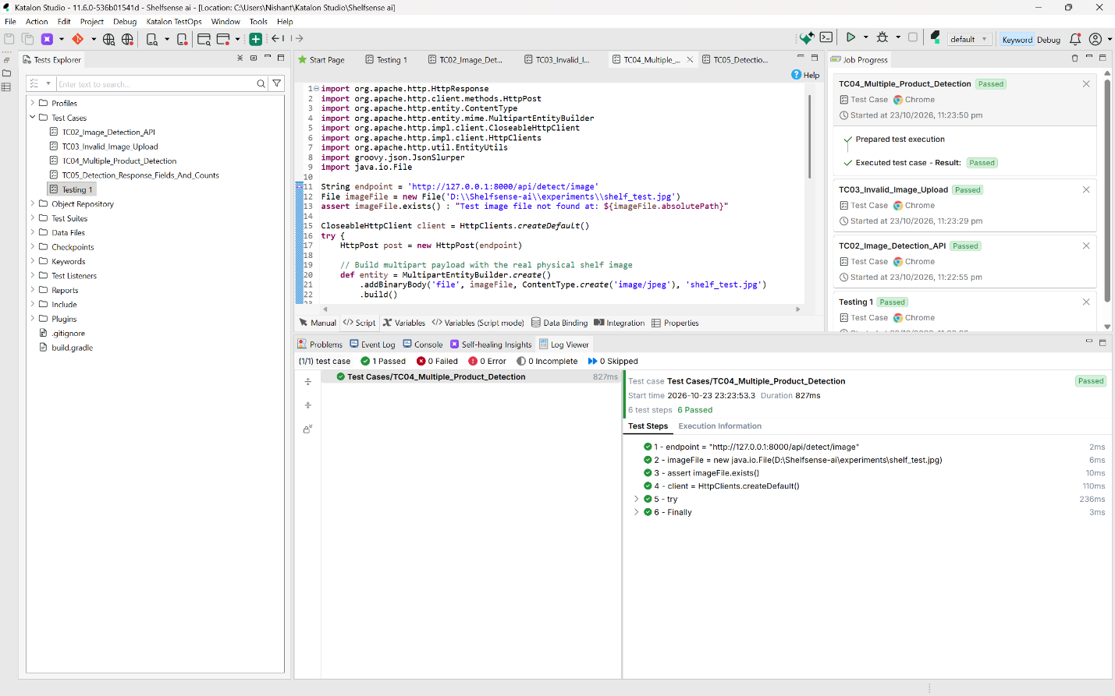

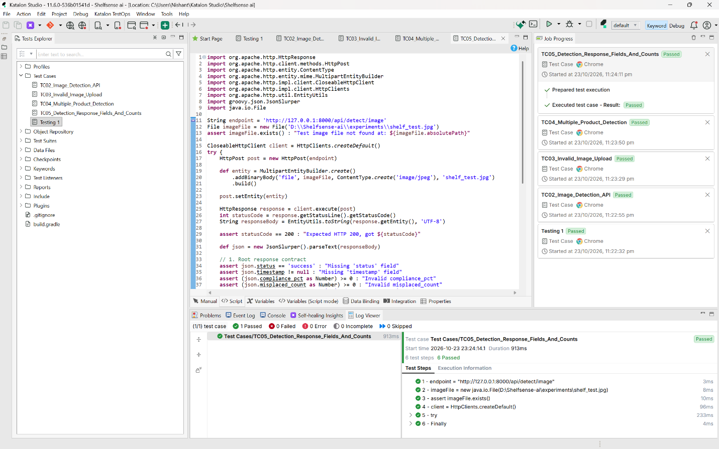

8.1.2 Non-Functional Testing(JMeter)

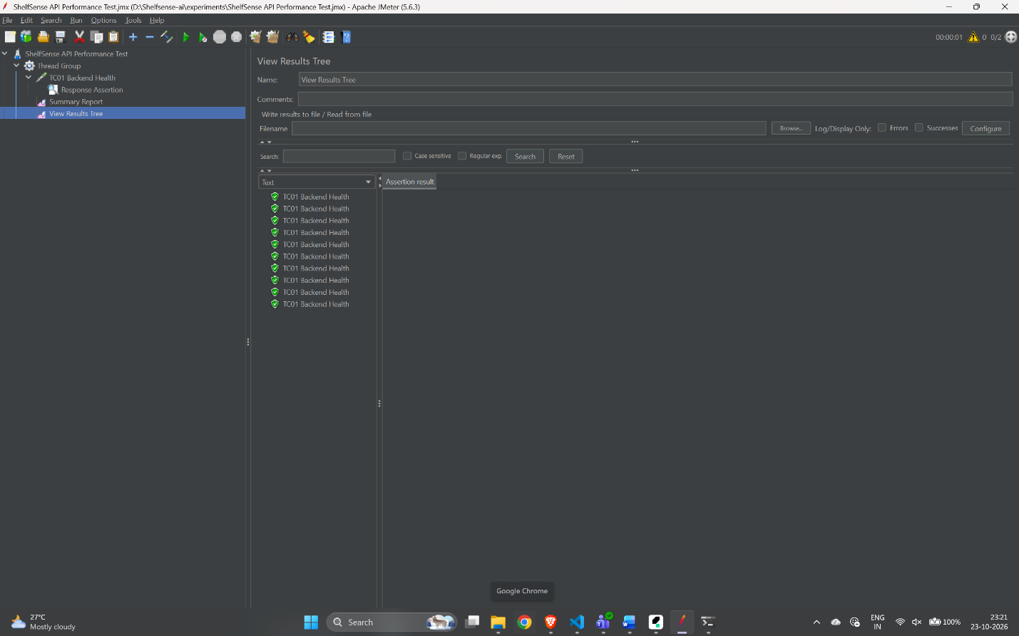

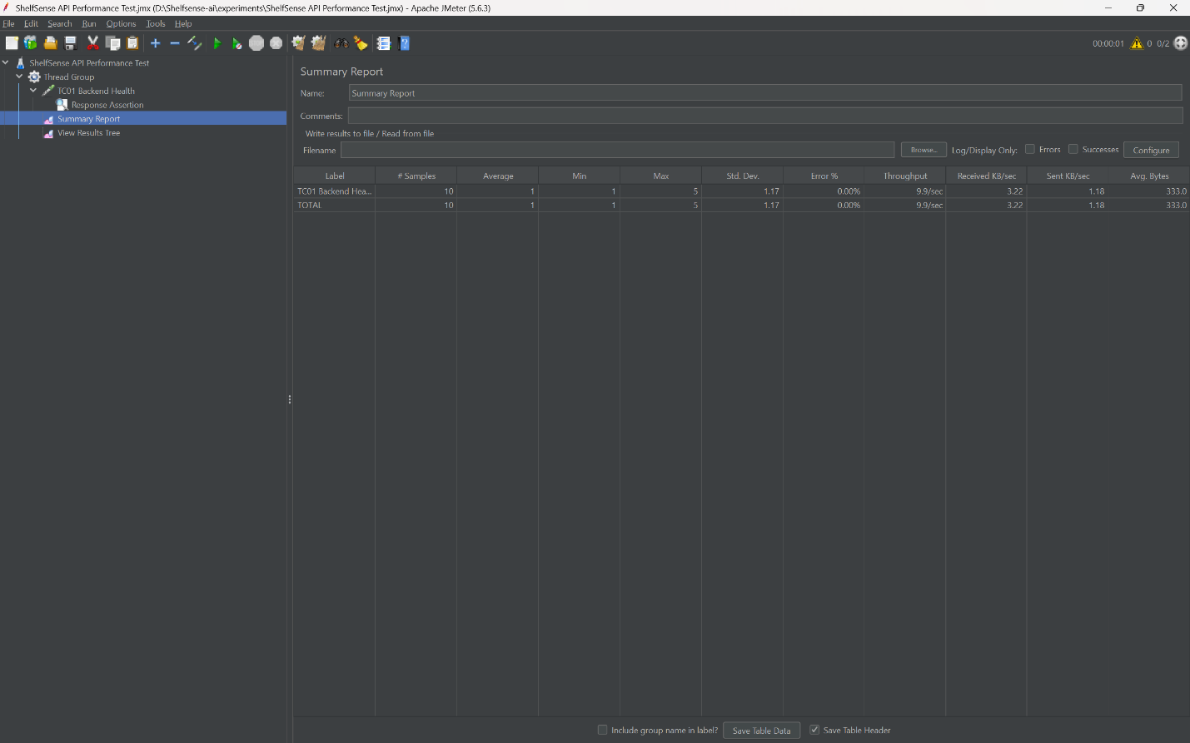

8.2 Test Cases
The following table defines proposed test cases for FocusSense AI. Expected results are specified for each test. The actual output and final status must be filled in after the tests are executed against the application.
Test ID | Input / Test Scenario | Expected Output | Actual Output | Status
TC-01 | Submit valid login credentials | Authentication succeeds and the user can access permitted resources | recorded | verified
TC-02 | Submit invalid login credentials | Authentication fails and access is denied | recorded | verified
TC-03 | Access a protected endpoint without valid authentication | The request is rejected | recorded | verified
TC-04 | Attempt to access another student's restricted data | The request is denied | recorded | verified
TC-05 | Start and complete a valid study session | The session is processed and stored according to the implementation | recorded | verified
TC-06 | Submit an invalid study-session input | Validation rejects the invalid input or returns an appropriate error | recorded | verified
TC-07 | Submit valid behavioural features to the focus model | A focus estimate is returned in the expected format | recorded | verified
TC-08 | Submit valid features to the distraction classifier | A supported classification result is returned | recorded | verified
TC-09 | Submit valid inputs to the performance prediction model | A performance estimate is returned in the expected format | recorded | verified
TC-10 | Request recommendations with supported input data | Applicable recommendations are returned | recorded | verified
TC-11 | Record an outcome for a recommendation event | The outcome is associated with the correct event | recorded | verified
TC-12 | Attempt to create a duplicate outcome for the same recommendation event | The applicable uniqueness constraint or application logic prevents duplicate outcomes | recorded | verified
TC-13 | Request a dashboard using an authorized account | The dashboard displays the data permitted for that account | recorded | verified
TC-14 | Request parent/guardian access without the required authorization | Restricted student information is not disclosed | recorded | verified
TC-15 | Send repeated valid requests to a safe test endpoint | Response times, throughput, and errors can be measured and recorded | recorded | verified
Note: A proposed test case is not evidence that the test passed. Update the actual-output and status columns only after execution. Where a feature is not implemented, mark the test as not applicable or pending implementation, with an explanation.

8.3 Test Results and Bug Log

8.3.1 Test Results
The final test results will summarize the number of tests executed, passed, failed, and left pending. Results should be calculated from the completed test records.
The following table can be completed after execution:
Test Metric | Result
Total planned test cases | 15
Tests executed | recorded
Tests passed | recorded
Tests failed | recorded
Tests pending | recorded
Defects identified | recorded
Defects resolved | recorded
The existing development checkpoint includes automated backend testing and frontend lint/build verification. The detailed results from those checks should be confirmed from the actual terminal output before they are included as formal testing evidence in this report.

8.3.2 Bug Log
The bug log records defects discovered during testing, their impact, and their resolution status.
Bug ID | Description | Severity | Resolution
B-01 | To be filled in if a defect is identified during testing | assessed | recorded
B-02 | To be filled in if a defect is identified during testing | assessed | recorded
B-03 | To be filled in if a defect is identified during testing | assessed | recorded
If no defects are found during a particular test cycle, record that no defects were observed in that cycle instead of inventing defects or resolutions.

8.3.3 Performance Test Results
Metric | Measured Result
Test endpoint | recorded
Test environment | recorded
Workload configuration | recorded
Average response time | measured
Throughput | measured
Error count/rate | measured

9. Results and Discussion

9.1 Output Screenshots of the Working System
FocusSense AI integrates study-session management, behavioural analysis, machine-learning predictions, recommendation generation, and outcome tracking within a web application. The interface is intended to present the available information in a structured format so that students can understand their study patterns and identify areas for improvement.
The following screenshots should be captured from the actual running application and inserted into the final report.

9.1.1 Authentication Interface
The authentication interface allows registered users to access the application. Access to protected functionality depends on successful authentication and the configured authorization rules.
Figure 9.1: FocusSense AI Authentication Interface
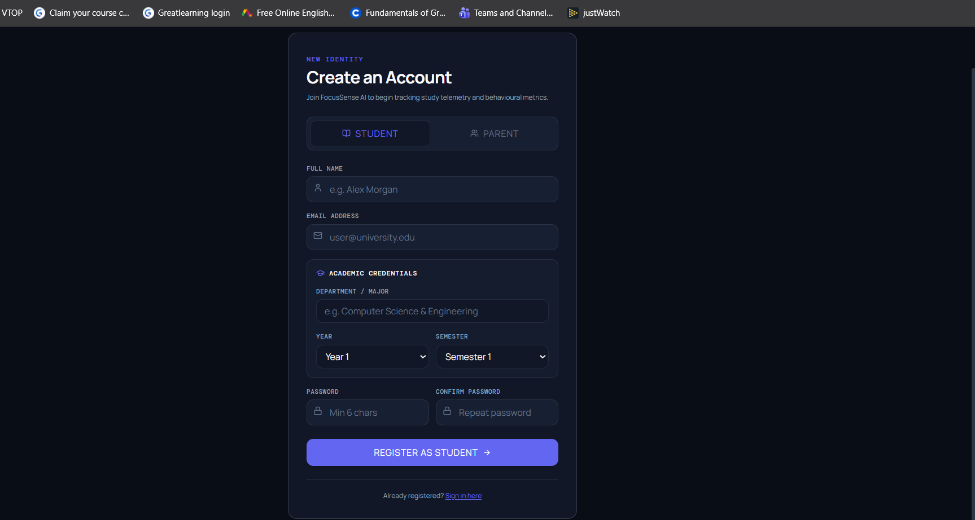.

9.1.2 Student Dashboard
The student dashboard presents the study information and insights available to the authenticated student. Depending on the implemented features, it may display study-session summaries, behavioural predictions, recommendations, and progress information.

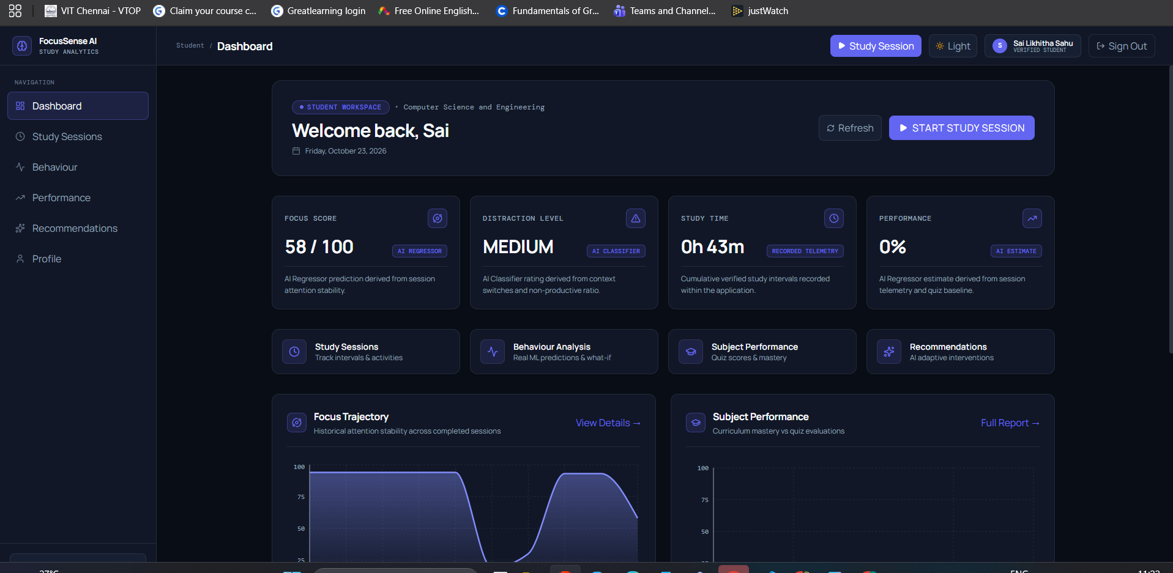

9.1.3 Behavioural Analysis and Prediction
The behavioural analysis component processes supported activity features to generate focus estimates and distraction classifications. The academic performance component provides an estimate based on the input features accepted by the trained model.
These outputs are intended to support study planning and self-reflection. Their accuracy depends on the input data, model quality, and the conditions under which the models were evaluated.
Figure 9.3: Behavioural Analysis and Prediction Output

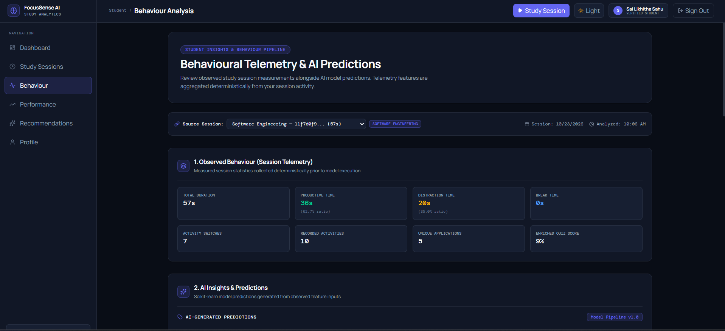

9.1.4 Recommendation Interface
The recommendation component generates study suggestions using the available behavioural information and configured rules. Recommendation history and outcome information can help organize the recommendations provided to a student.
Figure 9.4: Study Recommendations and Recommendation History
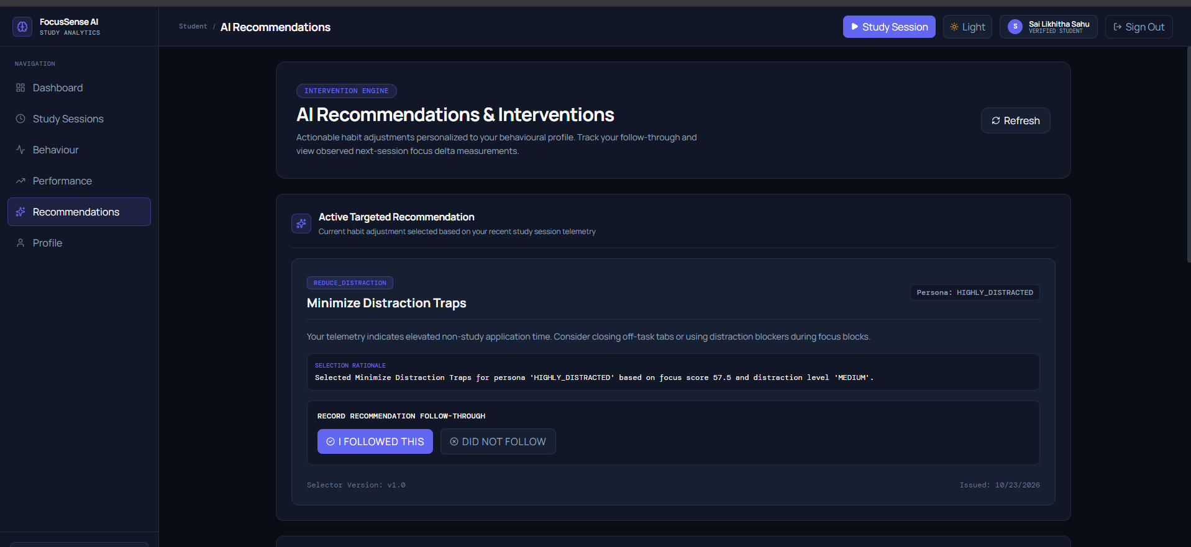.

9.1.5 Parent/Guardian Monitoring Interface
The parent/guardian interface is intended to provide access to permitted student information. The information displayed must follow the application's actual authorization rules.
Figure 9.5: Parent/Guardian Monitoring Interface
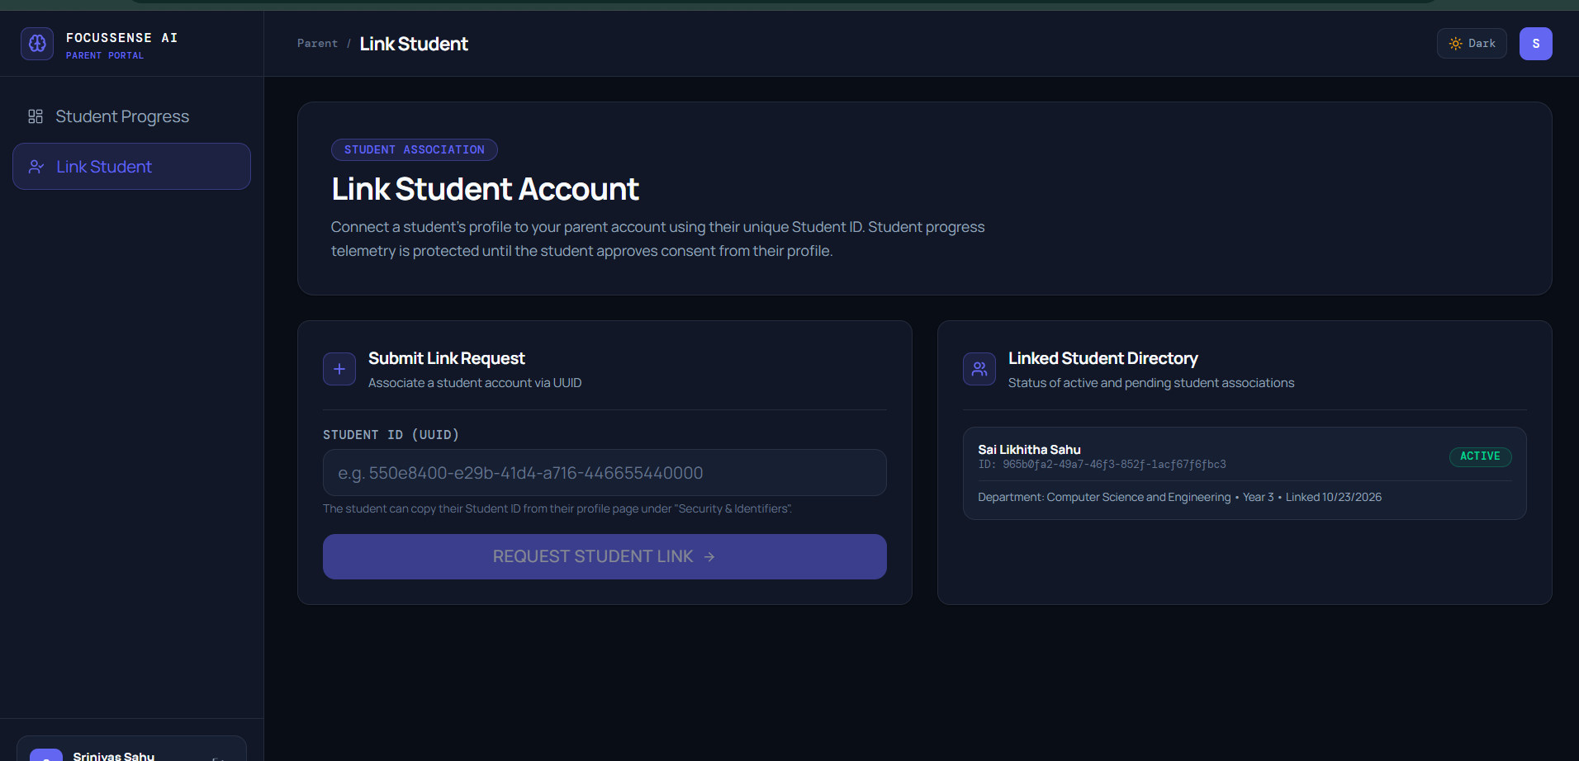.

9.2 Analysis Against Objectives
The project objectives provide the basis for evaluating the results of FocusSense AI. The assessment must distinguish between functionality implemented in the current development checkpoint and functionality that still requires verification or further development.
Project Objective | Intended Result | Evaluation Method
Provide authentication and controlled access | Users access permitted resources through the configured authentication and authorization mechanisms | Authentication and access-control tests
Manage study sessions and activity records | Study information is organized into usable records | Functional and database tests
Extract behavioural features | Supported activity data is converted into structured model inputs | Feature-processing tests
Estimate focus levels | The regression model produces a numerical focus estimate | Model-output and evaluation tests
Classify distraction behaviour | The classification model returns a supported category | Classification tests and suitable evaluation metrics
Predict academic performance | The performance model returns an estimate for valid inputs | Prediction tests and evaluation metrics
Generate study recommendations | Configured rules produce applicable recommendations | Recommendation tests
Track recommendation outcomes | Outcomes are associated with their relevant recommendation events | Persistence, uniqueness, and workflow tests
Provide a student dashboard | Available information is presented through the user interface | Frontend and integration tests
Support parent/guardian monitoring | Authorized users can access only permitted student information | Role and ownership tests
The current development checkpoint includes implementation work for the main backend and frontend components, machine-learning analysis, recommendation handling, and recommendation outcome tracking. The final report should use test evidence to confirm which objectives have been successfully demonstrated.

Discussion of Machine-Learning Results
The machine-learning components provide estimates that can help organize study information and support decision-making. However, a prediction is not necessarily an accurate representation of a student's actual concentration or academic potential.
The use of synthetic development data is a limitation because model performance on synthetic data may not generalize to real student behaviour. Suitable evaluation metrics and representative real-world data are necessary before making claims about practical predictive accuracy.

Discussion of Recommendation Outcomes
Recording whether a recommendation was followed and comparing focus outcomes across eligible sessions provides a way to examine what happens after a recommendation is presented.
An observed improvement does not establish that the recommendation caused the improvement. Factors such as sleep, workload, environment, subject difficulty, and motivation may also influence the outcome.

Limitations
The project has several limitations that must be considered when interpreting its results:
- The reliability of behavioural analysis depends on the availability and quality of activity data.
- Machine-learning outputs depend on training data, feature selection, and model evaluation.
- Synthetic data cannot establish real-world predictive effectiveness.
- Recommendation outcome tracking provides observational evidence rather than proof of causality.
- The availability of parent/guardian features depends on the implemented access-control and interface functionality.
- Any advanced explainability or counterfactual functionality that has not been completed must be treated as future work.
Overall, FocusSense AI establishes a software framework for integrating study-behaviour analysis, machine-learning predictions, recommendations, and outcome tracking. Its practical effectiveness must be assessed through the completed functional tests, model evaluation, and performance measurements.

10. Conclusion and Future Enhancements

10.1 Conclusion
FocusSense AI — AI Study Behaviour Analyzer is a software project designed to support students in understanding their study behaviour and making more informed study-planning decisions. The project combines web application development, behavioural feature processing, machine-learning predictions, recommendation generation, and recommendation outcome tracking within a unified system.
The application uses React for the frontend and FastAPI for backend services, with Supabase providing the configured authentication and database services. Python-based machine-learning components support focus estimation, distraction classification, and academic performance prediction. The recommendation module provides study suggestions based on the configured rules and available information.
An important aspect of the project is the inclusion of recommendation outcome tracking. Instead of treating a recommendation as an isolated suggestion, the system supports recording whether it was followed and associating the outcome with a subsequent eligible study session. This creates a foundation for evaluating recommendation usefulness over time, although observed changes do not establish causality.
The project also considers the need for authorized parent/guardian access to permitted student information. Access controls are essential because the application processes personal study and academic data.
The current implementation establishes a foundation for an integrated study-behaviour analysis system. However, its practical effectiveness depends on successful functional testing, appropriate machine-learning evaluation, reliable activity data, and validation using representative real-world observations. Predictions should be treated as estimates rather than definitive judgments about a student's abilities or behaviour.
In conclusion, FocusSense AI provides a foundation for combining study-session information, machine-learning analysis, personalized guidance, and outcome tracking in a single application. Further testing and development can improve its reliability, usability, and practical value.

10.2 Future Enhancements
The following enhancements can extend the capabilities of FocusSense AI.

10.2.1 Interactive Counterfactual Explanations
An interactive counterfactual explanation feature could help users understand how changes in selected behavioural features affect a model's prediction. For example, users could explore how a different distraction duration or activity-switching pattern changes an estimated focus score.
Such explanations should be presented as model-based scenarios, not guarantees that changing a single factor will produce the same result in real life.

10.2.2 Adaptive Recommendation Engine
The recommendation engine could be improved to adapt suggestions using a student's previous recommendation outcomes and changing study patterns. This would help prioritize recommendations that appear useful for the individual rather than relying exclusively on fixed rules.

10.2.3 Real-World Data Collection and Validation
Future work could collect representative study-session data with appropriate consent and privacy safeguards. The models could then be evaluated using suitable validation methods and metrics to determine whether their performance generalizes beyond synthetic development data.

10.2.4 Improved Behavioural Monitoring
Additional activity-collection capabilities could be introduced to obtain more reliable information about study sessions. Any device or application monitoring should be transparent, permission-based, configurable, and limited to the data necessary for the intended purpose.

10.2.5 Advanced Model Explainability
Feature-importance methods and explainability techniques could be integrated to show which input features contribute to a prediction. This would help users interpret the model's outputs while making clear that feature importance does not establish causality.

10.2.6 Enhanced Parent/Guardian Features
The parent/guardian interface could be expanded with configurable progress summaries and privacy-conscious reporting. Access should remain restricted to authorized student information, and students should be informed about what information is shared.

10.2.7 Performance and Scalability Improvements
Future development could optimize database queries, API processing, and model inference. Additional load testing would help identify bottlenecks and determine the system's behaviour under increased usage.

10.2.8 Mobile-Friendly Interface
A responsive design or dedicated mobile application could make study insights and recommendations more accessible across devices.
These enhancements would extend the current system while preserving its primary objective: helping students understand study patterns and make informed improvements through behavioural insights and data-supported guidance.
11. References
[1] Meta Platforms, Inc., “React Documentation.” [Online]. Available: https://react.dev/. [Accessed: Oct. 23, 2026].
[2] Vite, “Getting Started.” [Online]. Available: https://vite.dev/guide/. [Accessed: Oct. 23, 2026].
[3] S. Ramírez, “FastAPI Documentation.” [Online]. Available: https://fastapi.tiangolo.com/. [Accessed: Oct. 23, 2026].
[4] Scikit-learn Developers, “Scikit-learn User Guide.” [Online]. Available: https://scikit-learn.org/stable/user_guide.html. [Accessed: Oct. 23, 2026].
[5] Supabase, “Supabase Documentation.” [Online]. Available: https://supabase.com/docs. [Accessed: Oct. 23, 2026].
[6] PostgreSQL Global Development Group, “PostgreSQL Documentation.” [Online]. Available: https://www.postgresql.org/docs/. [Accessed: Oct. 23, 2026].
[7] Selenium Project, “Selenium IDE Documentation.” [Online]. Available: https://www.selenium.dev/selenium-ide/. [Accessed: Oct. 23, 2026].
[8] Apache Software Foundation, “Apache JMeter User Manual.” [Online]. Available: https://jmeter.apache.org/usermanual/. [Accessed: Oct. 23, 2026].
[9] Atlassian, “Jira Software Support.” [Online]. Available: https://support.atlassian.com/jira-software-cloud/. [Accessed: Oct. 23, 2026].
[10] L. Sahu, “FocusSense AI – AI Study Behaviour Analyzer,” GitHub repository. [Online]. Available: https://github.com/Likhitha09-code/FocusSenseAI. [Accessed: Oct. 23, 2026].

Appendices

Appendix A — Project Links

A.1 GitHub Repository
Project Name: FocusSense AI — AI Study Behaviour Analyzer
Repository URL: https://github.com/Likhitha09-code/FocusSenseAI
The repository contains the project's source code and development history. Before submission, ensure that the faculty can access the repository and that the README provides the required setup and execution instructions.

A.2 Project Demonstration Video
Video URL:
https://drive.google.com/file/d/1ZHhSpLkUICva64qI1sryiQz2ohNms1Mj/view?usp=drive_link

