/*第一题：直接使用了已经命好的名字与编号，若需要自行输入，附加一个二维char型数组保存姓名，一个短整型数组保存序号即可完成初始化，故未进行演示。*/
#include<iostream>
#define JudgeNum 5
#define PlayerNum 5
using namespace std;

class CompetitionResult {
short num; // 选手号码
char name[10]; // 选手姓名
float score[JudgeNum]; // 记录各评委给选手的打分
float average; // 选手最后得分，去掉一个最高分和一个最低分后的平均分

public:
CompetitionResult(); // 无参数构造函数
CompetitionResult(short n,const char* ps); // 一般构造函数
float MaxScore(); // 求评委打的最高分
float MinScore(); // 求评委打的最低分
void SetAvg(); // 求选手的最后得分
float GetAvg(); // 读选手的最后得分
short GetNo(); // 读选手的编号
void setNo(int i); // 设置选手的编号
char* GetName(); // 读选手的姓名
float GetScore(int j); // 读第j个评委的打分
void SetScore(int k, float av); // 记录第k+1个评委的打分
friend void Sort(CompetitionResult* pr, int n);// 按最后得分由高到低排序
};
CompetitionResult::CompetitionResult() {} // 无参数构造函数
CompetitionResult::CompetitionResult(short n,const char* ps){ // 一般构造函数
num = n;
strcpy_s(name, ps);
}
float CompetitionResult::MaxScore() { // 求评委打的最高分
float Max = 0.0;
for (int i = 0; i < JudgeNum; i++) {
if (score[i] >= Max) Max = score[i];
}
return Max;
}
float CompetitionResult::MinScore() { // 求评委打的最低分
float Min = this -> MaxScore();
for (int i = 0; i < JudgeNum; i++) {
if (score[i] <= Min) Min = score[i];
}
return Min;
}
void CompetitionResult::SetAvg() { // 求选手的最后得分
float sum = 0.0;
for (int i = 0; i < JudgeNum; i++) {
sum += score[i];
}
average = (sum - this->MaxScore() - this->MinScore()) / (float)(JudgeNum - 2);
}
float CompetitionResult::GetAvg() { // 读选手的最后得分
return average;
}
short CompetitionResult::GetNo() { // 读选手的编号
return num;
}
void CompetitionResult::setNo(int i) { // 设置选手的编号
num = (short)i;
}
char* CompetitionResult::GetName() { // 读选手的姓名
return name;
}
float CompetitionResult::GetScore(int j) { // 读第j个评委的打分
return score[j-1]; //第j个评委打分为score[j-1]
}
void CompetitionResult::SetScore(int k, float av) { // 记录第k+1个评委的打分
score[k] = av;
}
void Sort(CompetitionResult* pr, int n) { // 按最后得分由高到低排序
CompetitionResult temp;
for (int i = 0; i < n - 1; i++) {
for (int j = 0; j < n - i - 1; j++) {
if (pr[j].average >= pr[j + 1].average) {
temp = pr[j];
pr[j] = pr[j + 1];
pr[j + 1] = temp;
}
}
cout << "第" << i + 1 << "名是" << pr[n - 1 - i].GetName() << ",编号为" <<
pr[n - 1 - i].GetNo() << "，最终得分是" << pr[n - 1 - i].average << endl;
}
cout << "第" << n << "名是" << pr[0].GetName() << ",编号为" <<
pr[0].GetNo() << "，最终得分是" << pr[0].average << endl;
}

int main() {
CompetitionResult r[PlayerNum] = {
CompetitionResult(1,"wang"),
CompetitionResult(2,"li"),
CompetitionResult(3,"ming"),
CompetitionResult(4,"zhang"),
CompetitionResult(5,"qiang"),
};
float ftemp;
for (int i = 0; i < PlayerNum; i++) { //读数据
cout << "请依次输入"<<JudgeNum<<"个评委给"<< r[i].GetName() << "的评分：";
for (int j = 0; j < JudgeNum; j++) {
cin >> ftemp;
r[i].SetScore(j, ftemp);
}
r[i].SetAvg();
}
Sort(r, PlayerNum);
return 0;
}

测试数据：
10 50 50 50 100 （均50）
20 47 47 47 100 （均47）
32 45 45 45 98 （均45）
20.15 37.8 37.8 37.8 99 （均37.8）
10 50 60 70 100 （均60）
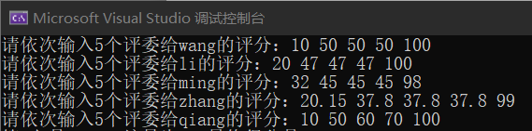
测试数据
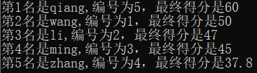
测试结果

/*第二问：*/
#include<iostream>
using namespace std;

class Shape {
private:
double x, y; //左上角顶点
public:
Shape() {};
Shape(double rx = 0.0, double ry = 0.0) :x(rx),y(ry){}
Shape(const Shape& tp) { this->x = tp.x; this->y = tp.y;}
void setX(double rx) { x = rx; }
void setY(double ry) { y = ry; }
double getX() { return x; }
double getY() { return y; }
};

class Rectangle :virtual protected Shape {
private:
double length, width;
public:
Rectangle(double rx, double ry, double l, double w):Shape(rx,ry),length(l),width(w){}
void showSize() {
cout<<"面积为"<< length * width << endl;
}
double getLength() { return length; }
void showPosition() {
cout << "左上角顶点为(" << getX() << "," << getY() <<
"),长为" << length << ",宽为" << width << endl;
}
};

class Circle :protected Shape {
private:
double radius;
public:
Circle(double rx, double ry, double r) :Shape(rx, ry), radius(r) {}
void showSize() {
cout << "面积为" << 3.141592*radius*radius<< endl;
}
void showPosition() {
cout << "圆心为(" << getX() << "," << getY() <<
"),半径为" << radius << endl;
}
};

class Square :public Rectangle {
public:
Square(double rx, double ry, double l) :Rectangle(rx, ry,l,l),Shape(rx, ry) {}
void showSize() {
Rectangle::showSize();
}
void showPosition() {
cout << "左上角顶点为(" << getX() << "," << getY() <<
"),长为" << getLength() << ",宽为" << getLength() << endl;
}
};

int main() {
Rectangle r1(1, 3, 5.2, 7.9);
Circle c1(1, 6, 9.2);
Square s1(3, 7, 2.3);
r1.showSize();
r1.showPosition();
c1.showSize();
c1.showPosition();
s1.showSize();
s1.showPosition();
return 0;
}

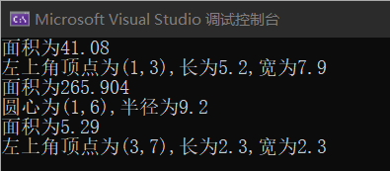
测试结果：

/*第三问*/
#include<iostream>
using namespace std;
#define MONTHLYPAY 4000
#define SALESMANRATE 0.005
#define SALESMANAGERRATE 0.002

class Employee {
protected:
char name[10]; //姓名
short number; //编号
double salary; //工资
public:
Employee(const char* cName, short num) :number(num){
strcpy_s(name, cName);
}
};
class Salesman :public Employee {
protected:
double commrate;
double sales;
public:
Salesman(const char* cName, short num,double rate = SALESMANRATE):Employee(cName,num),commrate(rate){}
void pay() {
cout << "请输入销售员工"<<name<<"的销售额：";
cin >> sales;
salary = sales * commrate;
}
void print() {
cout << "编号为" << number << "的销售员工"
<< name << ",工资为：" << salary << endl;
}
};
class Salesmanager:public Salesman{
protected:
double monthlypay;
public:
Salesmanager(const char* cName,short num,double rate = SALESMANAGERRATE)
:Salesman(cName, num, rate) {monthlypay = MONTHLYPAY;}
void pay() {
cout << "请输入销售经理" << name << "的销售额：";
cin >> sales;
salary = sales * commrate + monthlypay;
}
void print() {
cout << "编号为" << number << "的销售经理"
<< name << ",工资为：" << salary << endl;
}
};

int main() {
Salesman dcm("dcm", 100);
Salesmanager DanGe("fcx", 101);
dcm.pay();
dcm.print();
DanGe.pay();
DanGe.print();
return 0;
}

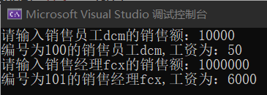
测试结果：

