**Feature Name**: Entity Selection from Business Cards via Google Vision

**Feature Statement**

As a ... Home Buyer applying or a Mortgage Loan

I would like ... use a camera to submit contact information via a Business Card

so that ... I may provide the contact information of the Real Estate Agent and Mortgage Loan Officer I am working with to a Pre-Qualification Web App

**Acceptance Criteria**

* The business card Entity Selection extraction should use the [Google Vision API](https://cloud.google.com/vision/)
* The program should use a camera on a mobile phone to capture the entities
  + Similar to the Google Translate functionality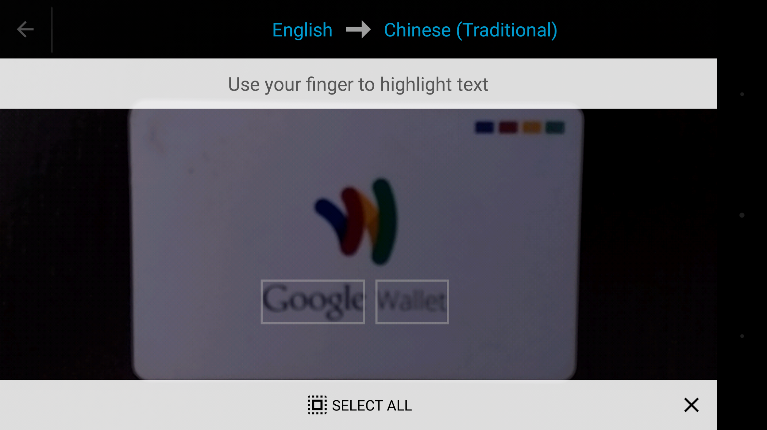
* The program should allow the user to select/confirm that the identified entities are:
  + First Name
  + Last Name
  + Email Address
  + Phone Number
* The user flow of this solution would be the following:
  + The user is presented with a card within the web app that asks for contact information.
  + The user may manually enter contact information or may choose to take a photo to automate this contact information entry.
  + The photo option brings up the camera on their phone.
  + The user takes a photo of the business card and the Google Vision capability identifies all entities on the card by surrounding the words with a rectangle.
  + The user selects the First Name, Last Name, Email Address, Phone Number and clicks “Done”.
  + The contact info screen is now populated with the text from the scanned business card.
* The infrastructure should be on Amazon Web Services
* The code for the Entity Selection from Business Cards should be deployed using Continuous Integration and Infrastructure as Code tools available on AWS
* Functionality and infrastructure should be deployed on Amazon Web Services [without any manual steps](https://www.youtube.com/watch?v=WL2xSMVXy5w#t=39m30)
* The Entity Selection from Business Cards should be deployed and demoed on AWS EC2 server
* A video file or video link should be committed to your Github repo, which includes the following components:
  + Instructions of how to run your code
  + Design and development steps that were taken
  + Demo of the functionality
  + Mention of some challenges that were faced
  + Proof on what makes your solution effective beyond the sample commands provided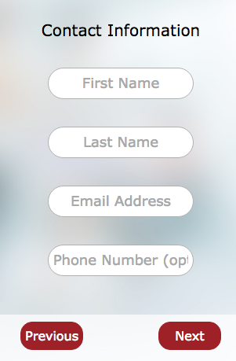

Example Contact Information Screen