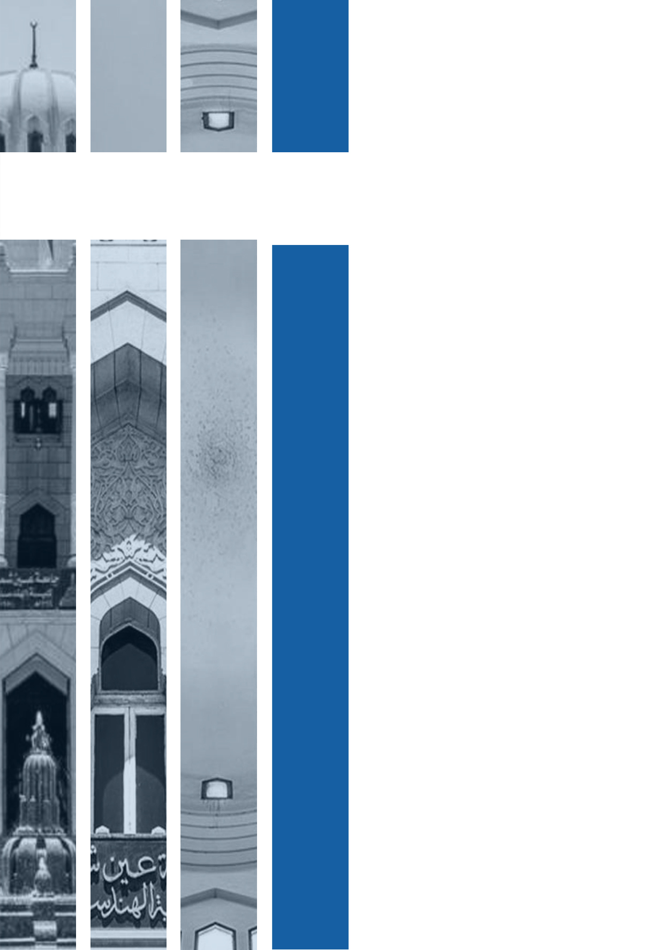

Blockchain-Project

**Program:**

***Course Name: Computer Security***

***Submitted to:***

***Dr. Mohamed Sobh***

**Ain Shams University**

**Faculty of Engineering**

**CSE Department**

**2021**

**Student Personal Information for Group Work**

|  |
| --- |
| **Student Names:** |

احمد خالد محمد عفيفى

آلاء شعبان حسين على شتات

سلمى على عبد الحليم عوض الله

نرمين عاطف عبد الكريم

هاجر وليد سليمان

هبة الله عاطف أحمد

هدير عفت عبد العزيز

|  |
| --- |
| **Student Codes and Section:** |

1700065, Section 1

1700271, Section 1

1600654, Section 2

1701571, Section 5

1701623, Section

1701636, Section

1701641, Section

Table of Contents

2. The hardness of the Puzzle 4

2.1 Target 4

2.2 Screenshots 4

2.3 Comments 5

3. Working Files 5

# The hardness of the Puzzle

## 2.1 Target

Control the puzzle hardness by varying N so that the block chain grows at 1 block per second.

## 2.2 Screenshots

* N = 1

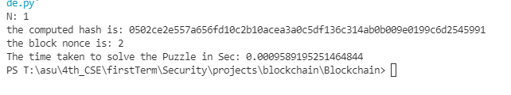

* N = 2

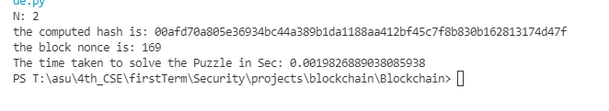

* N = 3

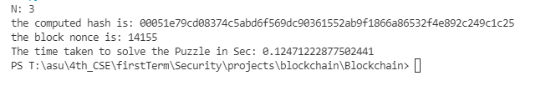

* N = 4

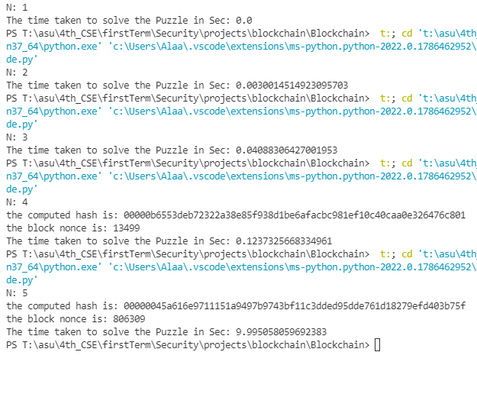

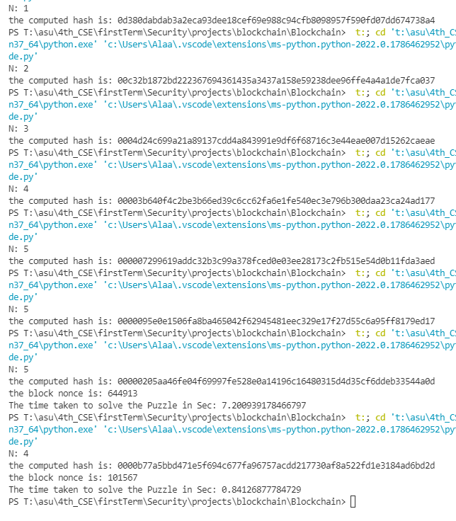

* N = 5





## 2.3 Comments

* At the same N, there are different nonce values and this makes the time it takes to solve the puzzle vary too.
* The time it takes to solve the puzzle won’t be exactly one second, since it’s random and the control variable N is an integer (not continuous).
* Hence, the most approximate time was “0.84126877784729” Seconds, at N= 4 and nonce = 101567.

# Working Files