
Pattern Recognition
Using Neural Network

*Introduction:

1-This is a pattern recognition program that recognizes
Characters using Neural Network
2-Back propagation learning method is used in this program.
3- We also calculated the error rate and drew it.

*Program Steps:

*First get input form user:

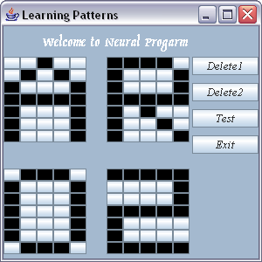

Go to Test Patterns Frame

Learning Patterns

Characters and numbers used in this example are (A, R, O, 2)

*Second get number of test characters to check:

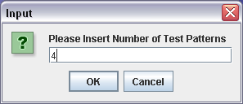

In this example we will test 4 Patterns

*Third insert test characters to check and try to recognize it :

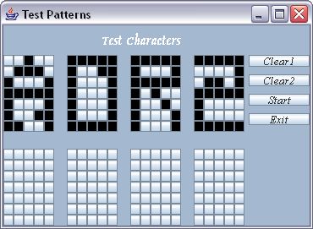

Start learning

Test Patterns Frame

Maximum allowed test patterns is 8

*Fourth show the right recognized characters (output):

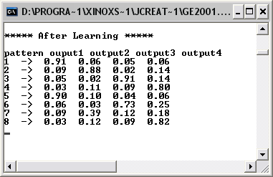
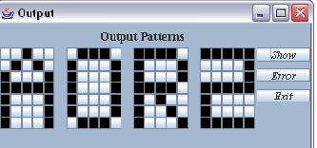

Result After learning

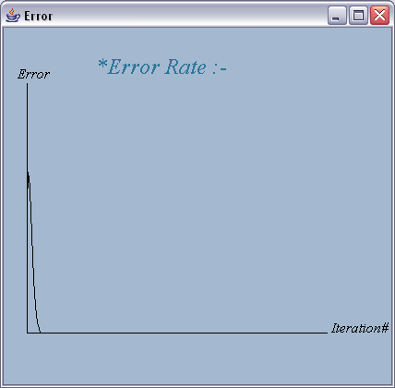

Error Rate

Hint:
You can test any combination of characters and number…

