

**Supervised By: Dr.Hatem El-Kadi**

**Group: IS_3,4**

**Names and IDs:**

|  |  |
| --- | --- |
| 20150396 | Heba Samer |
| 20160275 | Hebatallah Ahmed Kassem |
| 20160176 | Farah Walid Sobhi |
| 20160271 | Hagar Farouk Tolbaa |
| 20160110 | Salma Abdelaziz Mohamed |

Selected company:

* **Tradeline...**

We selected this line of business because most of us have at least one Apple device, so we deal with them a lot. We can get real actual information from this business operators.

* The business and the main functions
* Tradeline is a share holding company, established in 2007 as the first company to introduce the Apple Authorised Reseller concept to the Egyptian market where customers can live the mac experience.
* Tradeline stores is the retail arm and sister company of the Apple line Co. It sells iPhones, iMacs, MacBook, iPads and the like. It also sells their accessories and servicing all Apple inc. products.
* Location of the business
* Cairo(Mohandessin, Dandy Mall, city stars Mall, Mall of Arabia,kattameya,…),
* Alex(San Stefano Mall, carrefour city center mall),
* Mansoura(Talkha),
* Port said(port fouad).
* Size of the business
* Tradeline Stores hires people who care about technology and people who are good communicators whose priority is to serve our customers. All Tradeline Stores’ teams are well trained professionals and certified staff members: Apple Product Professional (APP) Certified & Apple Sales Professional (ASP) Certified.

In each Store there are 7 to 10 staff Members.

* Serving over 2 million customers and counting – each working day is a testament to tradeline's passion with which they represent Apple in Egypt.

So, number of customers per day Per store is 50:100 customers

* In Tradeline the minimum price is the accessories price which starts from 236 LE and the maximum price is the MacBook Pro which is 63,900 LE.

So Average purchase per customer: (236+63,900)/2=32000LE.

* Main Departments within the organization structure
* Tradeline is the one stop place for Apple products, solutions, or accessories. Tradeline also offers pre and after-sales support, repairing, Marketing, Finance and accounting, inventory and special promotions.
* **Sales Department:**

the sales department is the direct link between the tradeline products, services and its customers. However, a well-trained sales department does more than making sales. Tradeline sales staff builds relationships with their customers.

* **Customer Relationship Management (CRM):**

Customer service and support (CSS) is the part of Tradeline's customer relationship management ([CRM](https://searchcrm.techtarget.com/definition/CRM)) department that interacts with a customer for their immediate benefit, including components such as the [contact center](https://searchcrm.techtarget.com/definition/contact-center), the [help desk](https://searchcrm.techtarget.com/definition/help-desk), and the call management system.

* **Repairing engineers:**

If your device is under the Tradeline Stores warranty program you are welcome to visit the Authorized Service Centre with no prior appointment.

if your device was not purchased from Tradeline Stores and is covered by Apple's international warranty program, they provide the service for you as well.

* **Finance and accounting department:**

This department is responsible for recording and reporting the cash flow transactions of a company. This department has some key roles and responsibilities, including accounts receivable, accounts payable, payroll, financial reporting, and maintaining financial controls.

* **Inventory:**

Their responsibilities are avoiding stock-outs and excess stock, Balancing Supply and Demand and give Inventory Reports to purchase management.

* **Marketing**:

It serves as the face of Tradeline, coordinating and producing all materials representing the business. It is the Marketing Department's job to reach out to prospects, customers, investors and/or the community, while creating an overarching image that represents Tradeline in a positive light that demonstrate your industry expertise.

* List of the main work cycles

1. Procuring new goods by suppliers:

Suppliers procure each update for Apple products - iPhones, iMacs, MacBook, iPads and the like. Tradeline procures the items from Apple line Co.

1. Replenishing the shelves:

The store’s clerks always keep an eye on the shelves. They restock the shelves when needed to ensure optimum availability of products.

The store’s clerks also periodically renew the way the items are displayed.

1. Preparing the next month offer:

The sales department decides what should the offers be. There are 2 offers to be chosen to hold. First, purchase products and pay more than 2,000 LE to get a free accessory.

Second, purchase 3 phones and get one half off.

The department sends the offer to the store’s clerks to display it.

1. Display the current offers:

The store’s clerks display the current offer-if exists- clearly on the offer posters.

The offers are also updated on the store’s website, by the customer service staff.

1. Registering the customers purchased goods:

When a customer has purchased an order, he has legally complied with his part of the contract that 5% of the original item cost is charged by the him in case of return.

The cashier saves a copy of the purchase receipt and the customer’s data (first name, last name, E-mail, phone number). These information are sent to the store’s database team. The earned money is then sent to the Financial Department.

1. Preparing the discounts:

The sales department decides on the discounts. Discounts are on the old models or the last 2 pieces of the models in the store.

If a model is updated, the last model has a 25% discounts. If the shop has 2 last pieces of a model, then they will have a 30% discounts.

1. Managing banks accounts:

Customers are able to pay by credit card, and the shop deals with the bank account. The shop deals with all banks.

1. Receiving customers’ orders via Tradeline website:

Customers can feel free to order products online and pay by their credit card or cash when the product is delivered. Customer service notifies the customer that the shipping cost flat rate 50 L.E are added for any product. The online personnel shoppers are clerks that accurately select items ordered online by customers. They check the availability of the purchased products. They save a copy of the purchase receipt and the customer’s data (first name, last name, E-mail, phone number). These information are sent to the store’s database team.

1. Preparation of Delivery of online purchased products:

The online shoppers place the purchased product in the holding area for pick-up.

They then carry the order into delivery vehicles. The shoppers also give the customer’s address to the delivery men.

1. Deliver the product to the customer:

the delivery men head to the addresses they are given.

1. Communicate with the customers:

CRM informs the customers of all the new about the shop (new offers and new available products). They also get their feedback on the service.

1. Receive repair requests via Tradeline Stores:

Customer service receives the repair requests sent by customers. If the device is under the Tradeline Stores warranty program, the customer visits the Authorized Service Centre with no prior appointment. If the device was not purchased from Tradeline Stores and is covered by Apple's international warranty program, the customer visits the Authorized Service Centre but with a prior appointment. Repairing engineers at the Authorized Service Centre repair the devices.

1. Deliver repaired products:

After repairing, customer service reserves an appointment for the customer to head to the Authorized Service Centre to receive the repaired device.

1. Analyze the sales:

Sales managers analyze the sales according to the sales information in the database.

Managers use sales analysis reports to identify market opportunities and areas where they could increase volume. This data can be used to ask for additional business during these peak periods.

* Group of factors which used to prioritize the work cycles

1. Reduce the time necessary to serve customer
2. Reach the store’s strategic goals
3. Minimize the customer queue length
4. Reduce the number of staff personnel involved
5. Reduce the cost of operation
6. Reduce the complexity of cycle

* Let’s Prioritize the main work cycles using these factors

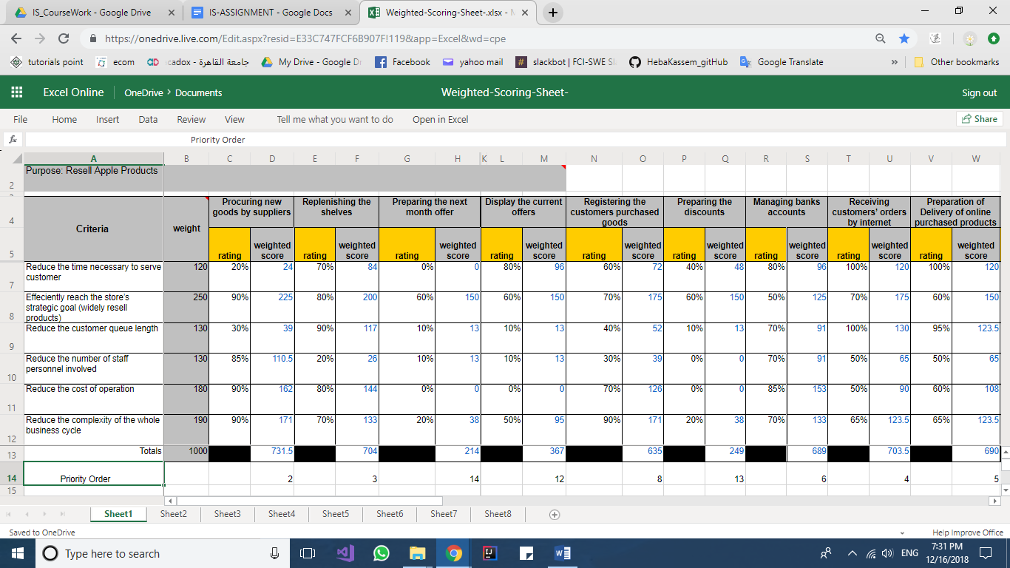

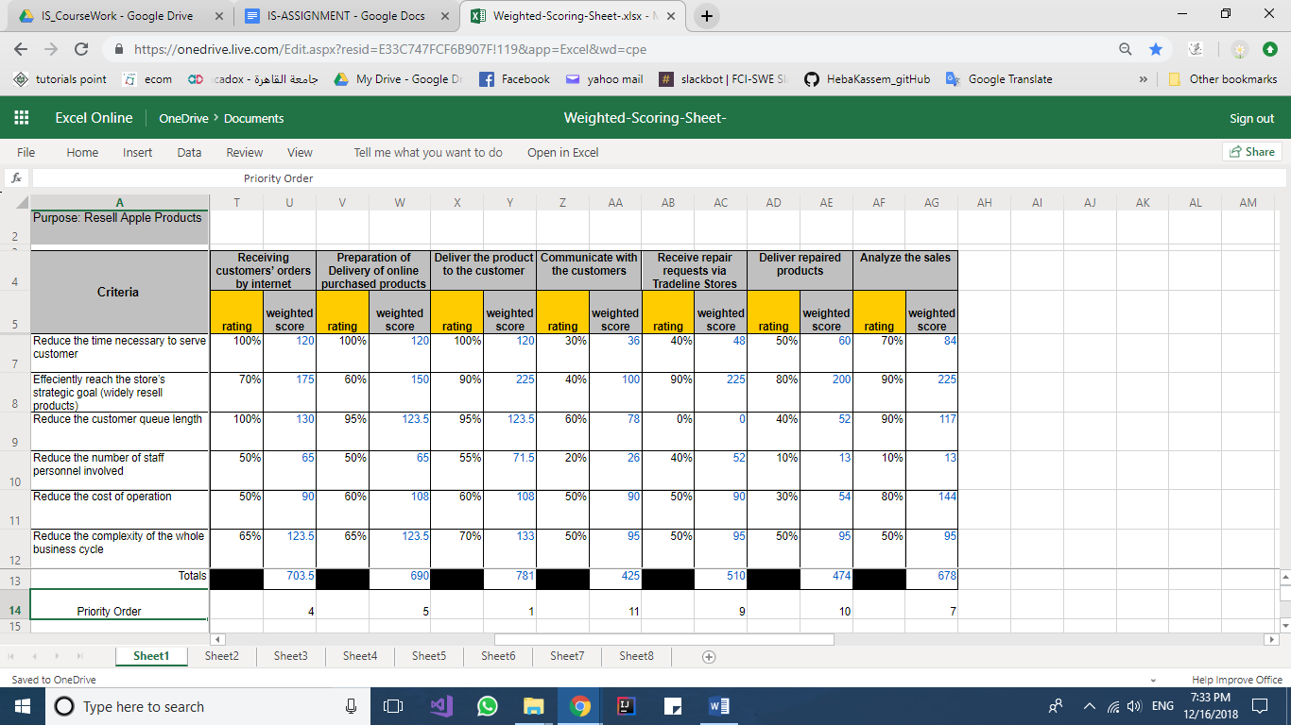

* Functions within Tradeline
* Receive repair requests via Tradeline Stores:

Customer service receives the repair requests sent by customers. If the device is under the Tradeline Stores warranty program, the customer visits the Authorized Service Centre with no prior appointment.

If the device was not purchased from Tradeline Stores and is covered by Apple's international warranty program, the customer visits the Authorized Service Centre but with a prior appointment. Repairing engineers at the Authorized Service Centre repair the devices.

* Preparing the discounts:

The sales department decides on the discounts. Discounts are on the old models or the last 2 pieces of the models in the store. If a model is updated, the last model has a 25% discounts. If the shop has 2 last pieces of a model, then they will have a 30% discounts.

* Description of the selected work cycle using BPMN
* Preparing the discounts:

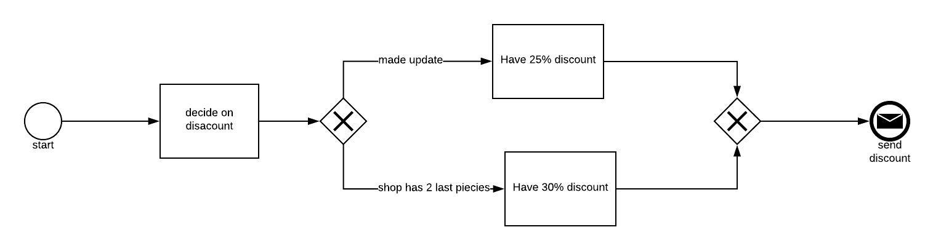

* Receive repair requests via Tradeline Stores:

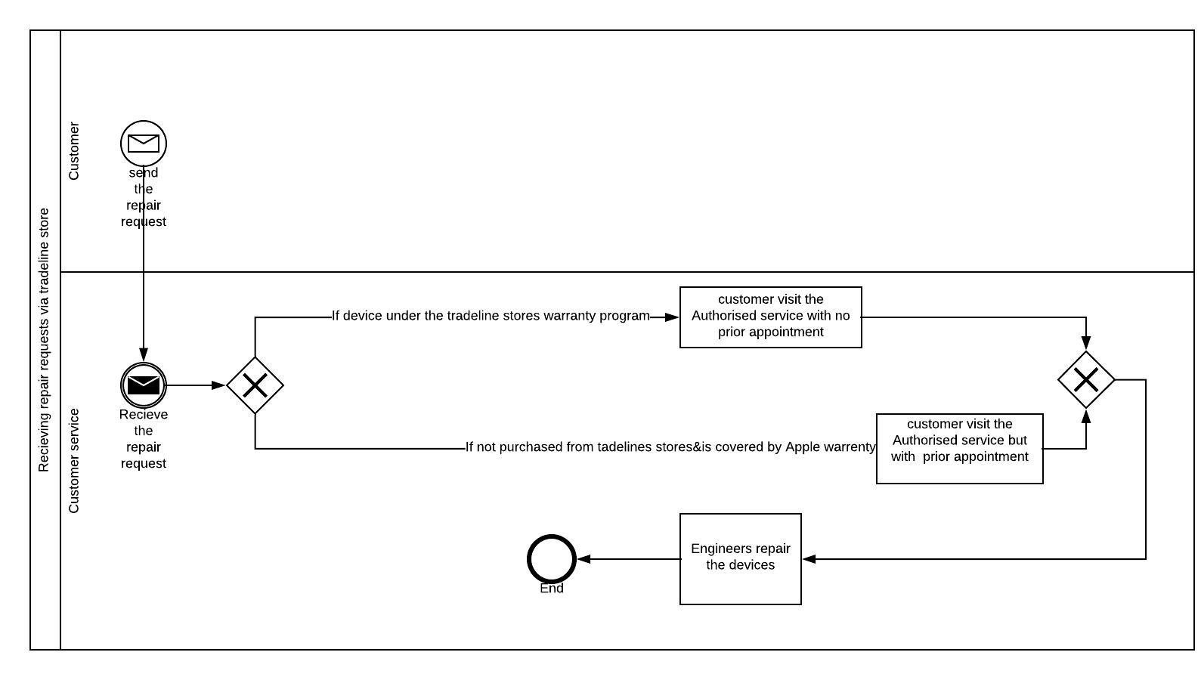

* The point of congestion within the described work cycle and suggest a proper solution

1. Problem: In displaying the current offers if offers are not attractive or posts that display offers not clear.

* Solution: make a lot of offers that make customer be attractive and satisfaction, and employees will be responsible of posting offers.

1. Problem: When Registering the customers purchased goods the cashier saves a copy of the purchase receipt and the customer’s data (first name, last name, E-mail, phone number). These information are sent to the store’s database team, If any information is wrong or customer change one of his information.

* Solution: Making any page or Website to communicate with customer and can update changes by sending temporary messages if he wants to do any change or add information.

1. Problem: customers can receive orders by internet if paying by credit not secure, or orders delayed to deliver it make customer not satisfied and may do not come to company again.

* Solution: Dealing with bank to send verifying number to customer when he pays by credit to be safety, and tell customer when he wants order the time that he will receive his/her order and if delayed give him/her discount or offer.

1. Problem: Communicate with the customers by feedback if no good interaction between company and clients.

* Solutions: make feedback easy like document with MCQ questions not exceeds 5 mins.

1. Problem: In some small branches if any traffic or a lot of people clerks not serve customer good and this will make a bad feedback to customers.

* Solution: Establishing new branches in many towns particular Cairo & Giza because they have a lot of people.
* ERP modules /Tradeline:

1. when apple release a new product the Supply Chain Management make contact with Apple line Co. to get this new product with the negotiated price.
2. The Sales informs the Inventory when the shelves are about to be empty.
3. if there’re discounts on products, Sales updates the system with the new prices and informs the CRM to post these offers in the websites.
4. when customer purchased from the store, the cashier takes his/her information. Then CRM and cashiers are integrated together to save the customers information in the store’s database to inform them if there’s discounts or opening a new store.
5. Sales system and cashiers are integrated together when cashiers get an alert of remaining 2 items of one product so cashiers report the sales to make discount on the remaining items or if Apple releases an updated version of existed product so the sales make a discount on the old versions.
6. Finance and Accounting Module is responsible for customer financial relations when customer pays the item/s by credit card.
7. when customer purchase online order, the CRM receives the order and checks the availability of the ordered products in the inventory. Then the CRM informs the Sales.
8. CRM notifies sales with the order. Then the sales inform the logistics to carry the order to the customer.
9. Logistics choose the shortest route between the customer and the inventory and selects the carrier who will deliver the order to the given address.
10. CRM retrieves the customers data from database to inform them when there are new offers, to get feedback or to make survey.
11. Engineers are responsible for repairing the customer device which is under the warranty program.
12. After engineers have finished repairing of the device they inform the CRM to reserve an appointment for customer to receive the device from the Authorized service center.

* Comparison between the different possible hosting techniques

1. We can host the application locally in the shop IT department.

This hosting is on the Local Area Network. This scenario ensures that the network is within the control of the administrator and on location.

* + PRO:

The network can be contained behind the corporate firewall and all data is kept private according the corporate security policies.

* + CON:

The high cost of internally hosted networks. IT has to spend resources in planning and building the network and setting up the server(s).

The amount of wasting time on troubleshooting network issues and fixing bugs.

1. we can host on our own servers at a professional data center (co-location).

It’s solution instead of wasting time and money in building our own data center, we can rent space for our servers and computer hardware.

* + PRO:

Increasing security by providing multiple layers of physical and technical security. Technology provides a higher level of protection than what we can afford on your own. It can be more cost-effective than owning your own data centers.

* + CON:

We’ll have to follow rules set by data center. Accessibility might make it harder for us to make changes to our servers. It might slow down the processes upgrading.

1. we can host on a rented virtual server at a cloud service provider.
   * PRO:

Easy setup and configuration.

Lower cost startup.

* + CON:

The Administrator may lose some control over the network. If the Internet connection is disrupted then the Digital Signage network is unreachable until the connection is restored. This means updates will not happen until connection is restored.

1. We can have a local installation and a remote replication system

* PRO:

It offers real time or near real time copies of working data transmitted to a remote location.

* CON:

sometimes it doesn’t copy the data, they send the transactions to the remote site, and re-execute them there. As a result, the database on the remote side is not exactly the same as it was on the primary side. Transaction numbers and locations of information will likely be different.

we can start using ONE solution then migrate to Another solution given certain condition. So, we will choose hosting on our own servers at a professional data center because it’s the most efficient technique as it saves time and money instead of building our own data center and it increases the security because of multiple levels.

* Network Configuration

the figure explains how the stores servers are connected to the data center by data center core which is connected to WAN as it represents the network between all the stores in Egypt and then it’s connected to many LANs every LAN epresents the network in each store and every store has its own server connected to the devices in the store. 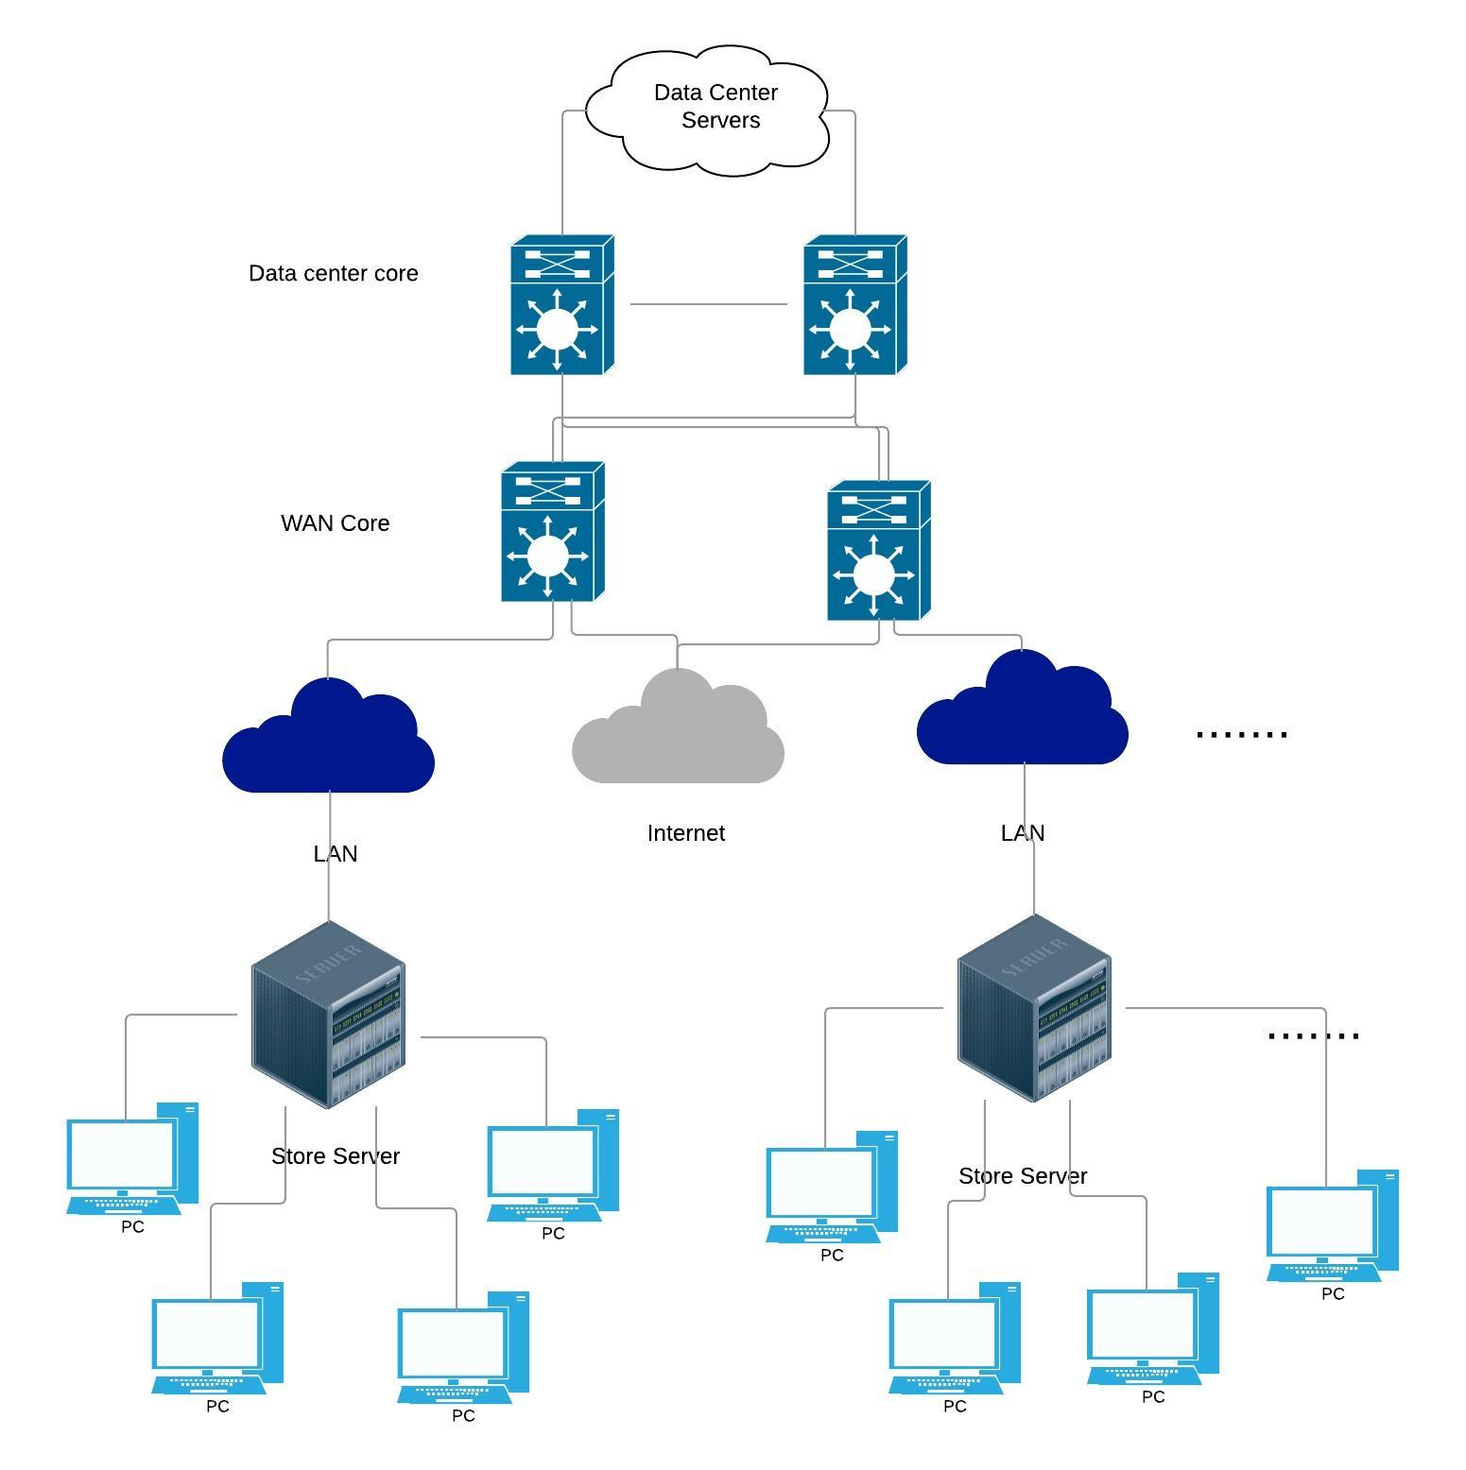

* Comparison between the different approaches to follow in order to implement the selected solution

1. We can customize the entire application and then apply it ALL at ONCE and stop the manual system.

* PROs:

when we apply it all at once we guarantee that the system will get along with all its parts.

* CONs:

the high cost of changing everything.

The difficulties of going back to the manual system if the new system failed.

1. We can implement one module at a time, until we complete all modules

* PROs:

the change is easier when it comes Gradually. For both employees and customers

* CONs:

time consuming, Incompatibility between the module.

1. We can implement ALL modules in parallel with the existing manual system

* PROs:

implementing the modules will not slow down the work cycle.

* + CONs:

implementing the modules and the manual system might conflict, the existence of two different systems might confuse the customers

1. We can implement ALL modules in a part of the operation and compare results with the existing manual system before full implementation, …

* PROs:

saves time, effort and money, more reliable, because it has been tested before, it will be easy to go back to the manual system in case the modules failed practically.

* CONs:

if something went wrong in the tested part the results will not be trustworthy

Tradeline is a technology company and the technology world is changing rapidly that is why it needs a time saving and reliable solution and it appears to me that the most suitable solution is number 4 because it has these requirement.

* Comparison between possible training plan for the personnel in order to use the new system

1. We can train the personnel at once, after working hours, but this means more salaries for the extra working hours, and this would be impossible if they work in different shifts.

* Pros:

all employees finish the training hours at the same time therefore we can see the result immediately

* CONs:

cost more money for the extra working hours, the different shifts of the employees make it hard to set a time.

1. We can train them a group at a time, but this would require the training company to provide for more training sessions and will charge us more money.

* PROs:

the flexibility of the training schedule

* Cons:

the extra cost for the extra sessions, the level of the trainer may change from a group to another therefore different levels of trainees.

1. We can train a group of the staff and then they can train their colleagues (training of trainers TOT).

* PROs:

Strengthen the bonds between the staff personnel, increase social experience of the trainers and improve their communication skills, the experienced trainers will train more than one group therefore save more costs.

* CONs:

Not everyone has the skill of training others.

We will choose number 3 because it is best suitable for training in Tradeline stores because working in technology field requires a high communication skill with both clients and colleges.