Diary

Week 1:
We had an orientation meet through which we were familiarized to the company and its inner workings. We were also provided with a link to MapMyIndia’s APIs and plugins. In the first week I spent a lot of time exploring their website and discovering their suite of tools for development.
Some of the APIs and plugins I found interesting are: the search API, navigation API, and the KML plugin.

Week 2:
I created a web page using the KML pluggin. This page highlights a district of Karnataka when the user clicks over that region. I only implemented it for a few districts as this was not a full scale project and its only objective was to understand the APIs better. From this I gleaned a better understanding of managing the various layers on the map.

Link to the website: https://hebbar72.github.io/map_my_india/

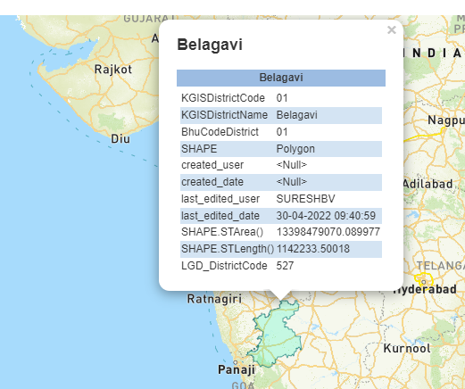
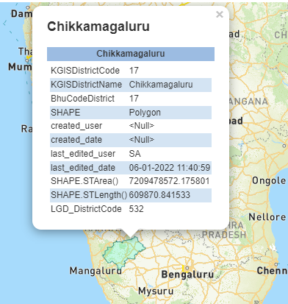

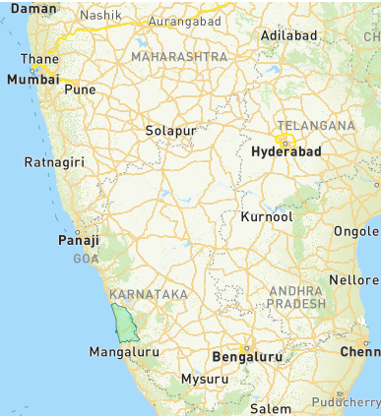
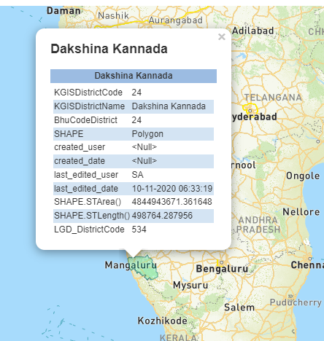

Week 3:
The project has not been assigned yet. We had a productive session on the current education system, its pitfalls and ways it can be improved.

Week 4:
Project: To create a native ios/android app which automatically displays the optimum route to the nearest hospital and to contact emergency services to send an ambulance to the users location along with the optimum route to get there.
I am learning flutter for this project and have obtained a fair understanding on how to make my app.
I am almost done with the front-end of the app.

