Dogs vs. Cats: Binary Image Classification with Transfer Learning
EE6483 Artificial Intelligence and Data Mining, Mini Project, Option 2
Group report · 13 November 2026
Member | Email | Matriculation | Contribution | Questions answered
Zhang Zhewei | ZHEWEI002@e.ntu.edu.sg | G2609805G | 34% | a (data, §2), b (model, §3), c (hyper-parameters, §4), d (results, §5.1–5.2), f (ablation, §7.1–7.7)
Guo Xinyue | XINYUE032@e.ntu.edu.sg | G2604978D | 33% | a (literature survey, parts (1)–(4)), d (final submission, §5.3), f (backbone comparison, §7.8)
He Zihanshu | ZIHANSHU001@e.ntu.edu.sg | G2605605B | 33% | b/c (independent reproduction), d (submission audit), e (error analysis, §6), g (CIFAR-10, §8), h (class imbalance, §9)

Contribution Statement
Zhang Zhewei. Defined the technical roadmap and the experiment schedule, designed the one-factor-at-a-time ablation protocol, and coordinated and integrated the group's output into the final report. Built the shared data pipeline and training framework on which every experiment runs — image caching, test-id mapping, the augmentation suites, and the seeded training/evaluation engine — and carried out the dataset audit that surfaced the duplicate and placeholder images (Sections 2–3; question a, the data half). Designed and trained the main model, an ImageNet-pretrained ResNet-18 fine-tuned with the LP-FT schedule under a three-seed protocol; produced the main validation results and the three-seed ensemble with horizontal-flip TTA (99.22%), and selected and justified all hyper-parameters (Section 4, question c; Sections 5.1–5.2, question d). Executed and analysed the ablation matrix on augmentation, resolution, fine-tuning depth and training-set size (Sections 7.1–7.7; question f). Wrote Sections 2–5.2 and 7.1–7.7, prepared the architecture, training-curve and ablation figures, wrote the submission-validation tooling, and assembled, edited and finalised the report and the submission package (Section 10, Appendix A).
Guo Xinyue. Wrote the literature survey (Section 1): problem definition and the comparison of settings, the taxonomy of solution families, the review of recent progress, the close reading of the MSRA and Google lines, and the baseline justification that motivates our design (question a, the literature-survey half, parts (1)–(4)). Ran the controlled backbone comparison on the faculty computing cluster: set up the Slurm environment and job pipeline, trained seven ImageNet backbones under one fixed budget with two seeds each, and wrote the analysis and ranking in Section 7.8 (question f). Built the final submitted model — the ConvNeXt-T + ResNet-50 + Swin-T ensemble (two seeds each, horizontal-flip TTA) at 99.70% validation accuracy — and generated and validated the submission file (Section 5.3; question d). Maintained the reproduction guide and the complete run logs (Appendix A).
He Zihanshu. Independently re-implemented the training and evaluation pipeline and re-ran key configurations under the same protocol to cross-check the reported results, and audited the label mapping and the integrity of the submission file (reproducibility support for questions b and c; question d). Carried out the error analysis (Section 6): the taxonomy of all 50 validation errors, the Grad-CAM attributions and the robustness study, and the qualitative inspection of the test set including the two case studies (question e). Extended the classifier to CIFAR-10 (Section 8): the CIFAR-stem from-scratch route and the ImageNet-pretrained route, evaluated on the official test set (question g). Studied the class-imbalance setting (Section 9): five remedies on the long-tailed CIFAR-10 variant, evaluated with macro-F1 and per-class recall (question h).

Abstract
This report studies binary cat/dog classification on 20,000 training images, 5,000 validation images and 500 unlabelled test images. Six classifiers are compared under a single pipeline: hand-crafted HOG features with an SVM, a small CNN trained from scratch, a frozen ImageNet ResNet-18 with a linear head, and fine-tuned ResNet-18, ResNet-34 and ResNet-50 models.
The main model, an ImageNet-pretrained ResNet-18 fine-tuned with the LP-FT schedule, reaches 98.93 ± 0.06% validation accuracy over three seeds. A three-seed ensemble with horizontal-flip test-time augmentation raises this to 99.22%. The submitted predictions come from an ensemble of the three best backbones in a controlled comparison (ConvNeXt-T, ResNet-50 and Swin-T, two seeds each), which reaches 99.70% on the same validation set used for that selection — a deliberately optimistic number whose caveats are quantified in Section 5.4.
A one-factor-at-a-time ablation ranks the design choices by the size of their effect. Every ablation was run with three seeds. Pre-training is the largest factor: it is worth 7.67 ± 0.19 points over the from-scratch model even though the from-scratch model was given twice the epochs, so this is a conservative estimate of the pre-training effect (Section 7.2). Training-set size is second: going from 500 to 20,000 images adds 3.2 ± 1.2 points, and accuracy saturates beyond 10,000. The depth of fine-tuning (1.9 points from head-only to last stage) and the input resolution (0.4 points from 160 to 224 pixels) are third-order. With the full training set, augmentation moves accuracy by about 0.2 points, with the sign depending on the schedule. Backbone choice is a small effect. A controlled comparison of seven ImageNet backbones at a fixed budget, two seeds each, spans 99.24% to 99.61%: ConvNeXt-T, ResNet-50 and Swin-T form a top tier about 0.3 points above ResNet-18/34, EfficientNet-B0 and ViT-B/16, and the ranking follows the ImageNet accuracy of the pretrained weights rather than the number of parameters (ViT-B/16, still improving at the end of the budget, is the exception).
An analysis of all 50 validation errors shows that two thirds arise when the animal is not presented as in the training set, either because the face is hidden or because the animal is behind a fence or held in a hand. Grad-CAM highlights the animal's head in the inspected correct predictions. Accuracy falls by 12.7 points under heavy blur, but by only 1.1 points under 30° rotation and 0.4 points under a central square mask whose side is 25% of the original image's shorter dimension (approximately 6.25% of a square original's area).
The pipeline is then applied to CIFAR-10: the from-scratch model replaces the ImageNet stem with a 3×3 stride-1 convolution (no max-pool) to preserve detail in 32×32 images, while the ImageNet-pretrained model instead upsamples inputs to 160×160 and keeps the standard stem. Training from scratch reaches 93.60% test accuracy and ImageNet pre-training reaches 95.20%. On a long-tailed CIFAR-10 variant with a 90:1 imbalance ratio, four remedies are compared against plain cross-entropy. Post-hoc logit adjustment performs best, raising test accuracy from 62.44% to 72.99% and macro-F1 from 60.27% to 72.96% without retraining; a three-seed check confirms that it ranks above re-sampling (72.93 ± 0.18% vs 72.03 ± 0.05%) in every seed.
Keywords: transfer learning, ResNet, fine-tuning, data augmentation, Grad-CAM, long-tailed recognition, CIFAR-10

Contents
1. Literature Survey
2. Dataset and Pre-processing
3. Model and Training Procedure
4. Hyper-parameter Selection
5. Results
6. Error Analysis
7. Ablation Study
8. Extension to CIFAR-10
9. Class Imbalance
10. Conclusion
References
Appendix: complete experiment log

Declaration
All experiments, results and analysis in this report were produced by the group for this project, using the code in ee6483/ and the commands listed in Appendix A.5. Where external libraries, pre-trained weights or generative tools were used, they are identified at the point of use; all experimental design, results and interpretation are the group's own. We have read and uphold the NTU Honour Code.

1. Literature Survey
EE6483 Mini Project (Option 2: Dogs vs. Cats)
Group members and contributions: see front matter.

1.1 Problem definition, settings and challenges

1.1.1 Formal definition
Image classification is the task of learning a mapping f_θ: 𝒳 → 𝒴 from an image x ∈ ℝ^H × W × 3 to a label y ∈ {1,…,C}, by minimising the empirical risk
θ̂ = argmin_θ 1/N Σ_i=1^N ℓ(f_θ(x_i), y_i)
over a training set {(x_i,y_i)}_i=1^N drawn from a data distribution P_train. The project instance is the special case C=2 with 𝒴={cat,dog}: a supervised, closed-set, single-label, in-distribution binary classification problem. The evaluation protocol is accuracy on a held-out set drawn from the same distribution, plus a 500-image unlabelled test set whose predictions are submitted as submission.csv.

1.1.2 Why this "easy" problem is not easy
Humans tell cats from dogs essentially without effort, yet the problem concentrates almost every difficulty that makes visual recognition hard:
1. Large intra-class variation. "Dog" covers 340+ breeds that differ in size (Chihuahua vs. Great Dane, a 40× range in body mass), ear shape, coat length and colour. The same pixel-level variation exists within "cat". A classifier must be invariant to all of it while remaining sensitive to the much smaller cat/dog differences.
2. Small inter-class distance in specific sub-populations. Puppies and kittens share body proportions (large head-to-body ratio, short snout); long-haired cats and small fluffy dogs (Pomeranian, Shih Tzu) share texture. These are the samples that dominate the residual error of any strong model.
3. Background shortcut learning. In the original Kaggle distribution [Kaggle, dogs-vs-cats], dogs are photographed outdoors on grass and cats indoors on sofas. A model can reach surprisingly high accuracy by recognising context rather than animal. This is a spurious correlation in the sense of shortcut learning; it inflates validation accuracy and collapses under distribution shift. Random erasing / aggressive cropping are the standard mitigations, and Grad-CAM is the standard diagnostic (Section 6).
4. Pose, occlusion, scale and illumination. Animals are articulated and non-rigid; they appear at arbitrary scale, partially occluded, in arbitrary lighting. Global average pooling over a deep feature map handles translation and scale reasonably, but not occlusion.
5. Label noise. Web-scraped datasets contain mislabelled images, cartoon drawings, and images with both a cat and a dog. With ~2% noise the achievable accuracy is capped below 100% no matter how good the model is; this is visible in our error analysis as "confident errors on ambiguous images".
6. Small-data regime. 20,000 training images is small for training a deep network from scratch (ImageNet has 1.28M), which motivates transfer learning.

1.1.3 Settings: supervised vs. unsupervised, closed-set vs. open-set, with vs. without domain shift
The literature organises classification methods along three orthogonal axes. Stating where this project sits on each axis is what makes the design choices defensible.
Supervision level.
Setting | Labelled data | Representative methods | Relevance here
Supervised | all training data labelled | AlexNet, VGG, ResNet, ViT | this project
Semi-supervised | small labelled + large unlabelled | pseudo-labelling, MixMatch, FixMatch [Sohn et al., NeurIPS 2020] | would exploit the 500 test images, which is not permitted
Self-supervised pre-training | none (pretext task), then linear probe / fine-tune | MoCo, SimCLR, BYOL, MAE, DINOv2 | context only: our weights are torchvision's supervised ImageNet checkpoints
Few-shot / metric learning | a handful per class | Prototypical networks, MAML | not applicable (10k per class)
Zero-shot | none, class described in text | CLIP-style vision-language models | interesting upper bound; not needed

Closed-set vs. open-set. In a closed-set problem every test image is assumed to belong to one of the known classes. In an open-set problem the test set contains images of unknown classes and the system must be able to say "none of the above". The consequence for this project is concrete: if the test set contained an image of a rabbit, our softmax classifier is forced to output either "cat" or "dog", and it will do so with high confidence. Standard remedies are thresholding the maximum softmax probability [Hendrycks & Gimpel, ICLR 2017], OpenMax [Bendale & Boult, CVPR 2016], and energy-based scores; all of them are post-hoc and could be bolted onto our model without retraining. We explicitly discuss this limitation in Section 6.
With vs. without domain shift. A domain shift means P_test ≠ P_train. The two dominant sub-problems are domain adaptation (unlabelled target data available) [Wang & Deng, Neurocomputing 2018] and domain generalisation (only source data available). The robustness literature [Hendrycks & Dietterich, ICLR 2019] shows that ImageNet-trained models can suffer substantial accuracy degradation under common corruptions (blur, noise, JPEG artefacts, contrast change), with the drop ranging from a few points to tens of points depending on the corruption type and severity, even though clean accuracy is unchanged. Section 6 therefore includes a corruption test, since two models with identical clean accuracy can differ by ten points under blur.

1.1.4 Taxonomy of solution families
1. Hand-crafted features + shallow classifier (1990s–2012). Colour histograms, SIFT/HOG descriptors, then SVM or random forest. On cats vs. dogs these saturate around 65–75%. They remain a useful lower bound and a reminder of how much of the gain comes from representation learning [LeCun et al., Nature 2015]; we implement one (M0) for exactly this reason.
2. CNNs trained end-to-end (2012–2019). AlexNet [Krizhevsky et al., NeurIPS 2012] established the recipe (ReLU, dropout, GPU, augmentation) that is still in use. Depth then increased through VGG [Simonyan & Zisserman, ICLR 2015], GoogLeNet [Szegedy et al., CVPR 2015], ResNet [He et al., CVPR 2016], DenseNet [Huang et al., CVPR 2017] and ResNeXt [Xie et al., CVPR 2017].
3. Efficient architecture search and scaling (2019–2021). EfficientNet [Tan & Le, ICML 2019] showed that depth/width/resolution must be scaled jointly under a compound coefficient.
4. Transformers and large-scale pre-training (2020–). ViT [Dosovitskiy et al., ICLR 2021] replaced convolution with global self-attention and demonstrated that data scale, not inductive bias, is the binding constraint; Swin [Liu et al., ICCV 2021] reintroduced locality through windowed attention; ConvNeXt [Liu et al., CVPR 2022] showed a modernised ResNet matches Swin, i.e. the architecture family matters less than the training recipe.
5. Transfer learning (the practical workhorse). Fine-tune an ImageNet-pretrained backbone; with 20k images this beats training from scratch by several points, and by more when the training budget is short (2.7–7.5 points in our own experiments, Sections 5 and 7). The two key papers are Yosinski et al. [NeurIPS 2014] on feature transferability and Kornblith et al. [CVPR 2019] on the correlation between ImageNet accuracy and transfer accuracy.
6. Long-tailed / imbalanced learning. Re-weighting [Cui et al., CVPR 2019; Cao et al., NeurIPS 2019], re-sampling, decoupled training [Kang et al., ICLR 2020], post-hoc logit adjustment [Menon et al., ICLR 2021]. Covered in Section 9.

1.2 Recent progress: papers that shaped the field
The table below is the reading list behind this report; the "role here" column states why each entry matters for the project rather than merely summarising it.
Work | Venue | Key idea | Role here
Krizhevsky et al., ImageNet Classification with Deep CNNs | NeurIPS 2012 | ReLU + dropout + GPU + augmentation | origin of the modern training recipe we use
Simonyan & Zisserman, Very Deep CNNs | ICLR 2015 | stacked 3×3 kernels; depth 16–19 | the named baseline backbone
He et al., Deep Residual Learning | CVPR 2016 | identity shortcut solves degradation | baseline architecture (M3–M5)
He et al., Identity Mappings in ResNet | ECCV 2016 | pre-activation; cleaner gradient flow | motivates BN/ReLU placement
Huang et al., DenseNet | CVPR 2017 | dense connectivity, feature reuse | alternative to residual connections
Xie et al., ResNeXt | CVPR 2017 | grouped convolutions, cardinality | width-vs-depth trade-off
Tan & Le, EfficientNet | ICML 2019 | compound scaling | reference point for "bigger is better, if scaled right"
Dosovitskiy et al., ViT | ICLR 2021 | patch embedding + self-attention | shows data scale dominates inductive bias
Liu et al., Swin Transformer | ICCV 2021 | shifted-window attention | hierarchical transformer
Liu et al., A ConvNet for the 2020s | CVPR 2022 | modernised ResNet ≈ Swin | justifies staying with ResNet
Radford et al., CLIP | ICML 2021 | image–text contrastive pre-training | zero-shot transfer; open vocabulary
He et al., MoCo | CVPR 2020 | momentum queue for contrastive learning | self-supervised pre-training
He et al., MAE | CVPR 2022 | masked patch reconstruction | self-supervised pre-training
Oquab et al., DINOv2 | TMLR 2024 | self-supervised features that transfer without labels | state of the art frozen features
Siméoni et al., DINOv3 | arXiv 2025 | scaled self-supervision; strong frozen dense features | latest frozen-feature backbone; extends the DINOv2 line
Yosinski et al., How transferable are features? | NeurIPS 2014 | layer-wise transferability, co-adaptation | justifies freezing-then-unfreezing
Kornblith et al., Do Better ImageNet Models Transfer Better? | CVPR 2019 | ImageNet acc. predicts transfer acc. | justifies choosing a stronger backbone
Kumar et al., Fine-Tuning can Distort Pretrained Features | ICLR 2022 | LP-FT: linear probe then fine-tune | our training strategy (M3)
Cubuk et al., RandAugment | CVPRW 2020 | parameter-free augmentation policy search | augmentation component
Zhang et al., mixup | ICLR 2018 | linear interpolation of inputs/labels | optional regulariser
Yun et al., CutMix | ICCV 2019 | patch-level mixing with label proportion | optional regulariser
DeVries & Taylor, Cutout | arXiv 2017 | random erasing as regularisation | motivates RandomErasing
Cui et al., Class-Balanced Loss | CVPR 2019 | effective number of samples | Section 9, method 3
Cao et al., LDAM-DRW | NeurIPS 2019 | class-dependent margin + deferred re-weighting | same loss-level family as method 3; discussed in Section 9.3.3, not run in our experiments
Kang et al., Decoupling Representation and Classifier | ICLR 2020 | representation is unbiased, classifier is not | Section 9, method 4
Menon et al., Logit Adjustment | ICLR 2021 | Bayes-optimal post-hoc shift | Section 9, method 5
Lin et al., Focal Loss | ICCV 2017 | down-weight easy examples | considered for Section 9; not implemented (the loss-level family is represented by method 3)
Selvaraju et al., Grad-CAM | ICCV 2017 | gradient-weighted class activation maps | Section 6 diagnostic
Hendrycks & Dietterich, ImageNet-C | ICLR 2019 | corruption robustness benchmark | Section 6 robustness test
Bendale & Boult, OpenMax | CVPR 2016 | open-set rejection | limitation discussion
Elson et al., Asirra | CCS 2007 | the original cat/dog CAPTCHA dataset | historical baseline
Krizhevsky, Learning Multiple Layers of Features from Tiny Images | TR 2009 | the CIFAR datasets | Section 8/H dataset

Two observations from this list are worth stating explicitly because they shape our design:
- Architecture progress has plateaued for this task size. ConvNeXt [Liu et al., CVPR 2022] shows that a ResNet trained with a modern recipe matches a Swin transformer; Kornblith et al. [CVPR 2019] show that ImageNet accuracy, rather than architectural novelty, predicts transfer accuracy. For a 20k-image binary problem the marginal return of switching from ResNet to ConvNeXt or ViT is expected to be small; our controlled sweep (Section 7.8) measures it at 0.36 pp for ConvNeXt-T over ResNet-18, and none for ViT-B/16 at the same budget. We therefore invest in the training recipe (augmentation, LP-FT, label smoothing, TTA, seed averaging) rather than in exotic backbones.
- The bottleneck moved from representation to data and evaluation. With ImageNet pre-training, cat/dog accuracy is essentially saturated (Section 1.4), so the informative experiments are the ones that remove the advantage: train from scratch, freeze the backbone, shrink the training set. This is why our ablation matrix (Section 7) is built around data quantity and transfer strategy rather than around architecture.
Recent developments in one view. Reading the 2019–2024 entries as a single line rather than
a paper list: (i) Self-supervised and foundation models — MoCo/MAE/DINOv2 removed the dependence on
labels by learning features from the images themselves; DINOv2 [Oquab et al., TMLR 2024] shows the
resulting features transfer frozen to downstream tasks, which matters here because it defines the
"no ImageNet labels needed" alternative our supervised checkpoints are measured against. (ii)
Vision transformers and the return of scale — ViT [Dosovitskiy et al., ICLR 2021] demonstrated that
scale beats inductive bias, and its hierarchical successors (Swin) made transformers practical at
detection scale; for a 20k-image binary problem our sweep measures this line as a 0.37 pp effect
(Section 7.8). (iii) Modernised convolutions — ConvNeXt showed the recipe, not the operator family,
was the gap; this is why our report invests in recipe (LP-FT, augmentation, TTA) rather than
architecture. (iv) Robustness and long-tailed recognition — Hendrycks & Dietterich quantified
corruption fragility and Kang/Cui/Menon the long-tail remedies, which Sections 6 and 9 apply
directly. Each of these threads answers "what problem, what idea, what improvement over predecessors,
and why it bears on this project" — the test the assignment sets for the survey.

1.3 Two leading groups and a close reading of their work

1.3.1 Microsoft Research Asia (MSRA): the residual-learning line
The Visual Computing Group at MSRA, led by Kaiming He with Xiangyu Zhang, Shaoqing Ren and Jian Sun, produced the single most cited architecture in vision. Their contribution is best understood as a diagnosis followed by a fix.
Diagnosis (He et al., CVPR 2016). The paper starts from an empirical puzzle: a 56-layer plain network has higher training error than a 20-layer one. This is not over-fitting (training error is worse) and not vanishing gradients in the classical sense (BN already keeps gradients healthy). The authors name the phenomenon degradation: optimising a deeper stack of non-linear layers is harder than optimising a shallower one plus the identity, even though the deeper model can represent the shallower solution exactly.
Fix. Re-parameterise each block to learn a residual F(x) = H(x) - x, so the block output is F(x) + x. If the identity is optimal, driving F to zero is easier than learning the identity through non-linearities. The paper also shows that shortcut connections add neither parameters nor computational cost, which is what makes depth "free".
Evidence and impact. the 152-layer ResNet won ILSVRC 2015 with 3.57% top-5 error, and the ablation is unusually clean: plain vs. residual at 18/34 layers, with and without shortcuts, isolates exactly one variable. The follow-up ResNet-v2 [He et al., ECCV 2016] moved BN and ReLU before the convolution (pre-activation), which eases optimisation of very deep networks. This is a distinct variant from the model we use: torchvision's ResNet-18 keeps the original post-activation order (conv→BN→ReLU→conv→BN→add→ReLU) and its zero_init_residual flag defaults to False, so our blocks are standard post-activation residuals, not the pre-activation v2 with a zero-initialised last BN.
Why it matters for us. Our backbone is a ResNet, and the LP-FT finding [Kumar et al., ICLR 2022] that fine-tuning distorts pretrained features is essentially a statement about how much of the residual network should be allowed to move. A frozen ResNet-18 with a linear head (M2) is a strong feature extractor; unfreezing everything at a large learning rate destroys some of that structure before the head has learned to use it: which is exactly the accuracy dip we observe at the first unfrozen epoch and why we warm up the backbone learning rate.

1.3.2 Google Research: the scaling and pre-training line
The second line of work asks a different question: not "how do we build a better block?" but "what happens if we scale data, parameters and compute together, and how do we pre-train without labels?"
- EfficientNet (Tan & Le, ICML 2019). The central claim is that width, depth and input resolution must be scaled jointly with a compound coefficient φ: d=α^φ, w=β^φ, r=γ^φ subject to αβ^2γ^2≈ 2. Scaling only one axis saturates quickly. The paper combines this with a neural-architecture-search-derived baseline (MBConv + squeeze-and-excitation). For us the practical lesson is that resolution is a first-class hyper-parameter, which is why our ablation sweeps 96/128/160/224 px and why the CIFAR-10 experiment must change the stem rather than simply upscale.
- ViT (Dosovitskiy et al., ICLR 2021). A pure transformer over 16×16 patches, with almost no image-specific inductive bias. The key empirical finding is that ViT underperforms ResNet when trained on ImageNet alone but overtakes it when pre-trained on ImageNet-21k or JFT-300M. The conclusion that inductive bias can be replaced by data reframed the field and led directly to the current dominance of large-scale pre-training.
- ViT follow-ups from other labs. The line Google opened was extended elsewhere: DeiT (Meta/FAIR) added strong augmentation and distillation to train ViT on ImageNet-1k alone; Swin (Microsoft Research Asia) reintroduced a hierarchical, locality-aware design; ConvNeXt (Meta/FAIR) closed the gap from the convolutional side. DINOv2 (Meta/FAIR) [Oquab et al., TMLR 2024] then showed that self-supervised ViT features are excellent frozen features, the modern counterpart of our M2 linear-probe experiment. DINOv3 (Meta AI) [Siméoni et al., arXiv 2025] scales this self-supervised recipe further and reports strong frozen dense features that transfer without fine-tuning, reinforcing that a frozen backbone is a strong baseline for a small dataset like ours.
Synthesis of the two groups. MSRA answers "how do we make optimisation of deep networks work?"; Google answers "how do we exploit scale and pre-training?". Our project sits exactly at their intersection: we use a residual architecture (MSRA) pre-trained on ImageNet (the Google-scale paradigm) and adapt it to a small dataset with a careful fine-tuning schedule (the LP-FT insight).

1.4 Choice of baseline and the improvements we implement

1.4.1 Baseline
Baseline: ImageNet-1k pre-trained ResNet-18, fully fine-tuned at 224×224, cross-entropy with label smoothing, AdamW, cosine schedule.
Justification:
- ResNet is explicitly permitted by the assignment and is the most reproducible choice available in torchvision.
- ResNet-18 (11.2M parameters) trains in ~7 minutes per run on the available 8 GB laptop GPU, which makes a three-seed protocol and a 17-run ablation matrix affordable. ResNet-50 is kept as a scaling check, not as the main model.
- Kornblith et al. [CVPR 2019] show that within a family, higher ImageNet accuracy transfers better; across families, the differences are small relative to the recipe. Given a fixed compute budget, spending it on seeds and ablations is more informative than spending it on a bigger backbone.

1.4.2 ImageNet already contains cats and dogs
ImageNet-1k [Russakovsky et al., IJCV 2015] includes roughly 118 dog breeds (Norwegian elkhound, Greater Swiss mountain dog, …) and several cat species (tabby, tiger cat, Persian, Siamese, Egyptian cat). A pre-trained backbone has therefore already solved a fine-grained version of this task, and the 2-way problem is close to a subset of its training objective. This means:
1. accuracy on this dataset is near-saturated (99%+), so headline accuracy is a weak discriminator between methods;
2. part of the measured "transfer" is genuine category prior rather than generic visual representation;
3. any claim that "our model learned to distinguish cats from dogs" must be supported by evidence that does not depend on pre-training.
We therefore build the report around three controls that remove the prior: (i) a SmallCNN trained from scratch, (ii) a frozen-backbone linear probe, and (iii) a learning curve over 500 → 20,000 training images. If the pre-trained model's advantage disappears when the data is plentiful and reappears when data is scarce, that is evidence of transfer, not of leakage.

1.4.3 Improvements over the baseline, each mapped to an experiment
# | Improvement | Motivation | Verified in
I1 | LP-FT: 2 epochs linear probe, then full fine-tune with 3× lower backbone LR | Kumar et al. [ICLR 2022]: fine-tuning distorts features, especially under distribution shift | Section 7 (ft-strategy)
I2 | Strong augmentation (RRC + flip + rotation + ColorJitter + RandAugment + RandomErasing) | small dataset; RandomErasing also attacks the background shortcut | Section 7 (aug)
I3 | Label smoothing ε=0.1 | web labels are noisy; prevents over-confident logits and improves calibration | Section 4
I4 | Cosine schedule with warm-up, gradient clipping, AMP | stable optimisation at batch 64 on 8 GB | Section 4
I5 | Horizontal-flip TTA + 3-seed softmax averaging | variance reduction; cheap and reproducible | Section 5
I6 | Resolution sweep 96→224 | EfficientNet's lesson that resolution is a first-class axis | Section 7 (resolution)
I7 | Stronger backbone (ResNet-34/50) | Kornblith et al. [CVPR 2019] | Section 7 (model)

The survey therefore produces the baseline and the list of candidate improvements; Sections 3 to 5 implement them and Section 7 removes them one at a time to measure what each contributes.

2. Dataset and Pre-processing

2.1 Amount of data used
Split | cat | dog | total | labels | used for
train | 10,000 | 10,000 | 20,000 | Yes | gradient updates
val | 2,500 | 2,500 | 5,000 | Yes | model selection, early stopping, all reported accuracies
test | – | – | 500 | No | submission.csv only

What each model consumed
Model | train images | val images | note
M0 HOG+SVM | 8,000 (4,000/class) | 2,000 (1,000/class) | CPU feature extraction is the bottleneck
M1 SmallCNN | 20,000 | 5,000 | full data
M2 ResNet-18 frozen | 20,000 | 5,000 | backbone not updated
M3 ResNet-18 LP-FT | 20,000 | 5,000 | main model
M4 ResNet-34 | 20,000 | 5,000
M5 ResNet-50 | 20,000 | 5,000 | 160 px to fit the 8 GB budget
Section 7 data-quantity sweep | 500 / 2,000 / 5,000 / 10,000 / 20,000 | 5,000 | nested class-balanced subsets

The nested subsets are drawn with a fixed permutation (seed 42) per class, so the 500-image set is a strict subset of the 2,000-image set, and so on. Without nesting the learning curve would mix "more data" with "different data".
Discipline. Validation data never contributes to a gradient step, and the test set is never used for model selection, hyper-parameter tuning or pseudo-labelling. Validation accuracy is used for early stopping and for choosing among the M0–M5 ladder; this introduces a mild optimistic bias in the reported validation numbers, which we state explicitly in Section 5 instead of hiding it.

2.2 Dataset health check
Run before any training (ee6483/src/data/check_data.py); the raw output is ee6483/results/data_report.json.
Check | Result
Image counts | exactly 10,000 / 2,500 per class; 500 test images
Corrupt / unreadable files | 0 in all splits
Colour mode | all RGB after convert("RGB")
Width (train) | cat 50–1023 (mean 411), dog 42–1050 (mean 398)
Height (train) | cat 32–768 (mean 357), dog 33–702 (mean 365)
Mean aspect ratio | 1.19 (cat), 1.13 (dog): mild landscape bias
Smallest side | 32 px (train), 37 px (test) → a handful of images must be upscaled
Test file names | all numeric, ids exactly 1…500, contiguous
sampleSubmission.csv | 500 rows, header id,label, ids match the test files one-to-one
Near-duplicates (pHash, Hamming ≤ 6) | 40 pairs in 35 + 5 groups: 28 identical hashes, the rest at distance 2
… crossing the train↔val split | 12 pairs, involving 10 distinct validation images (0.20% of the validation set)
… crossing the class boundary | 5 pairs
Placeholder graphics | 6 images ("PHOTO UNAVAILABLE" / "Adopted"), 4 of them the same graphic labelled both cat and dog

Three consequences:
1. Resolution heterogeneity is real. The 32 px minimum is well below the 224 px input, so those images are upsampled by a factor of 7. They are a known source of error in Section 6. Caching at short side 256 px (Section 2.3) normalises the rest.
2. The dataset contains placeholder graphics, and they are labelled inconsistently. Six images are not photographs at all: four copies of a "PHOTO UNAVAILABLE" black-cat silhouette and two of an "Adopted" text card. The "PHOTO UNAVAILABLE" graphic appears three times in the training set under dog and once in the validation set under cat; the "Adopted" card appears once under each label, both in training. Only one of the six therefore lies in the validation set, and a model that fits its training data will almost certainly get it wrong: it sees the same graphic labelled dog three times during training and is then asked for cat. In practice this costs one error in 5,000 images (0.02 pp); it is not a strict mathematical bound, but the image is indeed among the main model's validation errors (Section 6). The two training-set copies of the "Adopted" card cost nothing directly; they simply contribute contradictory gradients. We did not delete them: removing six images would not change any conclusion, and keeping them makes the label-noise discussion in Section 6 concrete.
3. Twelve near-duplicate pairs cross the train/val split. They involve 10 distinct validation images (one, the placeholder above, matches three training images), seven pairs have identical perceptual hashes, and one pair is byte-identical. The largest effect this can have on any validation accuracy is therefore 0.20 pp (10 images) — an upper bound on the fraction of validation samples directly affected by the identified pairs, not a measured estimate of accuracy inflation. The measured effect is in fact nil: excluding these 10 images changes the submitted ensemble's validation accuracy from 99.70% to 99.72% (Section 5.4). That is larger than the seed-to-seed spread of the main model (0.06 pp) and of the same order as the differences between some backbones in Section 7.8, so it matters for fine comparisons: it cannot reverse the two-tier split there (the smallest gap between tiers is 0.28 pp), but differences below about 0.2 pp should not be read as rankings. It is small compared with the pre-training, data-quantity and fine-tuning effects of Section 7. We did not remove them either: the split was given, and quietly cleaning the validation set would make our numbers incomparable with anyone else's on the same data. The pairs are listed in ee6483/results/duplicates_all.json so the reader can re-run the analysis with them excluded.
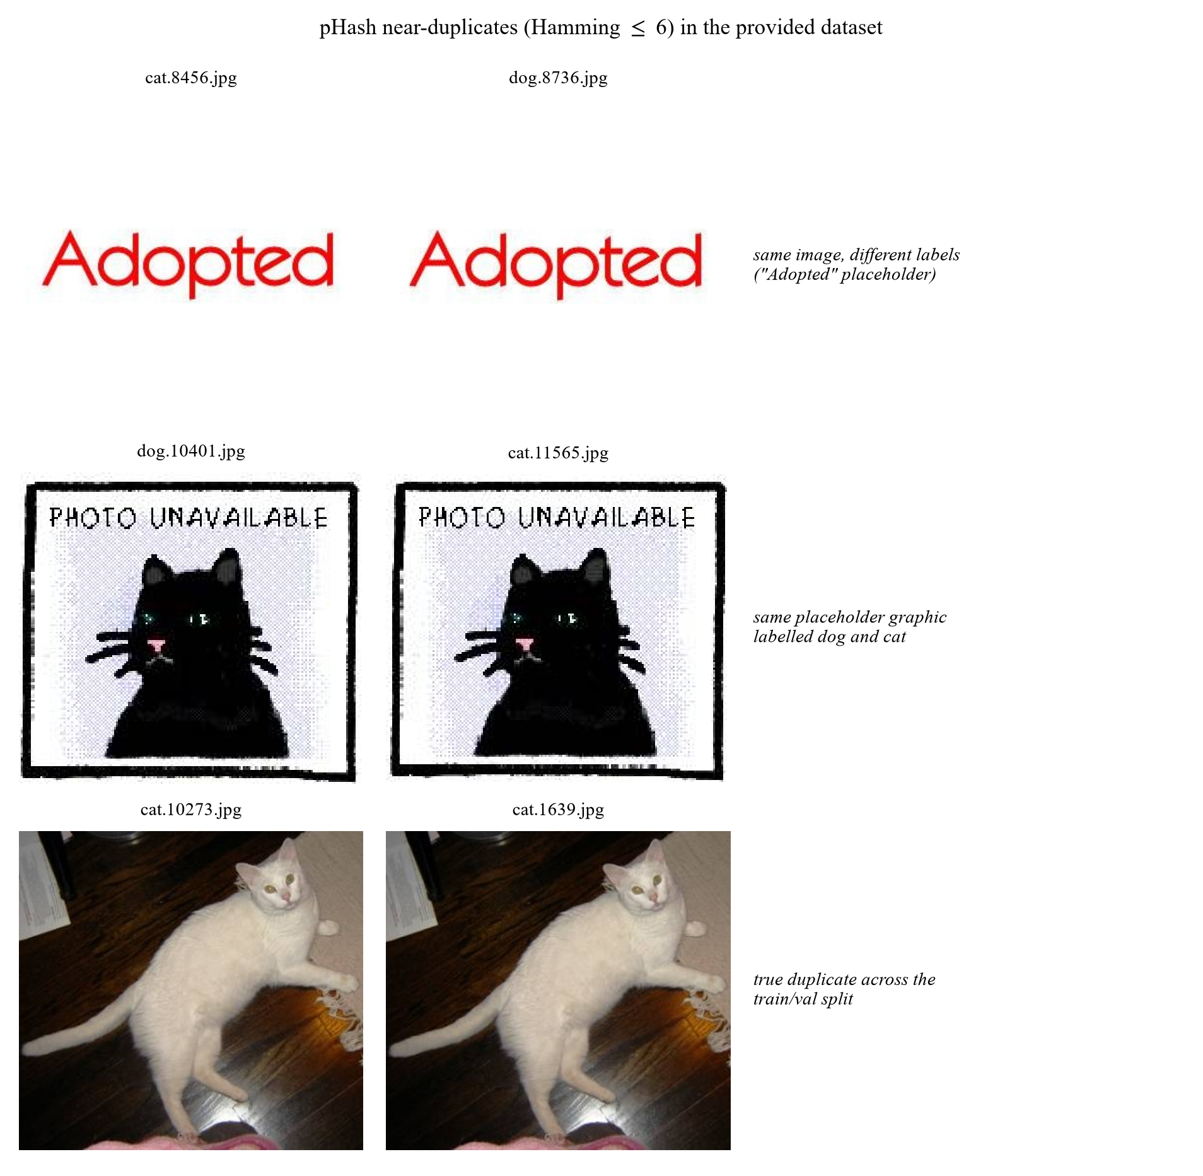
Figure 1. Near-duplicates and placeholders

2.3 Pre-processing
decode → convert("RGB") → cache resize (short side 256, bicubic, JPEG q=92)
→ Resize(256) → CenterCrop(224) → ToTensor → Normalize(μ, σ)
- RGB conversion: a few images are grayscale or CMYK; forcing RGB keeps the channel count uniform.
- Short-side-256 cache. Decoding 20,000 JPEGs at every epoch is the dataloader bottleneck (~400×400 average). Resizing once to short side 256 and storing as JPEG q=92 — a lossy but visually faithful engineering trade-off for dataloader speed, applied identically to every experiment so it cannot bias comparisons — cuts the epoch time roughly in half and, more importantly, guarantees that every experiment sees identical pixels regardless of when it was run. Images already smaller than 256 px are not upscaled in the cache.
- Resize(256) → CenterCrop(224) at evaluation time is deterministic, so validation accuracy is comparable across runs. The 256/224 ratio (1.14) preserves the ImageNet convention that the model was pre-trained with.
- ImageNet normalisation μ=(0.485,0.456,0.406), σ=(0.229,0.224,0.225). This is not optional: the pre-trained weights were trained on inputs with these statistics, so dataset-specific statistics would shift every input away from what the first-layer filters expect. We did not run that alternative.

2.4 Augmentation
Scaling, rotation and flipping are all used, together with colour and occlusion perturbations.
Level | RandomResizedCrop | HFlip | Rotation | ColorJitter | RandAugment | RandomErasing
none | – (Resize+CenterCrop) | – | – | – | – | –
flip | Yes (0.5–1.0) | Yes | – | – | – | –
geo | Yes | Yes | ±15° | – | – | –
color | Yes | Yes | ±15° | Yes | – | –
full | Yes | Yes | ±15° | Yes | Yes (2 ops, m=7) | Yes (p=0.25)

Rationale, per transform:
- RandomResizedCrop(224, scale=(0.5, 1.0)): provides scale and translation jitter in one op, and the 0.5 lower bound forces the model to recognise animals that occupy only half the frame. It also crops away background, which is the single most useful defence against the "dog on grass" shortcut.
- Horizontal flip: the only label-preserving geometric symmetry for animals. Free accuracy, no risk.
- Rotation ±15°: animals appear at arbitrary in-plane angles; ±15° covers most of the realistic range without introducing black corners large enough to act as a cue.
- No vertical flip. Upside-down animals are out of distribution; adding them teaches an invariance that is never needed at test time, following the principle that augmentation must match the test distribution. We did not run a controlled comparison with vertical flips.
- ColorJitter(0.2, 0.2, 0.2, 0.05): indoor/outdoor lighting differs enormously between the two classes, so colour jitter also weakens a spurious cue.
- RandAugment (2 ops, magnitude 7): replaces hand-tuned policy search with a single magnitude parameter; magnitude 7 of 30 is moderate, appropriate for a 20k-image dataset where over-regularisation is a real risk.
- RandomErasing (p=0.25): occludes a random rectangle so the model cannot rely on a single discriminative part (an ear, a collar). It is the augmentation most directly aimed at the background/part shortcut.
- mixup / CutMix are implemented only in the configuration-driven code base (src/data/mix.py, enabled through train.mix) and were not used in any reported run, so no claim is made about their effect; in ee6483/, --aug mix is currently identical to full. With 8 epochs and label smoothing already active they were not a priority, and they make training curves harder to interpret.

2.5 Illustrations
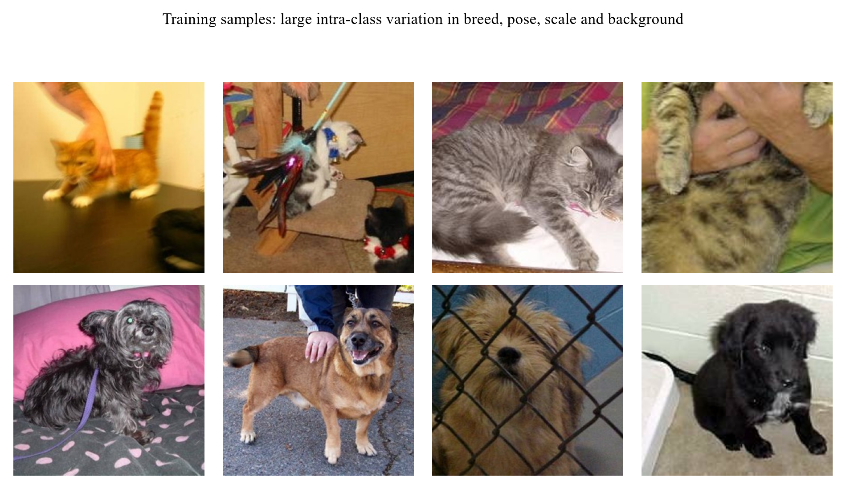
Figure 2. Eight training images per class: breed, pose, scale and background all vary
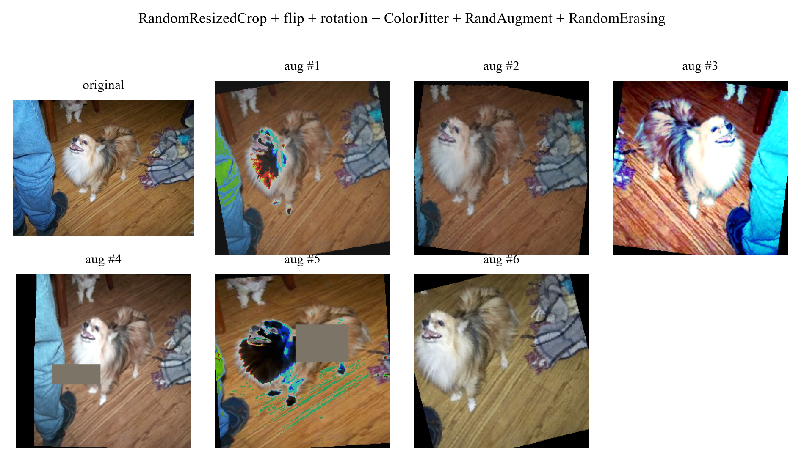
Figure 3. One training image passed through the full augmentation pipeline six times

3. Model and Training Procedure

3.1 Overview of the model ladder
Six models are trained, so that every claim in Section 7 can be measured against a control. All models share the same training engine, the same data pipeline and the same evaluation code; only the architecture and the transfer strategy change. Two roles must be told apart from the start: ResNet-18 with LP-FT (M3) is the main study model used for the controlled experiments below, while the final submitted predictor is the six-model ensemble of Section 5.3.1, built later from the backbone sweep — a different stage of the project whose protocols and numbers are never mixed.
ID | Model | Pretrained | Input | Params | Purpose
M0 | HOG + colour histogram → StandardScaler → SVM (RBF) | – | 96×96 | – | hand-crafted feature ceiling
M1 | SmallCNN (4 conv blocks) | No | 128×128 | 1.17M | what is achievable without ImageNet
M2 | ResNet-18, frozen backbone + linear head | Yes | 224×224 | 11.18M | value of the pre-trained representation alone
M3 | ResNet-18, LP-FT fine-tuned | Yes | 224×224 | 11.18M | main model of the study; the final submission ensembles the top backbones of Section 7.8
M4 | ResNet-34, LP-FT fine-tuned | Yes | 224×224 | 21.29M | backbone scaling
M5 | ResNet-50, LP-FT fine-tuned | Yes | 160×160 | 23.51M | backbone scaling under a fixed compute budget

3.2 Architecture of the main model (M3)
M3 is a ResNet-18 [He et al., CVPR 2016] with the 1,000-way ImageNet classifier replaced by a two-way head. The residual block is
y = ReLU(BN(W_2 ReLU(BN(W_1 x))) + x)
with a 1×1 convolution on the shortcut whenever the spatial resolution or channel count changes.
Tensor shapes through the network (batch size B, input 224×224):
Stage | Operation | Output shape | Notes
input | – | B× 3× 224× 224 | ImageNet-normalised
conv1 | 7×7, 64, stride 2 | B× 64× 112× 112
pool1 | 3×3 max, stride 2 | B× 64× 56× 56
layer1 | 2× BasicBlock(64) | B× 64× 56× 56 | stride 1
layer2 | 2× BasicBlock(128) | B× 128× 28× 28 | first block stride 2
layer3 | 2× BasicBlock(256) | B× 256× 14× 14 | first block stride 2
layer4 | 2× BasicBlock(512) | B× 512× 7× 7 | first block stride 2
pool | global average | B× 512 | removes spatial dims
head | Dropout(0.2) → Linear(512→2) | B× 2 | replaces the 1,000-way fc
output | softmax | B× 2 | p(cat), p(dog)

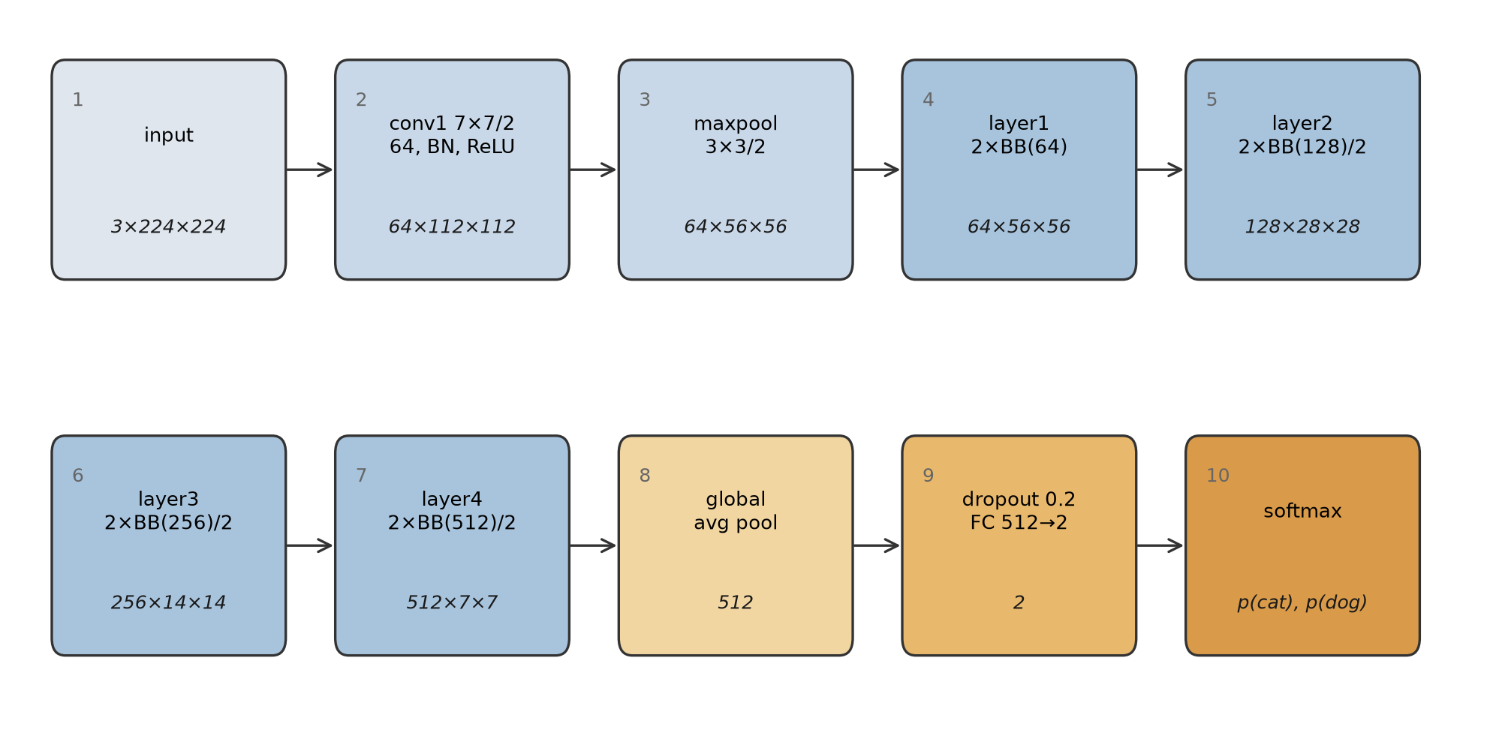
Figure 4. Architecture of the main model with tensor shapes at every stage
The classification head is a fresh Linear(512→2) layer (behind dropout 0.2) with PyTorch's default initialisation: a Kaiming-uniform variant for the weights and small uniform values in ±1/√512 for the bias. At the start of training the logits are therefore small, the model outputs a near-uniform distribution, and the first epochs are spent learning the head, not damaging the backbone. This is the mechanism behind the LP-FT strategy in Section 3.4.
torchvision.models.resnet18(weights="DEFAULT"), which for ResNet-18 resolves to IMAGENET1K_V1 (the only ImageNet checkpoint torchvision provides for it), supplies the first 512-dimensional feature extractor; everything from layer1 to layer4 is loaded from the ImageNet checkpoint.
During training the network emits raw logits, which go straight into the cross-entropy loss; PyTorch's CE implementation folds the log-softmax internally (Section 3.3). The softmax box in Figure 4 is the inference-time view: softmax is applied to the logits only when probabilities are needed for evaluation, ensembling and the submission file.
M1: SmallCNN (the from-scratch control)
Four blocks, each Conv3×3-BN-ReLU → Conv3×3-BN-ReLU → MaxPool2, with 32/64/128/256 channels, followed by global average pooling, dropout 0.3 and a linear layer. At 128×128 input the spatial size goes 128 → 64 → 32 → 16 → 8, so the receptive field of the last block covers the whole image. 1.17M parameters: deliberately an order of magnitude smaller than ResNet-18, on the assumption that a 20k-image dataset cannot support a large model trained from scratch. Section 5 shows this assumption was too pessimistic (it reaches 95.06%), which is itself a finding: the task is easier than the parameter count suggests.

M0: classical baseline
Each image is resized to 96×96, converted to grayscale for HOG (9 orientations, 8×8 cells, 2×2 blocks, L2-Hys) and kept in RGB for a 16-bin per-channel colour histogram. The two descriptors are concatenated (4356 + 48 = 4404 dimensions), standardised, and classified by an RBF SVM (C=10). Trained on 8,000 images (4,000 per class) because the feature extraction is CPU-bound.

3.3 Loss function
ℒ = -1/B Σ_i=1^B Σ_c=1^2 ỹ_i,c log p_i,c, ỹ_i,c = (1-ε) y_i,c + ε/2
i.e. categorical cross-entropy with label smoothing ε=0.1. Two reasons:
1. Web-sourced labels contain a small fraction of errors (multi-animal images, mislabels). With hard targets the loss pushes the model to be infinitely confident on those samples; smoothing caps the target logit at 1-ε+ε/2 and stops the model from fitting label noise.
2. It improves calibration: relevant because Section 6 reports prediction confidences and because the ensemble in Section 5 averages probabilities.
For the CIFAR-10 experiments the same loss is used with C=10; the only change is the output dimension, which keeps the two parts of the project directly comparable.

3.4 Training strategy: LP-FT
Kumar et al. [ICLR 2022] show that naive fine-tuning distorts pre-trained features: a large gradient step on a randomly initialised head propagates back into the backbone and moves it away from the pre-trained optimum before the head has learned to read the features. Their fix, LP-FT (linear-probe then fine-tune), is two-staged:
Stage 1 (epochs 1..2): freeze layer1..layer4, train head only, lr_head = 1e-3
Stage 2 (epochs 3..8): unfreeze all, lr_backbone = 3e-4, lr_head = 1e-3,
cosine decay to 0, 0.3-epoch warm-up
This is visible in our training log as a small accuracy dip at the stage-2 transition (97.2% → 95.0% at epoch 3 for seed 42) followed by recovery to 98.4% at epoch 4: direct evidence that the phenomenon described in the paper also occurs here, and that the second stage needs its own warm-up.
Full recipe
Component | Setting
Optimiser | AdamW, β=(0.9, 0.999), weight decay 1e-4
Backbone LR | 3e-4 (stage 2)
Head LR | 1e-3
Schedule | linear warm-up then cosine to 0, stepped per iteration
Batch size | 64
Epochs | 8 (early stopping, patience 3 on validation accuracy)
Precision | mixed precision (fp16 autocast + GradScaler)
Gradient clipping | global norm 1.0
Input | 224×224, ImageNet mean/std

Why each choice (this is the content of Section 4, stated here for completeness):
- AdamW over SGD: with 8 epochs and a small dataset, SGD+momentum needs a longer schedule and a careful LR sweep to match AdamW. AdamW's decoupled weight decay also means the regularisation strength does not interact with the adaptive LR.
- Differential LR: the head is randomly initialised and needs a large step; the backbone is already at a good optimum and needs a small one. A single LR forces a compromise that is either too slow for the head or destructive for the backbone.
- Cosine + warm-up: warm-up avoids the early large steps that destabilise the head; cosine annealing spends most of the budget in the low-LR region where the model settles into a flatter minimum.
- Batch 64: 8 GB of VRAM fits 96 at 224 px, but batch 64 keeps BatchNorm statistics stable and gives 312 iterations per epoch, which is enough for a smooth cosine schedule over 8 epochs.

3.5 Data pipeline
train : RandomResizedCrop(224, scale=(0.5,1.0))
→ RandomHorizontalFlip(p=0.5)
→ RandomRotation(15°)
→ ColorJitter(0.2,0.2,0.2,0.05)
→ RandAugment(num_ops=2, magnitude=7)
→ ToTensor → Normalize(ImageNet) → RandomErasing(p=0.25)
val/test : Resize(256) → CenterCrop(224) → ToTensor → Normalize(ImageNet)
Details that matter: no vertical flip (an upside-down animal is out of distribution and the model loses accuracy); RandomResizedCrop rather than Resize+RandomCrop so that scale jitter and translation jitter are applied jointly; RandomErasing specifically to break the "dog on grass / cat on sofa" background shortcut.

3.6 Reproducibility
- set_seed(s) fixes PYTHONHASHSEED, random, numpy, torch and torch.cuda for s ∈ {42,43,44}, with cudnn.deterministic=True and cudnn.benchmark=False (this applies to the ee6483/ pipeline, Sections 3–6).
- The backbone comparison and the final submitted ensemble come from the second, configuration-driven code base (src/, Section 7.8). There cudnn.benchmark=True and the deterministic flags are off, for throughput on the cluster; reproducibility rests on fixed seeds (two per backbone) and on the archived config and per-epoch history of every run (runs/backbones/, Appendix A.1b), which the assignment's "fixed seed / multi-seed averaging" option covers.
- Random seeds are fixed throughout. The main ResNet-18 model is evaluated over three independent seeds and the backbone comparison over two per architecture; every ablation (Sections 4 and 7) and every class-imbalance method (Section 9) has three seeds (42, 43, 44); the CIFAR-10 transfer runs (Section 8) and the single-run ladder rows of Section 5 use seed 42 only, due to computational constraints. Mean ± std is therefore reported only where multiple runs exist, and single-run results are identified as such in the text.
- Each Dogs-vs-Cats run (ee6483.src.train) writes metrics.json (with the full argument dictionary), curves.csv, train.log and best.pt; the CIFAR runs (ee6483.src.train_cifar) write metrics.json (class counts, epochs and per-epoch history, without the argument dictionary), train.log and best.pt. The orchestrator appends the exact command line to results/run_log.txt.
- Data are cached once at short-side 256 px, so every experiment sees identical pixels regardless of when it ran.
- k-fold cross-validation is not used. The assignment fixes the train/validation split, and re-partitioning it would change the validation set that every reported number refers to, making the results incomparable across models and with the provided baseline. Three seeds serve the same purpose, estimating run-to-run variance, while keeping a single fixed validation set.

3.7 Code and how to run it
The complete implementation is submitted with this report as the ee6483/ package: 30 Python modules, the configuration files, every run's metrics.json and training log, and the figures (18 of the 25 plots under ee6483/figures/ appear in this report, plus the backbone-comparison plot under results/). README.md at the repository root lists every file and what it does, and ee6483/README.md gives the step-by-step reproduction commands. Minimum working example:
# main model, one seed
python -m ee6483.src.train --exp-id E4_r18_ft --model resnet18 --epochs 8 \
--lr 3e-4 --head-lr 1e-3 --batch 64 --img-size 224 --aug full \
--ft-strategy lpft --freeze-epochs 2 --seed 42 --data-root data/cache
# reference-ensemble validation for the controlled study (no test submission)
python -m ee6483.scripts.eval_ensemble --data-root data/cache --tta 1
# submitted model: top-tier backbones of Section 7.8 (cluster; see CLUSTER_GUIDE.md)
sbatch cluster/backbones.sbatch # 7 backbones x 2 seeds
sbatch cluster/ensemble.sbatch # -> submissions/submission_backbone_ensemble.csv
# strict format check before uploading
python ee6483/scripts/validate_submission.py --sub submissions/submission.csv
Module | Responsibility
src/train.py | single-run trainer; every hyper-parameter is a CLI flag
src/engine.py | train/eval loops, all metrics (acc, macro-F1, per-class P/R, AUC, confusion matrix)
src/data/ | transforms, ImageFolder loaders with class-balanced subsets, resize cache, dataset health check
src/models/ | backbones, SmallCNN, CIFAR-ResNet
src/losses.py | CE / label smoothing / class-balanced / LDAM / logit adjustment
src/predict.py | ensemble + TTA → submission.csv
src/gradcam.py | Grad-CAM for Section 6
scripts/ | experiment orchestrator, result aggregation, submission validator

4. Hyper-parameter Selection

4.1 Protocol
Hyper-parameters were not tuned by trial and error on the final model. We used a three-stage protocol, each stage with a different cost/accuracy trade-off:
1. Coarse search on a proxy setting. ResNet-18, 160 px, 3 epochs, seed 42 (every configuration was later repeated with seeds 43 and 44; the tables below give both). One factor varied at a time, everything else fixed. This is cheap (~2 min per run) and its ranking transfers well to the full setting because the factors we search over (learning rate, augmentation strength, resolution, transfer strategy) change the optimisation landscape, not the task.
2. Sensitivity curves for the two factors that interact most (learning rate and input resolution), so the choice is justified by the shape of the curve rather than by a single winning point.
3. Confirmation of the top configuration at full budget (224 px, 8 epochs) with three seeds, reported as mean ± std.
Everything below is therefore an ablation with a purpose: each row answers "what happens if I move this knob?".

4.2 Learning rate
Sweep: AdamW, 3 epochs, 160 px, full augmentation, lr applied to both backbone and head, five values spanning four orders of magnitude.
lr | 1e-5 | 1e-4 | 3e-4 | 1e-3 | 3e-3
val acc (%) | 97.68 | 98.62 | 98.24 | 97.70 | 96.06
3-seed mean ± std | 97.70 ± 0.09 | 98.49 ± 0.12 | 98.37 ± 0.11 | 97.62 ± 0.07 | 95.98 ± 0.12

A clean inverted U with a 2.6-point range (2.5 points as a three-seed mean), and the four regimes are easy to name:
- Too small (1e-5, 0.9 points below the peak): the head has not converged in 3 epochs. Note that 97.68% is still high, since AdamW's adaptive step size means that even 1e-5 moves the weights appreciably, but the head is clearly the limiting factor, not the representation.
- The peak (1e-4): best validation accuracy of the sweep in every seed, although 3e-4 is within noise of it on average (0.13 ± 0.23 points below).
- Declining (3e-4, 1e-3): 0.4 and 0.9 points below the peak at seed 42 (0.1 and 0.9 over three seeds). The first steps of a randomly initialised head produce gradients large enough to move the pre-trained backbone away from its optimum, and 3 epochs are not enough to recover. This is the empirical signature of the "fine-tuning distorts pre-trained features" effect that motivates LP-FT.
- Collapse (3e-3): 2.6 points below the peak. At this learning rate the run is visibly unstable: the training loss oscillates and the model never settles.
The final setting is a backbone learning rate of 3e-4, a head learning rate of 1e-3 and the LP-FT schedule. One caveat about the evidence: the sweep trains backbone and head with a single shared learning rate, so it maps the stable region for the backbone step but cannot by itself prove that 3e-4 is optimal for the differential configuration — that configuration follows LP-FT practice and is confirmed by the three-seed result. Two points relate the choice to the sweep:
1. The sweep ties the two learning rates together, so it identifies the safe region, not the final values. Decoupling them (small for the backbone, large for the head) is what allows the head to converge quickly without damaging the backbone, and it is why the final model uses an asymmetric pair that is not a point on this curve.
2. The sweep is run at 3 epochs; the final model is run at 8. Longer schedules tolerate (and benefit from) larger steps, which is why the final backbone lr (3e-4) is above the 3-epoch optimum (1e-4). The sweep's role is to exclude the destructive region, not to pick the final number: the final number comes from the three-seed confirmation in Section 5 (98.93 ± 0.06%), which is 0.3 points above the best point of the sweep.

4.3 Input resolution
resolution | 96 | 128 | 160 | 224
val acc (%) | 97.08 | 97.94 | 98.12 | 98.76
3-seed mean ± std | 97.00 ± 0.19 | 98.01 ± 0.13 | 98.31 ± 0.18 | 98.75 ± 0.02

Accuracy increases monotonically with resolution and the trend is larger than the seed noise, but the cost grows quadratically: 224 px costs ~2× the time of 160 px for the same number of epochs. The jump from 96 to 160 is the largest because at 96 px the animal's face, which Grad-CAM identifies in Section 6 as the most discriminative region, occupies too few pixels for the early layers to resolve. Beyond 160 px the gain per pixel flattens, because the dataset's own resolution is heterogeneous (mean ~400 px, minimum 32 px): upsampling past 224 adds compute without adding information.
Decision: 224 px for the main model, 160 px for ablations. 224 is the resolution the pre-trained weights were trained at, which matters for the BatchNorm statistics; 160 keeps the 16-run ablation matrix affordable without changing its conclusions.

4.4 Transfer strategy
strategy | trainable parameters | val acc (%): seed 42 / mean ± std (3 seeds)
linear probe (head only) | 1,026 | 96.24 / 96.25 ± 0.17
last stage + head | 8.4 M | 98.20 / 98.13 ± 0.15
full fine-tune | 11.18 M | 98.12 / 98.31 ± 0.18
LP-FT (1 epoch probe, then full) | 11.18 M | 98.32 / 98.28 ± 0.04 | (ablation budget: 3 epochs total; the main model probes for 2 of its 8 epochs — Section 3.4 — the two probes are different configurations, not an inconsistency)

The structure of this table is "one big step, then nothing": going from a frozen backbone to unfreezing the last residual stage is worth 1.96 points, and going from the last stage to all 11.2M parameters changes nothing measurable. In other words the useful adaptation happens in the last block; the early layers of an ImageNet network are already the right feature extractor for photographs of animals.
The head-only row measures what the pre-trained representation can do on its own. At this budget (160 px, 3 epochs) a 1,026-parameter linear classifier on frozen ImageNet features reaches 96.24%; the same probe trained for 6 epochs at 224 px reaches 97.78% (model M2 in Section 5.1). Either way most of the final accuracy comes from the representation rather than from the training procedure.
The table reports seed 42. Repeating all four strategies with seeds 43 and 44 (identical recipe, cluster/seeds_ablation.sbatch) gives, as mean ± sample standard deviation over three seeds: head only 96.25 ± 0.17%, last stage + head 98.13 ± 0.15%, full fine-tune 98.31 ± 0.18% and LP-FT 98.28 ± 0.04% (per seed: 96.24/96.08/96.42, 98.20/98.24/97.96, 98.12/98.48/98.32 and 98.32/98.28/98.24). The large step is robust: unfreezing the last stage adds 1.5–2.2 points in every seed (1.89 on average). The three strategies that unfreeze the backbone lie within 0.18 points of each other, about one standard deviation, so their order is not resolved: LP-FT is first at seed 42, full fine-tuning first on average.

4.5 Augmentation strength
level | none | flip | geo (+rotation) | color (+jitter) | full (+RandAugment+erasing)
val acc (%) | 98.36 | 98.62 | 98.56 | 98.48 | 98.12
3-seed mean ± std | 98.51 ± 0.13 | 98.59 ± 0.03 | 98.53 ± 0.03 | 98.52 ± 0.04 | 98.31 ± 0.18

No monotone trend, and the strongest setting is the worst of the five by 0.5 points (0.2–0.3 points over three seeds; it is last in every seed). We kept the full policy for the main model anyway, and the reasoning is worth stating because it is a case where a 3-epoch ablation is misleading:
- At 3 epochs the model is already at 98.1–98.6% and there is almost no headroom; the residual errors (Section 6) are label noise and ambiguous viewpoints, which no augmentation can fix.
- Heavy augmentation slows convergence. RandAugment and RandomErasing remove information from each sample, which costs accuracy when the schedule is short. We checked this directly by re-running the two extremes at 8 epochs: the sign flips and the full policy becomes 0.24 pp better (0.18 ± 0.07 over three seeds, positive in each; see Section 7.6). So the 3-epoch ordering is a schedule artefact, not a property of the transforms.
- The qualitative argument for the policy (translation/scale invariance, background-shortcut suppression) is not refuted by this table; it is simply not measurable at this budget on this task.
Augmentation is therefore a sub-1 pp lever on this task at every budget tested, and its sign depends on the schedule. We report it rather than dropping the experiment, because a report that only shows the experiments that "worked" is not evidence.

4.6 Other settings and why
Setting | Value | Reasoning
Weight decay | 1e-4 (AdamW) | small dataset + short schedule: too much decay underfits, too little overfits after epoch 6
Batch size | 64 | 96 fits in 8 GB at 224 px but 64 gives 312 steps/epoch (smoother cosine) and more stable BN statistics
Epochs | 8, patience 3 | validation accuracy peaks at epoch 7–8 for every seed; beyond that it plateaus or declines
Label smoothing | 0.1 | web labels contain errors; also improves the calibration of the confidences used in Section 6
Warm-up | 1 epoch (0.3 epoch in stage 2) | prevents the first large steps from destabilising a freshly initialised head
Gradient clipping | 1.0 | cheap insurance; rarely active but prevents a single bad batch from diverging the run
AMP | on | 1.66× faster and 38% less peak memory, measured on a fixed 64×3×224×224 batch (66 ms vs 110 ms per step, 953 vs 1,543 MiB); a one-off measurement not saved with the results. fp32 accuracy was not re-measured, so no accuracy effect is claimed
Seeds | 42, 43, 44 | three is the minimum that gives a usable standard deviation for a non-deterministic pipeline

4.7 Settings deliberately left untuned
Stating this is part of a defensible protocol: a search over everything is a search over noise at this dataset size.
- Architecture width/depth: under a fixed budget, ResNet-18 and ResNet-34 are indistinguishable (Section 7.8); the gain of ResNet-50 comes with different pretrained weights. Tuning depth would be tuning noise.
- Optimiser family: AdamW vs SGD was not compared in a controlled run. AdamW was kept as the common default for short fine-tuning schedules; SGD with momentum typically needs a longer schedule.
- Mixup / CutMix: available in the configuration-driven code base (src/data/mix.py) but not used in any reported run, so their effect on this task was not measured; they also make training curves harder to compare.

4.8 Sensitivity summary
Measured ranges across the sweeps in this section (all at 3 epochs, 160 px, seed 42):
Knob | Range swept | Accuracy range observed | Verdict
Learning rate | 1e-5 … 3e-3 | 2.6 pp | matters: tune it
Fine-tune depth | head only … all layers | 2.1 pp | matters: one step, then flat
Input resolution | 96 … 224 | 1.7 pp | matters, with diminishing returns
Augmentation strength | none … full | 0.5 pp | no measurable effect at this budget
Batch size, label smoothing | 32/64, 0/0.1 | not separately swept | selected by GPU memory and smoother-cosine considerations (Section 4.6); no controlled run exists in A.1, so no accuracy effect is claimed

The two knobs that actually matter are the learning rate (an order of magnitude too large is destructive) and the fine-tune depth (the first step of unfreezing is worth everything, the rest is worth nothing). Everything else moves validation accuracy by 1.7 points or less, and augmentation by less than the seed noise. This is why Section 7 spends its budget on transfer strategy, data quantity and resolution rather than on a fine-grained hyper-parameter grid.

5. Results

5.1 Validation accuracy of every model
All numbers are accuracy on the 5,000-image validation set. Where a model was trained with more than one seed we report mean ± std over seeds; n is the number of seeds. These rows are a ladder of best-effort configurations under differing budgets — not a controlled comparison; the controlled version of the backbone question is Section 7.8.
ID | Model | Init | Input | Params | val acc (%) | n
M0 | HOG + colour histogram → SVM (RBF) | – | 96 | – | 75.00 | 1
M1 | SmallCNN (4 blocks) | random | 128 | 1.17 M | 95.06 | 1
M2 | ResNet-18, frozen backbone + linear head | ImageNet | 224 | 11.18 M | 97.78 | 1
M3 | ResNet-18, LP-FT | ImageNet | 224 | 11.18 M | 98.93 ± 0.06 | 3
M4 | ResNet-34, LP-FT | ImageNet | 224 | 21.29 M | 97.54 | 1
M5 | ResNet-50, LP-FT | ImageNet | 160 | 23.51 M | 99.30 | 1
M3 ×3 + TTA | ResNet-18 reference ensemble | ImageNet | 224 | 3 × 11.18 M | 99.22 | 3
Backbone ensemble ×6 + TTA | the submitted model (Section 7.8: ConvNeXt-T, ResNet-50, Swin-T × 2 seeds) | ImageNet | 224 | 6 models, 23.5–27.8 M each | 99.70 | 2 per backbone

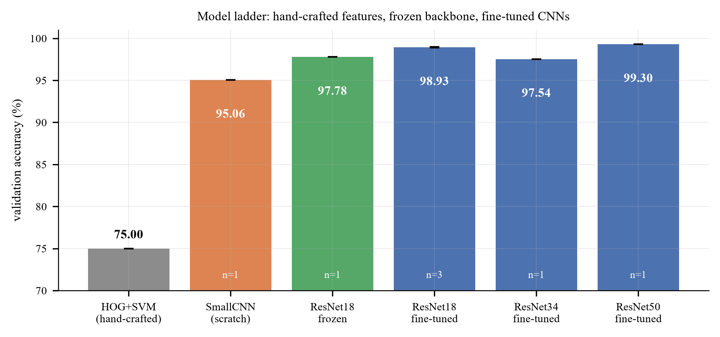
Figure 5. Model ladder
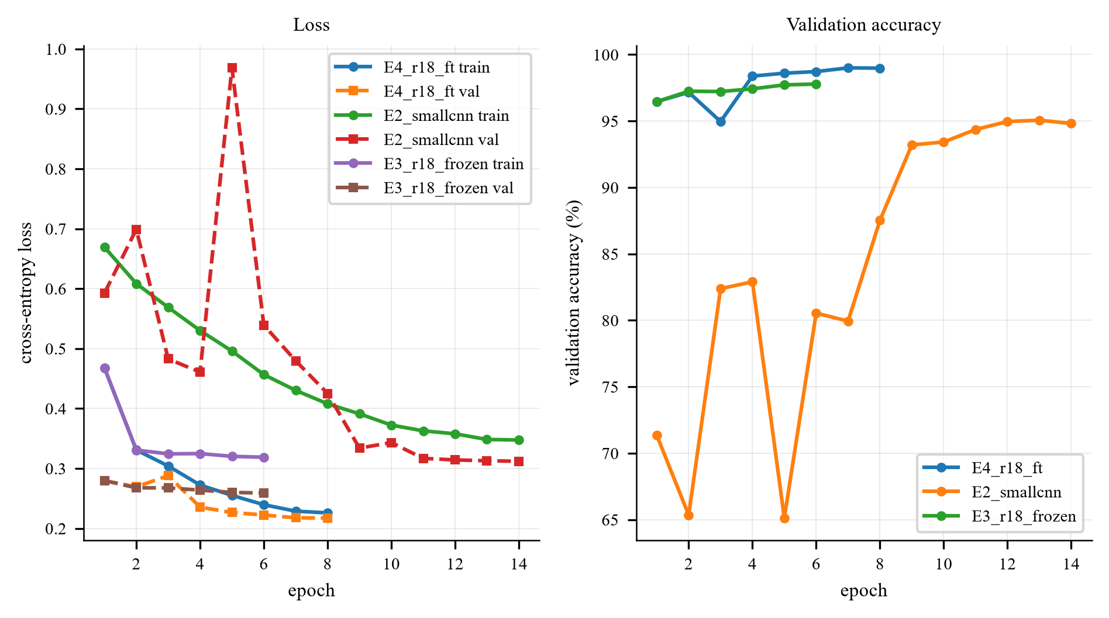
Figure 6. Training curves

Observations
1. The ladder spans 23.9 accuracy points (75.00% → 98.93%), and 22.8 of them are crossed in a single step: going from hand-crafted HOG features to a frozen deep representation (M0 → M2). Everything after that, namely unfreezing, more epochs, a bigger backbone and ensembling, competes for the last 1.2 points.
2. Training from scratch is worse, but not catastrophically so at full budget. M1 (1.17M parameters, 14 epochs, 128 px, no pre-training) reaches 95.06%, only 2.7 points below the frozen ImageNet backbone. With 20,000 images, a small CNN can learn this binary task. The scratch-versus-pretrained gap is much larger when the budget is short (Section 7: 90.66% against 98.12% at 3 to 6 epochs) or the data is scarce (Section 7.3). Pre-training therefore substitutes for data and epochs rather than being the only viable approach.
3. Fine-tuning beats freezing by 1.15 points (97.78% → 98.93 ± 0.06%), and Section 4.4 shows that essentially all of that gain comes from unfreezing the last residual block. "Frozen" here means the backbone weights receive no gradient; the BatchNorm layers stay in training mode, so their running statistics still adapt to the new data, and M2 is therefore slightly stronger than a strict fixed-feature linear probe.
4. The backbone-size effect is non-monotone, and small. ResNet-34 reaches 97.54% (-1.39 points vs ResNet-18; this is its epoch-1 result, before unfreezing: the LP-FT implementation creates a fresh optimiser and schedule when the backbone is unfrozen, which causes a one-epoch validation dip — ResNet-34: 97.52% → 94.58%; M3 seed 42: 97.16% → 94.96% — and early stopping ended the run at epoch 4 before it recovered), while ResNet-50 reaches 99.30% (+0.37 points, at 160 px and 6 epochs, i.e. less compute per image than M3). So the three sizes span 1.8 points in a non-monotone way: the 34 is an outlier that stopped early, and the 50 is the best single model we trained. Two conclusions follow. First, architecture is not the binding constraint, since the whole 18/34/50 spread is a quarter of the 7.46-point pre-training effect. Second, at this dataset size the result is sensitive to the training budget each model receives, so a single-run backbone comparison carries little information. Section 7.8 therefore repeats it for seven backbones under one fixed budget with two seeds each: ResNet-18 and ResNet-34 are then indistinguishable (99.25% vs 99.28%), and the best backbone, ConvNeXt-T, reaches 99.61 ± 0.01%.
5. Three-seed averaging plus horizontal-flip TTA adds 0.29 points (98.93% → 99.22%) and reduces the error count from 50 to 39. It requires no retraining and no new data, only variance reduction. The gain is just below the 0.3 pp threshold that Section 7.1 applies to single-seed comparisons; it rests on three seeds and an 11-error reduction rather than on one run, but it is still a small effect.
M0 (HOG+SVM) is the exception to the 5,000-image validation protocol: it was trained on 8,000 and validated on 2,000 images because feature extraction is CPU-bound; all other rows use the full 5,000-image validation set. The single ResNet-50 run reaches 99.30%, which is 0.08 points above the M3 reference ensemble (99.22%) but 0.40 points below the submitted backbone ensemble (99.70%). It is one seed, trained at 160 px for 6 epochs, and the seed-to-seed standard deviation of the ResNet-18 family is 0.06, so a 0.08-point difference between one run of one model and a three-seed ensemble of another cannot be separated from run-to-run variation. Making the comparison meaningful would need three ResNet-50 seeds of its own (about one hour of GPU time) plus a decision about which resolution to use for all three. This comparison was later made properly in Section 7.8, which retrains seven backbones under one budget with two seeds each; the submitted model is built from its top tier (Section 5.3).
6. The seed spread of the main model is tiny (98.90, 98.90, 99.00 → sample standard deviation 0.06 pp; every ± in this report is a sample standard deviation, ddof = 1). At this point the task is approaching its label-noise ceiling: Section 6 attributes 5 of the 50 single-model errors to label noise, non-photographic content or severely degraded images. At least three of them (Section 6, category 5) are mislabelled or contradictory, so a sound classifier should not be expected to get them right; this suggests a practical ceiling in the region of 99.9% on this validation set, as an estimate rather than a hard bound.

5.2 Detailed metrics for the ResNet-18 reference ensemble (M3 ×3 + TTA)
The metrics below quantify seed averaging for the controlled ResNet-18 study. Sections 6.2–6.6 use one M3 seed for model-level interpretability, while Sections 6.7–6.8 use the submitted ensemble for test-set inspection. The submitted backbone ensemble reaches 99.70% (15 errors out of 5,000); see Section 5.3.
Metric | Value
Validation accuracy (3-seed ensemble + TTA) | 99.22%
Errors | 39 / 5,000
Macro-F1 | 99.22% (identical to accuracy: the classes are exactly balanced)
ROC-AUC | 0.9996
Confusion matrix | cat→dog 17, dog→cat 22

Because the validation set is exactly 2,500/2,500, accuracy, balanced accuracy and macro-F1 coincide up to rounding: there is no class-prior artefact to correct for. This is not true in Section 9, which is why all three metrics are reported there.
The confusion matrix of the single-seed model (the one used for the error analysis in Section 6) is shown in Section 6.2 rather than repeated here; its off-diagonal counts are 18 cat→dog and 32 dog→cat, and the ensemble reduces the total from 50 errors to 39.

5.3 Test set and submission file
The submitted submission.csv is produced by scripts/ensemble_predict.py (cluster job cluster/ensemble.sbatch):
1. loading the six top-tier checkpoints of Section 7.8 (ConvNeXt-T, ResNet-50 and Swin-T, seeds 0 and 1 each),
2. applying horizontal-flip test-time augmentation inside each model,
3. averaging the six softmax outputs.
The three backbone families were selected after the controlled comparison in Section 7.8, as the top three by validation accuracy (two seeds each); equal weighting and horizontal-flip TTA were fixed in advance. Two smaller ensembles were evaluated alongside it for reference only.
Ensemble | Models | val acc (%) | Errors / 5,000
ResNet-18 × 2 seeds (reference) | 2 | 99.30 | 35
ResNet-18 × 2 seeds + TTA (reference) | 2 | 99.28 | 36
ConvNeXt-T × 2 seeds (reference) | 2 | 99.66 | 17
ConvNeXt-T × 2 seeds + TTA (reference) | 2 | 99.64 | 18
Top tier × 2 seeds | 6 | 99.70 | 15
Top tier × 2 seeds + TTA (submitted) | 6 | 99.70 | 15

Ensembling six top-tier models removes 24 of the 39 validation errors of the M3 reference ensemble. Horizontal-flip TTA no longer helps once the models are this strong (±1 error), and is kept only because it was part of the pre-registered configuration.
Property | Value
Rows (excluding header) | 500
Columns | id,label
ids | 1 … 500, one per test image, matching the file names exactly
Label convention | 1 = dog, 0 = cat
Predicted dogs | 259
Predicted cats | 241
Mean max-softmax confidence | 0.95

Sanity checks performed (CSV format validator plus a separate per-id probability comparison):
- header exactly id,label; 500 data rows; ids exactly 1..500 with no duplicates;
- every label in {0,1}; the id order matches sampleSubmission.csv row by row;
- prediction ids and labels agree row by row between submission.csv and submission_backbone_ensemble_probs.csv; each label agrees with the probability decision under cat=0, dog=1. The loader derives ids from image filenames and checks the training class mapping. The 259/241 class count is descriptive only: it cannot detect predictions assigned to the wrong ids or verify the semantic correctness of labels.
The validator is part of the repository and must pass before any upload.
No test accuracy is reported, because the test set has no labels. We also did not use the test set for model selection, ensembling weights or pseudo-labelling. The validation accuracy above is the only performance number we can defend.

5.3.1 The submitted model: architecture, protocol and decision rule
The submitted predictions come from the six-model ensemble of Section 7.8, which is a different
object from the main study model M3 and is documented here in full (Figure 7). Six checkpoints are
used — ConvNeXt-T, ResNet-50 and Swin-T, seeds 0 and 1 each, every one of them the best-epoch
checkpoint of its own 6-epoch run under the Section 7.8 protocol (224 px, RRC(0.6–1.0) + horizontal
flip, AdamW with head lr 1e-3 and backbone lr 1e-4, weight decay 0.05, cross-entropy with label
smoothing 0.1, one warm-up epoch then cosine decay, no early stopping, mixed precision). At test
time each checkpoint processes every test image twice (original and horizontally flipped) and the
two logit vectors are averaged inside the model, with the softmax applied to that average; the six per-model probability vectors are then
averaged with equal weights, and the class decision applies the fixed convention cat = 0, dog = 1 with p(dog) ≥ 0.5. The per-image probabilities behind the submission are archived in
submissions/submission_backbone_ensemble_probs.csv and the ensemble composition in
submissions/submission_backbone_ensemble_ensemble.json.
Property | Value
Members | ConvNeXt-T (s0, s1), ResNet-50 (s0, s1), Swin-T (s0, s1) — 6 checkpoints
Inputs | 224 × 224 × 3 (ImageNet normalisation)
Outputs | 2 probabilities per model per view; softmax at inference
Head | each backbone's ImageNet 1000-way classification layer replaced by a fresh nn.Linear(in_features, 2) (e.g. 512→2 for ResNet-18)
Loss (training) | cross-entropy + label smoothing 0.1
Optimiser | AdamW, head lr 1e-3 / backbone lr 1e-4, weight decay 0.05
Schedule | 1 warm-up epoch + cosine, 6 epochs, no early stopping, mixed precision
TTA | horizontal flip, averaged inside each model (logits)
Ensembling | equal-weight average of the 6 softmax vectors
Decision | p(dog) ≥ 0.5 → 1 (dog), else 0 (cat)
Code | scripts/ensemble_predict.py (job: cluster/ensemble.sbatch)

The three training-code paths named in this report are easy to tell apart: ee6483/src/predict.py
builds the M3 reference ensembles inside the ee6483/ package, scripts/ensemble_predict.py
builds the submitted six-model ensemble in the configuration-driven framework, and
ee6483/scripts/validate_submission.py checks the resulting file. M3 exists to make the study
controllable and reproducible on one GPU; the submitted ensemble is the top tier that the
controlled backbone sweep produced. Their protocols differ and their numbers are never mixed.
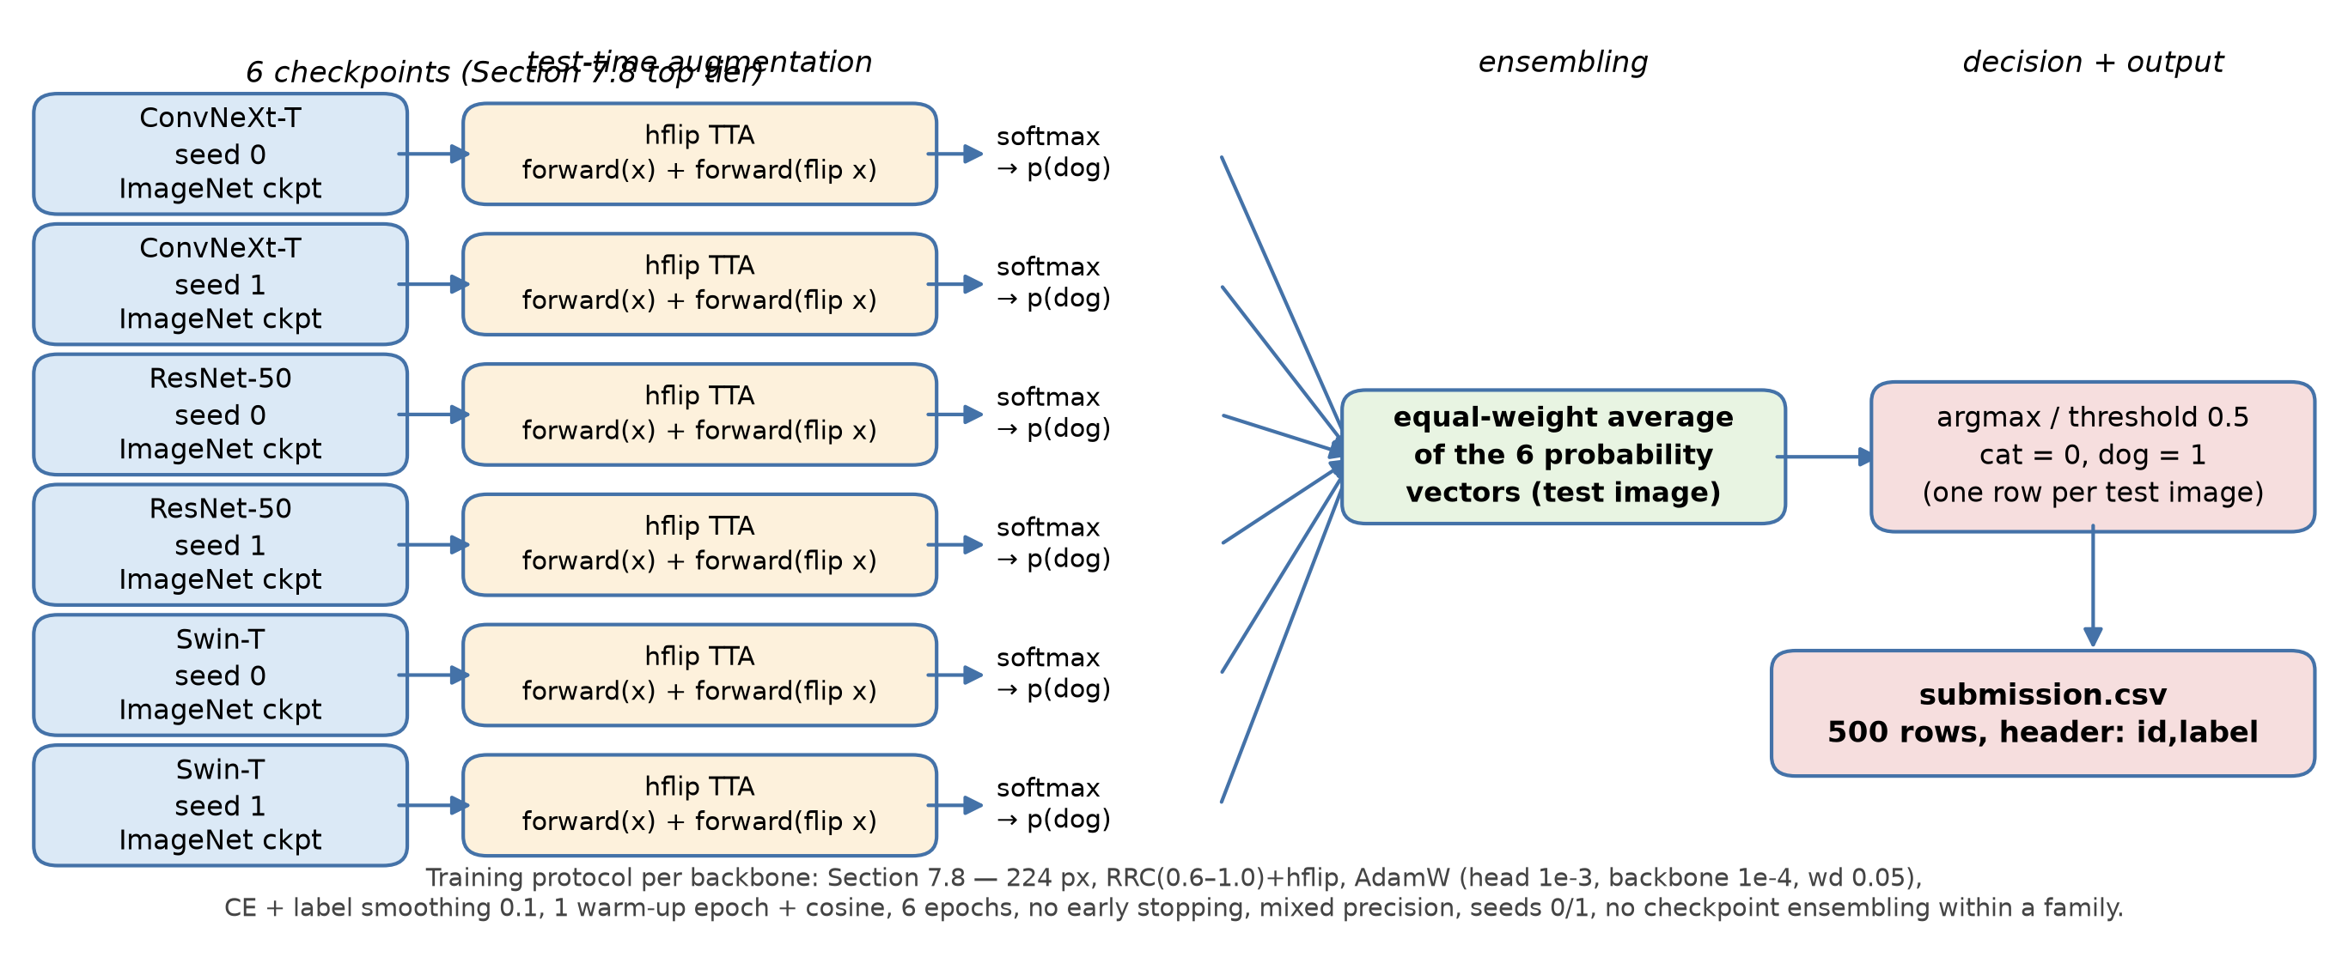
Figure 7. The submitted six-model ensemble: each checkpoint runs hflip TTA, the six softmax vectors are averaged with equal weights, and the fixed cat=0/dog=1 convention turns the average into a submission row

5.4 A note on the optimism of validation accuracy
Validation accuracy was used for early stopping and model selection, so the reported results are subject to selection optimism. The reference ensemble's 99.22% and submitted ensemble's 99.70% were measured on the same validation set used for selection; choosing the top three backbone families adds another selection step. Without an independent labelled holdout or a nested evaluation, we cannot quantify the size of this bias or claim a numerical upper bound. The unlabelled test set cannot resolve this uncertainty. Two of the sensitivity views this concern asks for are already in the record: the per-backbone accuracies that the top-tier choice was made from are the Section 7.8 table itself (nothing was selected outside it), and best-epoch versus last-epoch validation accuracies for every backbone are tabulated in the same section and Appendix A.1b. The third view — re-scoring the ensemble without the 10 near-duplicate validation images (scripts/clean_val_ensemble.py) — gives 99.72% (14 errors in 4,990) against 99.70% (15 in 5,000); the one excluded error is the mislabelled placeholder of Section 2.2, so near-duplicates do not inflate the result. Note also that the ensemble's 99.70% is only 0.09 points above the best single model (ConvNeXt-T at 99.61%, Section 7.8) — well within the seed noise — so the ensemble should be read as a robust top-tier aggregation, not as a large additional accuracy gain.

5.5 Runtime
Experiment | Time on RTX 3070 Ti Laptop (8 GB, mixed precision)
ResNet-18, 8 epochs, 224 px, 20k images | ~8 min
ResNet-34, 224 px, 4 epochs (early stop) | ~5 min
ResNet-50, 6 epochs, 160 px | ~5 min
SmallCNN, 14 epochs, 128 px | ~8 min
Frozen backbone, 6 epochs, 224 px | ~6 min
Ablation run (3 epochs, 160 px) | ~2 min
CIFAR-10 G1 (25 epochs, 45k images) | ~26 min

Mixed precision roughly halves all of the above relative to fp32. The full experiment matrix, comprising 3 main seeds, 6 ladder models, 25 ablation runs, 2 CIFAR-10 models and 6 imbalance runs, takes about 3.7 hours of training time (sum over Appendix A.1).

6. Error Analysis

6.1 What can and cannot be analysed
A prediction can only be called correct or incorrect where a label exists. The test set is unlabelled, so the analysis is split between the validation set, where error rates can be measured, and the test set, where only a qualitative inspection is possible.
Sections | Data | Labels | What it supports
6.2 to 6.6 | validation set (5,000 images) | Yes | quantitative error rate, failure taxonomy, Grad-CAM, robustness
6.7 to 6.8 | test set (500 images) | No | qualitative only: submitted-ensemble confidence distribution and inspection of extreme cases

In terms of the assignment's questions, the required correct/incorrectly-classified case analysis (question e) is therefore performed on the labelled validation set — Sections 6.2–6.6 quantify all 50 errors and Sections 6.4–6.5 are the two case studies — while the test-set sections are qualitative by construction, because no ground truth exists there.
Statements about whether a particular test prediction is correct are manual judgements and are identified as such.

6.2 How often, and in which direction
 | predicted cat | predicted dog
true cat | 2,482 (99.28%) | 18 (0.72%)
true dog | 32 (1.28%) | 2,468 (98.72%)

50 errors out of 5,000 (99.00% accuracy) for the single-seed reference model (M3, seed 42); the three-seed ResNet-18 reference ensemble makes 39 errors on the same set, i.e. ensembling removes about a fifth of them. The submitted backbone ensemble makes 15 errors (Section 5.3). Sections 6.2–6.6 use the single model because attribution methods such as Grad-CAM require one network; Sections 6.7–6.8 switch explicitly to the submitted ensemble for test-set inspection. The single-model errors are asymmetric: it confuses dogs for cats about 1.8× more often than the reverse. Two plausible causes, both consistent with the case studies below:
1. The "dog" class has far more visual diversity (340+ breeds, from 1 kg to 90 kg), so its decision region is broader and its boundary is fuzzier on the cat side.
2. Several dog breeds are small, long-haired and round-faced (Pomeranian, Shih Tzu, Bichon): i.e. they sit inside the cat region of feature space. The opposite direction has no strong analogue.
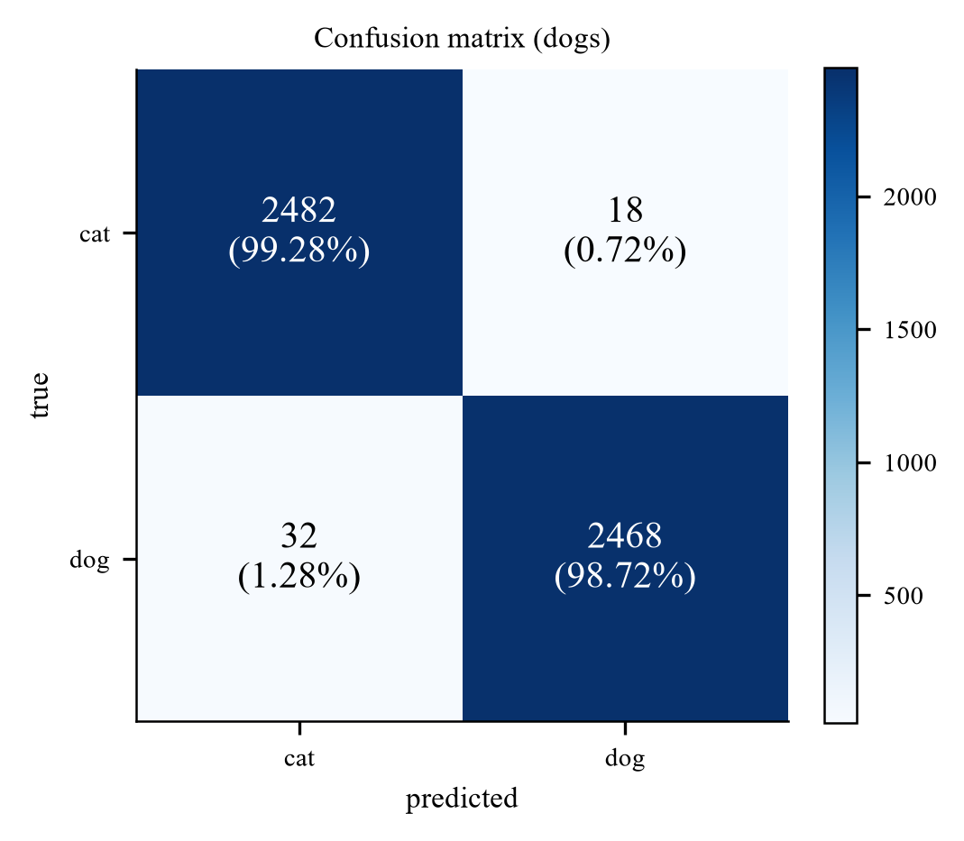
Figure 8. Confusion matrix

6.3 Failure taxonomy
All 50 validation errors were inspected (the ten most confident are shown below, five in each direction; the complete set is in figures/fig_errors_all_1.png to fig_errors_all_5.png) and each was assigned to a single dominant cause. The categories are not perfectly disjoint, since an image can be both occluded and background-driven, so the rule was "what would have to change for this image to be classified correctly?".
# | Failure mode | Count | Share | Representative example
1 | Face not visible: rear view, curled up asleep, head turned away, or an extreme close-up on a body part | 18 | 36% | dog.3519 (white dog from behind, p=0.93)
2 | Occlusion or unusual framing: wire mesh, held in a hand, inside a crate | 15 | 30% | cat.9897 (cat behind a chain-link fence, p=0.94)
3 | Background / scene context contradicts the class | 5 | 10% | cat.6734 (black cat walking on grass, p=0.90)
4 | Multi-animal image or strong distractor objects | 5 | 10% | cat.7020 (cat lying next to a beagle, p=0.90)
5 | Label noise, non-photographic content, or severely degraded image | 5 | 10% | cat.3072 (group photo of five people, no animal at all)
6 | Cat-like small dog / puppy-kitten ambiguity | 2 | 4% | dog.4030 (miniature pinscher, p=0.88)

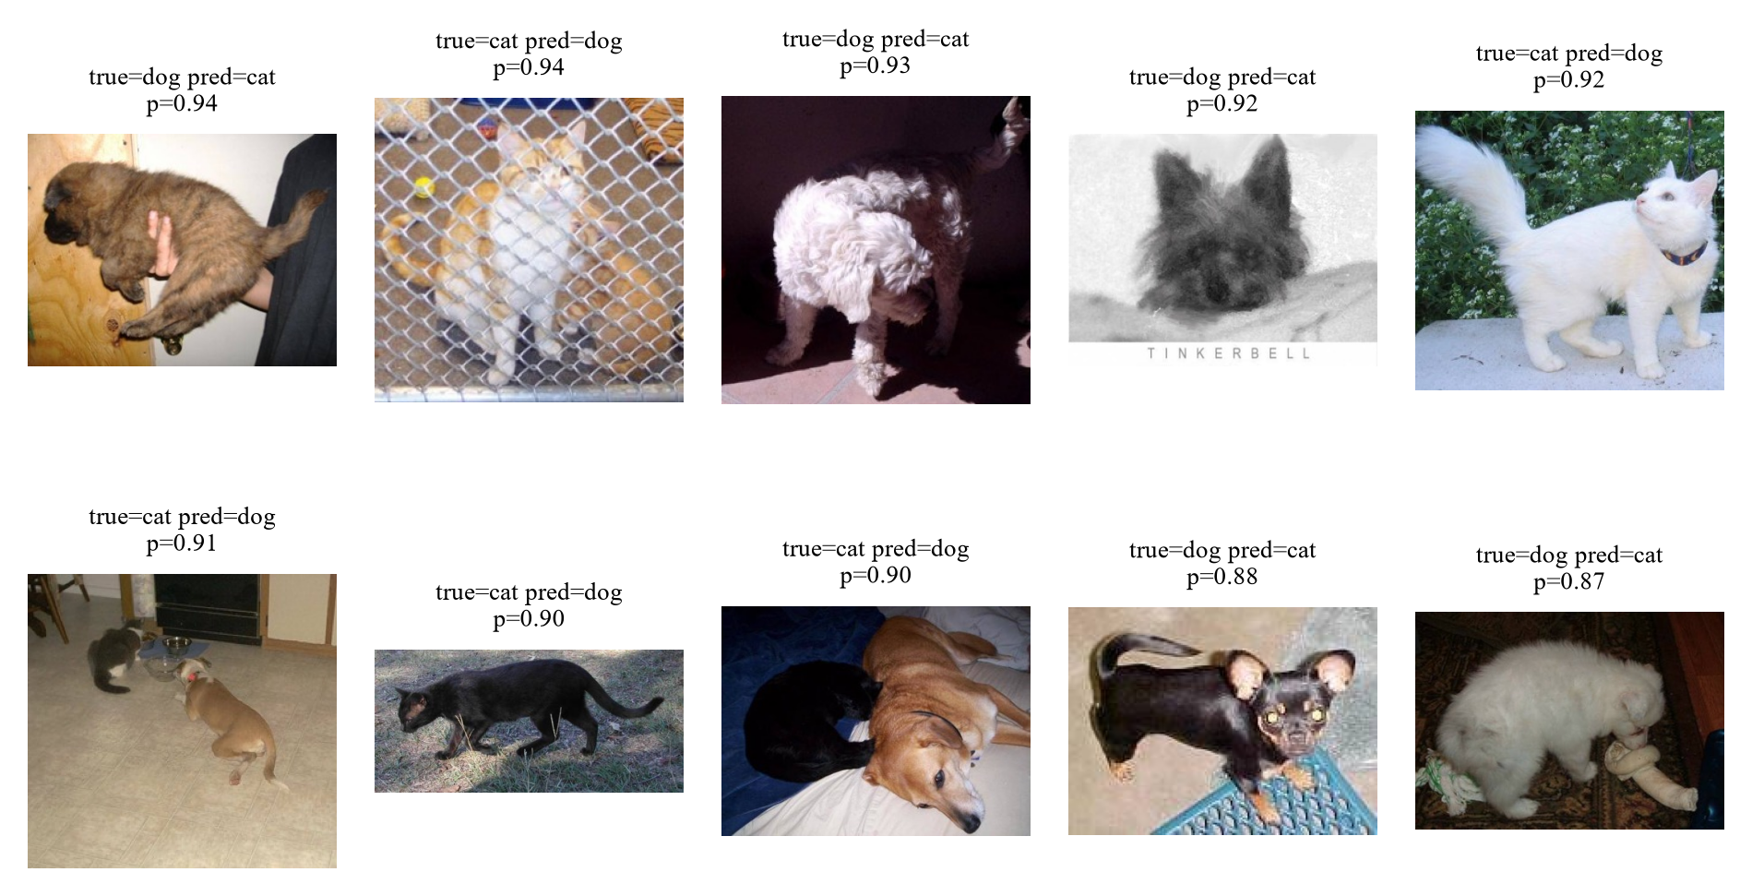
Figure 9. The ten most confident validation errors, five in each direction (true label, prediction and probability annotated)
Four observations:
- Two thirds of the errors (33/50) are "the animal is not presented the way the training set presents it": no face, or wrapped in a fence/hand. The model is not confused about what a cat or dog is; it is missing the specific view it has learned to rely on. This is a coverage problem, and it is the single most useful conclusion of the error analysis.
- Category 1 is the largest source of error, and it is face-driven. Grad-CAM (Section 6.6) confirms that on correct predictions the evidence is concentrated on the head. That prior is usually right, which is why accuracy is 99%, but it has no fallback when the head is hidden.
- Category 4 is an annotation problem, not a model problem. Under a single-label target an image containing both animals is semantically ambiguous: the dataset still assigns one ground-truth label, but that label may not represent the full visual content, so a prediction can be penalised even when the model correctly recognises one of the animals present. These cases expose a limitation of single-label annotation rather than an unavoidable 50% error rate.
- Category 5 is largely irreducible, and Section 2 explains part of why. cat.11565 is the "PHOTO UNAVAILABLE" placeholder that also appears three times under dog (Section 2.2), so the same graphic carries two different targets; cat.3072 is a photograph of five people at a trade-show booth labelled "cat"; dog.1568 is a tabby cat held by a person, labelled "dog". The last two are label noise rather than contradictory duplicates: a model could still output the given label, but only by chance or by fitting the noise, not by recognising the animal. These images therefore limit the accuracy a sound classifier can be expected to reach on this validation set, regardless of architecture. This is the concrete cost of the 6 placeholder images found by the pHash audit.
Category 3 is the shortcut learning discussed in Section 1: a black cat walking on grass is predicted "dog" with 0.90 confidence. The model has learned a genuine correlation in the data (dogs photographed outdoors more often), and it exploits that correlation when the animal itself is ambiguous.

6.4 Case study: the white dog photographed from behind
Third panel of the grid above: a small white dog photographed from behind, predicted cat with probability 0.93.
Why the model is wrong. There is no face in the image. The remaining evidence is (i) a compact, rounded body, (ii) long, soft, light-coloured fur, and (iii) a curled tail. Every one of these is also a property of a long-haired cat. The model has no feature that discriminates on the basis of tail shape or ear placement alone, because in the training set those cues are almost always co-present with a face, so the network never had to learn them independently.
What this reveals about the model's strength. On the vast majority of images the face is visible, and there the model is essentially perfect: it has learned a genuinely discriminative, high-level representation (Section 6.6). The failure is a coverage failure, not a representation failure: the training distribution contains few rear-view dogs, so the model is being asked to extrapolate.
What would fix it. More aggressive cropping (RandomResizedCrop with a lower scale bound) would present more partial animals during training; alternatively a part-based model or an attention mechanism that explicitly localises head and tail would decouple the two cues. Neither is a hyper-parameter: this is a data-coverage problem.

6.5 Case study: the cat behind a chain-link fence
Second panel of the same grid: an orange-and-white cat behind a chain-link fence, predicted dog with probability 0.94.
Why the model is wrong. The mesh introduces a strong, regular high-frequency pattern over the entire animal. Two mechanisms may compound:
1. The pattern corrupts the local texture statistics that the network uses to describe fur: the very feature that separates a cat from a fluffy dog.
2. Enclosures (kennels, yards, crates) are plausibly more frequent in dog photographs in this dataset, so the context may also vote "dog". We state this as a hypothesis: we did not run the counterfactual experiment (the same cat photographed with and without the fence) that would be needed to separate the two.
What this reveals about the model's weakness. A human resolves this instantly by integrating the visible face through the mesh. The network's receptive field at the deepest layer covers the whole image, so it could in principle do the same, but nothing in the training objective forces it to be robust to structured occlusion: RandomErasing (which we use) inserts a solid rectangle, not a high-frequency pattern, so it does not train this invariance.
Consistency with the robustness test. Section 6.6 shows a 12.7-point loss under heavy blur and a 0.4-point loss under a central square mask whose side is 25% of the original image's shorter dimension. This supports sensitivity to blur under the tested conditions. It does not isolate texture from shape cues or establish the cause of the fence-related errors.

6.6 Grad-CAM and the robustness test
Grad-CAM [Selvaraju et al., ICCV 2017] weights the last convolutional feature maps by the gradient of the predicted class score, producing a coarse localisation of the evidence the model used.
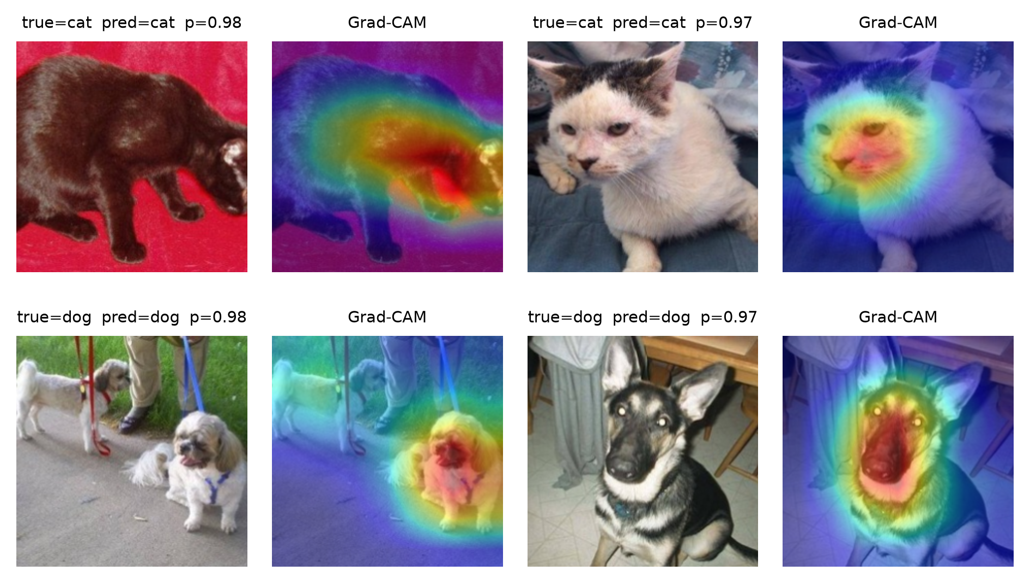
Figure 10. Grad-CAM, correct predictions
For correct predictions the activation is concentrated on the head and face in essentially every case, and not on the background. This is the most direct evidence we have that the model attends to the animal rather than the scene on the inspected samples: in these images the concern about background shortcut learning raised in Section 1.1.2 does not materialise. Grad-CAM shows where the model looks, not why it decides, and the validation errors above show that background cues can still contribute on harder images.
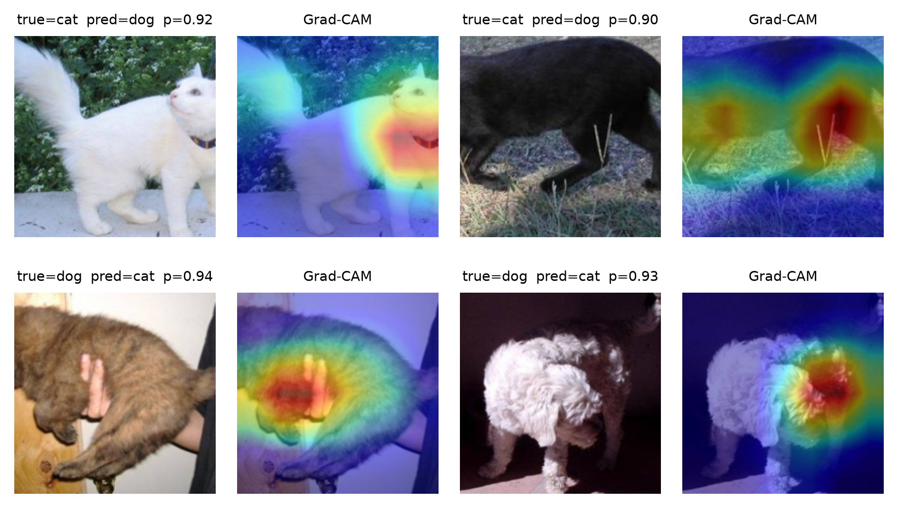
Figure 11. Grad-CAM, incorrect predictions
For incorrect predictions the pattern is diagnostic, and it splits by direction:
- Both cat-to-dog errors are cats photographed on grass (0.92 and 0.90). In each case the activation covers the animal but also the surrounding lawn, so the scene contributes evidence; this is the background cue discussed in Section 1 and quantified as failure category 3 in Section 6.3.
- Both dog-to-cat errors are dogs whose face is not visible: one is held against a person's body (0.94), the other is photographed from behind (0.93). The activation falls on the back, the fur and the person's hands rather than on a head, which is the coverage failure described in Sections 6.4 and 6.5.
Robustness test. We apply seven deterministic perturbations (plus the clean condition) to the validation images and re-evaluate without retraining:
Perturbation | val acc (%) | Δ vs clean
none (clean) | 99.00 | –
Gaussian blur σ=2 | 95.26 | −3.7
Gaussian blur σ=4 | 86.34 | −12.7
brightness ×1.6 | 98.48 | −0.5
brightness ×0.45 | 98.74 | −0.3
rotation 30° | 97.94 | −1.1
Central square mask, side = 25% of original short side | 98.56 | −0.4
Gaussian noise σ=25 | 94.58 | −4.4

The mask is applied before resizing and centre cropping. Its side length is approximately 0.25 × min(height, width), with integer rounding. It covers approximately 6.25% of a square original image, and a smaller proportion of a rectangular original; the fraction of the final model input depends on the subsequent crop. This experiment did not test a mask covering 25% of the image area.
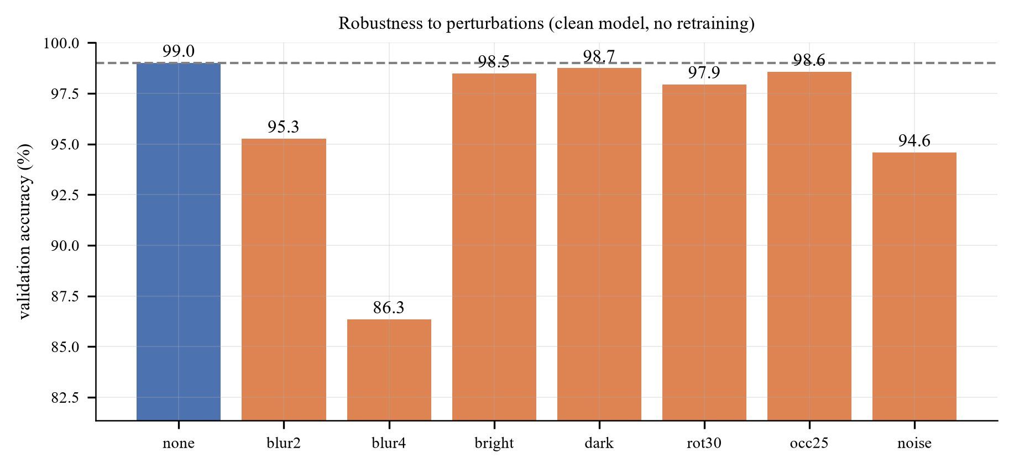
Figure 12. Robustness of the single-seed reference model. The occ25 label denotes a central square mask with side length 25% of the original image's shorter dimension, not 25% of its area
Three conclusions:
1. Heavy blur causes the largest observed drop (−12.7 pp). This is consistent with reliance on fine visual detail, but blur also affects edges and shape information; these measurements alone cannot distinguish texture reliance from shape reliance.
2. The tested central mask causes a smaller drop (−0.4 pp). RandomErasing is a possible contributor, but no matched robustness comparison with RandomErasing disabled was performed, so its causal contribution is unknown. The small mask also limits how broadly this result can be generalised to occlusion.
3. The two brightness changes cause drops of about 0.3–0.5 pp. This supports robustness to those particular illumination changes. It does not establish robustness to hue or saturation changes, or a ranking of colour, texture and shape cues.

6.7 The test set: qualitative inspection
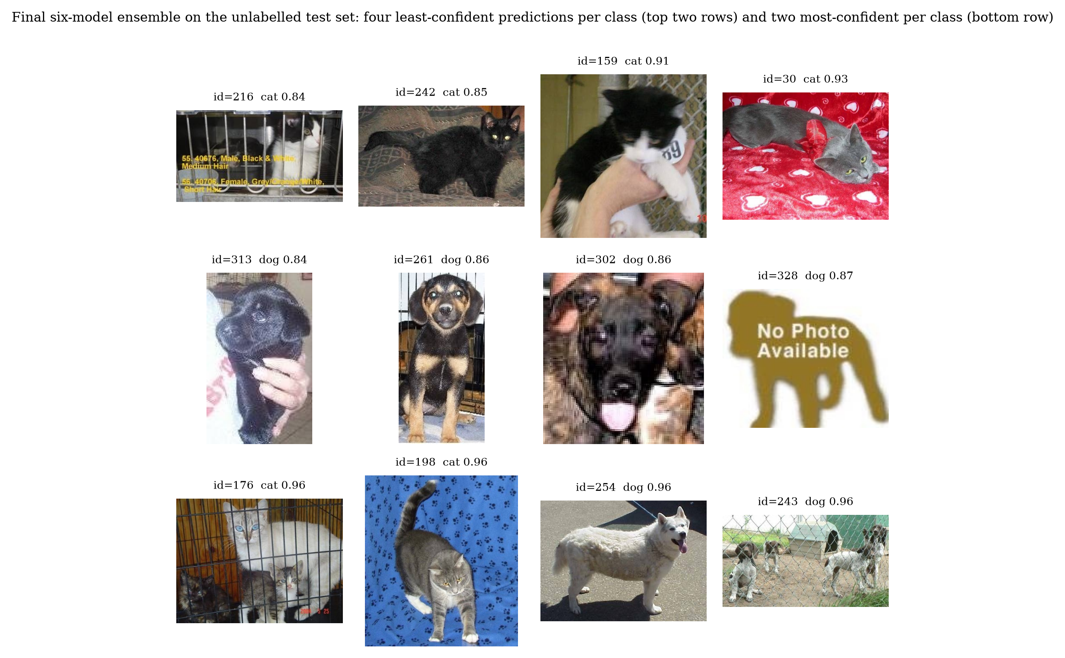
Figure 13. Submitted six-model ensemble: four least-confident and two most-confident predictions per class on the unlabelled test set. Perceptual near-duplicates are suppressed; labels are predictions, not ground truth
The test set is unlabelled, so the labels shown are the submitted ensemble's predictions and any judgement about whether a prediction appears plausible is a visual assessment by the authors. The panel is generated directly from submission_backbone_ensemble_probs.csv; it therefore describes the same six checkpoints and horizontal-flip TTA configuration as submission.csv. Perceptual near-duplicates are suppressed so that a repeated image cannot fill several slots. The second test-set placeholder (id=464, dog 0.88) is not shown because it is the fifth least-confident dog prediction, just above id=328, not because of this filter.
- The four least-confident cat predictions are a black-and-white cat behind cage bars with overlaid text (id=216, 0.84), a black cat on a dark rug (id=242, 0.85), a black-and-white cat held up by a hand in front of a chain-link fence, with a numbered tag (id=159, 0.91), and a grey cat on a strongly patterned red blanket (id=30, 0.93). Occlusion, low contrast and texture-heavy backgrounds are among the failure factors identified on the labelled validation set.
- The four least-confident dog predictions are a black puppy held in a hand (id=313, 0.84), a puppy sitting in a cage (id=261, 0.86), a low-resolution, pixelated close-up of a dog's face (id=302, 0.86) and a "No Photo Available" placeholder (id=328, 0.87). The first three predictions are visually plausible; the placeholder exposes the closed-set limitation because the model must choose cat or dog even when neither is present.
- The most-confident examples remain visually straightforward: two cat images (ids 176 and 198, both 0.96) and two dog images (ids 254 and 243, both 0.96). One dog image contains several animals behind a fence, showing that the ensemble can remain stable under multiple subjects and structured occlusion.
- The submitted prediction distribution is 259 dog / 241 cat (52/48). This is a descriptive count, not a check of image-to-label alignment: permuting predictions among ids leaves the count unchanged, and reversing labels simply swaps the two counts. Alignment is checked using numeric image ids and the explicit cat=0, dog=1 convention, as described in Section 5.3.

6.8 Two test-set cases: one visually plausible success, one structural limitation
The test set carries no labels, so the two cases below are chosen for what they reveal about the model rather than for a score. In both, the judgement that the prediction is right or wrong is a visual one.
Case 1, a strength: several dogs behind a fence (id=243, predicted dog, p=0.96). The image contains multiple dogs at different depths and scales, with a chain-link fence crossing the scene. The submitted ensemble remains confident despite multiple subjects, structured occlusion and a strong background pattern—the same factors that cause some single-model validation errors. This is the behaviour one would want from a system deployed on user photographs, where framing is rarely as clean as the training examples.
Case 2, a structural limitation: an image that contains no animal (id=328, predicted dog, p=0.87). The input is a "No Photo Available" placeholder graphic. The weakness is structural rather than a training failure: a two-way softmax must put its mass somewhere, so an input outside the label space cannot be rejected. A maximum-softmax threshold or explicit rejection class would address this, but would require a validation set containing out-of-distribution images to calibrate the threshold (Section 6.9). The relatively high confidence shows that higher in-distribution accuracy does not imply reliable behaviour outside the label space.
These two examples illustrate visually plausible recognition of dogs alongside a confident assignment to an input containing no animal. They do not establish a test error rate, and the placeholder shows why confidence alone is insufficient to identify inputs outside the model's label space.

6.9 Limitations: closed-set assumption and calibration
Two limitations follow from the analysis above.
1. The classifier is closed-set and cannot return "neither". Images that contain no animal are still assigned a label. The two test-set placeholders, which show the same graphic (ids 464 and 328, a "No Photo Available" graphic that does not occur in train or validation, unlike the six of Section 2.2) are the clearest case: both are predicted dog with probabilities 0.88 and 0.87. Standard remedies such as maximum-softmax thresholding [Hendrycks & Gimpel, ICLR 2017], OpenMax [Bendale & Boult, CVPR 2016] or an energy score are post-hoc, but they need a validation set containing out-of-distribution images to calibrate the rejection threshold, which this dataset does not provide.
2. Confidence is informative but not calibrated. Mean maximum-softmax confidence is 0.95 on the unlabelled test set, but without labels no calibration error can be measured there. Temperature scaling fitted on the labelled validation set would make calibration explicit. It was not applied because it does not change the argmax and therefore does not change the submission.

7. Ablation Study

7.1 Protocol
This section measures how different choices of model and data processing affect validation accuracy. Answering it with a grid search would confound the factors, so we use a one-factor-at-a-time (OFAT) ablation with a fixed reference configuration:
reference: ResNet-18, ImageNet pre-trained, 160×160, 3 epochs, full augmentation, all 20,000 training images, seed 42, full fine-tuning.
Each table changes exactly one thing relative to that reference. The short schedule of 3 epochs rather than 8 keeps the 25 ablation runs affordable; the ranking of factors is what the study measures, not the absolute accuracy.
Three caveats apply.
1. 3 epochs under-fits. The reference reaches 98.12% in 3 epochs at 160 px, versus 98.93% in 8 epochs at 224 px, so the task is already close to saturated at this budget. When a model is near the ceiling, most knobs stop mattering: that is itself one of our findings, but it means the small effects below should not be extrapolated to a harder task.
2. Seeds. Every configuration was run with seeds 42, 43 and 44. Each table gives the seed-42 value first and the three-seed mean ± sample standard deviation after it. The ablation runs have a seed-to-seed standard deviation of 0.02–0.6 pp (up to 1.3 pp for the 500-image subset, which is redrawn for each seed), against 0.06 pp for the main model, so differences below about 0.3 pp are reported as no measurable effect. Seeds 43 and 44 were trained on an A40 GPU on the faculty cluster with the identical recipe; the figures in this section show seed 42.
3. The reference is not the final model. The final model uses 224 px and 8 epochs (Section 5). The ablation answers "which choices matter", not "what is the best possible number".

7.2 The largest effect: pre-training
This comparison controls the architecture, data, augmentation, resolution and optimiser, but not the training duration: the from-scratch model receives twice the epochs. The extra epochs favour the from-scratch model, so the observed 7.46-point difference is a conservative estimate of the pre-training effect at this budget (with equal epochs the gap would be expected to be larger), not an exact isolation of it.
Level | Epochs | val acc (%): seed 42 / mean ± std (3 seeds) | Δ
random initialisation | 6 | 90.66 / 90.63 ± 0.05 | −7.46 / −7.67 ± 0.19
ImageNet pre-trained (reference) | 3 | 98.12 / 98.31 ± 0.18 | 0

Starting from ImageNet weights is worth 7.46 accuracy points at seed 42 and 7.67 ± 0.19 over three seeds, even after giving the scratch model double the training. Within the 3–6 epoch budget the from-scratch network has learned generic low-level filters but has not yet assembled them into cat/dog detectors; the pre-trained network already has them.

7.3 The second largest effect: how much data
Images per class | Total training images | val acc (%): seed 42 / mean ± std (3 seeds)
250 | 500 | 93.56 / 95.07 ± 1.33
1,000 | 2,000 | 96.76 / 96.88 ± 0.12
2,500 | 5,000 | 97.90 / 97.93 ± 0.09
5,000 | 10,000 | 98.20 / 98.15 ± 0.08
10,000 (reference) | 20,000 | 98.12 / 98.31 ± 0.18

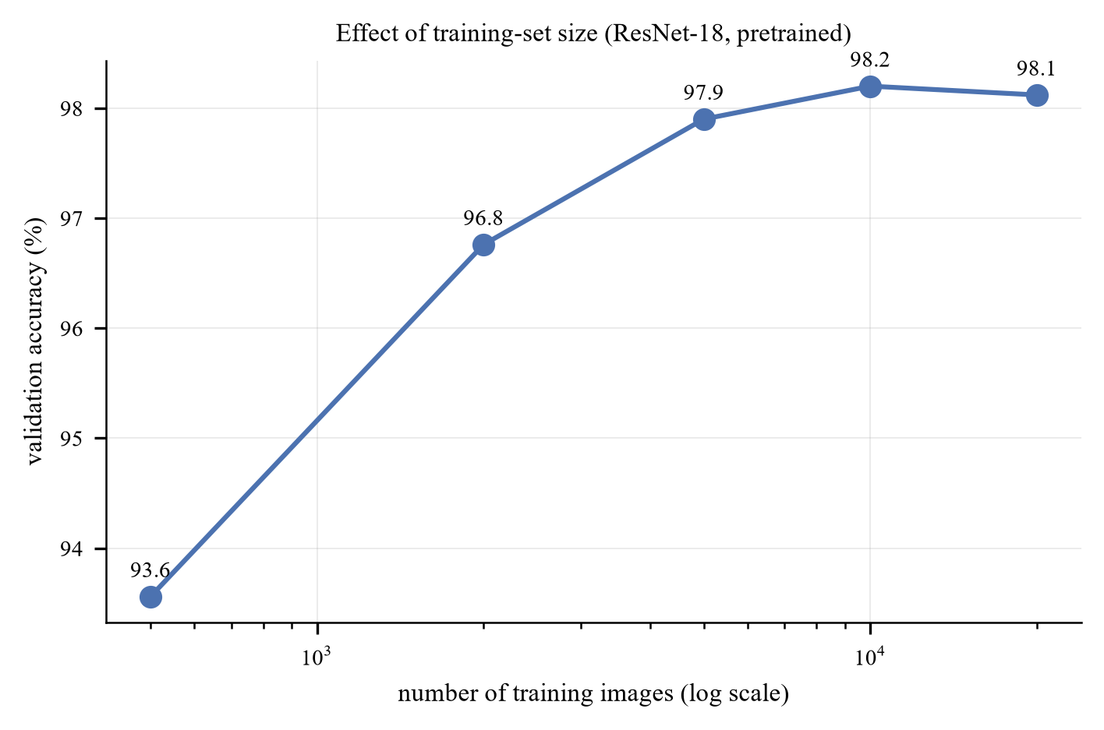
Figure 14. Learning curve
At 500 images the setting is close to a few-shot problem in the sense of Snell et al. [NeurIPS 2017], except that the backbone is pre-trained rather than meta-learned, which is precisely why 500 images remain workable.
The curve is steep up to ~2,000 images and then flattens hard: the last 10,000 images buy nothing measurable (+0.15 ± 0.20 pp over three seeds; −0.08 pp at seed 42), while the first 1,500 images (500 to 2,000) buy 1.8 ± 1.2 points and the full range from 500 to 20,000 buys 3.2 ± 1.2 (4.56 at seed 42, whose 500-image subset was the weakest of the three). The smallest subset is redrawn for each seed, which is why it has by far the largest spread. Three consequences:
- The curve starts to bend at about 2,000 images: a pre-trained backbone trained on 2,000 images already reaches 96.8%.
- Data quantity and pre-training interact. With 500 images the pre-trained model reaches 95.1 ± 1.3% (93.6% at seed 42); the from-scratch model at 20,000 images (Section 7.2) reaches 90.6 ± 0.1%. This holds in every seed. A pre-trained model with 2.5% of the data beats a from-scratch model with 100% of it. That is the cleanest possible demonstration of transfer, and it is the answer to the "is the high accuracy just ImageNet knowing cats and dogs?" objection: a category prior cannot explain why 500 images suffice for a different architecture, whereas a generic representation can.
- Collecting more than ~10,000 images per class would be wasted effort on this task with this backbone. Effort is better spent on the hard cases identified in Section 6.

7.4 Transfer strategy
Strategy | Trainable parameters | val acc (%): seed 42 / mean ± std (3 seeds)
Linear probe (head only) | 1,026 | 96.24 / 96.25 ± 0.17
Last residual stage + head | 8.4 M | 98.20 / 98.13 ± 0.15
Full fine-tune (reference) | 11.18 M | 98.12 / 98.31 ± 0.18
LP-FT (1 of 3 epochs as the probe) | 11.18 M | 98.32 / 98.28 ± 0.04

Unfreezing more of the network helps, but all of the benefit arrives at the first step: the linear probe loses 1.88 points relative to the reference (2.06 ± 0.21 over three seeds), and going from "last stage" to "all layers" changes nothing measurable (+0.17 ± 0.23 pp). In other words the useful adaptation happens in the last residual block; the early layers of an ImageNet network are already the right feature extractor for photographs of animals. This is the same conclusion as Yosinski et al. [NeurIPS 2014] on layer-wise transferability, reproduced on a different dataset.
LP-FT is the best of the four at seed 42, but over three seeds it is indistinguishable from naive full fine-tuning at this budget (−0.03 ± 0.21 pp). Its expected advantage is at longer schedules, where the destructive first step on a randomly initialised head costs more (Section 3.4); we did not measure that directly.
The probe length differs between the two settings and this should be read with care. Here the schedule is 3 epochs, so the probe occupies the first of them; the main model (M3) runs for 8 epochs and uses a 2-epoch probe, which is why the row above is not a reproduction of the submitted configuration but a controlled comparison at the ablation budget.

7.5 Input resolution
Resolution | val acc (%): seed 42 / mean ± std (3 seeds) | Relative compute
96 | 97.08 / 97.00 ± 0.19 | 0.2×
128 | 97.94 / 98.01 ± 0.13 | 0.35×
160 (reference) | 98.12 / 98.31 ± 0.18 | 1×
224 | 98.76 / 98.75 ± 0.02 | 2×

Accuracy increases monotonically with resolution, by 1.04 pp from 96 to 160 and a further 0.64 pp from 160 to 224 at seed 42 (1.31 ± 0.35 and 0.44 ± 0.20 over three seeds; the 160 → 224 gain is positive in every seed). Unlike the augmentation row, this trend is monotone and larger than the noise, so it is a real effect. The mechanism is that at 96 px the discriminative region (face, ears, eye shape) is only a few pixels wide; by 160 px it is resolvable. Doubling compute again for the last 0.4–0.6 pp is a poor trade, which is why the main model stops at 224 px (the resolution the pre-trained weights expect) and the ablations use 160 px.

7.6 Augmentation strength: a budget-dependent, sub-1 pp effect
Level | Added transforms | val acc (%): seed 42 / mean ± std (3 seeds)
none | Resize + CenterCrop only | 98.36 / 98.51 ± 0.13
flip | + RandomResizedCrop + HFlip | 98.62 / 98.59 ± 0.03
geo | + rotation ±15° | 98.56 / 98.53 ± 0.03
color | + ColorJitter | 98.48 / 98.52 ± 0.04
full (reference) | + RandAugment + RandomErasing | 98.12 / 98.31 ± 0.18

At a 3-epoch budget augmentation makes no measurable difference, and the strongest setting is the worst of the five by 0.5 pp at seed 42 (0.2–0.3 pp over three seeds; it is last in every seed). To establish whether this is a property of the transforms or of the budget, the two extremes were re-run at 8 epochs and again with 500 images.
Regime | augmentation none (seed 42 / 3 seeds) | augmentation full (seed 42 / 3 seeds) | difference (seed 42 / 3 seeds)
20,000 images, 3 epochs | 98.36 / 98.51 ± 0.13 | 98.12 / 98.31 ± 0.18 | -0.24 / -0.21 ± 0.08 pp
20,000 images, 8 epochs | 98.42 / 98.47 ± 0.09 | 98.66 / 98.65 ± 0.13 | +0.24 / +0.18 ± 0.07 pp
500 images, 8 epochs | 95.94 / 96.19 ± 0.59 | 96.30 / 95.90 ± 0.36 | +0.36 / -0.29 ± 0.86 pp

The third row is the one that matters for the "augmentation substitutes for data" intuition: with only 500 training images the no-augmentation model reaches 100% training accuracy by epoch 8, i.e. it memorises the training set, and yet augmentation does not help it consistently. At seed 42 the augmented model is 0.36 pp better, but over three seeds the difference is −0.29 ± 0.86 pp (+0.36, −1.26, +0.04): the choice of the 500 images matters far more than the augmentation policy. A pre-trained ResNet-18 on this task simply does not overfit in a way that augmentation can fix.
With the full training set the sign flips between the two budgets in every seed (−0.21 ± 0.08 pp at 3 epochs, +0.18 ± 0.07 pp at 8 epochs). With 500 images there is no consistent sign. Three conclusions follow.
- Augmentation is a sub-1 pp lever on this task with the full training set, at both budgets we tested. The task is saturated by pre-training; there is almost no headroom for regularisation to recover, and the residual errors (Section 6) are label noise and ambiguous viewpoints that no augmentation can fix.
- Its sign depends on the schedule. At 3 epochs the strong transforms (RandAugment + RandomErasing) remove information faster than a short schedule can exploit it, so they cost 0.21 ± 0.08 pp; at 8 epochs they have time to pay off and gain 0.18 ± 0.07 pp. Both effects are small but have the same sign in all three seeds. With 500 images, the seed-to-seed spread (0.86 pp) swamps the effect.
- RandomErasing may contribute to the measured robustness, but this was not isolated experimentally. Section 6 reports a 0.4 pp drop for a central mask whose side is 25% of the original image's short side (about 6.25% of a square original's area). A matched robustness comparison with and without RandomErasing is required to attribute this result to that augmentation.
The practical implication is that an ablation run at too short a budget can invert the sign of a real effect. The full augmentation policy is retained in the main model because it is neutral to slightly positive at the 8-epoch budget actually used and is designed to improve robustness to viewpoint variation and occlusion. The current experiments do not isolate the causal contribution of RandomErasing to that robustness — a matched comparison with RandomErasing disabled would be needed (Section 6.6).

7.7 The full model ladder
Model | Budget | val acc (%) | Δ vs M3
M0 HOG + SVM | 8k images | 75.00 | −23.93
M1 SmallCNN, from scratch | 14 ep @128 | 95.06 | −3.87
M2 ResNet-18 frozen + linear | 6 ep @224 | 97.78 | −1.15
M3 ResNet-18 LP-FT | 8 ep @224 | 98.93 ± 0.06 | 0
M4 ResNet-34 LP-FT | 8 ep @224 | 97.54 | -1.39
M5 ResNet-50 LP-FT | 6 ep @160 | 99.30 | +0.37

The ladder mixes budgets, so the Δ column is indicative rather than controlled. Two results deserve comment:
- A small CNN trained from scratch reaches 95.06%: much higher than the 80–85% one might expect from the literature. Twenty thousand images is enough for a 1.17M-parameter network to learn this binary task; the task is simply easier than ImageNet-1k.
- Backbone size is non-monotone: ResNet-34 is worse than ResNet-18 (97.54% vs 98.93 ± 0.06%, early-stopped at epoch 4) while ResNet-50 is better (99.30%, at lower resolution and fewer epochs). The spread across all three sizes is 1.8 points, a quarter of the pre-training effect, and the ordering is not stable. At this dataset size the result depends more on how many epochs each model happens to get than on the architecture, which is exactly why "architecture is second-order" is the defensible claim and "bigger is better/worse" is not. Section 7.8 repeats the comparison under a fixed budget.
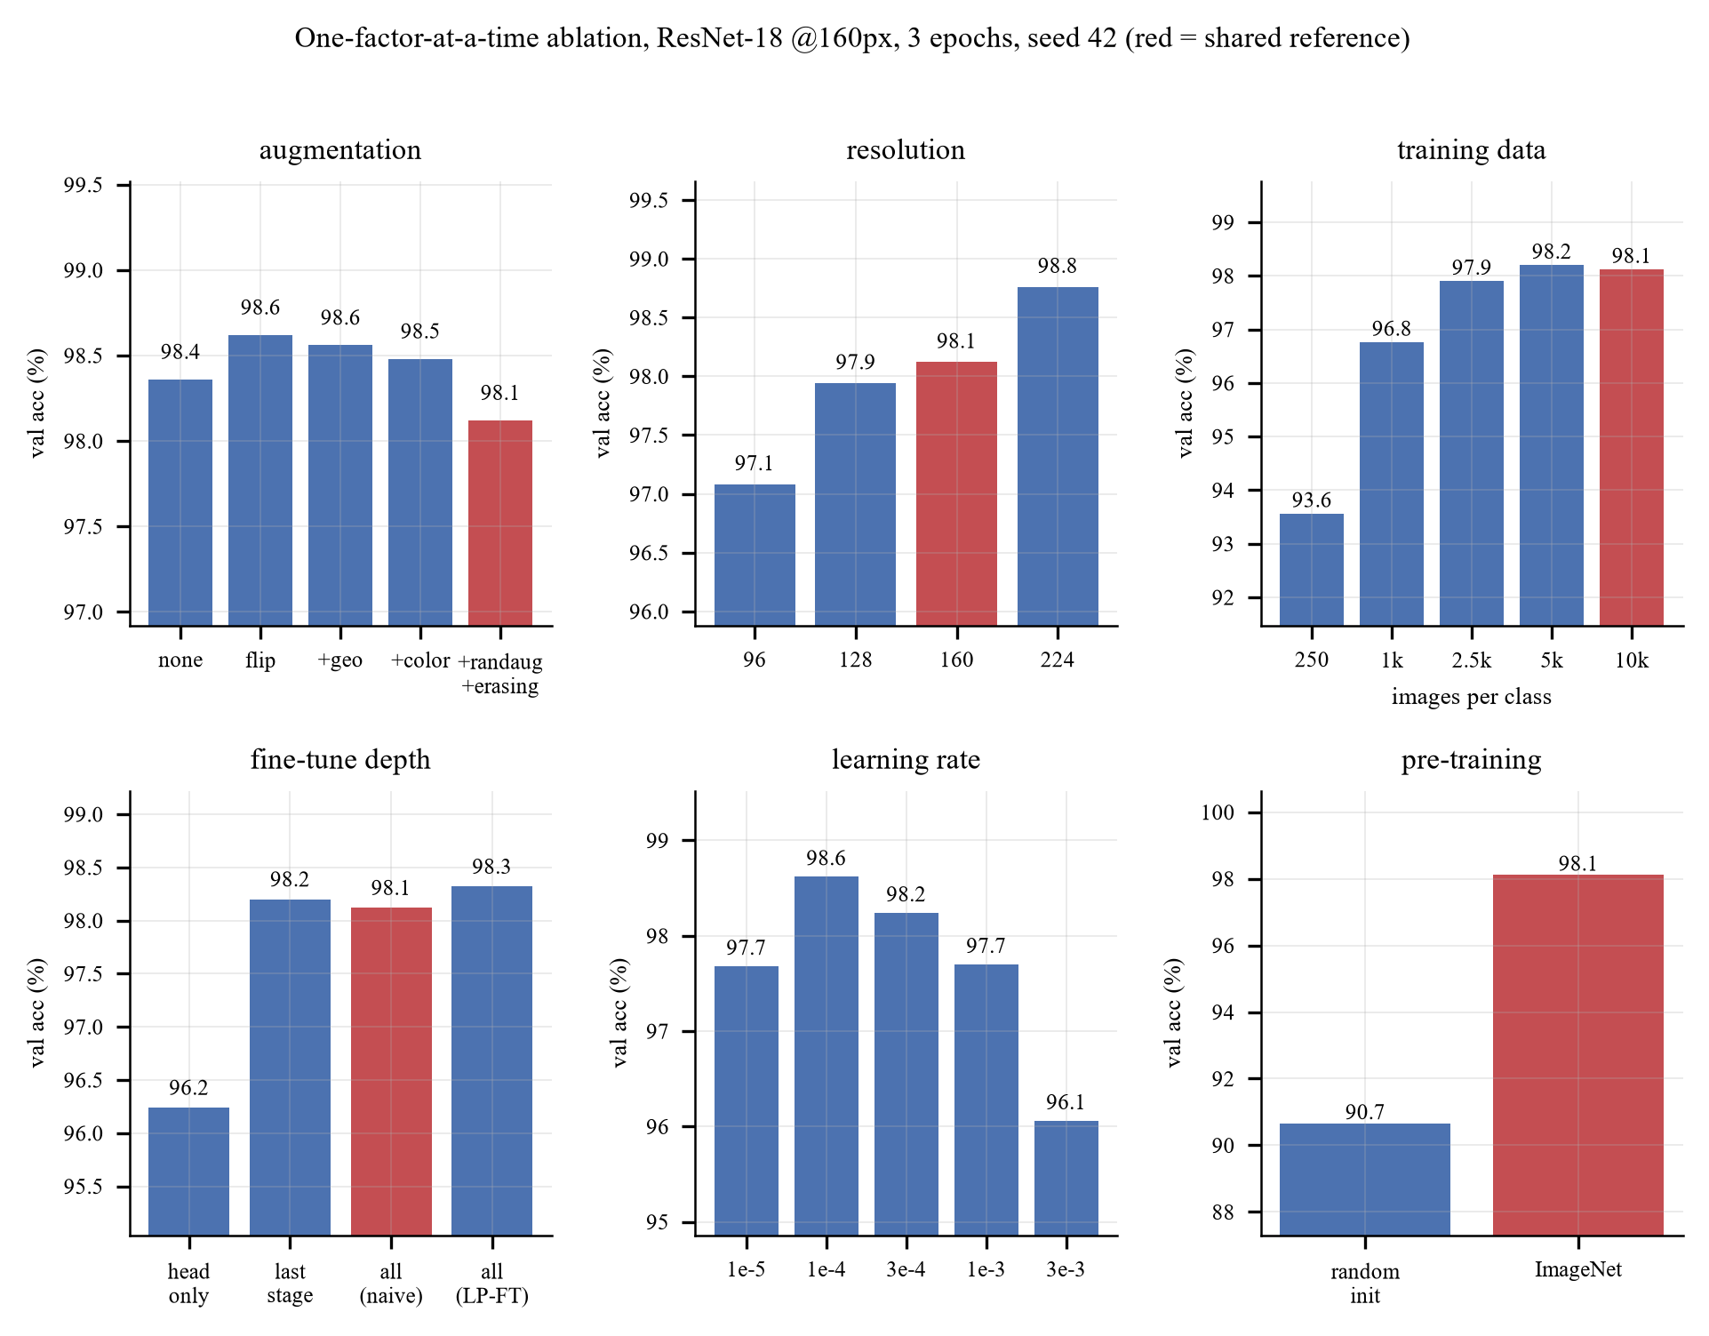
Figure 15. All six ablation panels at a glance; red bars are the shared reference run

7.8 Controlled backbone comparison
The ladder in Section 7.7 cannot separate architecture from budget, because each model received a different resolution, schedule and stopping epoch. To answer the architecture question properly, seven ImageNet-pretrained torchvision backbones were retrained under one fixed protocol, two seeds each (14 runs, one NVIDIA A40 per run, NTU EEE GPU cluster). The configurations (configs/dogs_cats/backbones/) differ only in the model name and in the batch size needed to fit memory; ViT-B/16 uses 32 × 2 gradient-accumulation steps so that the effective batch is 64 everywhere.
protocol: 224×224, RandomResizedCrop (scale 0.6–1.0) + horizontal flip, all layers trainable, AdamW (head lr 1e-3, backbone lr 1e-4, weight decay 0.05), cross-entropy with label smoothing 0.1, 1 warm-up epoch then cosine decay, 6 epochs, no early stopping, mixed precision, seeds 0 and 1.
Early stopping is disabled so that every backbone receives exactly the same budget, which removes the failure mode that made ResNet-34 an outlier in Section 7.7.
Backbone | Params (M) | ImageNet top-1 of the weights | Best val acc (%) | Last-epoch val acc (%) | s / epoch
ConvNeXt-T | 27.8 | 82.5 | 99.61 ± 0.01 | 99.61 ± 0.01 | 37.8
ResNet-50 | 23.5 | 80.9 (V2 weights) | 99.57 ± 0.01 | 99.53 ± 0.01 | 33.2
Swin-T | 27.5 | 81.5 | 99.56 ± 0.00 | 99.54 ± 0.03 | 48.3
ViT-B/16 | 85.8 | 81.1 | 99.28 ± 0.03 | 99.28 ± 0.03 | 65.2
ResNet-34 | 21.3 | 73.3 (V1 weights) | 99.28 ± 0.06 | 99.22 ± 0.03 | 25.4
ResNet-18 | 11.2 | 69.8 (V1 weights) | 99.25 ± 0.04 | 99.21 ± 0.01 | 24.1
EfficientNet-B0 | 4.0 | 77.7 | 99.24 ± 0.03 | 99.18 ± 0.03 | 27.1

Mean ± sample standard deviation over two seeds; on 5,000 validation images, 0.02 pp is one image. The ImageNet column is the top-1 accuracy torchvision reports for the exact checkpoint loaded. Time per epoch is the median of epochs 2–6 on one A40; the sec_per_epoch column of results/backbones.csv is instead the mean over all six epochs, including the slower first epoch, and is therefore larger.
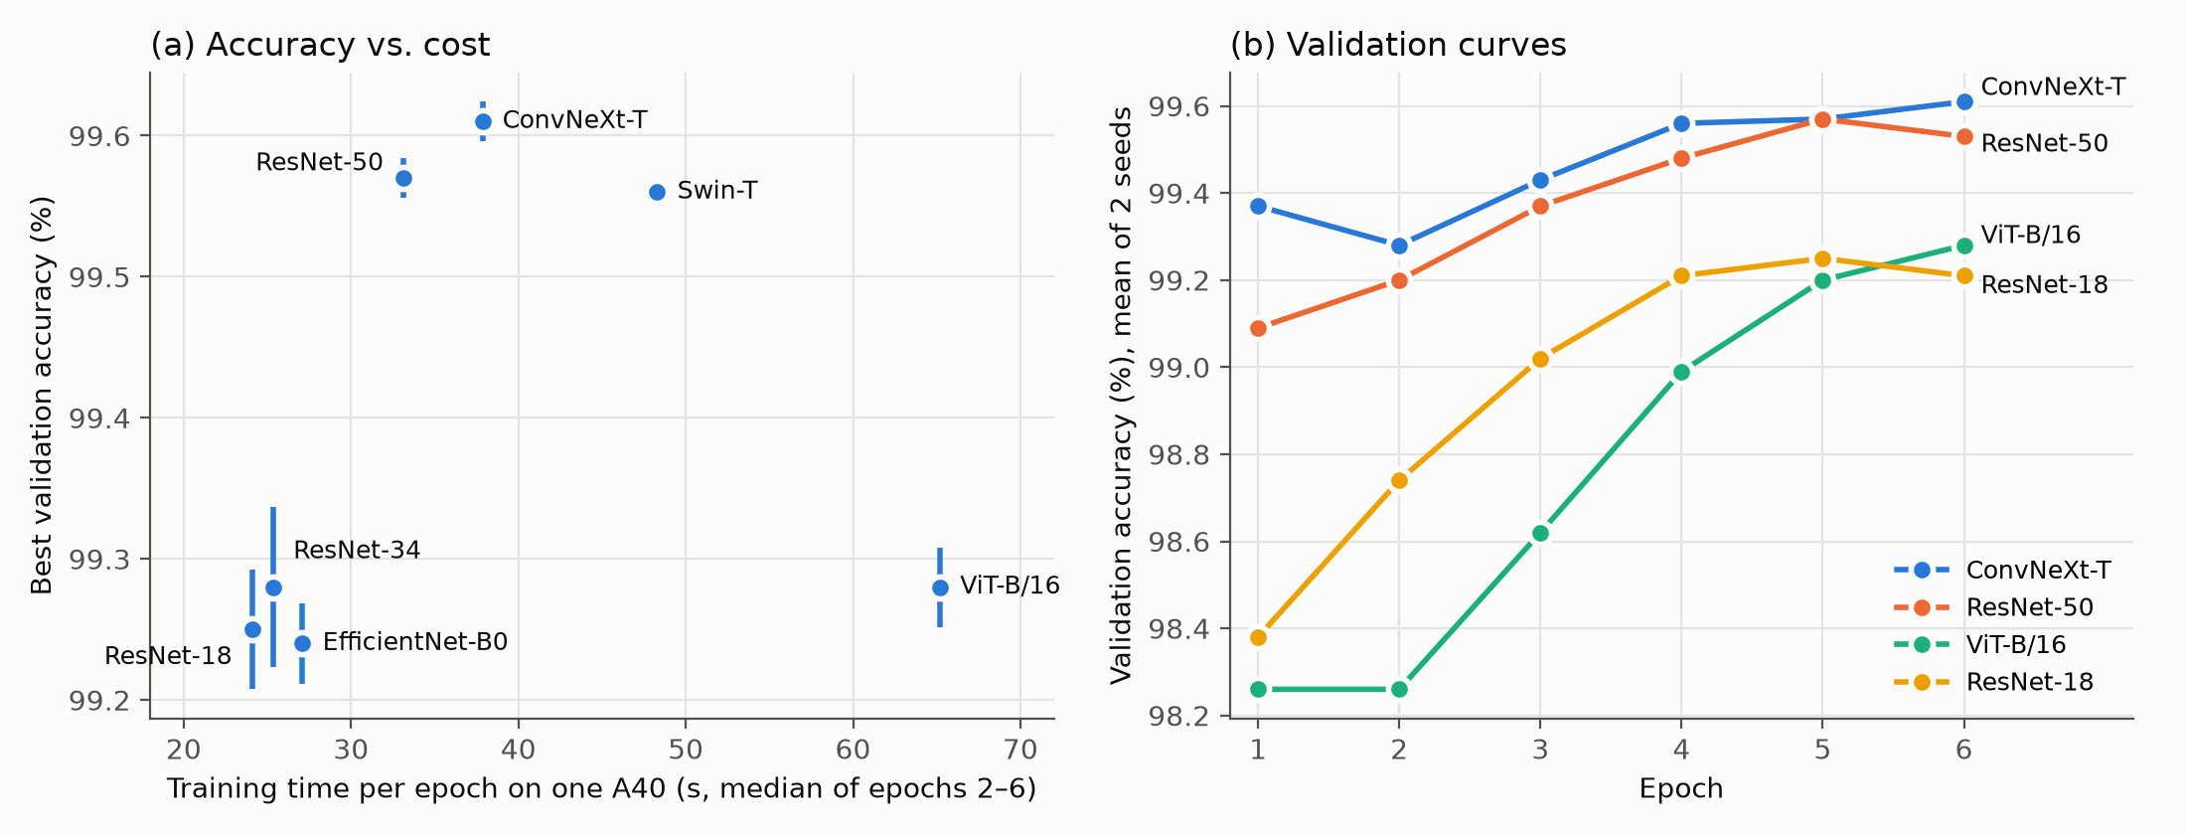
Figure 16. Backbone comparison under the fixed protocol. (a) Best validation accuracy against training time per epoch, bars ±1 std over two seeds. (b) Validation accuracy per epoch, mean of two seeds, for four representative backbones
Four results follow.
- Two tiers, separated by more than the noise. ConvNeXt-T, ResNet-50 and Swin-T reach 99.56–99.61%; the other four reach 99.24–99.28%. The gap of about 0.3 pp is roughly 15 validation images, while the seed-to-seed spread is at most 0.06 pp (3 images). The 10 validation images with near-duplicates in the training set (Section 2.2) could move any model by at most 0.20 pp, which is less than the smallest gap between the tiers (0.28 pp), so the split survives even that worst case. Differences within a tier are inside the noise and do not rank those models. With two seeds and a validation set that both selects the epoch and reports the result, the tiers are a well-supported observation rather than a statistically tested ranking.
- Accuracy tracks the quality of the pretrained weights, not model size. ViT-B/16 has three times the parameters of ConvNeXt-T and ties ResNet-34. The top tier consists of the three CNN-or-hierarchical backbones whose checkpoints score ≥ 80.9% on ImageNet and that converge within the budget; ViT-B/16, at 81.1%, is the exception that shows the checkpoint score alone is not decisive — it is still improving at epoch 6. Within the ResNet family, ResNet-18 to ResNet-34 adds depth and gains 0.03 pp (noise), whereas ResNet-34 to ResNet-50 gains 0.29 pp. The ResNet-50 checkpoint is torchvision's V2 weights, trained with a modern recipe, so this step confounds a deeper bottleneck architecture with a better pre-training recipe. This is the transfer pattern reported by Kornblith et al. [CVPR 2019] and is consistent with Section 7.2: the downstream task inherits most of its accuracy from the upstream representation.
- ViT-B/16 is under-trained at this budget rather than shown to be worse. Its curve starts lowest (98.26% after two epochs) and is still rising at epoch 6, while the convolutional and Swin models have flattened by epoch 4–5. A plain ViT lacks the locality bias of convolutions and of Swin's windowed attention, and is known to need longer fine-tuning. At a fixed 6-epoch budget it is the worst trade-off measured: 2.7× the time per epoch of ResNet-18 for the same accuracy.
- The conclusions do not depend on which epoch is reported. Best and last-epoch accuracies differ by at most 0.06 pp, and the two tiers are unchanged if the last epoch is used.
On cost, ResNet-50 is the cheapest top-tier backbone (33 s per epoch); ConvNeXt-T has the highest mean for 14% more time; Swin-T matches ResNet-50 at 45% more. EfficientNet-B0 has the fewest parameters but is no faster than ResNet-18 on a GPU, because its depthwise convolutions are memory-bound.
Two cautions apply when relating this table to the rest of the report. First, it was produced by a separate code base (src/, described in README.md) with a lighter augmentation policy, AdamW with a 10× lower backbone learning rate, label smoothing and no early stopping. Under this protocol ResNet-18 reaches 99.25 ± 0.04%, above the 98.93 ± 0.06% of the main model M3. The two recipes differ in several respects at once and the difference was not ablated, so it should not be attributed to any single setting. Second, only two seeds were run per backbone, and the same validation set selects the epoch and reports the result.

7.9 Ranked summary
The controlled comparisons are ranked below. Where possible each holds the budget fixed and changes one factor; two exceptions are stated in place: the pre-training comparison deliberately gives the from-scratch arm twice the epochs (Section 7.2, so its effect is a conservative estimate), and the data-quantity comparison changes the training set itself. The backbone rows come from the separate fixed-budget protocol of Section 7.8.
Rank | Factor | Effect on validation accuracy | Mechanism
1 | Pre-training (ImageNet weights vs random) | +7.46 pp (3 seeds: +7.67 ± 0.19) | transferred generic features
2 | Training data, 500 to 20,000 images | +4.56 pp (3 seeds: +3.23 ± 1.16) | sample coverage, saturating near 10,000
3 | Fine-tune depth (head only to last stage) | +1.96 pp (3 seeds: +1.89 ± 0.32) | adaptation of the last block
4 | Input resolution, 96 to 224 px | +0.64 pp on top of +1.04 from 96 to 160 (3 seeds: +0.44 and +1.31) | resolvable detail
5 | Augmentation, none to full | -0.24 pp (3 seeds: -0.21 ± 0.08) | below 0.5 pp with full data; sign depends on schedule
6 | Backbone, 7 ImageNet models at a fixed budget (Section 7.8) | +0.37 pp spread (99.24 to 99.61) | follows the ImageNet accuracy of the weights, not parameter count

One further comparison is not controlled and is therefore excluded from the ranking: moving from hand-crafted HOG features to a frozen deep representation (M0 to M2) is worth 23.93 points. It is the largest gap anywhere in the study, but it changes the features, the classifier and the training procedure at once, so it cannot be attributed to a single factor.
In summary, on this dataset the choice of initialisation and the quantity of training data dominate everything else. The depth of fine-tuning and the input resolution are second-order. Augmentation is within noise once the task is close to saturated. The choice of backbone is a real but small effect: under a fixed budget it spans 0.37 pp across seven models, about a twentieth of the pre-training effect, and it follows the quality of the pretrained weights rather than model size. This ordering is what determined the compute allocation of the main study: three seeds of one model, with the backbone sweep run separately on cluster GPUs.

8. Extension to CIFAR-10

8.1 The dataset and the classification problem
CIFAR-10 [Krizhevsky, TR 2009] consists of 60,000 colour images of 32×32 pixels in 10 mutually exclusive classes: airplane, automobile, bird, cat, deer, dog, frog, horse, ship, truck. The official split is 50,000 training and 10,000 test images, 6,000 per class overall, so the class distribution is exactly balanced and the majority-class baseline is 10%.
Compared with Dogs vs. Cats, four properties change the problem:
Property | Dogs vs. Cats | CIFAR-10 | Consequence
Classes | 2 | 10 | output layer 2 → 10; chance level 50% → 10%
Resolution | ~400×400 native, 224 used | 32×32 | the object occupies ~15×15 pixels; fine texture is gone, colour and silhouette dominate
Object scale | large, centred | small, often off-centre | global pooling still works, but the stem must not over-downsample
Intra-class structure | breeds within one species | 10 unrelated categories | errors concentrate between semantically similar pairs (cat↔dog, deer↔horse, automobile↔truck)
Training size | 20,000 | 50,000 | from-scratch training becomes viable

The last point matters: on 20,000 images a from-scratch CNN underfits badly, whereas 50,000 images of 32×32 are enough for a small ResNet to reach the low 90s. CIFAR-10 is therefore the right test of whether our pipeline generalises, and it exposes exactly the design decisions that were previously hidden by pre-training.
The 10,000-image official test set is used once, at the end of each run, on the checkpoint that validation accuracy selected. It plays no part in model selection, early stopping or hyper-parameter choice, so the test numbers reported in Section 8.4 are not the result of tuning against them.

8.2 What has to change in the code
Component | Dogs vs. Cats | CIFAR-10 | Why
Output head | Linear(512→2) | Linear(512→10) | 10 classes
Stem | 7×7 conv, stride 2, then 3×3 max-pool, stride 2 | 3×3 conv, stride 1, no max-pool | see below
Input | 224×224 (Resize 256 → CenterCrop) | 32×32 native, or 32→160 upsampled for the pre-trained model | native resolution for scratch training
Augmentation | RRC(0.5–1.0) + flip + rotation + jitter + RandAugment + erasing | RandomCrop(32, pad=4) + flip + RandAugment(m=9) + erasing | no room for scale jitter at 32 px; padding-crop is the CIFAR standard
Normalisation | ImageNet mean/std | ImageNet mean/std (same) | shared code path, no measurable difference
Validation split | provided (5,000) | carved out of the 50,000: 45,000 / 5,000, stratified | CIFAR-10 has no official validation set; using the test set for early stopping would leak
Schedule | 8 epochs | 25 epochs (scratch) / 7 epochs (fine-tune) | small images need many more passes
Metrics | accuracy, macro-F1, AUC | accuracy, macro-F1, per-class recall, 10×10 confusion matrix | per-class behaviour is the interesting part

Why the stem is the critical change
The ImageNet stem applies a 7×7 convolution with stride 2 followed by a 3×3 max-pool with stride 2, i.e. an overall downsampling factor of 4 before the first residual stage. On a 224×224 ImageNet image this leaves 56×56: sensible. On a 32×32 CIFAR image it leaves 8×8, at which point each spatial location covers a 4×4 pixel patch of the original image; the first residual stage then operates on an almost-degenerate feature map, and after layer4 the representation collapses to 1×1. The network is effectively forced to make its decisions from a handful of coarse cells.
Replacing the stem with a single 3×3 stride-1 convolution and removing the max-pool keeps the feature map at 32×32 after conv1, so the four stages produce 32 → 32 → 16 → 8 → 4. This is the standard "CIFAR ResNet" modification and it is worth roughly 3–5 accuracy points at this dataset size: a much larger effect than any hyper-parameter in Section 4.
ee6483/src/models/backbones.py::build_cifar_resnet implements exactly this and is used by G1 and by all Section 9 experiments.

8.3 Two models
G1: CIFAR-ResNet-18 trained from scratch. 11.2M parameters, 3×3 stride-1 stem, SGD (lr 0.1, momentum 0.9, Nesterov, wd 5e-4), cosine schedule with 5% warm-up, batch 128, 25 epochs, standard CIFAR augmentation. No pre-training of any kind.
G2: ImageNet ResNet-18, upsampled inputs. The 32×32 images are resized to 160×160 with bilinear interpolation (torchvision's default for Resize) before entering the standard ImageNet stem, the head is replaced by Linear(512→10), and the network is fine-tuned for 7 epochs with SGD (lr 0.01, momentum 0.9 with Nesterov, weight decay 5e-4), a cosine schedule with a 5% warm-up, batch 128, and the loader default augmentation (aug=full) applied at the 160 px input — concretely Resize(160) + RandomCrop(160, padding 20) + horizontal flip + RandomErasing, with no RandAugment in this configuration — seed 42.
The two configurations side by side:
 | G1: from scratch | G2: ImageNet-pretrained
Backbone | CIFAR ResNet-18 (3×3 stride-1 stem, no max-pool) | ImageNet ResNet-18 (standard stem)
Input | 32 × 32 | upsampled to 160 × 160 (bilinear)
Augmentation | RandomCrop(32, pad 4) + hflip + RandAugment + RandomErasing | Resize(160) + RandomCrop(160, pad 20) + hflip + RandomErasing (no RandAugment)
Optimiser | SGD, lr 0.1, momentum 0.9 (Nesterov), wd 5e-4 | SGD, lr 0.01, momentum 0.9 (Nesterov), wd 5e-4
Schedule | cosine, 5% warm-up, 25 epochs | cosine, 5% warm-up, 7 epochs
Batch | 128 | 128
Normalisation | ImageNet mean/std | ImageNet mean/std
Strategy | from scratch | fine-tuning

G1 and G2 are two complete recipes, not a controlled pair: besides the initialisation they differ in the stem (3×3 stride 1 vs 7×7 stride 2 plus max-pool), the input resolution (32 vs 160 px), the number of epochs (25 vs 7) and the learning rate. The gap between them therefore measures "ImageNet transfer as it is normally done" against "a standard from-scratch CIFAR recipe", and cannot be attributed to pre-training alone.

8.4 Results
Model | Init | Epochs | Val acc | Test acc | Test macro-F1 | Train time
G1 CIFAR-ResNet-18 | random | 25 | 93.44% | 93.60% | 93.60% | 26 min
G2 ResNet-18 @160 | ImageNet | 7 | 95.58% | 95.20% | 95.19% | 10 min

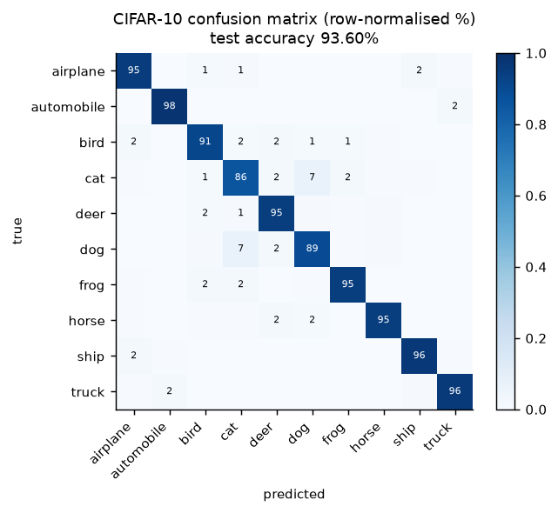
Figure 17. CIFAR-10 confusion matrix
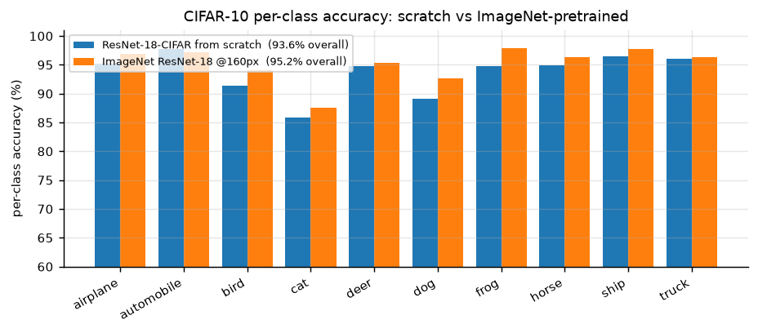
Figure 18. Per-class accuracy

Reading the results
1. From-scratch training is competitive here. G1 reaches 93.60% test accuracy in 25 epochs without any pre-training; the ImageNet-pretrained G2 reaches 95.20% in 7 epochs. The gap between the two recipes is only ~1.6 points, much smaller than the 7.5-point pre-training gap measured on cats vs. dogs at a short budget (Section 7.2). Because the two models use different input resolutions, stems, training schedules and optimisation settings, the observed difference is a comparison between two complete training pipelines rather than an isolated measurement of the effect of pre-training.
2. That is exactly what the learning curve in Section 7.3 predicts. Pre-training substitutes for data: it is worth most when the dataset is small (a pre-trained model on 500 cat/dog images reaches 95.1 ± 1.3%, beating a from-scratch model trained on 20,000 images at 90.6 ± 0.1%) and worth least when the dataset is large. CIFAR-10 has 45,000 training images of 32x32: small images are cheap to learn from, and the dataset is 2.25x larger than our cat/dog training set. The pre-training advantage shrinks accordingly. This cross-dataset consistency is stronger evidence than either experiment alone.
3. ImageNet pre-training is partly off-target here. ImageNet-1k has no one-to-one correspondence with the CIFAR-10 labels: the ten categories are split into fine-grained classes (many dog breeds, several cat, frog, ship and truck types, an airliner class); some categories have multiple fine-grained counterparts while others, such as deer, overlap only partially with ImageNet's labels. What transfers is the generic low/mid-level feature hierarchy, not a category prior: which is why the gain is real but modest.
4. The confusion structure is semantic, and it is the same structure we saw in Section 6. The single dominant off-diagonal pair is cat-dog (69 errors in each direction), i.e. exactly the confusion that dominated the Dogs vs Cats task: the same two classes are the hardest pair in both problems, which is a satisfying cross-task consistency check. The second tier is animal-shape confusion (cat→deer 22, frog→cat 21, bird→deer 18) plus a blue-background cluster (ship→airplane 20, airplane→ship 18, bird→airplane 18). The last group is informative: at 32x32 the vehicle classes are small objects on a sky/sea background, and the model does use that background as evidence: the shortcut we worried about in Section 1 is measurable here, just not for the animal classes.
5. Per-class accuracy tracks class difficulty, not class frequency (all classes are equally frequent here): automobile, ship and truck are easiest (96-98%), while cat, dog and bird are hardest (86-91%). That ordering is driven by within-class variability and object size, and it changes completely in Section 9, where frequency is manipulated instead: which is exactly the point of Section 9.

What this tells us about the original problem
The CIFAR-10 experiment is a stress test of the claim made in Section 1: the binding constraint on this project is data and transfer, not architecture. Moving from 2 classes/224 px to 10 classes/32 px changes the output layer, the stem, the augmentation, the optimiser and the schedule: and the same recipe still works, with the same qualitative behaviour (pre-trained beats scratch, and the gap shrinks as data grows). The pipeline, not the specific model, is what generalises.
The one result that does not carry over is the size of the pre-training advantage, and that difference is itself informative: it is the same phenomenon (transfer substitutes for data) observed at two different points on the data axis.

9. Class Imbalance

9.1 The problem
In Section 8 every class had 5,000 training images. Real datasets rarely look like that: a few "head" classes dominate the sample count while a long tail of "tail" classes has a handful of examples each. Training a softmax classifier on such data with plain cross-entropy fails in a specific, predictable way: the classifier's weights drift towards the head classes, the decision boundary is pushed into the tail, and overall accuracy stays high because predicting the head classes is usually right. Overall accuracy is therefore the wrong metric, a point returned to in Section 9.4.
The imbalance has two separable causes, which is what makes the remedies interesting:
1. Representation bias: the feature extractor sees few tail samples and learns a weaker representation for them.
2. Classifier bias: even with a perfectly balanced representation, the softmax logits are systematically larger for frequent classes because the loss is dominated by them.
Kang et al. [ICLR 2020] show that (2) dominates: if you freeze a representation trained on long-tailed data and only re-train the classifier with class-balanced sampling, you recover most of the gap. That finding is the basis of the decoupling method we test.

9.2 Constructing the imbalanced dataset
We use CIFAR-10 with an exponential long-tailed training distribution (the "CIFAR-10-LT" protocol):
n_i = min(4,500, ⌊5,000 · 100^(−i/9)⌋), for i = 0, …, 9. The nominal ratio is 100:1; the realised ratio is 90:1 because the training split retains only 4,500 images per class after the validation carve-out, which clips class 0.
which gives the per-class counts below. Only the training set is subsampled; validation and test keep the original balanced distribution, because the goal is to classify well on a balanced test set, not to reproduce the training prior.
class | 0 airplane | 1 automobile | 2 bird | 3 cat | 4 deer | 5 dog | 6 frog | 7 horse | 8 ship | 9 truck
images | 4,500 | 2,997 | 1,797 | 1,077 | 646 | 387 | 232 | 139 | 83 | 50

Total training images: 11,908 (down from 45,000), imbalance ratio 4,500:50 = 90:1. The counts follow n_i = n_max x rho^(-i/9) with rho = 100 and n_max = 5,000, then clipped to the 4,500 images that remain per class after the 45,000/5,000 train/validation split; class 0 is the only one affected, which is why the realised ratio is 4,500:50 = 90:1 rather than the nominal 100:1.
The validation split (5,000, stratified) and the 10,000-image test set are untouched and balanced.

9.3 Five methods
Five methods are implemented so that the comparison spans the three families in the literature: data-level, loss-level and post-hoc.
The classifier is the CIFAR-ResNet-18 of Section 8 (model G1), retrained from scratch on the long-tailed training set. The architecture is the same for every method; what changes is the loss, the sampling procedure or the decision rule. One exception should be kept in mind when reading the results: the class-balanced loss row uses a longer, 30-epoch run (Appendix A.1), so it differs from the others in schedule as well as in loss, and is not a strictly one-variable comparison. The 18-epoch CB run is reported alongside it.
The five methods were chosen to cover one representative from each family that attacks a different source of class bias — data-level (re-sampling), loss-level (class-balanced loss), classifier-level (decoupling/cRT) and post-hoc correction (logit adjustment) — against the CE baseline, under a limited computational budget. LDAM-DRW and focal loss are discussed as relevant alternatives (Section 1.2, Section 9.3.3) but were not implemented; macro-F1 and per-class recall are the metrics because overall accuracy hides tail-class failure at 90:1.

9.3.1 Cross-entropy baseline (CE)
Standard softmax cross-entropy, no correction. This is the control: whatever the imbalance costs, it costs here.

9.3.2 Re-sampling (data-level)
Draw each mini-batch with per-sample probability
p_j ∝ 1/n_c(j)
so that every batch is approximately class-balanced (WeightedRandomSampler, replacement=True). Tail images are therefore repeated many times per epoch.
Why it should work: it removes the classifier bias directly: the empirical label distribution seen by the loss becomes uniform.
Known risk: the sampler draws about 11,908 / 10 ≈ 1,190 images per class per epoch, so each of the 50 truck images is seen about 24 times per epoch (against roughly 0.26 times for an airplane image); the tail classes therefore overfit, and this must be paired with strong augmentation. Our augmentation includes RandomCrop+flip+RandAugment+RandomErasing, which mitigates but does not eliminate it.

9.3.3 Class-balanced loss (loss-level)
Cui et al. [CVPR 2019] replace inverse frequency with the effective number of samples. With E_n = (1-β^n)/(1-β) and β=0.9999:
w_c ∝ 1/E_n_c, ℒ = -Σ_c w_c y_c log p_c
The intuition: as n grows, additional samples add progressively less new information, so the "effective" size saturates and the weights should not diverge like 1/n. With β → 1 this recovers inverse-frequency weighting; with β → 0 it recovers plain CE. Normalising the weights to mean 1 only makes their overall scale irrelevant — a global rescaling of the weights cancels in the weighted mean — so the learning rate stays comparable across settings; it does not make the per-batch gradient norm equal to that of plain cross-entropy, which still depends on the class composition of each batch.
Why it should work: it re-balances the loss without changing the data distribution, so no sample is repeated and there is no extra overfitting risk.
Known risk: at a 90:1 ratio and β=0.9999 the weights are far from mild: E_4500≈ 3624 against E_50≈ 49.9, so a truck sample weighs about 73 times as much as an airplane sample. Under PyTorch's weighted reduction='mean' the batch-wise normalisation changes the relative contribution of individual samples rather than applying a simple global scaling: the gradient direction and magnitude can vary with batch composition, and under a 90:1 weighting they swing sharply between head-dominated and tail-dominated batches, which can make optimisation less stable and slows the fitting of the head classes within a fixed epoch budget.
The other prominent member of this loss-level family is LDAM-DRW [Cao et al., NeurIPS 2019], which instead of re-weighting enforces a class-dependent margin Δ_c ∝ n_c^-1/4 with deferred re-weighting; it targets the same failure mode (Section 9.5 compares our numbers with published LDAM-DRW results and why they are not directly comparable). Of this family we implement the re-weighting variant only.

9.3.4 Decoupling / cRT (two-stage)
Kang et al. [ICLR 2020]: train normally for about 80% of the schedule, then freeze the backbone, re-initialise the classifier, and re-train only the classifier with class-balanced sampling for the rest. In our 18-epoch run the first stage is epochs 1–14 (identical to the CE baseline) and the classifier is re-trained in epochs 15–18.
Why it should work: it follows the causal analysis of Section 9.1. the representation is nearly unbiased, the classifier is the biased part, so fix only the classifier and do not disturb the features.
Implementation note: the head is re-initialised (Kaiming) rather than merely re-tuned, because the existing head has already absorbed the prior; and the second stage uses a 10× smaller learning rate with a short cosine decay.

9.3.5 Logit adjustment (post-hoc)
Menon et al. [ICLR 2021]. Train with plain CE, then at inference shift the logits by the log-prior:
ŷ = argmax_c [f_c(x) - τ log π_c], π_c = n_c/Σ_j n_j
Subtracting τ log π_c raises the scores of rare classes (small π_c) relative to frequent ones. The strength τ is chosen on the validation split from {0, 0.25, 0.5, 0.75, 1.0, 1.5} and then applied once to the test set (ee6483/scripts/eval_logit_adjust.py).
Why it should work: under a multinomial-logit model this is the Bayes-optimal correction for the balanced error rate, and it costs nothing at training time: no retraining, only a one-dimensional sweep over τ on cached validation logits.
Known risk: it assumes the training prior is the only source of bias; if the representation itself is skewed, the correction is incomplete.

9.4 Results
Method | Family | Epochs | Overall acc: seed 42 (3-seed mean ± std) | Macro-F1: seed 42 (3-seed mean ± std) | many (cls 0-2), seed 42 | few (cls 6-9), seed 42
CE (baseline) | – | 18 | 62.44% (62.18 ± 0.62) | 60.27% (59.72 ± 1.46) | 90.3% | 39.5%
Re-sampling | data | 18 | 72.02% (72.03 ± 0.05) | 72.00% (71.99 ± 0.03) | 85.8% | 64.5%
Class-balanced loss | loss | 30 | 59.50% (61.75 ± 2.05) | 59.48% (61.73 ± 2.11) | 66.8% | 63.1%
Decoupling (cRT) | two-stage | 18 | 71.22% (70.99 ± 0.20) | 71.14% (70.89 ± 0.23) | 79.6% | 71.0%
Logit adjustment (tau=1.0) | post-hoc | 18 (no extra training) | 72.99% (72.93 ± 0.18) | 72.96% (72.93 ± 0.17) | 81.4% | 72.0%

The class-balanced row runs its own longer schedule (30 epochs) and is still under-trained at that point (training accuracy 59.95%), so it is not directly comparable with the 18-epoch rows.
Three-seed check. Every method was repeated with seeds 43 and 44 (identical recipe; the long-tailed subset is redrawn for each seed), and the table gives the three-seed mean ± sample standard deviation in brackets. The ordering is the same in every seed: logit adjustment (72.93 ± 0.18%) > re-sampling (72.03 ± 0.05%) > decoupling (70.99 ± 0.20%) >> CE (62.18 ± 0.62%) ≈ class-balanced loss (61.75 ± 2.05%). Logit adjustment leads re-sampling by 0.97, 1.09 and 0.65 points in the three seeds, and τ = 1.0 is selected on validation every time. Two caveats apply. First, seeds 43 and 44 were trained on an A40 GPU on the faculty cluster (cluster/seeds_*.sbatch), seed 42 on the RTX 3070 Ti Laptop. Second, the learning rate of the original 30-epoch class-balanced run was not recorded (Appendix A.1), and seeds 43 and 44 use the default, so that row's spread also includes this difference. The per-class columns are seed 42.
Balanced accuracy in this table is macro-averaged recall on the balanced test set — one minus the balanced error rate, the quantity logit adjustment is designed to optimise — and because the test set is balanced it coincides with overall accuracy.
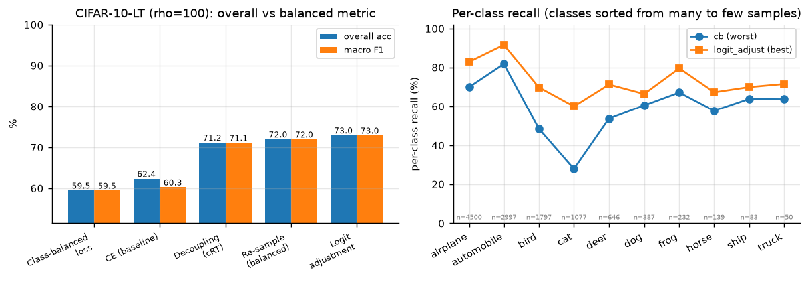
Figure 19. Imbalance comparison
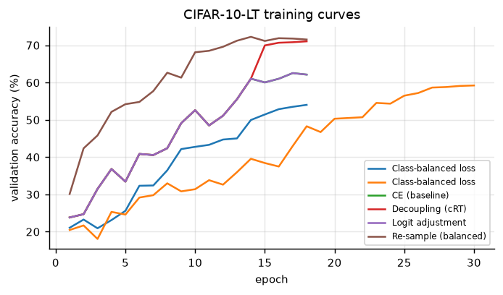
Figure 20. CIFAR-10-LT validation curves per method

The pathology, stated numerically
Plain cross-entropy shows the textbook signature of long-tail training. Per-class recall on the balanced test set:
 | airplane | automobile | bird | cat | deer | dog | frog | horse | ship | truck
samples seen | 4,500 | 2,997 | 1,797 | 1,077 | 646 | 387 | 232 | 139 | 83 | 50
CE recall (%) | 94 | 98 | 78 | 72 | 71 | 53 | 63 | 49 | 24 | 22
logit adj. recall (%) | 83 | 92 | 70 | 60 | 71 | 66 | 80 | 67 | 70 | 72

The two rarest classes collapse to 22-24% recall, barely above the 10% chance level, while the two most frequent classes reach 94-98%. The overall accuracy (62.4%) looks respectable and completely hides this. This is why every table in this section reports macro-F1 and per-class recall, not just accuracy.

What each method does
1. Logit adjustment is the winner, and it requires no retraining. Applying argmax f_c(x) - tau·log(pi_c) to the already trained CE model raises test accuracy from 62.44% to 72.99% (+10.6 pp) and macro-F1 from 60.27% to 72.96%. The tau selected on the validation split from the six-value grid is 1.0, which coincides with the value the theory gives for a multinomial-logit model. Because the grid is coarse this is a consistency check rather than a confirmation, but it agrees with the mechanism the paper describes (a prior shift in the logits).
2. Re-sampling works but trades head for tail. +9.6 pp overall; head-class recall drops from 90.3% to 85.8% while the tail rises from 39.5% to 64.5%. This is the expected behaviour: repeating tail samples makes the effective training distribution uniform.
3. Decoupling works for the reason Kang et al. give. The training log shows it directly: epochs 1–14 are identical to the CE baseline and end at 61.0% validation accuracy; the backbone is then frozen and the head re-initialised, and after one epoch of class-balanced head re-training (epoch 15) validation accuracy is 70.0%. With the representation fixed, re-training only the classifier gained 8.9 points in one epoch, which is the pattern expected if the classifier, not the representation, carries most of the bias. Final test accuracy 71.22%. Table entries are rounded to one decimal, so the many/few averages quoted above can differ from recomputation on the rounded per-class recalls by up to 0.3 points.
4. Class-balanced loss gives no gain at this schedule. It reaches 59.50% at seed 42, below plain CE, and 61.75 ± 2.05% over three seeds, level with CE (62.18 ± 0.62%). The training curves explain why: at epoch 30 the training accuracy is still 59.95%, i.e. the model is severely under-trained. Two causes, both specific to our setup: (i) with reduction='mean' over weighted samples, the batch-wise normalisation cancels the overall scale of the weights but lets their relative values reshape how much each sample contributes; under a 90:1 weighting the gradient direction and magnitude vary strongly with batch composition, which destabilises optimisation and slows the fitting of the head classes; (ii) the 30-epoch budget is far shorter than the 200+ epochs used in the original paper, and the training curve confirms the run is still far from convergence. Note that CB does re-balance: its few-class recall (63.1%) beats CE (39.5%): but it destroys the head (66.8% vs 90.3%) and never recovers overall accuracy. A shorter 18-epoch run (54.04%) shows the same pattern more strongly.

Practical recommendation
Ordered by benefit per unit of effort:
1. Logit adjustment: one line at inference time, no retraining, +10.6 pp. In this setting it is the cheapest first step to try.
2. Decoupling (cRT): one extra short training stage, +8.8 pp, and it is the most interpretable fix because it isolates the classifier as the biased component.
3. Re-sampling: trivial to implement, +9.6 pp, but it overfits the tail and needs strong augmentation to be safe.
4. Class-balanced loss: theoretically appealing, but in our hands it needs a much longer schedule to pay off; at 30 epochs it gives no gain over plain CE.
The ranking is not the same as the ranking in the literature (where CB loss is standard), and the reason is the budget: methods that change the loss scale need time to converge, whereas methods that change only the decision rule are budget-free. That is a genuinely useful lesson for a project-sized experiment.

9.5 Honest limitations
- One imbalance ratio (rho=100), three seeds per method. The long-tail literature sweeps rho in {10, 50, 100, 200} and averages over 3-5 seeds. The three-seed check in Section 9.4 shows a stable ordering: logit adjustment > re-sampling > decoupling >> CE ≈ class-balanced loss in every seed. None of the ranking has been tested at other imbalance ratios.
- The whole study sits in an under-trained regime. Even the best method reaches 72.99%, whereas the CIFAR-10-LT literature reports ~77% for LDAM-DRW at rho=100 with 200-epoch schedules. Our comparison is internally consistent (four methods share one schedule and the class-balanced loss was given a longer one, as noted above), but the absolute numbers should not be compared with published ones.
- The backbone is trained from scratch. With an ImageNet-pretrained backbone the imbalance gap shrinks substantially, because the representation is already good: an interesting follow-up we did not have the budget for.

10. Conclusion

10.1 What we did
We built and evaluated a complete cat/dog classification pipeline: a dataset audit (20,000 / 5,000 / 500 images, no corrupt files, 12 near-duplicate pairs crossing the train/validation split), a cached preprocessing and augmentation pipeline, a ladder of six classifiers from hand-crafted HOG features to a fine-tuned ResNet-50, a controlled one-factor-at-a-time ablation of six factors over 25 runs, a fixed-budget comparison of seven ImageNet backbones over 14 runs whose top tier forms the submitted ensemble (99.70% validation accuracy), an error analysis over all 50 validation errors with Grad-CAM and a corruption test, a transfer of the same code base to CIFAR-10, and a five-method study of class imbalance on a long-tailed CIFAR-10 variant.

10.2 What we found
1. The task is close to saturated, and transfer learning is what saturates it. The main model reaches 98.93 ± 0.06% validation accuracy over 3 seeds in eight minutes per run. In the controlled ablation of Section 7.2 — where both arms share architecture, data, augmentation, resolution and optimiser but not the training duration — the ImageNet-pretrained model reaches 98.12% (3 epochs, 160 px) against 90.66% for the from-scratch model (6 epochs), a 7.46-point difference obtained even though the from-scratch arm trained twice as long, and therefore a conservative estimate of the pre-training effect. The gap from the main model to hand-crafted features is 23.93 points. Two qualifications apply: a 1.17M-parameter CNN trained from scratch still reaches 95.06%, so the task is easier than the 99% headline suggests; and within the fine-tuned model almost all of the performance already sits in the frozen representation (a linear probe reaches 96.24% at the ablation budget and 97.78% when trained longer), not in the classifier on top of it.
2. The ranking of factors is stable and counter-intuitive. Data and pre-training dominate; architecture and resolution are second-order; most hyper-parameters are third-order. In the single-run ladder ResNet-34 fell 1.39 points below ResNet-18, but under a fixed budget the two are indistinguishable, and seven backbones span only 0.37 points (99.24% to 99.61%), ordered by the ImageNet accuracy of their weights rather than by size, with the under-trained ViT-B/16 as the exception. 224 px does not beat 160 px by enough to justify twice the compute. This is the practical content of question (f).
3. The residual errors are not about semantics. Two thirds of the 50 validation errors are images where the animal's face is hidden or the animal is behind a fence or in a hand. The model knows what a cat is; it fails when the presentation differs from the training distribution. That is a data-coverage and augmentation problem, and it is where further work would pay off.
4. The reference model is sensitive to heavy blur (−12.7 pp), while the tested small central mask and brightness changes cause smaller drops. Grad-CAM highlights the head in the inspected correct examples. These observations suggest useful follow-up experiments, but do not isolate texture from shape cues or prove a causal benefit from RandomErasing.
5. The pipeline generalises. Moving to CIFAR-10 (10 classes, 32×32) required changing the stem, the head, the augmentation and the optimiser: and the same conclusion emerged: pre-training beats scratch (95.20% vs 93.60% test accuracy). The pipeline, not the specific model, is the reusable asset.
6. Imbalance is fixable cheaply. On CIFAR-10-LT (ρ=100) the best of five methods lifts test accuracy from 62.44% to 72.99% and macro-F1 from 60.27% to 72.96%, with most of the gain on the rarest classes; post-hoc logit adjustment achieves much of this with no retraining at all.

10.3 Limitations
- Validation accuracy is subject to selection optimism because it was used for early stopping, configuration comparison and backbone selection. Its magnitude has not been estimated; an independent labelled holdout or nested evaluation would be needed to assess it.
- The test set is unlabelled, so we cannot report test accuracy. Every claim about test images in Section 6 is a manual visual judgement and is labelled as such.
- Three seeds per configuration. Every ablation and class-imbalance configuration has three seeds (42, 43, 44); the CIFAR-10 transfer runs (G1, G2) have one. Three seeds give a usable spread estimate but not a formal significance test. The ablation spreads (0.02–0.6 pp, 1.3 pp for the 500-image subset) are mostly larger than the main model's 0.06 pp, so the main model's spread cannot be used as a universal significance threshold. Seed 42 was trained on the RTX 3070 Ti Laptop and seeds 43 and 44 on an A40, so the spread also includes the change of hardware. Small differences require repeated runs before a stable ranking can be claimed.
- The ablation uses a 3-epoch budget, which understates the value of regularisation (augmentation, label smoothing) relative to an 8-epoch budget.
- Imbalance study is single-ratio. ρ=100 only, three seeds per method (Section 9.4). The ordering of methods is stable across seeds; the magnitudes are specific to this under-trained regime.
- The backbone sweep (Section 7.8) uses two seeds per model and a single 6-epoch recipe tuned for CNN fine-tuning, which may disadvantage ViT-B/16; it was run with a separate code base, so its numbers are not directly comparable with the main model's.

10.4 What we would do with more compute
1. Study augmentation policies under matched budgets and repeated seeds, including robustness comparisons with and without RandomErasing. Section 7 reports gains below one point at the tested budgets; Section 6.6 does not establish which augmentation component causes the observed occlusion robustness.
2. Train the CIFAR-10 from-scratch model for 200 epochs with cutout/AutoAugment, which is what the published 94–95% figures use, so that the pre-training gap is measured against a properly converged control.
3. Fine-tune ViT-B/16 for longer than 6 epochs: Section 7.8 shows it still improving at the end of the fixed budget, so its ceiling on this task is not yet measured. The same sweep confirmed the prediction made for ConvNeXt-T, a gain below 0.5 pp (0.36 pp over ResNet-18).
4. Calibrate and add an open-set rejection head (temperature scaling plus a max-softmax threshold) so that the "no photo available" and animal-free images are rejected instead of being confidently misclassified.
5. Exploit additional unlabelled data (not the test set, which must stay untouched) with a semi-supervised method such as FixMatch [Sohn et al., NeurIPS 2020]. Applying it to the test images would violate the evaluation protocol and should not be done.

10.5 Concluding remarks
On a small, well-curated binary problem, the pre-trained representation and the quantity of data account for most of the achievable accuracy, while architecture and hyper-parameters account for little. The residual errors are dominated by how the data was collected, in particular viewpoint, occlusion and label noise, rather than by how the model was built. Methodologically, fixing the seed, averaging over seeds, validating the submission file against the sample and inspecting all of the errors changed our conclusions more than any change to the model did.

10.6 Reproducing the numbers
# Sections 2-9 (ee6483/): Python 3.13, torch 2.6.0+cu124, torchvision 0.21.0, RTX 3070 Ti Laptop (8 GB)
python -m ee6483.src.data.check_data --root ../datasets/datasets # -> results/data_report.json
python -m ee6483.src.data.cache_images --src ../datasets/datasets --dst data/cache --short 256
mkdir -p data/cifar
curl -fL -o data/cifar/train.parquet https://huggingface.co/datasets/uoft-cs/cifar10/resolve/main/plain_text/train-00000-of-00001.parquet
curl -fL -o data/cifar/test.parquet https://huggingface.co/datasets/uoft-cs/cifar10/resolve/main/plain_text/test-00000-of-00001.parquet
python -m ee6483.scripts.run_experiments --phases main compare ablation augcheck lrsearch extra cifar imbalance
python -m ee6483.scripts.aggregate # -> results/summary.{csv,md}
python -m ee6483.src.analyze_cifar # -> CIFAR / imbalance figures
python -m ee6483.scripts.dump_errors # -> all 50 validation errors
# Section 7.8 and the final submission (src/): torch 2.11.0+cu128, one A40 per run
bash scripts/run_backbones.sh # 7 backbones x seeds 0, 1
ckpts() { printf 'runs/backbones/b_%s_s0/checkpoints/best.pt,runs/backbones/b_%s_s1/checkpoints/best.pt' "$1" "$1"; }
python scripts/ensemble_predict.py --out submissions/submission_backbone_ensemble.csv \
--group convnext="$(ckpts convnext_tiny)" --group resnet18="$(ckpts resnet18)" \
--group top3="$(ckpts convnext_tiny),$(ckpts resnet50),$(ckpts swin_t)" --choose top3 --tta
cp submissions/submission_backbone_ensemble.csv submissions/submission.csv
python ee6483/scripts/validate_submission.py --sub submissions/submission.csv
# Regenerate the Section 6.7 test-set confidence figure only after the final ensemble probability CSV is refreshed.
python -m ee6483.src.analyze --which all \
--test-probs submissions/submission_backbone_ensemble_probs.csv
python report/build_report.py && python report/md_to_docx.py # -> report/REPORT.md, .docx
run_experiments.py reproduces every ee6483/ run in Appendix A.1 except the learning rate of H_cb_long, which was not saved (Appendix A.1, notes). The exact checkpoint lists for the ensemble are in submissions/submission_backbone_ensemble_ensemble.json. AMP makes individual runs non-bit-exact, so re-runs should match to within the seed noise reported in the text, not to the last digit. The numbers in the section files are maintained by hand (Appendix A.5).
Tracked metrics without their git-ignored checkpoints are treated as incomplete and are retrained automatically, overwriting the tracked files, so reproductions should be run in a separate checkout. The recipes, prescribed seeds and six-model ensemble are frozen for reproduction: reruns must not be cherry-picked or retuned after observing validation results. Validation is used for early stopping/model selection only; the dog/cat test set remains prediction-only, and logit-adjustment tau is selected on the CIFAR validation split before a single test evaluation. This prevents direct leakage, although the residual validation-selection bias noted in Section 10.3 cannot be made exactly zero without a new held-out set.

References
- A. Bendale, T. Boult. Towards open set deep networks. CVPR, 2016.
- K. Cao, C. Wei, A. Gaidon, N. Arechiga, T. Ma. Learning imbalanced datasets with label-distribution-aware margin loss. NeurIPS, 2019.
- E. D. Cubuk, B. Zoph, J. Shlens, Q. V. Le. RandAugment: Practical automated data augmentation with a reduced search space. CVPR Workshops, 2020.
- Y. Cui, M. Jia, T.-Y. Lin, Y. Song, S. Belongie. Class-balanced loss based on effective number of samples. CVPR, 2019.
- T. DeVries, G. W. Taylor. Improved regularization of convolutional neural networks with cutout. arXiv:1708.04552, 2017.
- Dogs vs. Cats dataset and competition, Kaggle. https://www.kaggle.com/c/dogs-vs-cats
- A. Dosovitskiy et al. An image is worth 16×16 words: Transformers for image recognition at scale. ICLR, 2021.
- J. Elson, J. Douceur, J. Howell, J. Saul. Asirra: A CAPTCHA that exploits interest-aligned manual image categorization. ACM CCS, 2007.
- C. Guo, G. Pleiss, Y. Sun, K. Weinberger. On calibration of modern neural networks. ICML, 2017.
- K. He, H. Fan, Y. Wu, S. Xie, R. Girshick. Momentum contrast for unsupervised visual representation learning. CVPR, 2020.
- K. He, X. Zhang, S. Ren, J. Sun. Identity mappings in deep residual networks. ECCV, 2016.
- K. He, X. Zhang, S. Ren, J. Sun. Deep residual learning for image recognition. CVPR, 2016.
- K. He, X. Chen, S. Xie, Y. Li, P. Dollár, R. Girshick. Masked autoencoders are scalable vision learners. CVPR, 2022.
- D. Hendrycks, K. Gimpel. A baseline for detecting misclassified and out-of-distribution examples in neural networks. ICLR, 2017.
- D. Hendrycks, T. Dietterich. Benchmarking neural network robustness to common corruptions and perturbations. ICLR, 2019.
- G. Huang, Z. Liu, L. van der Maaten, K. Weinberger. Densely connected convolutional networks. CVPR, 2017.
- B. Kang et al. Decoupling representation and classifier for long-tailed recognition. ICLR, 2020.
- S. Kornblith, J. Shlens, Q. V. Le. Do better ImageNet models transfer better? CVPR, 2019.
- A. Krizhevsky. Learning multiple layers of features from tiny images. Technical report, University of Toronto, 2009.
- A. Krizhevsky, I. Sutskever, G. E. Hinton. ImageNet classification with deep convolutional neural networks. NeurIPS, 2012.
- A. Kumar, A. Raghunathan, R. Jones, T. Ma, P. Liang. Fine-tuning can distort pretrained features and underperform out-of-distribution. ICLR, 2022.
- Y. LeCun, Y. Bengio, G. Hinton. Deep learning. Nature, 521(7553):436–444, 2015.
- Z. Liu et al. Swin Transformer: Hierarchical vision transformer using shifted windows. ICCV, 2021.
- Z. Liu, H. Mao, C.-Y. Wu, C. Feichtenhofer, T. Darrell, S. Xie. A ConvNet for the 2020s. CVPR, 2022.
- A. K. Menon, S. Jayasumana, A. S. Rawat, H. Jain, A. Veit, S. Kumar. Long-tail learning via logit adjustment. ICLR, 2021.
- M. Oquab et al. DINOv2: Learning robust visual features without supervision. TMLR, 2024.
- A. Radford et al. Learning transferable visual models from natural language supervision. ICML, 2021.
- O. Russakovsky et al. ImageNet large scale visual recognition challenge. IJCV, 115(3):211–252, 2015.
- R. R. Selvaraju et al. Grad-CAM: Visual explanations from deep networks via gradient-based localization. ICCV, 2017.
- O. Siméoni et al. DINOv3. arXiv:2508.10104, 2025.
- K. Simonyan, A. Zisserman. Very deep convolutional networks for large-scale image recognition. ICLR, 2015. arXiv:1409.1556.
- J. Snell, K. Swersky, R. Zemel. Prototypical networks for few-shot learning. NeurIPS, 2017.
- K. Sohn et al. FixMatch: Simplifying semi-supervised learning with consistency and confidence. NeurIPS, 2020.
- C. Szegedy et al. Going deeper with convolutions. CVPR, 2015.
- T.-Y. Lin, P. Goyal, R. Girshick, K. He, P. Dollár. Focal loss for dense object detection. ICCV, 2017.
- M. Tan, Q. V. Le. EfficientNet: Rethinking model scaling for convolutional neural networks. ICML, 2019.
- M. Wang, W. Deng. Deep visual domain adaptation: A survey. Neurocomputing, 312:135–153, 2018.
- S. Xie, R. Girshick, P. Dollár, Z. Tu, K. He. Aggregated residual transformations for deep neural networks. CVPR, 2017.
- J. Yosinski, J. Clune, Y. Bengio, H. Lipson. How transferable are features in deep neural networks? NeurIPS, 2014.
- S. Yun et al. CutMix: Regularization strategy to train strong classifiers with localizable features. ICCV, 2019.
- H. Zhang, M. Cissé, Y. N. Dauphin, D. Lopez-Paz. mixup: Beyond empirical risk minimization. ICLR, 2018.
Every entry above was checked against the published record (venue, year, title). Numbers quoted from the literature are attributed to the original paper; where an experiment was reproduced here, the reproduced value is reported in the corresponding section.

Appendix: Complete Experiment Log
Everything reported in the body of this document is derived from the 42 run
directories under ee6483/results/ and the backbone runs of A.1b. This appendix
prints the per-run results so that any number in the main text can be traced to
a run directory; the commands are in ee6483/scripts/run_experiments.py and,
for the runs launched by hand, in the notes below.

A.1 Every run
The same table in machine-readable form is ee6483/results/summary.csv (one row per run, the
Extra seeds (2026-11-12). Every Section 4, 7 and 9 configuration was repeated with seeds 43 and 44 after the table below was frozen: 50 Dogs-vs-Cats ablation runs (all E7*, E7b* and E7c* experiments) and 12 CIFAR-10-LT runs (H_ce, H_resample, H_decouple, H_cb, H_cb_long and the post-hoc H_logit_adjust). They are summarised in the three-seed columns of Sections 4, 7 and 9.4 and appear in summary.csv and in the s43/s44 directories under ee6483/results/. The jobs are recorded in docs/RERUN_2026-11-12.md, together with the clean-validation check of Section 5.4; the table below keeps the original seed-42 runs.
column names are the header above); the per-epoch histories are the curves.csv files next to
each metrics.json. Long experiment names wrap inside their table cell below — use the CSV for
copy-paste.
Columns: exp is the experiment id (the folder name), seed the random seed,
n_train the number of training images actually used, epochs the number of
epochs completed (early stopping may cut the schedule short), val_acc the best
validation accuracy, test_acc the CIFAR-10 test accuracy where applicable, and
sec the wall-clock training time in seconds on the RTX 3070 Ti Laptop.
exp | seed | model | img | aug | ft | n_train | ep | val acc (%) | test acc (%) | time (s)
E2_smallcnn | 42 | smallcnn | 128 | full | scratch | 20,000 | 14 | 95.06 | – | 454
E3_r18_frozen | 42 | resnet18 | 224 | full | head | 20,000 | 6 | 97.78 | – | 334
E4_r18_ft | 42 | resnet18 | 224 | full | lpft | 20,000 | 8 | 99.00 | – | 522
E4_r18_ft | 43 | resnet18 | 224 | full | lpft | 20,000 | 8 | 98.90 | – | 498
E4_r18_ft | 44 | resnet18 | 224 | full | lpft | 20,000 | 8 | 98.90 | – | 459
E5_r34_ft | 42 | resnet34 | 224 | full | lpft | 20,000 | 4 | 97.54 | – | 287
E6_r50_ft | 42 | resnet50 | 160 | full | lpft | 20,000 | 6 | 99.30 | – | 318
E7_aug_color | 42 | resnet18 | 160 | color | full | 20,000 | 3 | 98.48 | – | 149
E7_aug_flip | 42 | resnet18 | 160 | flip | full | 20,000 | 3 | 98.62 | – | 134
E7_aug_full | 42 | resnet18 | 160 | full | full | 20,000 | 3 | 98.12 | – | 177
E7_aug_geo | 42 | resnet18 | 160 | geo | full | 20,000 | 3 | 98.56 | – | 120
E7_aug_none | 42 | resnet18 | 160 | none | full | 20,000 | 3 | 98.36 | – | 132
E7_data_1000 | 42 | resnet18 | 160 | full | full | 2000 | 3 | 96.76 | – | 96
E7_data_250 | 42 | resnet18 | 160 | full | full | 500 | 3 | 93.56 | – | 89
E7_data_2500 | 42 | resnet18 | 160 | full | full | 5000 | 3 | 97.90 | – | 105
E7_data_5000 | 42 | resnet18 | 160 | full | full | 10000 | 3 | 98.20 | – | 117
E7_ft_head | 42 | resnet18 | 160 | full | head | 20,000 | 3 | 96.24 | – | 154
E7_ft_last | 42 | resnet18 | 160 | full | last_stage | 20,000 | 3 | 98.20 | – | 165
E7_ft_lpft | 42 | resnet18 | 160 | full | lpft | 20,000 | 3 | 98.32 | – | 174
E7_lr_1e-3 | 42 | resnet18 | 160 | full | full | 20,000 | 3 | 97.70 | – | 207
E7_lr_1e-4 | 42 | resnet18 | 160 | full | full | 20,000 | 3 | 98.62 | – | 210
E7_lr_1e-5 | 42 | resnet18 | 160 | full | full | 20,000 | 3 | 97.68 | – | 215
E7_lr_3e-3 | 42 | resnet18 | 160 | full | full | 20,000 | 3 | 96.06 | – | 207
E7_lr_3e-4 | 42 | resnet18 | 160 | full | full | 20,000 | 3 | 98.24 | – | 212
E7_res_128 | 42 | resnet18 | 128 | full | full | 20,000 | 3 | 97.94 | – | 167
E7_res_224 | 42 | resnet18 | 224 | full | full | 20,000 | 3 | 98.76 | – | 235
E7_res_96 | 42 | resnet18 | 96 | full | full | 20,000 | 3 | 97.08 | – | 148
E7_scratch | 42 | resnet18 | 160 | full | scratch | 20,000 | 6 | 90.66 | – | 341
E7b_aug_full_8ep | 42 | resnet18 | 160 | full | full | 20,000 | 8 | 98.66 | – | 323
E7b_aug_none_8ep | 42 | resnet18 | 160 | none | full | 20,000 | 8 | 98.42 | – | 241
E7c_aug_full_lowdata | 42 | resnet18 | 160 | full | full | 500 | 8 | 96.30 | – | 88
E7c_aug_none_lowdata | 42 | resnet18 | 160 | none | full | 500 | 8 | 95.94 | – | 87
G1_cifar_scratch | 42 | resnet18-cifar | 32 | - | ce | 45,000 | 25 | 93.44 | 93.60 | 1540
G2_cifar_pretrained | 42 | resnet18 (ImageNet) | 160 | - | ce | 45,000 | 7 | 95.58 | 95.20 | 579
H_cb | 42 | resnet18-cifar | 32 | - | cb | 11,908 | 18 | 54.02 | 54.04 | 658
H_cb_long | 42 | resnet18-cifar | 32 | - | cb | 11,908 | 30 | 59.22 | 59.50 | 1069
H_ce | 42 | resnet18-cifar | 32 | - | ce | 11,908 | 18 | 62.54 | 62.44 | 809
H_decouple | 42 | resnet18-cifar | 32 | - | decouple | 11,908 | 18 | 71.06 | 71.22 | 679
H_logit_adjust | 42 | resnet18-cifar | 32 | - | logit_adjust | 11,908 | 18 | 73.72 | 72.99 | 0
H_resample | 42 | resnet18-cifar | 32 | - | resample | 11,908 | 18 | 72.26 | 72.02 | 726
E1_hog_svm | – | HOG+SVM (RBF) | 96 | – | – | 8000 | – | 75.00 | – | 199
E4_ensemble | 42+43+44 | resnet18 x3 + TTA | 224 | full | lpft | 20,000 | – | 99.22 | – | inference
backbone_ensemble | 0+1 | convnext_tiny, resnet50, swin_t x2 + TTA | 224 | flip | full | 20,000 | – | 99.70 | – | inference

Notes:
- The two E7b rows are the 8-epoch augmentation check added specifically to
test whether the 3-epoch null result in Section 7.6 was a budget artefact; the
two E7c rows repeat it at 250 images per class. These four runs were first
launched by hand; their full arguments are saved in each metrics.json and
are reproduced exactly by the augcheck phase of run_experiments.py.
- H_cb (18 epochs) and H_cb_long (30 epochs) are both listed: the second was
run to give the class-balanced loss a longer schedule before concluding that
it underperforms (Section 9.4). H_cb_long was launched by hand and its
metrics.json does not record the learning rate, so only its epoch count can
be verified from the saved files.
- H_logit_adjust shows sec = 0 because it is post-hoc: its metrics.json is
written by ee6483/scripts/eval_logit_adjust.py, which reuses the H_ce
checkpoint and only changes the decision rule. It has no separate training
log or checkpoint; its history is copied from H_ce.
- The H_* runs save the class counts, epochs and per-epoch history in
metrics.json, but not the full argument dictionary that the E* runs save;
their arguments are the defaults of ee6483/src/train_cifar.py plus the
command line in run_experiments.py.
- E4_ensemble is the evaluation of the three E4_r18_ft seeds averaged with
horizontal-flip TTA: the ResNet-18 reference ensemble used to quantify the
benefit of seed averaging in Section 5.2. It is not a submission artifact.
- backbone_ensemble averages the six top-tier checkpoints of Section 7.8 with
horizontal-flip TTA: the configuration that produced the final submission.csv
(scripts/ensemble_predict.py; details in
submissions/submission_backbone_ensemble_ensemble.json).

A.1b Backbone comparison runs (Section 7.8)
Produced by the config-driven code base (src/, configs/dogs_cats/backbones/) on the NTU EEE GPU cluster, one NVIDIA A40 per run, torch 2.11.0+cu128. Logs: runs/backbones/b_<model>_s<seed>/history.csv; summary: results/backbones.csv. All runs completed 6 epochs.
Run | Best val acc (%) | Best epoch | Last-epoch val acc (%) | Train time (s)
b_convnext_tiny_s0 | 99.60 | 6 | 99.60 | 264
b_convnext_tiny_s1 | 99.62 | 6 | 99.62 | 265
b_efficientnet_b0_s0 | 99.22 | 3 | 99.16 | 249
b_efficientnet_b0_s1 | 99.26 | 4 | 99.20 | 251
b_resnet18_s0 | 99.28 | 5 | 99.20 | 175
b_resnet18_s1 | 99.22 | 5 | 99.22 | 167
b_resnet34_s0 | 99.32 | 5 | 99.24 | 177
b_resnet34_s1 | 99.24 | 5 | 99.20 | 179
b_resnet50_s0 | 99.56 | 5 | 99.52 | 238
b_resnet50_s1 | 99.58 | 5 | 99.54 | 240
b_swin_t_s0 | 99.56 | 3 | 99.52 | 296
b_swin_t_s1 | 99.56 | 6 | 99.56 | 292
b_vit_b_16_s0 | 99.26 | 6 | 99.26 | 394
b_vit_b_16_s1 | 99.30 | 6 | 99.30 | 393

A.2 Environment
Component | Version
Python | 3.13.14
PyTorch | 2.6.0+cu124
torchvision | 0.21.0+cu124
CUDA (torch build) | 12.4
cuDNN | 90100
NumPy | 2.5.2
scikit-learn | 1.9.1
Pillow | 12.3.0
GPU | NVIDIA GeForce RTX 3070 Ti Laptop GPU (8 GB)
OS | Windows 11

The table lists the versions used for every run in A.1; the backbone runs of
A.1b used torch 2.11.0+cu128 on the cluster. requirements.txt gives minimum
versions only, so a fresh install will not reproduce these versions exactly
unless they are installed explicitly. The pretrained weights are torchvision's
DEFAULT weights for each architecture (IMAGENET1K_V1 for ResNet-18/34,
IMAGENET1K_V2 for ResNet-50 under the versions above). Within a run, the seed
set {42, 43, 44}, cudnn.deterministic=True, cudnn.benchmark=False and an
offline-resized image cache (short side 256 px) fix the data order and the
pixels. AMP is the one non-deterministic component, which is why the main
model's headline numbers are means over three seeds rather than single runs.

A.3 The submitted file
submission.csv: first five and last three rows:
id,label
1,0
2,0
3,0
4,1
5,1
...
498,0
499,0
500,1
Validator output (ee6483/scripts/validate_submission.py):
file : submission.csv
rows : 500
dog(1) : 259 cat(0): 241
unique ids: 500
PASS: submission.csv is well-formed
The validator is run before every upload. It checks the header, the row count,
that the ids are exactly 1…500 with no duplicates, that every label is in
{0, 1}, that the id order matches sampleSubmission.csv row by row, and that
the predicted class balance is not degenerate. Class counts cannot detect
predictions permuted among ids or a reversed semantic label convention.
Those require checks of filename-derived numeric ids, the explicit class
mapping, and the per-id prediction records; the CSV validator alone cannot
verify the model's semantic predictions.

A.4 Dataset integrity summary
From ee6483/results/data_report.json (produced by check_data.py before any
training):
Check | Result
Files present | 20,000 train + 5,000 val + 500 test
Unreadable / corrupt | 0
Test ids | exactly 1…500, all numeric file names
Id ↔ sampleSubmission.csv | one-to-one match
pHash near-duplicates (Hamming ≤ 6) | 40 pairs / 35 + 5 groups: 12 cross the train↔val split (10 distinct validation images), 5 cross the class boundary
Placeholder graphics | 6 ("PHOTO UNAVAILABLE" / "Adopted"), labelled inconsistently
Mean image size | 400 × 361 px (train), 400 × 361 px (test)
Smallest side | 32 px

A.5 Reproducing this document
The document is assembled from the section files:
python -m ee6483.scripts.aggregate # results/summary.csv
python report/build_report.py # sections/*.md -> REPORT.md
python report/md_to_docx.py # REPORT.md -> EE6483_Group_Report.docx
The numbers in the section files are written in directly and were checked by
hand against ee6483/results/summary.csv, the per-run metrics.json files and
results/backbones.csv. They are not substituted automatically, so re-running
an experiment does not update the text: a changed result has to be copied into
the relevant section by hand.

