Homework 2
  - Xinghao Chen
xchen785@gatech.edu

what is a sandwich?

A list of whether I consider sandwiches or not
- What is a sandwich?
Name | Is sandwhich? | Description
BLT on white bread | True | Square; bread+bacon+lettuce+mayonnaise+bread
Hamburger | False | Fillings placed in one bun sliced by two
Turkey and swiss on potato roll | True | Uncertain shape; bread+turkey+potato+cheese
Meatball sub | False | Rounded-rectangle; bread+3 meatballs+bread
Tuna salad on brioche | True | Undefined shape for brioche
Chicken wrap | False | Thin flour wrapping chicken in a cylinder
Chip butty | true | Bread+chips+sauce+bread
Burrito | False | Thin flour wrapping meat, cucumber, rice, etc.
Ice cream sandwich | true | Bread+ice-cream+bread
Grilled cheese | true | Bread+cheese+bread
Turkey hero | False | French bread cut lengthwise; turkey, cheese, vege
Ice cream taco | False | corn or wheat tortilla topped with ice cream
Vada pav | False | Fried potato dumpling inside one bread bun
Toast | False | Piece of bread exposed to radiant heat
Cheese quesadilla | False | Heated tortilla (flour) with melted cheese inside
Toaster strudel | False | Bread+layered pastry+filling inside
Veggie burger | False | Hamburger without meat
Klondike bar | False | Ice cream in chocolate shell
Egg & cheese biscuit | False
Buttered biscuit | False
Gyro | False | Meat and vege in gyroscope-shaped bread roll
Sushi rolls | False | Seaweed, rice, miscellaneous filling
Patty melt | True | Beef between toasted bread with cheese
Calzone | False | Fillings pocketed (sealed) in bread
Sloppy joe | False | Beef paste between a sliced bread bun

Illustrating incremental concept learning using potential sandwiches
See Figure 1—Figure 4 for the incremental heuristic process of concept learning. From the first two positive examples, concepts about the structure and ingredients are learned. Comparatively, the two negative examples inspires the learning agent about the wrong structures of bread. In Figure 3, plentitude features of hamburgers, including fillings and the bread structure, are exploited to address all the possibilities for something not to be a sandwich.
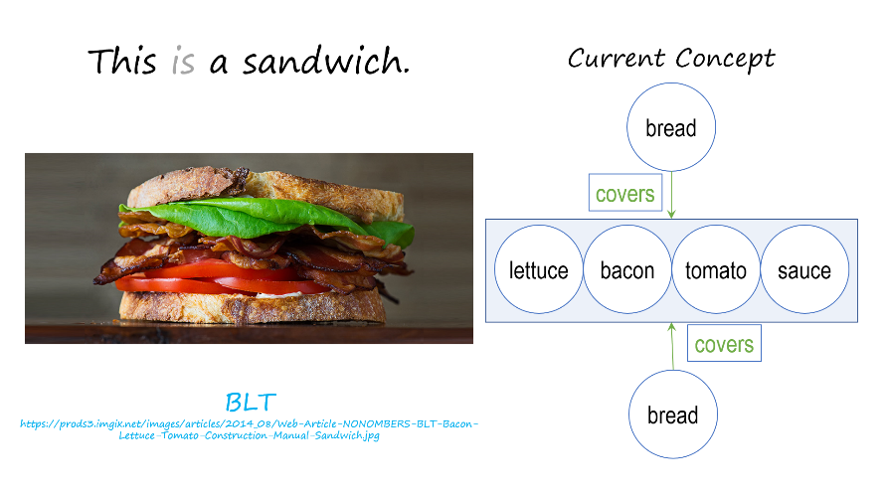
- BLT is sandwich
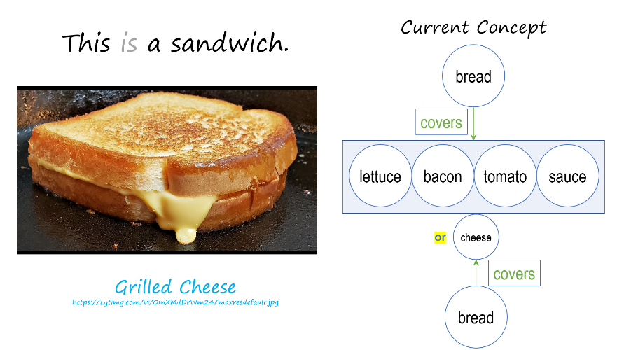
- Grilled cheese is sandwich
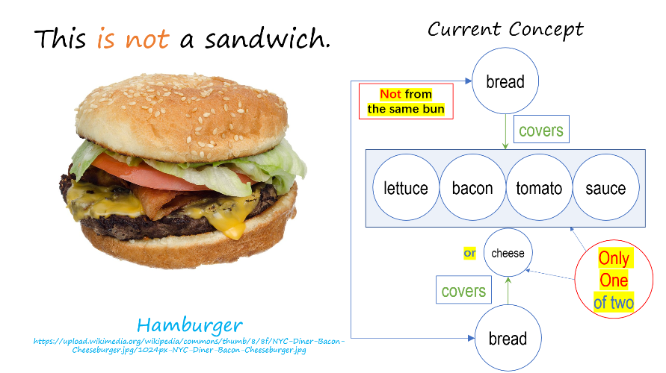
- Hamburger is NOT sandwich
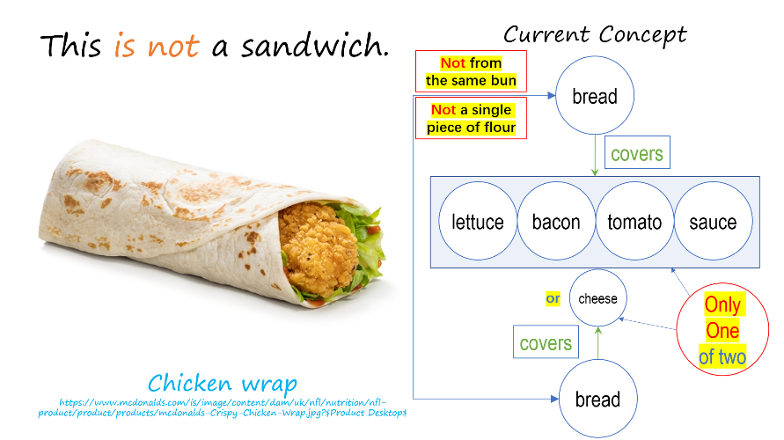
- Chicken wrap is NOT sandwich

The potential sandwich that could make a significant difference
If the next input to the model is an ice cream sandwich, the learning agent would make major revises on the ingredients. More varieties of ingredients would be accepted for a sandwich.

Parameters that may help differentiating sandwiches
- Parameters for sandwiches
Parameter | Description
How many pieces of flour? | Usually 2 pieces of flour for a sandwich
Flour pieces not from a single dough? | The bread of a hamburger is from a single bun
All pieces of flour are high-protein flour? | Biscuits are made of low-protein flour
Has ingredients besides flour? | Must be TRUE for sandwiches
Has structure flour + non-flour + flour? | Structures like rolls do not account for a sandwich
- Values of parameters for six sandwiches (part 1)
Parameter | BLT | Turkey & swiss | Tuna salad on brioche
How many pieces of flour? | 2 | 2 | 2
Flour pieces from a single dough? | False | False | False
All pieces of flour are high-protein flour? | TRUE | TRUE | TRUE
Has ingredients besides flour? | TRUE | TRUE | TRUE
Has structure flour + non-flour + flour? | TRUE | TRUE | TRUE
- Values of parameters for six sandwiches (part 2)
Parameter | Chip butty | Ice cream sandwich | Grilled cheese
How many pieces of flour? | 2 | 2 | 2
Flour pieces from a single dough? | False | False | False
All pieces of flour are high-protein flour? | TRUE | TRUE | TRUE
Has ingredients besides flour? | TRUE | TRUE | TRUE
Has structure flour + non-flour + flour? | TRUE | TRUE | TRUE

Classification rules for a sandwich
has 2 pieces of flour ∧ all high-protein flour
∧ ¬ flour from the same dough
∧ has ingredients besides flour
∧ 2 pieces of flour cover all the other ingredients

Is a hotdog a sandwich?

Through increment concept learning
Referring to Figure 4, hotdog is not sandwich, in that the bread for a hotdog is from a single flour bun.

Using the classifier based on parameters
Hotdog is not sandwich, still because the bread is from a single bun.

Using case-based reasoning
The nearest-neighbor of hotdog may be meatball sub, which is not a sandwich. Therefore, hotdog is not sandwich. The closest sandwich to hotdog might be turkey and swiss on potato roll.

Understading the sentence: “Maria didn’t say I kicked the can.”

Explain how an AI agent might make sense of that sentence
verb: say
- happened: False
agent: Maria
object: meta-obj

verb: kick
agent: I
object: can

- The frame representation of the sentence
The AI agent may first detect the subjects (Maria; I; can; “I kicked the can”) in the sentence. To verify the can as a subject instead of a modal verb, we need the help from its context. With the word “can” serving as an object of the verb “kick”, and appended after “the”, the AI agent may explore its knowledge base to search for the meaning of “can” as a noun.
Besides, to verify the clause “I kicked the can” as a whole object, grammar knowledge is necessary for the AI. It should know that a sentence can be appended after a transitive verb, and identify that a single “I” is not likely to be the object of “say”, according to both the semantics and the grammar.

Different emphasis on the sentence
In Figure 5 the emphasis is put on the verb about whether Maria did say a sentence. However, the emphasis can be also on any other agent, object or verb in the sentence.
verb: say
agent: Maria
object: meta-obj
verb: say
agent: Maria
- actual: False
object: meta-obj
verb: kick
agent: I
object: can

verb: kick
- happened: False
agent: I
object: can

- Extra 2 different emphases on the sentence

Possible tactics for an AI to find the emphasis
To identify what is the actual emphasized component, we shall make use of the context of the sentence by detecting the frequency of different types of components that has been recently mentioned. For example, if the preceding text has frequently mentioned what Mary has done, we may infer that the current sentence is emphasizing that Mary didn’t “say”, and she might had written the sentence or sent it via text message.
Following this idea, we may first list all the possible emphases, and classify these components into different equivalent classes. Then we can detect whether similar components of the same equivalent class have been mentioned in the context. If components of a specific equivalent class are intensively discussed nearby, we may infer the major topic that is being discussed in the current sentence.

The AI’s understanding about different emphases changing the meaning of the sentence
Different emphases change the key information delivered by the sentence. When the AI has determined the emphasized component in the sentence, it can then extract new working knowledge from this whole article. By comparing the knowledge acquired by different emphases, the AI can understand the impact of different emphases altering the meaning, simply by generate & test. Inferences of different equivalent classes can be deduced from different emphases, asking the AI to pay attention to different types of information in the subsequent text.

How an AI might be able to infer whether the sentence is literal or figurative
This can also be achieved by matching equivalent classes. For example, if Mary is in her working office, and components related to “work” or “schedule” is frequently mentioned in the context, the AI may be likely to take the sentence as figurative. In contrast, if Mary is in a park and having fun, then she is more likely to kick a literal can.
Besides, there is a prior possibility of humans using figurative expressions. Evidently humans use less rhetoric than straightforward sentences. Based on the prior possibility, higher threshold is need to determine that the sentence is figurative. Extra knowledge is needed about human’s frequency of using figurative sentences.

