Deployment Lead Report Section

1. Introduction
As the Deployment Lead, I was responsible for containerising the Student Grade Calculator application and implementing continuous deployment to Render.com through GitHub Actions. The goal was to ensure that code is built, tested, packaged, and deployed in a reliable and repeatable way using DevOps practices.
My deliverables included:
- Docker containerisation using a multi-stage Dockerfile
- Deployment automation with .github/workflows/deploy.yml
- Render.com service setup with deploy hook integration
- Verification of successful production deployment

2. Docker Containerisation
The application was containerised to guarantee consistency across development and production environments. A multi-stage Docker build was used: Stage 1 builds the WAR file with Maven and Java 11, and Stage 2 deploys the WAR to Tomcat 9 as ROOT.war. This approach reduces image size and improves deployment reliability.
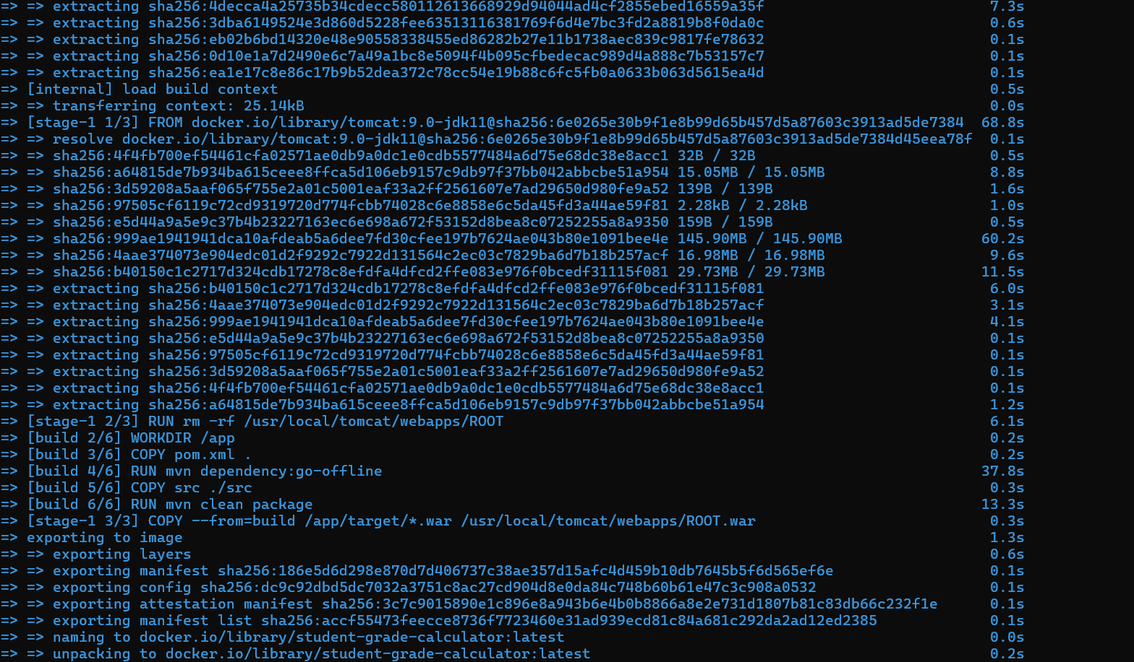
Figure 1. Docker image build completed successfully.
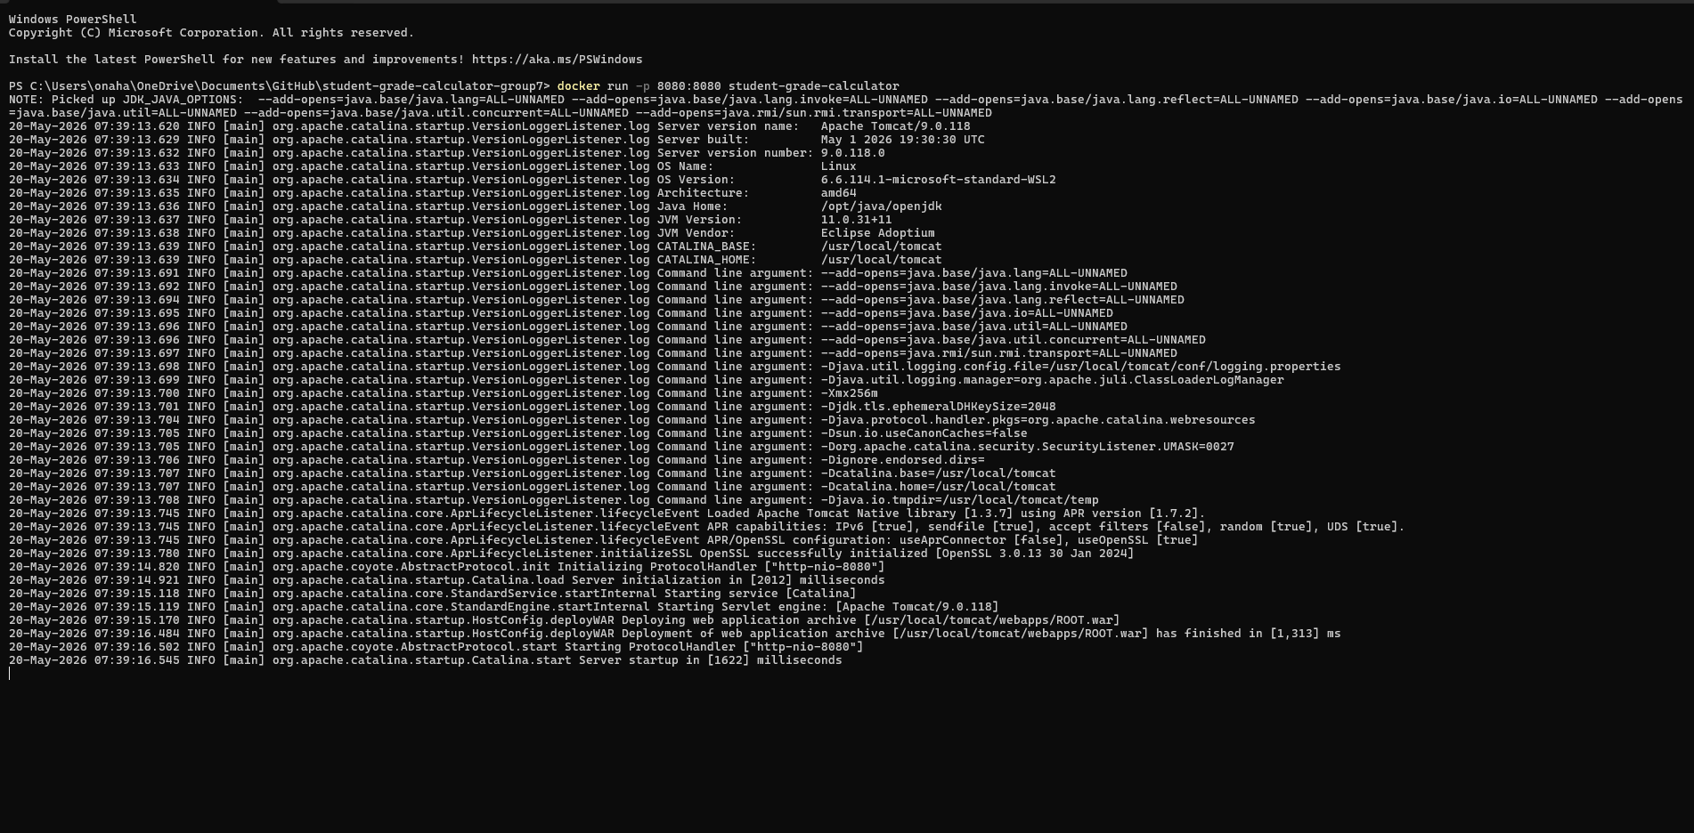
Figure 2. Docker container running Tomcat on port 8080.
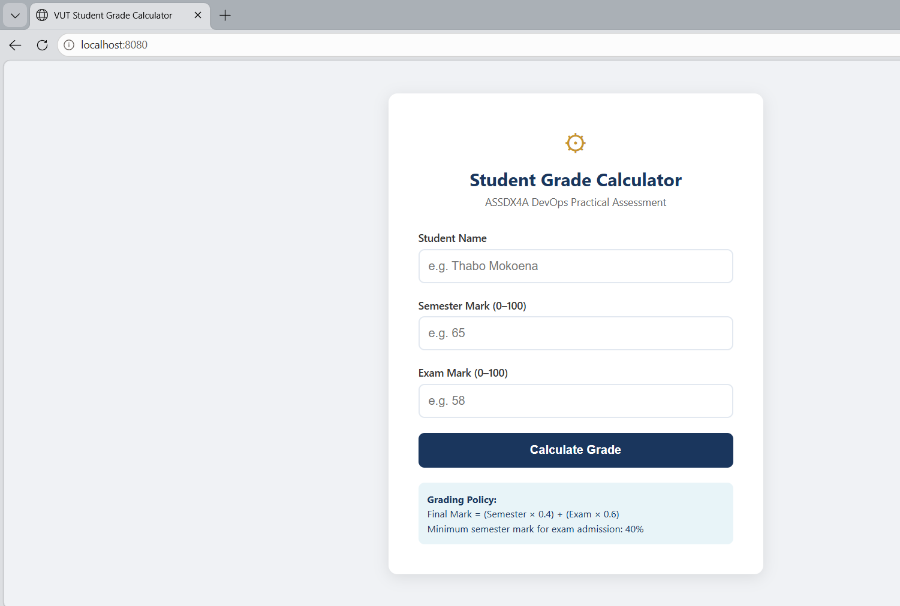
Figure 3. Application running locally at http://localhost:8080.

3. Render Cloud Deployment Setup
A Render Web Service was configured using the project Dockerfile. To meet assessment requirements and enforce controlled releases, Auto-Deploy was disabled, deployment was triggered through a secure Deploy Hook, and the GitHub repository secret RENDER_DEPLOY_HOOK_URL was used to protect the hook URL.
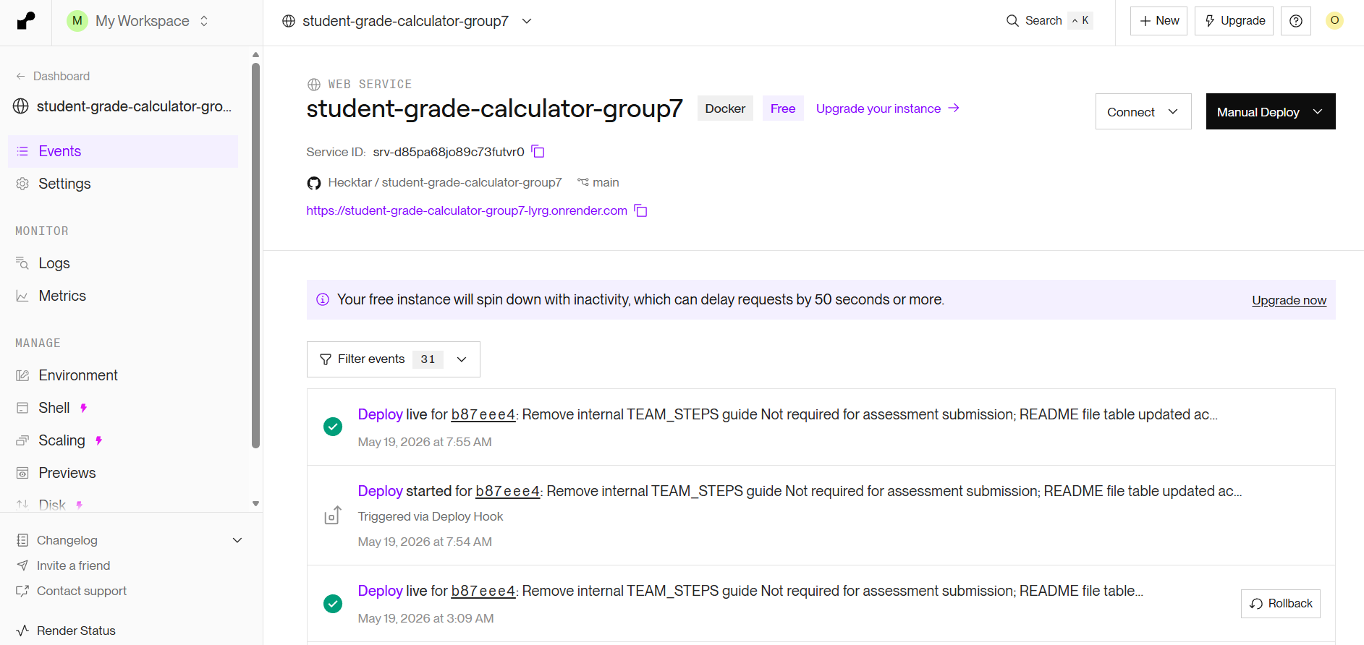
Figure 4. Render service overview (Docker runtime and live URL).
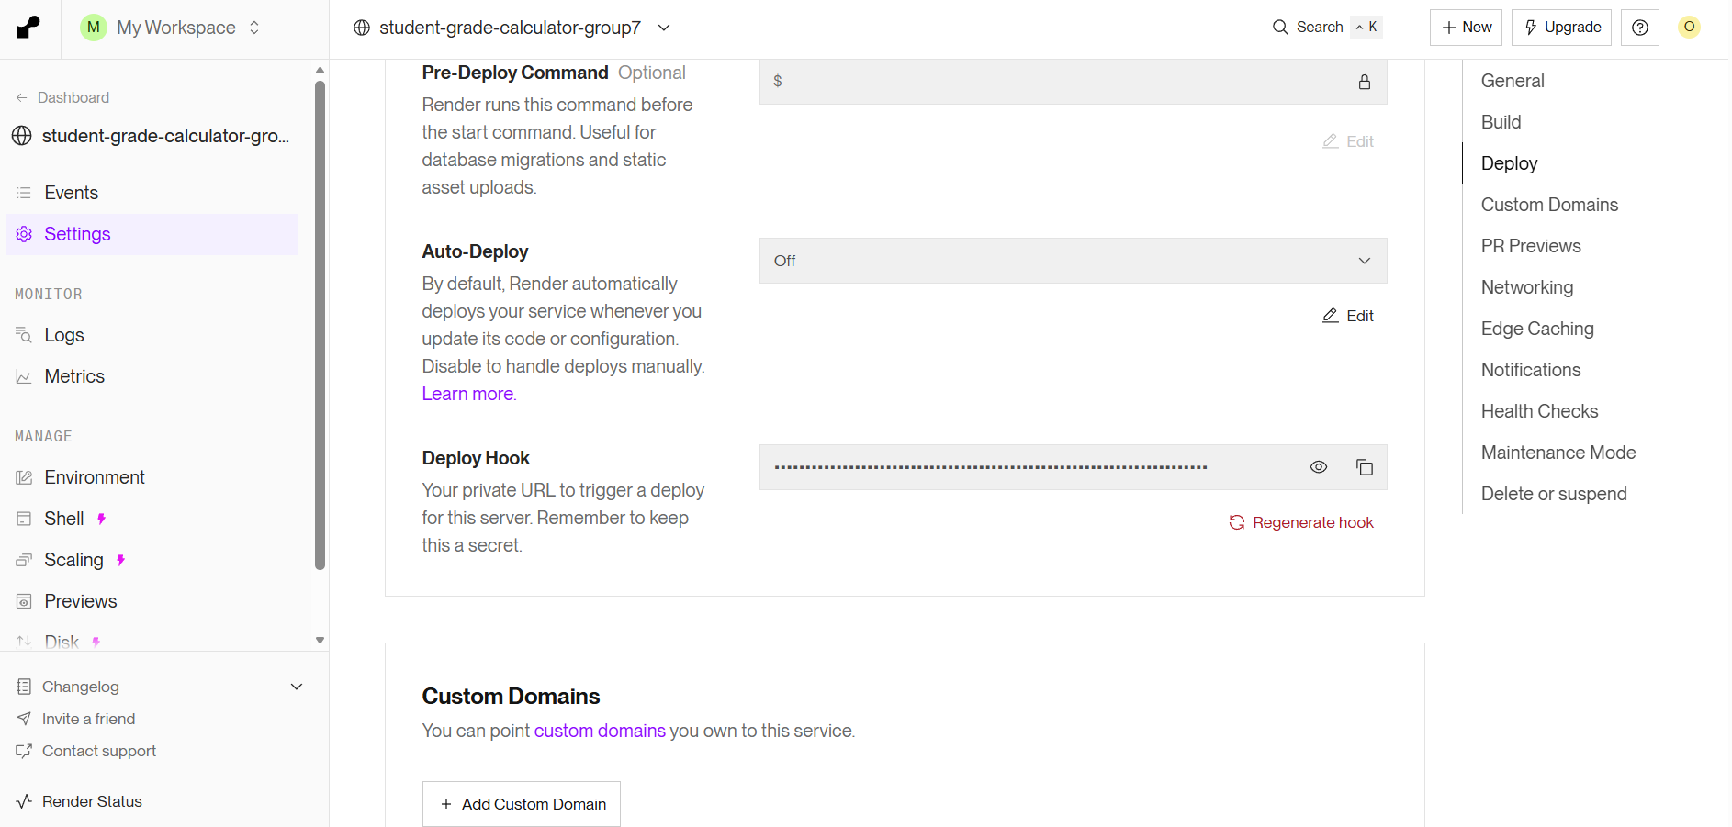
Figure 5. Auto-Deploy disabled in Render settings.

Figure 6. Deploy Hook configuration in Render.
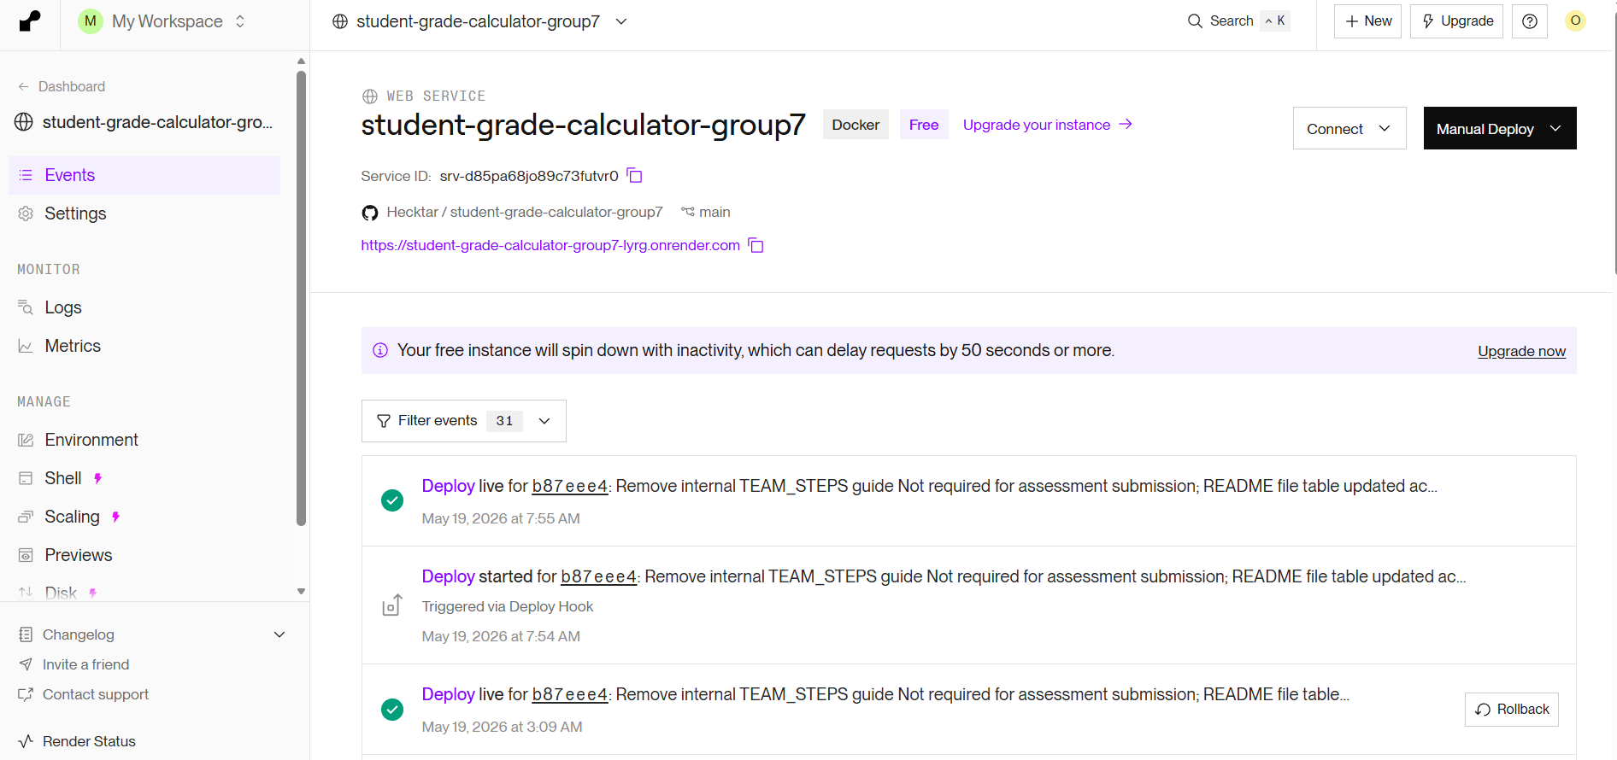
Figure 7. Render Events showing successful deployment activity.

4. GitHub Actions Deployment Workflow
The deployment workflow was implemented in GitHub Actions (deploy.yml) and configured to trigger after a successful CI pipeline on main. The flow is: push/merge to main, CI workflow executes build and tests, deploy workflow runs on successful CI result, GitHub Actions calls the Render deploy hook via curl, and Render rebuilds and redeploys the application.
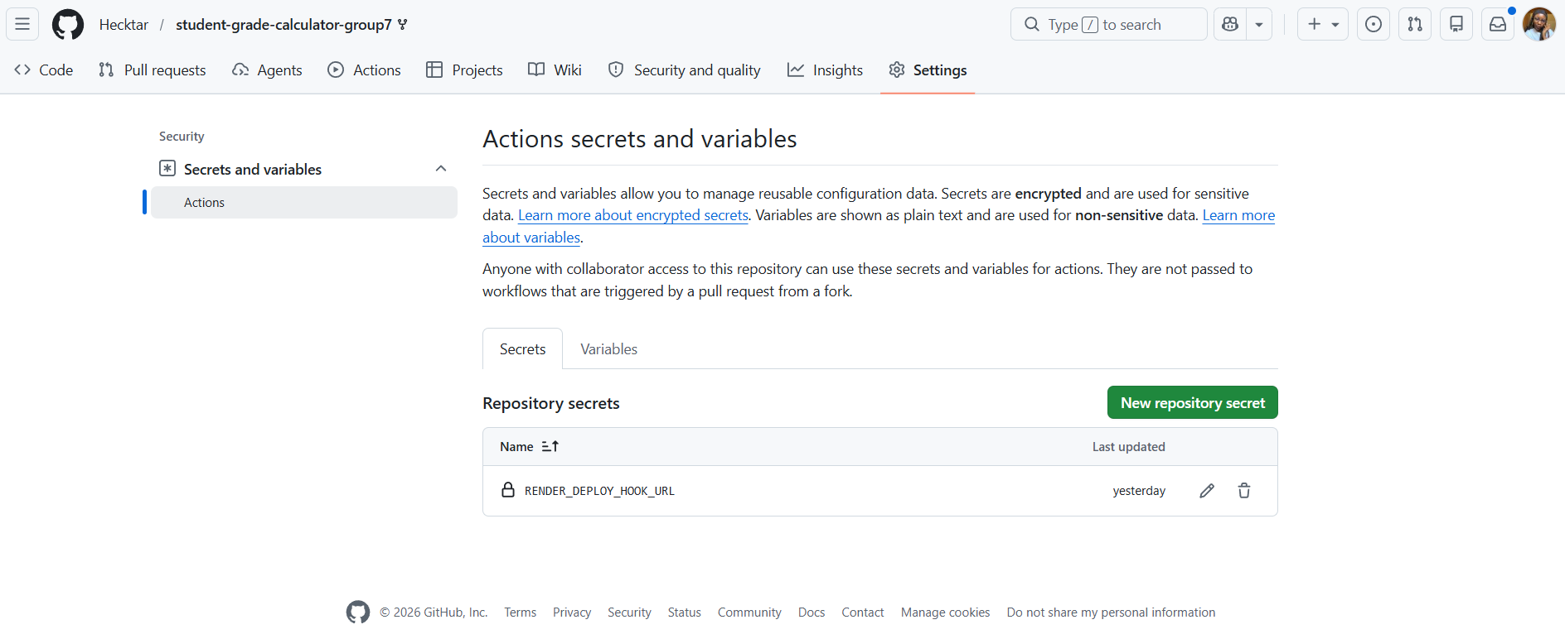
Figure 8. GitHub repository secret (RENDER_DEPLOY_HOOK_URL) configured.
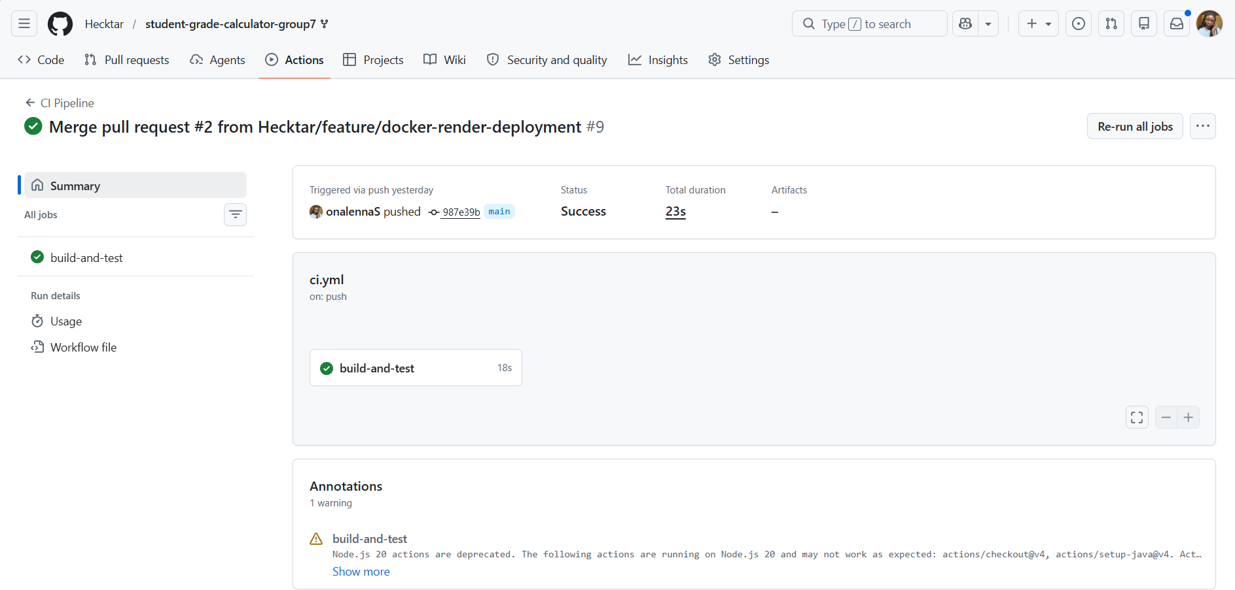
Figure 9. CI Pipeline successful on main branch.
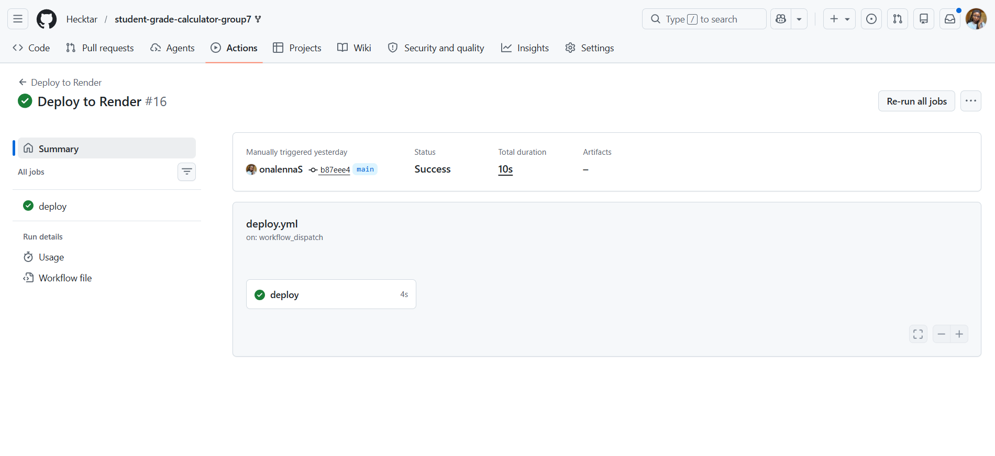
Figure 10. Deploy to Render workflow run successful.
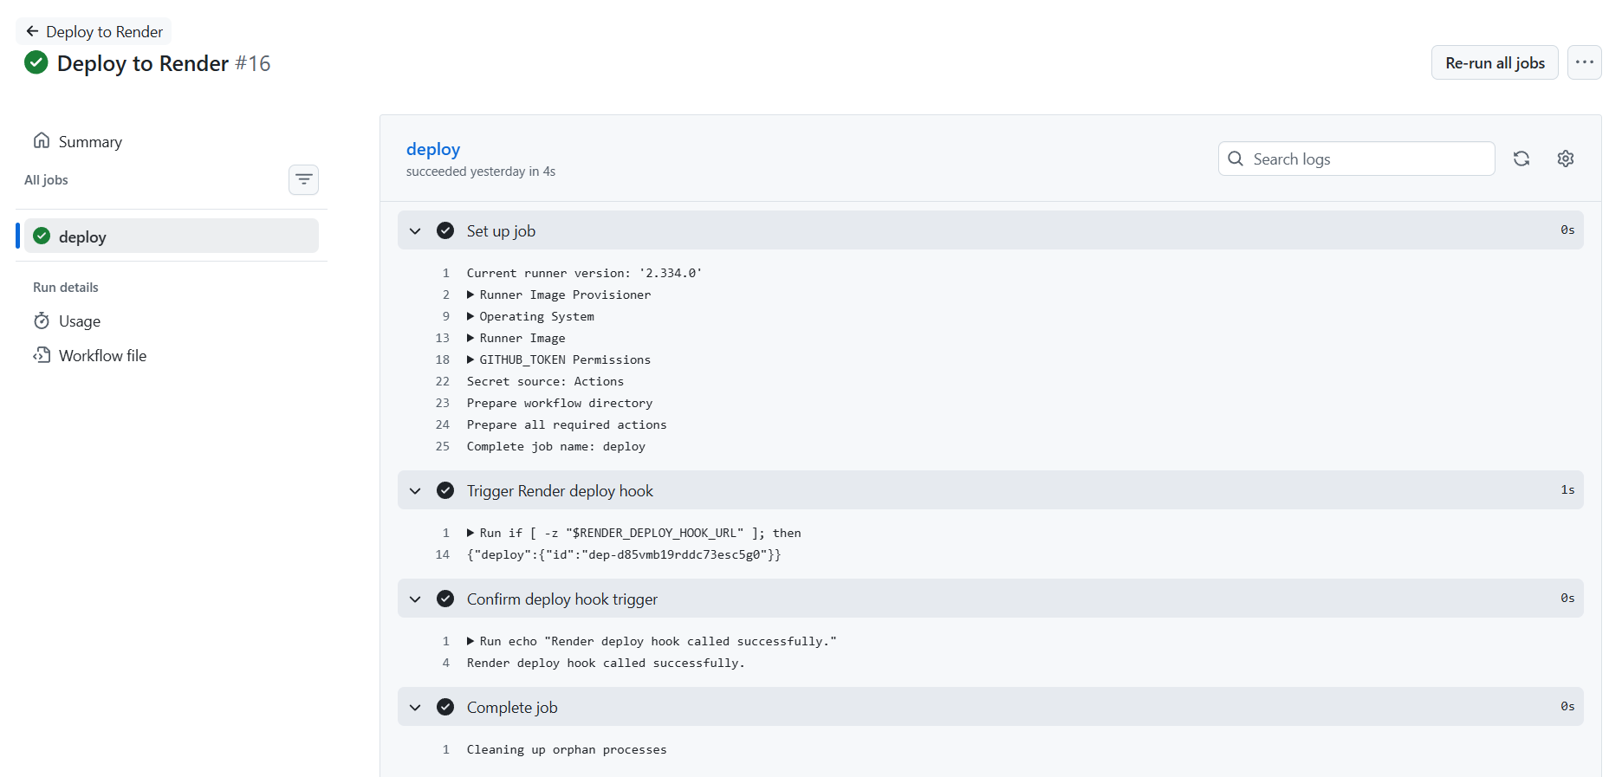
Figure 11. Deploy job logs confirming deploy hook trigger success.

5. Live Deployment Verification
The deployed production application was verified at https://student-grade-calculator-group7-lyrg.onrender.com. This confirms that the full CI/CD path successfully publishes working application updates to the internet.
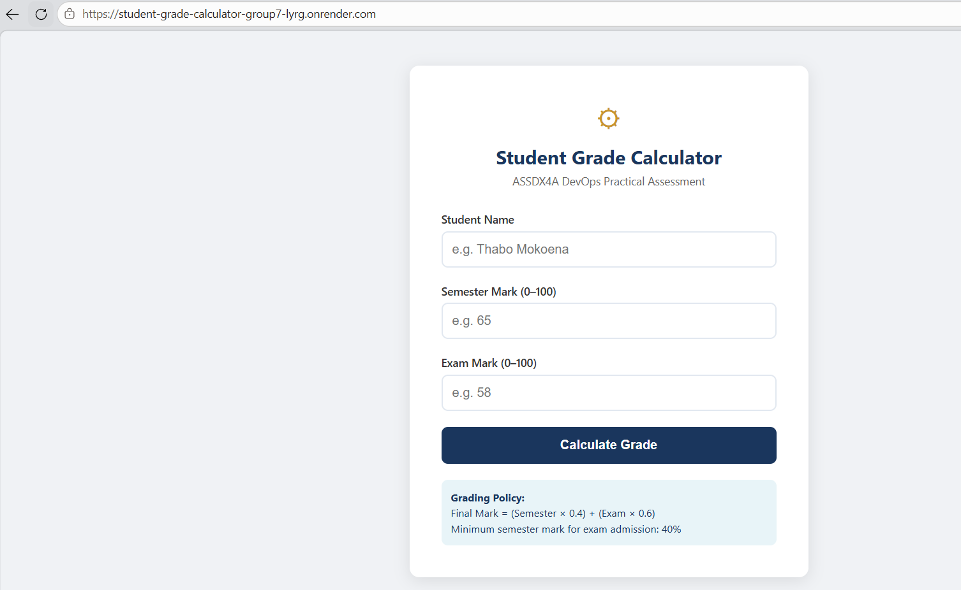
Figure 12. Live Render-hosted application page.

7. Conclusion
The deployment component of the project was completed successfully. The application was containerised using Docker, integrated with GitHub Actions for automated release, and deployed to Render.com with secure hook-based triggering. The resulting pipeline ensures that only tested code reaches production and demonstrates practical CI/CD implementation aligned with the ASSDX4A assessment requirements.

