QUT UAV Autopilot
Project Owner:  An Le (WIL)  Project Supervisor:  Kenneth Sands  Project Manager:  Steven Bulmer | Timeline:  22/11/2023: Received handover documents.  27/11/2023: Accessed the ordered components from previous engineer.  28/11/2023: Send a similar project online, Steven approved passed it to the units for feedback.  29/11/2023: Research on required compoments and their availability. | ToDos:  Go through previous progress (handover notes).  Research on requied components.  Send findings to Project Manager.  Gather all components that might suit the project.  Work out components that need ordered.  Design and build the autopilot controller inspired by findings.
Start: 22/11/2023
End: 03/01/2024
Location: S913 – S Block
Account: lea7
Timeframe, Key

Dates
03/01/2024 - Handover
Notes:
Previously, QUT used PixHawks as autopliots for on campus drones activities. However, due to the newer controllers in the markets’ tendency to becoming irrelavant in a few years’ time, Steven is lookig to explore the possibility of making our “in-house” autopilot. The focuses of such subject are to ultilize the open-source PX4, emphasize on sustainability, scaling, and innovative.

Project Directories:

- U:\...

Software:

- PX4
- KiCAD

Hardware:
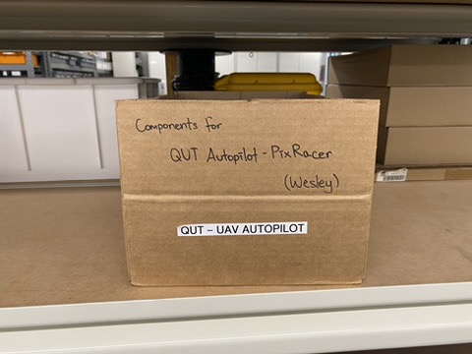
- List of sensors onboard the Holybro Pixhawk 6X (for inspirations, not recommneded for reverse engineering):
FMU Processor | STM32H753
IO Processor | STM32F100
Accel/Gyro | ICM-20649 or BMI088
 | ICM-42688-P
 | ICM-42670-P
Mag | BMM150
Barometer | 2x BMP388

- List of Sensors and Hardware from a built project:
 | MPU9250, replace by ICM-20948. | Discontinued.  $30.21 | DigiKey
Pressure Sensor 0.15PSI ~ 17.4PSI (1kPa ~ 120kPa) Absolute 24 b 8-SMD | MS5611 | $19.05 | DigiKey
Servo Driver | PCA9685
4 Channel with Programmable Gain Amplifier | ADS1115 | $32.70 | Core Electronics
Controller I²C, SPI, UART Interface 28-TSSOP | SC16IS752 | $9.11 | DigiKey
Series Voltage Reference IC Fixed 5V V ±0.1% 10 mA 8-VSSOP | REF5050 | $5.76 | DigiKey
 | other peripheral circuit, such as SBUS inverter and reference voltage source

- Used/Tried component:
Main Processor | STM32F427VIT6 | not yet tested, need to verify the integrity of the chip.
Magnetometer | LIS3MDxx | MISO and MOSI pins swapped around
 | GPS Module

Summary:
The project is forming its own path, and awaits the next “adventerer” to roam. From the handover documents, there were attempts to build the controller. However, those lack consistency, reliability, while cost were reasonably high. This run focus on researches. A promising prior project was found and approved by Steven. The components had yet to be ordered, more research will be needed on this matter. Among the purchases, ICM-20948 and a few usefull others were detected, these will potentially be be used when designing/building the controller.

