Thumbnail View Sample
Overview
This sample shows how to access the thumbnail image of an Inventor document using Microsoft's API that queries compound files (COM implementation of Structure Storage architecture).
The thumbnail can be directly and easily accessed using the full Inventor API or Inventor's Apprentice API. When using the Inventor API, the thumbnail can be accessed using the "Thumbnail" iProperty of the "Document" object or through the Thumbnail property of the “Inventor Summary Information” property set. When using the Apprentice API, the thumbnail can be accessed using the "Thumbnail" property of the "ApprenticeServerDocument" object and also through the iProperty.
However, an important point to note is that the thumbnail image is not saved in the standard Microsoft defined "Summary Information" property set. Instead, the thumbnail property belongs to a non-standard property set that corresponds to the Inventor defined "Inventor Summary Information" property set. Therefore, an implication of this is that if the thumbnail property is moved to another property set in the future, then programs like this sample that query a particular property set for the thumbnail using Microsoft's API will fail. Therefore, it is generally recommended that the Inventor or Apprentice API be used to access the thumbnail so that clients can be insulated from such internal changes.
This sample serves two purposes. First, the source code serves as an example of how to access an Inventor thumbnail so you can reuse that source code within your own application without adding any dependencies on external components. Second, the sample is provided as a COM component that you can register and reference within your application to provide access to Inventor thumbnails.
For developers who are interested in the source code or wish to incorporate the thumbnail functionality in their own client applications, the source code project (InventorThumbnailView.vcproj) which is in the "Source" folder demonstrates how to access the Inventor defined "Summary Information" property set using it's unique GUID identifier and then extract the image from the thumbnail property in this property set. The output of the project is the "InventorThumbnailView.dll" which is an ActiveX dll that provides the "ThumbnailProvider" interface.
For those who are not interested in the source code but only wish to access Inventor thumbnails in their applications, you can simply register the "InventorThumbnailView.dll" in the "Bin" folder.
Registering the Component
In order for a program to use the component it must first be registered. The files can be located anywhere on the file system. Registering it allows programs using the component to know it’s available and where it’s located. Before registering the component you need to first determine if you need the 32 or 64-bit version. If you’re using a 32-bit OS then it will always be the 32-bit version of the component. For 64-bit OS, you can use either the 32 or 64-bit version of the component. Since 32-bit applications can run on a 64-bit machine it's possible to have a 32-bit application and in that case you'll need the 32-bit version of this component. For 64-bit applications you'll need to use the 64-bit version of the components.
Win10 and Win11
On Win10 and Win11 machines you’ll likely need to do some additional steps to successfully register the component. It depends on how the UAC (User Access Control) is configured and your account. The following describes the worst case process. You’ll still need to have Administrator privileges.
- Open a Command Prompt window using the “Run as administrator” option in the context menu, as shown below.
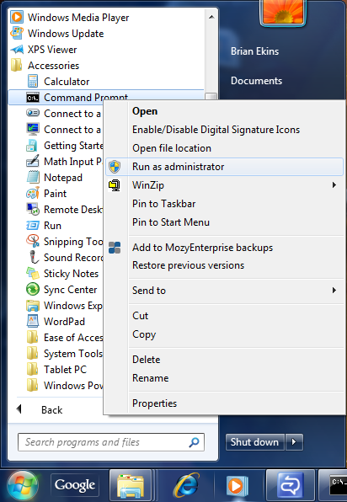

- In the command window, change the directory to where you copied the component’s files, as shown below.
- Run RegSvr32 with the argument being the name of the component, as shown below.
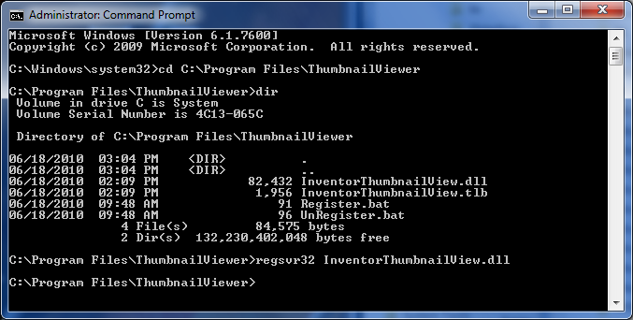

- You should see the dialog shown below if it was successful.
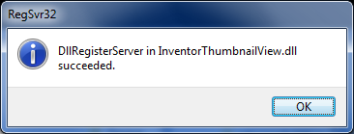

Editing and rebuilding the project
- Open the "Source\InventorThumbnailView.sln" solution in Microsoft Visual Studio 2017 or later versions. In Windows10/Windows11 OS, when build the InventorThumbnailView project, be sure to run Visual Studio as administrator if UAC is on.
- Edit the source code and rebuild the project.

Samples
The "ThumbnailView Samples" folder contains a VB.net sample that demonstrates how to get the thumbnail using the "GetThumbnail" method of the "ThumbnailProvider" interface in the "InventorThumbnailView.dll".
In order to run the VB.net sample:
- Firstly register the component as described above.
- Then copy the Interop.InventorThumbnailViewLib.dll from the Source folder to the folder where the sample executable ViewThumbnail.exe is located.
- Then run the executable for the sample, this will bring up a dialog that will allow you to browse and select an Inventor file on disk. The thumbnail image will be displayed on the picture box control on the dialog.

Language/Compiler: Visual C++ with Visual Studio 2017.

