

**Elec 2660** - Mobile Applications Project

**Mobile Application Documentation –** SimpleElectronic and Electrical Calculator

**Name:**

Alexander Bolton

**Student Identification Number:** 200938078

Table of Contents

Specification 3

Brief Overview 3

Specification list 3

General User Interface 3

Storyboard 3

Annotated Storyboard 4

Design Rationale 5

Class Diagrams 6

Interaction Diagrams 7

# Specification

## Brief Overview

This application provides multiple calculators for designing simple circuits and filters in Electronics and Electrical Engineering. This will shorten prototyping time down and I see this as very beneficial towards Engineers making big circuits but need small things like RC Filters, potential dividers, etc to make sure the circuits are within constraints so they work effectively and correctly.

## Specification list

* This app will allow users to input numbers into a text box and use the appropriate equation selected to calculate that values needed for the circuit
* It will display an simple example circuit in an image box on the selected calculator chosen
* The user will simply use the calculator from a table view controller and it will have an accurate simple description
* Show results in both dB and other values appropriately.

# General User Interface

## Storyboard

E:\Storyboard (1).png

## Annotated Storyboard

E:\Storyboard Annotated (1).png

**Navigation Controller:** The navigation controller manages a stack of view controllers. I am using this so the user can go back to the table view after selecting the calculator it requires.

**UITableView:** This displays items from a data source in a single column. I am using this so the user can select the calculator needed.

**TableView Name:** This is the name of the UITableView. I am going to use this to state that the user must choose a calculator on this page.

**UITableViewCell:** This is where the UITableview Cell is located. This is where the user clicks for which calculator they require. For example, if they selected this cell for an RC High-pass filter calculator then where it says “Cell” would say “RC High Pass Filter” and they would select that cell.

**ViewController (Calculator):** This is the view controller for the calculator. A view controller is the view of the application. It updates the contents of views, responds to the users interaction, and resizes which is dependent on pinning of the application.

**ViewController Name:** This is the name of the view controller in the calculators view. I will use this to display which calculator has been selected. For example if they chose an RC High Pass Filter Calculator then the value of the text would be “RC High Pass Filter”.

**UIImageView:** This will show an image of the circuit design diagram or an example diagram of what is being calculated if it is on a graph for example a band diagram used in semiconductors.

**UIScrollView:** This is a view in the view controller where the user can scroll to see more components within the scroll view. I will be using this for the

**Back Button:** This button tells the Navigation controller to terminate the current view and go to the previous one in the stack which would be the table view. This enables the user to go back to the tableview to select a different calculator.

**UIButton:** A button is a trigger for code. When the user pushes this button a piece of code runs. In this application when the button is pushed it checks which calculator is active and works out the answer using the variables provided by the user in the Text fields.

**ViewController (For ScrollView):** This is a view controller. This view controller will be used in the UIScrollView. This means there will be a whole view controller in a UISlideView. The reason I have decided to do this is so I can have as many variables as needed for the different calculators.

**UILabel:** This is a label. This will be used to show the user which variables are which. When the calculator is selected the labels will change names as required. Also if only 2 labels are needed then only 2 will be visible, if 3 are need then 3 will be visible, etc. I have done it like this to keep the number of view controllers required to a minimum. If you wish to find the result of a certain variable then you click the label and it becomes blue which states this is the variable you wish the result of and it will disable the UITextfield next to it.

**UITextfield:** This is a textbox. The user will insert their variables into these boxes. If a textbox is going to be used as an output e.g. the result, then it will be disabled so the user cannot type in it and when calculate is touched then the result will be worked out.

## Design Rationale

**Navigation Controller:** I have decided to use a navigation controller to make it easier for the user to navigate the app and be able to go back to the TableView if required.

**UITableView:** I have decided to use a UITableView because I believe this will make it simple for the user to be able to choose which calculator they wish to use.

**TableView Name:** I have chosen to show a TableView Name because I can use it as a hint to tell my user that they must choose a calculator by saying in it “Choose Calculator”

**ViewController Name:** I have decided to show a view controller name so the user can see easily which calculator they are on so they can be sure they have the correct variables and the correct equation to get the correct results.

**UIImageView:** I have chosen to use an image so the user can see where each variable goes where on either a circuit diagram or graph(e.g. band graph).

**UIScrollView:** I have decided to use a scroll view so the user can easily see all the variables clearly without the variables being squashed and unreadable.

**Back Button:** I have chosen to have a back button so the user can easily go back to the table user if required.

**UIButton:** I decided to have a red button because I believe this makes it clear to the user that this is the button they push to make the calculator calculate. I chose to have the font white and saying “Calculate” to make it more clear to the user that this us what you touch to calculate the result.

**UILabel and UITextfield:** I have decided to use a UILabel to be able to show the user which variable they are editing at what time. I have decided to use the UITextfield to make it easy for a user to enter the variables.

### Overview of design rational

First I decided to be able to select via a Table View because I believed this was a very simple way for users to be able to select a calculator. In the calculator view I chose to put the calculate button at the bottom because it’s out of the way until needed and can be easily pushed with the thumb. I decided to include an image so the user can understand what he/she is calculating. I decided to use a scroll view under the image so the user can see the image at all times and that a scroll view allows me to have many variables and not have them all squashed up to keep them clear. In the scroll view I decided to have many labels and text fields to I can show and hide as many as I need so I can have less view controllers.

# Class Diagrams

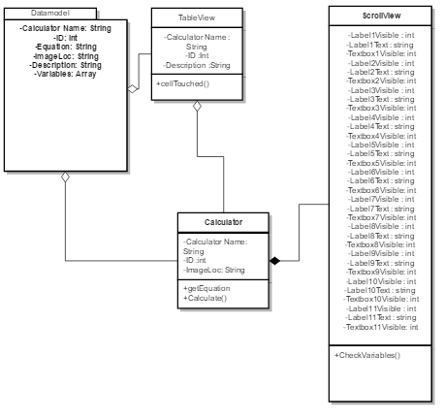

# Interaction Diagrams

