AidConnect – SDG 1: No Poverty

# 1. Abstract

AidConnect is a prototype web platform designed to reduce poverty by connecting donors, organizations, and beneficiaries in need. The system supports Sustainable Development Goal 1 (No Poverty) by leveraging technology to improve transparency and efficiency in aid delivery.

# 2. Introduction

Poverty continues to hinder social and economic development worldwide. Digital technologies can play a vital role in streamlining aid delivery, reducing misuse of funds, and connecting resources to those who need them most. AidConnect seeks to achieve this by creating a simple and effective digital bridge between aid providers and recipients.

# 3. Problem Statement

Many individuals and communities suffer due to unequal access to aid. Manual processes make it difficult for donors to identify legitimate beneficiaries. AidConnect aims to solve this by automating aid matching and record management through an online platform.

# 4. Objectives

• Develop a web platform for managing and distributing aid.  
• Simplify donor–beneficiary interactions.  
• Promote transparency and accountability in aid distribution.  
• Contribute to achieving SDG 1 – No Poverty.

# 5. System Design & Architecture

The system is designed using a modular approach with Flask as the backend and MySQL as the database. HTML, CSS, and Jinja2 templates form the frontend layer. The architecture follows an MVC pattern for scalability and maintainability.

# 6. Implementation

The system supports two primary user roles: Donor and Beneficiary.  
• Donors can log in, view aid requests, and offer help.  
• Beneficiaries can register, submit requests, and view their status.  
Data is securely stored in a MySQL database, and pages are dynamically rendered through Flask.  
  
⚙️ Note: The system is still under development. Future updates will include full authentication, improved interface, and additional features.

# 7. Screenshots

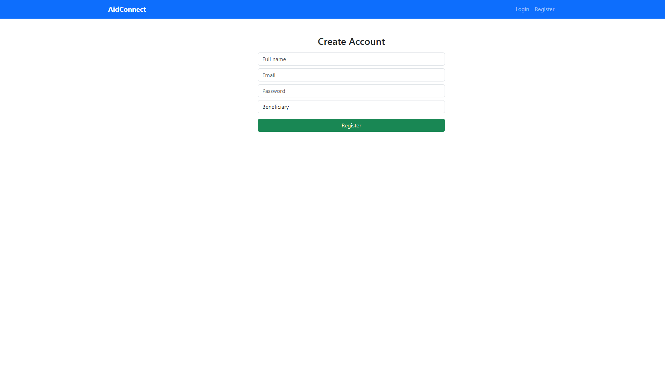

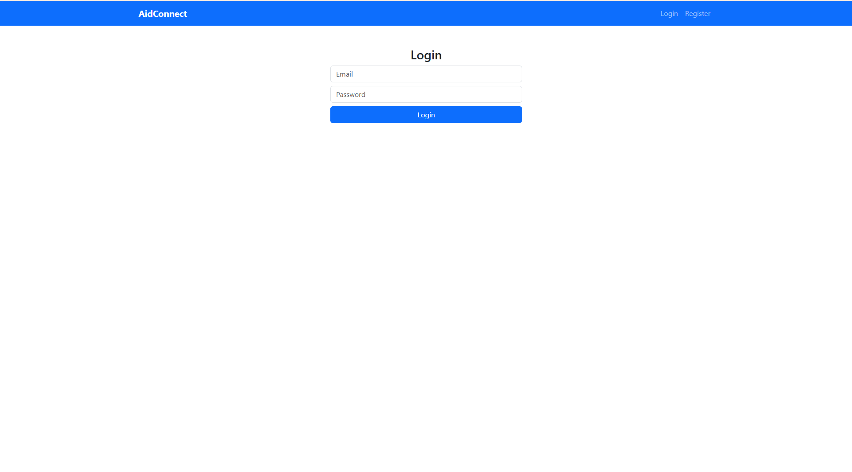

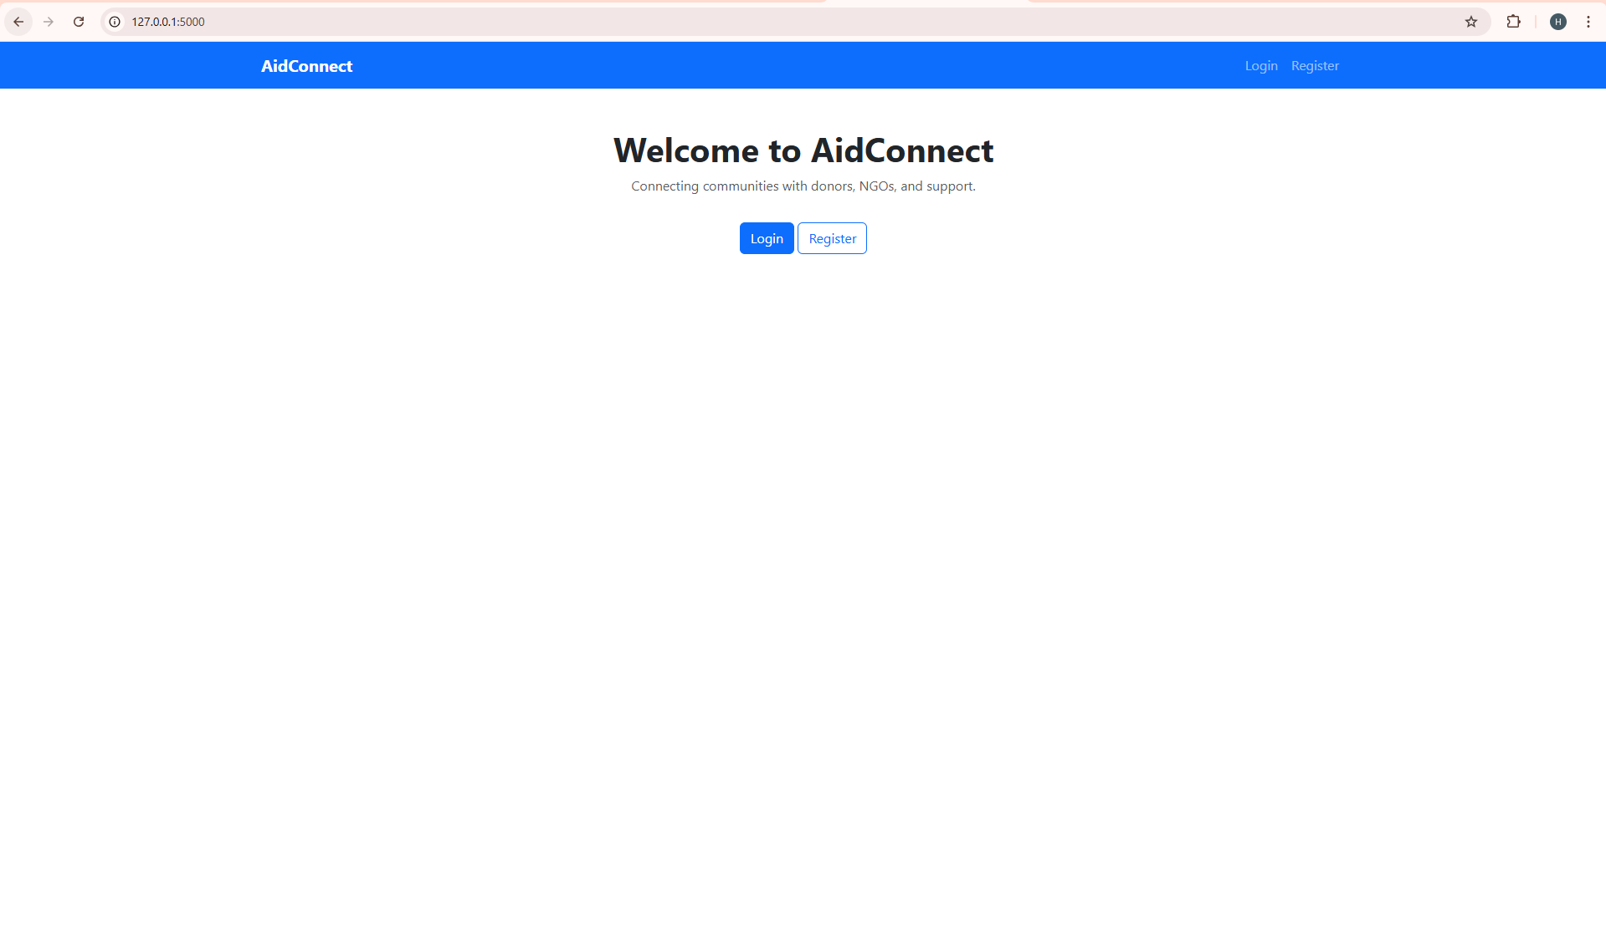

# 8. Challenges & Limitations

• Incomplete implementation due to time constraints.  
• Need for better UI/UX design.  
• Limited validation and security features.

# 9. Conclusion

AidConnect demonstrates the potential of web technology in achieving global goals such as poverty reduction. Although still under development, it provides a solid foundation for a scalable and impactful aid management system.

# 10. Recommendations

• Add AI-based matching between donors and aid seekers.  
• Implement mobile-friendly design.  
• Deploy on a live server for wider reach.