Héctor David Curiel Sánchez

Cinematica de robots  UPZMG

Practica.2

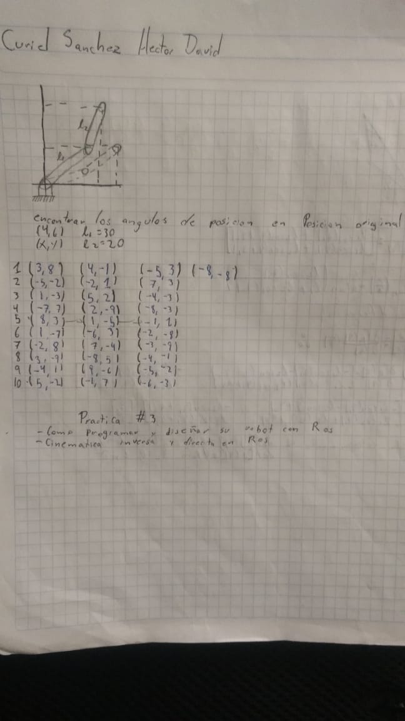

5.- (8, 3) (1, -5) (-1, 1)

$q_{2}=\left(\frac{{\left(8\right)}^{2}+{\left(3\right)}^{2}-{\left(30\right)}^{2}-{\left(20\right)}^{2}}{2\left(\left(20\right)\left(30\right)\right)}\right)=-1.02$

$atan=-45.63$

$q_{1}=\operatorname{atan}\left(\frac{8}{3}\right)-\operatorname{atan}\left(\frac{\left(30\right)sen\left(-45.63\right)}{\left(20\right)+\left(30\right)\cos\left(-45.63\right)}\right)=97.06$

(1, -5)

$q_{2}=\left(\frac{{\left(1\right)}^{2}+{\left(-5\right)}^{2}-{\left(30\right)}^{2}-{\left(20\right)}^{2}}{2\left(\left(20\right)\left(30\right)\right)}\right)=-1.06$

$atan=-46.66$

$q_{1}=\operatorname{atan}\left(\frac{1}{-5}\right)-\operatorname{atan}\left(\frac{\left(30\right)sen\left(-46.66\right)}{\left(20\right)+\left(30\right)\cos\left(-46.66\right)}\right)=16.75$

(-1, 1)

$q_{2}=\left(\frac{{\left(-1\right)}^{2}+{\left(1\right)}^{2}-{\left(30\right)}^{2}-{\left(20\right)}^{2}}{2\left(\left(20\right)\left(30\right)\right)}\right)=-1.08$

$atan=-47.20$

$q_{1}=\operatorname{atan}\left(\frac{-1}{1}\right)-\operatorname{atan}\left(\frac{\left(30\right)sen\left(-47.20\right)}{\left(20\right)+\left(30\right)\cos\left(-47.20\right)}\right)=16.39$

