Curiel Sánchez Héctor David

Cinematica de robots

Tarea.4

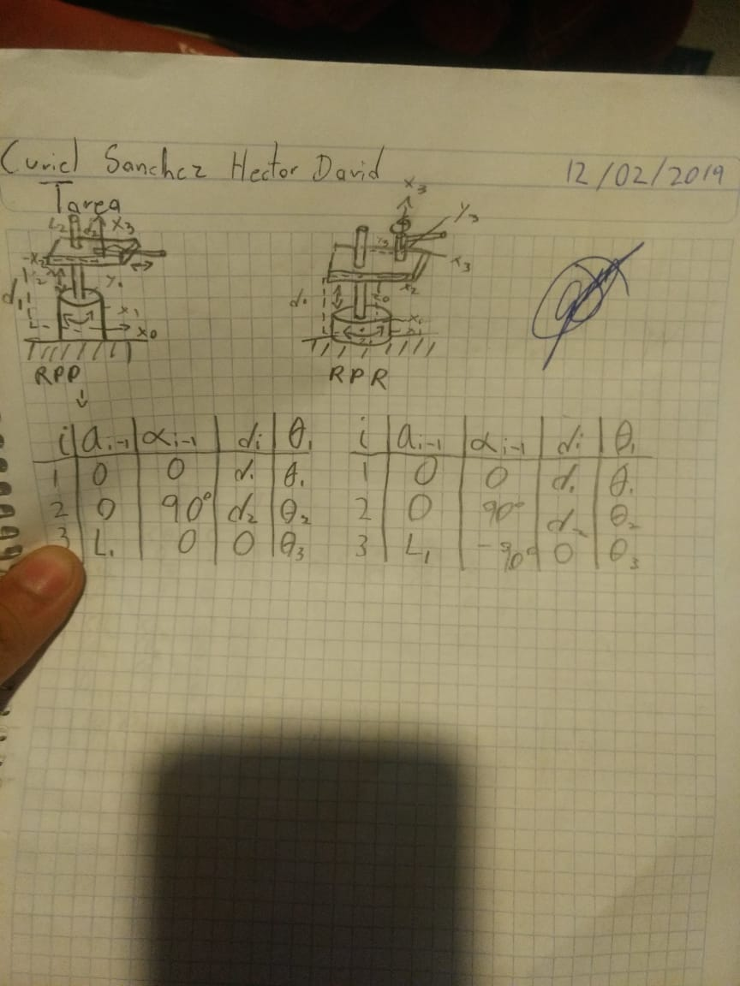

|  |  |  |  |  |
| --- | --- | --- | --- | --- |
| $$i$$ | $$Ai-1$$ | $$∝i-1$$ | $$di$$ | $$θ_{i}$$ |
| 1 | 0 | 0 | D1 | $$θ_{1}$$ |
| 2 | 0 | -90° | D2 | $$θ_{2}$$ |
| 3 | L1 | 0 | 0 |  |



|  |  |  |  |  |
| --- | --- | --- | --- | --- |
|  |  |  |  |  |
| 1 | 0 | 0 | D1 | $$θ_{1}$$ |
| 2 | 0 | 90° | D2 | $$θ_{2}$$ |
| 3 | L1 | -90° | 0 | $$θ_{3}$$ |

