ID: hh2537; Name: Haoze He

Q1:

When $\frac{n}{2^{i}}=k$, the quick sort stops. It takes $O\left(n_{i}\right)=O\left(nlog\left(\frac{n}{k}\right)\right).$ For each subarray with size k, use insertion sort, the time complexity is $O(k^{2})$ for each one. Sum them together, it is

$$O(nk+nlog(\frac{n}{k}))$$

To improve the result, using master theorem, we choose smaller k to make sure $O\left(nk\right)$ is not dominant comparing with $O(nlog(\frac{n}{k}))$. To make sure $O\left(nk\right)<O(nlogn)$, K should be $Olog\left(n\right).$

To proof that, we select $c_{1}$ for quick sort and $c_{2}$ for insertion sort.

$$C_{2}nk+C_{1}nlog\left(\frac{n}{k}\right)<C_{1}nlogn$$

$$C_{2}k<C_{1}logk$$

Thus, k = $O(logn)$

Q2.

a)

If all elements are the same, our recurrence becomes: $T\left(n\right)=T\left(n-1\right)+ θ(n)$, the time complexity becomes $Θ(n^{2})$

b)

The pseudocode of the modified algorithm shows below:

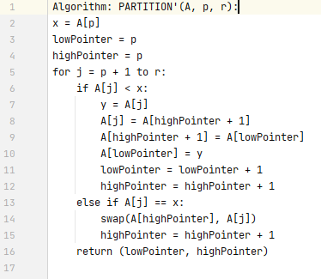

c)

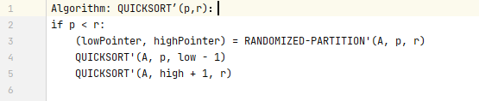

d)

When all input elements are distinct, he sub-problem of QUICKSORT’ is actually not larger than the sub-problem of QUICKSORT. It sometimes performs better since it’s more balanced.

Q3.

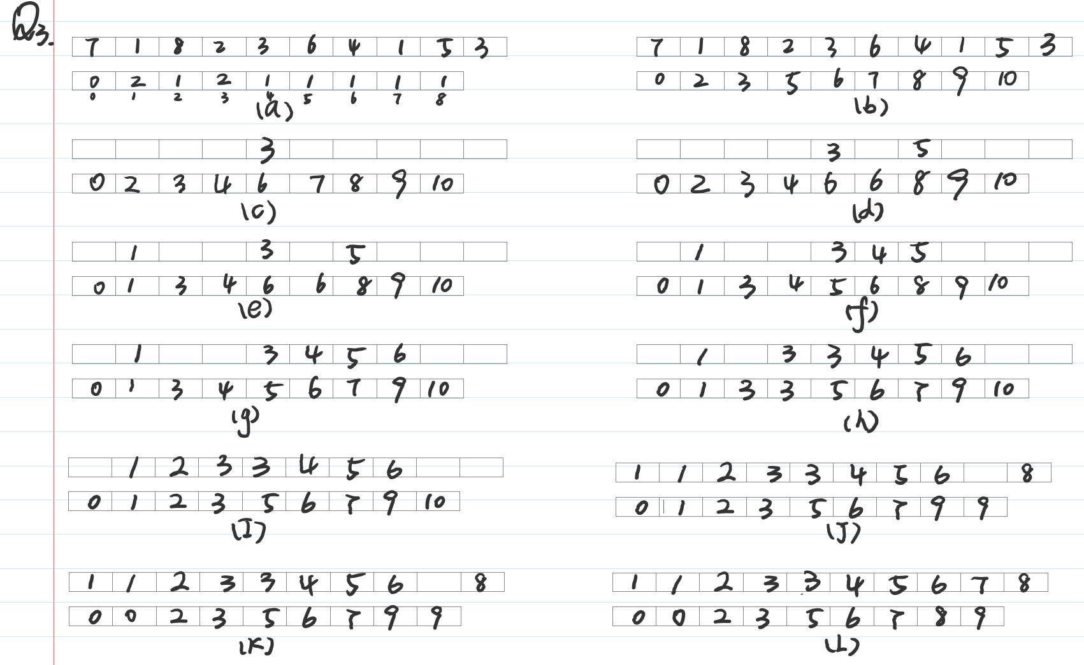

Q4.

There are two cases, n is odd or even.

Case1, n is odd:

$$number of comparisons= 1+ \frac{3(n-3)}{2}+2=(\left[\frac{3n}{2}\right]-\frac{1}{2})-\frac{3}{2}=\left[\frac{3}{2}\right]-2$$

Case2, n is even:

$$number of comparisons= 1+ \frac{3(n-3)}{2}=\frac{3n}{2}- 2=\left[\frac{3}{2}\right]-2$$

Hence, proof is done.

Q5.

Sorting number running time = $O(nlogn)$, running time of listing $i$ largest = $O(i)$.

Hence, total running time = $O(nlogn+i)$

b)

Running time of building a max-priority queue = $O(n)$, running time of each time call EXTRACT-MAX = $O(logn)$.

Hence, total running time = $O(n+i logn)$

c)

Running time of finding $i^{th}$ largest number and partitioning is $O(n)$, running time of sorting the $i^{th}$ largest number is $O(ilogi)$.

Hence, the total running time is $O\left(n+i logi\right).$