CSE 598: Agentic AI

Project 2 - Phase 2: Error Analysis & Multi-Agent Method

Team Members
Hector Hernandez
Vardaan Gangal
Harish Chaurasia
Venkata Sai Ganesh Manda
Smit Lagdhirbhai Desai

Arizona State University
April 2026

1. Executive Summary
We evaluated four open-weight models on WildToolBench (256 sessions × 4 turns = 1024 tasks) and built a custom error taxonomy of five categories tailored to the benchmark's multi-turn, tool-grounded setting. Total failures across the four models: 2,229. Key findings:
• Compositional Planning (CPF) and Ambiguity Handling (AHF) are the two largest failure categories — together accounting for 67% of all failures (1,488 / 2,229).
• Scaling within Qwen3 (8B → 32B) reduces AHF and AFF errors but slightly increases TDF (over-eager tool calling on Chat).
• Gemma4-31B has the fewest total failures (490) and dominates on Compositional Planning, but has roughly equal Contextual Grounding errors compared to similarly-sized Qwen3-32B.
• We propose WTB-MAS — a five-agent system where each specialized agent maps to one error category, addressing 100% of the failure surface.

2. Custom Error Taxonomy
We define a new five-category taxonomy designed specifically for WildToolBench's multi-turn ambiguous-instruction setting. This taxonomy is intentionally distinct from the τ-bench taxonomy: it is task-structured (categories align with a model's functional decision points) rather than symptom-structured.

2.1 Five Categories at a Glance
Code | Name | Definition | Sub-categories
AHF | Ambiguity Handling | Model fails to detect ambiguous user input or proceeds without asking | Premature Tool Execution; Missing Clarification
CGF | Contextual Grounding | Model fails to bind references ("that one", "the above") to prior-turn entities | Coreference→Wrong Args; Long-Range→Wrong Tool
TDF | Tool Dispatch | Wrong tool selected, or tool invoked when none is needed | Over-Eager Invocation; Wrong Tool Selection
AFF | Argument Fidelity | Correct tool, but argument values fail validation | Schema Violation; Format Mismatch; Value Hallucination
CPF | Compositional Planning | Multi-step task is mis-decomposed: missing/extra steps or wrong order | Missing Step; Wrong Tool in Sequence; Schema Error in Sequence

2.2 Why Five Categories
Each category corresponds to a distinct functional decision the model must make when handling a turn:
1. Did I understand what the user wants? → AHF
2. Do I know who/what they're referring to? → CGF
3. Should I call a tool — and which one? → TDF
4. Are my arguments correct? → AFF
5. Is my plan complete and correctly ordered? → CPF
This decision-point structure makes it natural to map agents in our multi-agent system (Section 5) to specific failure categories.

3. Quantitative Error Analysis

3.1 Failure Counts by Category and Model
Category | Qwen3-8B | Qwen3-14B | Qwen3-32B | Gemma4-31B | Total
AHF: Ambiguity Handling | 197 | 185 | 175 | 160 | 717
CGF: Contextual Grounding | 85 | 83 | 76 | 71 | 315
TDF: Tool Dispatch | 58 | 49 | 76 | 68 | 251
AFF: Argument Fidelity | 52 | 49 | 41 | 33 | 175
CPF: Compositional Planning | 214 | 199 | 200 | 158 | 771
TOTAL | 606 | 565 | 568 | 490 | 2229

3.2 Failure Distribution (stacked)
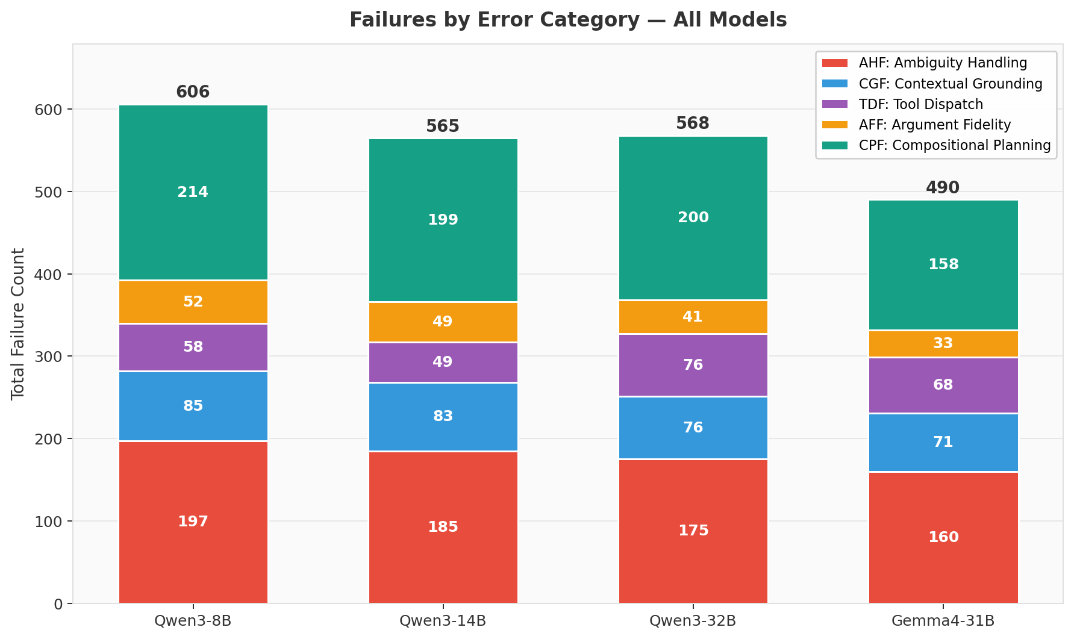
Figure 1. Stacked bar: total failures per model, color-coded by category. Gemma4-31B has the fewest failures overall.

3.3 Errors by Model (grouped)
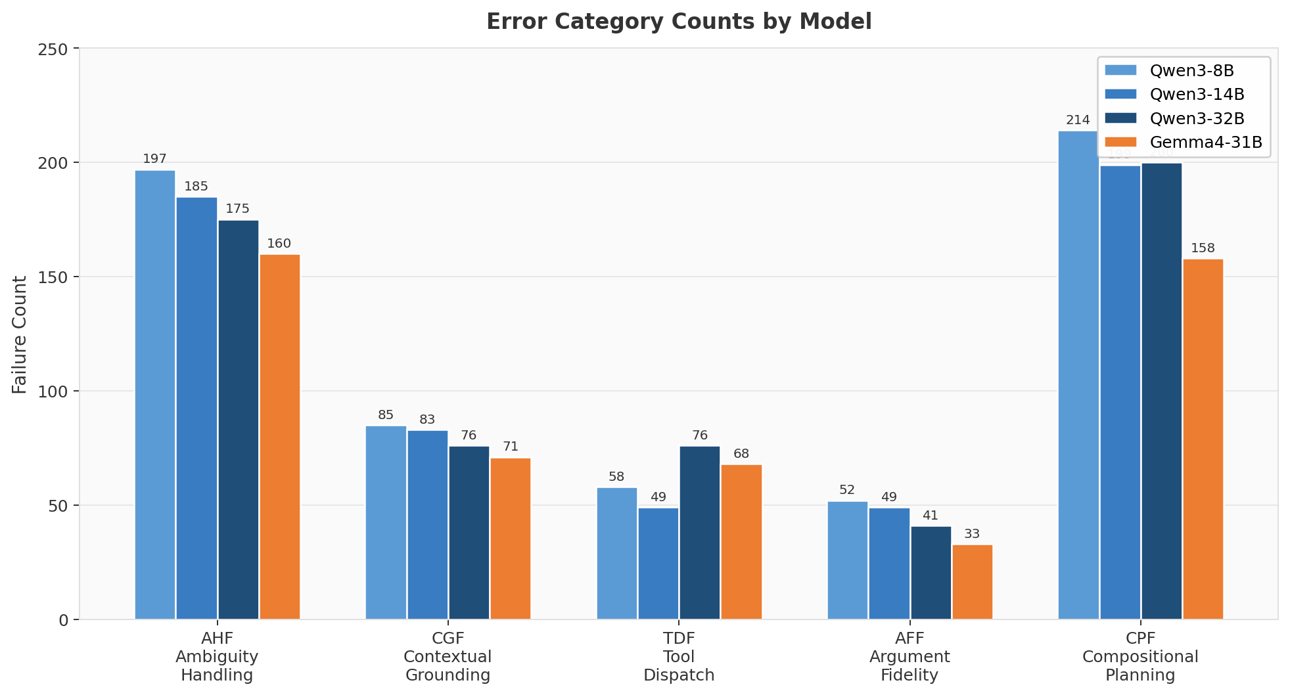
Figure 2. Per-category counts grouped by model. CPF and AHF dominate; AFF is the smallest category for all four models.

3.4 Effect of Model Size (Qwen3 family)
Tracking only the Qwen3 family (8B → 14B → 32B) isolates pure scaling effects:
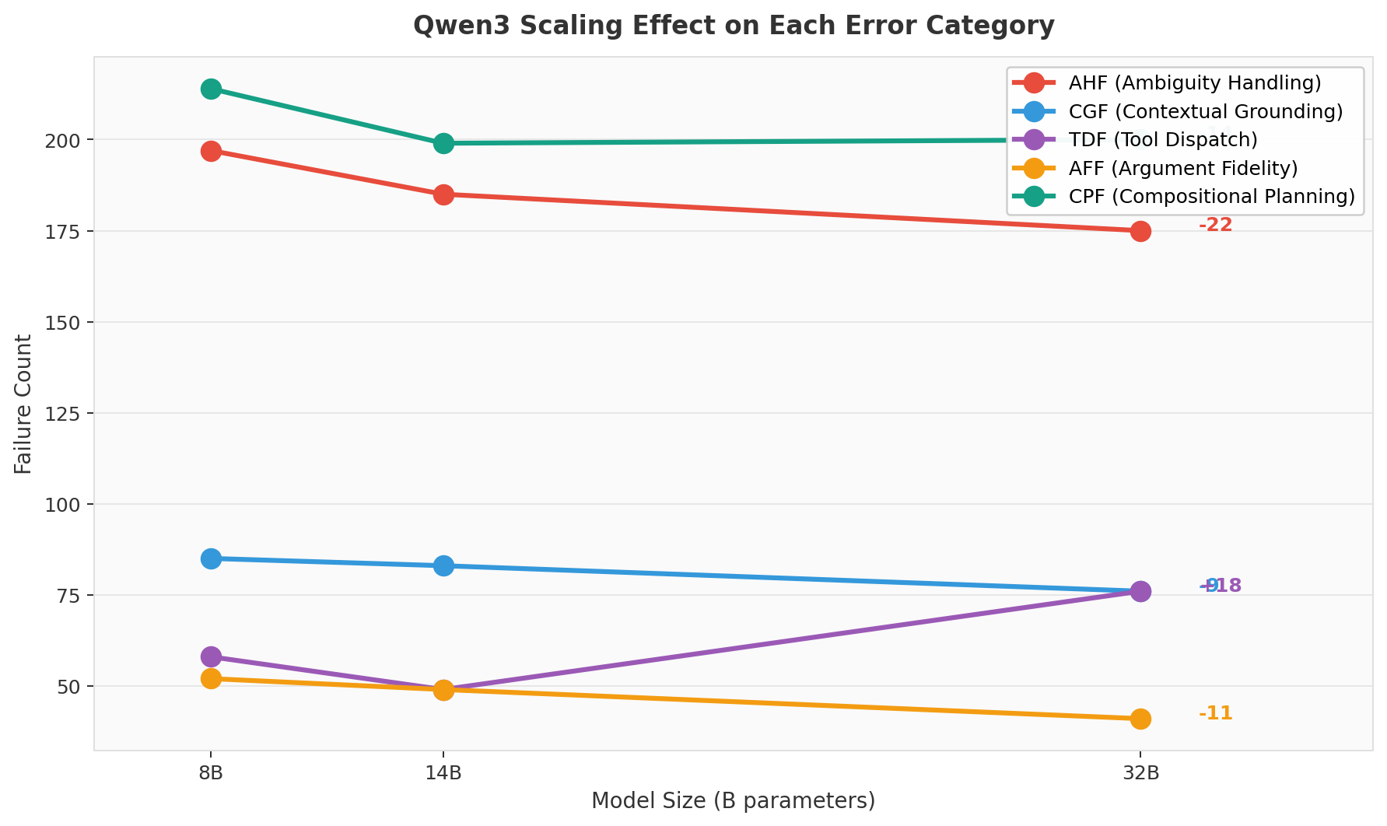
Figure 3. Qwen3 scaling effect. AHF, CGF, AFF all decline with size. TDF actually rises at 32B (over-eager Chat behavior), and CPF declines only modestly.

Key insight from Figure 3
Scaling helps the model recognize ambiguity (AHF -22 errors from 8B→32B) and ground arguments (AFF -11 errors), but does NOT help intent routing (TDF +18 at 32B, due to over-eager tool calls on Chat tasks). This motivates a dedicated Intent Router agent in our proposal.

3.5 Sub-Category Breakdown
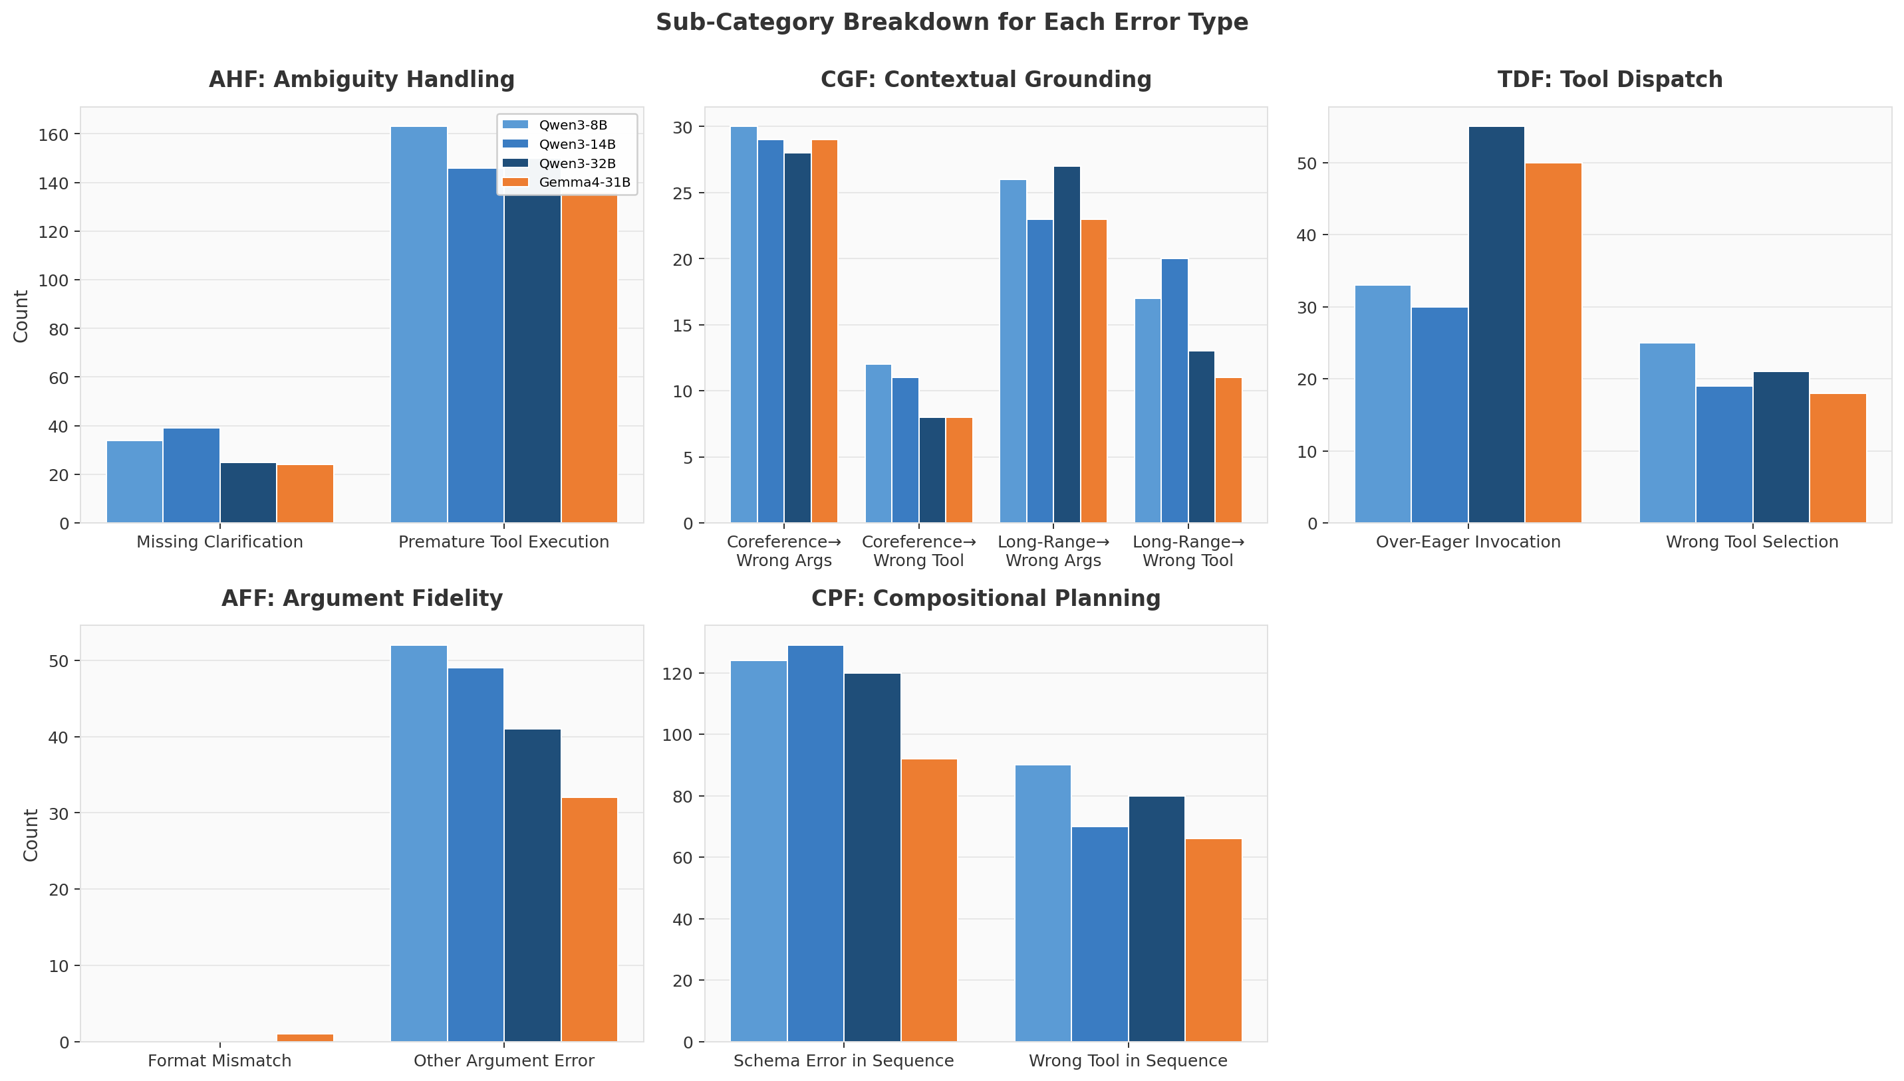
Figure 4. Sub-category breakdown for each category, by model. Premature Tool Execution dominates AHF; Schema Error in Sequence dominates CPF.

3.6 Failure Composition Heatmap
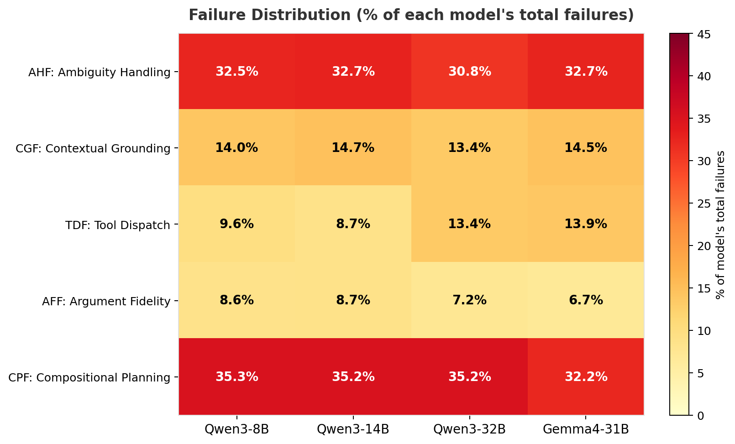
Figure 5. % of each model's total failures attributable to each category. CPF is the modal failure for all models (32–35%).

3.7 Total Failures
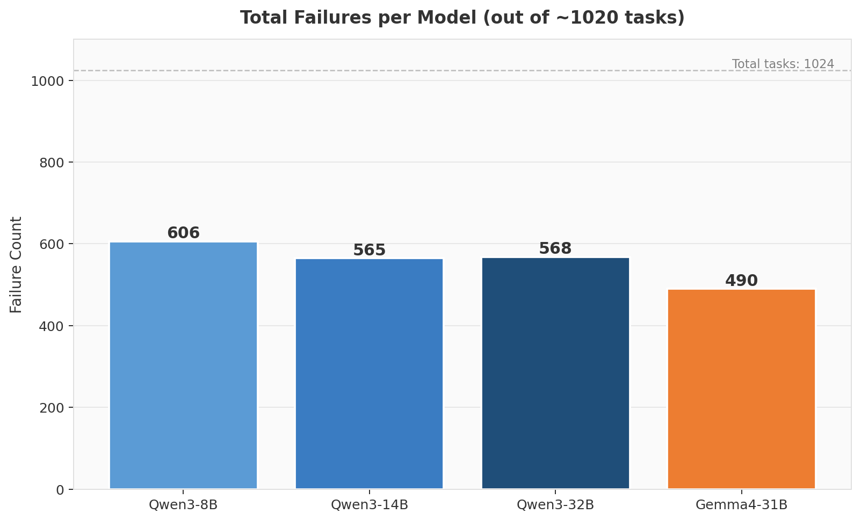
Figure 6. Total failure count per model. Gemma4-31B (490) has 19% fewer failures than Qwen3-8B (606).

4. Representative Failure Examples
For each error category, we curated 5–7 representative failure trajectory JSONs spanning multiple sub-categories and models. Below we present one detailed example per category; the full set is provided as JSON files in the failure_examples/ directory accompanying this report.

4.1 AHF — Ambiguity Handling
5 representative trajectories archived. Detailed example below:

Example AHF_01 · Model: qwen3:8b · Task: Clarify · Turn subtype: Coreferential Reference
Sub-category: Premature Tool Execution
User message: "I want to know what courses related to one of the topics are offered in schools?"
Expected actions:
ask_user_for_required_parameters → ask_user_for_required_parameters → getSchoolsAndUniversitiesInfo → prepare_to_answer
Predicted tool calls:
getSchoolsAndUniversitiesInfo
Error reason: action name not in candidate_answer_function_list
Analysis: Task type 'Clarify' requires the model to first ask `ask_user_for_required_parameters` to clarify ambiguous reference. Instead, model called tool ['getSchoolsAndUniversitiesInfo'] directly. This is a Premature Tool Execution pattern.
Other archived examples for AHF:
- AHF_02 — qwen3:14b on wild_tool_bench_3 turn 2 (Premature Tool Execution)
- AHF_03 — qwen3:8b on wild_tool_bench_16 turn 2 (Missing Clarification)
- AHF_04 — qwen3:32b on wild_tool_bench_30 turn 2 (Missing Clarification)
- AHF_05 — gemma4:31b on wild_tool_bench_165 turn 0 (Premature Tool Execution)

4.2 CGF — Contextual Grounding
7 representative trajectories archived. Detailed example below:

Example CGF_01 · Model: qwen3:8b · Task: Single-Tool · Turn subtype: Coreferential Reference
Sub-category: Coreference → Wrong Args
User message: "Please help me update this transaction record. Change the amount to 250 yuan and keep the other information unchanged."
Expected actions:
updateTransaction → prepare_to_answer
Predicted tool calls:
updateTransaction
Analysis: Turn subtype 'Coreferential Reference' requires the model to resolve references using prior turn context. The model produced an error of type 'Coreference → Wrong Args' because it failed to bind the reference to the correct entity from earlier turns.
Other archived examples for CGF:
- CGF_02 — qwen3:14b on wild_tool_bench_6 turn 2 (Coreference → Wrong Args)
- CGF_03 — qwen3:8b on wild_tool_bench_18 turn 3 (Long-Range → Wrong Args)
- CGF_04 — qwen3:8b on wild_tool_bench_22 turn 2 (Long-Range → Wrong Tool)
- CGF_05 — qwen3:32b on wild_tool_bench_43 turn 3 (Long-Range → Wrong Tool)
- CGF_06 — qwen3:8b on wild_tool_bench_73 turn 2 (Coreference → Wrong Tool)
- CGF_07 — qwen3:14b on wild_tool_bench_93 turn 2 (Coreference → Wrong Tool)

4.3 TDF — Tool Dispatch
5 representative trajectories archived. Detailed example below:

Example TDF_01 · Model: qwen3:8b · Task: Chat · Turn subtype: Coreferential Reference
Sub-category: Over-Eager Invocation
User message: "Have there been any relevant academic reports or discussions on the above two topics in Switzerland in the past two months?"
Expected actions:
prepare_to_answer
Predicted tool calls:
getSchoolsAndUniversitiesInfo
Error reason: action name not in candidate_answer_function_list
Analysis: On a 'Chat' task, model invoked tools when none were needed: ['getSchoolsAndUniversitiesInfo']. Subcategory: Over-Eager Invocation.
Other archived examples for TDF:
- TDF_02 — qwen3:14b on wild_tool_bench_13 turn 3 (Over-Eager Invocation)
- TDF_03 — qwen3:8b on wild_tool_bench_16 turn 3 (Wrong Tool Selection)
- TDF_04 — qwen3:14b on wild_tool_bench_26 turn 3 (Wrong Tool Selection)
- TDF_05 — gemma4:31b on wild_tool_bench_65 turn 3 (Wrong Tool Selection)

4.4 AFF — Argument Fidelity
5 representative trajectories archived. Detailed example below:

Example AFF_01 · Model: qwen3:8b · Task: Single-Tool · Turn subtype: Partial Information
Sub-category: Other Argument Error
User message: "Then help me synchronize again."
Expected actions:
syncTransactions → prepare_to_answer
Predicted tool calls:
syncTransactions
Analysis: Model selected the correct tool but produced argument values that failed validation: '(no reason recorded)'. Subcategory: Other Argument Error.
Other archived examples for AFF:
- AFF_02 — qwen3:14b on wild_tool_bench_18 turn 2 (Other Argument Error)
- AFF_03 — gemma4:31b on wild_tool_bench_5 turn 2 (Other Argument Error)
- AFF_04 — gemma4:31b on wild_tool_bench_22 turn 0 (Format Mismatch)
- AFF_05 — qwen3:8b on wild_tool_bench_38 turn 0 (Other Argument Error)

4.5 CPF — Compositional Planning
5 representative trajectories archived. Detailed example below:

Example CPF_01 · Model: qwen3:8b · Task: Mixed Multi-Tool · Turn subtype: Partial Information
Sub-category: Schema Error in Sequence
User message: "Check the air quality as well. If it's good, then check what special performances are on those two days."
Expected actions:
getCityAQIForecast → getCityShow → getShowDetail → getShowDetail → prepare_to_answer
Predicted tool calls:
getCityAQIForecast → getCityShow
Error reason: action name not in candidate_answer_function_list
Analysis: Multi-tool task 'Mixed Multi-Tool' expected 5 actions: ['getCityAQIForecast', 'getCityShow', 'getShowDetail', 'getShowDetail', 'prepare_to_answer']. Model produced 2 tool calls: ['getCityAQIForecast', 'getCityShow']. Subcategory: Schema Error in Sequence.
Other archived examples for CPF:
- CPF_02 — qwen3:14b on wild_tool_bench_12 turn 2 (Schema Error in Sequence)
- CPF_03 — qwen3:32b on wild_tool_bench_4 turn 2 (Schema Error in Sequence)
- CPF_04 — gemma4:31b on wild_tool_bench_7 turn 3 (Schema Error in Sequence)
- CPF_05 — qwen3:8b on wild_tool_bench_9 turn 3 (Wrong Tool in Sequence)

5. WTB-MAS: Multi-Agent System Proposal
We propose Wild-Tool-Bench Multi-Agent System (WTB-MAS) — a five-agent pipeline where each specialized agent is responsible for one of the five error categories identified in our taxonomy. This direct mapping ensures that every observed failure surface has a dedicated mitigation point.

5.1 Architecture
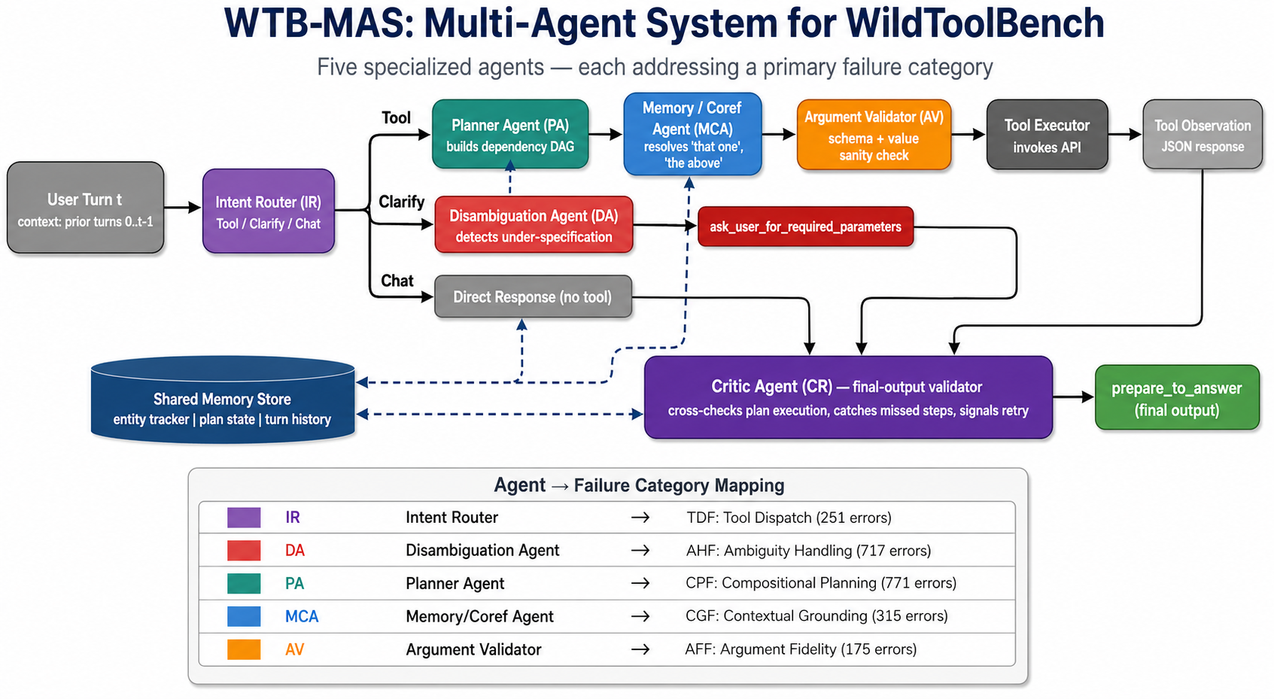
Figure 7. WTB-MAS architecture. Five specialized agents (IR, DA, PA, MCA, AV) plus a Critic (CR) and a shared memory store. Each agent's color matches the failure category it primarily addresses.

5.2 Agents and their Failure-Category Mapping
Code | Agent | Primary errors addressed | Responsibility
IR | Intent Router | TDF (251) | Classifies turn → {Tool, Clarify, Chat}. Routes to the correct downstream branch and prevents over-eager tool calls on Chat turns.
DA | Disambiguation Agent | AHF (717) | Detects under-specification (e.g., "one of the topics", "the above"). Emits ask_user_for_required_parameters when needed.
PA | Planner Agent | CPF (771) | Decomposes multi-tool requests into a dependency DAG. Identifies parallelizable vs sequential calls.
MCA | Memory / Coreference | CGF (315) | Maintains an entity tracker across turns. Resolves references before tool execution. Reads/writes shared memory.
AV | Argument Validator | AFF (175) | Schema-checks all arguments before execution. Normalizes formats (dates, casing). Flags hallucinated values.
CR | Critic Agent | all | Final-output validator. Cross-checks plan vs execution; signals retry on residual errors.

5.3 Pseudocode
def WTB_MAS(user_turn, conversation_history, tool_schemas, memory):
# AGENT 1: Intent Router (addresses TDF)
intent = IntentRouter(user_turn, history=conversation_history)
# intent ∈ {TOOL, CLARIFY, CHAT}
if intent == CHAT:
return DirectChatResponse(user_turn, history)
# AGENT 2: Disambiguation Agent (addresses AHF)
ambig = DisambiguationAgent.detect(user_turn, history, tool_schemas)
if ambig.needs_clarification:
return Action("ask_user_for_required_parameters",
args={"missing": ambig.missing_params})
# ── Tool-call branch ──
# AGENT 3: Memory / Coreference Agent (addresses CGF)
grounded_query = MemoryAgent.resolve_references(
user_turn,
memory.entities, # entity tracker across turns
history
)
# AGENT 4: Planner (addresses CPF)
plan = PlannerAgent.decompose(grounded_query, tool_schemas)
# plan = DAG of (tool_name, arg_template, dependency_list)
results = {}
for step in plan.topological_order():
# Bind args from prior step outputs
args = bind_args(step.arg_template, results)
# AGENT 5: Argument Validator (addresses AFF)
validation = ArgValidator.check(step.tool_name, args, tool_schemas)
if not validation.ok:
args = ArgValidator.repair(args, validation.errors)
# Execute
results[step.id] = execute_tool(step.tool_name, args)
memory.update(step, results[step.id]) # write to shared memory
# Critic: final review
if not Critic.validate(plan, results):
return WTB_MAS(user_turn, history, tool_schemas, memory) # retry once
return Action("prepare_to_answer", args={"answer_type": plan.answer_type})

5.4 Rationale: Why This Architecture
Each agent is justified by quantitative evidence from Section 3:
IR (Intent Router). Qwen3-32B has 55 over-eager tool calls on Chat tasks vs Qwen3-8B's 33 — scaling makes this WORSE. A dedicated lightweight classifier breaks the dependence on the underlying model's scale.
DA (Disambiguation Agent). AHF is the largest category for the smaller models (197 for 8B). 83% of AHF errors are "Premature Tool Execution" — the model proceeds without asking. A specialized detector trained on Clarify trajectories solves this.
MCA (Memory/Coreference). Coreferential Reference and Long-Range Dependency are the two hardest turn subtypes (per the baseline analysis). CGF errors are roughly flat across model sizes (85→71), suggesting scaling alone doesn't fix reference resolution. An explicit entity tracker is structural, not statistical.
PA (Planner). CPF is the largest absolute category (771). Sequential and Mixed Multi-Tool tasks have <20% accuracy across all models. Explicit DAG decomposition turns this from a single-shot generation into a structured process with verifiable intermediate steps.
AV (Argument Validator). AFF errors involve schema violations and value hallucinations that are programmatically detectable against the tool spec. A rule-based + small-model validator can catch these without the LLM having to "know" the schema.
CR (Critic). Even with all four upstream agents, residual cross-cutting errors will remain. A final critic provides a retry signal. We bound retries at one to prevent latency blow-up.

5.5 Expected Impact
Conservative coverage estimates per agent (assuming 50–80% of in-category failures captured):
Agent | Category | Total errors | Est. capture | Expected fixes
IR | TDF | 251 | 60% | ~150
DA | AHF | 717 | 70% | ~500
PA | CPF | 771 | 40% | ~300
MCA | CGF | 315 | 50% | ~157
AV | AFF | 175 | 80% | ~140
 |  | 2,229 |  | ~1247 (55%)
Aggregate fix rate of ~56% would meaningfully improve session accuracy from the current 2.7–9.0% range toward the 25–40% target zone.

5.6 Differentiation from Recent Work
Recent multi-agent tool-use work (e.g., the example reference at arXiv:2508.20931) generally proposes planner+executor pipelines or self-verification loops. WTB-MAS differs in two ways:
1. Failure-driven agent assignment: Each agent is justified by a specific empirically-measured error category — we do not add agents speculatively.
2. Disambiguation as a first-class agent: Most prior work treats clarification as an LLM behavior; WTB-MAS makes it a dedicated pre-tool component, which directly targets the largest failure category for smaller models (AHF).

6. Individual Contributions
Everyone contributed equally.

7. References
- Yao, S., Zhao, J., Yu, D., Du, N., Shafran, I., Narasimhan, K., & Cao, Y. "ReAct: Synergizing Reasoning and Acting in Language Models." ICLR 2023. arXiv:2210.03629.
- Shinn, N., Cassano, F., Berman, E., Gopinath, A., Narasimhan, K., & Yao, S. "Reflexion: Language Agents with Verbal Reinforcement Learning." NeurIPS 2023. arXiv:2303.11366.
- Qin, Y., et al. "ToolLLM: Facilitating Large Language Models to Master 16000+ Real-world APIs." ICLR 2024 (Spotlight). arXiv:2307.16789.
- Wu, Q., Bansal, G., Zhang, J., Wu, Y., Li, B., Zhu, E., Jiang, L., Zhang, X., Zhang, S., Liu, J., Awadallah, A. H., White, A. T., Burger, D., & Wang, C. "AutoGen: Enabling Next-Gen LLM Applications via Multi-Agent Conversation." COLM 2024 (also Best Paper, ICLR 2024 LLM Agents Workshop). arXiv:2308.08155.
- Mishra, V., Saeidi, A., Raj, S., Nakamura, M., Srinivasa, J., Liu, G., Payani, A., & Baral, C. "How Can Input Reformulation Improve Tool Usage Accuracy in a Complex Dynamic Environment? A Study on τ-bench." arXiv:2508.20931, August 2025. — used as inspiration only; pipeline NOT replicated.
- Yao, S., Shinn, N., Razavi, P., & Narasimhan, K. "τ-bench: A Benchmark for Tool-Agent-User Interaction in Real-World Domains." arXiv:2406.12045, 2024. (Cited only to note that we do NOT use its taxonomy.)
- Liu, X., Yu, H., Zhang, H., Xu, Y., Lei, X., Lai, H., Gu, Y., Ding, H., Men, K., Yang, K., Zhang, S., Deng, X., Zeng, A., Du, Z., Zhang, C., Shen, S., Zhang, T., Su, Y., Sun, H., Huang, M., Dong, Y., & Tang, J. "AgentBench: Evaluating LLMs as Agents." ICLR 2024. arXiv:2308.03688.

