**MECT 613 – MICROCONTROLLERS – FALL 2017**

**MIDTERM PROJECT**

SELF-BALANCING ROBOT

|  |  |
| --- | --- |
| **PREPARED BY** | |
| Mohd Saiful Akmal Bin Razali | 171021 |
| Gabriel de Brito Silva | 171020 |
| Hedaya Ali | 171103 |
| Berit Adina Haendel | 171018 |

**Prepared for:**

Prof. Mahmoud El-Samanty

**SCHOOL OF ENGINEERING & APPLIED SCIENCES (EAS)**

**DATE OF SUBMISSION:**

**‏04‏/12‏/2017**

# 0 Introduction

# 1 Hardware

# 2 Theoretical analysation

## 2.1 Inverted pendulum

The self-balancing robot can be described as an inverted pendulum. As a simplification we assume that the robot is mainly unstable in rotation around the wheel axis. Therefore, the model becomes 2-diminsional (z- and x-axis) and 2-DOF (position on x-axis and inclination angle).

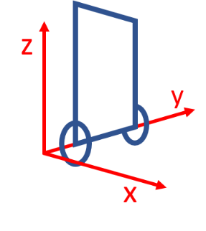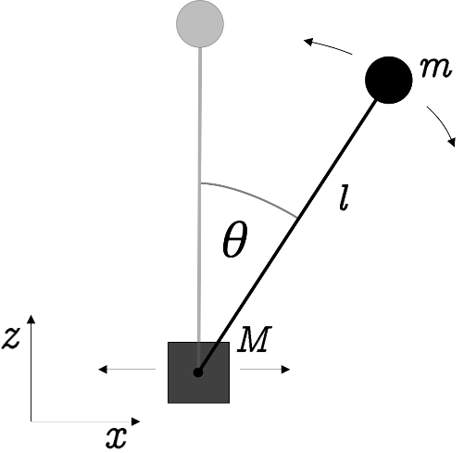

Fig. 1 Coordinate system for self-balancing robot. Relates to a fixed point on the ground. Assuming that robot will not rotate around z-axsis.

The pendulum consists of a mass point *m* at ($x_{m}, z_{m}$) which is connected to the base’s mass point *M* at ($x_{M}, z_{M}$). The pendulum can freely rotate around the joint point and *M* can be move along the *x*-axis. To obtain the equations of motion for the system, we first determine the Lagrange equation consisting of the cinematic energy *T* and the potential energy *V* of the system:

$$L=T+V=\frac{1}{2} M {\dot{x}}_{M}^{2}+\frac{1}{2} m \left({\dot{x}}_{m}^{2}+{\dot{z}}_{m}^{2}\right)+\frac{1}{2} J {\dot{θ}}^{2}-m g z_{m}$$

With the inertia moment $J=m l^{2}$ of the mass *m* rotating around point *M*. Since the coordinates are given through

$x_{M}=x$, $z_{M}= 0$, $z_{m}=l\cos\left(θ\right)$, $x_{m}=x+l\sin\left(θ\right)$

we can derivate them

${\dot{x}}_{M}=\dot{x}$, ${\dot{z}}_{M}= 0$, ${\dot{z}}_{m}=- l \dot{θ}\sin\left(θ\right)$, ${\dot{x}}_{m}=\dot{x}+l \dot{θ}\cos\left(θ\right)$

and insert the results into the Lagrange equation:

$$L\left(x,θ, \dot{x},\dot{θ}\right)=\frac{1}{2} \left(M+m\right) {\dot{x}}^{2}+m l\cos\left(θ\right)\dot{θ} \dot{x}+m l^{2} {\dot{θ}}^{2}-m g l\cos\left(θ\right)$$

Now, the relevant equation of motion for the system can be obtained by applying the following Euler-Lagrange equation.

$$\frac{d}{dt}($$

## 2.2 Calculation of angle

# 3 Design

## 3.1 Frist design approach

## 3.3 Reworked: Second design approach

# 4 Code

# 5 Others

## 5.1 Descriptions of attachments

## 5.2 Used references

<http://www.kerrywong.com/2012/03/08/a-self-balancing-robot-i/>

Ogata, 2010, Modern Control Engineering, Fifth Edition, p.69 ff.