**Mini map**

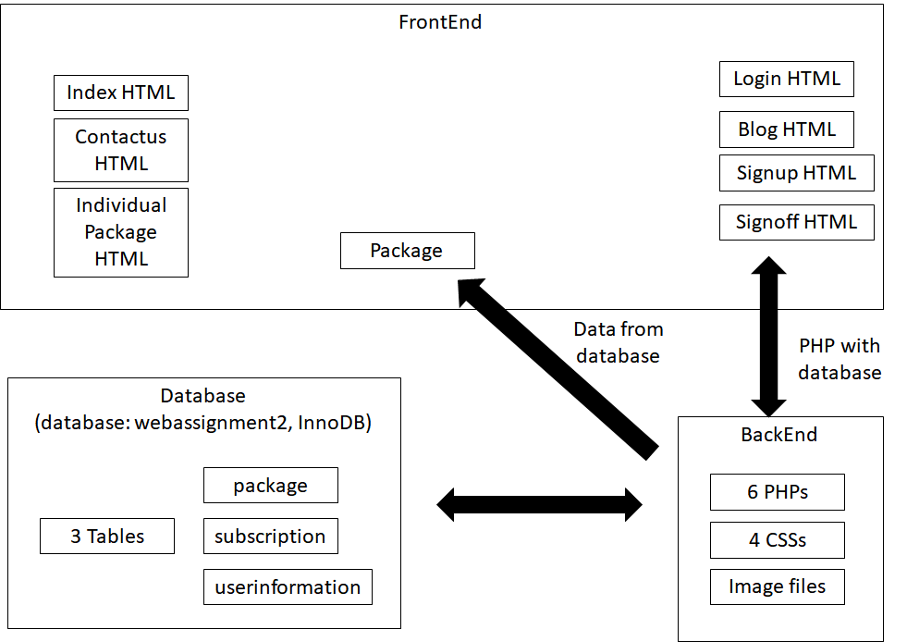

**Introduction**

When users use any browser and type in “GitTour.com”, it will allow them to get into the Home page of our GitTour website, the navigation system on the top will show them what services and interaction GItTour travel agency provide, they can feel free to select any services or purely browse the blog section to obtain references from feedbacks of other users’ experience in our travel services.

**Components**

1. index HTML

* Summary
  + The index provides travel package based on each concepts.
* Functionality
  + Animation in promotion: images are changed automatically and can be controlled by controller
  + Animation in recommendation: if an user clicks a city button, the grid is changed with transition.
  + Visible for go to top button: if an user scrolls down in a page, go to top button is visible.
* Special considerations
  + Header & Footer: they have links for other pages
  + Page Accessibility: When shrinking the page to a small screen, the page will fit in the screen size and change the grid area to fit it.

2. package PHP

* A picture containing PowerPoint

  Description automatically generatedSummary
  + The package page includes special promotion packages at the top of the page and the package page provides users with travel packages to choose from, a search bar to search through the packages and a filter which will sort by province.
* Functionality
  + Contents from database: When a package is clicked on, the page gets the data from the database. The page also checks if there is a connection error and redirect users to index page if there is a bad connection.
  + Promotion animation: This page includes a promotion package section at the top which cycles through a variety of images and descriptions for different promotion packages.
  + Search bar: The user can type in any keywords in the search bar, and the list will then filter to match the letters and word the user has input. It changes the results as soon as the user inputs a character, no submit or search button required.
  + Filter function: The user can click on the filter and a drop-down menu will appear listing the available provinces to choose from. When a user clicks on one of the provinces listed in the drop-down menu, the results will change according to whichever province the user chose and the list will only display the packages that are in that province.
* Special considerations
  + Page Accessibility: The package page adjusts its contents to fit different screen sizes so that its accessible on various devices.

3. individual travel HTML

* Summary
  + Text, letter

    Description automatically generatedThe individual package page provides user to search, filter and browse the tour package for individuals.
* Functionality
  + Search function: User can input any keywords in the search bar and then click the search button (e.g. location, price, nights, etc.). The scroller will direct the page to the result once the search button is clicked.
  + Filter function: User can filter the packages by province using the filter blocks. The scroller will direct the page to the result once the search button is clicked. Click show all can show all the packages.
* Special considerations
  + Direct to the specific position in page: when an user click a button, it directs an user to direct the individual travel data in the same page for a better user experience while they are browsing the page.
  + Page Accessibility: When shrinking the page to a small screen, the page will fit in the screen size and reduce the detailed information automatically.

4. blog HTML

* Summary
  + A picture containing shape

    Description automatically generatedUsers can subscribe to our newsletters by inputting their email from this page. The review link and previous users’ blog will bring users to the travel package page and find the interested travel packages if they are inspired by any articles in the blog section.
* Functionality
  + Client-side email verification: it provides validation for the format of email when clicking the button and also provides user-appropriate error messages as reminders if the format is wrong.
  + Form action to PHP: if an user clicks the button, the email is sent to subscription.php.
* Special considerations
  + Page Accessibility: When shrinking the page to a small screen, the page will fit in the screen size and change the grid area to fit it.

4-1. subscription PHP

* Summary
  + It gets data from global variables and stores them into database.
* Functionality
  + Database implementation: MySQL connection -> Check connection -> Make a query to insert data into subscription table

5. contact us HTML

* Summary
  + This page shares the information of the employees and partnerships of the company.
* Functionality
  + No function in this page
* Special considerations
  + Page Accessibility: When shrinking the page to a small screen, the page will fit in the screen size.

6. login HTML

* Table

  Description automatically generated with low confidenceSummary
  + After new users completed the sign-up page, they can be guided to the login page by clicking “Log in” button at the bottom of Signup page or welcome page.
* Functionality
  + Form action to PHP: if an user clicks the button, the email is sent to checklogin.php.
  + Reset login data: The reset button let all input empty.
* Special considerations
  + No special consideration in this page.

6-1. checklogin PHP

* Summary
  + It gets data from global variables and verify data on server side.
* Functionality
  + Database implementation: MySQL connection -> Check connection -> Make a query to check data whether it’s duplicate or not by using SELECT statement -> alert or redirect an user to another page based on the result of verification.

7. signup HTML

* Summary
  + This page will allow users to create accounts by inputting corresponding information
* Functionality
  + Client-side verification: This sign-up form provides validation data which will be implemented on the client side, and also provides user-appropriate error messages as reminders.
  + Form action to PHP: if an user clicks the button, the data are sent to registration.php.
  + Reset data: The reset button let all input and error messages empty.
* Special considerations
  + Page Accessibility: When shrinking the page to a small screen, the page will fit in the screen size.

7-1. registration PHP

* Summary
  + It gets data from global variables and verify data on server side and insert data to database.
* Functionality
  + Database implementation: MySQL connection -> Check connection -> Make a query to check data whether it’s duplicate or not by using SELECT statement -> Make a query to insert data into userinformation table unless it’s duplicate -> alert or redirect an user to another page based on the result.

7-2. welcome PHP

* Summary
  + It gets data from global variables and display username to welcome users.
* Functionality
  + Data display: username data from registration.php is displayed.

8. signoff HTML

* A picture containing table

  Description automatically generatedSummary
  + If users don’t want to use our service, and they would like to delete their account from our website, they can send a request by inputting their user information i.e. email and password.
* Functionality
  + Form action to PHP: if an user clicks the button, the email is sent to checkaccount.php.
  + Reset login data: The reset button let all input empty.
* Special considerations
  + No special consideration in this page.

8-1. checkaccount.PHP

* Summary
  + It gets data from global variables and verify data on server side.
* Functionality
  + Database implementation: MySQL connection -> Check connection -> Make a query to check data whether it’s existed or not and then delete it if existed -> alert or redirect an user to another page based on the result of verification.