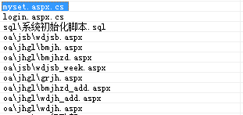
示例：
原：
Response.Cookies["mretail_bcount"].Value = bigpagesize.Text.ToString();
Response.Cookies["mretail_bcount"].Expires = new DateTime(2015, 1, 1);
改为：
Response.Cookies["mretail_bcount"].Value = bigpagesize.Text.ToString();
Response.Cookies["mretail_bcount"].Expires = DateTime.Today.AddMonths(1);

