1a. You see a dip in a spike-triggered average about 50 ms before the spike time, a peak close to the spike time, and zero after the spike time. Explain what this can mean.

The dip around 50 ms before the spike time likely indicates that the neuron received inhibitory input. This means that the activity of other neurons or some external stimulus briefly suppressed the firing of the target neuron. The peak close to the spike time represents the excitatory input that ultimately triggered the spike. The zero activity after the spike time reflects the refractory period. After firing, the neuron needs a brief time to recover before it can be excited again. This prevents the neuron from firing uncontrollably and helps maintain information processing within a specific timeframe.

1b. You see a peak in a spike-triggered average near the spike time that lasts for 20 ms after the spike time. Explain what this can mean.

A peak in a STA near the spike time indicates that the signal is positively correlated with the spike train, meaning that the signal is more likely to occur at times when the neuron is firing.

There are a few possible explanations for why you might see a peak in a STA near the spike time that lasts for 20 ms. One possibility is that the signal is directly driving the neuron to fire. For example, if the signal is a current pulse, it could depolarize the neuron's membrane potential and cause it to fire an action potential.

Another possibility is that the signal is indirectly driving the neuron to fire. For example, the signal could be causing other neurons to fire, which in turn could excite the neuron in question. In this case, the delay between the signal and the spike would be due to the time it takes for the other neurons to fire and excite the neuron in question.

2. Sketch the spatiotemporal receptive field of a neuron that responds most to a drifting grating with a spatial period of 5 degrees, moving from left (negative-x) to right (positive-x) at a speed of 20 degrees per second.

If we consider color white as light and black as dark. The response would be like below graph. I think moving causes delay in inhabitation (dark color) and excitation (light color) response of the adjacent neurons.

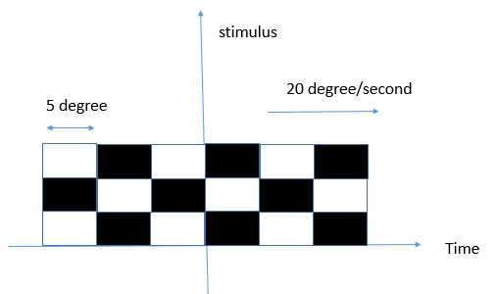

3. Rank the following spike processes from smallest to largest CV of ISIs, then from smallest to largest CV2 of ISIs:

a.  A neuron with regular spikes every 50 ms.

b.  A Poisson process with mean rate of 20 Hz.

c.  A regularly bursting neuron with 5 spikes separated by 5 ms within a burst, then a pause of 500 ms before the next burst.

d.  A regularly spiking neuron whose rate gradually increases from 0.01 Hz to 100 Hz over an hour.

CV: a,b,d,c

CV2:a,d,b,c